

BA BUSINESS MANAGEMENT

MARKETING FUNDAMENTALS

ASSIGNMENT 1

BRITISH AIRWAYS BLOG

MODULE: Marketing Fundamentals

CODE: LCBB4004

LECTURER: Mohammad Rahmad

NAME: Amarildo Petre Kisck

SUTDENT ID: 2133169

SUBMITTED ON: 22/11/2022

Table of Contents
INTRODUCTION 3
EXPERIENCE LUXURIOUS MOMENTS WITH BRITISH AIRWAYS 3
WORK TRIP JUST TURNED MORE FUN – CHOOSE BRITISH AIRWAYS FOR YOUR BUSINESS TRIP 4
BRITISH AIRWAYS – BUSINESS CARD 5
NOT ENOUGH TIME FOR YOU TO REACH THE BAG DROP OFF DESK? WE’LL SORT IT OUT FOR YOU. 6
FOOD FOR YOUR HEART 6
FLIGHTPATH TO NET ZERO BY 2050 8
Bibliography: 9

BRITISH AIRWAYS

INTRODUCTION

With an extensive operational activity of 48 years, British Airways is UK’s largest international airline that serves over 160 destinations from around the world, serving travellers who seek a leisure holiday or a business trip. Ever since its establishing in 1974, the airline carried more than 37 million customers on a yearly basis, invested in innovation, constantly evolving, and putting efforts into delivering the best customer care they have. (CTP, 2022)

British Airways is a large company, hiring over 40,000 employees who are covering extensive roles. The company rose to success when it became the first airline to schedule the first commercial service in UK, to acquire the first commercial jet and supersonic services, the first fully flat business class beds and over in 2013, it has become the first airline in Europe to operate the A380 and the Boeing 787 Dreamliner which are the most known aircrafts to have flown. (CTP, 2022)

EXPERIENCE LUXURIOUS MOMENTS WITH BRITISH AIRWAYS

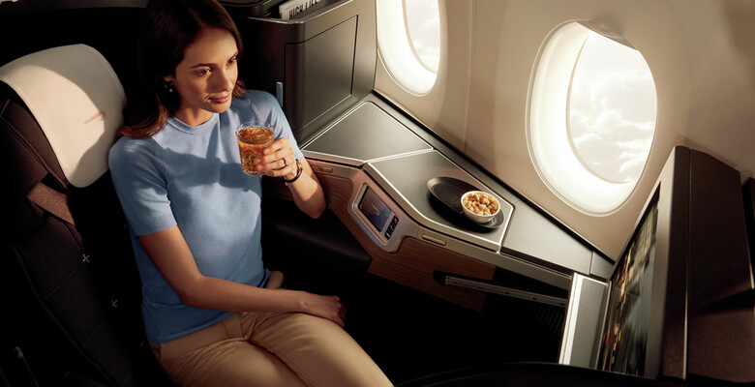

Are you ready for a FIRST class experience? British Airways First Class flights are the finest experience that we have crafted for you and your loved ones. We know long-haul flights can be a little stressful and sometimes uncomfortable but choosing a FIRST class long-haul flight can now be more than delightful; with an exceptional and elegant British service and having your own private spacious suite, your travel can now be a reason to celebrate rather than worry. (British Airways, 2022)

Our FIRST class experience doesn’t stop here, there’s more:
- Enjoy a good night sleep in your suite that contains a flat bed built with foam and topped with a microfibre mattress
- Treat your taste buds to a deliciously indulgent fine dinner served in exquisite crockery, cutlery and glassware designed with a British twist by our finest designers: William Edwards, Studio William and Dartington
- Enjoy wearing our Temperly London designed loungewear, make use of amenity bags and slippers
- Treat your skin to our luxurious seven-piece skin and body collection from Elmis
- Use of our exclusive on board Wi-Fi called BAWi-FI which allows you to connect to the internet all throught your flight with no additional charges.
- We are mastering entertainment on our Boeing 787 Dreamliner with incorporated 15-inch flat screens that allow you to connect your phone and even charge it.
- We are also putting at your disposal noise-cancelling headphones, for you to enjoy your movies or music with no disturbance.

It all sounds so good, and we are not stopping here; upon your airport arrival, we have created a dedicated and exclusive service and check-in desk just for you, take your time through Priority Boarding and Gate Crossing and as you walk through, our First Wing Lounge awaits your arrival. At London Heathrow Airport in Terminal 5, being an Executive Club Gold member gains you exclusive access to our fantastic lounge where our team at the First Wing Lounge are ready to serve you the finest canapés and the finest drinks.

For more information and bookings, visits our website www.britishairways.com and get ready to fly FIRST class. (British Airways, 2022)

WORK TRIP JUST TURNED MORE FUN – CHOOSE BRITISH AIRWAYS FOR YOUR BUSINESS TRIP

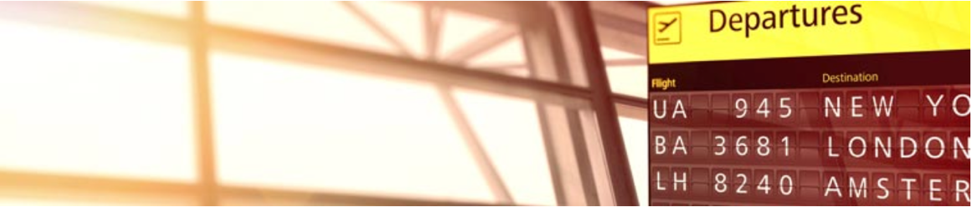

Choosing British Airways for your work trip can prove to be the best choice for your business; whether you are choosing a long-haul flight or a short-haul flight, we are here to help you make the best decision for your much needed trip. We have available a travel class to satisfy all tastes and budgets, from our best value economy services to luxurious and impeccable FIRST class services. (British Airways, 2022)

Moreover, we are flying to more than 140 destinations worldwide giving you access to hundreds of additional destinations obtained in partnership with Oneworld Alliance. Our top long-haul business destinations are: New York, San Francisco, Los Angeles, San Jose, CA, Chicago, and Austin with return flights starting from just £359/per person. (British Airways, 2022)

In need of a hotel? On our website www.britishairways.com, you can book your flight and enjoy the luxury of booking additional services such as hotel rooms, airport transportation, rent a car and more. Choose between any of the travel classes available: Economy, Premium Economy, Business/Club and First. (British Airways, 2022)

All our Business Member UK travellers can enjoy an additional 10% discount on most business destinations across Europe and USA. For more information, visit our website. (British Airways, 2022)

BRITISH AIRWAYS – BUSINESS CARD
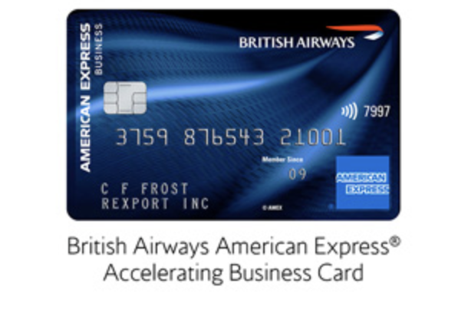

Our customers are the heart of all our work, and we always want to give back and reward our customers loyalty which is why we have created the British Airways American Express Accelerating Business Card. You could earn up to 120,000 Avios points per year, just by choosing to pay your everyday business expenses with the British Airways American Express Accelerating Business Card. (British Airways, 2022)

How does it work?
For every £1 spent you are going to collect 1.5 Avios Points; plus, receive a bonus of 10,000 Avios Points for every £20.000 spent on the Card, up to 3 times per year. You can use your card not only for your travels, but you can use it to pay suppliers, for market investments or even just paying your own personal bills.

To make things better, when you choose to fly again with British Airways, for each £1 spent, you can earn 2 On Business Points which will help accelerate your points earnings. Use your points to purchase British Airways flights and services. (British Airways, 2022)

Interest rate for purchases: 24.2% p.a. variable. Representative APR: 100.3% variable based on £250 annual fee and assumed annual credit amount of £1,200. (British Airways, 2022)
Terms and Conditions apply. For more information and how to obtain your own Business AMEX Card, visit our website www.britishairways.com

NOT ENOUGH TIME FOR YOU TO REACH THE BAG DROP OFF DESK? WE’LL SORT IT OUT FOR YOU.
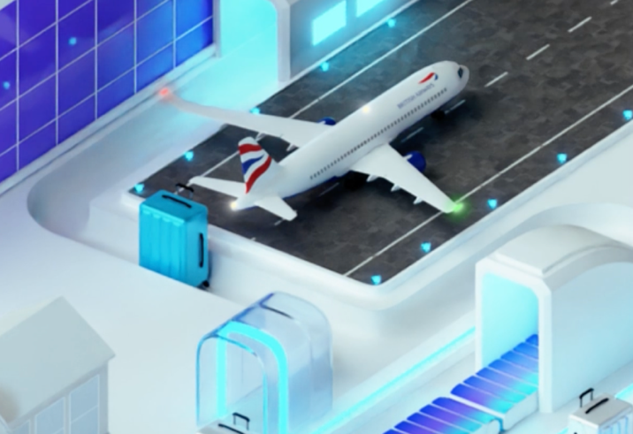

At British Airways, we understand how precious time is and how just a few minutes late can ruin an entire holiday. For our busy customers, we have partnered with AirPortr to make things easier for you; AirPortr is a dedicated service that you can book to have your luggage collected from your home/hotel and taken straight to the airport and checked-in for your future flight.
Sounds like a dream, right? Well, it isn’t a dream. Booking this service is very easy, head over to www.airportr.com and arrange for your luggage to be collected. (British Airways, 2022)

Choose between the 2 AirPortr services:
- Standard AirPortr Bag – a dedicated standard service that collects your bags from home/hotel and takes them into the airport to the Landside AirPortr Kiosk ready for collection, for you to drop them off at the bag drop off desk.
- AirPortr and Bag Check-in (ABC) – through this service, your bags are being collected and taken to the airport for bag drop off. If you are using this service and you have already checked-in, head straight to the Departures area. This means plenty of time for you to enjoy our delicious canapes and drinks in our Number 1 Lounge. (British Airways, 2022)

For more information, visit AirPortr website.

FOOD FOR YOUR HEART

Sometimes food is all you need, and we know that are British Airways travellers deserve the best foods there are. Whether you are a picky eater or simply hungry, we have a menu for every single one of our travellers.

Short-haul flights

Short-haul economy
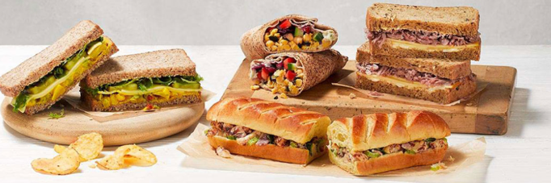

Our Speedbird Café menu is available for everyone to pre-order/purchase in Euro Traveller featuring a delicious gourmet range by Michelin-starred chef, Tom Kerridge. Each purchase comes with a complimentary bottle of water or snack of choice. (British Airways, 2022)

Short-haul business
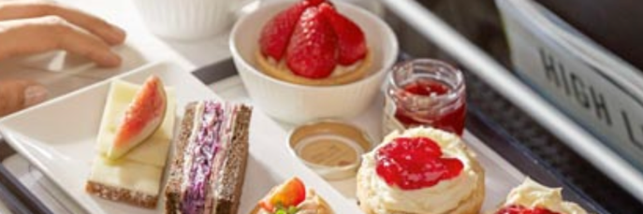

All our Club Europe travellers can enjoy on flight full English breakfast, lunch, traditionally British afternoon tea and dinner. To cure your thirst, we are offering a range hot, cold, and alcoholic drinks. (British Airways, 2022)

Long-haul flights

Long-haul economy
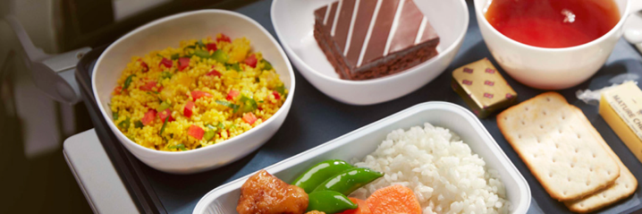

In World Traveller we offer our passengers delicious starters, main and desserts with your own choice of a cold, hot and alcoholic drinks. And if hunger wasn’t cured, we are offering mid-flight snacks and a second meal on longer flights. (British Airways, 2022)

Long-haul premium economy
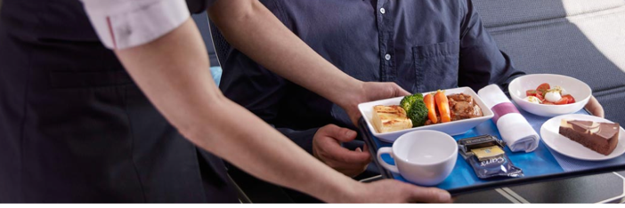

In World Traveller, we will welcome you on board by serving you a glass of sparkling wine, a starter, main and dessert. During your flight, we put at your disposal a range of sweet and salty snacks, cold and alcoholic beverage and tea or coffee. (British Airways, 2022)

Long-haul business
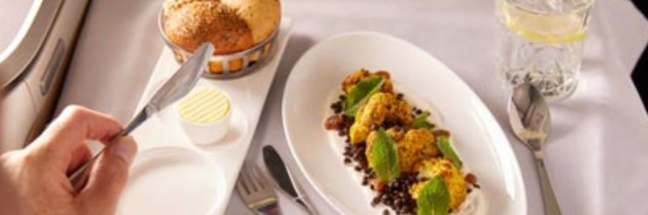

In Club World you can choose your preferred main course, accompanied by a starter, dessert, and a cheese board. All thorough your flight, you can choose from our snack selection, and our hot and cold drinks, wines and spirits. (British Airways, 2022)

Long-haul First Class
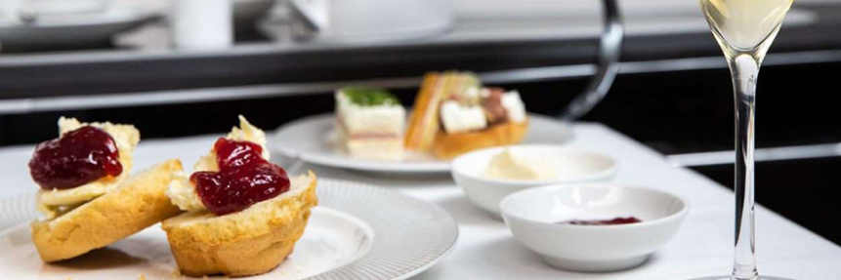

In our First Class be the main creator of your desired dining experience by choosing the perfect dish from our a la carte “Dine Anytime” menu containing signature dishes made with high quality British ingredients, served, and delivered with impeccable service.
Together with your dinner, we offer a range of snacks, beverages including cocktails, mocktails, Champagne, spirits, and wines. (British Airways, 2022)

All our menus are available on www.britishairways.com; for food allergies, please consult our menu and inform beforehand by using the comment section of your booking.

FLIGHTPATH TO NET ZERO BY 2050


At British Airways we understand the need of a clean, safe, and sustainable planet which is why we have implemented our Flightpath to Net Zero greenhouse gas emissions by 2050.

So, we can reach our target, we are looking into replacing our old aircrafts with newer, fuel-efficient ones and as well we are committed to reducing our carbon footprint through the mere development of new, green aviation fuels and as well through introducing more electrical vehicles during airport operations. (Stefan et. all, 2020).

Bibliography:

Airways, B., n.d. British Airways. [Online]
Available at: https://www.britishairways.com/en-gb/information/travel-classes/first/first
[Accessed 19 November 2022].

Airways, B., n.d. British Airways. [Online]
Available at: https://www.britishairways.com/en-gb/business-travel
[Accessed 19 November 2022].

Airways, B., n.d. British Airways. [Online]
Available at: https://onbusiness.britishairways.com/web/ba/promotion-details?id=916
[Accessed 19 November 2022].

Airways, B., n.d. British Airways. [Online]
Available at: https://www.britishairways.com/travel/askbainter/public/en_gb?p_faqid=5623
[Accessed 19 November 2022].

Airways, B., n.d. British Airways. [Online]
Available at: https://www.britishairways.com/en-gb/information/food-and-drink
[Accessed 19 November 2022].

CTP, n.d. CTP. [Online]
Available at: https://www.ctp.org.uk/job-finding/directory/british-airways/about
[Accessed 19 November 2022].

Stefan Jackson, J. T., 2020. A VISION FOR DATA SCIENCE AT BRITISH AIRWAYS. Impact, 2020(1), pp. 15-19.

