Marketing Fundamentals Analysis and Evaluation Assignment

Introduction

Marketing management and having a successful marketing campaign is a process every viable business must have in order to succeed and stay up to date with market changes, and new competition joining the market. The Chartered Institute of Marketing defines marketing as “The management process responsible for identifying, anticipating and satisfying customer requirements profitably” (The Chartered Institute of Marketing, 2018, p. n.p). Marketing is important because it is very customer driven, which means that marketing is revolved around the customer. If a company’s marketing campaign has not been taken seriously and done to a high standard then they can expect their products to go into the decline stage of the product-life cycle much faster than the competition. This essay will also look at the charity The Rising Stars Theatre Company, and how the marketing mix is integrated with their campaign.

The Marketing Process
Ultimately, one of the main purposes of marketing is to create customer value. According to CustomerThink, “Customer Value is the perception of what a product or service is worth to a Customer versus the possible alternatives. Worth means whether the customer feels she or he got benefits and services over what she or he paid.” (Mahajan, 2016). In context, this means that customers need more than the ‘value for money’ of a product or service, they need a guaranteed good quality product in order to satisfy their needs and wants. This then could lead to them repurchasing a product from a company which then in the long run could increase their loyalty to the company therefore could show that their marketing campaign is viable. (Beard, 2014)

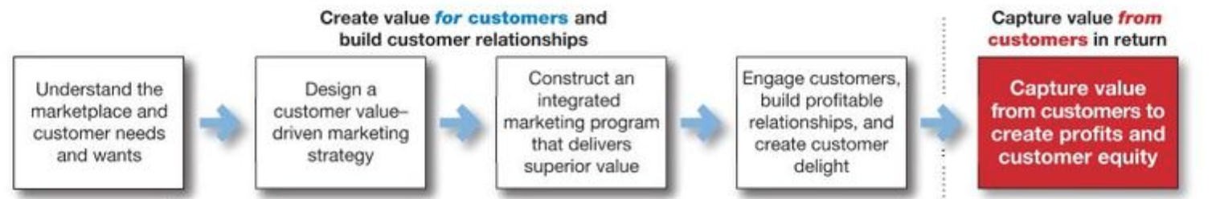

Figure 1.1 – The Marketing Process (Kotler & Armstrong, 2018)

The diagram above shows a brief representation of the marketing process. The first four steps are based on creating customer value, and the final step is the main profit-making situation the whole process has gained. In the first step, the main aim for the company is to understand the marketplace they are selling their product or service in, and through this getting to grips with the amount of competition they have in order to find a unique selling point to be a cut above the rest. The company must feel comfortable in the marketplace in order to succeed. A popular saying to support this theory is: “by failing to prepare, you are preparing to fail” (Business Insider, 2011). Therefore, if a company is going into a marketplace without any preparations, their product will be overshadowed by a competitor.
The second, third, and fourth step is mainly focused on creating customer value. Thus, matching a product with the customer’s needs and wants. Although, this is a very important aspect of the marketing process, a company cannot please everyone, therefore they have to keep profit in mind. One of a company’s main aims and objectives among others is to make a profit, therefore the company should concentrate on their main target audience and create a product in order to satisfy their needs and wants. (Kotler & Armstrong, 2018)
The final step of the marketing process is ultimately the most important. It’s combining all the information from the first 4 steps in order to create an integrated marketing program, whilst integrating the four p’4s. The company must target their main customers by marketing their product properly. This means, using pricing strategies and using special offers to create customer value. Also, the company must create a strong brand identity, this meaning the message a company portrays from the product or service they are selling. The importance of creating a strong brand identity is if you have a large and loyal customer base, but you’re charging more for your product or service over your competitor, creating a strong brand identity will ultimately be one of the things that differentiates your company from the competition. (Small Business, 2017)
One of the main reasons that the marketing process is important is because the company needs to secure good relationships with customers in order to be profitable and ahead of market changes. The company must create good customer value in order to assure that loyal customers buy the company’s products or services again. By doing this the company can achieve a greater customer base by word of mouth from current customers.
In today’s world, markets are constantly changing therefore companies must adapt to these changes adequately. While creating customer relationships, companies must take advantage of opportunities that become available, whether it be international or global, or small technological changes within the company. The marketing process will help the company to market their products or change the marketing campaign of current products in order to adapt to modern day changes.

The Marketing Mix – 4p’s

The marketing mix is an important tool to marketers globally, as it supports the company in its goal to reach its sales target. The marketing mix consists of the 4 p’s, which are the Price, Product, Place and Promotion and was developed by E. Jerome McCarthy. He said, “the marketers essentially have these four variables which they can use while crafting a marketing strategy and writing a marketing plan.” (Linkedin, 2015). According to Kotler & Armstrong (2018) “The marketing Mix is the set of tactical marketing tools that the firm blends to produce the response it wants in the target market” (Armstrong & Kotler, 2017). This means that in order to reach its target market then the marketing mix, must be done correctly in order for the company to succeed in reaching its sales and profit margins.
Originally, the marketing mix consisted of the 4 p’s, but were changed to the 7p’s. The additions to the 4 p’s are Physical Evidence, Process, and People. The 7p’s were developed in 1981 by Booms and Bitner. (Professional Academy, n.d). Marketers realised that the 4-p’s needed updating and this is why the 3 extras were added. These extra 3 p’s could help the company to give a broader range of information to help strengthen their marketing strategy overall.

If a company cannot detail the Price correctly in their marketing mix, then this could have a detrimental effect in sales for the company, because if the price is too high, some customers might buy from the competition, therefore the Product, and Promotion would not be taken into full affect. On the contrary, even if the price is considerably more than the competition, if the company has a good brand reputation, and people are loyal to the name and brand, then reaching its sales figures shouldn’t prove to be a problem.

In order to show how marketing has changed over the years it is important to understand how the marketing mix is integrated with more modern styles of marketing. As e-commerce and buying online from companies such as Amazon is on the rise, these companies must integrate the marketing mix into their strategies in order to understand their target market. Whether people use their mobile phones, the internet, television or even social media platforms to buy online, the market for buying online is massive today compared to traditionally buying from shops, and market stalls for example. (Ryan, 2014)
Therefore, companies such as Amazon will not have high street shops as all of their buying and selling is done from offices and warehouses, but coffee shops for example will still have high street locations as this cannot be done online. With regards to the charity The Rising Stars, location is not the most important aspect to their marketing mix. This is because they have so many stakeholders and parents and children who attend the charity, if they were to move locations, they have so many people who support them then they would have no problem moving with them. This may be different in profit making organisations because if a shop would move to an inconvenient location, consumers are obviously going to look elsewhere for their products.

According to Jim Blythe
“Marketers define a product as being a bundle of benefits. This means that the product is more than just the sum of its physical characteristics; it includes fringe elements such as the brand image, the way the product is packed and delivered, even the colour of the box it comes in.” (Blythe, 2012, p. 120)
Some marketers may say that the product is the most important aspect of the marketing mix, because if they didn’t have a product then they would not be trading in a marketplace.
There are three levels of product according to Kotler’s Principles of Marketing: see the diagram below:
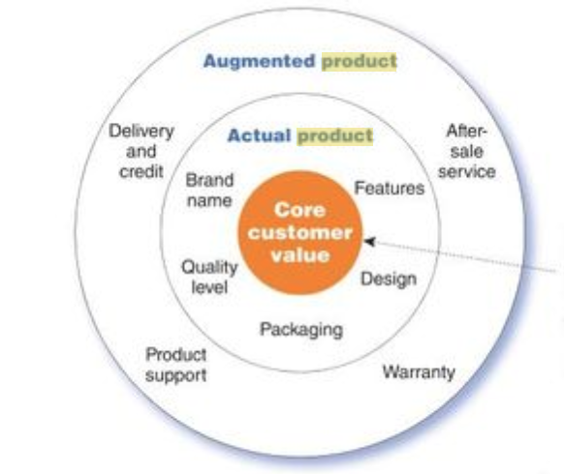
Figure 1.2 – 3 Levels of Product (Kotler & Armstrong, 2018)
The most basic stage is the core customer value which is having a product in mind. This is then backed up by the ‘Actual Product’ which means giving identity to the brand. Thus meaning, giving the product a brand name, a logo, insuring that the packaging is up to standard and that the buyer knows exactly what they’re buying. The company would now be ready to sell their product if they have a marketplace at hand, but they could use the third part of this diagram which is the ‘Augmented Product’ these are additional benefits the company could sell the consumer to go with their product, warranty and insurance for example. (Kotler & Armstrong, 2015)

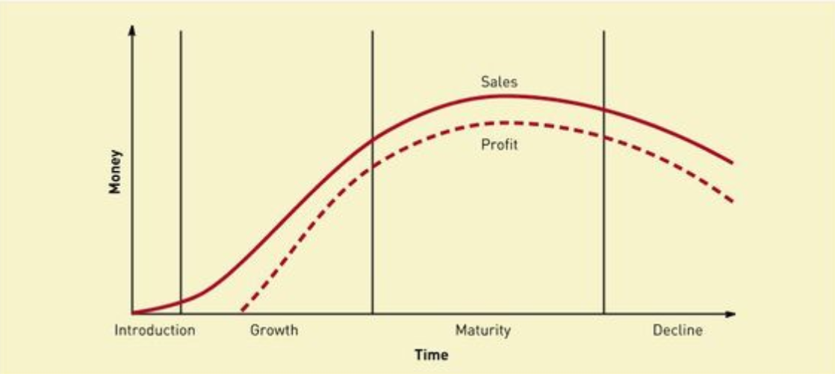
Figure 1.3 – Product life cycle (Blythe, 2012)

This diagram shows the life cycle of a product and this graph measures the sales and profit at that time. The maturity stage is where companies want their products to stay. This is the stage where the advertisement of the product must be substantial because competitors begin to join the market, and the company must keep its share of the market in order to keep trading. This is the stage where the sales and profit should be at its peak.
If a company’s products are unsuccessful then they will begin to decline in the decline stage, and therefore the company will stop major advertisement of these products, and concentrate in the most profitable products in their portfolio. In order to stop products from going into the decline stage, businesses can use extension strategies to keep the product in maturity. These extension strategies include changing the position of the product in the marketplace, and possibly launching the product again. (WJEC, 2015-2016)

Promotion is the strategies or tactics that the company is going to use to make people aware of their product. This can be done by advertisement and Public Relations. Sales advertising could also be done, for example giving away free samples in order to draw people’s attention to their company. This as well could build potential relationships with customers and increase the brand loyalty. (Blythe, 2012)
One of the main forms of promotion is advertising. There are so many forms of advertising a company could use, such as Above the Line Advertising, and Below the Line Advertising. Above the line advertising is using media as their main form of advertisement, such as TV advertisements and radio ads. This form is costlier to the company as using media as a form of advertising costs a lot of time and money to the company. Below the line advertising is the use of pamphlets or posters. These can be done internally in the business and therefore would cost less for the company overall. (The Advertising Club, 2011).

The 3 other P’s include Physical Evidence, People, and Process. People are important to a company as these are the people who can help the company to grow, by voicing their opinions by surveys, writing reviews and so on. The process is how easy the customer gets to consume the product. Thus meaning, fast track, and easy ordering for example. An organisation that supports this is Domino’s Pizza, they have used an emoji that people can text to them to order their favourite pizza. Lastly, the Physical Evidence can mean the atmosphere in which the consumer buys the product. An example of this is Hollister, and their dark shops, this is used to set the mood in the shop. Opposite to this is Apple, where most of their stores are big and light in order for the customers to see their products in their full potential.

Stakeholders
According to N. Bowie (2012) “The purpose of business is value creation for the various stakeholders of the business.” (Bowie, 2012). This shows that the business must assure that they’re creating value in order to satisfy the stakeholders. Stakeholders in some businesses hold some power over who is the director for example. If the director isn’t doing well at their job, then this can be disputed by the stakeholders over meetings or a vote. Being a stakeholder includes “The process of winning influence with specific groups whose goodwill is vital to the organization and to whom it is important to portray an effective corporate image, for example shareholders, employees, and customers.” (Doyle, 2011).
Stakeholders have an interest in the company, but it could be for two very different reasons, the customers and staff for example will have an interest in the company doing well, and therefore they may be investors in a company if it’s a PLC. The opposite to this is a rival company or a competitor that might have an interest in the company, as they want to know what they’re up against. Also, some competitors will have an interest in the company in order to see where they can cease the opportunity to steal potential sales or customers, and gain a bigger market share. Therefore, for a business, having stakeholders is good in order for them to have different opinions on how to improve for example. As The Rising Stars isn’t a business that has profit in its mind, they still have people and stakeholders who have an interest in the company, such as parents of the attendees, the volunteers and staff, and even the community. If a charity like this were at the risk of shutting down, then some stakeholders could potentially come together to prevent this from happening.

To conclude, marketing is an important department of a business because without marketing and advertising a product, no sales would be generated in order to make a profit. The same could be said about The Rising Stars Theatre Company, although they’re a not-for-profit organisation, marketing is still an important tool that they use in order to try and get more people to know about what they’re doing all over the world. As a part of this project, the group as one communication tool created a blog site in order to raise awareness for the charity, the blog site consisted of blogs such as recent pantomimes, what parents think of their children attending The Rising Stars, and much more. Where marketing is concerned, we posted links to our site onto other social media websites, such as sending links to friends and family to read. We also put posters up in The Business School and other organisations around Wales. The blog site also got views from countries such as Canada, Spain, and New Zealand. This then shows how powerful marketing is in a modern world. If the group were selling a physical good, then if someone in Canada for example were to like and buy a product, then messages can be passed on and this then means that their marketing strategy must be working.

While raising awareness for the charity the AIDA model was taken into consideration. The AIDA Model consists of:
- Awareness
- Interest
- Desire
- Action

According to Kotler & Armstrong: “Ideally the message should get attention, hold interest, arouse desire, and obtain action, in practice, few messages take the consumer all the way from awareness to purchase, but the AIDA framework suggests the desirable qualities of a good message” (Kotler & Armstrong, 2018). When the group were raising awareness, they assured that the communication tools used were interesting, facts were displayed on the blog site and posters in order to reach an audience worldwide. The posters created were eye catching and desirable to read therefore people and stakeholders would walk past and read them. The action needed was that the people reading the blogs and posters read more into the charity’s background and their Facebook page in order to find out more about what they do and in fact spread more awareness overall that way.
The target audience for The Rising Stars can vary. There is no age group or sex that would hold more of an interest over the other. The target audience for what the charity do weekly are the attendees and their parents, staff, volunteers, and committee members. They have a range of people who go to their shows, therefore they don’t have a set target audience to deliver their message to.

These communication tools have proven to be a success because although posters and blogs may not be as successful as TV Advertisements or newspaper ads, when one person reads the blogs or posters, they might use word of mouth to tell their friends and family and therefore these communication tools can reach audiences worldwide.

References

Armstrong, G. & Kotler, P., 2017. Principles of Marketing. 17th Edition ed. Essex: Pearson Education Limited.

Beard, R., 2014. Why Customer Satisfaction Is Important. [Online]
Available at: http://blog.clientheartbeat.com/why-customer-satisfaction-is-important/
[Accessed 2nd January 2018].

Blythe, J., 2012. Essentials of Marketing. 5th Edition ed. Essex: Pearson Education Limited.

Bowie, N., 2012. Stakeholder Theory: The State of the Art. Business Ethics Quarterly, 22(1), pp. 179-185.

Business Insider, 2011. BusinessInsider. [Online]
Available at: http://www.businessinsider.com/7-must-read-life-lessons-from-benjamin-franklin-2011-6?IR=T
[Accessed 3 January 2018].

Dictionary.com, 2017. Blog. [Online]
Available at: http://www.dictionary.com/browse/blog
[Accessed 11 December 2017].

Doyle, C., 2011. Stakeholder Marketing. In: -, ed. A Dictionary of Marketing. 3rd Edition ed. Oxford: Oxford University Press.

Kotler, P. & Armstrong, G., 2015. Principles of Marketing. 15th Edition ed. Essex: Pearson Education Limited.

Kotler, P. & Armstrong, G., 2018. Principles of Marketing. 17th Edition ed. Essex: Pearson Education Limited.

Linkedin, 2015. History of Marketing Mix from the 4P's to the 7P's. [Online]
Available at: https://www.linkedin.com/pulse/history-marketing-mix-from-4ps-7ps-yousef-baalbaki
[Accessed 7 January 2018].

Mahajan, G., 2016. What is Customer Value and How Can You Create It?. [Online]
Available at: http://customerthink.com/what-is-customer-value-and-how-can-you-create-it/
[Accessed 2nd January 2018].

McCarthy, E. J. & Parkinson, S., 2014. Basic Marketing. new york: McGraw-Hill.

Professional Academy, n.d. Marketing Theories. [Online]
Available at: https://www.professionalacademy.com/blogs-and-advice/marketing-theories---the-marketing-mix---from-4-p-s-to-7-p-s
[Accessed 8 January 2018].

Ryan, D., 2014. Understanding Digital Marketing. 3rd Edition ed. UK and USA: Kogan Page Limited.

Small Business, 2017. The importance of brand identity. [Online]
Available at: http://smallbusiness.co.uk/rules-product-pricing-know-2541414/
[Accessed 4 January 2018].

The Advertising Club, 2011. Difference between above the line and below the line advertising. [Online]
Available at: http://www.theadvertisingclub.net/index.php/features/editorial/3256-difference-between-above-the-line-and-below-the-line-advertising
[Accessed 10 January 2018].

The Chartered Institute of Marketing, 2018. Practical Guide - Introduction to Marketing, Maidenhead: s.n.

WJEC, 2015-2016. Chapter 3 - Product, Cardiff: WJEC.

