Carrie Saunders 1203455

Slide 1

have chosen to speak about the allotment today as it is an
effective way of learning through being outdoors.
- Why is the outdoor important for foundation phase?
- Children may learn in different ways
- Supports healthy and active lifestyles
- Space and freedom
- Developing creativity skills
- Understanding and respect of the natural world

Slide 2
- How does the outdoor facilitates developing skills and knowledge?
- Physical skills - different opportunities to develop skills.
- Improving their literacy and numeracy skills - doing activities to do with the allotment that involves literacy and numeracy.
- Cognitive skills - asking open - ended questions to the children to see what they have done, what they will do next and what to do.

Slide 3
- Self - confidence - Seeing their work and done a good job, seeing their plants grow and taking good care of them with sunlight and giving them water.
- Responsibility - Giving the children their own patch to plant and feed their plant. Understanding the effects that may occur through the process of growing.
- Motor skills - They use a lot of these skills by picking small seeds, planting, using garden resources, water the plants. These skills are good for using resources in the classroom to do work and to hold pencils properly.
- Gain an understanding of the natural world - learning about different food, where they come from? how do they grow? Understanding of without water the plant won't survive.
- Social skills - to be able to work together, sharing ideas and experiences (if any) discussing different fruit and vegetables. Helping each other to look after their plants.

Slide 4
How learning in the outdoors can be planned and assessed?
- Make sure that the area is safe, with no hazards around, no broken resources
- Plan for change of weather,making sure children are wearing old clothes and clothes that are suitable for rain.
- Suitable resources for each individual and adaptable for each child's needs.
- Tasks are suitable for each child as they develop differently

In my workplace, we planned for the local community gardeners to come into the school to talk about their role of gardening. Discussing the process of planting, demonstrating what they do, talking about different fruits and vegetables.

Slide 5

- Assessing the children by questioning to see what they know and to see where they could improve their knowledge.
- Assessing the childs well - being - they could do questionnaires to see their strengths and weaknesses.
- Tracking information over time, to see if they have progressed since the last assessments.

Example - In my workplace, we have thrive questionnaires as i work with thrive practitioners who uses well - being profiles. And this helps us to know how they deal with change and doing different things and how they move forward. Understanding their needs and abilities.
- Risk assessments to be made in the area where you will be spending time outdoors. To see if there are any hazards, to see who could be at risk and how you could control it.

Slide 6
This is an example of a risk assessment :
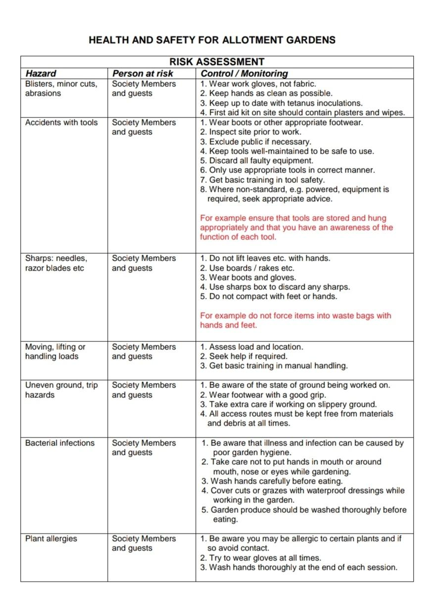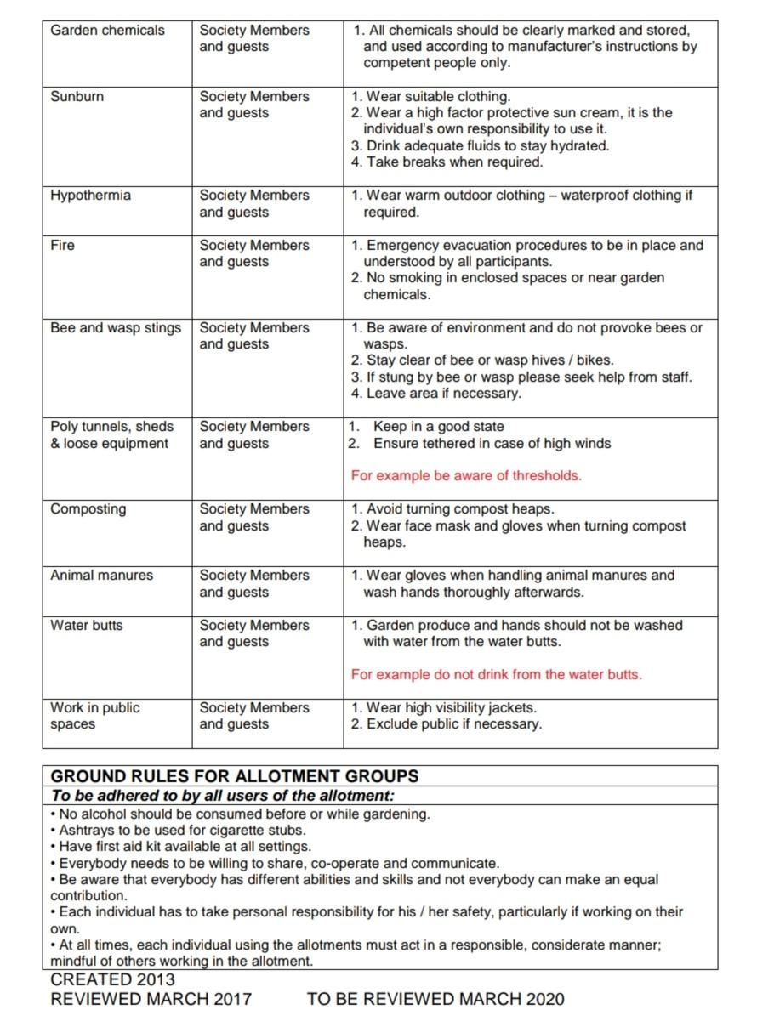

Slide 7
Friedrick Froebel (1782 - 1852)
- He thought highly of outdoor play, as children will improve their understanding of the world they live in.
- According to Froebel (1837) in play, children construct their understanding of the world by experiencing it.
- Froebel known for his kindergarten, which he believes that children can interact with nature and a place where they can grow and develop freely.

Slide 8
- Doing gardening activities indoors will be limited as there’s different dimensions when doing them outdoors.
- He introduced kindergarten in 1837. Froebel thought it was a great way for children to learn about different vegetables, fruit or flowers. Learning about where they come from? Different types of vegetables,fruit,flowers, the process of them growing. Tasting them when they've ryped.

Slide 9
Main points
Main points of the presentation is that children learn from doing, they don't like sitting down in once place for long. By doing outdoor activities they have their freedom but they also learn as they are doing and experiencing different things. They are using every part of their body to do some gardening. Using all their skills that needs to be used.
Implications of the future?
Outdoor activities will help children in the future as:
- Developed different skills, which they will need for employment
- Understand the natural world, understanding more about plants, animals, where things come from
- It will help their self - independent as they had to be responsible for their own work.
- patience skills as they had to wait for the plants to grow. Haved to try and gain this skill as you wont get as angry, stressed or overwhelmed. If you have good patience you will be in more control and in a better situation to deal with problems. This will make you a happier and healthier person.

