Question 1
Organisations don’t operate in isolation from the wider environment meaning long-term planning is essential (Farnham, 2015). HR and business leaders must continually horizon scan for future developments that could impact the business (CIPD, 2017). Long-term planning enables leaders to define future goals and consider variables that may impact their goals (Forbes, 2020). It allows people professionals to plan effective utilisation of their people resources to realise the organisational objectives (CIPD, 2021). A consequence of not doing so can leave organisations floundering unable to benefit from long-term strategy (Dickins, 2020).
Severn Trent describes a clear plan that seemingly stood the course as the global pandemic swept the country (Powell, 2022). The company had already shared their organisational plans and they maintained high levels of engagement whilst adapting to Covid19. With a clearly defined strategy already in place, the executive team were able to make well-informed decisions such as utilising furlough (ibid). Providing stability in times of crisis is important in maintaining the psychological contract, high levels of engagement and high performance, during periods of change (Burnes, 2020; Cummings, et al., 2016), essential for Severn Trent to realise their targets.
Chwarae Teg (CT) had a very clear mission (Chwarae Teg, n.d.) but no organisational or HR strategy. Unable to effectively reassess its strategy, employees were left in a state of uncertainty regarding how their services fitted in their new world (Chwarae Teg [internal document], 2021). Typical of organisations lacking in long-term planning, CT attempted to adapt without checking their products or services for relevancy in the wider market (Business Wales, n.d.; Farnham, 2015) resulting in loss of income and further uncertainty for their staff (Chwarae Teg [internal document], 2021).
Evidently whilst a global pandemic couldn’t be predicted, long-term planning has a positive impact on an organisation’s ability to react and flex to the external environment with minimal impact on operations and staff.

Question 2
PESTLE provides a comprehensive framework for external analysis (Farnham, 2015; Business Wales, n.d.) and STEEPLE goes that one step further recognising ethical practices (Businessballs, 2017). The five forces model is significantly different as it focuses on factors directly impacting market value/share (Harvard Business School, n.d.), but does not consider political or legal factors, for example, which can have a significant impact on an organisation.
Internal analysis enables organisations to identify areas they can capitalise on and areas to improve to achieve their organisational outcomes (Chermack & Kasshanna, 2007). A Gap Analysis identifies the difference between the organisation’s existing functions and its goals (Grundy, 2013) and SWOT analysis can link internal strengths and weaknesses against external opportunities and threats (CIPD, 2021; Chermack & Kasshanna, 2007).
Whilst there is limited empirical research, all tools should be exercised with caution. They provide a snapshot in time and require ongoing monitoring. Additionally, the results can be impacted by the people completing the activity, their skills knowledge and any underlying bias. This can be counteracted by techniques such as Delphi forecasting but access to such resources can be a challenge for small organisations (Shelton & Creghan, 2015).
Severn Trent benefitted from strategic analysis as whilst many variables remained unchanged, they could focus on those that were impacted by the pandemic and ‘pivot’ accordingly, resulting in continued operations, high employee engagement and no redundancies (Powell, 2022).
CT illustrates what could be avoided if a full strategic analysis had been completed. A simple gap analysis could quickly identify whether their service required adapting to remain viable and provide employees with clarity and stability (Chwarae Teg [internal document], 2021).

Question 3
HR professionals must be expert facilitators of change working closely with the CEO and executive teams (Lamb & Balogun, 2015), demanding an excellent understanding of change. The CIPD Profession Map outlines the need to have business knowledge, and the ability to implement the right engagement tools at the right time (CIPD, 2009).
The HR function must work as enablers by removing obstacles and operating as efficiently as possible (CIPD, 2014). Automating basic and repetitive tasks creates capacity for the human element of the HR function which cannot be replicated by technology (Gartner, 2022; CIPD, 2021).
A breakdown in effective change management can result in an organisation losing its market value, impact the credibility of executive teams, increased staff turnover and reduction in employee engagement (CIPD, 2021; Forbes, 2011).
Severn Trent provides several examples of HRM recognising what actions the business can undertake to create stability in the face of extreme uncertainty (Powell, 2022). They avoided redundancies and furlough and maintained constant communication with the wider workforce. The HRM likely played an active part in making this happen by advising the exec team on effective change management principles, updates on covid legislation and the workforce’s continued capacity to deliver against targets.
Despite this, one statement within the case study contradicts other key messages, “This is the plan, no excuses. We’re going to deliver this.” (Powell, 2022). An alarming statement for employees who have been allowed “to feel like they own the company’s targets” (ibid). Additionally, the HRM describes a desire to bring everyone back to the office to aid collaboration. They could be disregarding all the good work and benefits associated with flexible working. There is a growing trend toward organisations embracing hybrid working as a permanent feature of their working practices (ACAS, 2021; TUC, 2021; Marx, et al., 2021).
This case study does not include feedback from employees which would provide a fuller picture of the reality for employees working through the pandemic at Severn Trent. Other people professionals reviewing the case study should be looking for a ‘warts and all’ review to effectively replicate best practices.
CT’s CEO similarly remained in constant communication with their workforce providing regular video call updates and email updates in between. Additionally, the HRM brought forward the review and consultation of their employee value proposition, reminding staff of their benefits package which could support health and wellbeing during the pandemic and minimise the impact of the great resignation (Brignall, 2021; Harvard Business Review, 2021). The outcome of which resulted in very low turnover and high attraction to vacancies until the end of 2021.
When recruitment activity finally increased, CT employed an additional part-time resource without considering the merits of automation. This resulted in the HR function being spread too thinly and receiving a wave of criticism from employees who felt other aspects of the HR function failed (Chwarae Teg [internal document], 2021). CT would have benefitted from assessing the needs of employees in the context of significant change and identifying the best way to invest resources based on those findings.

Question 2.1.a.
The Executive Chair of the World Economic Forum described us as being at the start of the fourth industrial revolution, symbolised by the scale at which technology is “merging the digital, physical and biological worlds” (Schwab, 2017). Embracing technology is vital for business success – sometimes survival (Sauer & Willcocks, 2022). As organisations evolve, so will employees’ digital skills. People professionals will need to ensure they facilitate the opportunity for this skill development to support the intergenerational and ageing workforce (Pew Research Center, 2019).
There has been a seismic shift in online learning since the pandemic widening the digital skills gap (Burgess, 2022). Before the pandemic, the UK Consumer Digital Index found earning potential increased with digital skills along with organisations’ increased protection from cyber-attacks (Lloyds Bank, 2019; Nania, et al., 2019) presenting personal and organisational gains.
There is a growing trend in self-directed learning (The Open University Business School, 2022), particularly in digital training (Lloyds Bank, 2019). Self-reliance reduces the pressure on people professionals to be the sole supplier of learning and development in organisations, however sourcing relevant and accurate information is a skill and there is a risk for employees to obtain misinformation (Vosloo, 2021; Guess & Lyons, 2020).
There is an opportunity for people professionals to encourage a culture of self-directed, continuous improvement whilst also supplying the necessary skills and signposting towards relevant and credible online sources (Personnel Today, 2017). This can be achieved through the identification of free or low-cost support such as that funded by the Government (fig.1).

Figure 1 Example of fully-funded digital skills training (HM Government, n.d.)
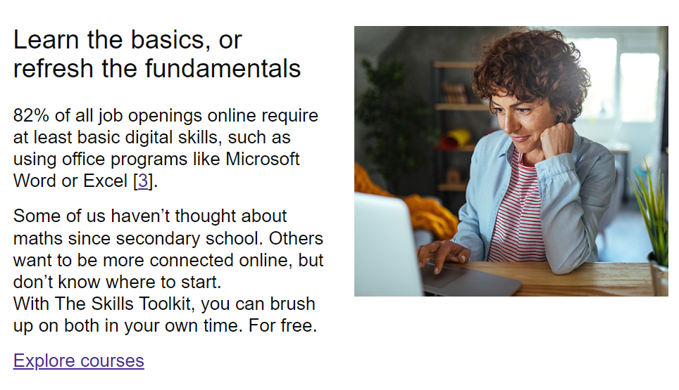

Access to continuous professional development is amongst the top attractive features for recruits and should be part of attraction and retention strategies (CIPD, 2017; Govaerts & Govaerts, 2011).

“Familiarity with and interest in digital technology varies widely among employees. Your training efforts should reflect those differences.”
(Knight, 2015)
Investment in employees’ digital skills to carry out daily tasks and to accomplish effective self-directed learning may well provide organisations with a more sustainable long-term solution to continuous professional development (Amar, 2018).
Failure of organisations to embrace the technological revolution runs the risk of not attracting and retaining talent and also failure to effectively innovate and continue to maintain market value and/or profitability (Gartner, 2022).

“By continually updating our skills and seeking alternative work arrangements, we can ‘race with the machines’. Whether we like it or not, change is coming, and the worst move of all would be to ignore it.” (Saunders, 2018)
Some worry that the advances in technology can mean job losses (Saunders, 2018), however, advances in technology have been linked to growth and job creation (World Economic Forum, 2020). The main difference is the type of work people are involved in, where people continue to provide the human element that can not be replicated by robotics (Edwards, n.d.).
Therefore organisations embracing technology does not have to mean a negative impact on the workforce - in an L&D context at least. If anything there is evidence technology can enhance it. Employees can benefit from enhanced skills and access to continuous professional development and organisations benefit from improved performance and talent that can carry the organisation forward in a sustainable way.

Question 2.2.b
Open and inclusive cultures are essential for organisations to successfully navigate turbulent times. Organisational culture contributes to improved engagement and is linked to high performance (Inabinett & Ballaro, 2014; CIPD, 2014). Furthermore, an open collaborative culture is expected from today’s job seekers (CIPD, 2019) (Bhattacharjee, 2015).
Moreover, inclusion improves organisational performance and innovation (Ordorica, 2022; McKinsey & Company, 2020), likely to be a result of improved morale and a broader range of skills (Ordorica, 2022). Inclusion isn’t just a business issue, it is an ethical issue too. 2020 saw widespread protests where people came together to raise awareness of marginalised groups (Financial Times, 2020). This is not a new phenonium. The rise of social activism has seen employees protest perceived unethical practices of employers for several years (fig.2) which seriously impacted employee engagement and organisational culture.

Figure 2 Excerpts from newspapers regarding employee protests over ethical issues (NBC News, 2019; The Guardian, 2018)
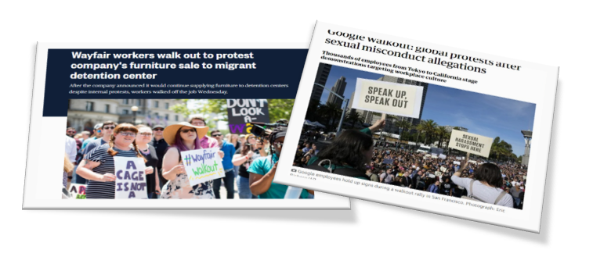
There is limited empirical research in this area however occupational psychologists at Utrecht University identified key areas that affect work engagement which can be linked to culture (table 1). Feeling engaged is good for employees with research evidencing the link between high engagement and extra-role performance and organisational performance (Madden, et al., 2015).

Table 1 Engagement is a state of mind (Schaufeli & Bakker, 2004) taken from CIPD (2021)
Vigour | Energy, resilience, effort
Dedication | Enthusiasm, inspiration, pride
Absorption | Concentration, engrossed in work

There is always the choice of doing nothing to address organisational culture however there is no evidence to support any benefit from doing nothing. On the contrary, there appears to be an abundance of advice from a broad spectrum of sources suggesting workplace culture is a priority for all stakeholders (Harvard Business Review, 2022; Workplace Law, 2019; Walton, 2015). Furthermore, organisations bare the risk of increasing turnover and losing their competitive edge in the war for talent (fig.4) during a time when employees will freely leave for better terms with another employer (Harvard Business Review, 2021; Marx, et al., 2021).
There are barriers to good workplace culture such as; a lack of awareness relating to diversity or the absence of role modelling behaviours from leaders. Some organisations are holding onto a culture of ‘brilliance’ where high value is placed on individuals rather than teams resulting in self-serving behaviour (Harvard Business Review, 2022). Whatever the cause, people professionals and business leaders are key actors in influencing change.

Figure 3 Understanding organisational barriers to a more inclusive workplace (McKinsey & Company, 2020)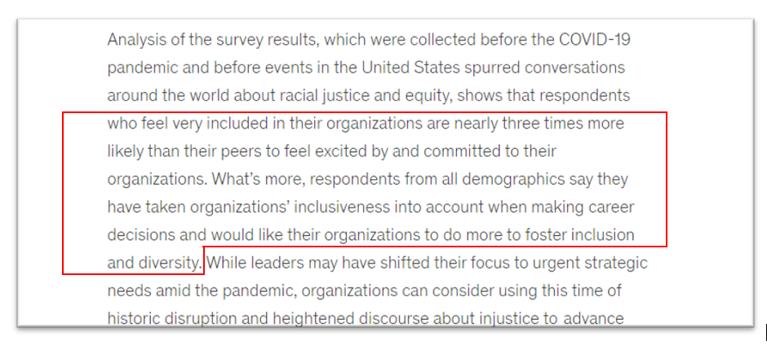
Culture needs to be cultivated and guided if it is to function well. There are many ways organisations can help make their workplaces more open and inclusive:
- Shared goals and incentives encouraging individuals to value team success “An organization creates a culture of brilliance by nurturing an environment where passion thrives and success comes through unified purpose.” (Harvard Business Review, 2022).

- Compassionate leadership, practising active listening and honest communication This involves treating people with genuine care and concern in turbulent times (Bryan, 2011). Leaders must role model organisational values through their behaviour (Psychology Today, 2022; Swanborough, 2018).

- Demonstrating organisational values through action, not just words Values are acknowledged as an imperative element that transforms an organisation’s goals into reality (Swanborough, 2018). Deeds, not words (commonly associated with the suffragette movement) are a good principle to measure organisational action (or inaction) in openly demonstrating its values.

Creating an open and inclusive culture takes time and people professionals should identify metrics to indicate progress towards the desired culture. These metrics could include measuring employee engagement, employee views and overall business performance (CIPD, 2021). However, there is a need to be aware that studies to date demonstrate correlation as opposed to a causal relationship between culture and performance (Madden, et al., 2015; Bakker & Bal, 2010).
Question 2.3.a
Legislation and government policy have a significant impact on how organisations run and deliver their services (Farnham, 2015). For those in Wales, these policies are made by the UK Parliament and Welsh Government. Before Brexit, some legislation was derived from the EU Parliament.
The General Data Protection Regulation (GDPR) is an example of an EU law passed in the UK in 2016 and it has remained unchanged since Brexit (GDPR.EU, 2022). It brought together important elements of privacy and human rights law and enhanced the existing UK Data Protection Regulation (Information Commissioner's Office, 2018).
The regulation brought with it many changes and identified key people and new rules such as:
- Individuals who are regarded as data controllers and processors
- The circumstances under which you can collect data
- The circumstances under which you can keep data
- Timeframes to respond to subject access requests
It highlighted the consequences of non-compliance with fines of up to 4% of annual revenue (GDPR.EU, 2022).
The public was not in short supply of information relating to the proposed regulation, along with high profile breaches occurring under the existing law (fig.4). CT did not want to fall foul of the regulation for fear of reputational risk which can have devastating consequences for organisations (Deloitte, 2016).

Figure 4 Excerpts of UK press articles regarding the data protection in the lead up to the new regulation (The Guardian, 2015; BBC, 2015; Daily Mail, 2015)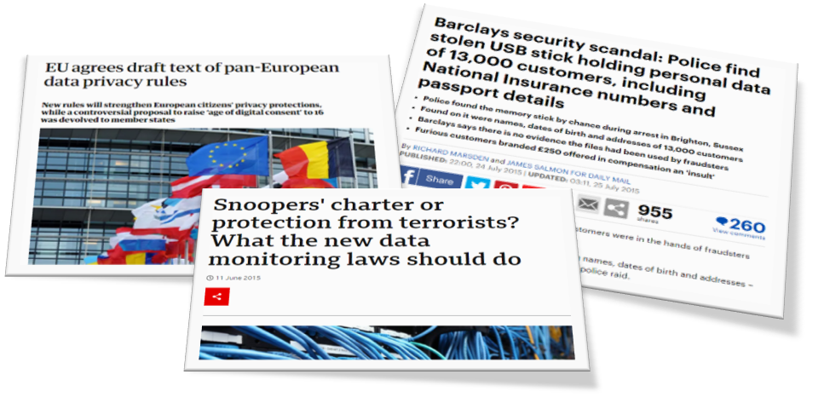

CT handled large volumes of personal data, from projects spanning 20 years, in paper and electronic form. CT acquired the data under circumstances deemed unlawful under the new regulation. All their learners completed enrolment forms requiring them to ‘opt-out’ of marketing communications. The new regulation stipulated people had to ‘opt-in’ and had ‘the right to be forgotten’ (GDPR.EU, 2022). CT had to conduct a thorough data cleanse. Additionally, data subjects had the right to access their data (ibid) meaning CT had to consolidate their data which was held in multiple formats across various departments in the organisation.
This presented a significant negative impact on CT:
- The marketing list would reduce and was a significant source of repeat custom
Organisational statistics illustrated the potential loss of income generated via marketing lists. This revenue was used to support staff costs.
- The work involved in preparing for the implementation of the new regulation involved additional staffing resource
Initially, tasks were undertaken by several individuals however it became apparent the volume of work involved increased the likelihood of burnout and errors. A decision was made to employ an additional staff member as 1FTE at £24k per annum fixed-term.
- All staff required training to understand their responsibilities as data processors
Several training sessions and briefings were held which also included information relating to the company and individual liability for getting it wrong. Each time a training or briefing session was held, staff were taken away from their day job incurring the organisation further losses from income revenue.
Ongoing maintenance has become the responsibility of all post-holders and job descriptions were updated accordingly. This has somewhat reduced the cost of the regulation.

References
ACAS, 2021. New study reveals half of employers expect more flexible working requests from staff after the pandemic is over. [Online]
Available at: https://www.acas.org.uk/new-study-reveals-half-of-employers-expect-more-flexible-working-after-pandemic
[Accessed 17 May 2022].
Amar, Z., 2018. Digital Skills and Inclusion. [Online]
Available at: https://digitalinclusion.blog.gov.uk/2018/03/14/why-charities-need-to-invest-in-digital-skills/
[Accessed 18 May 2022].
Bakker, A. B. & Bal, M., 2010. Weekly work engagement and performance: A study among starting teachers. [Online]
Available at: https://bpspsychub.onlinelibrary.wiley.com/doi/abs/10.1348/096317909X402596
[Accessed 18 May 2022].
BBC, 2015. Snoopers' charter or protection from terrorists? What the new data monitoring laws should do. [Online]
Available at: https://www.bbc.co.uk/news/newsbeat-33092771
[Accessed 19 May 2022].
Bhattacharjee, A., 2015. How open and inclusive is your organisation’s culture?. [Online]
Available at: https://www.linkedin.com/pulse/how-open-inclusive-your-organisations-culture-asmita-sen/
[Accessed 18 May 2022].
Brignall, M., 2021. ‘The Great Resignation’: almost one in four UK workers planning job change. [Online]
Available at: https://amp.theguardian.com/money/2021/nov/01/the-great-resignation-almost-one-in-four-workers-planning-job-change
[Accessed 18 May 2022].
Bryan, D. N., 2011. The Elements of Power: Lessons on Leadership and Influence. Aorn Journal, 94(5), pp. 514-515.
Burgess, G., 2022. Tackle the digital divide. [Online]
Available at: https://www.cam.ac.uk/stories/BeyondThePandemic_digitaldivide
[Accessed 18 May 2022].
Burnes, 2020. The Origins of Lewin’s Three-Step Model of Change. The Journal of Applied Behavioral Science, pp. 32-59.
Business Wales, n.d. Understanding Your Market. [Online]
Available at: https://businesswales.gov.wales/starting-up/market-research/understanding-your-market
[Accessed 17 May 2022].
Businessballs, 2017. PEST (PESTLE/STEEPLE) Market Analysis Tool. [Online]
Available at: https://www.businessballs.com/strategy-innovation/pest-pestle-steeple-market-analysis-tool/
[Accessed 17 May 2022].
Chermack, T. J. & Kasshanna, B. K., 2007. The use and misuse of SWOT analysis and implications for HRD professionals. Human Resource Development International, 10(4), pp. 383-398.
Chwarae Teg [internal document], 2021. Employee Pulse Survey , Cardiff: Chwarae Teg.
Chwarae Teg, n.d. Our mission. [Online]
Available at: https://chwaraeteg.com/about/mission/
[Accessed 17 May 2022].
CIPD, 2009. Explore the Profession Map. [Online]
Available at: https://peopleprofession.cipd.org/profession-map
[Accessed 19 May 2022].
CIPD, 2014. Leading Transformational Change, London: CIPD.
CIPD, 2014. Research Report: Keeping culture, purpose and values at the heart of your SME. [Online]
Available at: https://www.cipd.co.uk/Images/keeping-culture-purpose-and-values-at-the-heart-of-your-sme_2014_tcm18-10881.pdf
[Accessed 19 May 2022].
CIPD, 2017. Future of technology and learning survey report. [Online]
Available at: https://www.cipd.co.uk/Images/the-future-of-technology-and-learning_2017-infographic_tcm18-29349.pdf
[Accessed 19 May 2022].
CIPD, 2017. Organisations need to pursue a long-term strategy on workforce planning and skills development. [Online]
Available at: https://www.cipd.co.uk/news-views/news-articles/strategic-workforce-planning
[Accessed 17 May 2022].
CIPD, 2019. Building inclusive workplaces. [Online]
Available at: https://www.cipd.co.uk/knowledge/fundamentals/relations/diversity/building-inclusive-workplaces
[Accessed 18 May 2022].
CIPD, 2021. Change management. [Online]
Available at: https://www.cipd.co.uk/knowledge/strategy/change/management-factsheet
[Accessed 17 May 2022].
CIPD, 2021. Employee engagement and motivation. [Online]
Available at: https://www.cipd.co.uk/knowledge/fundamentals/relations/engagement/factsheet
[Accessed 17 May 2022].
CIPD, 2021. SWOT analysis. [Online]
Available at: https://www.cipd.co.uk/knowledge/strategy/organisational-development/swot-analysis-factsheet#8018
[Accessed 17 May 2022].
CIPD, 2021. Using technology to improve hiring and onboarding. [Online]
Available at: https://www.cipd.co.uk/knowledge/work/technology/digital-transformation-insights/improve-hiring-onboarding#:~:text=How%20can%20people%20functions%20leverage%20automation%20and%20digital,four-fifths%20of%20respondents%20in%20a%20recent%20CIPD%20survey.
[Accessed 18 May 2022].
Cummings, Bridgman & Brown, 2016. Unfreezing change as three steps: Rethinking Kurt Lewin’s legacy for change management. Human Relations, 69(1), pp. 33-60.
Daily Mail, 2015. Barclays security scandal: Police find stolen USB stick holding personal data of 13,000 customers, including National Insurance numbers and passport details. [Online]
Available at: https://www.dailymail.co.uk/news/article-3173866/Security-breach-shambles-Barclays-Fraudsters-personal-financial-details-13-000-customers-seven-years.html
[Accessed 19 May 2022].
Deloitte, 2016. Barclays security scandal: Police find stolen USB stick holding personal data of 13,000 customers, including National Insurance numbers and passport details. [Online]
Available at: https://www2.deloitte.com/content/dam/Deloitte/uk/Documents/risk/deloitte-uk-reputation-matters-june-2016.pdf#:~:text=In%20this%20sense%2C%20reputation%20is%20one%20of%20an,as%20customers%2C%20regulators%20or%20investors%20perceive%20an%20organisation.
[Accessed 19 May 2022].
Department for Digital, Culture, Media & Sport, 2019. No Longer Optional: employer demand for digital skills. [Online]
Available at: https://assets.publishing.service.gov.uk/government/uploads/system/uploads/attachment_data/file/807830/No_Longer_Optional_Employer_Demand_for_Digital_Skills.pdf
[Accessed 18 May 2022].
Dickins, S., 2020. Small firms in Wales 'struggle' with long-term planning. [Online]
Available at: https://www.bbc.co.uk/news/uk-wales-51770234
[Accessed 17 May 2022].
Edwards, R., n.d. Digitalization and the human element in digital change. [Online]
Available at: https://www.i-scoop.eu/digitalization-human-element-technological-change/
[Accessed 18 May 2022].
Engage for success, 2012. Nailing the evidence. [Online]
Available at: https://engageforsuccess.org/nailing-the-evidence
[Accessed 18 May 2022].
Farnham, D., 2015. Human Resource Management in Context. 4 ed. London: CIPD.
Financial Times, 2020. 2020: A year in protests. [Online]
Available at: https://www.ft.com/content/6e95f7d8-508b-40db-9d0d-4fb561cbfa48
[Accessed 18 May 2022].
Forbes, 2011. Change Fatigue: Taking Its Toll on Your Employees?. [Online]
Available at: https://www.forbes.com/sites/johnkotter/2011/09/15/can-i-use-this-method-for-change-in-my-organization/?sh=5f838a771ce6
[Accessed 18 May 2022].
Forbes, 2020. How To Optimize Long-Term Strategy To Maximize Success. [Online]
Available at: https://www.forbes.com/sites/forbescoachescouncil/2020/01/27/how-to-optimize-long-term-strategy-to-maximize-success/?sh=42a98da579e7
[Accessed 17 May 2022].
Gartner, 2022. Gartner Top Strategic Technology Trends for 2022. [Online]
Available at: https://www.gartner.com/en/information-technology/insights/top-technology-trends
[Accessed 17 May 2022].
GDPR.EU, 2022. Complete guide to GDPR compliance. [Online]
Available at: https://gdpr.eu/
[Accessed 19 May 2022].
Govaerts & Govaerts, F., 2011. Influence of learning and working climate on the retention of talented employees.. The Journal of Workplace Learning, 23(1), pp. 35-55.
Grundy, T., 2013. SWOT your way to the future. Industrial Management, 11(1), pp. 43-44.
Guess, A. M. & Lyons, B. A., 2020. Misinformation, Disinformation, and Online Propaganda. Cambridge: Cambridge University Press.
Harvard Business Review, 2021. 6 Strategies to Boost Retention Through the Great Resignation. [Online]
Available at: https://hbr.org/2021/11/6-strategies-to-boost-retention-through-the-great-resignation
[Accessed 18 May 2022].
Harvard Business Review, 2022. Create a Culture that Values Team Accomplishments More Than Individual Successes. [Online]
Available at: https://hbr.org/sponsored/2022/05/create-a-culture-that-values-team-accomplishments-more-than-individual-successes
[Accessed 18 May 2022].
Harvard Business School, n.d. The Five Forces. [Online]
Available at: https://www.isc.hbs.edu/strategy/business-strategy/Pages/the-five-forces.aspx
[Accessed 17 May 2022].
HM Government, n.d. The Skills Toolkit. [Online]
Available at: https://theskillstoolkit.campaign.gov.uk/#source3
[Accessed 18 May 2022].
Inabinett, J. & Ballaro, J., 2014. Developing An Organization By Predicting Employee Retention By Matching Corporate Culture With Employee’s Values: A Correlation Study.. Organization Development Journal, 32(1), p. 55.
Information Commissioner's Office, 2018. Guide to the General Data Protection Regulation. [Online]
Available at: https://ico.org.uk/for-organisations/guide-to-data-protection/guide-to-the-general-data-protection-regulation-gdpr/?template=pdf&patch=97#link0
[Accessed 19 May 2022].
Knight, R., 2015. Convincing Skeptical Employees to Adopt New Technology. [Online]
Available at: https://hbr.org/2015/03/convincing-skeptical-employees-to-adopt-new-technology
[Accessed 18 May 2022].
Kontoghiorghes, 2016. Linking high performance organizational culture and talent management: satisfaction/motivation and organizational commitment as mediators. International Journal of Human Resource Management, 27(16), pp. 1833-1853.
Lamb, P. & Balogun, J., 2015. Landing transformational change. [Online]
Available at: https://www.cipd.co.uk/podcasts/landing-transformational-change
[Accessed 18 May 2022].
Lloyds Bank, 2019. UK Consumer Digital Index. [Online]
Available at: https://www.lloydsbank.com/assets/media/pdfs/banking_with_us/whats-happening/lb-consumer-digital-index-2019-report.pdf
[Accessed 18 May 2022].
Madden, A., Alfes, K. & Fletcher, L., 2015. The Meaning, Antecedents and Outcomes of Employee Engagement: A Narrative Synthesis. International Journal of Management Reviews, 19(1), pp. 31-53.
Marx, C. K., Reimann, M. & Diewald, M., 2021. Do Work–Life Measures Really Matter? The Impact of Flexible Working Hours and Home-Based Teleworking in Preventing Voluntary Employee Exits.. Social Sciences, 10(1), p. 9.
McKinsey & Company, 2020. Understanding organizational barriers to a more inclusive workplace. [Online]
Available at: https://www.mckinsey.com/business-functions/people-and-organizational-performance/our-insights/understanding-organizational-barriers-to-a-more-inclusive-workplace#:~:text=McKinsey%E2%80%99s%20research%20has%20shown%20that%20diversity%20can%20help,and%20em
[Accessed 18 May 2022].
NBC News, 2019. Wayfair workers walk out to protest company's furniture sale to migrant detention center. [Online]
Available at: https://www.nbcnews.com/news/us-news/wayfair-workers-walkout-protest-company-s-furniture-sale-migrant-detention-n1022201
[Accessed 18 May 2022].
Ordorica, S., 2022. The Business Benefits Of Greater Diversity And Inclusion. [Online]
Available at: https://www.forbes.com/sites/forbesbusinesscouncil/2022/04/06/the-business-benefits-of-greater-diversity-and-inclusion/?sh=617a6b0115c8
[Accessed 18 May 2022].
Personnel Today, 2017. The future of HR: Embrace technology, but stay human. [Online]
Available at: https://www.personneltoday.com/hr/future-hr-embrace-technology-stay-human/
[Accessed 18 May 2022].
Pew Research Center, 2019. Millennials stand out for their technology use, but older generations also embrace digital life. [Online]
Available at: https://www.pewresearch.org/fact-tank/2019/09/09/us-generations-technology-use/
[Accessed 19 May 2022].
Powell, C., 2022. Covid enabled Severn Trent to supercharge its strategy. [Online]
Available at: https://www.peoplemanagement.co.uk/article/1751726/covid-enabled-severn-trent-supercharge-strategy
[Accessed 17 May 2022].
Psychology Today, 2022. Compassionate Leadership During COVID-19. [Online]
Available at: https://www.psychologytoday.com/au/blog/psychological-trauma-coping-and-resilience/202205/compassionate-leadership-during-covid-19#:~:text=%20Tangible%20Tips%20for%20Becoming%20a%20Compassionate%20Leader,know%20your%20colleagues%2Fstaff%20by%20asking%20qu
[Accessed 18 May 2022].
Sauer, C. & Willcocks, L., 2022. Winners and losers in the digital divide. Journal of Information Technology, 17(1), pp. 1-2.
Saunders, A., 2018. Technology’s Impact on Growth and Employment. [Online]
Available at: https://www.bbvaopenmind.com/en/articles/technology-s-impact-on-growth-and-employment/
[Accessed 18 May 2022].
Schaufeli, W. B. & Bakker, A. B., 2004. Job demands, job resources, and their relationship with burnout and engagement: a multi-sample study. [Online]
Available at: https://www.wilmarschaufeli.nl/publications/Schaufeli/209.pdf
[Accessed 18 May 2022].
Schwab, K., 2017. The Fourth Industrial Revolution. New York, United States: Random House USA Inc.
Shelton, K. & Creghan, K. A., 2015. Demystifying the Delphi Method. Texas: Lamar University .
Swanborough, S., 2018. Defining your organisational values. [Online]
Available at: https://www.hrmagazine.co.uk/content/features/defining-your-organisational-values
[Accessed 18 May 2022].
TATA Steel, n.d. Culture@TATA. [Online]
Available at: https://www.tatasteel.com/careers/culture-at-tata-steel/culture-tata/
[Accessed 18 May 2022].
The Guardian, 2015. EU agrees draft text of pan-European data privacy rules. [Online]
Available at: https://www.theguardian.com/technology/2015/dec/16/eu-agrees-draft-text-pan-european-data-privacy-rules
[Accessed 19 May 2022].
The Guardian, 2018. Google walkout: global protests after sexual misconduct allegations. [Online]
Available at: https://www.theguardian.com/technology/2018/nov/01/google-walkout-global-protests-employees-sexual-harassment-scandals
[Accessed 18 May 2022].
The Open University Business School, 2022. Curiosity and Unlearning - Overcoming the inertia to learn. [Online]
[Accessed 18 May 2022].
TUC, 2021. The future of flexible working: A TUC Report. [Online]
Available at: https://www.tuc.org.uk/sites/default/files/2021-06/Flexibleworkingreport2.pdf
[Accessed 18 May 2022].
Vosloo, S., 2021. Digital misinformation/disinformation and children. [Online]
Available at: https://www.unicef.org/globalinsight/stories/digital-misinformation-disinformation-and-children
[Accessed 18 May 2022].
Walton, H., 2015. The cost of bad culture. [Online]
Available at: https://www.linkedin.com/pulse/cost-bad-culture-helen-walton/
[Accessed 18 May 2022].
Workplace Law, 2019. Workplace culture gone wrong and how to make it right. [Online]
Available at: https://www.workplacelaw.com.au/posts/workplace-culture-gone-wrong-how-to-make-right#:~:text=As%20you%20can%20see%20from%20the%20examples%20above%2C,to%20walking%20off%20the%20job%20or%20resigning%20altogether.
[Accessed 18 May 2022].
World Economic Forum, 2020. How has technology changed - and changed us - in the past 20 years?. [Online]
Available at: https://www.weforum.org/agenda/2020/11/heres-how-technology-has-changed-and-changed-us-over-the-past-20-years/
[Accessed 18 May 2022].

