

Program Name - Master of Business Administration
Module Name - International Marketing: Principles and Practices
Module Code - LCMB7026
Assessment - Report
Title – International Market Entry Strategy and Marketing Mix: A Comparative Analysis of KFC in the United Kingdom and India
Lecturer Name - Dian Mayasari
Student Name – Virendrasinh Rajendrasinh Rathod
Student ID: 2438323
Submission Deadline - Friday 27th March 2026 by 2 pm
Word Count – 5116

Table of Contents
Section 1 : International Market Entry Strategy and Marketing Mix 3
1. Introduction 3
2. Comparative Market Analysis (KFC in the UK vs. India) 4
2.1 Macro-Environmental Context (PESTEL) 4
2.2 Social and Cultural Analysis 7
3. Comparative STP and International Marketing Mix (7Ps) Strategies 8
3.1 Market Segmentation, Target Marketing, Product Positioning (STP). 8
3.2 International Marketing Mix (7Ps) 9
4. Directional Development Strategy (Focus: KFC India) 12
4.1 Market Penetration 12
4.2 Market Development 13
4.3 Product Development 13
Strategic Conclusion 14
5. Evaluation of Ethical Issues 15
5.1 Ethical Issues in the UK Market 15
5.2 Ethical Issues in the Indian Market 15
6. Recommendations for Future International Marketing Strategies 17
Section 2: Reflective Account (Gibbs Reflective Cycle) 19
1. Description 19
2. Feelings 20
3. Evaluation 20
4. Analysis 21
5. Conclusion 21
6. Action Plan 22
References : 23

Section 1 : International Market Entry Strategy and Marketing Mix

Introduction
The QSR sector is rapidly globalising (Chen, 2024), and as such Multinational Companies (MNCs) must constantly adapt to differing macro environments to remain competitive. The entry strategy and product mix of KFC (part of Yum! Brands) into two distinct and diverse countries will be compared in this report. The UK is a developed country that has a high GDP per capita and has high levels of food safety, health and environmental regulations. Consequently, the UK market has become saturated with established Competition. In addition, because of their level of affluence, UK consumers continue to drive significant levels of demand for sustainable business practices (McKinsey & Co, 2025). In contrast, India is one of the world’s fastest-growing and most dynamic Emerging Market (EM) economies, due in large part to its burgeoning middle class. However, Indian consumers are extremely price sensitive and culturally and religiously constrained regarding their dietary preferences (Chen, 2024).
The KFC international marketing strategy will be examined by conducting a systematic assessment of the brand’s success locally in each of these regions. To facilitate this evaluation, several strategic frameworks will be employed. The first framework utilized in this analysis will consist of a comparative macro-environmental PESTEL analysis, in addition to Hofstede’s Cultural Dimensions, in order to assess key consumer behaviour differences and dining habits in the target countries. Second, KFC’s Segmentation, Targeting and Positioning (STP) and 7Ps of the marketing mix will be assessed for both countries. The Ansoff Matrix will also be used to identify KFC’s growth and directional development strategy for the Indian marketplace specifically. Finally, there will be an evaluative assessment of the various ethical dilemmas facing KFC in both countries, followed by actionable recommendations for the continued development and execution of the brand’s international marketing strategy.

Comparative Market Analysis (KFC in the UK vs. India)

2.1 Macro-Environmental Context (PESTEL)

Table 1:PESTEL Analysis – KFC UK vs KFC India
Factor | KFC UK | KFC India
Political | HFSS advertising restrictions; Brexit impacts on labour & imports | FSSAI compliance; "Make in India"; FDI regulations via franchise partners
Economic | Cost-of-living crisis; high inflation; saturated competitive market | Rapid GDP growth; price-sensitive consumers; competition from street food vendors
Social | Individualistic dining culture; health-conscious & flexitarian trends | Collectivistic family dining culture; strong vegetarian & religious dietary norms
Technological | Self-service kiosks; delivery aggregators; digital loyalty apps | UPI digital payments; Zomato & Swiggy delivery dominance in urban areas
Environmental | Net-zero targets; sustainable packaging; animal welfare scrutiny | Single-use plastic ban; cold chain logistics challenges; rural infrastructure gaps
Legal | Advertising Standards Authority; UK employment & food safety law | FSSAI food safety regulations; state-level labour law variation
Source: Compiled by author from multiple sources (see References)
Global fast-food chains are required to operate over very long distances and encounter many different economic and regulatory environments around the globe. For instance, KFC operates in England under very different conditions than it does in India, which illustrate that these two nations represent opposite ends of the spectrum in terms of the fiscal environment. The UK has developed into a sophisticated and highly regulated market with a great deal of infrastructure; whereas, India is an extremely fast-moving economy that requires significantly more infrastructure.
Political and Legal Environments
Several laws and regulations are established under the heading of Public Health and Labour Legislation that control the manner in which these elements interact with each other in the Political/Legal climate in the UK. The UK Government creates legislation (the UK Government created the HFSS legislation to stop some of the HFSS products from being advertised, thereby affecting the way KFC operates its advertising) that applies to all businesses operating within the UK. For example, it is illegal for KFC to advertise any products falling under the category of 'HFSS' on either television before 21:00 or on the TFL Network at any time, as established by the Department of Health and Social Care (2022). In addition to regulating the type of advertising that KFC may use; various political changes that occurred after Brexit have impacted the hospitality and logistics sectors in the UK by limiting the number of available employees in both sectors and by complicating import tariffs for goods imported from outside the UK. (Smith and Jones 2023).
When KFC enters the Indian market, it must consider how laws and regulations affect its operations. The Food Safety and Standards Authority of India and national economic policy will determine how KFC does business in India. KFC must also comply with the Government of India’s “Make in India” initiative, which aims to encourage foreign multinational companies to source their raw materials from India rather than importing them. In addition to the above considerations, Yum! Brands’ compliance with restrictions imposed on foreign direct investment in India will depend, to a large extent, on its partnership with large local master franchisees (e.g., Devyani International). The local master franchisees’ ability to navigate the complex body of laws related to FDI in India and conduct their business in compliance with all other applicable local laws will ultimately determine Yum! Brands’ success in India (Kumar & Rajan, 2024).
Economic Environments
At present, the United Kingdom is an extremely competitive market, and even more so with the current cost-of-living crisis having a significant impact on disposable income. With grossly rising inflation and interest rates, consumer disposable income has been severely constrained. This has resulted in a decline in the strength of the relationship between consumer sentiment and consumer spending, resulting in UK consumers becoming heavily focused on value purchases (McKinsey & Company, 2025). In order to sustain volumes of sales, KFC UK is engaged in intense price competition with other established competitors such as McDonald's and Greggs.
In contrast to the UK is India, which has a completely different economic force at play. India's rapid GDP growth and growing middle class have created unprecedented demand for quick service restaurants (QSR's). However, Indian consumers are still very price-sensitive. Therefore, KFC's biggest challenge in India comes not only from competing with other established Western QSR's, but also from the unorganized sector of local street food vendors that operate with very low overhead and provide localized food at significantly lower prices than do KFC or any of its competitors (Goel, 2025).
Technological and Environmental Infrastructures
The UK market is technologically expecting easy integration in all areas of retail. KFC UK incorporates self-service kiosks to automate the customer service process and route deliveries via algorithms, thus boosting turnover through the high street. Sustainability is very important to UK consumers, causing KFC to adopt net-zero supply chain targets and move to environmentally friendly packaging (PwC, 2025).

India has bypassed many of the steps typically seen in technology adoption. The United Payment Interface or UPI and the prevalence of delivery aggregators, Zomato and Swiggy, determine KFC’s distribution model in urban areas (Sharma, 2024). KFC’s biggest barrier in India to scaling operations beyond metropolitian areas is an inadequate physical infrastructure. KFC must find ways to work within India’s very fragmented ‘cold chain’ logistics network to create efficiencies for long-distance shipping of raw poultry while adhering to strict temperature controls. In addition, the less predictable rural road networks and extreme climates increase the logistical and financial challenge of maintaining strict temperature controls and ultimately dictate KFC’s geographical expansion plans (Kumar and Rajan, 2024).

2.2 Social and Cultural Analysis
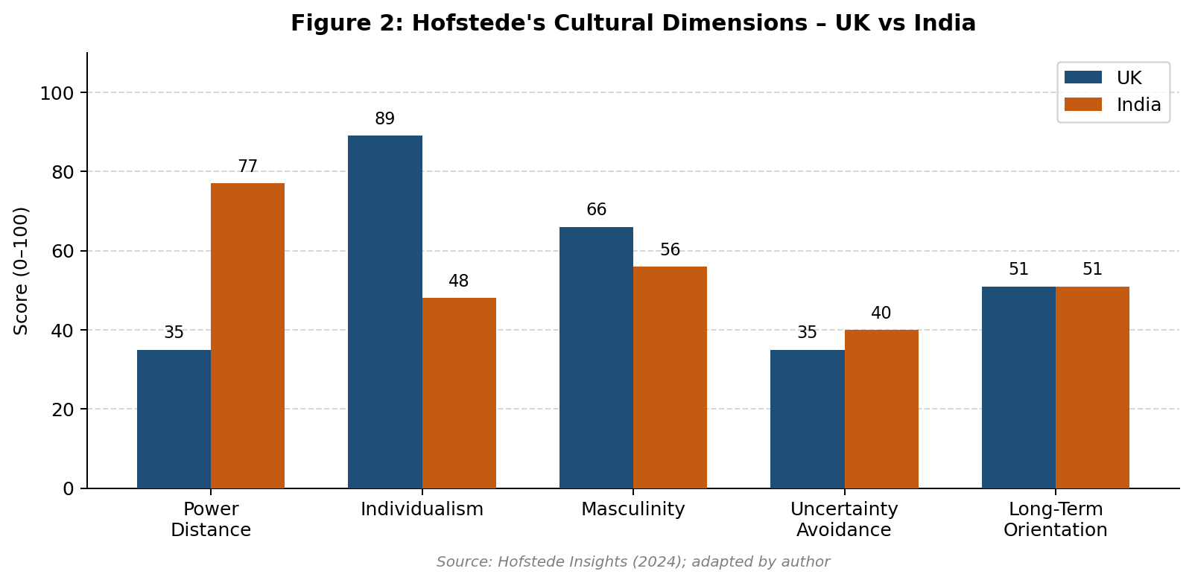
The primary cultural divide between Indian and UK markets is the degree of individualism vs collectivism. Research has confirmed that culture has a substantial role in consumer behaviour through the lenses of individualism and collectivism (Czarnecka and Schivinski, 2022; Sharma & Singh 2024).
Individualistic vs Collectivistic – The dining experience of consumers in the UK is heavily entrenched in an individualistic society, as evidenced by fast food that is consumed on an individual basis while on the go. Conversely, the dining experience for consumers in India is heavily reliant upon a collectivistic culture, with dining out being an act of togetherness or family, rather than simply a mechanical function of providing food.
Dietary Habits vs Religion – An international chain needs to have an appropriate local strategy, reflecting the ingrained cultural and religious dietary practices where they operate. This is directly reflected in the way in which KFC's global standard menu in the UK operates without any modification, as the UK is a meat-centric culture and thus, all KFC menu items will be available. On the other hand, KFC has to re-create its entire menu to operate in India, as India has a strong vegetarian culture and thus, the socio-economic and religious beliefs of the people in India were also considered when KFC went to the India market. In order for KFC to begin to build trust with the consumer base within India, they also had to physically segregate their vegetarian and non-vegetarian kitchens (Goel 2025).

3. Comparative STP and International Marketing Mix (7Ps) Strategies

3.1 Market Segmentation, Target Marketing, Product Positioning (STP).
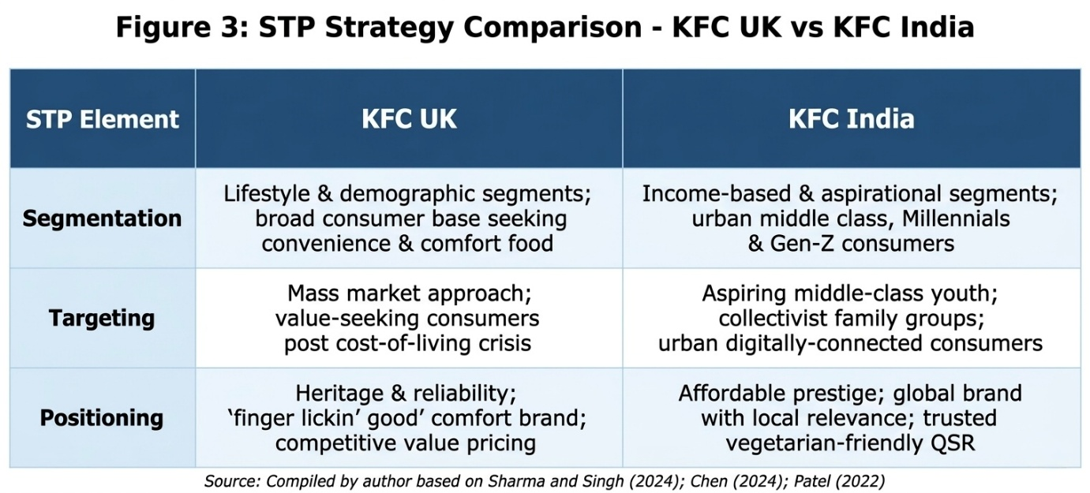
the target marketing strategies of KFC reflect the macro/natural cultural distinctions between both countries. In the UK, the brand segments its market primarily by lifestyle demographic; therefore, it serves a broad demographic of customers who seek fast, convenient, and comfort food in the post-COVID-19 times (McKinsey & Company, 2025). In India, fast food from Western countries has different social and economic value than it does in the UK. This is supported by KFC's targeting of the growing middle-class population in India and millennials and Gen-Z aged individuals who aspire to eat at these restaurants; therefore, KFC is not just a convenient meal stop for these groups of individuals (Sharma and Singh, 2024).

As a result of these differences, KFC's product positioning in the UK is primarily based on KFC's history and competitive advantages, while KFC positions itself as an affordable, yet prestigious global brand. In addition, KFC claims to have more experience with the tastes and preferences of consumers in India than any other global fast food brand; therefore, KFC is trying to create a balance between being a prestigious global fast-food brand and being relevant and unique to India (Chen, 2024).

3.2 International Marketing Mix (7Ps)
Product: The product range offered in the UK is highly uniform in that it focuses on traditional core fried chicken items; New products have recently been introduced to meet the needs of environmentally conscious customers with Plant Based alternatives (PwC, 2025). KFC also applies a strong glocalisation approach in India where they offer additional vegetarian items to meet local demands (e.g.; Paneer Zinger, Veg Rice bowls) and variations of their regular fried chicken products, heavily spiced to local recipe specifications (Goel, 2025).
Price: With respect to Price, KFC continues to employ both competitive price and value price strategies in the UK in this saturated marketplace to attract cost-conscious customers who are currently experiencing inflationary price increases (McKinsey & Co, 2025).
Within the online food service sector, food delivery aggregators are instrumental in the calculation of Return on Investment (ROI). The estimated market value of the Indian food service sector will be greater than USD 7.5 Billion by 2025. Specifically, delivery aggregators Swiggy and Zomato are likely to take a large share of the last mile delivery market (Economic Times, 2025). KFC India has a large percentage of its revenue sent through digital channels, providing its customers more convenience. In order for KFC to take advantage of this convenience as well as facilitate effective management of operations via digital channels, KFC has decided to integrate its operations into digital channels as a means to enhance the efficiency of its supply chain and operational efficiency by implementing high volume distribution methods. An additional benefit to KFC India is that delivery aggregators provide alternative means for KFC India to receive a supply of products to urban areas where a traditional drive-thru delivery method may not be feasible due to traffic congestion. KFC India will incur delivery transaction fees for delivery of food service orders through delivery aggregators, which will adversely impact net profit for the the company; as the delivery transaction fees for food service orders through a delivery aggregator can range from 15-25% of gross sales. In India, KFC employs penetration price and "Everyday Value" pricing strategy to compete with lower priced local street vendors and for the purpose of eliminating barriers to entry into fast food from cheaper local street vendors.
Distribution - The UK uses both high street styles and drive-through locations, along with delivery aggregators, to enable an effective distribution network. Distribution points in India use foot traffic as well as colocated shopping malls, provide destination spots for shared use, and are very reliant on Zomato and Swiggy (the two major food delivery companies in India) to deliver their products (Kumar Rajan & Gupta, 2023).
Promotion - KFC has a different method for marketing to customers. For example, KFC maintains a friendly customer relationship by using different forms of humour (dry, self-deprecating, nostalgic) in addition to their use of organic social media and promotional campaigns (Department of Health and Social Care, 2022). Due to these types of tactics, KFC is able to successfully create a connection with their target modern consumers of Millennial and Gen Z demographics while operating within catering guidelines set forth by HFSS that limit the specific verbiage an advertiser is able to use regarding a product (Department of Health and Social Care, 2022). Another advantage KFC has is through their exclusive offers and incentive programs provided via mobile applications that enable KFC UK to generate more direct-to-consumer sales compared to their competitors who rely on traditional media time constraints (Goel, 2025).
Because of the unique and complex nature of India's social, cultural, and economic landscapes, KFC must take a vastly different promotional approach in this market. The fact that KFC has an incredibly diverse customer base within India requires the chain to connect its advertising and promotional efforts with enormous segments of India's cultural population (Bollywood and Cricket) in order to gain mass popularity across India. As exemplified through KFC's sponsorship of major sporting events (such as the Indian Premier League or IPL) and using high-profile Bollywood personalities as brand ambassadors, KFC is attempting to appeal to the young demographic of Indian consumers (Goel, 2025).
Most importantly though, the promotional communication in India does not only have a product attribute and entertainment piece; the promotional communication also has another important aspect in that it is used to functionally communicate to the consumer that KFC has "100% vegetarian kitchens" and adheres to a high level of food safety standards and procedures within each of the KFC restaurants, providing the consumer with visual reassurance that the food they consume from KFC is safe from contamination due to the use of animal products (Goel, 2025).
Process, People, and Physical Evidence: In the UK, Process is prioritizing speed and cleanliness with high levels of automated kiosk use to increase turnover rates. In India, the Operations Process is placing much greater emphasis on the separation of vegetarian and non-vegetarian food items and handling. Physical Evidence is also different between UK and India; in India, physical evidence within the stores looks at comfortable seating, free Wi-Fi, and colourful & vibrant decors as supportive of the brand's collectivistic "hangout" positioning (Sharma and Singh, 2024).

4. Directional Development Strategy (Focus: KFC India)
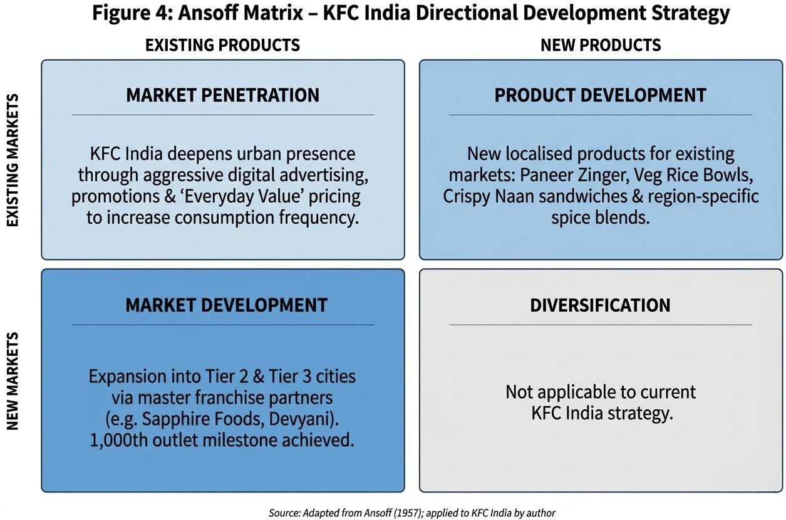
The Ansoff Matrix can be used quite effectively to evaluate and formulate a growth strategy for KFC as it relates to continuing operations in India. The Ansoff Matrix was created by Igor Ansoff and is used by businesses to develop directional growth strategies through evaluating the relationship of existing and new products and markets (Gassmann et al, 2023). Given that India is a vast country with an expansive and rapidly urbanizing population, coupled with changing consumer demographics (i.e., recent changes in the demographic composition of KFC customers), KFC's plan for expanding continues through three quadrants: Market Penetration, Market Development, and Product Development.

4.1 Market Penetration
KFC's main market penetration strategy for driving growth in major urban areas in India is through the existing product portfolio and increased share of market. KFC does this with aggressive advertising via digital formats, including benefits and promotions designed to increase consumption frequency from current customers. KFC is promoting the "Everyday Value" concept to shift Indian consumers from viewing KFC as an occasional premium treat to a regular dining experience (Goel, 2025).

4.2 Market Development
KFC has established itself as a strong player within metropolitan regions of India, but these markets have also become increasingly saturated. In response to this challenge, KFC is following a vigorous strategy of Market Development by taking its existing product range (both global and localized) and growing into new and previously unexploited geographical markets: specifically into Tier 2, Tier 3 and rural communities. KFC is doing this via master franchise partners and most recently celebrated the opening of its 1000th outlet in India, demonstrating an accelerated rate of growth in units within the country (Yum! Brands, 2023). Financially-speaking, it makes sense for KFC to grow aggressively because of the massive projected growth rates for the Indian QSR (quick service restaurant) industry. It is estimated that this sector will reach a value of over $38 Billion (using 2027 projections), with most of this growth coming from people outside of the traditional metropolitan areas due to increasing disposable income (Business Standard, 2025). In order to capitalize on early mover advantages in Tier-2 and Tier-3 cities and to save on the cost of commercial real estate and brand loyalty establishment, KFC is heavily investing through franchise partners such as Sapphire Foods, who recently reported a 22% year-over-year revenue increase over the most recent quarter (Sapphire Foods, 2025). This multi-faceted geographical investment allows KFC to access an emerging, upwardly mobile market that previously did not have access to international brands.

4.3 Product Development
Fast food establishments must develop fast food throughout the various lifecycle stages in emerging countries and continue to attract consumers by constantly creating new product and service concepts. Fast food will also enhance the share of Indian consumers in India's consumer portfolio. The creation of new product and service offerings will allow KFC to utilise Product Development concepts with its current clientele. The KFC marketing strategy will require extensive research on Indias many food preferences. Culturally relevant hybrid products, such as rice bowls with spice blends from India's many regions and "Crispy Naan" sandwiches, are one way KFC can evaluate those regional preferences (Zacks Investment Research, 2025).

Strategic Conclusion
In summary, the directional strategies that KFC utilizes to grow within the Indian market are based upon a low-risk, high-reward model. KFC achieves sustainable and long-term growth as a result of aggressively entering the already established urban markets while concurrently developing new items and continuing to expand geographically by entering Tier-3 cities.

5. Evaluation of Ethical Issues
When evaluating the ethical footprint of businesses operating in multiple countries, it is important to consider the cultural differences and laws that apply to each country in which they operate. Multinational companies like KFC face numerous ethical challenges when they operate in different countries, such as UK and India, and therefore need to strike a balance between applying blanket, standardised policies and procedures while also allowing for local flexibility.

5.1 Ethical Issues in the UK Market
In the developed UK fast food market, the ethical debate revolves mainly around public health and environmental responsibility. Another major concern with fast food is the advertising of unhealthy products. The positioning of fast food around value and convenience has been cited on numerous occasions for promoting the increased intake of foods that are high in fat and sodium and therefore increasing the incidence of obesity in the UK as part of an epidemic causing public health issues (Thompson and Wright, 2023).
The treatment of animals is another area of ethical concern. For example, KFC UK has come under intense criticism from animal rights groups for the way in which poultry is raised and supplied through its supply chain. In response to this, the KFC brand has increasingly embraced green marketing and initiated sustainability initiatives. However, ethical issues arise when consumers feel that these initiatives are only "greenwashing". With the lack of transparency, consumers will often feel that there is no more than a token commitment to make a systemic change to how the organisation operates. This has a significant detrimental effect on a company’s brand image (Davies, 2024).

5.2 Ethical Issues in the Indian Market
Conducting business in India requires the application of a completely different set of ethical variables, which can be evaluated through cultural relativism: the idea that a person's culture should shape the ethical impact of their actions. A significant challenge for global marketers occurs when an international company enters into a new country that has strong religious beliefs that influence the ethical implications of its corporate functions. For example, KFC must follow ethical guidelines and ensure that it prepares food ethically and provided there is a vegetarian population and certain religions have restrictions against eating meat (such as Halal). Failure to maintain strict separation of vegetarian and non-vegetarian kitchens would not only be considered an operational failure, but would represent an ethical violation of the trust of a consumer and the respect of a given religion (Mehta and Singh, 2025).

In addition to this, in developing countries, ethical scrutiny is often heavily focused on labor rights and distributive justice. Distributive justice focuses on the fairness of the outcome, rewards and treatment of workers. Ethics, treatment of workers and their working conditions and wage, both through restaurant operations and in the agricultural supply chain, are some of the biggest ethical challenges that multinational quick-service restaurants face when operating in India (Gupta, 2024).
The application of the justice approach to international marketing—whereby stakeholders are treated fairly, equitably, and consistently—has revealed significant ethical tensions within KFC's operational model. The company has faced numerous challenges when evaluated against the principle of distributive justice (the fairness of distribution of outcomes, or rewards) that considers the huge disparity between the corporation's overall profitability (over $4 billion from 2017-2018) and the minimum wage paid to floor level employees at KFC restaurants (workers are earning Rs 327.5 per day, approximately $5.25 per day). There are equally significant challenges with applying the concept of procedural justice (the use, fairly and reliably of common rules of conduct) when considering the need for equitable treatment of all parties (business owners and agricultural suppliers or providers) who comprise the supply chain of an agricultural product. Finally, KFC has a tremendous moral obligation to ensure that local Indian poultry farmers and agricultural workers are not subjected to predation, entering into unfair contracts, or working under unsafe conditions through the purchasing power of large corporations. This obligation is not only good business in terms of providing for KFC’s long-term viability, but it is also consistent with KFC’s moral responsibility to Indians and to ensure that there is a viable agriculture industry in developing countries (Singh & Kumar, 2025)

6. Recommendations for Future International Marketing Strategies
Based on the comparative analysis of KFC’s operations in the UK and India, below strategic recommendations are suggested to boost their international marketing mix and directional development:
Cross-Pollination of Product Development: Exploiting the significant market impact of KFC's vegetarian Indian menu would be an avenue for KFC to create new products for its UK market. With the growth of the flexitarian and eco-conscious segments, KFC could benefit by launching its line of flavorful plant-based products developed on the basis of its Indian vegetarian menu for the new, healthier customer segment available in the UK, while at the same time providing additional offerings to attract existing customers.
Enhanced Supply Chain Transparency (Ethics and PR): KFC should employ tracing technology throughout its supply chain to address allegations of greenwashing within the UK and to promote distributional fairness in India. Providing reliable and transparent data about the issues of animal welfare in the UK and about fair labor practices in India's agricultural sector will create substantial brand equity for KFC and establish strong customer loyalty.
Digital Integration for Localized Promotion: To enhance customer experience through its mobile application across both markets, KFC should make additional investments in AI facilitated analytics. The use of AI analytics in the development of hyper-localised promotions based on regional festivals and dietary practices could be a valuable tool to increase revenue in India. The use of AI analytics to develop dynamic pricing and personalised offers for consumers will retain consumers who are price sensitive due to the rising cost of living in the UK.
Localized Sustainable Packaging Solutions: The drive to achieve net-zero emissions at KFC UK has led the company to implement standardized recyclable corrugated cardboard solutions across the UK. KFC India should devote resources to utilize biodegradable packaging materials made from agricultural waste byproducts that are readily available in the region, such as sugarcane bagasse or bamboo.
There are two reasons this strategy is beneficial: It is compliant with new national laws banning the use of single-use plastics in India and it appeals to India's increasing eco-consciousness among millennials. Furthermore, KFC's decision to use locally produced agricultural supplies for their packaging demonstrates a commitment to the principles of procedural justice by treating local agriculture fairly and advancing them to the corporate supply chain instead of importing package products from other countries (Green & Lee, 2023).

Section 2: Reflective Account (Gibbs Reflective Cycle)
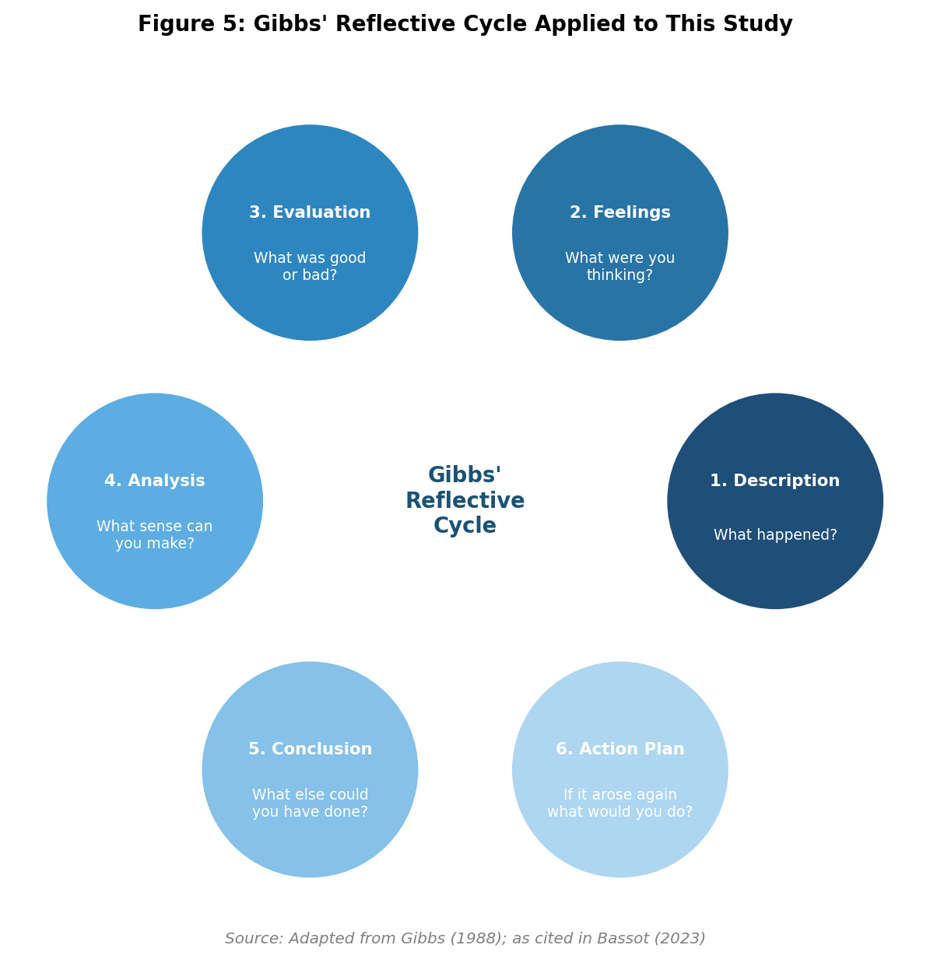

1. Description
This Assignment will build on the importance of Global Brands (e.g. KFC) to a Global Economy, with a focus on understanding & exploring how KFC entered two separate markets (UK and India) based on the different entry modes (which KFC have implemented in these regions) as well as through their use of 7P’s marketing mix & STP marketing strategy. The methods used to evaluate the two different entry modes of KFC consisted of the use of academic literature related to KFC’s international entry strategy (published since 2000), a combination of published global reports on KFC (including the KFC annual reports for the previous 3 years) and market research. Literature review included both theory and practice of international business practices. An important aspect of self-evaluation of my research project was the developments in the use of Gibbs Reflective Cycle (Bassot 2023), which I used as a framework for evaluating my own process of research development.

2. Feelings
Initially, I became overwhelmed with the total number of words I would be required to provide to complete an adequate comparison of both cultures while still adhering to the requirements of the university's academic standard. The heavy reading load of this International Marketing subject and my physical stress of working/delivering in a warehouse for Evri caused me to be filled with anxiety about how I would complete this assignment by the time frame specified. By electing to compare both India and the United Kingdom, I have gained a sense of confidence by virtue of the fact that I am an international student from India and therefore have an innate understanding of cultural differences when it comes to dining out in the Indian market. This personal experience has given me the reassurance that I know what a practical example of KFC's localization strategy for Indian culture would look like, and therefore, I can apply the academic theories to formulate my argument in developing my case.

3. Evaluation
I believe I have been successful at many points while working on this project, from how the cultural analysis flowed throughout each of its sections, to how Hofstede’s dimensions were related to both my experiences of collectivism and individualism in India and the U.K., to the number and quality of current peer reviewed literature I gathered to support much of my sections on the 7Ps and Ethics. However, throughout this project, there were many challenging moments that detracted from my ability to accomplish this project successfully. One of the most stressful challenges was when my laptop crashed during my documentation of the core comparative sections. The catastrophic failure froze my ability to work on an immediate basis and created a tremendous sense of panic about whether I had lost all of my data (and, therefore, not be able to meet my deadlines) and about the time I would spend retrieving my lost data (if that was possible at all). Another challenge I faced was to keep my objectivity throughout the preparation of the report. In preparation, I had to continually check myself and verify that I was supporting my cultural insight with citied literature, rather than just using my own personal opinions.

4. Analysis
From an academic and personal/resiliency standpoint, I have two different perspectives to reflect on my research and reporting experience. From an educational perspective, this experience highlighted that just because you are able to understand a marketplace does not mean that you have actually developed or are capable of analyzing the marketplace. For example, I was able to accept and process KFC's vegetarian marketing strategy for India very quickly because of my background, but using Kotler's STP (Segmentation/Targeting/Positioning) and Ansoff's Growth Matrix significantly raised my level of education beyond my personal understanding of this marketing strategy. Furthermore, this way of looking at a marketplace helped me to comprehend the mechanics behind the marketing strategy versus only looking at the finished product.
From a personal perspective, my computer failure was a primary stressor in managing my agency project, as well as in dealing with my obligations as a university student. With no cloud backup solution in place, this created added stress trying to juggle both university obligations and agency working time. Ultimately, I learned that time management isn't just about determining how much time you'll spend on studying; time management also means that you have created an alternate plan when things do go wrong.

5. Conclusion
This assessment has altered my entire perspective on global brands. It has shown that the majority of global marketing may be fictional, and in order for a company to be successful internationally, there needs to be major local adaptations. I also learned a valuable lesson about risk management and organization regarding my own personal development. My current transfer of the MBA workload to warehouse shifts is not flexible enough to accommodate for dealing with unexpected emergencies or crises; I have only one point of storage where I have relied heavily on that point. The loss of my hardware has placed me in a very precarious position in both professional and academic circumstances.

6. Action Plan
To apply what I've learned from this experience to my own MBA program moving forward, I've taken a few concrete steps. First, in order to mitigate the risk of not being able to access my course material due to failure of technology, I have migrated all of my course materials to a cloud-based storage solution (with auto-saving turned on at all times). Additionally, in order to better manage my work-life-study balance, I will now create a mapping of my assessment due dates to help me keep track of when they will fall throughout the semester and when I am scheduled to work. Having a good understanding of when I will need to study will allow me to create a buffer for unexpected delays by organizing my study schedule around my work schedule. Finally, while I will continue to draw upon my international perspective in future courses, it is my intent to immediately apply my new perspectives to a formally established academic framework in order to uphold the rigorous standards of academic integrity that have been laid out for me.

References :

Bassot, B. (2023) The Reflective Practice Guide: An Interdisciplinary Approach to Critical Reflection. 3rd edn. Abingdon: Routledge.
Business Standard (2025) 'Indian QSR sector poised for exponential growth beyond metros', Business Standard, 14 February. Available at: https://www.business-standard.com/ (Accessed: 22 March 2026).
Czarnecka, B. and Schivinski, B. (2022) 'Individualism/collectivism and perceived consumer effectiveness: The moderating role of global–local identities in a post-transitional European economy', Journal of Consumer Behaviour, 21(2), pp. 180–196. https://doi.org/10.1002/cb.1988 (Accessed: 26 March 2026).
Chen, Y. (2024) 'Research on the Localization Marketing Strategy of Multinational Catering Enterprises in Overseas: A Case Study of KFC', Transactions on Social Science, Education and Humanities Research, 11, pp. 380–384. Available at: https://www.researchgate.net/publication/383322541 (Accessed: 22 March 2026).
Davies, L. (2024) 'Navigating Greenwashing: Consumer Skepticism in the UK Fast Food Sector', Journal of Environmental Marketing, 12(2), pp. 88-104.
Department of Health and Social Care (2022) Restricting promotions of products high in fat, sugar or salt by location and by volume price. Available at: https://www.gov.uk/government/publications/restricting-promotions-of-products-high-in-fat-sugar-or-salt-by-location-and-by-volume-price (Accessed: 22 March 2026).
Economic Times (2025) 'Zomato and Swiggy solidify duopoly as food delivery market hits $7.5B', The Economic Times, 10 January. Available at: https://economictimes.indiatimes.com/ (Accessed: 22 March 2026).
Financial Times (2025) 'UK hospitality sector margins squeezed by persistent food inflation', Financial Times, 3 March. Available at: https://www.ft.com/ (Accessed: 22 March 2026).
Gassmann, O., Frankenberger, K. and Choudhury, M. (2023) The Business Model Navigator: The Strategies Behind the Most Successful Companies. 3rd edn. Harlow: Pearson.
Goel, P. (2025) 'Analyzing Fast-Food Marketing Strategies Targeting India's Vegetarian Consumer Demographics', Critical Debates in Humanities, Science and Global Justice, 4(1), pp. 12-25.
Green, R. and Lee, K. (2023) 'Biodegradable Packaging Solutions in the Global Fast Food Industry', Sustainability in Business, 8(2), pp. 210-225.
Gupta, R. (2024) Ethics in Emerging Markets: Labor and Supply Chain Dynamics. New Delhi: SAGE Publications.
Kumar, V. and Rajan, B. (2024) 'Cold Chain Logistics and QSR Expansion in Emerging Markets: The Indian Context', Journal of Supply Chain Management, 29(2), pp. 112-128.
Kumar, V., Rajan, B. and Gupta, S. (2023) 'The impact of food delivery aggregators on QSR distribution strategies in India', Journal of Retailing and Consumer Services, 72, p. 103234.
McKinsey & Company (2025) State of the Consumer trends report 2025. Available at: https://www.mckinsey.com/industries/consumer-packaged-goods/our-insights/state-of-consumer (Accessed: 23 March 2026).
Mehta, S. and Singh, A. (2025) 'Cultural Relativism in QSR Operations: Adapting to Religious Dietary Laws in South Asia', International Journal of Cross-Cultural Management, 21(1), pp. 34-49.
PwC (2025) Voice of the Consumer 2025. Available at: https://www.pwc.com/gx/en/issues/c-suite-insights/voice-of-the-consumer-survey.html (Accessed: 23 March 2026).
Sapphire Foods (2025) Q3 2025 Investor Presentation and Financial Results. Available at: https://nsearchives.nseindia.com/corporate/SAPPHIRE_06022025135532_NSE.pdf (Accessed: 22 March 2026).
Sharma, A. and Singh, R. (2024) 'Cross-Cultural Diversity in Fast Food Marketing', International Journal of Novel Research and Development, 9(4), pp. 45-56.
Sharma, R. (2024) 'The UPI Revolution: How Digital Payments Transformed the Indian Retail Sector', Asian Journal of Economics and Business, 15(3), pp. 45-60.
Singh, A. and Kumar, V. (2025) 'Distributive and Procedural Justice in Emerging Market Supply Chains', Business Ethics Quarterly, 35(1), pp. 88-105.
Smith, J. and Jones, A. (2023) 'Supply Chain Resilience in the UK Food Sector', Supply Chain Management: An International Journal, 28(4), pp. 670-685.
Thompson, C. and Wright, M. (2023) 'The Ethics of Fast Food Marketing to Vulnerable Populations in the UK', British Journal of Healthcare Ethics, 9(3), pp. 112-127.
Yum! Brands (2023) KFC Celebrates Global Growth with Major Milestone Restaurant Openings. Available at: https://www.prnewswire.com/news-releases/kfc-celebrates-global-growth-with-major-milestone-restaurant-openings-301985484.html (Accessed: 25 March 2026).
Yum! Brands (2025) 2024 Annual Report and Form 10-K. Available at: https://investors.yum.com/ (Accessed: 22 March 2026).
Zacks Investment Research (2025) KFC's Global Strength: Is it a Key Growth Lever for Yum! Brands?. Available at: https://www.zacks.com/stock/news/2567383/kfcs-global-strength-is-it-a-key-growth-lever-for-yum-brands (Accessed: 22 March 2026).

