  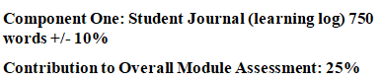 | Student No: | 2245642
 | Module Title: | Operating Hotel Facilities
 | Module Code: | BMIH4006
 | Lecturer: | Natalie Brailsford  Daniel Payne  Lisa Bassler  Giulia Ghifari  Ben Chong  Scott James
Introduction
I will use GIBBS's Reflective Cycle for reflective practice as a student beginning my journey to acquire the necessary abilities to work in the housekeeping member at Best Western Abbots Barton Hotel, Canterbury. Reflection, conceptualization, and experimentation are the four phases of successful Reflective in GIBBS's model, which transform raw experiences into knowledge. Reflection, conceptualization, and experimentation are the four phases of successful Reflective in GIBBS's model, which transform raw experiences into knowledge. I will write about my experiences and skills in my diary, connecting them to theoretical ideas and practical uses of the important skills that the housekeeping team has identified (Ibragimovich et al, 2023).
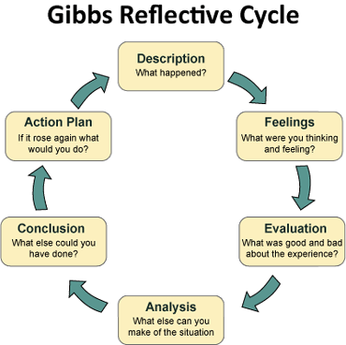
Figure: Gibbs (Koutoulas et al, 2023).
Description
I gained a lot of knowledge about the core skills required to be successful in this field of employment during my first practical experience with the Best Western Abbots Barton Hotel, Canterbury housekeeping staff. Teamwork, time management, and attention to detail were the three most crucial skills. In all of my daily tasks, I first made paying close attention to detail a priority. I quickly learned that in housekeeping, even the little imperfections matter. Every aspect of a guest room had to be meticulously planned and developed to ensure that it was spotless and welcoming (Ibragimovich et al, 2023).
Feelings
During my placement at Best Western Abbots Barton Hotel, I gained valuable experience by working in the housekeeping department. Initially, I found it challenging to complete the cleaning of a room within the hotel's standard time of 30 minutes and felt tired. However, after working several shifts, I learned that with determination and practice, achieving this goal was possible. Consequently, I was able to clean rooms effectively within the designated time frame and felt confident in my abilities.
Secondly, effective time management was essential. I had several rooms to clean and strict deadlines to achieve, so I had to schedule my time well to maintain the highest standards of organisation and cleanliness in each space. This skill enabled me to operate effectively under pressure and yet deliver excellent work. Ultimately, the housekeeping team's success may be attributed mostly to their collaborative skills. I realised that collaboration among co-workers, prudent responsibility distribution, and mutual support during challenging times were critical to sustaining the department's seamless functioning (Mun et al, 2023).
Evaluation
After my first interactions, I let myself some time to reflect on how I had performed. My attention to detail had increased, I noticed, after I learned to recognise areas that need more cleaning. Moreover, I could see how working with others and Reflective from their expertise may increase my productivity. This thought aligns with the theoretical underpinnings of housekeeping, which include maintaining cleanliness and sanitary standards in lodging establishments. It takes careful attention to detail to ensure the happiness and safety of guests (Koutoulas et al, 2023).
Analysis
In the hospitality industry, a hotel's reputation is crucially dependent on its housekeeping staff. An example of how a single hygienic issue might cause a visitor to write a negative review, damaging the hotel's income and image, is this one. In an effort to further refine my skills, I decided to look at housekeeping theory. I was trained on a variety of cleaning techniques, cleaning products, and the need of adhering to health and safety laws. This information has enhanced my comprehension of the motivations underlying human action and the consequences of task abandonment (Asshofi et al, 2023).
Conclusion
The importance of theoretical knowledge, which enhances comprehension and efficacy in housekeeping tasks, is congruent with this level (Mun et al, 2023). The industry is familiar with the cleaning supplies, equipment, and techniques used by knowledgeable housekeeping staff because they are aware of the laws and regulations unique to their business, their work meets both high standards and the expectations of visitors. By using this approach, I have been able to comprehend the theoretical foundations of housekeeping more thoroughly and see how these concepts transfer into the kind of useful abilities required for success in this field. As I want to gain the necessary skills within the Housekeeping department of Best Western Abbots Barton Hotel, Canterbury, Canterbury. The GIBBS Reflective Cycle has shown to be a very beneficial framework (Orhan et al, 2023).
Action plan
Armed with not just academic understanding but also practical experience, I returned to my cleaning duties. I found my ability to be notably improved. My increased efficiency enabled me to ensure that the guest rooms were not only spotless but also safe for their stay. The active experimental stage validates the application of theoretical knowledge to real-world scenarios. (Asshofi et al, 2023) This promotes Reflective and the growth of skills. To ensure guests' comfort and safety, the industry employs trained housekeeping staff who promptly cleans and prepares rooms. This has a direct influence on both guest satisfaction and the hotel's reputation. It highlights how effective Reflective requires a synthesis of theory, experimentation, reflection, and experience. Hopefully, I may maintain using GIBBS's model as a useful reference as I learn and practice my way up to become a proficient housekeeper (Koutoulas et al, 2023).
.

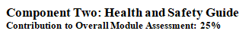

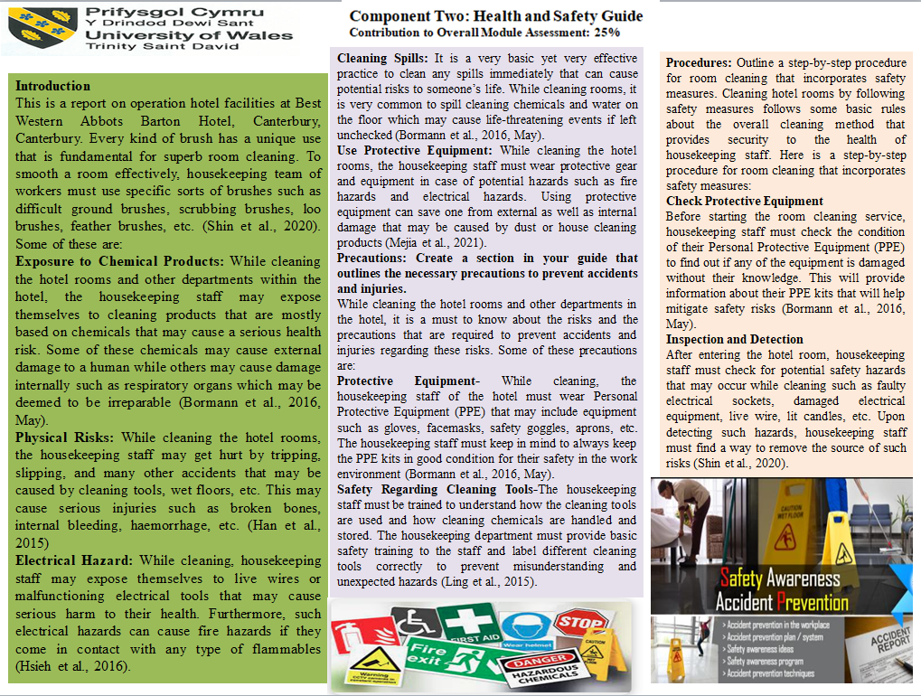
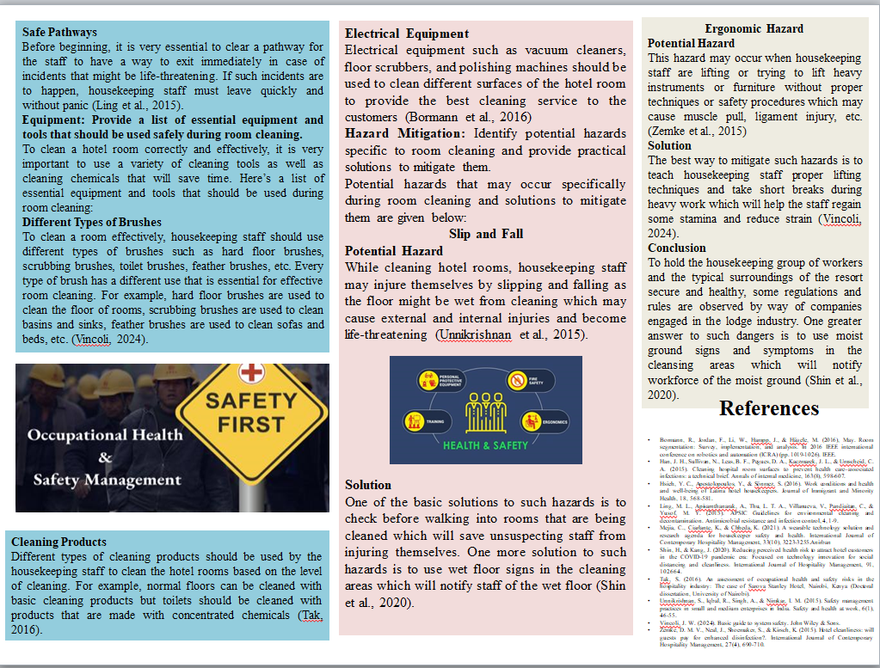

Introduction
This is a report on operation hotel facilities at Best Western Abbots Barton Hotel, Canterbury, Canterbury. Every kind of brush has a unique use that is fundamental for superb room cleaning. One of the simple options to such risks is to test earlier than taking walks into rooms that are being cleaned which will shop unsuspecting team of workers from injuring themselves. To smooth a room effectively, housekeeping team of workers must use specific sorts of brushes such as difficult ground brushes, scrubbing brushes, loo brushes, feather brushes, etc. (Shin et al., 2020).

Identify potential risks, and gather information on industry best practices and regulations related to housekeeping safety. Some potential risks while cleaning hotel rooms and other departments within the hotel may range from mere to life-threatening for the cleaners. Some of these are:
Exposure to Chemical Products: While cleaning the hotel rooms and other departments within the hotel, the housekeeping staff may expose themselves to cleaning products that are mostly based on chemicals that may cause a serious health risk. Some of these chemicals may cause external damage to a human while others may cause damage internally such as respiratory organs which may be deemed to be irreparable (Bormann et al., 2016, May).
Physical Risks: While cleaning the hotel rooms, the housekeeping staff may get hurt by tripping, slipping, and many other accidents that may be caused by cleaning tools, wet floors, etc. This may cause serious injuries such as broken bones, internal bleeding, haemorrhage, etc. (Han et al., 2015)
Electrical Hazard: While cleaning, housekeeping staff may expose themselves to live wires or malfunctioning electrical tools that may cause serious harm to their health. Furthermore, such electrical hazards can cause fire hazards if they come in contact with any type of flammables (Hsieh et al., 2016).
Use Protective Equipment: While cleaning the hotel rooms, the housekeeping staff must wear protective gear and equipment in case of potential hazards such as fire hazards and electrical hazards. Using protective equipment can save one from external as well as internal damage that may be caused by dust or house cleaning products (Mejia et al., 2021).

Precautions: Create a section in your guide that outlines the necessary precautions to prevent accidents and injuries.
While cleaning the hotel rooms and other departments in the hotel, it is a must to know about the risks and the precautions that are required to prevent accidents and injuries regarding these risks. Some of these precautions are:
Protective Equipment- While cleaning, the housekeeping staff of the hotel must wear Personal Protective Equipment (PPE) that may include equipment such as gloves, facemasks, safety goggles, aprons, etc. The housekeeping staff must keep in mind to always keep the PPE kits in good condition for their safety in the work environment (Bormann et al., 2016, May).
Safety Regarding Cleaning Tools-The housekeeping staff must be trained to understand how the cleaning tools are used and how cleaning chemicals are handled and stored. The housekeeping department must provide basic safety training to the staff and label different cleaning tools correctly to prevent misunderstanding and unexpected hazards (Ling et al., 2015).
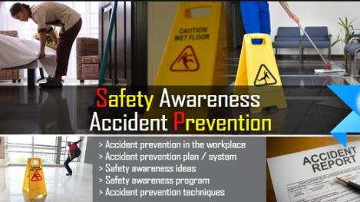
Figure: Prevent accidents (Bormann et al., 2016).

Procedures: Outline a step-by-step procedure for room cleaning that incorporates safety measures.
Cleaning hotel rooms by following safety measures follows some basic rules about the overall cleaning method that provides security to the health of housekeeping staff. Here is a step-by-step procedure for room cleaning that incorporates safety measures:
Check Protective Equipment
Before starting the room cleaning service, housekeeping staff must check the condition of their Personal Protective Equipment (PPE) to find out if any of the equipment is damaged without their knowledge. This will provide information about their PPE kits that will help mitigate safety risks (Bormann et al., 2016, May).
Inspection and Detection
After entering the hotel room, housekeeping staff must check for potential safety hazards that may occur while cleaning such as faulty electrical sockets, damaged electrical equipment, live wire, lit candles, etc. Upon detecting such hazards, housekeeping staff must find a way to remove the source of such risks (Shin et al., 2020).
Safe Pathways
Before beginning, it is very essential to clear a pathway for the staff to have a way to exit immediately in case of incidents that might be life-threatening. If such incidents are to happen, housekeeping staff must leave quickly and without panic (Ling et al., 2015).

Equipment: Provide a list of essential equipment and tools that should be used safely during room cleaning.
To clean a hotel room correctly and effectively, it is very important to use a variety of cleaning tools as well as cleaning chemicals that will save time. Here’s a list of essential equipment and tools that should be used during room cleaning:
Cleaning Products
Different types of cleaning products should be used by the housekeeping staff to clean the hotel rooms based on the level of cleaning. For example, normal floors can be cleaned with basic cleaning products but toilets should be cleaned with products that are made with concentrated chemicals (Tak, 2016).

Hazard Mitigation: Identify potential hazards specific to room cleaning and provide practical solutions to mitigate them.
Potential hazards that may occur specifically during room cleaning and solutions to mitigate them are given below:
Slip and Fall
Potential Hazard
While cleaning hotel rooms, housekeeping staff may injure themselves by slipping and falling as the floor might be wet from cleaning which may cause external and internal injuries and become life-threatening (Unnikrishnan et al., 2015).
Solution
One of the basic solutions to such hazards is to check before walking into rooms that are being cleaned which will save unsuspecting staff from injuring themselves. One more solution to such hazards is to use wet floor signs in the cleaning areas which will notify staff of the wet floor (Shin et al., 2020).
Ergonomic Hazard
Potential Hazard
This hazard may occur when housekeeping staff are lifting or trying to lift heavy instruments or furniture without proper techniques or safety procedures which may cause muscle pull, ligament injury, etc. (Zemke et al., 2015)
Solution
The best way to mitigate such hazards is to teach housekeeping staff proper lifting techniques and take short breaks during heavy work which will help the staff regain some stamina and reduce strain (Vincoli, 2024).

Conclusion
To hold the housekeeping group of workers and the typical surroundings of the resort secure and healthy, some regulations and rules are observed by way of companies engaged in the lodge industry. Different sorts of cleansing merchandise must be used with the aid of the housekeeping team of workers to smooth the lodge rooms primarily based on the degree of cleaning. One greater answer to such dangers is to use moist ground signs and symptoms in the cleansing areas which will notify workforce of the moist ground (Shin et al., 2020
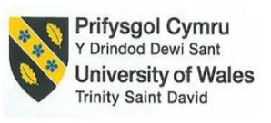

Reference List

Alhassan, T., Kidido, J.K. and Tannor, O., (2023). Assessment of facilities management sourcing approaches in hotels in Ghana: a study of selected hotels in Wa. Property Management.
Asshofi, I.U.A., Putri, M.A., Saputra, R.D. and Wijayanti, A., (2023). Analysis of room rates setting in hotel daily operations. Journal of Gastro Tourism, 1(1), pp.35-42.
Bormann, R., Jordan, F., Li, W., Hampp, J., & Hägele, M. (2016), May. Room segmentation: Survey, implementation, and analysis. In 2016 IEEE international conference on robotics and automation (ICRA) (pp. 1019-1026). IEEE.
Han, J. H., Sullivan, N., Leas, B. F., Pegues, D. A., Kaczmarek, J. L., & Umscheid, C. A. (2015). Cleaning hospital room surfaces to prevent health care–associated infections: a technical brief. Annals of internal medicine, 163(8), 598-607.
Hsieh, Y. C., Apostolopoulos, Y., & Sönmez, S. (2016). Work conditions and health and well-being of Latina hotel housekeepers. Journal of Immigrant and Minority Health, 18, 568-581.
Ibragimovich, T.K., (2023). Characteristics of Hotel Facilities Development in the Samarkand Region. Central Asian Journal of Innovations on Tourism Management and Finance, 4(4), pp.134-138.Anirban_Rifat
Korpacz, P.F. and Lesser, D.H., (2023). Hotel Property Tax Issues. Journal of Property Tax Assessment & Administration, 20(1), pp.31-42.
Koutoulas, D. and Vagena, A., (2023). The present and future of hotel star ratings through the eyes of star rating operators. Journal of Tourism Futures.
Ling, M. L., Apisarnthanarak, A., Thu, L. T. A., Villanueva, V., Pandjaitan, C., & Yusof, M. Y. (2015). APSIC Guidelines for environmental cleaning and decontamination. Antimicrobial resistance and infection control, 4, 1-9.
Mejia, C., Ciarlante, K., & Chheda, K. (2021). A wearable technology solution and research agenda for housekeeper safety and health. International Journal of Contemporary Hospitality Management, 33(10), 3223-3255.
Mun, S.G. and Park, S., (2023). Effects of abnormal weather conditions on the performance of hotel firms. Journal of Hospitality & Tourism Research, 47(7), pp.1299-1324.
Orhan, E., (2023). Locational attributes of the lodging industry: An empirical study on urban hotels in Ankara, Turkey. Land Use Policy, 125, p.106504.
Shin, H., & Kang, J. (2020). Reducing perceived health risk to attract hotel customers in the COVID-19 pandemic era: Focused on technology innovation for social distancing and cleanliness. International Journal of Hospitality Management, 91, 102664.
Tak, S. (2016). An assessment of occupational health and safety risks in the hospitality industry: The case of Sarova Stanley Hotel, Nairobi, Kenya (Doctoral dissertation, University of Nairobi).
Tokarz-Kocik, A., Bera, A., Drela, K. and Malkowska, A., (2023). The Impact of the COVID-19 Pandemic on the Labour Market in the Hotel Industry: Selected Conditions in Poland. Sustainability, 15(6), p.4886.
Unnikrishnan, S., Iqbal, R., Singh, A., & Nimkar, I. M. (2015). Safety management practices in small and medium enterprises in India. Safety and health at work, 6(1), 46-55.
Valdivia Nodal, Y., Hernandez Herrera, H., Reyes Calvo, R., Álvarez Guerra, M., Silva, J. and Santana Justiz, M., (2023). Energetic analysis in a hot water system: A hotel facility case study. Journal of Sustainable Development of Energy, Water and Environment Systems, 11(1), pp.1-15.
Vincoli, J. W. (2024). Basic guide to system safety. John Wiley & Sons.
Zemke, D. M. V., Neal, J., Shoemaker, S., & Kirsch, K. (2015). Hotel cleanliness: will guests pay for enhanced disinfection?. International Journal of Contemporary Hospitality Management, 27(4), 690-710.

