The Life and Times of Caesar and Cicero (HPAH5046/HPAH6046) – The Reception of Spartacus

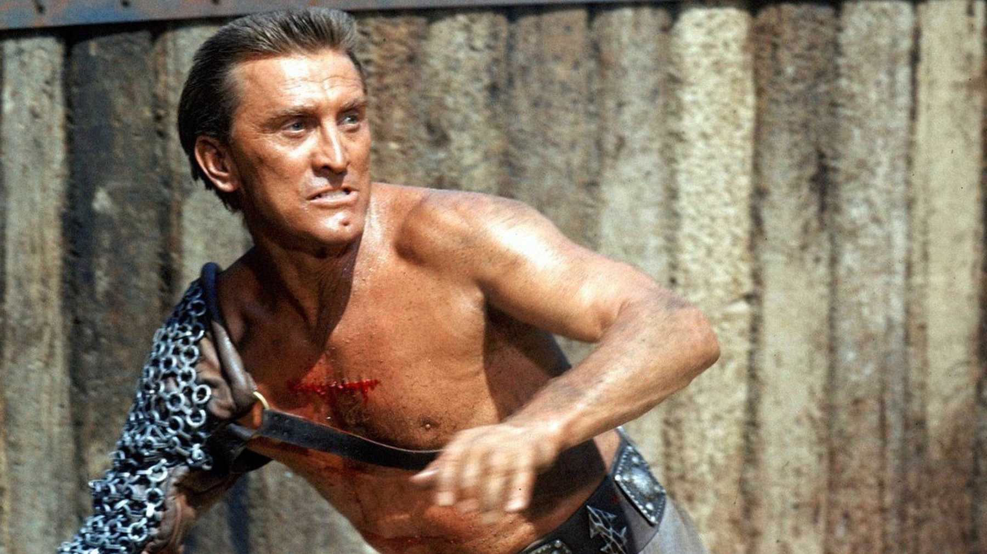
Image from the movie Spartacus (1960), starring Kurt Douglas

In this workshop we will examine the way in which Spartacus’ memory has been repurposed by intellectuals, “freedom-fighters”, politicians and artists in more history (by which I mean the last 250-300 years). Brief extracts of Plutarch, Appian and Sallust’s Historiae (our main surviving sources for the Third Servile War; unfortunately only fragments of this work of Sallust have survived) are given below so you can get a sense of how surviving ancient authors thought about this figure. This is then followed by a series of short extracts, quotes and images from more “recent” history, with accompanying questions. Consider these individually or in your groups and then write up your responses.

Ancient characterisations of Spartacus

Sallust Histories fragments [3.64] {3.96M} and [3.66] {3.98M} – transl. by A. Kurfess (1957)
But [the slaves] were almost at blows with each other, because they could not agree on a plan of action; Crixus and his fellow Gauls and Germans wanted to go out to confront [the Romans] and offer battle, while Spartacus [argued against attacking them].
. . . [that they should] not, [wandering around] in the way that they were at that time . . . and then they would be cut off [during their journey] and wiped out . . . and at the same time the concern . . . and so they should [leave as quickly as possible]. A few sensible men, with [free and] noble minds, [approved of the plan] that they should escape in this way . . . and praised [what he directed them to do]. But some of [the slaves] stupidly trusted in the forces which were coming to join them and in their own fierce courage; others [dishonourably] neglected their country of origin; and most, with [the true character] of slaves, [sought nothing] but plundering and savagery . . . [ 2 lines missing ] . . . seemed to be the best plan. Then he advised them to go off into more open countryside, richer in cattle, where they could increase their numbers with picked men, before Varinius returned with a new army. He soon found a suitable guide, one of the prisoners from Picentia, and then he went over the Eburine heights to Nares Lucanae, from where he advanced at dawn to Forum Anni, before the inhabitants realised. Immediately the slaves, contrary to the orders of their leader, turned to raping the young girls and mothers, and others . . . [ 2 lines missing ] . . . now and tormented those who remained in a shocking way with horrible wounds, and sometimes left their mutilated bodies still half alive. Others set fire to the buildings, and many of the slaves from the district, whose character inclined them to be their allies, brought out the possessions which their masters had hidden, or dragged out their masters themselves. Nothing was sacred or inviolable to these men, who had the savagery of barbarians and the temperament of slaves. Since Spartacus could not stop these [outrages], he earnestly begged them to forestall the news of what they had done, and quickly . . . [ 3 lines missing ] . . . that they would [earn the hatred of the inhabitants], who had been cruelly attacked [and slaughtered] . . . heavy mostly . . . after staying there for that day [and the following] night, with the number of [slaves in his army] now doubled, he [moved camp] at first light and [halted] in a fairly wide plain, [where he saw] that the farmers had come out of their buildings. By that time, the autumn crops were already ripe [in the fields]. But when it was already fully daytime, the residents learnt from their [fleeing] neighbours that the slaves were heading [in their direction], and [hurried away to the nearby mountains] with all [their families].

Plutarch Life of Crassus 8, 11 – trans. from Bernadotte Perrin (1916).
‘The insurrection of the gladiators and their devastation of Italy, which is generally called the war of Spartacus, had its origin as follows. A certain Lentulus Batiatus had a school of gladiators at Capua, most of whom were Gauls and Thracians. Through no misconduct of theirs, but owing to the injustice of their owner, they were kept in close confinement and reserved for gladiatorial combats. Two hundred of these planned to make their escape, and when information was laid against them, those who got wind of it and succeeded in getting away, seventy-eight in number, seized cleavers and spits from some kitchen and sallied out. On the road they fell in with waggons conveying gladiators' weapons to another city; these they plundered and armed themselves. Then they took up a strong position and elected three leaders. The first of these was Spartacus, a Thracian of Nomadic stock, possessed not only of great courage and strength, but also in sagacity and culture superior to his fortune, and more Hellenic than Thracian. It is said that when he was first brought to Rome to be sold, a serpent was seen coiled about his face as he slept, and his wife, who was of the same tribe as Spartacus, a prophetess, and subject to visitations of the Dionysiac frenzy, declared it the sign of a great and formidable power which would attend him to a fortunate issue. This woman shared in his escape and was then living with him. …
In the first place, when his horse was brought to him, he drew his sword, and saying that if he won the day he would have many fine horses of the enemy's, but if he lost it He did not want any, he slew his horse. Then pushing his way towards Crassus himself through many flying weapons and wounded men, he did not indeed reach him, but slew two centurions who fell upon him together. Finally, after his companions had taken to flight, he stood alone, surrounded by a multitude of foes, and was still defending himself when he was cut down…

Appian Civil Wars 1.116-117, 120. Trans. from John Carter (1996)
In Italy, at this same time, Spartacus, a Thracian who had served as a soldier with the Romans and after being taken prisoner and sold had become a gladiator in a troop which was kept to provide entertainments at Capua, persuaded about seventy of his fellows to risk their lives for freedom rather than for exhibition as a spectacle. With them, he overpowered their guards and escaped. Then he equipped himself and his companions with staves and daggers seized from travelers and took refuge on Mount Vesuvius, where he allowed many runaway domestic slaves and some free farm hands to join him. …
In the aftermath they retreated in confusion, while Spartacus, first sacrificing 300 Roman prisoners to Crixus, made for Rome with 120,000 foot soldiers after burning the useless equipment and putting all the prisoners to death and slaughtering the draught animals to free himself of all encumbrances; and although a large number of deserters approached him he refused to accept any of them. …
Spartacus himself was wounded by a spear-thrust in the thigh, but went down on one knee, held his shield in front of him, and fought off his attackers until he and a great number of his followers were encircled and fell. The rest of his army was already in disorder and was cut down in huge numbers; consequently their losses were not easy to estimate (though the Romans lost about 1,000 men), and Spartacus' body was never found.

Questions: Can you see any different shades of characterisation of Spartacus between the different authors? Does Spartacus seem to be presented differently?

“Modern” characterisations of Spartacus

French colonial era and Haitian reception of Spartacus
Bernard-Joseph Saurin’s tragedy Spartacus has its premiere in 1760, in which the plot revolves around Crassus’ daughter falling in love with Spartacus [other European dramatists like Gotthold Ephraim Lessing (1729–81) and Franz Seraphim Grillparzer (1791-1872) depict Spartacus as a figure who fought against tyranny].

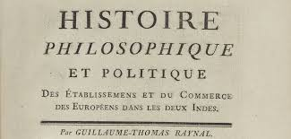
Guillaume Thomas François [Abbé] Raynal and Denis Diderot, Histoire des deux Indes (1770)
In this work on global commerce these authors explore various economic and social themes, denouncing the brutality of European colonialism and slavery. At one point in the work, it is pondered if there is a need for a “heroic benefactor” of humankind, the black Spartacus who will one day arise to rescue enslaved Africans and restore their rights:
“Where is this great man that nature owes to her troubled, tormented, and oppressed children? Where is he? He will appear, let there be no doubt of it, he will come forth, he will raise the sacred standard of liberty… The old world will join with the new in applauding him. Everywhere the name of the hero who has restored the rights of the human race will be blessed, everywhere monuments will be erected to his glory…”

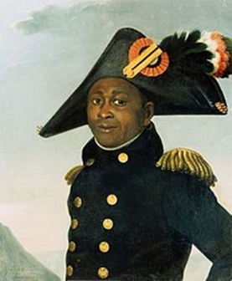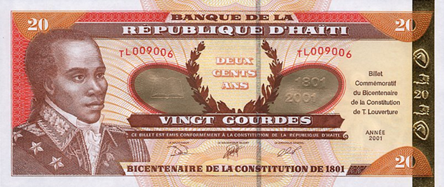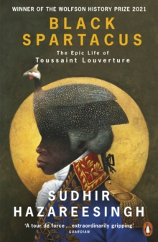
A posthumous portrait of Toussaint Louverture (early 19th cent.); a Haitian banknote issued in 2001 for the Bicentennial Anniversary of Constitution of 1801
Toussaint Louverture (1743–1803) was an ex-slave and a key figure in the Haitian Révolution that took place on the island of Saint-Domingue between 1791–1804. ‘His Republican friends hailed him as the “Black Spartacus”, the modern incarnation of the legendary gladiator…’ (Hazareesingh 2020, p. 22). Hazareesingh comments that in his speeches and letters Toussaint Louverture shows an awareness of Abbé Raynal’s work, among other French thinkers, and that he had develop a neo-Roman conception of liberty, most explicitly in his identification with the Spartacus legend. He contrasted republican freedom in contrast to enslavement to tyranny (2020, p. 27). Indeed, Toussaint’s friend, Étienne Laveaux (one time governor of Saint-Domingue), referred to him as ‘the black Spartacus, the leader announced by Raynal to avenge the crimes perpetrated against his race.’

Question: Why do you think many French-speaking intellectuals, artists and freedom fighters in this period picked Spartacus as a symbolic figure and not another figure from Graeco-Roman Antiquity?

Karl Marx on Spartacus, communist revolution and Soviet culture
Letter from Marx to Engels (written in London, 27 February, 1961) [Transcribed by Sally Ryan, published in Gesamtausgabe, International Publishers, 1942]
‘As a relaxation in the evenings I have been reading Appian on the Roman Civil Wars, in the original Greek text. A very valuable book. The chap is an Egyptian by birth. Schlosser says he has "no soul," probably because he goes to the roots of the material basis for these civil wars. Spartacus is revealed as the most splendid fellow in the whole of ancient history. Great general (no Garibaldi), noble character, real representative of the ancient proletariat.
Pompeius, reiner Scheisskerl [an utter rotter]; got his undeserved fame by snatching the credit, first for the successes of Lucullus (against Mithridates), then for the successes of Sertorius (Spain), etc., and as Sulla's "young man," etc. As a general he was the Roman Odilon Barrot. As soon as he had to show what he was made of--against Caesar--a lousy good-for-nothing. Caesar made the greatest possible military mistakes --deliberately mad--in order to bewilder the philistine who was opposing him. An ordinary Roman general--say Crassus --would have wiped him out six times over during the struggle in Epirus. But with Pompeius everything was possible. Shakespeare, in his Love's Labour Lost, seems to have had an inkling of what Pompey really was.’

Letter of Lenin to the Spartacist group in Germany [18th October 1918] (the group was originally set up in 1914 by Karl Liebknecht and Rosa Luxemburg, later to become subsumed under the Communist Party of Germany (KPD)). A “Spartacist Revolt” would take place in January 1919 by communists opposed to the post-WW1 provisional government led by Friedrich Ebert. The group wanted to replicate the Russian revolution and establish soviets (workers’ and soldiers’ councils), although the Freikorps (ex-army soldiers who hated the communists) killed more than 100 workers quelling the revolt.

Dear Comrades,
We have had news today that the Spartacus group, together with the Bremen Left Radicals, has taken the most energetic steps to promote the setting up of Workers’ and Soldiers’ Councils throughout Germany. I take this opportunity to send our best wishes to the German revolutionary internationalist Social-Democrats. The work of the German Spartacus group, which has carried on systematic revolutionary propaganda in the most difficult conditions, has really saved the honour of German socialism and the German proletariat. Now the decisive hour is at hand: the rapidly maturing German revolution calls on the Spartacus group to play the most important role, and we all firmly hope that before long the German socialist proletarian republic will inflict a decisive blow on world imperialism.
…
With best greetings and firm hopes that in the very near future it will be possible to hail the victory of the proletarian revolution in Germany.
Yours, N. Lenin
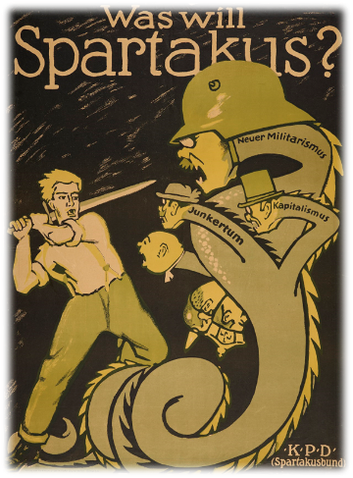

Spartacus in Soviet classical reception in the 1920s and 1930s. He appears to be a key figure in sport and in artistic activities, such as ballet.
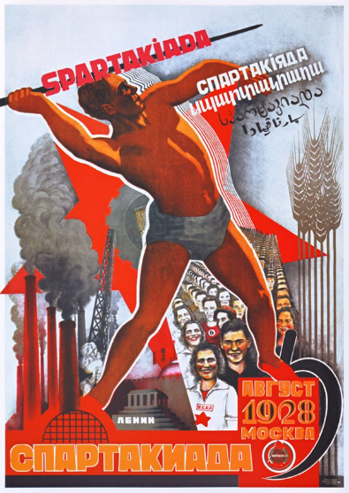
A poster linked to the first Summer Spartakiad held in August 1928 in Moscow (an initial Winter Spartakiad took place in February 1928 in Oslo). The Spartakiad competitions took place between 1928-1937.

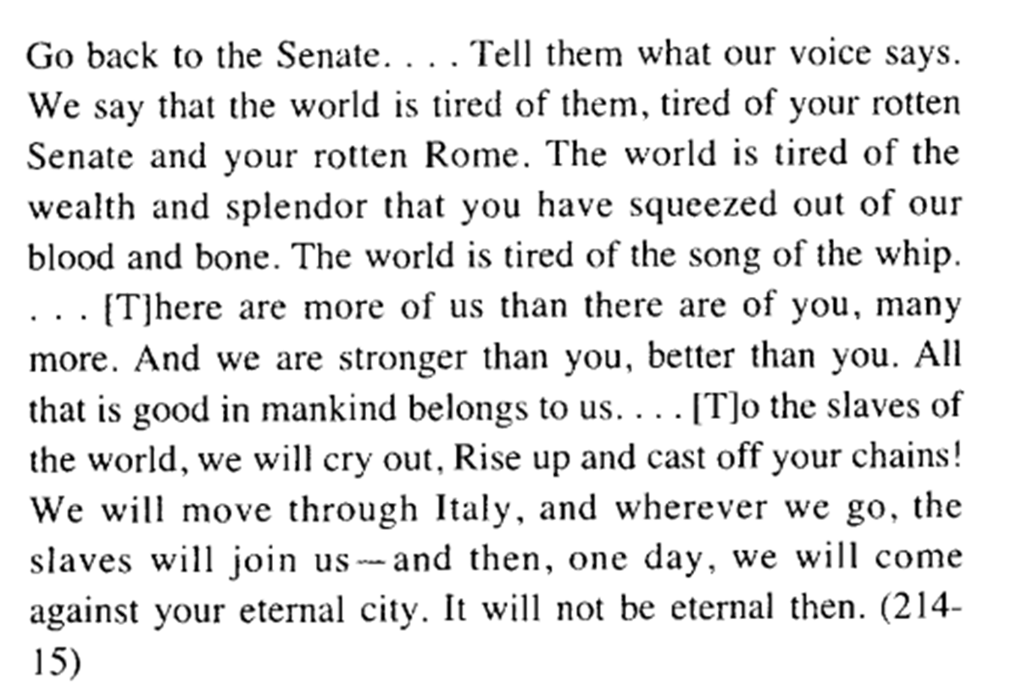
A section of Howard Fast’s novel Spartacus (published in 1951). Howard Fast was a noted American communist.

Questions: Why does Spartacus seem to be singled out as a uniquely distinctive figure by early communist thinkers and revolutionaries? More specifically, why do you think that Spartacus was picked out as a figure to associate with Sportsmanship in the Soviet Union?

Spartacus as a (sanitised) freedom fighter
The 1960 film Spartacus stars Kirk Douglas and was directed by Stanley Kubrick. One of the more critically acclaimed “swords and sandals” films (although Stanley Kubrick seems to make a dig at his own movie in the first scene his subsequent film Lolita released in 1962). It draws somewhat on our surviving ancient sources but is also heavily based on the novel Spartacus by Howard Fast, with the screenplay being developed by Dalton Trumbo [Trumbo, like Fast, was a known communist who got caught up in the Macarthy era “Red Scare”].

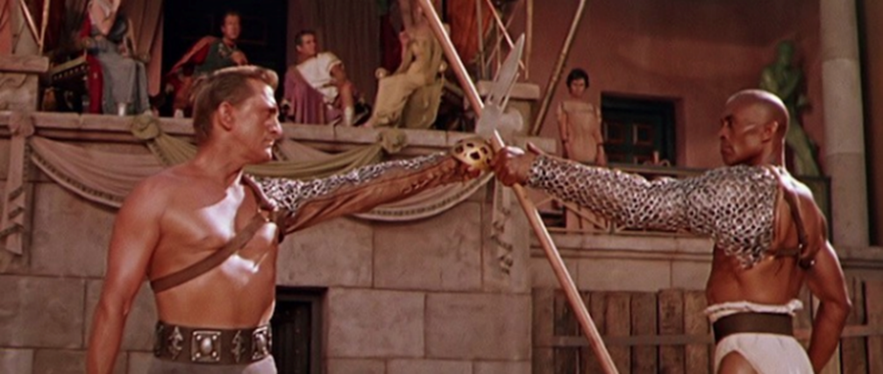
Spartacus and Draba (played by the actor Woody Strode) about to fight in Capua gladiator school – however, despite winning, Draba refuses to kill Spartacus and instead hurls his weapon at the watching Romans.

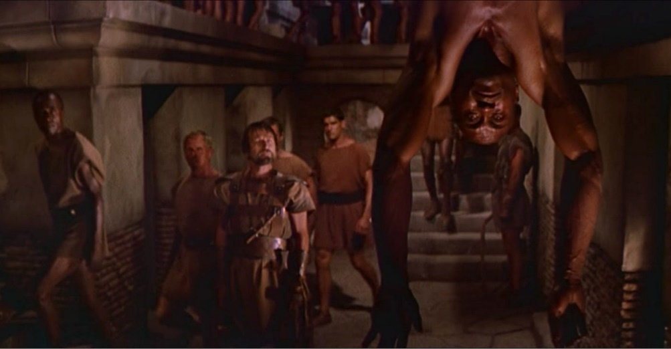
The punishment of Draba for his defiance (for social resonance consider Billie Holiday’s song Strange Fruit)

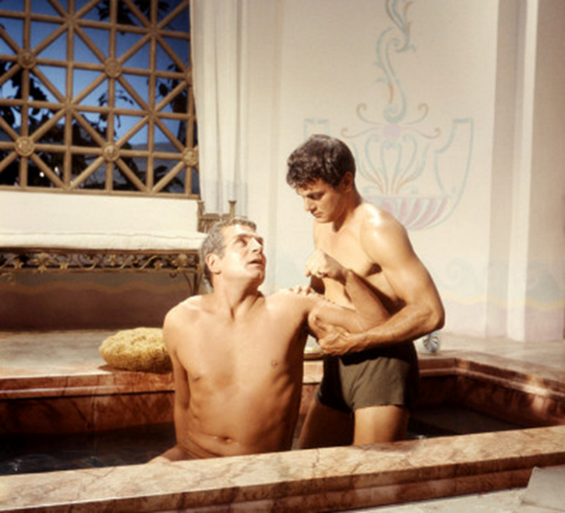
The snails and oysters scene in which Crassus asks the slave Antoninus the following:
Crassus: Do you eat oysters?
Antoninus: When I have them, master.
Crassus: Do you eat snails?
Antoninus: No, master.
Crassus: Do you consider the eating of oysters to be moral and the eating of snails to be immoral?
Antoninus: No, master.
Crassus: Of course not. It is all a matter of taste, isn’t it?
Antoninus: Yes, master.
Crassus: And taste is not the same as appetite, and therefore not a question of morals.
Antoninus: It could be argued so, master.
Crassus: My robe, Antoninus. My taste includes both snails and oysters.

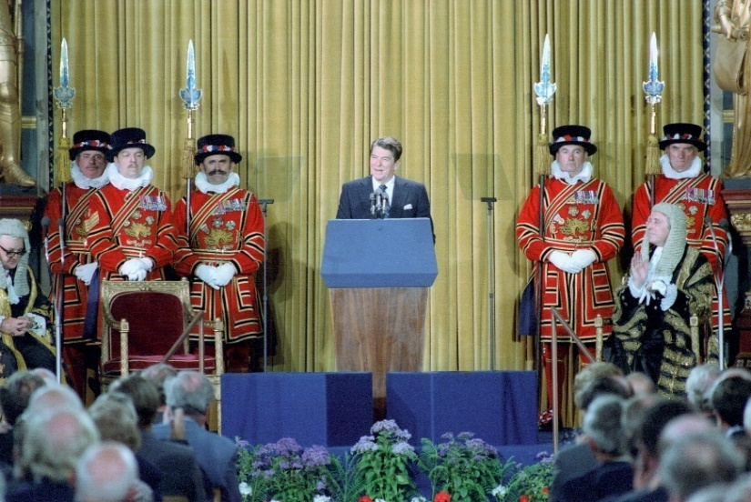
Ronald Reagan’s address to the British Parliament (8th June 1982)
“The hard evidence of totalitarian rule has caused in mankind an uprising of the intellect and will. Whether it is the growth of the new schools of economics in America or England or the appearance of the so-called new philosophers in France, there is one unifying thread running through the intellectual work of these groups -- rejection of the arbitrary power of the state, the refusal to subordinate the rights of the individual to the superstate, the realization that collectivism stifles all the best human impulses. Since the exodus from Egypt, historians have written of those who sacrificed and struggled for freedom -- the stand at Thermopylae, the revolt of Spartacus, the storming of the Bastille, the Warsaw uprising in World War II…”

Questions: What allusions to social issues and tensions can you observe in the 1960s Spartacus movie? If you have seen the movie, does it seem overtly communist or more populist [compared in particular to the tone of Fast’s novel]? Why might Regan have chosen to use Spartacus as one of his examples of opposition to ‘totalitarian rule’?

