Database Analysis and Design
Introduction to Web and Database Concepts – ACCA4023
Joshua James Harries – 2021807 – 5TH MAY 2021

Contents
Introduction 2
Entity Relationship Diagram 2
Context Diagram 2
Data Flow Diagram 3
Access Tables 4
Customer 4
Orders 5
Products 5
Staff 6
Stores 6
Access Forms 6
Main Menu 6
Customer 7
Orders 8
Products 8
Staff 9
Stores 9
Access Macro 9
Access Report 10
Access Querys 11
List All Customers 11
Incomplete Orders 11
Conclusion 12
References 12

Introduction
In this document, I will be looking at the access database I designed and developed for Celtic Caterers, as part of the assignment brief.
I would like to state for transparency that I had to use the referenced YouTube video for support in creating my ERD, as I really struggled with this aspect of the assignment. [1]

Entity Relationship Diagram
Screenshot of ERD in Visio below.
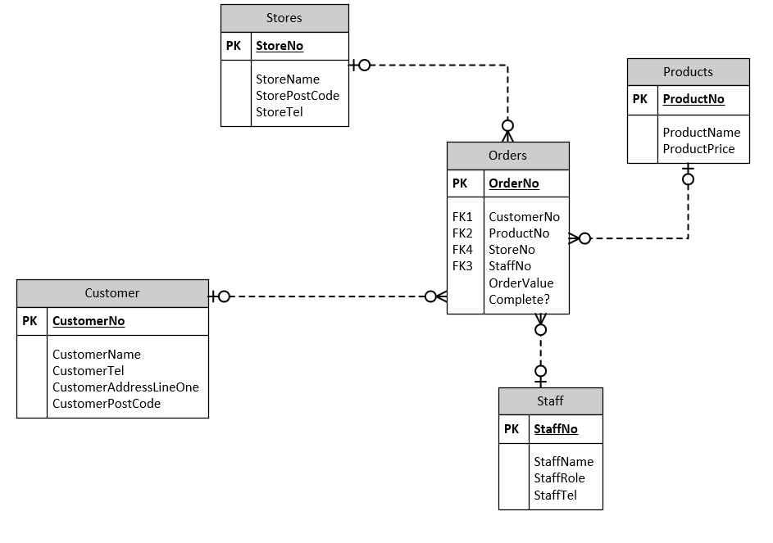

Context Diagram
Screenshot of Context Diagram in Visio below.

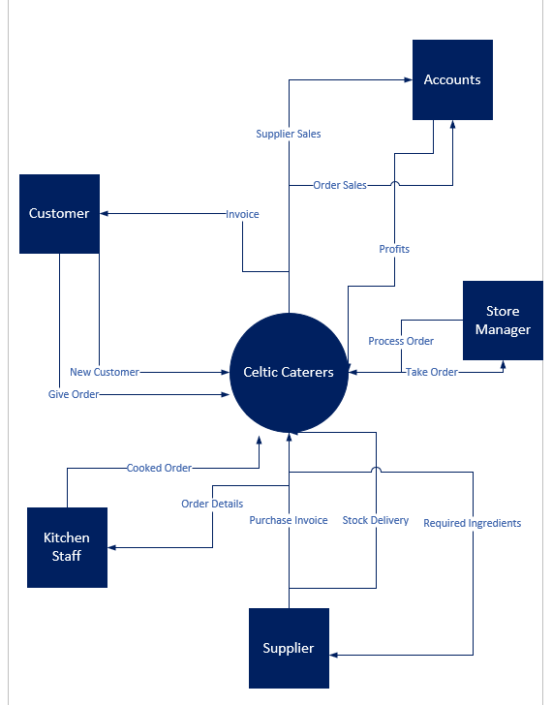

Data Flow Diagram
Screenshot of DFD in Visio below.

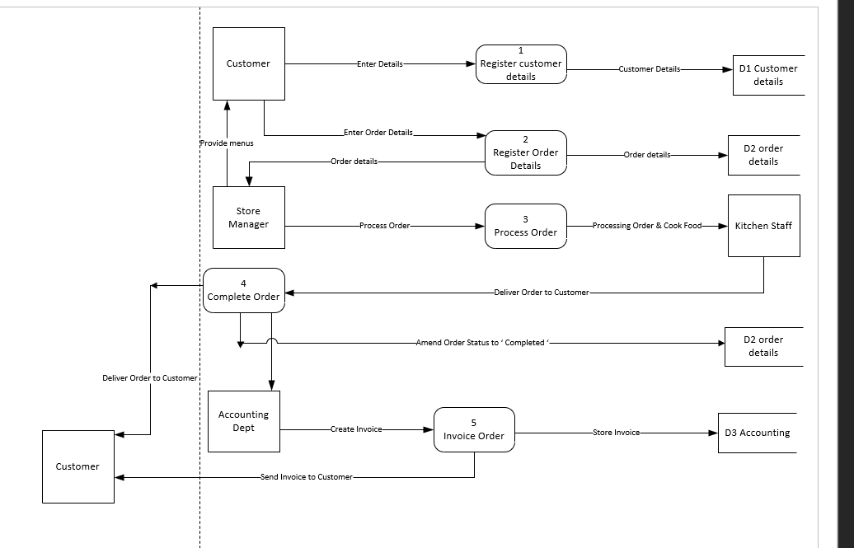

Access Tables

Customer
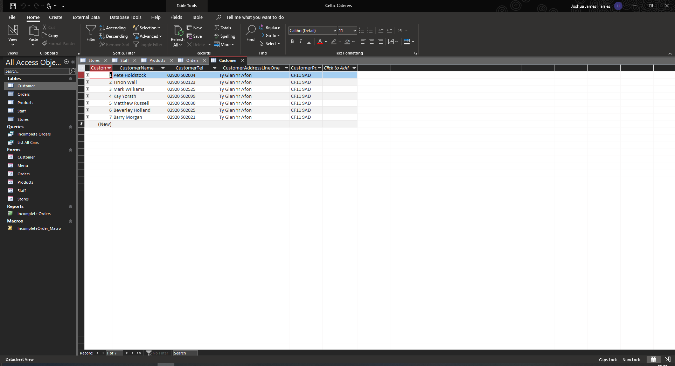

Orders
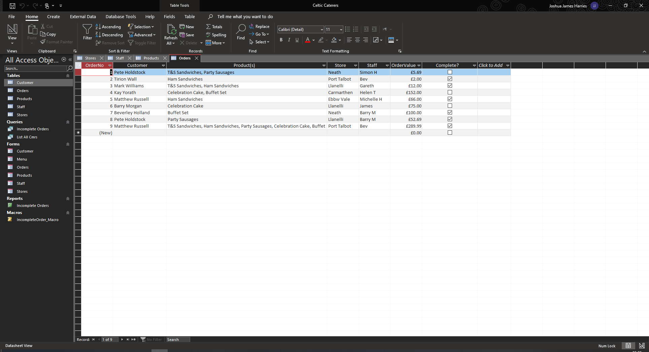

Products
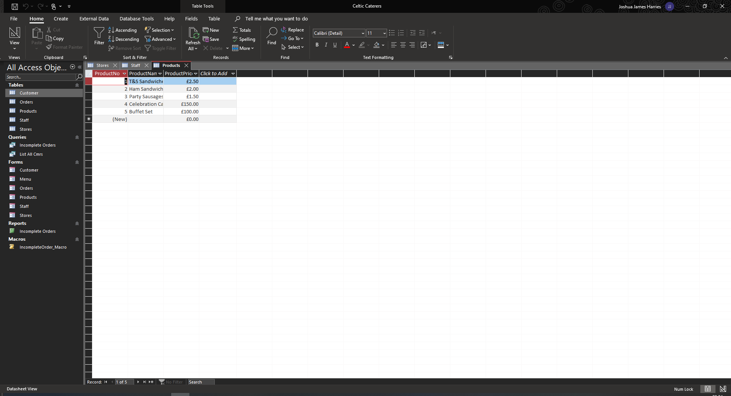

Staff
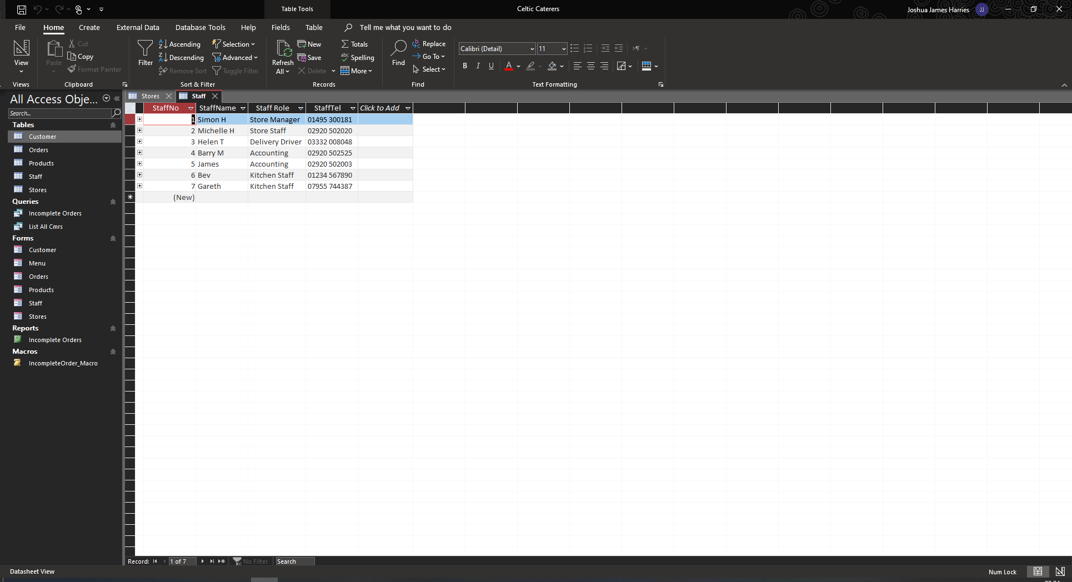

Stores
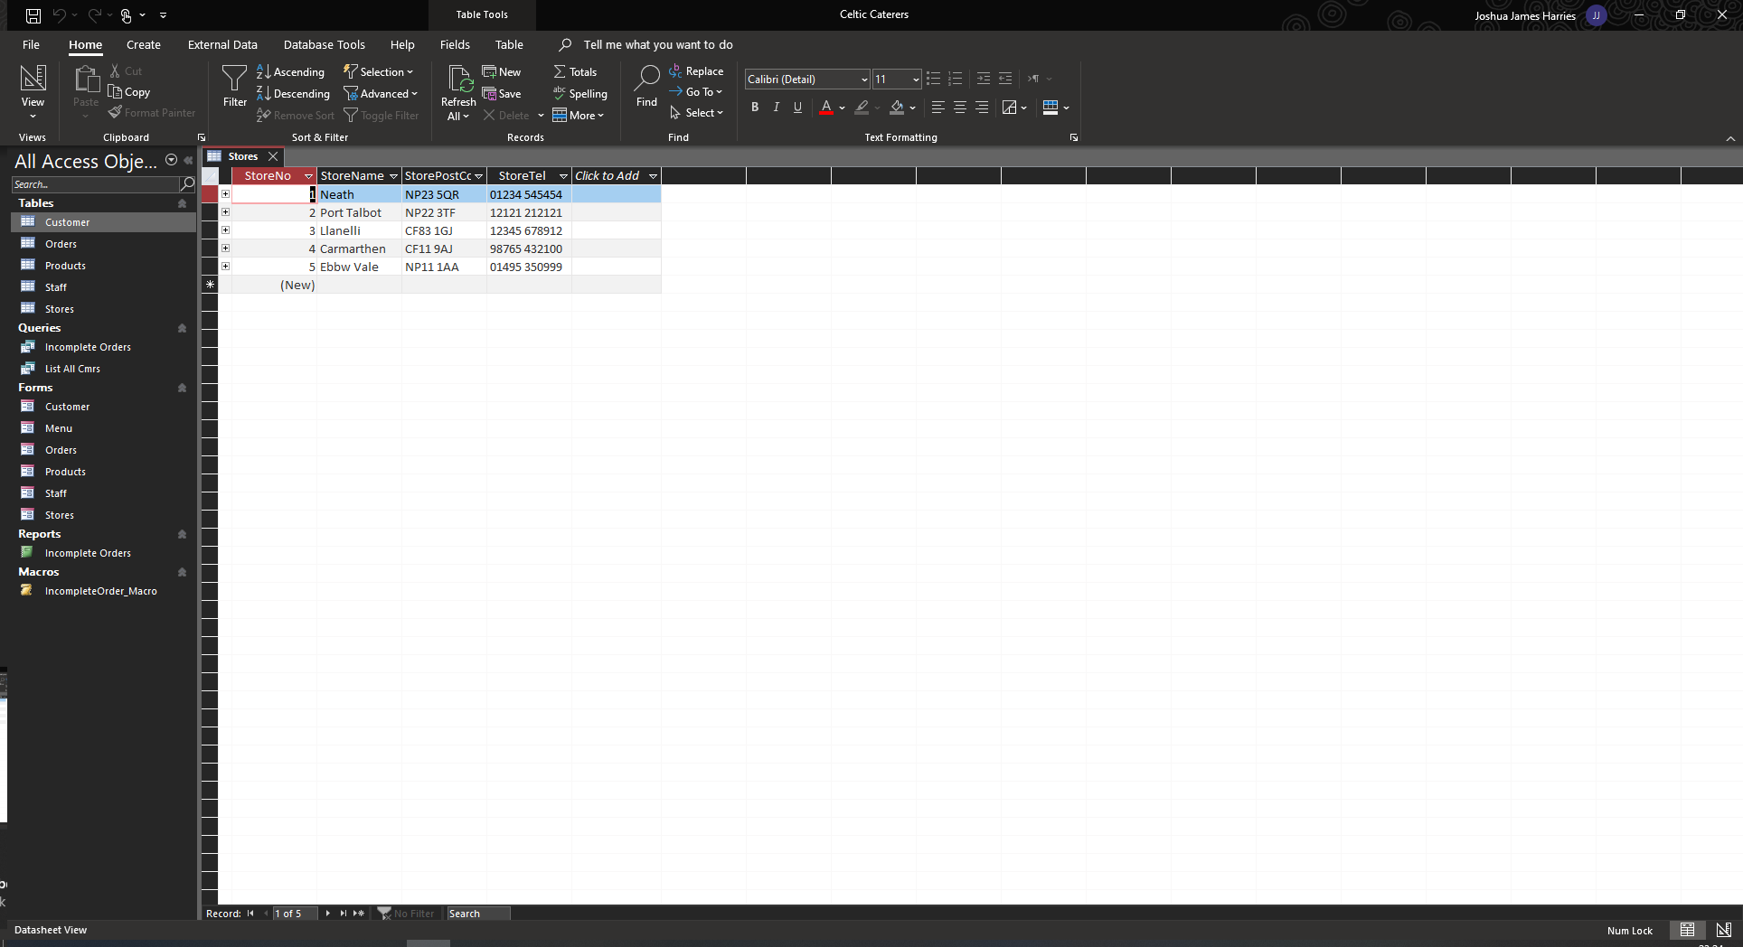

Access Forms
All forms have buttons that allow to create a new record, search for a record, print the record, and to exit to main menu. The records can be navigated via the buttons or the search function, and they can be edited. This would be the main inputs for the users.

Main Menu
The end users will be greeted with this menu upon start-up so that they can navigate the forms that are accessible to the,
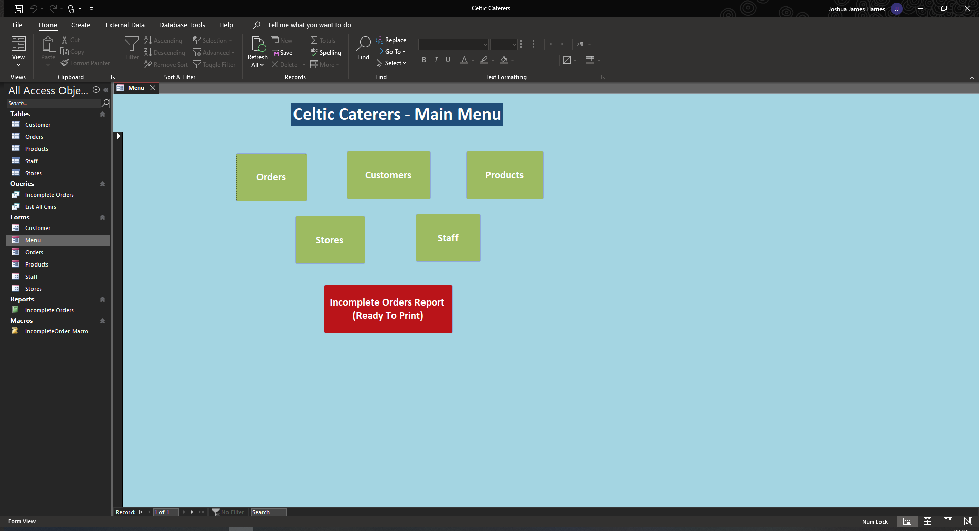

Customer
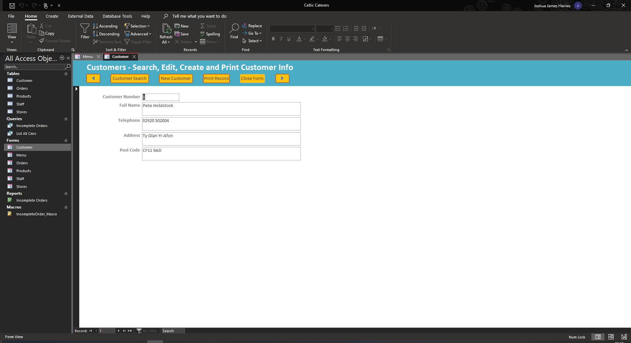

Orders
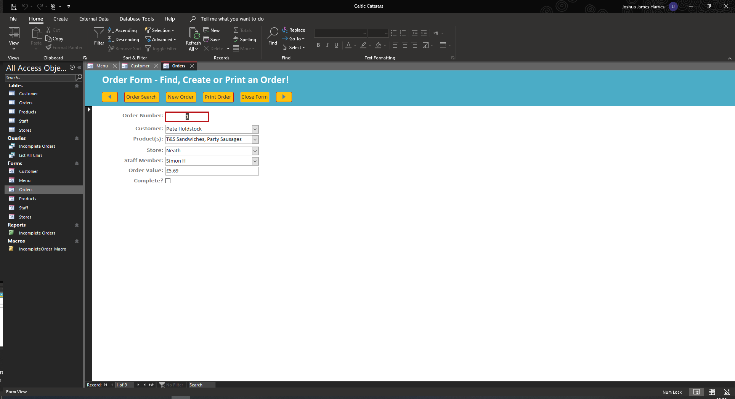

Products
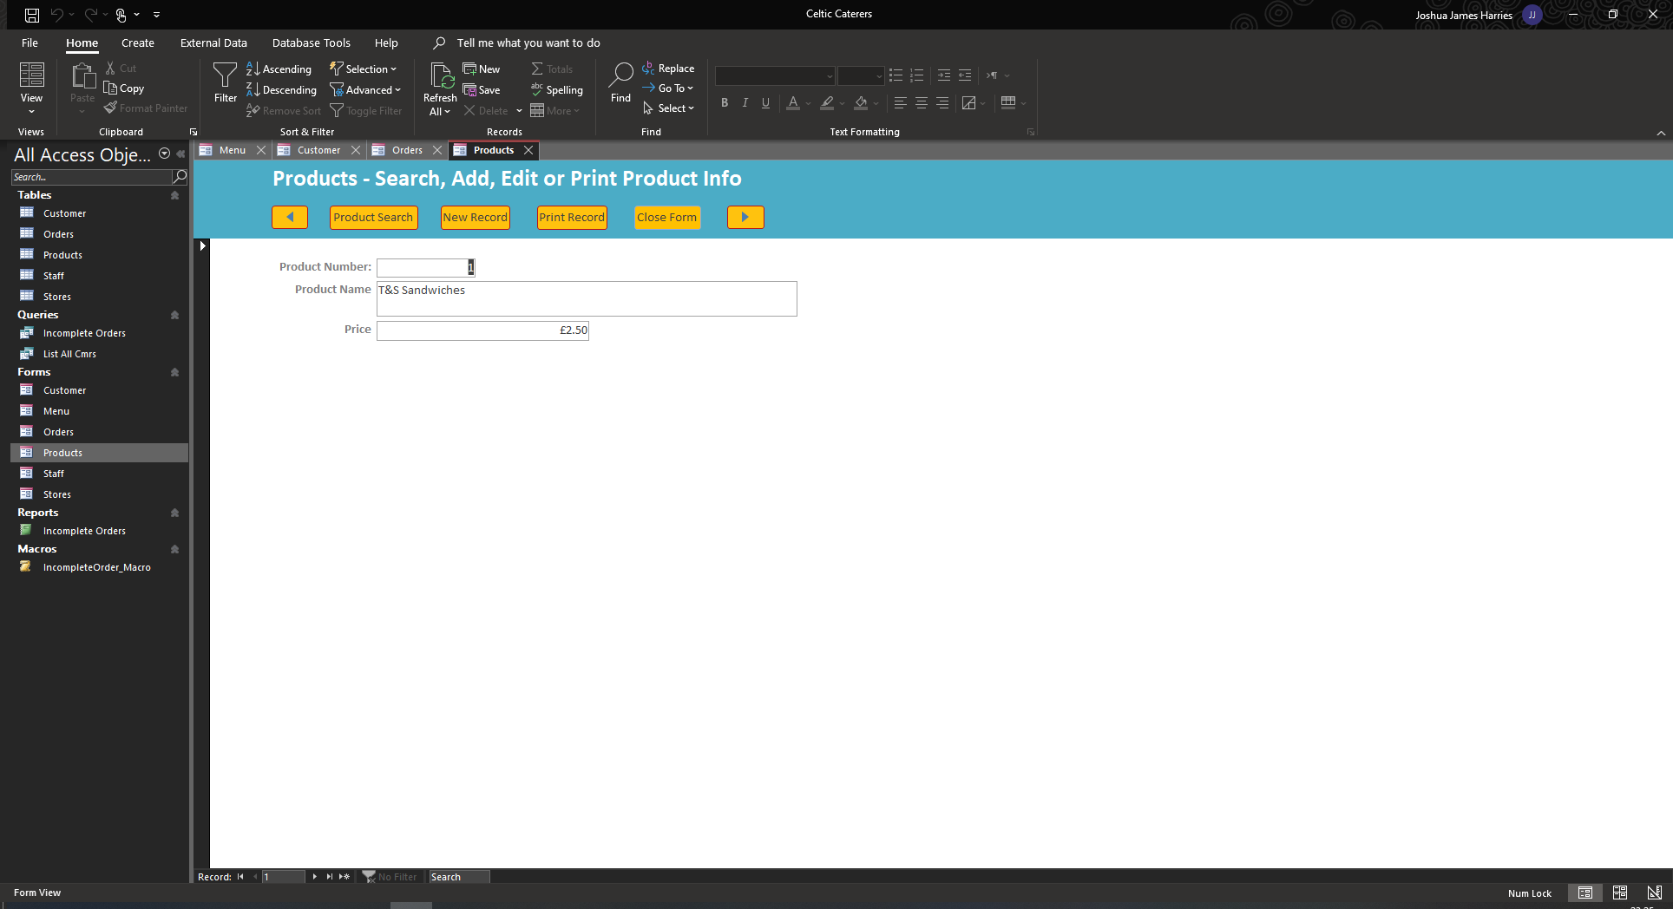

Staff
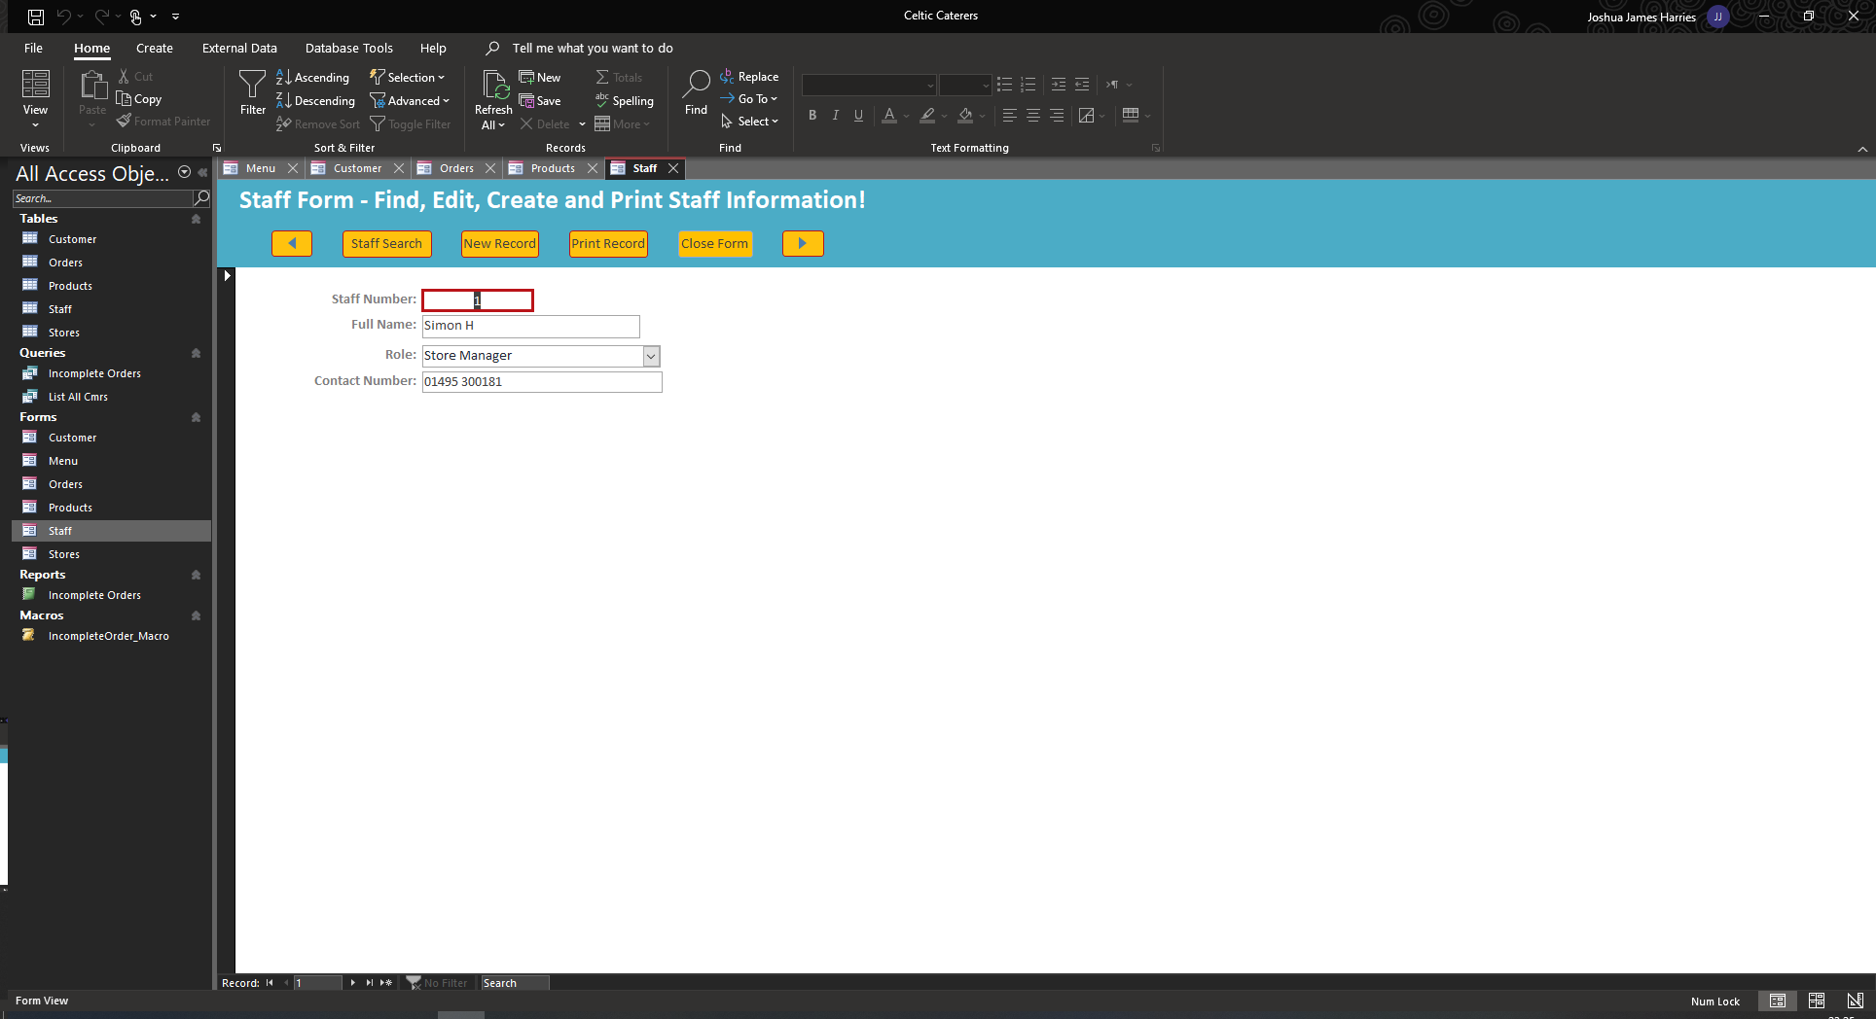

Stores
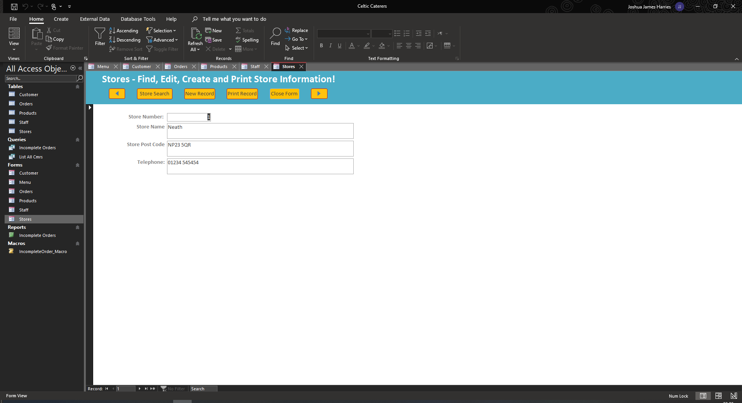

Access Macro
Screenshot of Macro in design view below – this creates a print preview of the Incomplete Orders Query and Report
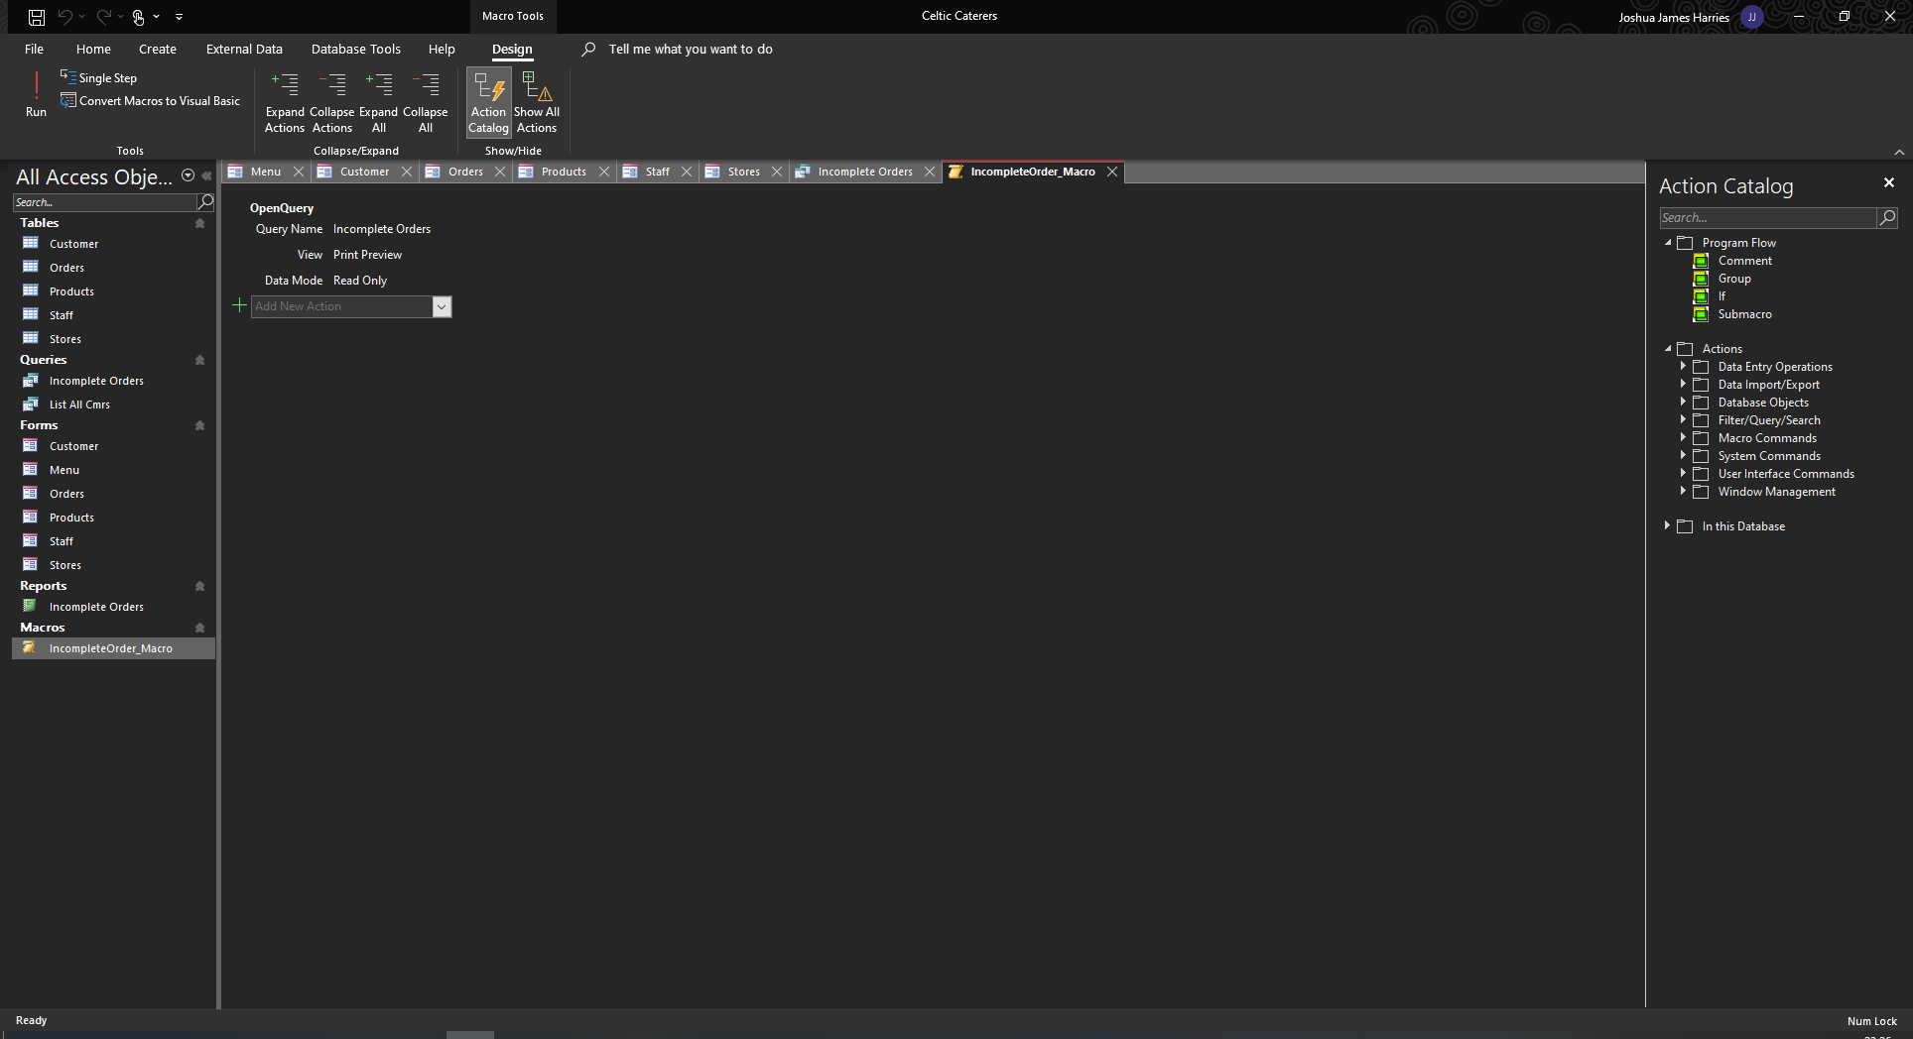

Access Report
Report to see any orders that have not been ticked as Completed.
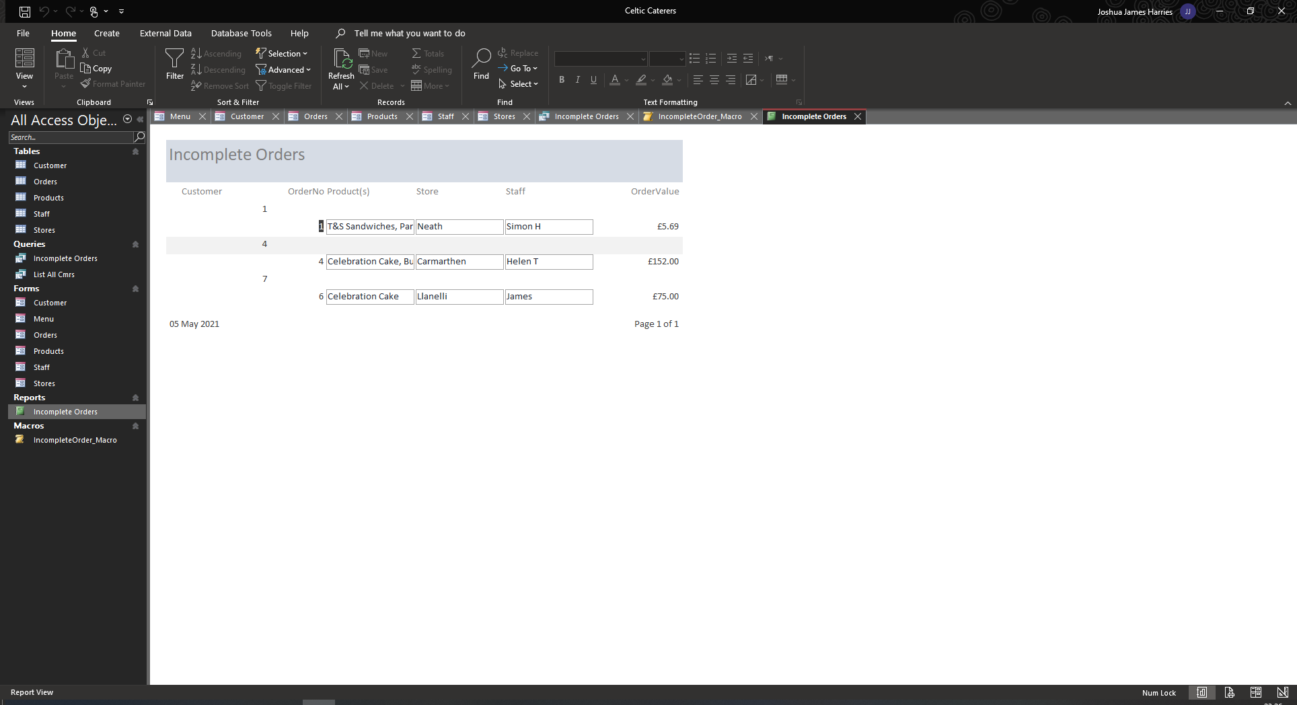

Access Querys

List All Customers
Design View: 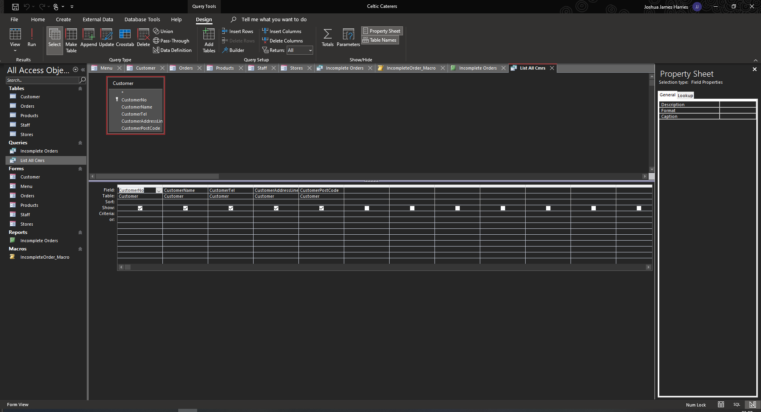
After Running:
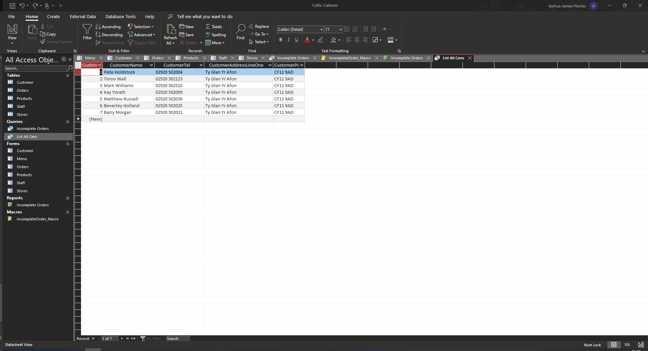

Incomplete Orders
Design View:
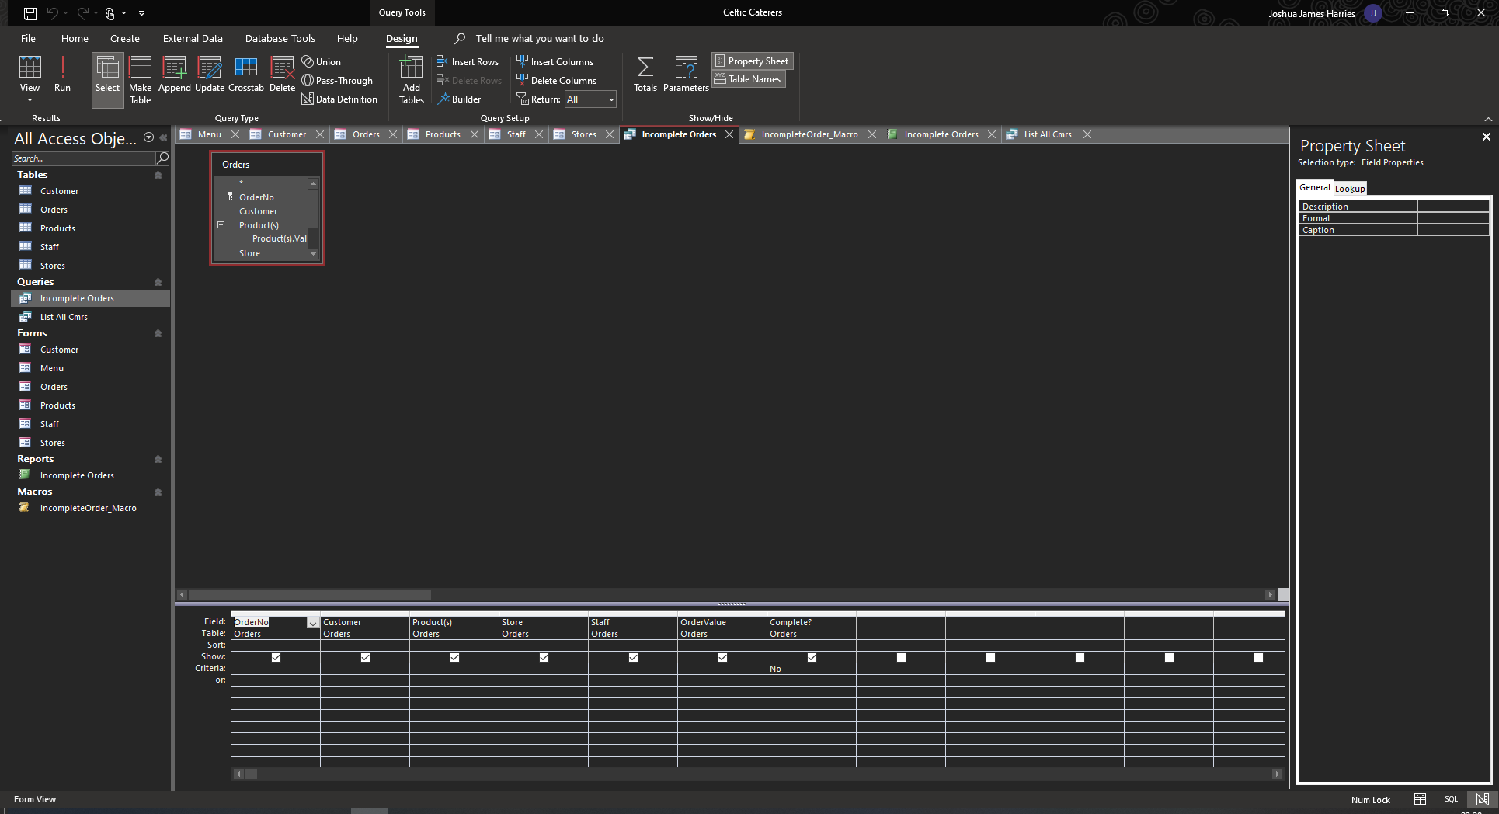
After Running the Query:
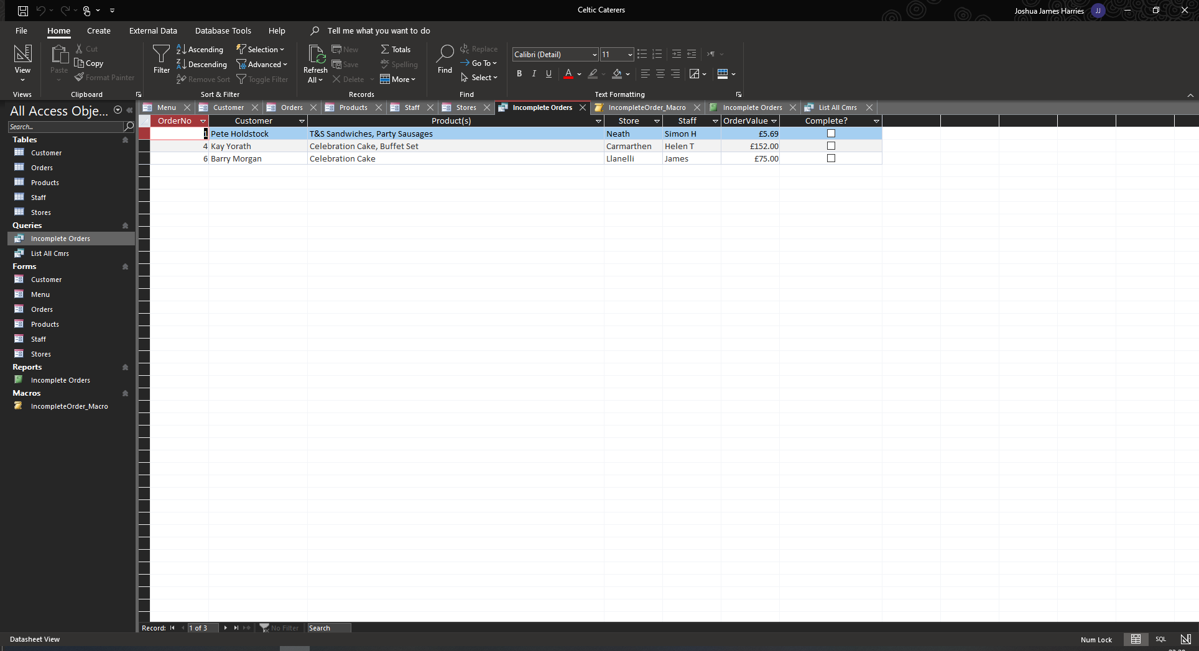

Conclusion
I believe that in the future, with more planning, research and knowledge building, and organisation on my part, I could create an improved database, that would incorporate saving to file and possibly accessible on a webpage. I would also like to have a login function, so that all inputs can be audited via management.

References

[1] | LucidChart, “Entity Relationship Diagram (ERD) Tutorial - Part 1,” 2017.

