

Report on Stroke:

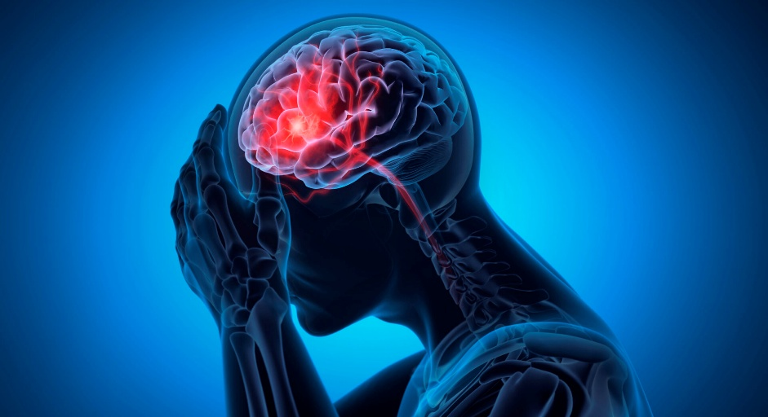

Annam rahman
2213992
LCHS4008 Component 2
Introduction to Public Health
Lecturer: Debra Odeh

Contents
Introduction: 3
What are the different approaches used to measure and monitor these diseases? 3
Explain how this disease is controlled? 4
What are the consequences of this illness on people in the community? 5
What health and social care support services are required to meet the needs of individuals affected by this condition within the community? 5
Conclusion: 6
References: 7

Introduction:
Dementia is a progressive neurological condition characterised by a decline in cognitive functioning beyond what might be expected from normal ageing. It affects memory, thinking, behaviour and the ability to perform everyday activities, significantly impacting on an individual’s independence and the quality of their life. Dementia is not a single disease but an umbrella term encompassing several conditions, including Alzheimer’s disease, vascular dementia and dementia with Lewy bodies. Common early symptoms include memory loss, confusion, difficulty in communication, and impaired judgment, which worsen over time. Demetia represents a major global health challenge. According to the World Health Organization (2024), approximately 57 million people were living with dementia worldwide in 2021, with nearly 10 million new cases annually. In the United Kingdom, around one million individuals are currently affected, with projections suggesting this will increase to 1.4 million by 2040 (Alzheimer’s Society 2024). These statics demonstrate the severity and the growing impact of dementia on health system, economics, and communities worldwide.

What are the different approaches used to measure and monitor these diseases?

A range of approaches are used to measure and monitor dementia, combining clinical, cognitive and technological methods. Cognitive assessment tools remain central to diagnosis and ongoing evaluation. Commonly used tools include the mini-mental state examination (MMSE) and the Montreal Cognitive Assessment
(MoCA), which assess domains such as memory, attention, language, and executive functioning. These standardised tests allow healthcare professionals to establish a baseline and monitor disease progression over time. However, their reliability can be influenced by factors such as education level, language, and cultural background highlighting the importance of using them alongside other diagnostic methods (Hsieh et al., 2022).

Neuroimaging techniques provide future insights into the biological basis of dementia. Magnetic Resonance Imaging (MRI) scans are used to detect structural changes in the brain, such as atrophy in regions associated with memory while positron emission tomography (PET) scans can identify abnormal protein deposit including amyloid plaques and tau tangles linked to Alzheimer’s diseases. These imaging methods improve diagnostics accuracy and enable earlier detection, which is crucial for effective management (Li et al.,2025).
In recent years, digital technologies have emerged as innovation tools for monitoring dementia. Digital Biomarkers, including speech analysis, handwriting patterns, and movement tracking, can detect subtle cognitive changes that may not be identified through traditional assessments. Wearable devices and smart home systems also enable continuous monitoring of daily activities, providing real-time data on changes in behaviour and functioning. These approaches enhance early detection and support independent living, although ethical considerations such as privacy and data security must be addressed (Yamada et al.,2022).

At a population level, dementia is monitored through epidemiological studies and national health database. In the UK, data collected through primary care record and public health initiatives help track prevalence, diagnosis rates, and service use. This information is essential for planning healthcare services and allocating resources effectively.

Explain how this disease is controlled?
Although there is currently no cure for dementia, various strategies are used to control symptoms and slow disease progression, Pharmacological treatments are commonly prescribed, particularly for Alzheimer’s disease. Cholinesterase inhibitors, such as donepezil, and NMDA receptor antagonist, such as memantine, can help improve the cognitive function and manage symptoms. However, these treatments offer only temporary benefits and do not prevent the underlying neurodegeneration (National institute for Health and Care Research,2022).
Non-pharmacological intervention plays a crucial role in dementia management are increasingly emphasised in care strategies. Cognitive stimulation therapy (CST) is widely used and has been shown to improve cognitive function and the quality of life. Physical activity is beneficial, as it promotes cardiovascular health and may reduce the rate of cognitive decline. Additionally, social engagement and meaningful activities are essential in maintaining mental wellbeing and reducing feeling of isolation.
Preventative approaches are also important in addressing dementia. Research suggests that up to 40% of dementia cases may be preventable by modifying risk factors such as smoking, physical inactivity, poor diet, and social isolation (Livington et al., 2023). Managing conditions such as hypertension, diabetes, and obesity can also reduce the risk of developing dementia. These findings highlight the importance of public health intervention aimed at prompting healthy lifestyles across the lifespan.
At a policy level, national Demetia strategies have been implemented to improve diagnosis, care, and support. In the UK, these strategies focus on increasingly awareness, reducing stigma, and ensuring access to high quality, person- centred care. Integrated care models are increasingly promoted, recognising the need for collaboration between health and social care services.

What are the consequences of this illness on people in the community?
Dementia has significant consequences for individuals, affecting both physical and mental health. As the condition progresses, individuals experience a gradual loss of independence, require increasing level of support with daily activities such as dressing, eating, and personal hygiene. Cognitive decline are often accompanied by behavioural and psychological symptoms, including anxiety, depression, aggression, and hallucinations, which can further reduce quality of life.
The impact of dementia extends beyond the individuals to families and caregivers. Many individuals rely on informal care provided by relatives, which can be physically, emotionally, and financially demanding. Caregivers often experience a high number of stress and burnout, particularly as the condition progresses and care needs become more complex. The emotional burden of witnessing a loved one’s cognitive decline can also have long-term psychological effects.
At a community level, dementia contributes to social isolation and stigma. Misunderstanding and lack of awareness about the condition can lead to discrimination and exclusion, preventing individuals from participating fully in society. Dementia friendly initiatives aim to address these challenges by prompting conclusion and improving the public understanding.

The economic impact of dementia is substantial. In the UK, dementia costs are estimated at over £40 billion annually, with a considerable proportion attribute to unpaid care provided by families (Alzheimer’s Society, (2024). This places considerable strain on both households and public services. Globally, the economic burden are expected to increase significantly as the population ages, highlighting the urgent need for sustainable care solutions.

What health and social care support services are required to meet the needs of individuals affected by this condition within the community?

A comprehensive range of health and social care service are required to meet the needs of individuals living with dementia. Primary care services play a key role in the early identification and ongoing management. General
Practitioners (GPs) are often the first point of contact and are responsible for recognising symptoms, providing initial assessments, and referring individuals to specialist services. Early diagnosis is essential, as it enables access to treatments, support, and future care planning. Specialists’ services, such as a memory clinic, neurologists and geriactions, provide detailed assessments and develop personalised care plans.
These services often involve multitenancy teams, including psychologists, nurses, and social workers, ensuring a comprehensive approach to care.
Community based services are essential in supporting individuals to remain in their own homes for as long as possible. These include home care services, day centres, and support groups, which provide social interactions and practical assessments. Assistive technologies, such as telecare systems and medication reminders can enhance safety and independence.
Social care services address the broader needs pf individuals with dementia, including personal care, safeguarding and housing support. The respite care services are particularly important and providing temporary relief for caregivers and helping prevent the burnouts, In addition, voluntary organisation plays a vital role in providing information, advocacy, and emotional support.
Integrated care is widely recognised as best practice in dementia carte. By coordinating services across health and care services, integrated approach ensures continuity of care and improves outcomes. Furthermore, the development of dementia friendly communities aims to create supportive environment that enables individuals to live well with dementia.

Conclusion:
In conclusion, dementia is a complex and progressive condition that poses significant challenges for individuals, families, and healthcare systems worldwide, with rising prevalence in both the Uk and globally, it represents a major public health concern requiring urgent attention. Advances in measurements and monitoring, including cognitive assessments and neuroimaging, have improved early diagnosis and management. However, the absence of a cure highlights the importance of prevention and supportive care. The consequences of dementia extend beyond the individuals, affecting caregivers, communities and economics. Effective health and social care services, including early diagnosis, community support, and integrated care, are essential to meet the needs of those affected. Continued research, policy development, and public awareness are crucial in addressing the growing burden of dementia and improving quality of life for the individual’s living with the conditions.

References:

Alzheimer’s Society (2024) Dementia UK: update report.
Hsieh, W.T., et al. (2022) ‘Cognitive assessment a d Alzheimer’s diseases classification’, Journal of Medical Systems, 46(11), pp.1-50.
Livingston, G., et al, (2023) ‘dementia prevention, intervention, and caew: 2023 report; The Lancet, 402(10402), pp.1-50.
Li, Y., et al. (2025) ‘Advances in neuroimaging for dementia diagnosis; Neuroimage, 290, pp. 120-135.
National Institute for Health and Care Research (NIHR) (2022) Dementia Overview of treatment and care.
World Health Organization (2024) Dementia fact sheet.
Yamada, Y. et al. (20220 ‘Digital biomarkers for early detection of dementia; npj Digital Medicine,5 (1), pp.1-9.

