Research Project

Assignment Title: Apply the principles and practices of Data security,
Governance and Compliance based on a given scenario.

Student name: Ben Wang
Student ID number: 2106352
Lecturer: Assoc. Prof. Carlene Campbell
Submission date: 05/01/2022
University/Programme: University of Wales Trinity Saint David/Computer Networks and Cyber Security
Word count: 3000

1 Security Framework Research
With the development of the Internet, information has become an important asset of enterprises. Once the information security of enterprises has been corrupted, such as customer data leakage, system downtime, data deletion, etc. They will bring huge losses to enterprises. [1] mentioned that information security within an organization is an essential measure, especially in the context of increasing data transmission within and between companies.
Based on the need for learning security framework and model, I studied ISO/IEC 27001[2], COBIT[3], and NIST[4].

ISO/IEC 27001
ISO/IEC 27001 information security management system, published in 2005, is a management framework, which is established, implemented, operated, monitored, reviewed, maintained, and improved by an organization that aims to protect information assets and achieve its business objectives[5].
As a representational information security management system standard in the world, ISO/ IEC 27001 gains recognition from more and more countries. The standard consists of 14 chapters[2] which are as explained in Figure 1.
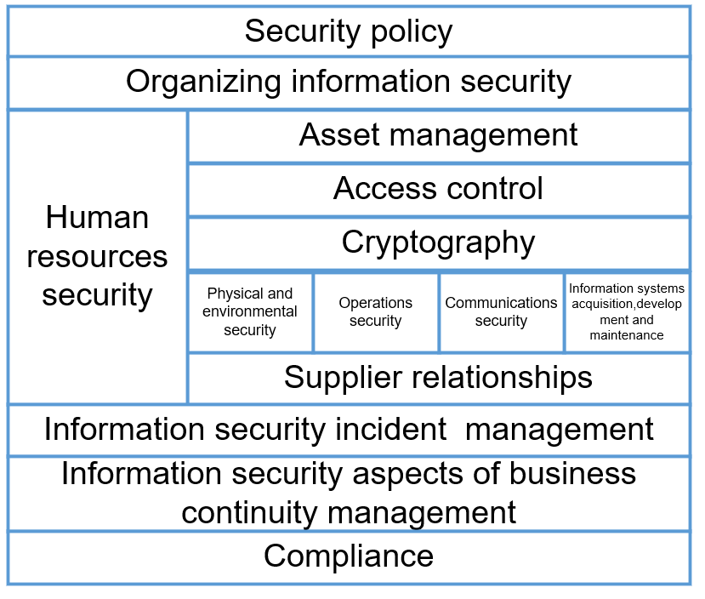
Figure 1 ISO/IEC27001 clauses
As shown in Figure 1,The content of ISO/IEC 27001 clauses is as follows: Security policy, Organizing information security, Human resources security, Asset management, Access control, Cryptography, Physical and environmental security, Operations security, Communications security, Information systems acquisition,development and maintenance, Supplier relationships, Information security incident management, Information security aspects of business continuity management, Compliance.
The standard adopts the PDCA process method[6] shown in Figure 2 and the risk management concept of risk assessment to comprehensively and systematically continuously improve the organization's information security management.
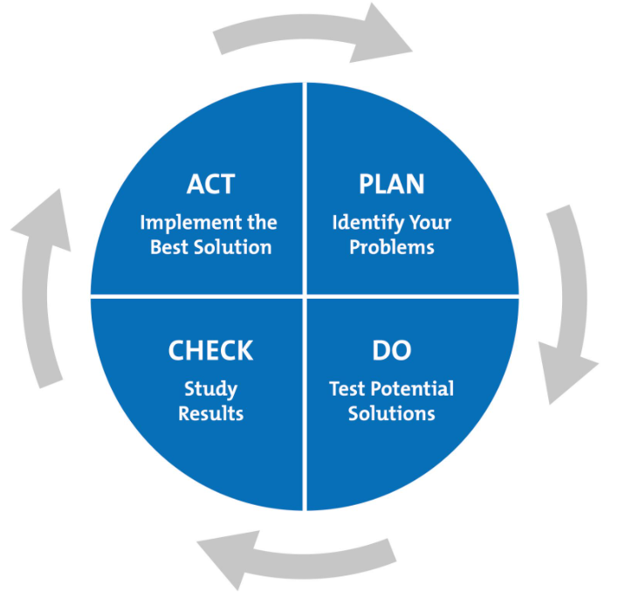
Figure 2 PDCA process
Plan: Based on the information security situation survey and diagnosis, set the distribution scope of isms and established policies, plan systematic risk assessment policies, develop asset identification and asset risk assessment methods, adapt risk response methods, define the basic measures for access control and output a Statement of Reasonable Applicability (SOA).
Do: according to the plan, start to build the security information management mode, implement its specific selected access control scheme from different angles, and carry out training for resource access, human resource scheduling, and other specific contents.
Check: monitor and evaluate the risks of each part according to the implemented information security system, and count the risk causes and risk data for the weak parts; In addition to self-inspection, invite a third party for evaluation; At the same time, whether the new retrieval system is enough to make up for the loopholes in the past and include this part of new information; Different assessment methods are required for different risks. Large risks must be avoided, and small and medium-sized risks need to be able to roll back, record, and report all activities and events;
Act: obtain the opinions of relevant personnel according to the measured data, evaluation results, and risk loopholes. In order to avoid major errors, improve these problems and ensure the continuous operation of the system.
It is widely recognized that as long as the process of ISO 27001 is correct, the built security barrier will be very firm. However, there is research[7] shows that the establishment process is too long and requires a particularly high time cost and economic cost, so those small and medium-sized enterprises can not bear this burden. Moreover, when the system was first established, the security information of the whole enterprise was in a chaotic state, which is very dangerous.
In view of the implementation of non-profit institutions, schools, small and medium-sized enterprises and large enterprises in various fields of ISO 27001, literature[8] make a gap analysis on the above four types of institutions by using the case study research methodology and comes to the conclusion that in the case, no institution can get ISO 27001 certification, among which educational institutions are the most in line with ISO 27001 standard, Followed by enterprises, small and medium-sized enterprises, and non-profit enterprises. In the survey, the most concerned organization is a.7 human resource security, while the least concerned is A.15 supplier relationship.

COBIT
Control Objectives for Information and related Technology (COBIT) was developed by the Information Systems Audit and Control Association of America (ISACA) in 1969 and was finally launched in 1996 as a body of knowledge for "IT auditing".
Weill and Ross [9] define IT governance as the designation of decision-making authority and accountability frameworks to encourage desirable behaviour in the use of IT. It is important to note that IT governance is quite different from IT management, which focuses on exactly how to use IT systems to improve company efficiency. In contrast, governance stands at a higher level and is geared towards the decision makers in IT and how they are held accountable when mistakes are made. Providing IT governance capabilities is essential if an effective management system is to be able to optimise bureaucracy and obstacles and increase the awareness of decision makers, which is the role of COBIT in IT governance.
While the original audience for COBIT was primarily management, its application has now shifted to serve as an audit framework for IT controls[10]. It is a tool that can be used to help companies balance IT risk and control of assets[11].
COBIT is a core model of IT governance which comprises 34 IT process controls and is divided into four main areas: IT planning and organisation, system acquisition and implementation, delivery and support, and information system operational performance monitoring. COBIT is now internationally renowned as a standard of excellence in IT management and control. In addition, COBIT is based at its core on five principles that are essential for IT governance and for making relevant decisions, as shown in Figure 3.
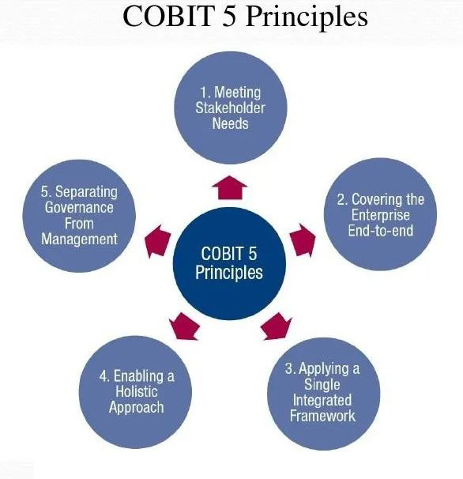
Figure 3 COBIT 5 Principle
The core idea of COBIT is business orientation, and to some extent this can provide some help to users and auditors, but business orientation is really essentially designed for business process managers and directors. More importantly, it allows the business or organisation to determine whether they are sailing in the right direction and to ensure that they do not get sidetracked in the process that follows.
According to the literature [12], the Financial industry and the IT industry have the largest share of all COBIT publications published, and not only that, the Financial sector has the best COBIT implementation results.
The literature [13] shows that the CobiT indicators appear to have a stronger relationship with project management than with individual project perspectives. They reflect an overall view of project management within the organization and therefore fail to recognize that many personal, relational, and contextual factors are important moderators of project management success.

NIST
NIST standards and guidelines support a bottom-up approach to security[16].The framework is risk-based and consists of three main components: the Core, the Implementation Tiers, and the Profiles[4], as shown in Figure 4.
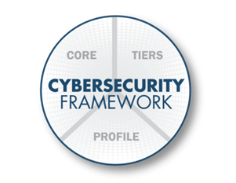
Figure 4 three main components of NIST
The Core of the framework provides a set of required network security activities and results using an easy-to-understand common language. The core guidance organization manages and reduces its network security risks in a way that complements the organization's existing network security and risk management processes.
The Implementation Tiers of the framework help the organization by providing the background of how the organization views network security risk management. Tiers guide organizations to consider the appropriate level of rigor in their cybersecurity plans and are often used as a communication tool to discuss risk preferences, task priorities, and budgets.
The Profiles of the framework are the organization's unique adjustment to its organizational requirements and objectives, risk appetite and resources, and the expected results at the Core of the framework. Profiles are primarily used to identify and prioritize opportunities to improve organizational network security.
IPDRR Security Model, shown as Figure 5, which means Identity - Protect - Detect - Respond - Recover, is a part of NIST. This model is more commonly adopted in day-to-day security construction work. The core of the framework contains four elements: functions, categories, sub-categories, and references, where the functions section is IPDRR, the categories are subdivided into groups of cyber security outcomes that are closely related to planning needs and specific activities, the sub-categories further divide a category into specific technical and/or management activity outcomes, and the references are specific to standards, guidelines, and practices commonly found in the critical infrastructure sector sections that describe the approach to achieving the outcomes associated with each sub-category.
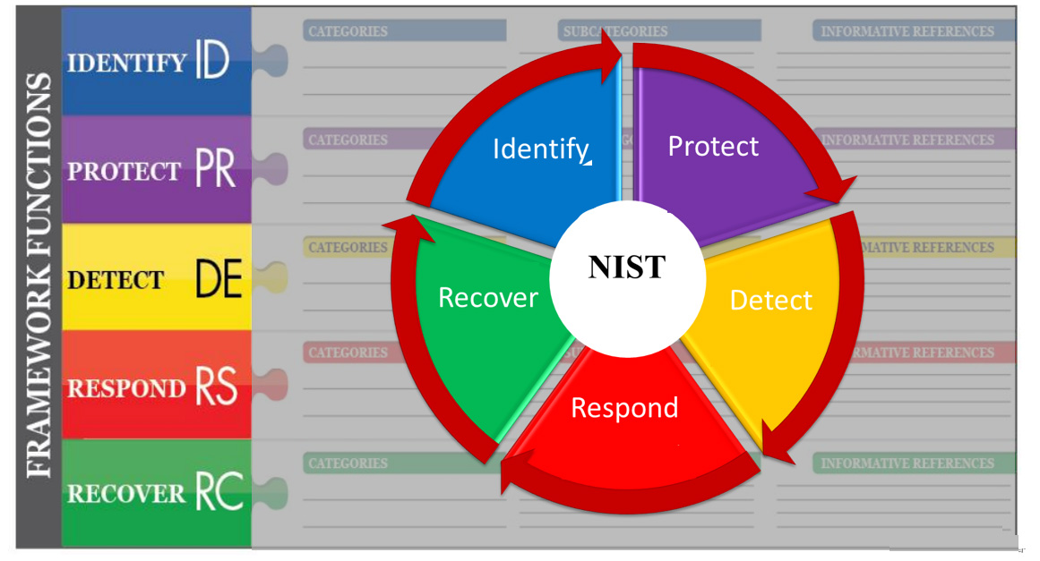
Figure 5 IPDRR Security Model
Based on the NIST framework, [15] evaluated the cyber security posture of a local government organization in Western Australia, received a score of Identify, Protect, Detect, Respond, and Recover for this item. Besides, The literature [14] specifies a Role-Based Access Control reference model based on the NIST standard, a model that provides multiple access control management functions.

2 The Security Model Of CoffeeBlue
CoffeeBlue's main operating item is the sale of Blue Mountain Peak coffee from Jamaica, one of the best and most popular blends in the world. One of the best and most popular blends in the world.
As CoffeeBlue has an extensive global presence, the company uses cloud services to provide its employees and customers with IT services to its employees and customers. It is estimated that nearly 95% of the company's network is wireless-based. At the same time, the company has a large network and social media presence to promote its activities.
Having never built a secure information management system, the company has recently been under enormous pressure in the face of a large workforce, an international customer base, and a complex sales operation. There is enormous pressure to allow its employees and customers to use their devices to access the company's network/resources. The security of personal employee data and customer data is a major concern for the company. The company is also concerned about protecting its intellectual property. The company is also concerned with protecting its intellectual property worth billions of dollars. Therefore, the company needs to build its security model.

2.1 The Overall Flow Of The Security Model
When the security model is under construction, its flow conform to the above-mentioned PDCA process method[17], which is shown in Figure 6.

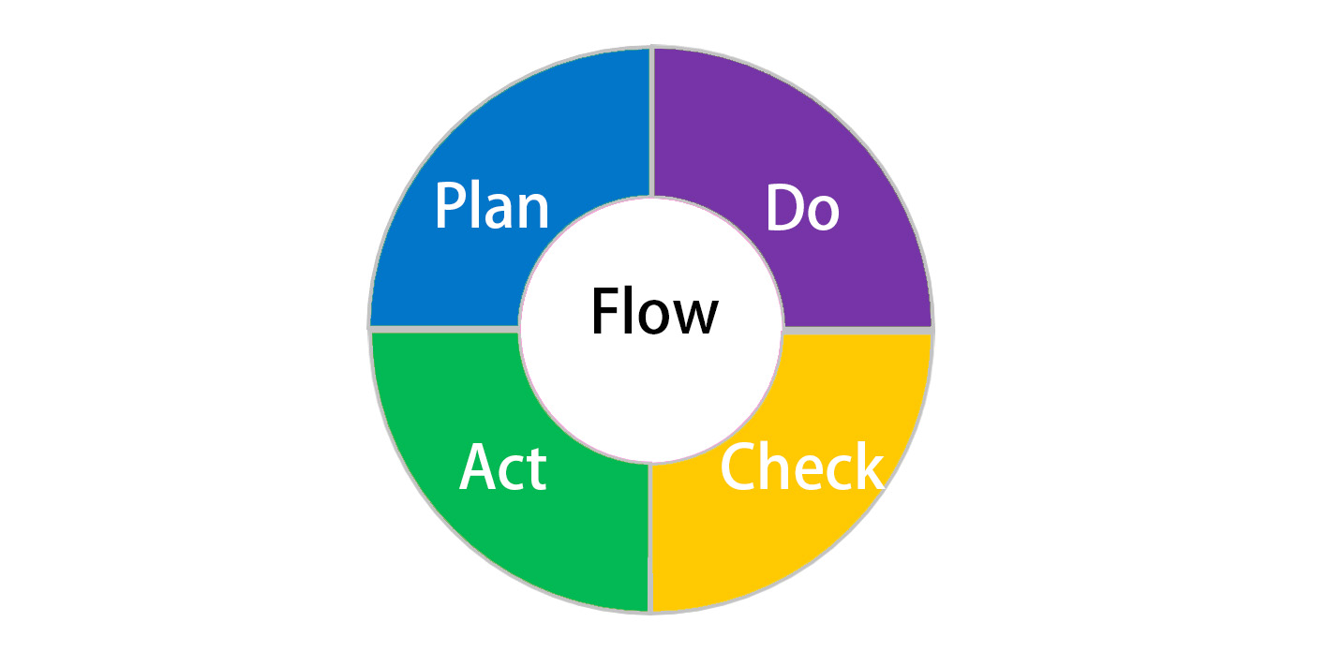
Figure 6 The Overall Flow Of The Security Model
Each module needs to be iterated using the PDCA process method and each iteration has a different objective, but overall the information security management system should be progressive.

2.2 The Stage-based Model Of The Security Model
In this paper, a Stage-based is formed based on CMMI.
CMMI[18], or Capability Maturity Model Integration, was conceived by the US Department of Defense and developed in 1994 in conjunction with the Software Engineering Research Center at Carnegie Mellon University and the National Defense Industrial Association, who planned to integrate all existing implementations and the various capability maturity models to be developed into a single framework.
Since its debut, the objectives that CMMI has achieved have not changed, the first being quality, the second being timelines and the third being to do so at the lowest possible cost. The TSP was also created to support such a system for CMMI. So what exactly is CMMI? It is not a process, nor is it telling you how to do something. If you sum up what CMMI is in one sentence, it is a key element of the processes, a point of integration in many areas. It's a basic structure that can be used to measure your effectiveness and usefulness; to identify such opportunities for continuous improvement, in terms of business objectives, strategy , and risk reduction of the project.
CMMI is a multidisciplinary, extensible collection of products, initially developed with the motivation of using two or more single discipline models to achieve integrated process improvement in an organisation.
CMMI is essentially a part of software management engineering. Software process improvement is a central issue in current software management engineering, and the development of computing over the past 50 years has led to the recognition that software production processes must be improved in order to develop software efficiently, with high quality and at low cost. Model-based process improvement is the use of a capability model to guide an organisation's process improvement, so that its process capabilities can be steadily improved and the organisation can become more mature.
As shown in Figure 7, I have divided The Security Model into three levels, mature, under-complete and unsystematic.
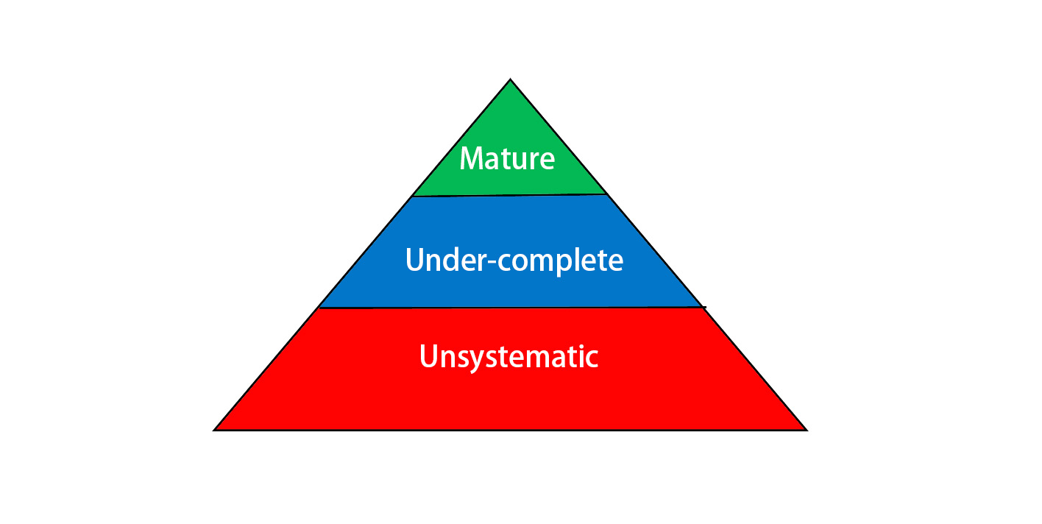
Figure 7 The Stage-based Model Of The Security Model
The unsystematic level means that the system is completely unstructured, with no allocation of permissions or data division, and that users access their own stored information and public resources based on a basic password.
The under-complete level means that the system for each of the existing users implements access control, divides the database, and hierarchies the vast majority of functions. However, for future new users and future new functions, there is no specification for the division, and each time new content enters it requires a special effort to evaluate and detect, which is not easy to manage. For the risk management, the system is able to avoid large information risk incidents, roll back information for small to medium sized incidents and hold perpetrators accountable.For the contingencies planning,when some external factors affect the operation of the system, there are certain hedging measures, for example, in case of fire, the lost data can be reverted by field backup
The under-complete level means that the system has a standardised and complete data management system that restricts access to each piece of information and allows for the assignment of rights. The assignment of permissions to new functions is managed through a set of specifications. Besides, the system completed and standardised these functions: governance and strategic planning for security, security policies, risk management, security management models and practices, contingencies planning, protection mechanisms, service level agreement.

2.3 The Education Program Of The Security Model
Education is a very important part of an information security management system, and even the best system cannot guarantee the security of a company's information if the operator does not operate it in a standard way. Therefore, a complete security program for operators is required.
The education should be divided in such a way as to provide training in a comprehensive manner.
The first is self-learning. All systems require operating instructions manuals, instructions, and related textual or video content. When an employee is initially introduced to a system, he needs to learn this self-learning content completely, otherwise, he will not be allowed to use any function that is an information security risk and access any content that requires authorized access.
Secondly, training. Many safety issues cannot be completely solved by self-learning, so the company or organization needs to carry out regular training for different positions. The main aim is to prevent large safety risks caused by improper operations, which, if they are lost, are almost impossible for the employees involved to cover and make up for the damage they cause. These large risks can be avoided if employees are trained to use safety models.
Finally, the company or organization needs to regularly assess the safety of its staff so that they do not become rusty on the relevant points of their self-study and training. The appraisal can facilitate a review and reduce all the risks associated with improper operation.
Self-study, training and assessment make up the entire Education Program, which is very important for information security management systems.After all, any well-built security framework or security model is implemented by people, and if it is not done properly or even if no security measures are taken at all, it will not work as a security framework.

Reference
- A. Z. Maingak and L. D. Harsono,“Information Security Assessment Using Iso / Iec 27001 : 2013 Standard,” vol. 17, no. 1, pp. 28–37, 2018.
- ISO 27001, “Information Technology, Security Techniques, Information Security Management Systems, Requirements,” International Organization for Standardization ISO, Geneve, 2005.
- Bernard, Pierre. COBIT® 5-A management guide. Van Haren, 2012.
- Guttman, Barbara, and Edward A. Roback. An introduction to computer security: the NIST handbook. Diane Publishing, 1995.
- Gikas, Constantine. "A general comparison of fisma, hipaa, iso 27000 and pci-dss standards." Information Security Journal: A Global Perspective 19.3 (2010): 132-141.
- Disterer, Georg. "ISO/IEC 27000, 27001 and 27002 for information security management." (2013).
- Gillies, Alan. "Improving the quality of information security management systems with ISO27000." The TQM Journal (2011).
- Hamdi, Zaidatulnajla, et al. "A Comparative Review of ISMS Implementation Based on ISO 27000 Series in Organizations of Different Business Sectors." Journal of Physics: Conference Series. Vol. 1339. No. 1. IOP Publishing, 2019.
- Weill, Peter, and Jeanne W. Ross. IT governance: How top performers manage IT decision rights for superior results. Harvard Business Press, 2004.
- Tuttle, Brad, and Scott D. Vandervelde. "An empirical examination of CobiT as an internal control framework for information technology." International Journal of Accounting information systems 8.4 (2007): 240-263.
- Lainhart, John W. "An IT assurance framework for the future." Ohio CPA Journal 60.1 (2001): 19-24.
- Ridley, Gail, Judy Young, and Peter Carroll. "COBIT and its Utilization: A framework from the literature." 37th Annual Hawaii International Conference on System Sciences, 2004. Proceedings of the. IEEE, 2004.
- Bernroider, Edward WN, and Milen Ivanov. "IT project management control and the Control Objectives for IT and related Technology (CobiT) framework." International Journal of Project Management 29.3 (2011): 325-336.
- Ferraiolo, David F., et al. "Proposed NIST standard for role-based access control." ACM Transactions on Information and System Security (TISSEC) 4.3 (2001): 224-274.
- Ibrahim, Ahmed, et al. "A security review of local government using NIST CSF: a case study." The Journal of Supercomputing 74.10 (2018): 5171-5186.
- Ross, Ron. "Managing enterprise security risk with NIST standards." Computer 40.8 (2007): 88-91.
- Johnson, Corinne N. "The benefits fo PDCA." Quality Progress 35.5 (2002): 120.
- Team, CMMI Product. "CMMI for Development, version 1.2." (2006).

