

Sentiment Analysis for
A Movies Recommendation System

By Mohamad Wael Baghdadi

Supervisor: Dr Nicola J. Whitehead

Project submitted as part of the requirements for the
award of MSc (Hons) Data Science and Analytics

2021

Declaration
I, Mohamad Wael Baghdadi declare that I am the sole author of this Project; that all references cited have been consulted; that I have conducted all work of which this is a record, and that the finished work lies within the prescribed word limits.

This work has not previously been accepted as part of any other degree submission.

Signed: Mohamad Wael Baghdadi

Date: 12 November 2021

FORM OF CONSENT

I Mohamad Wael Baghdadi hereby consent that my Project, submitted in candidature for the BSc (Hons) Computing (Software Engineering) degree, if successful, may be made available for inter-library loan or photocopying (subject to the law of copyright), and that the title and abstract may be made available to outside organisations.

Signed: Mohamad Wael Baghdadi

Date: 12 November 2021

Abstract
The importance of technology is increasing day by day, and one of the technologies that is increasing in importance and use among many companies around the world is recommendation systems, so this project highlights the importance of this technology and the knowledge of the science that has arisen from it to understand how it works. The origins of this technology and how these systems are applied on more than one level and use of more than one approach and algorithm, including the cosine similarity that the system used to recommends an item based on similar user's preferences, and also another approach that can allow items to be recommended based on the popularity of that item. Where this project has used movies data to be able to recommend movies using several methods such as cosine similarity, matrix factorization, deep hybrid system and others, which the results that gained from using those methods were quite satisfactory.

Table of Contents
Declaration 1
Abstract 2
Table of Contents 3
Table of Figures 7
Table of Tables 8
1. Introduction 9
Purpose and outline 9
2. Literature review 10
2.1 Machine Learning 10
2.1.1 Overview 10
2.1.2 Definition 10
2.1.3 Approaches 11
2.1.3.1 Supervised learning 11
2.1.3.2 Unsupervised learning 11
2.1.3.3 Semi-supervised learning 12
2.1.3.4 Reinforcement learning 12
2.2 Natural language processing 14
2.2.1 Overview 14
2.2.2 Definition and background 14
2.2.2.1 History of NLP 14
2.2.3 Types of NLP 15
2.2.4 Techniques 15
2.2.5 Applications 16
2.2.6 Challenges 16
2.3 Sentiment Analysis 17
2.3.1 Overview 17
2.3.2 Terminology, Definitions, and background concepts 17
2.3.2.1 Background 17
2.3.2.2 History 17
2.3.2.3 Definition 18
2.2.1 Sentiment Analysis types 18
2.2.3.1 Fine-grained sentiment 18
2.3.3.2 Emotion Detection Sentiment Analysis 18
2.3.3.3 Aspect-based 19
2.3.3.4 Intent analysis 19
2.3.4 Sentiment Analysis Algorithms 19
2.3.4.1 Rule-based approach 19
2.3.4.2 Automatic Approaches 19
2.3.4.3 Hybrid Approaches 20
2.3.5 Sentiment Analysis Process 20
2.3.5 Impact of Sentiment Analysis 21
2.3.5.1 On social media 21
2.3.5.2 Businesses/Industries 22
2.4 Recommendation System 23
2.4.1 Definition 23
2.4.2 History of Recommendation System 24
2.4.3 Types of recommender systems 24
2.4.3.1 Simple Recommenders 25
2.4.3.2 Collaborative Filtering 25
2.4.3.2.1 Memory-based collaborative filtering methods 26
2.4.3.2.2 Model-based collaborative filtering methods 27
2.4.3.3 Content Based Recommender 28
2.4.3.4 Hybrid Engine 29
2.4.3.5 Popularity based recommendations 29
2.4.4 Challenges 29
2.4.4.1 Cold Start 29
2.4.4.2 Data Sparsity 30
2.4.4.3 Scalability 30
2.4.4.4 Attacks issues 31
Conclusion 31
3. Methodology 32
3.1 Overview 32
3.2 Research Methodology 32
3.2.1 Philosophy 32
3.2.2 Approaches 32
3.2.3 Strategy 32
3.3 Ethical Issues & Limitations 32
3.3.1 Ethical issues 32
3.3.2 Limitations 33
3.4 Validity, Reliability & Generalisability 33
3.4.1 Validity 33
3.4.2 Reliability 33
3.4.3 Generalisability 33
3.5 Data Evaluation Methods 33
3.5.1 Data Collection 33
3.3 Development Methodology 34
3.3.1 CRISP-DM 34
3.3.2 Feature-driven development 34
3.4 Resources 34
3.4.1 Hardware and Software 34
Conclusions 34
4 Implementation 35
4.1 Business understanding 35
4.1.1 Movies Recommendation System 35
4.1.1 Project Plan 35
4.2 Data Understating 35
4.2.1 Initial Data Collection 35
4.2.2 Data Description 36
4.2.3 Data Exploration 36
4.2.4 Data Quality 37
4.3 Data Preparation 38
4.4 Modelling 40
4.4.1 Mean Rating: 40
4.4.2 Weighted Mean Rating 41
4.4.3 Cosine Similarity (User - User) 42
4.4.4 TF-IDF and Cosine similarity 43
4.4.5 Secondary data processing 45
4.4.6 Matrix factorization & Gradient Descent (MF & SGD) 46
4.4.7 Deep Hybrid system 48
Conclusion 49
5 Evaluation 50
5.1 Mean Rating: 50
5.2 Weighted Mean Rating 51
5.3 Cosine Similarity User-User 52
5.4 TF-IDF and Cosine Similarity 52
5.5 Matrix Factorization & Gradient Descent 53
5.6 Deep Hybrid system 53
5.7 Comparison of models 54
5.8 Research Question 55
Conclusion 55
6 Conclusions and Recommendations 56
7 Reflection 57
References 58
Appendix 69

Table of Figures
Figure 1: Clarity on AI, ML and NLP [13] 10
Figure 2: Models for machine learning [16]. 11
Figure 3: Example of Supervised and Unsupervised learning[27]. 12
Figure 4: Reinforcement Learning cycle [32]. 13
Figure 5: Feature extraction example. 20
Figure 6: Feature extraction example 2. 20
Figure 7: Feature Selection example. 21
Figure 8: Example of User-based collaborative filtering [133]. 26
Figure 9: Cosine Distance/Similarity. 26
Figure 10: Example of Item-based collaborative filtering [133]. 27
Figure 11: Example of Content Based Recommender. 28
Figure 12: Content-based filtering example [141]. 28
Figure 13: Data Sparsity matrix issue 30
Figure 14: Showing the shape of the dataset. 36
Figure 15: Data exploration, Increase movies over years 37
Figure 16: Row dataset in Excel file. 37
Figure 17: Data Preparation steps. 38
Figure 18: Data cleaning using Tableau Software. 39
Figure 19: Checking data with empty data or no values. 39
Figure 20: Getting the Mean Ratings. 40
Figure 21: Predicting the top 5 movies based on Mean Ratings 40
Figure 22: Calculating the means and applying the Weighted Mean Rating formula. 41
Figure 23: Setting up the number of similar users for a recommendation. 42
Figure 24: Calculating the top similar users with their ratings. 42
Figure 25: Initial result of Cosine similarity. 42
Figure 26: Result of TF-IDF approach[161]. 43
Figure 27: Setting the plot parameter and getting indices & scores of similar movies. 44
Figure 28: Excluding small, rated movies and small rating users. 45
Figure 29: Converting empty values 45
Figure 30: Matrix Factorization of Movie Ratings Data. 46
Figure 31: Sitting model layers and embedding dimension size 47
Figure 32: RMSE Error. 47
Figure 33: The architecture of neural network used. 48
Figure 34: Setting embedding for movies and users on Deep Hybrid system. 49
Figure 35: Setting the train and test network in a Deep Hybrid system. 49
Figure 36: MEA & RMSE calculation. 50
Figure 37: MEA & RMSE results of Mean Rating. 50
Figure 38: The ranking of the best 10 Mean-Movie-Ratings: 51
Figure 39: MEA & RMSE results of Weighted Mean Rating 51
Figure 40: Output of the best 10 movies based on Weighted Mean Raring. 51
Figure 41: MEA & RMSE result of Cosine Similarity. 52
Figure 42: Result of top movies using TF-IDF & Cosine similarity. 52
Figure 43: Lack of memory error in TF-IDF 52
Figure 44: Matrix Factorization & SGD RMSE result. 53
Figure 45: Based on Matrix Factorization the ranking of the best movies recommended to the user. 53
Figure 46: Adding dense layers in Deep Hybrid system. 54
Figure 47: Result of RMSE using Deep Hybrid system. 54

Table of Tables
Table 1: Rule-based approach example. 19
Table 2: Comparison of models results. 54

Introduction
With the advancement of science and information technology in this world, data has become an important part of our world as today there is an infinite amount of data available to us and every day more and more data is being generated by governments, companies and even individuals, and with this data, an individual can benefit from it significantly by analysing it and making use of this huge stock. this benefit lies in many important things in a human’s life, of which we can see that the most important benefit is the ability to know what human feels through the science of sentiment analysis, which in turn works to analyse what is behind his words and what he produces and what the human feels behind these sentences.
So, in this report, the author will highlight the science of Sentiment Analysis and recommendation system from both sides the theoretical and practical side, and on the theoretical side, the literature review will be started by investigating the science of machine learning then natural language processing and what techniques used in NLP, moreover a wide explanation of sentiment analysis technique will be discussed with the impact of this technique, and at the last part recommender system which will be covering the definition, history and techniques that used in this system.
On the practical side, and implementation of a movies recommender system will be implemented in terms to use several approaches to compare between them and discover the best approach that can be used.

Purpose and outline
The aim of this study is to investigate sentiment analysis and the work of the recommendation system with the movie recommendation system scenario, as well as to get an idea of the origin of this technique by including a summary of machine tendencies, natural language processing, sentiment analysis and recommendation system, and investigate each of them of how they work and then implementing a practical scenario to check which algorithm is the best to use in term of accuracy and processing time.

Literature review

Machine Learning

Overview
Recently, the attention of the entire world and especially technology companies has become focused on AI (Artificial Intelligence) and ML (Machine Learning) and the races between companies have become much larger than before to reach the largest possible amount of technological development[4]. Today, we can see the number of models that prove that AI is close to competing with human intelligence, as well as it recognized this with the creation of self-driving cars, the Sophia robot [5] who developed by Hong Kong-based Hanson Robotics[6], and several others innovations, and with this gaining after another, the area of growing interest in what It is known as ML and its development to move forward towards greater successes in employing AI, but what is the meaning exactly of ML and why it is important and what is the working principle.

Definition
Machine learning or as it is known by ML has been defined by Kohavi and Provost [7] as one of the most important parts of AI, as shown in Figure 1. It is one of the sciences of artificial intelligence from which natural language processing and deep learning arose as well, Therefore ML is concerned with the design and development of algorithms and techniques that allow the machine to own the property of learning through programming and coding, and as Srinivasan and Fisher [8] pointed out that the machine learning relies on programming machines to perform tasks in various forms and execute commands without human intervention and on the basis of entering the data to be analysed to obtain the specific results sought by the user[7]. This means that the programmer gives the machine the ability to make decisions on its own by dealing with inputs or data it has previously handled, especially without human intervention to teach it to step by step and is represented in cases where there are huge numbers of possible answers [9][10], according to Mohri, Rostamizadeh and Talwalkar [11] It is noteworthy that the term of machine learning appeared in 1959 within the scope of the work of IBM Laboratories from the pioneer of artificial intelligence Arthur Samuel[12].
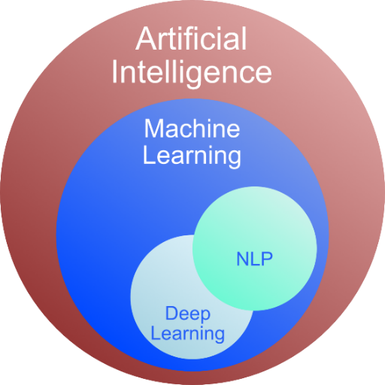
Figure 1: Clarity on AI, ML and NLP [13]

Approaches
As Muhammad and Yan [14] indicated that machine learning approaches are divided into four main categories, and in each section, certain types of algorithms are used to achieve different results and analysis[15], each one of those approaches has different techniques and algorithm to apply, and as it shows in Figure (2) how the input data can be for each one of them and the difference of their outputs. So, below there is a brief description of each one of those approaches:
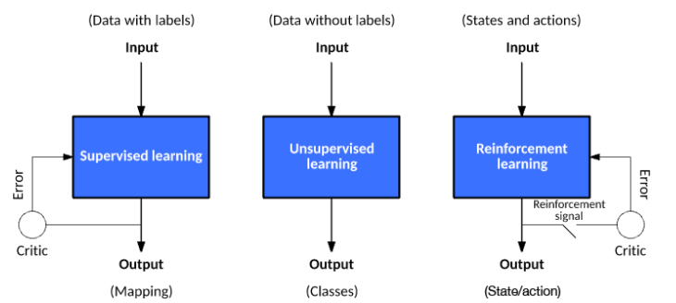
Figure 2: Models for machine learning [16].

Supervised learning
In this type, you may not know the internal relationships of the data you are processing, but you know the output you need from your model, meaning that the ML algorithm is trained using manually labelled and pre-sorted data. Where this algorithm is used by building a mathematical model of a set of data called training data to be used as examples of machine training through which iterative optimization is used for an objective function These algorithms learn a function that can be used to predict the output associated with the new input, and as a result of this iteration, the algorithm will allow to determine Input outputs that were not part of the initial training data. Over time, the algorithm learns to improve its predictions or the accuracy of its output[17][18].
For example, the image recognition feature, where the algorithm is told at the stage of education whether there is a picture of a particular person among the pictures or not. In supervised learning, there are two types of algorithms Classifications and Regression[19], where regression algorithms are used when the output has any numerical value within the range such as forecasting the temperature based on historical data, in addition to the direction of the wind and clouds and so on, and classification algorithms are used when the output is limited to a limited set of values and the classifications can be used to predict colours, types of animals, types of fruits, and so on, as well as other important algorithms that used a lot like Decision Tree and Logistic Regression[20][21].

Unsupervised learning
In this class, the algorithm takes a set of data containing the inputs only, then the program collects similar data into groups, through these inputs you can find a data structure such as collecting points or similar inputs by collecting commonalities in the data and interacting with new data that is entered is categorized and identified based on commonalities identified in the past[22][23]. In this type, the user may not know what he wants to extract from the model or whether there are any relationships or connections between the available data because this data is huge or complex and unpredictable, so it is necessary to organize this data to categorize and arrange it through Unsupervised Learning[24]. the most popular algorithm in this category is K-Means, and the important applications are the estimation of density in statistics, such as finding the probability density function, and classifying things, societies, or people such as people with common interests, which is the same as what we can see in social networking sites or dating apps and others[25][26].
In Figure (3) shows the difference between supervised and unsupervised learning and can be noticed how supervision labelled the data with different colours while the unsupervised does not as it works alone to explore the data structure.
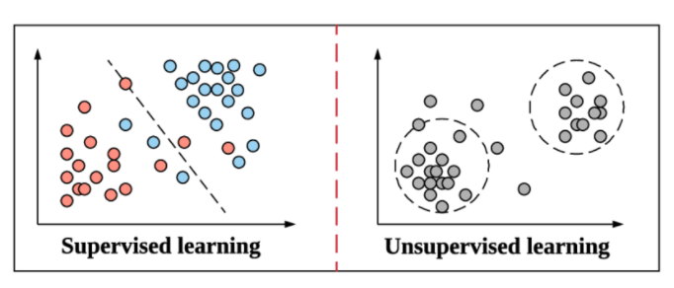
Figure 3: Example of Supervised and Unsupervised learning[27].

Semi-supervised learning
This category is based on supervised learning and unsupervised learning which means that training data is fully labelled and with unlabelled data. Some researchers have found that when unlabelled data is used with a small amount of labelled data, the results can significantly improve learning accuracy[28][29].

Reinforcement learning
This method is concerned with how software representatives take actions in an environment to maximize the idea of cumulative reward, this category is similar to human learning, in which an algorithm learns a policy of how to behave in a given environment [30]. Each action has some effect on the environment, and the environment provides rewards that guide the learning algorithm. Meaning that this type makes the machine learn by itself through the experiments it performed in the past, and if it did something right, it will move to the next stage, if made a mistake, it will stop and does not repeat the same mistake. Sometimes more than one algorithm can be used to perform one task, such as using the clustering algorithm and then training a classification algorithm based on it [31].
In Figure 4 is an example of the reinforcement learning cycle, step 1 starts with the Agent observing the Environment, and then after getting a state and reward by the Agent in step 2 in turn to use them to decide the action that needs to do next. In step 3 the agent forwards an act to the environment in an endeavour to monitor it favourably, In last step 4 the environment transforms, its internal state changes as a result of the past state and the agent's behaviour. The cycle then repeated[32].
The most common use of reinforcement learning algorithms lies in learning a game against a human opponent, such as what we see in chess[33], and in self-driving vehicles[34].
Until this day there are a huge amount of applications in ML that already exist and serve a large number of industries such as (Healthcare, Banks, computer network, Agriculture, Astronomy, business and marketing, Citizen science, Cheminformatics and lots of other fields).
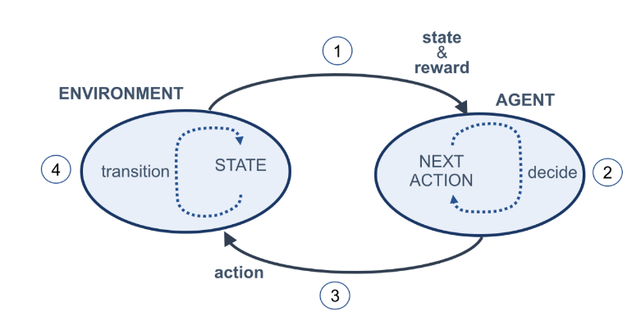
Figure 4: Reinforcement Learning cycle [32].
So at the end of this part, we can know what machine learning is and how it works and what the approaches of this science, and as we can see the Natural Language Processing is one of the techniques in ML, so in the next part we will dive into the Natural language processing to know the definition of the technique and how it works, as well as the techniques and the applications that used NLP to work.

Natural language processing

Overview
Natural language processing or as it is known by NLP is a software engineering technique that is a subgroup of linguistics, computer science and AI techniques, so in this section, extensive research has been done to find out exactly what is the definition of NLP and the history of this science, and then a brief description of both types in NLP followed by techniques used in NLP such as speech recognition, text classification and others, and at the end of this section the author has listed some important applications, which we use every day without knowing how to create them, which all of them created by the science of NLP.

Definition and background
In simple words, it is a processing and analysis of (spoken) natural languages represented by texts in order to achieve optimal interaction between computers and humans language more intuitive and efficient and to narrow the communication gap between machines and humans[35], meaning helping the computer to understand the natural human language such as English, Arabic, French or any other human language by program the machines to be able to process and analyse a huge amount of data that comes from our natural language so that they can automatically perform repetitive tasks such as summarization, ticket classification, machine translation[36] and spell-check[37][38][39]. Therefore, the particular goal in NLP is to read these inputs and then decode and understand the meaning behind each sentence and the contents of documents as well as the nuances of the language within them by analysing each word to be able to know the meaning of these inputs in a valuable way, which the technology can then strictly extract the ideas and information that contained in the text as well as group and organize the documents themselves[40][41][42].

History of NLP
According to Jones [43], the history of Natural Language Processing (NLP) goes back to many eras and the first one was called Symbolic NLP and it was from the start of the 1950s tell early 1990s [43], but the main idea of NLP originated from the idea of machine translation that appeared in the 1940s during World War II, whose main goal was to convert a human language into another human language [44].
The second phase of NLP and MT was when they gained new life at the time of the emerge of Artificial Intelligence in the 1960s [45], and in the 1970s some programmers started to write "conceptual ontologies, which organized real-world information into data that could be understood by a computer like MARGIE (Schank at the date of 1975). Until the 1980s, most NLP systems relied on complex sets of handwritten rules but after that period the field of computational grammar became more active in the research aspect that was associated with the science of thinking about the meaning and considering the beliefs and intentions of the user [44][46].
According to Kumar [44], the year 1990 in NLP is called the statistical period, and because of the large research that has been done and specifically in IBM research, there have been many successes in statistical methods in NLP in the aspect of MT[46].
Nowadays and after the massive revolution in technology, we can see how NLP become one of the most important researches for researchers around the world and how technology companies are trying to make the machine understand humans language and interact with a human as much as possible to be like human communication, and the only way to program the machine to be able to interact with human is through natural language processing, an example, we can see many gadgets around us that use NLP to interact with human such as Alexa, Siri, Google Assistant and others[45][47].

Types of NLP
In this part, we will discuss the most important natural language processing techniques, but before that we need to clarify that, these types and techniques can be divided into two main headings[46], namely:
- Natural Language Understanding: This part relates to dealing with natural language or human language and understanding it after displaying it to the computer or device as an input, regardless of the input format, whether this language is presented in the form of text or sound. The goal of this method is to make the machine understand the natural language (human language)[48].
- Natural Language Generation: This technology is called natural language generation because it allows a computer or machine to be able to generate content, whether this content is text or audio, and it is similar to what a normal human might generate, which means that in this technology the machine deals with language as output and not input[49].

Techniques
Since sentiment analysis is considered as one of the most popular techniques that use NLP, there are also other NLP techniques that are widely used in our daily time, so the author highlighted a shortlist of these techniques [50]:
- Speech recognition: It is used to convert voice data into text data, with the aim of giving voice commands or asking some questions with voice without having to type, for example (Siri and Alexa)[51].
- Text Classification: Through this technique, we can deal with texts of different shapes and purposes and then distribute them into different classifications based on their content[52], and one of the most prominent sub-techniques of text classification [53][54] Topic Classification, Intent Detection and Authorship Attribution.
- Text Extraction: This technique helps when it needs to search for information or certain parts of texts within books or very large and wide content [55], and under this technology, there are many algorithms that fall under it Keyword Extraction and Named Entity Recognition.
- Sentiment Analysis: It means to understand the feelings that underlie the texts and recognize the situations that result from them, whether they are specific feelings, confusion, sarcasm, doubt, or something else. Nowadays, many companies use this technology in order to automatically respond to their customers, where they can distinguish complaints from praise and respond to the two in appropriate ways according to the orders set by the company[56].
- Part of speech tagging: When dealing with language or texts, machines need to identify or classify the parts of speech, and this is done through part of speech recognition technology. The sentence is divided into its parts of verbs, adjectives, nouns, adverbs, etc., and this helps the machine to understand the text correctly. Or the sound someone sends her[57].

Applications
Because the NLP is a very large science, so it has hundreds of important uses and applications, and although we have covered some of them while talking about the different techniques of this science that are direct uses of NLP, there are many others [58]. The science of Natural Language Processing has greatly helped us to perform the tasks required of us efficiently and effectively, and today it is an essential component of many applications such as search engines, daily routine tasks, customer service and many more [41] [59]. And the most popular applications in our days are Customer Feedback Analysis, Automation of Customer Support Tasks, Chatbots, Analysis and Categorization of Medical Records, Text Prediction, Proofreading, Email Filters and Plagiarism Detection[60].

Challenges
Natural languages are very difficult even for us humans, even if they are from the same narrow geographic range, speak the same dialect, and are the same age, let alone train a machine or artificial intelligence to do this difficult job and to speak as well as a human.
There are many difficulties and challenges facing specialists in natural language processing, which make us so far, we have not reached the hoped-for development that we seek, and these challenges are Precision, Sentence division problems or Crash Blossoms, dialects and vernaculars, figurative expressions, new words, words with other meanings like tags, words that indicate different meanings, joking, Language Evolution.

At the end of this part, we can learn what NLP means, the history of this science as well as the types of NLP and what techniques and applications are using NLP nowadays, and because sentiment analysis is one of the most important techniques used in NLP, In the next part, it will highlight this technology and describe the meaning and background in addition to the types and backgrounds used in this technology, which ends with a broad explanation of the beneficial effects on humans through analyses in social media and business.

Sentiment Analysis

Overview
If we are looking back at the change that took place on the Internet in the last 10 years, we can see that the Internet has generated huge amounts of data and this data is available in many different forms such as text, audio, and image. The textual data sources can be user or customer ratings on specific products, posts, comments, tweets. , news articles, various information on web pages, and etc.
Where companies and decision-making support centres are interested in the opinions of their customers and target groups for study and analysis, so knowing what they like, or dislike represents a high value for making any decision that may increase the market share of the company or push for a decision for a civil society organization or even a government agency.

Terminology, Definitions, and background concepts
In recent days and with the large influx of data on the Internet, especially in social networking sites, we often hear about opinion analysis using machine language, and we note the trend of elite researchers in this field. So, in this section and before we delve deeper into this research, we need to know what is sentiment analysis? How is that? And what is its importance?

Background
Sentiment analysis is an area of research originating in Natural Language Processing (NLP), and as D’Andrea et al. [61] and Pang B et al. [62] describe that this technique aims to discover subjectivity in text and/or extract and categorize opinions and feelings. Sentiment analysis studies people's feelings, opinions, attitudes, ratings, and feelings toward services, products, people, organizations, issues, events, and their attributes [61][62].
Text analysis and knowing the feeling behind the text is one of the biggest challenges facing data analysis experts, no matter how huge or complex digital data is, it can be easily subjected to arithmetic operations and mathematical equations to draw conclusions from them[63]. In the era of social media and the boom of social networks that allow people to express their opinions in their own language and in their multiple expressions, so the need is still urgent to develop algorithms for analyzing meanings and thus extracting the feelings and impressions that users reflected in their writings [64][65].

History
Manttyla and Danie [66] provide useful information about the early days of sentiment analysis, they state that the first paper on this topic was published in 1940, called “The Cross-Out Technique as a Method in Public Opinion Analysis”[67], Then three research papers appeared in 1945 and 1947, which were released in the Public Opinion Quarterly magazine, and talked about measuring public opinions in post-World War II countries that suffered during the war. and it is considered the most influential that helped in the emergence of sentiment analysis is the work completed by the Association that established in 1962 for Computational Linguistics.
It was a bit tricky to find the first paper that mentioned sentiment analysis directly, as it used many volatile names and terms in the early years. Hatzivassiloglou and McKeown published a paper In 1997 called "Predicting the Semantic Orientation of Adjectives" [68] where it mentioned that they used data from the Wall Street Journal corpus and create a statement of negative and positive traits and predicted whether the correlated traits were in the same direction or the other.
Until the year 2002, a paper was written by "Bang et al." and called "Thumbs up? Sentiment Classification using Machine Learning Techniques"[69] where he applied film review data and discovered that ML rating of an item outperformed a human being, which this paper is the most popular one that related to this field. At the same time, "Turney" published a paper with has a similar name and called "Thumbs Up or Thumbs Down? Semantic Orientation Applied to Unsupervised Classification of Reviews” [70] where he applied science and achieved 74% of recommendations.

Definition
Sentiment and opinion analysis is a complex process of analysing textual data and identifying views and opinions into positive, negative, or neutral trends [71]. It can be said that the analysis of feelings and opinions is an automatic process for identifying and extracting personal information that forms the basis of the text, which can be an opinion on a particular topic, a judgment on a particular situation, or a feeling towards a particular conversation [72]. According to the people of analysis [73], they call it polarity, meaning that the feeling is one of three directions: a positive, negative, or neutral direction, and the latter sometimes can be considered a state of not forming an opinion or attitude or sometimes hesitation, and this is due to the nature of the data and the subject to be monitored. and analyse it [74][75].
So, in our days, text analysis and knowing the feeling behind the text is one of the biggest challenges facing data analysis experts, no matter how huge or complex digital data is, it can be easily subjected to arithmetic operations and mathematical equations draw conclusions from them. In the era of social media and the boom of social networks that allow people to express their opinions in their own language and in their multiple expressions, so the need is still urgent to develop algorithms for analysing meanings and thus extracting the feelings and impressions that users reflected in their writings [76].

Sentiment Analysis types
There are several main types of sentiment analysis, and each type represents a slightly different analysis and focuses differently from the other, and they are [77]:

Fine-grained sentiment
This type includes determining the polarity of vision. This type of analysis can give you an understanding of the customer feedback you're getting. As for the input polarity, accurate results can be obtained, and it can be a simple binary differentiation of positive/negative emotions. This type can take more categories like (very positive, positive, neutral, negative, very negative) or even by specifying a star rating like rating hotels or products from 1 to 5 stars [78][79].

2.3.3.2 Emotion Detection Sentiment Analysis
This type of analysis is based on detecting feelings such as sadness, anger, frustration, excitement, joy, etc. This is a more complex way of identifying feelings in a piece of text [80].
In this analysis, lexical systems and machine learning are used to identify the feelings and words that these words are positive or negative, making it easy to separate the terms according to their feelings[81][82].
One of the biggest issues with this analysis is that some people express their feelings in different ways like sarcasm (I can't describe customer support) which is understandable in many ways including that customer support is bad or very good [80].

2.3.3.3 Aspect-based
This type is used to target a specific thing in the service or product that the company is marketing for. For example, mobile or computer companies usually market to speed, screen, resolution, battery, capacity, etc [83].
Through it, the company can understand the feelings of customers about each individual part of this product, for example (the processor speed in this computer is unbelievable) [84].

2.3.3.4 Intent analysis
This type is all about action, meaning understanding the customer's intent to buy or not, and using it in customer support and marketing systems to streamline the workflow. This means that a specific customer's intent can be tracked,a pattern formed, and then used for marketing and advertising[85][86].

2.3.4 Sentiment Analysis Algorithms
There are many algorithms that can be applied in sentiment analysis, and each of them varies according to the required accuracy or the amount of data entered, those algorithms are[87]:

2.3.4.1 Rule-based approach
The methodologies are based on the manual selection of a set of rules for determining the polarity and target entity (for example, product name) and are based on an algorithm with a clear description of the opinion to select it. Includes defining subjectivity, polarity, or subject matter of opinion. This approach also includes a basic routine of natural language processing[88].
It includes the following operations with the text collection: Tokenization, Part of speech tagging, Stemming, Parsing and Lexicon analysis (depending on relevant context), So basically this system needs a set of rules that designed and entered manually[89]. So, as it shown in the Table (1) the rule-based approach works when -1 means is negative, and +1 means is positive.
Words | Sentiment
Good | 0.5
Great | 0.8
Terrible | -0.8
Alright | 0.1
Table 1: Rule-based approach example.

2.3.4.2 Automatic Approaches
This methodology does not rely on designed or written rules like the Rule-based approach, as it works entirely on machine learning algorithms without the need to set manual rules or any user intervention. Instead, a classifier is applied that evaluates the text and returns the results. This includes lots of data tags and annotations on the data to help the models understand the data being fed, as they are used to tell the gist of the message[90]. Information can be processed according to many criteria without complexity. In this approach, several algorithms are used, including Naive Bayes, Support Vector Machines, Linear Regression, RNN derivatives LSTM and GRU [91].

2.3.4.3 Hybrid Approaches
These methods combine both approaches (rule-based and automatic approaches) into a single system, the results of which are often more accurate here than the prior methods[92], where the user can formulate the rules he wants to put into the system while allowing the system to use a specific type Algorithms to learn from automatically entered data[93][94].

2.3.5 Sentiment Analysis Process
The sentiment analysis is considered as a complex procedure that involves a few different steps that need to follow to extract and analyse sentiment data. these steps are [61][95]:
- Data preparation:
Data processing aims to clean the data in general and cleaning data mean that to remov any tags and phrases from texts, removing diacritics, excluding words and prepositions, removing unnecessary dots and commas, repetitions, and replacing unimportant characters and phrases in the text[2].
- Feature extraction:
The model requires that the data be clearly arranged, and because the length of texts and words and the number of words in them may vary and does not make the text clear or arranged as it shows in Figure (5) we use feature extraction techniques for each word to discover the text that required in the sentences and enter the model clearly[96].

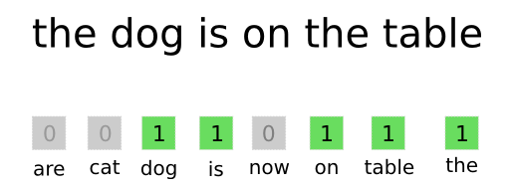
Figure 5: Feature extraction example.
The most prominent feature extraction technique is Count Vectorization Technique: In this process, it converts words into numbers, and give each word a number, for example in Figure (6) create a lexicon representing each word and its number and number of repetitions, and so the data is valid to be inserted into the machine learning model[97].

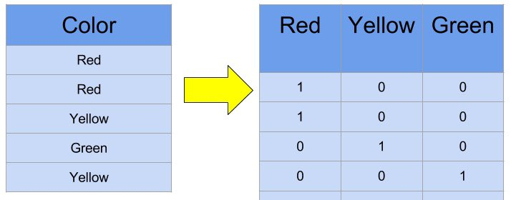
Figure 6: Feature extraction example 2.
- Feature Selection:
After extracting the features, a choice is made between them and there are several ways to choose the features, the most prominent of which is choosing the most frequent features, or the highest value in all the data, and the rare features are deleted, or the frequently repeated features are deleted[98] which Figure (7) can show us that the features in the first step have been minimizing to be 3 features in the third and final step. choosing features might be is not a necessary task, because it is possible to use all the features within an array where each column represents a value, and each row represents a text from the training data where the row consists of the number of feature repetitions within the intended text and the result is a matrix whose length is the number of texts and width is the number of feature[100].

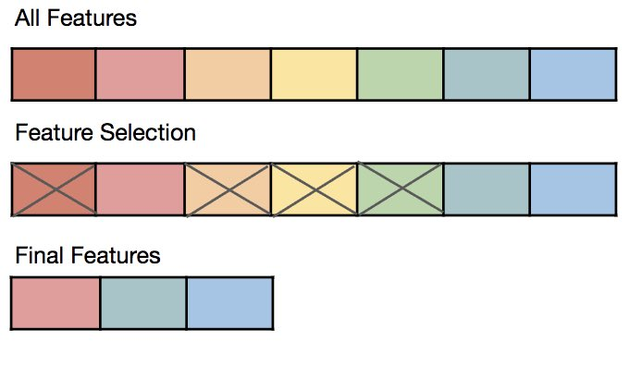
Figure 7: Feature Selection example.
- Model Training:
After completing the previous steps which go under the name of "Data Transformation or Data Processing"[101], the data will be ready for the user to train the machine learning model through one of the Supervised Learning algorithms. To train the model on the data, the matrix is entered with the classification of each text with the model and the form automatically divides the rows in the array into two different parts and they are called “Training and Validation part”[102][103].

2.3.5 Impact of Sentiment Analysis

2.3.5.1 On social media
It is true that Google is the first choice for researchers on the Internet[104], as it performs about 81 thousand searches per second[105], but social media still account for the largest share of daily publication for about half of the world's population! Today, social media sites represent the most spacious space for expressing thoughts, feelings, and moments[106]. As of the end of 2019, the number of Facebook users reached more than 2.3 billion active users, which is equivalent to a third of the world's population (7.7 billion people) and is more than double the population of China, which reached 1.44 billion as of November 2019.
Although Twitter ranks far behind in the number of users, it is considered the most popular and official social networking site, as it is the number one source of news for 74% of social media users around the world. It is the platform used by elites, opinion leaders, and activists in various fields around the world. It is worth noting that Twitter is one of the most popular social media platforms for micro-blogging, allowing tweets with a maximum of 280 characters since November 2017, when only 140 characters were allowed when it launched Dorosi on March 21. , 2006. According to some statistics of 2018, there are 335 million active accounts. And that Twitter's share of Internet users is 24%. As for the daily activity of tweeters on Twitter, there are 500 million tweets that are tweeted at a rate of 6000 tweets every second, and with more than 330 million active users, and about 500 million tweets per day at a rate of 6000 tweets per second, it is not surprising that companies, research institutions and data analysts considered the platform. Twitter microblogging is an essential resource for understanding the trends and impressions of customers, followers, and activists[107][108][76].
Nearly 80% of the digital data in the world is unorganized, meaning that it contains numbers, symbols, expressions, and mixed characters and is not in a specific format as in Excel tables, for example, or travellers' lists, although it also may need cleaning and initialization operations before processing. The following statements: “The design of the new phone is bad and does not meet my needs,” “Some features do not work, and the old design was better,” “Not good and I will not waste more money just for a phone”; Sentiment analysis algorithms can mark them as negative, and so for sentences with positive vocabulary. Of course, this is a process that is not easy and direct as much as it is multiple and sequential steps and depends on analysing the components of each sentence and repeating each word with consideration of what is before and after it, and this requires invoking language considerations, rules of writing and meanings. In addition to all this, the writing should be in the colloquial or official language, or even the chat language, which depends a lot on abbreviations and symbols[109][92].

2.3.5.2 Businesses/Industries
According to two surveys that have been done of more than 2000 American adults in each of them[62], 81% of Internet users (or 60% of Americans) have done an online search for a product at least once, between 73% and 87% stated that reviews had a significant impact on their purchase or the brand they would buy[110], consumers also reported being willing to pay 20% to 99% more for products rated with five stars rather than for items rated with 4 stars[111][112].
Sentiment analysis is the process of inferring, measuring, or understanding the image that your product, service or brand has in the market. So, as we mentioned before sentiment analysis is also opinion mining. and with the spread of social media, people started talking more openly about their experiences with products and services online through blogs, video blogs, social media stories, reviews, recommendations, reports, hashtags, comments, direct messages, news articles, and various other platforms. When this happens online, it leaves a digital fingerprint of an individual's expression of the experience. Now, this experience can be positive, negative, or simply neutral.
Sentiment analysis is the exploration of all these expressions and experiences online in the form of texts. With a wide range of opinions and expressions, a brand can accurately capture the voice of its target audience, understand market dynamics, and even recognize its market position among end users. In short, sentiment analysis brings out what people think about a brand, product, service, or all of these things.
Social media channels are treasure chests of information about your business and with simple yet effective analysis techniques, you can learn everything you need to know about your brand.
At the same time, we have to remove the misconception about sentiment analysis. Contrary to what it seems, sentiment analysis is not a one-step tool or technique that can instantly bring you opinions and feelings about your brand. It is a mixture of algorithms, data mining techniques, automation, and even Natural Language Processing (NLP) and requires complex implementations.

Recommendation System
Human nature tends to follow certain patterns in the selection of available choices, and the individual usually prefers things of the same classification. For example, if someone buys a book on data science, chances are that they will be interested in buying books on data visualization in the future.
Nowadays many people wonder how to read their minds or how YouTube knows what they like or how Netflix knows what their favourite movies are, and they think that the recommendation system is an exciting thing because of the ambiguity around it, but with the early development of the recommendation system to the present time, science was able to Today, it proves to us that technology has become incomparably advanced than before, as this system has been updated by many companies and take advantage to know what is going on or what the customer wants[113], Where this system is one of the secrets of the success of many companies, this system is a magic marketer for services and products, it observes customers and recognizes their behaviour to assist them to take their decisions, and the ability of companies to provide a service or product to individuals without them searching for it in advance accelerates trade exchange and increases customer satisfaction[114]. and these days the recommendation system has been greatly improved and improved to continuously improve the user experience.
So, in this project, let us know what a recommendation system is and how it works by developing a movie recommendation system that can demonstrate the ability of this system to recommend movies to others based on the data we have provided and then apply the algorithm to that data.

2.4.1 Definition
The recommendation system is one of the most important applications in ML[115], which has gained massive momentum due to its prosperity in more than one field, as it is the best method to recognise the interests and pattern of individuals’ behaviour by deriving their interest and using them in predicting products that follow those patterns and then presenting them to them as recommendations, so the individual feels that the system Understands it, which enhances the customer's confidence in service providers[116].
It acts as a dynamic marketing tool particularly with online marketing and is helpful in making the purchase repeated by customers. but it must be emphasized that it is also used with other services such as social networks. On the corporate side, the recommendation engine is seen as a smart and sophisticated seller who knows the customer’s taste and behaviour, and thus this engine can make smarter decisions about recommendations that will appeal to the customer, it can entice the customer to buy, it is true that it serves the owner of the store, but it also serves the customer to get Products you may like and need[117]. The recommendation system uses many methods to filter the information that is being poured on the customer from everywhere by filtering it dynamically according to the customer’s preferences, interests and behaviour, the recommendation system bets on the ability to predict whether a particular user prefers a product or service or not, based on the user profile and behaviour in the past[118].

2.4.2 History of Recommendation System
The recommendation system is an idea that is not old, as it is considered as a customized information retrieval tool that belongs to the Internet era, and with the presence of big data and the emergence of the Internet, promoting an element has become time-consuming and ineffective for the user. The history of the basics of recommender systems dates back to its foundation through research cognition science [119] and information retrieval [120] as Mark and Croft, Bruce indicated in Sanderson the first appearance of this system was when Duke University established a Usenet communication system in the mid of 1970s [121][122], at the time, this system was not built directly on users' preferences, but rather the system was based only on sharing textual content with each other and classifying news groups into subgroups to facilitate the search for a specific material.
In the first known such solution, was a computer librarian, who first interviewed users about what their preferences were and then recommended books to them with this information in mind. Based on the information gathered, the system assigns the user to a set of templates using a somewhat primitive method, thus recommending the same books to all people in the same set.
In the 1990s the first automatic recommendation system was launched by the Minnesota Group Lens Research Group, GroupLens [121]. Whereas, it has been suggested that collaborative filtering is an important technique in the recommendation system.
In the 1990s, due to the wide application of the term recommender system, this system became an important research field in the late 1990s where the system was further developed by the RSs, and the implementation of Amazon Collaborative Filtering in 1998 was one of the most well-known techniques that became more popular and was implemented on many online systems, and e-commerce systems[123].
After the successful era at the end of the 1990s, the recommendation system quickly became more popular. The industry generously funded the implementation of RS research, and in 2006 a million-dollar competition was announced by streaming media provider Netflix for the winner who could make the best recommendation for a movie[113], which announced the winner in 2009, and because of the success that accompanied this system, YouTube in 2010 implemented the recommendation system as well on its site, and then the system was applied in many big companies such as TripAdvisor, Pandora and others. With the development of artificial intelligence, information retrieval and human-computer interaction, the recommendation system has become more active and effective, where in 2016 YouTube announced the use of a deep neural network recommendation system to obtain broad recommendations, the most likely recommendations. nowadays this system has become applied to many different industries between different fields and is not limited to a specific industry[122].

2.4.3 Types of recommender systems
There are different approaches used in recommendation systems, and each one of them has specific uses, which are according to the interests of the company that uses it. For example, the uses of retail sales differ in their recommendations from the film industry or social networking sites. Here is a simple explanation of the types of these systems:

2.4.3.1 Simple Recommenders
Simple recommenders or as it is known by Demographic Filtering it recommends items based on users' demographic information and ranks users based on traits to provide general recommendations for each user based on, for example, the popularity of a movie and sometimes genre. The techniques demographic form "user-user" links like collaborative ones, but in fact, they use different data. In this approach, the algorithms need to search for the right market in the desired region defined by the user, as well as perform a short survey or filter to collect data in order to rank. when applying this approach, the weighted rating formula is normally used as follow:
WeightedRating(WR) =
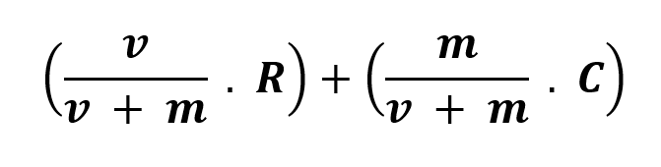
- v is the number of votes in movie.
- R is the average film rating.
- m is the minimum votes number.
- C Average rating across entire report.
This approach has been followed by many industries due to its ease of implementation and uncomplicatedness. In addition, the advantage of this approach is that it does not require as many things as other methods and does not require a history for user ratings.

2.4.3.2 Collaborative Filtering
This technique is a famous technique for creating recommendation systems [124], its basic premise is that if users agree with each other previously, they are probable to coincide with each other after time, unlike a content-based recommendation system, these systems attempt to predict the rating on items by a user determined based on formerly expressed reviews by this user and other similar users [125]. Since the descriptions of the items are not exploited in this system and this is convenient since it is not always possible to get the attributes of the items, for example in the application for the movies the prediction of the rating given by the user (Jack) on the movie (Superman), the system will try to find users similar to (Jack) any other users who rate the same movies similarly, then the ratings expressed by those similar users are aggregated and considered as a predictive rating. In the end only the movies with the highest predicted rating (most preferred by users) will be recommended to that user[126].
There are several collaborative filtering systems developed in industry and academia, it can be said that the "Grundy" system [119] was the first recommendation system, which propositioned the utilize of "stereotypes" as a technique for creating user models based on a restricted amount of input on each independent user[127], using these "stereotypes". The Grundy system will create and use independent user models to recommend books that are relevant and important to each user. Subsequently, a "Tapastry" system was introduced that relied on each user to manually identify like-minded users[127]. So were the "GroupLens"[128], "Video Recommender"[129], "Ringo"[130] systems. One of the first systems that used CF algorithms to automate the prediction process. Other examples of CF include Amazon's book recommendation system, "PHOAKS"[131], which helps people find relevant information on the Internet.
Collaborative filtering algorithms can be grouped into two main categories Memory-based collaborative filtering methods and Model-based collaborative filtering methods:

2.4.3.2.1 Memory-based collaborative filtering methods
Memory-based algorithms are basically empirical methods that produce predictions and evaluations based on the full set of pre-evaluated items by the user. These methods compared to other methods are slower in rating prediction because they have to explore the entire ratings empirically, but they are considered easy to achieve and give good predictive value for this reason they are preferred by many commercial companies such as Amazon, Google, Netflix and other commercial companies[131].
Memory-based collaborative filtering methods can be further divided into:
- User-based collaborative filtering
The method is also known by "K-Nearest Neighbour" and is considered as the first automatic collaborative filtering method that has been found. This method makes predictions about user interests by collecting information about the tastes of similar users, and its basic premise is that users who agree in the past tend to agree again in the future[132]. for example, shown in Figure (8) if we have 3 users, when user 1 likes (Hotel A and restaurant) and he has a high correlation with user 3 who likes (hotel 1, restaurant, hotel 2), the system will recommend (Hotel 2) to user 1.
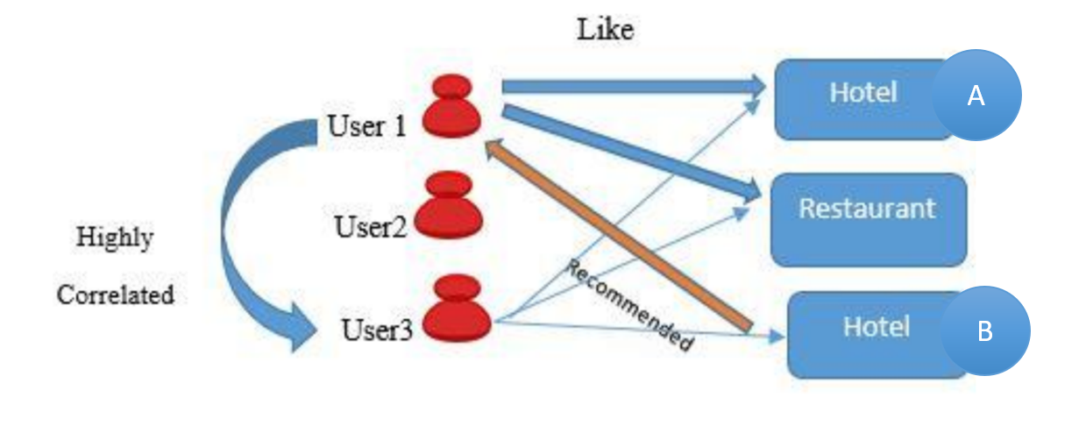
Figure 8: Example of User-based collaborative filtering [133].
In order for this method to work, it needs to function to calculate the similarity between users, as well as a method for using evaluations and the similarity value in the prediction calculation, where the similarity calculation is an important step for user-based methods and there are several proposed techniques to do this, including the method of calculating similarity based on users "Cosine Similarity" or what is known as "Vector Space Similarity" or "VSS" as in Figure (9) and the other method of calculating similarity based on the amount of connection between the users "Similarity Based-Correlation" or as its known "Pearson Correlation Coefficient"[132].
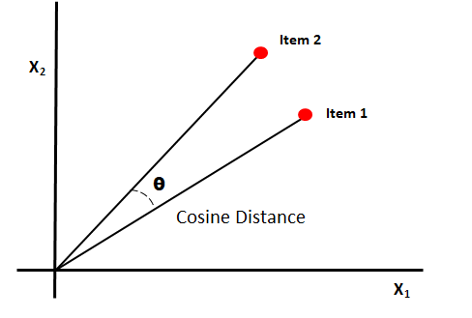
Figure 9: Cosine Distance/Similarity.

- Item-based collaborative filtering
The item-based method explores the set of items that have been rated by the user and compute users similarity with the target item and then chooses the extreme similar item on the basis of its corresponding similarity values [131] as shown in Figure (10). This method is slightly similar to the concept of content-based recommendations, but here the similarities are calculated from user ratings across items rather than the merits of the items themselves, this is why this algorithm can provide similarity between two items of two different types such as summer clothes and an ice cream maker where the user then has similar behaviour across both, and this is one of the things that content-based methods cannot find[134].
Item-based methods still need to find the most similar elements to work, but this similarity is computed across smaller dimensions as commonly the number of elements is less than the number of users. The main benefit of this method comes from the fact that it allows the person to calculate the similarities between the items in advance, which is not possible in the user-dependent method since when the user performs more actions in the system such as giving ratings to more items, or purchasing other items, the special ratings ray It will change, so users similar to it will also change. Also, ratings given by other users can change resulting in a change in similarity as well. This means that the similarity in the system can be changed by what any user does in the system. Whereas when the number of users is greater than the number of items the similarity between two items will not change when any action is taken in the system, especially if the two items already have enough previous ratings[134].
This method also needs a function to calculate similarities between items and a follower to predict the evaluation as in the user-based methods and calculating the similarity between two items is similar to calculating the similarities of users.
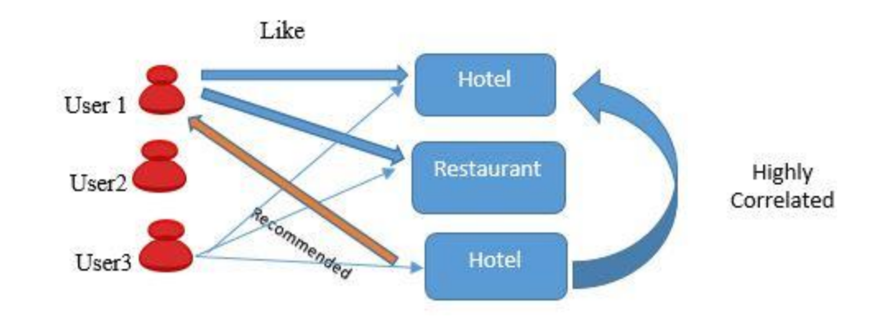
Figure 10: Example of Item-based collaborative filtering [133].

2.4.3.2.2 Model-based collaborative filtering methods
Model-based algorithms use the set of ratings to pick up a model and then don't need to access the entire ratings again as it can learn the model parameters and use them later to calculate the predictions[135]. Unlike memory-based methods, model-based methods have a learning phase that can be time-consuming. On the other hand, the model-based methods are very fast because they use the model parameters only to calculate the predicted evaluation. These methods are usually difficult to achieve and pick more time to structure the system, which gives relatively better predictions, but with the risk of losing important information as most of them perform some kind of pressure or summarize the information [135]. The popular algorithm that are known and used are " Bayesian models", "Matrix Factorization models" [136] and "Singular Value Decomposition" or as it is known by SVD, and others[137].

2.4.3.3 Content Based Recommender
As the name describes itself, this type relies on the content of the item that has been preferred by the user, the content-based filtering has its roots in research on Information Filtering and Information Retrieval [138]. Due to the early and important developments by the information retrieval and Filtering, and because of the abundance and importance of text-based applications, most existing content-based recommender systems concentrate on recommending text-based information such as news, books, documents, websites links, etc. The improvement offered by content-based methods compared to traditional information filtering and retrieval methods comes from the use of user profiles, which include information about their needs, preferences and interests, as well as element files that contain their characteristics and advantages. User profile information can be deduced explicitly through surveys, for example, it is implicitly learned from users' transmission behaviours over time[139]. So, an example in Figure (11) if a user likes a hotel A, then the system will recommend the user another hotel that has the same features the user likes in hotel A.
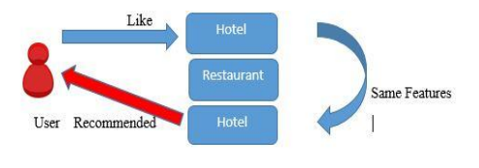
Figure 11: Example of Content Based Recommender.
So, this technique recommends items based on the individual preferences and interest of the user rather than the other simple type that gives the same recommendation to everyone, regardless of the user's personal interest, it analyses the attributes of the items to create predictions. Descriptive attributes of items are used to form recommendations, for example, recommendations are made based on attributes extracted from the content of items with which the user has interacted in the past[140]. The user recommends items that are mostly related to the highest-rated items. The following is that in this approach if the user profile changes, the technology can still modify the recommendations within a short period of time because this technology does not need the profiles of other users as it does not affect the recommendations. The most prominent companies using this technology are the movie companies, with which you can make recommendations based on the user's style, such as action movies, dramas, and others. An example in movies side can shows in Figure (12) when the user watches some movies, and this movie is similar to other movies the system will recommend to the user.
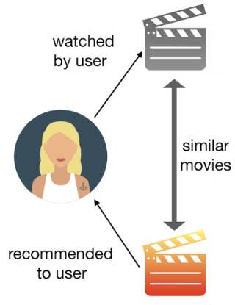
Figure 12: Content-based filtering example [141].

2.4.3.4 Hybrid Engine
To avoid the limitations found in single-recommendation systems such as content-based and collaborative filter-based systems, hybrid methods combine several methods together to take advantage of their advantages and improve the accuracy of recommendations. like what happened with the Netflix award mentioned earlier[142], where it was found that the best recommendation methods correspond to the compilation of many different recommendation algorithms[143], there are several ways to integrate the collaborative method and the content-based method in a hybrid recommendation system and they can be categorized as follows:
- Achieve the collaborative method and the content-based method separately and integrate their predictions.
- Inclusion of some advantages of the content-based method in the collaborative method.
- Inclusion of some advantages of the collaborative method in the content-based method.
- Building a generic unified model that integrates content-based and collaborative features.
Where each one of those ways has a bit different method to use and implement which those methods recommended by researchers.

2.4.3.5 Popularity based recommendations
This system relies on star rating or movie review data to recommend it to specific people without even having to know who those users are or what their interests are, which takes each movie to calculate the star rating and then present it as a recommendation. It befits this recommended system that it does not require any information about the user, their description, what the genre is or who the actors are in this movie, and all it needs to know is just the star rating given by viewers.

2.4.4 Challenges
There are several challenges that faced recommendation systems such as Cold Start, Data Sparsity and Scalability[144][145].

2.4.4.1 Cold Start
This problem happens when a fresh user enters the system, where it is tricky to detect similar users or items because there is not sufficient information. Therefore, this problem of collaborative filtering methods can be taken from two aspects[146]:
- New User Problem: It is considered as the same problem as with content-based systems, where collaborative methods require user assessments to make recommendations. If the user does not evaluate enough items, the collaborative system will not be able to provide accurate recommendations of a personal nature, and to solve this problem several techniques have been proposed to address this problem, most of which use the hybrid method[147].
- New item problem: This means that new items are constantly combined to recommended systems and collaborative systems rely only on user preferences to provide predictions, so the recommended is unable to recommend the new item unless it is evaluated by enough users[147].

2.4.4.2 Data Sparsity
In any recommendation system, the amount of ratings obtained is commonly smaller compared to the amount of ratings expected as shown in Figure (13). Effectively predicting ratings from a small number of known ratings is very important, since the success of collaborative filter systems depends on having enough users available, for instance in films recommendation systems, there may be lots of movies rated by a small group of users, these films will rarely be recommended, even if a couple of users give them high ratings, Also, for a user whose taste is unusual compared to the rest of the users, there will be no other users similar to that user, which leads to bad recommendations[148].
Several model-based methods have been proposed to solve the problem of data sparsity in recommendation systems, one of which is the use of user profile information when calculating the similarity between users, so users are considered similar not only if they rate the same films similarly but also if they belong to the same demographic. For instance, the gender, age, education, area code, and job information of users are used in the restaurant recommendations app[149]. This extension of traditional CF techniques is called demographic filtering. Another way to deal with data sparsity matrices was found [150] where one of the dimensionality reduction techniques "SVD" was used which reduces the dimensions of the data sparsity matrices and provides a better lower approximation of the original matrix.
Items
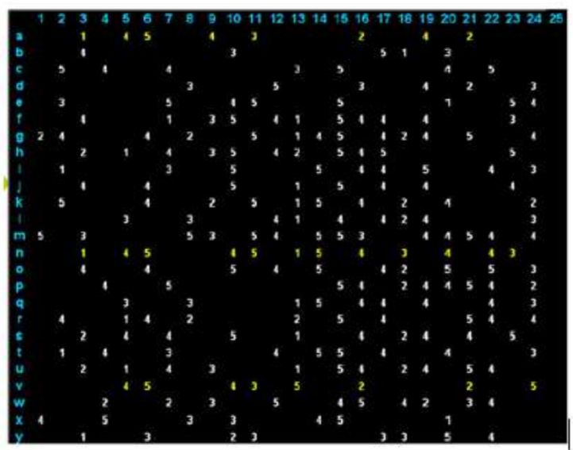
Users
Figure 13: Data Sparsity matrix issue

2.4.4.3 Scalability
When the numbers of users and items grow exponentially, traditional collaborative filtering algorithms will suffer from serious scaling problems, and the computational resources required to process them will exceed the limits of acceptable practical levels. It also needs several systems to respond immediately to requests and make recommendations for users regardless of their purchasing history or their rating records, which requires high scalability from a collaborative filtering system, dimensional technologies such as SVD can deal with the scalability problem and produce high-quality recommendations quickly. However, it has to undergo costly stages of matrix analysis, and memory-based collaborative filtering algorithms, especially item-based ones, can achieve satisfactory scalability[151]. Whereas, instead of calculating the similarities between all pairs of items, it calculates the similarities between a pair of items that were jointly rated by the user. Also, a simple collaborative filtering algorithm based on Bayesian models can solve the scalability problem by making predictions based on only known ratings[152].

2.4.4.4 Attacks issues
In situations where anyone can make recommendations, humans award many positive recommendations for their own materials and items and many negative recommendations for their competitors, it is advisable for collaborative filtering systems to introduce precautions that discourage this type of phenomenon, as attacks are designed to make the recommendation system behave the way they would the attacker wants them so that he recommends the desired elements to him and prevents the recommendation of other elements. Recently, attack models for collaborative filtering have been defined and their effectiveness studied. The researchers found that the element-based collaborative filtering algorithm is less affected by attacks than the user-dependent collaborative filtering algorithm[153], and they suggested that new methods should be used to evaluate and detect attacks on recommendation systems[154]. This challenge is believed that hybrid and model-based collaborative filtering systems have the potential to produce some kind of solutions to the attack issue.

Conclusion
At the end of the literature review, a brief description of the background of Machine Learning, Natural language processing, Sentiment Analysis has been done to reach the main idea of the project in the Recommender System.
In each side of the research above has been defined the history of the sciences and what techniques are used and why it is important, as well as the challenges that faced each one of them, with a description of the algorithm that used in the Recommender system.
In the next chapter, it will include an explanation of the methodologies that will be used in this project in both aspects starting with research methodologies and then development methodologies, and through this chapter, we can know the risks that may affect the project and how the author can deal with them, and what resources will be used to implement this project successfully.

Methodology

Overview
In this chapter, the author will define research and development methodologies for this project, starting with the research one which includes the type of each method such as philosophy, approach, method and then outlining what the ethics could be in this project or what risks could affect it, as well as validating the project's validity and reliability Its generalizability, and because it is important to know which development methodologies to need to follow, the author has identified two methods that can be useful in implementing a software system implemented using data mining, at the end of this chapter the resources required to know and prepare the project well and know exactly what it needs are added.

3.2 Research Methodology
Since the first methodology to be defined in any project is research methodologies, which contain and describe the philosophy methods, and methods to be followed for any project, so the author in this section defined the research methodology followed as follows:

Philosophy
In terms of philosophy in research methodologies and according to the project topic and rationale for its application, the philosophy of the project will be positivist, because the project will study the facts and give credibility and objectivity to the research, as a result. The project will rely exclusively on scientific evidence, and there will be no survey of findings, conclusions, or external conclusions for a particular part of the project. By using techniques and algorithms in this project, will result in the production of quantitative data through a software system that will be created by following certain steps such as design, development, testing and evaluation.

3.2.2 Approaches
The approach in this project is the inductive approach where the construction of this project is based on already known theories previously and based on theoretical and scientific research, where this approach identifies a hypothesis through theoretical testing and then tests this hypothesis through the process of data collection, for which the deductive approach is the best option for it [155].

3.2.3 Strategy
Regarding the research methodology and appropriate research strategy for this project has been defined in relation to the research methodology, as follows:
The first strategy in this project is a Document Review as there will be deep and extensive research into the project topics in order to carry out the literature review, as well as the project will end up with a software system that uses dataset and other algorithms to define a sentiment behind texts, which that will be a case study strategy and software development.

3.3.4 Ethical Issues & Limitations

3.3.4.1 Ethical issues
This project will be implemented in general without targeting any person, organization, company, or anything in particular, or using any name in particular in theoretical research other than the names of researchers that are available online and through academic references, and in practical application, all data used does not contain any names, whether for people or others, and all existing information will be public and does not contain any confidential information.
This project is a software project and will not need to interact with any person/people to implement it or make a survey or questionnaire to finish the project and depends on individual research and coding skills. Even though, appropriate precautions will be taken to follow the regulations and rules related to the General Data Protection Regulation (GDPR), as well as following the rules of Code of Ethics in projects.

3.3.4.2 Limitations
The limitation in this project may be in the data set as the selected data set has recorded up to 2017 which could affect the analysis of the last few years, but because the project targets the idea of sentiment analysis and not targeting time, this deficiency will not affect the project significantly.

3.3.5 Validity, Reliability & Generalisability

3.3.5.1 Validity
Because the project will contain and use a data set that contains movies name, users ratings, reviews and opinions of people and what they feel about certain films, these reviews mainly reflect how people feel about what they think, so we can say that the project has a high validity as the project aims to analyse and measure feelings through analysing feelings people towards movies.

3.3.5.2 Reliability
The project has high reliability because the project will use a database based on user’s ratings on movies and details about movies and assessments towards a particular topic, and because the practical use will depend on certain algorithms, so it can say this project is reliable because if it run by another experimenter the results will be same even in different times or environment as it is based on rules that followed in some specific algorithm which those will be same rules, and the only difference will be when using a different dataset or different parameters or different algorithms for the project.

3.3.5.3 Generalisability
The project in general, has high generalizability, as sentiment analysis techniques can be used in several fields, with different disciplines and with different data, but in terms of the data set used in this project, it has low generalizability because these data have their own data attributes, we cannot apply the same models that have been developed from this data set to other data sets.

3.3.6 Data Evaluation Methods

3.3.6.1 Data Collection
Data collection in this project will be research to collect quantitative data as the main idea is to use sentiment analysis techniques and machine learning science, and to achieve successful results the project will depend on a large amount of data set based on ratings and ratings of user opinions related to the film industry.

3.3 Development Methodology

3.3.1 CRISP-DM
Since the main idea of this project will use data mining and the implementation of this project will mainly be in a certain dataset, the optimal way to deal with data that will be used in this project is CRISP-DM, and following this method can give the developer the ability to get business understanding, understand the data that going to be, prepare and clean the data, model, evaluate and then deploy the entire project, as this methodology provides unified framework for project planning and management with the ability to study and understand the business objectives and understand what issues need to be solved.

3.3.2 Feature-driven development
While this project will be used and implemented by the author himself, the first and optimum method that will be used for this project is feature-driven development (FDD) which is a smart method that can help the developer to deconstruct the entire project which contains complex steps into several small easy steps to implement a project large smoothly to the success of the project.
Through this method, the developer can identify the requirements and plan the features of the project and then move to the development side followed by testing and then review the entire project, where in this method the developer can take advantage of this organized method to implement the system step by step and in each step he has the ability to test the step he completed, and at the end of the project these steps are collected among themselves to complete the project completely, which can give the developer the ability to modify and change any part of the project during the implementation.

3.4 Resources
In terms of resources, there are a number of hardware/physical resources in addition to software resources that will be used during implementation which are:

3.4.1 Hardware and Software
The hardware and physical resources that will be used in this project will be:
- Laptop and network
- Webcam, Headphones, Speakers, external hard disk for backup and desk
- Physical Books or online resources.
- Microsoft Office word to implement the theoretical side
- Tableau Prep for data pre-processing and Weka software if necessary.
- Visual Studio Code to be used for coding side and Python language libraries.
- Mendeley to be used for references and save the resources.

Conclusions
At the end of this chapter, research and development methodologies have been successfully defined in each part, including the ethics of the project and the risks that may occur during implementation, and the resources that the project needs to be completed such as software and hardware side.
In the next chapter, the design and implementation section will take place to see exactly how this project was carried out as well as an explanation of each step on the practical side.

Implementation
By following the development methodology and specifically CRSIP-DM methods, the design and the implementation of this project will be followed by several steps to get best results of the project idea.

Business understanding
Understanding business requirements in data science and analysis is critical, especially when taking the CRISP-DM approach. With an understanding of what the current problem is, this problem can be turned into specific analyses to develop a strategy to solve it instead of spending time and effort by solving an undefined issue and analysing it without any understanding of the goal.

Movies Recommendation System
The movies industry is a large and deep field and has fierce competition, as each company seeks to produce a variety of films in order to be able to draw the viewer’s attention to achieve the largest possible number of views, and this depends on several methods, including the type of film, performance, actors and target segment of a particular movie, and to achieve success for a specific company that produces films, it is necessary to know and understand the viewers’ interests and what attracts their attention to provide what they are looking for.
- Research Questions
- Will data mining be the best solution to create recommended system?
- Can data mining tools provide recommendations based on users' previous views?
- Does recommend system work for users without knowing their interest/history?
- Can the recommendation system predict a user's preference for an item/movie?
- What is the best algorithm that can be used to build a recommendation system?

Project Plan
Developing a project plan can lead to reducing efforts and time to solve the required problems instead of trying to solve other or unrelated problems and unimportant at the present time, so here is a plan of how to achieve business objectives and obtain the data analysis targets:
- Using different algorithms such as collaborative and content-based recommendation systems.
- Provide adequate data processing, considering the steps to be followed in the creation of the data.
- Applying several techniques and algorithms to compare the best and accurate one.

Data Understating
The data understanding and preparation phase encourages focus on ascertaining data sets that can help you achieve project goals and reach the respective goal, so the following steps can show how the data understating can be done.

Initial Data Collection
The Initial dataset has been successfully collected and is ready for the next step in data exploration and processing. The data contains two parts. The first file titled (movie_Data) is downloaded through the Google Data website and it belongs to Netflix, which is the same data that was used in the competition presented by the company, also because the project target belongs rating calculations, another file titled with (combined_data) that contain the movie ratings with an id and year of the movie has been downloaded. The third file called (movies_meta) belongs to MovieLens and is available on many sites, including Google Data, Kaggle and TMDB website as well.
All the initial data files have been uploaded using Tableau Prep, Visual Studio Code, and Jupyter Notebook successfully without any issue.

Data Description
The downloaded data contains many files which will be shortened as needed, So the first file of "MovieLens" contains a description of about 45 thousand films, where the records contain films released before July 2017, this data includes scores representing records of actors, crew, plot keywords, posters, revenue, budget, release dates, languages, Productions, companies, countries, TMDB votes and rating averages. In the other file for Netflix, only one file was kept containing the movie names, year of releasing their Id.

Data Exploration
The first file of the data has 24 columns and contains records with around 26M ratings from 270K users for around 45k movies as it can show in Figure(14) when we get the shape of the dataset, also the ratings of those movies are between a scale of 1 to 5, and as it is shown in Figure (16).
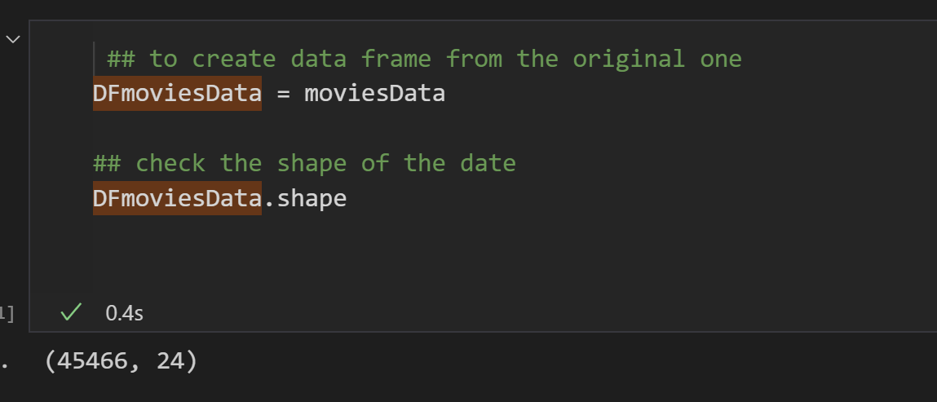
Figure 14: Showing the shape of the dataset.
Because there are many unwanted features and unrelated to the project targets, a data selection will take place to choose only the required features, giving more accuracy with less time than running the whole dataset. and due to the noises in the data, it is a bit difficult to visualise everything in this dataset especially by genre.
So, by using Tableau software Figure (15) shows the count of movies from 1950 until 2014, and as we can notice the number of movies has been increased significantly in the last 15 years.

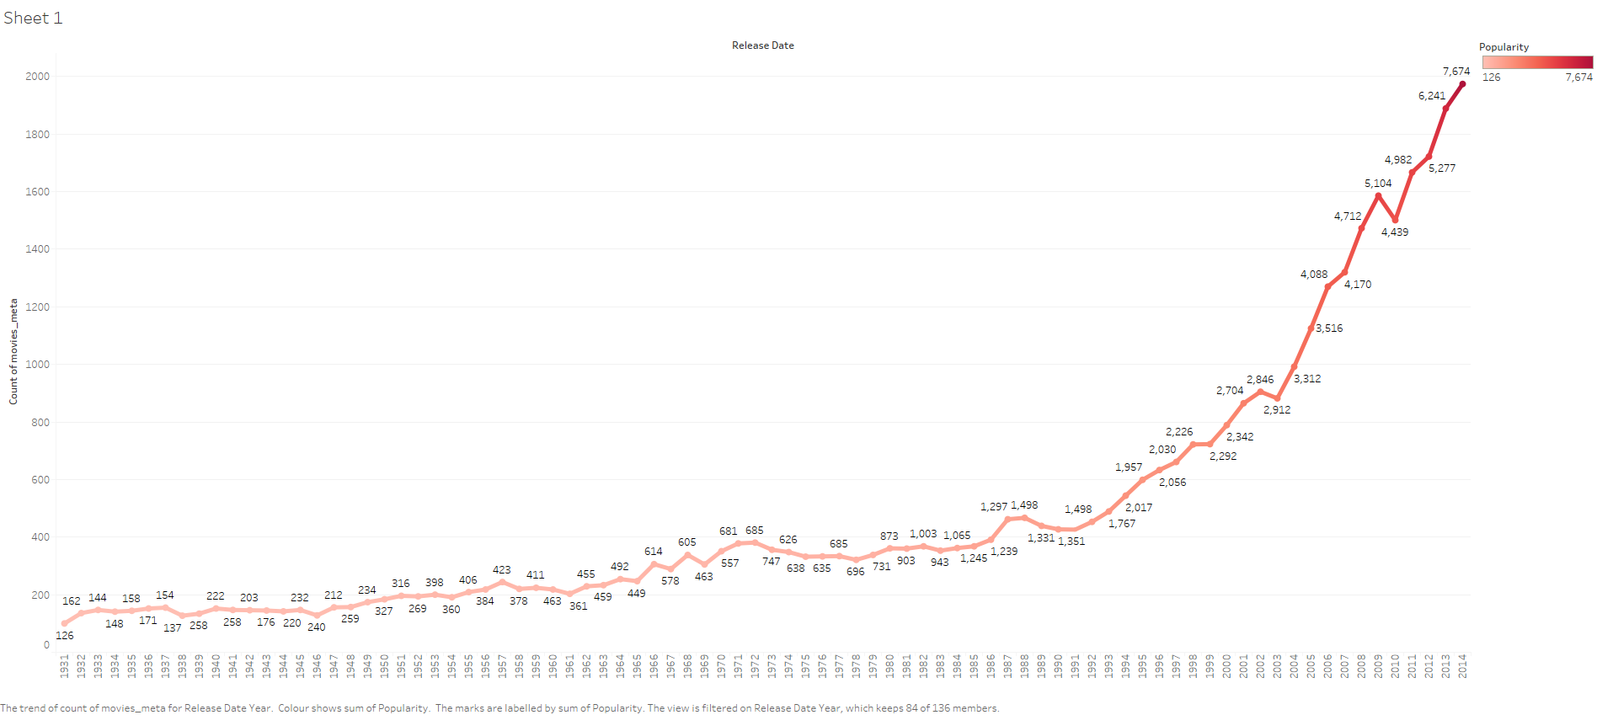
Figure 15: Data exploration, Increase movies over years
In Figure (16) shows the initial dataset from excel file sheet.
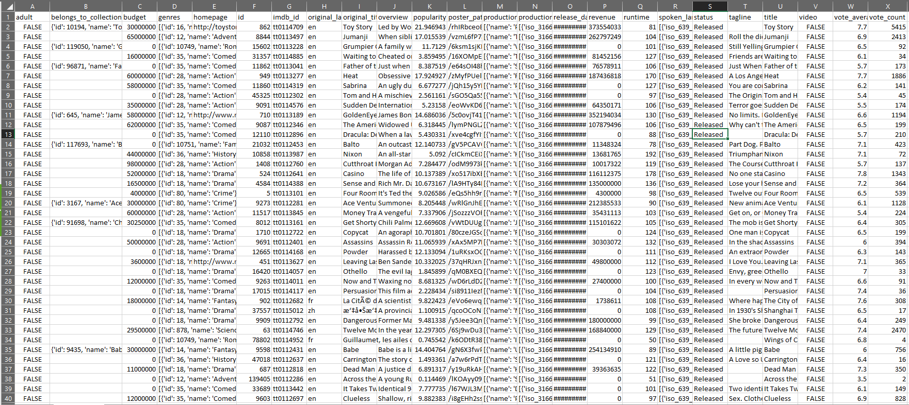
Figure 16: Row dataset in Excel file.

Data Quality
As mentioned above in the Initial Data Collection, the data was collected from MovieLens and TMDb and Google Datasets, which are considered as one of the important sites for downloading data for this purpose. So after exploring and reviewing the data In terms of checking data quality, it was found that there are some missing data and unclean entries such as lowercase or uppercase letters combined with each other, not to mention the presence of some unwanted characters or punctuation marks such as (?, !, “, <, ^). apart from the data missing and its noises, the data is meet the business goals and is suitable for the purpose of this project, it can be said that this data and its characteristics cover what is required to complete and achieve the identified objectives as well as the accuracy, validity, completeness, and consistency.

Data Preparation
To achieve better accuracy and performance, the entered data must be prepared and cleaned properly in order to apply the modelling process, and it is known that the raw data usually carries a lot of noise inputs that must be cleaned or columns that are not required for the desired goal, so this part considered as an important part and take a bit long to finish, which is called Data preparation, data munging or data wrangling, the aim of which is to develop the final dataset, and as a data scientist, it should consider a few stages in terms to pass the data preparation, as it shows in Figure (17) which it was made by the author to describe his approach of doing this project, the data preparation includes gathering the data, discovery, cleaning the data and validation, attribute selection, transformation, Integrate data and others, in order to make this data ready for modelling. so, the initial data has been uploaded to Tableau software to prepare it by following the steps below:
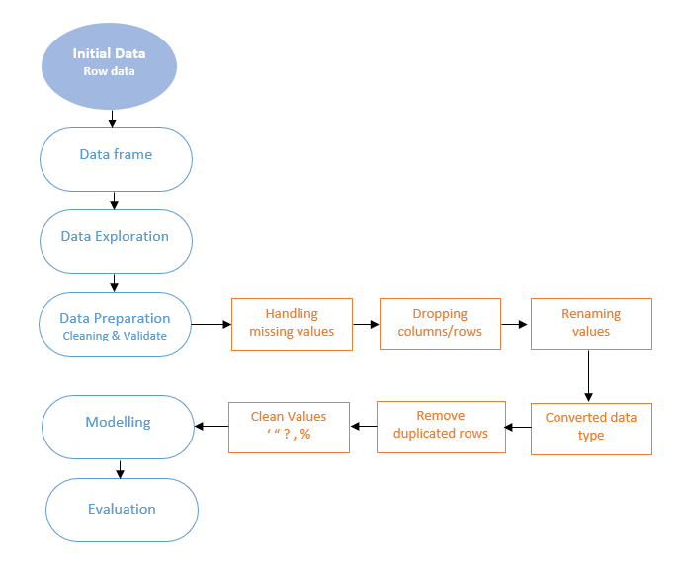
Figure 17: Data Preparation steps.
Data Selection: The unrelated and unimportant features have been excluded from the dataset such as (budget, production_company, _production country, revenue, runtime, spoken language, tagline, video, poster_path, homepage )
Splitting values: Some column has data with different values, so splitting them into different columns can give a better read for the values
Cleaning values: There are many techniques used in relation to the implementation of this part and each tool has different benefits and is not limited to them, such as Excel, Tableau Prep and Python, where the researcher intentionally implemented them to show the ability of those techniques and how these methods can reduce time and effort instead of using and applying all the steps in one style.
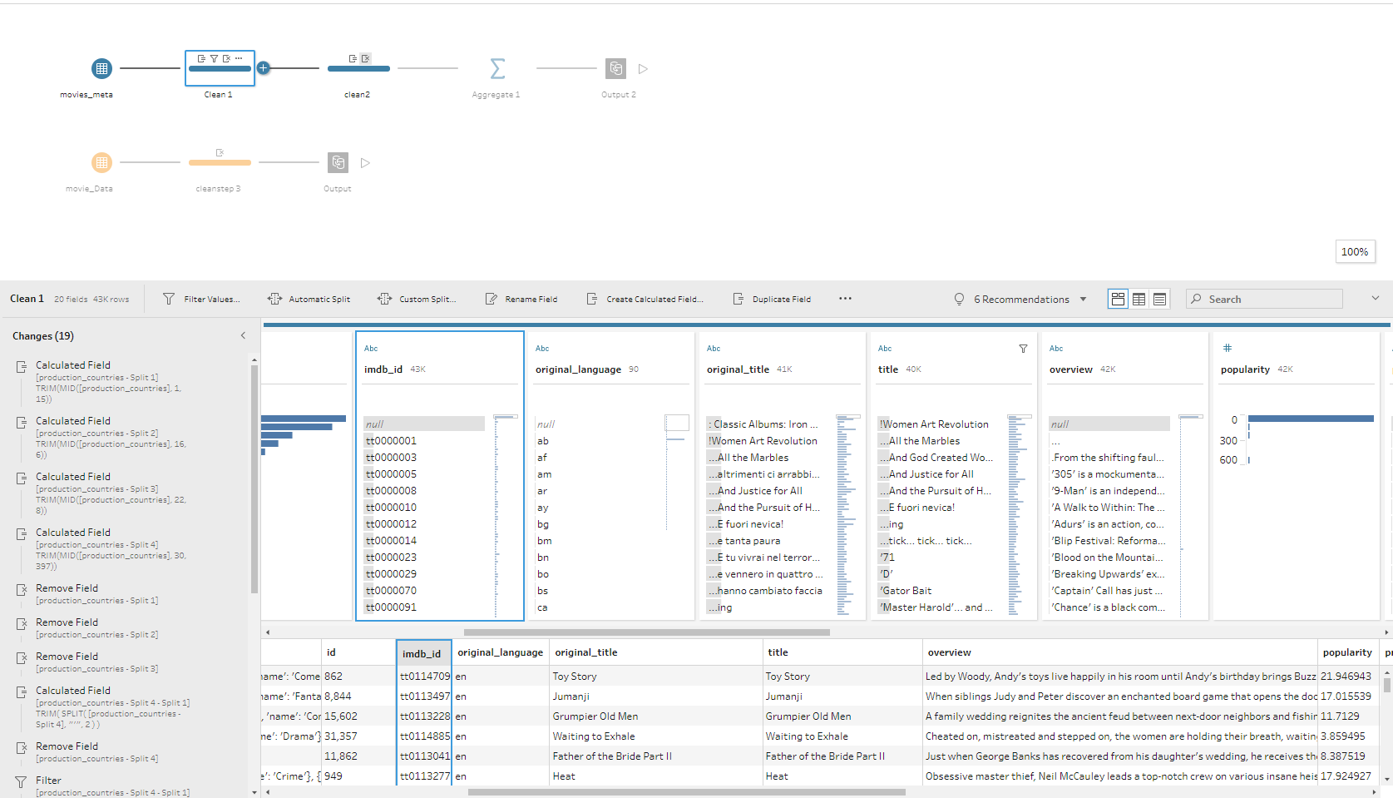
Figure 18: Data cleaning using Tableau Software.
So, few steps have been done in Tableau as it shows in Figure (18) for cleaning values such as Renaming some columns and values correctly, converting data type for some of the columns, getting rid of and dropping the duplicated rows in (Oridignal_title as the title is the only place that can catch if there are any duplicated rows), as well as checking and handle missing values Figure (19).
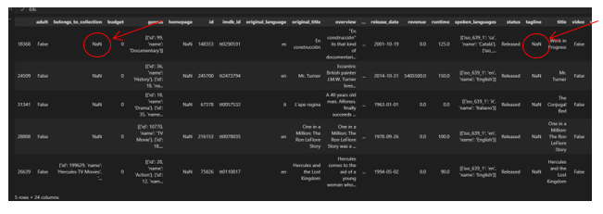
Figure 19: Checking data with empty data or no values.

Modelling
After finishing the data preparation and passing all the steps to make the data ready for modelling, it is time to apply the algorithm to the data to show how can recommend system works.
There are several approaches and algorithms that can be used to implement movies recommended system, and in this project, the author has used the following techniques:

Mean Rating:
As a first step in the implementation side and in the position of cold start challenge as described before, when there is no information for a user, the recommendation will be the same for all users.
So, this approach is measuring the average absolute differences between the actual valid ratings given by the user and the ratings predicted by the system to which the recommendation is applied, which it can be done by calculating the mean ratings and then getting the sum of the number of ratings for all movies, therefore, combining them to predict the best number of movies as it shows in Figure (20), which is obtained to get the top 5 movies based on rating and ratings mean and following the mean formula.
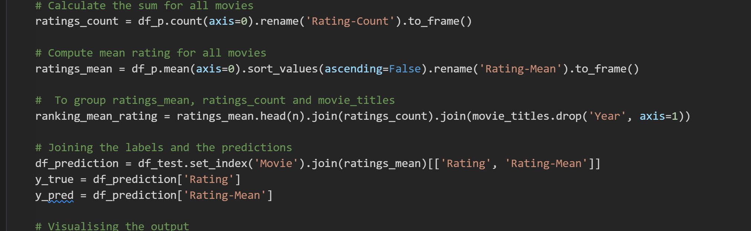
Figure 20: Getting the Mean Ratings.
This is considered as a basic or normal predictor, and as it shows in Figure (21) the best 5 movies predicted.
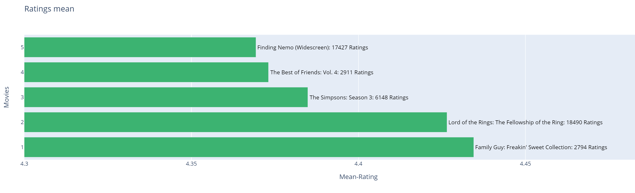
Figure 21: Predicting the top 5 movies based on Mean Ratings

Weighted Mean Rating
Because there are many movies with few ratings which was a challenge for some companies that there were using the previous approach, and to tackle this issue IMDb [156] started using the weighted average ratings in their recommendation system [157] to rank the top 250 films based on users' votes which they get it from registered users who vote regularly, which the weighted rating formula considered as equivalent to a Bayesian posterior mean[158].
So, in this scenario the average mean has been calculated Figure (22) with the sum of ratings and set the minimum voters to 500 to apply the Weighted rating formula:
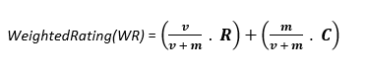
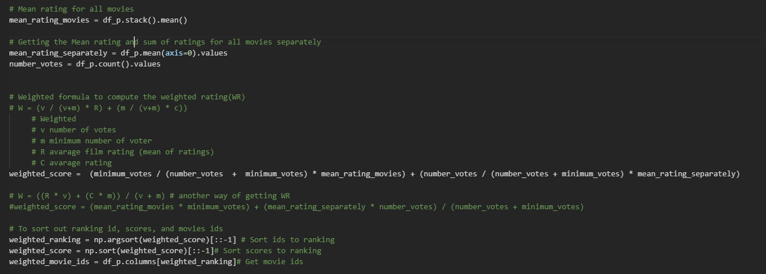
Figure 22: Calculating the means and applying the Weighted Mean Rating formula.

To test and evaluate the model with MEA, the result was 0.99245 MEA which is good for the first step.

Cosine Similarity (User - User)
Cosine similarity applies the cosine value of the angle between two vectors in vector scope as a gauge of the difference between the two humans. The nearer the cosine value is to 1, the closer the angle is to 0 degrees, that is, the two vectors are more similar, otherwise they are not [159][160].
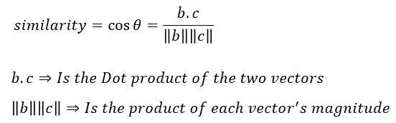
In this model, the scikit learn library was used to import a built-in cosine function to be able to compute the similarity between all users Figure (23), then the number of similar users to recommend was set to 100 which the goal is to give us the top 10.
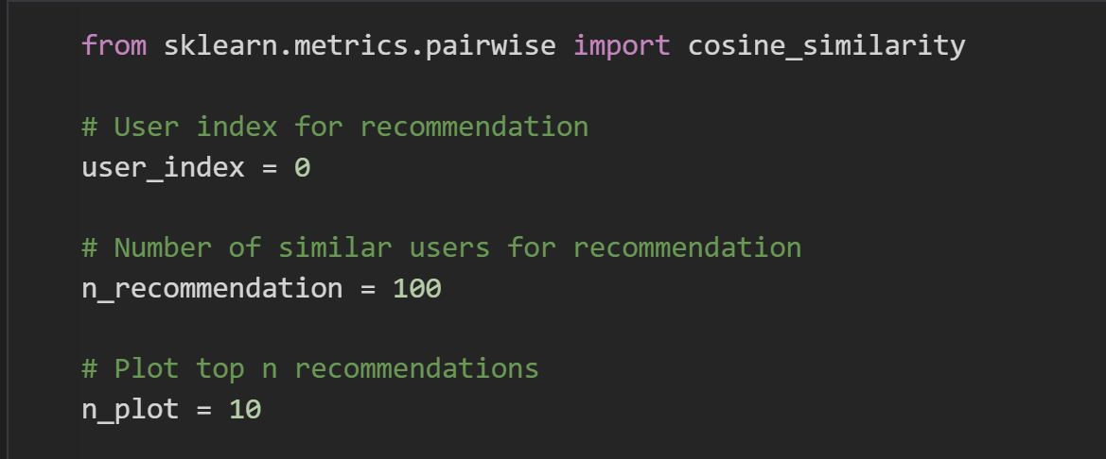
Figure 23: Setting up the number of similar users for a recommendation.
To find all similar users and act on recommendations to the user, we need to calculate the similarity of all user vectors, which can be done by transforming each row of the array to use as a vector.
Because there are some empty values the best approach is to fill them is by getting the mean of each user, then weighted all similar users’ ratings with their similarity score as well as calculating the mean for each movie, and then filtering the unrated movies to get better recommendation Figure (24).
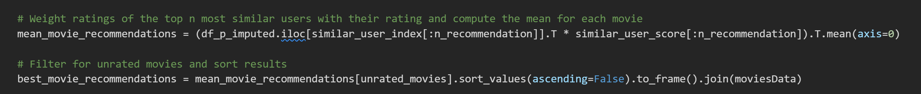
Figure 24: Calculating the top similar users with their ratings.
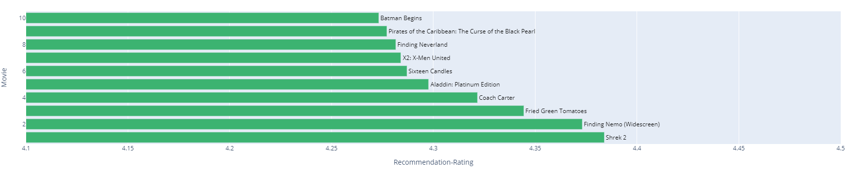
Figure 25: Initial result of Cosine similarity.

TF-IDF and Cosine similarity
TF-IDF is refer to “term frequency and inverse document frequency”, and this approach is used for content-based filtering to recommend movies based on users’ activity in the past. This approach is a numerical statistic used as a weighting factor in text searches, information retrieval and user modelling, and this approach aims to evaluate the importance of a word in a given document by looking at the weight of that word and the number of times it appears[161].
The term of TF-IDF can be explained separately as TF and IDF which:
- TERM FREQUENCY (TF) refers to several times a given term appears in a document, and then the TF will be divided by the total number of terms in the document.
- Inverse Data Frequency (IDF) Is checking and measuring if a word is popularly used or uncommon in certain documents, and that can be gained by dividing the total number of documents by the number of the document containing the same word in the set of documents.
For example, in a book on mathematics, it is obvious that the emergence of the word mathematics or algorithm or algebra will be common words. So, this method assigns weights to each word according to the following formula. For every word i in document j, the following equation applies[161]:
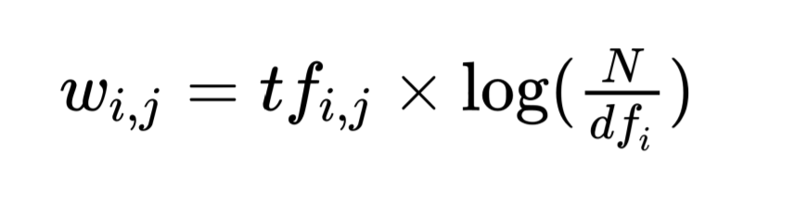
"wi, jis" weight of word "i" in document "j", and "N" is the total amount of documents, and "dfi" is the amount of documents that contain the term "i". In Figure 26 shows how the results can be when using TF-IDF in python.
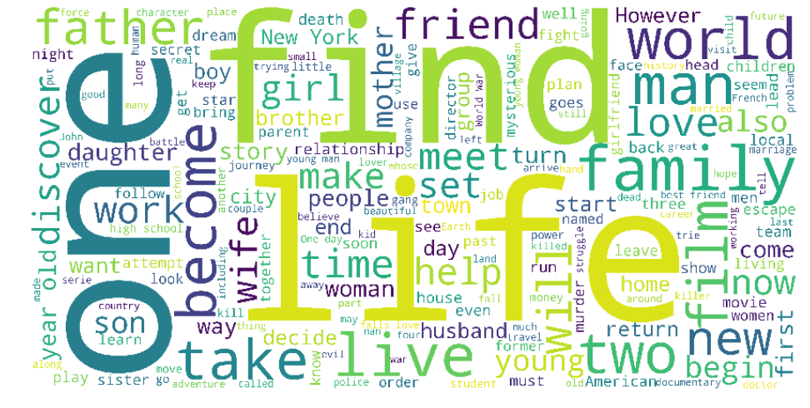
Figure 26: Result of TF-IDF approach[161].
The reason for using TF-IDF with cosine similarity (describe it in the previous model) is to speed up the calculation of cosine similarity score between a pair of documents.
So, in this scenario, because there is no history related to users, the mode will compare the movies to find similar movies and that can be done by creating TF-IDF matrix. So, by importing a scikit learn library we can use a built-in function called TfidfVectorzer to create a matrix of comparison, and that can count and weights words in moves’ descriptions, and then by using the built-in function cosine_similarity to calculate the similarity between all movies’ description.
After removing the self-similarity from matrix by assigning it to "eye" parameter that provided from np (NumPy library), then we can indicate to a certain word (name of movies) to let the system find it by getting the indices and scores of all similar items in the dataset Figure (27).
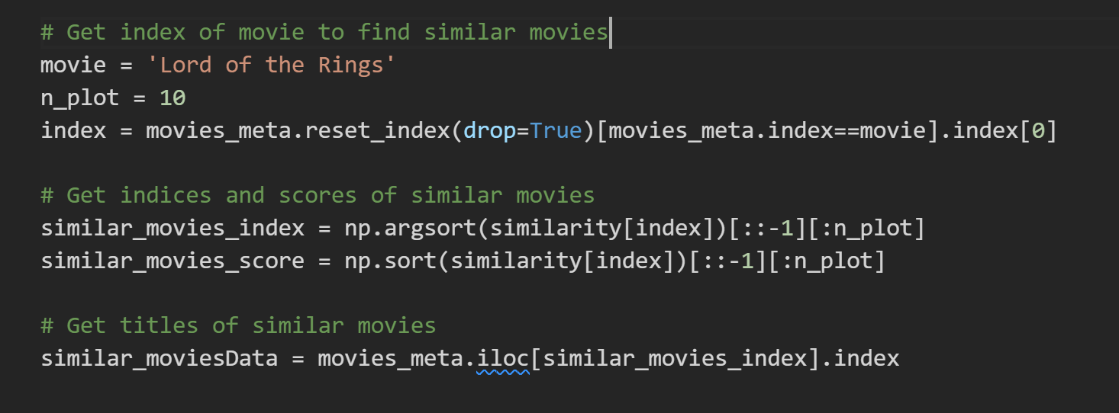
Figure 27: Setting the plot parameter and getting indices & scores of similar movies.
Because this model is not aiming to recommend the movie exactly, it cannot calculate the RMSE score.

Secondary data processing
While executing the models, it was found that the data still needed more processing to produce better accuracy and reduce the time to work with the data, this could be by:
Data Selection: Another data selection has been done as some of the models do not need to handle all features.
Excluding values: by excluding the little rated movies and small rating users from the dataset to decrease the dimensionality of the data.
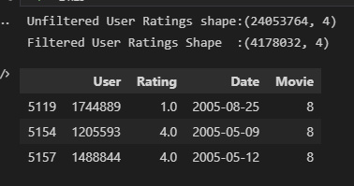
Figure 28: Excluding small, rated movies and small rating users.
As it shows in Figure (28) the data that going to keep now has around 4.2m ratings rather than 24m, so excluding the unused data can minimize the time significantly, especially when applying modelling and training the data.
Converting values : Converting values in user rating to be as matrix in user movies will give us rows that represented users with ratings and the columns represented the movies as it shows in Figure (29). Those empty values are the unrated movies, which the benefit of this converting can estimate those values to help users and provide a viewer better recommendation.
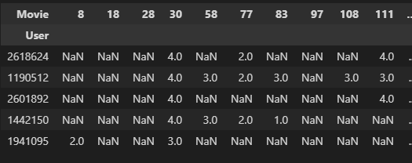
Figure 29: Converting empty values

Matrix factorization & Gradient Descent (MF & SGD)
This Algorithm is one of the most popular model-based collaborative filtering methods and called Matrix Factorization or as known as "MF", and it is a factorization of a matrix into a product of matrices by decomposing the user-item interaction matrix into the product of two lower dimensionality rectangular matrices[162]. The formula of the MF can represent as:
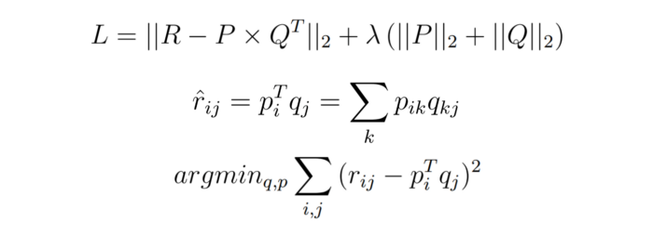
As it shows in Figure (30) using MF will give us a result of how much can a user be aligned with a set of latent features, and how much a movie right into this collection of latent features.
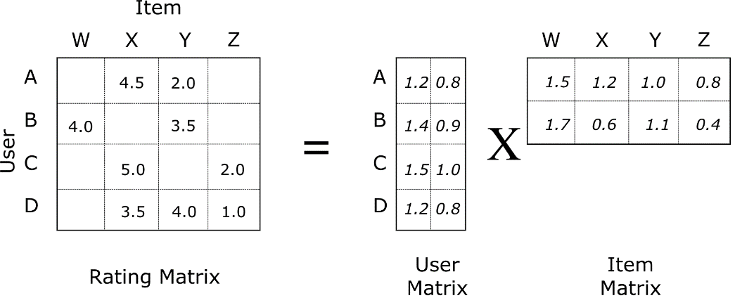
Figure 30: Matrix Factorization of Movie Ratings Data.
So, the MF is a latent factor model that seeks to find latent factors for both users and items inherent in the data, and that can be done by creating a low-rank matrix approximation of the rating matrix. which to tries to map users and items to a joint latent factor space.
The reason for using Stochastic Gradient Descent (SGD) aiming at finding a local minimum of the difference and minimize the cost function, in turn, these latent variables can then be used to rebuild the original matrix and predict the ratings that have been missing for each user.
So, in this scenario, a “TensorFlow” library has been used to import several build-in functions and create the model.
After creating the mapping for the user and movie id and setting the train and test sets for each of them, the embedding layers were created by using the built-in function "Embedding" which is from "Keras" library.
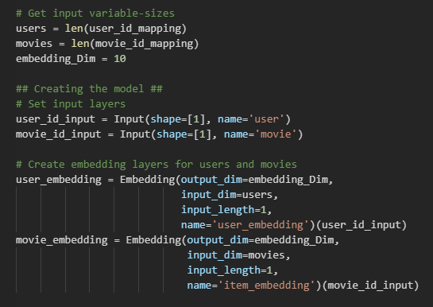
Figure 31: Sitting model layers and embedding dimension size
The parameter for embedding dimensionality size has been set to '10' at first to reduce the time training as shown in Figure (31), the calculation of Dot Product has been done by using the build-in function “Dot” from Keras, after using several optimizers the best one was 'adam' with the Mean squared error “mse” as loss function, as ‘adam’ provide an optimization algorithm that can deal with sparse gradients on noisy issues. The hyperparameter in this model has been set to validate split with 0.1 only.
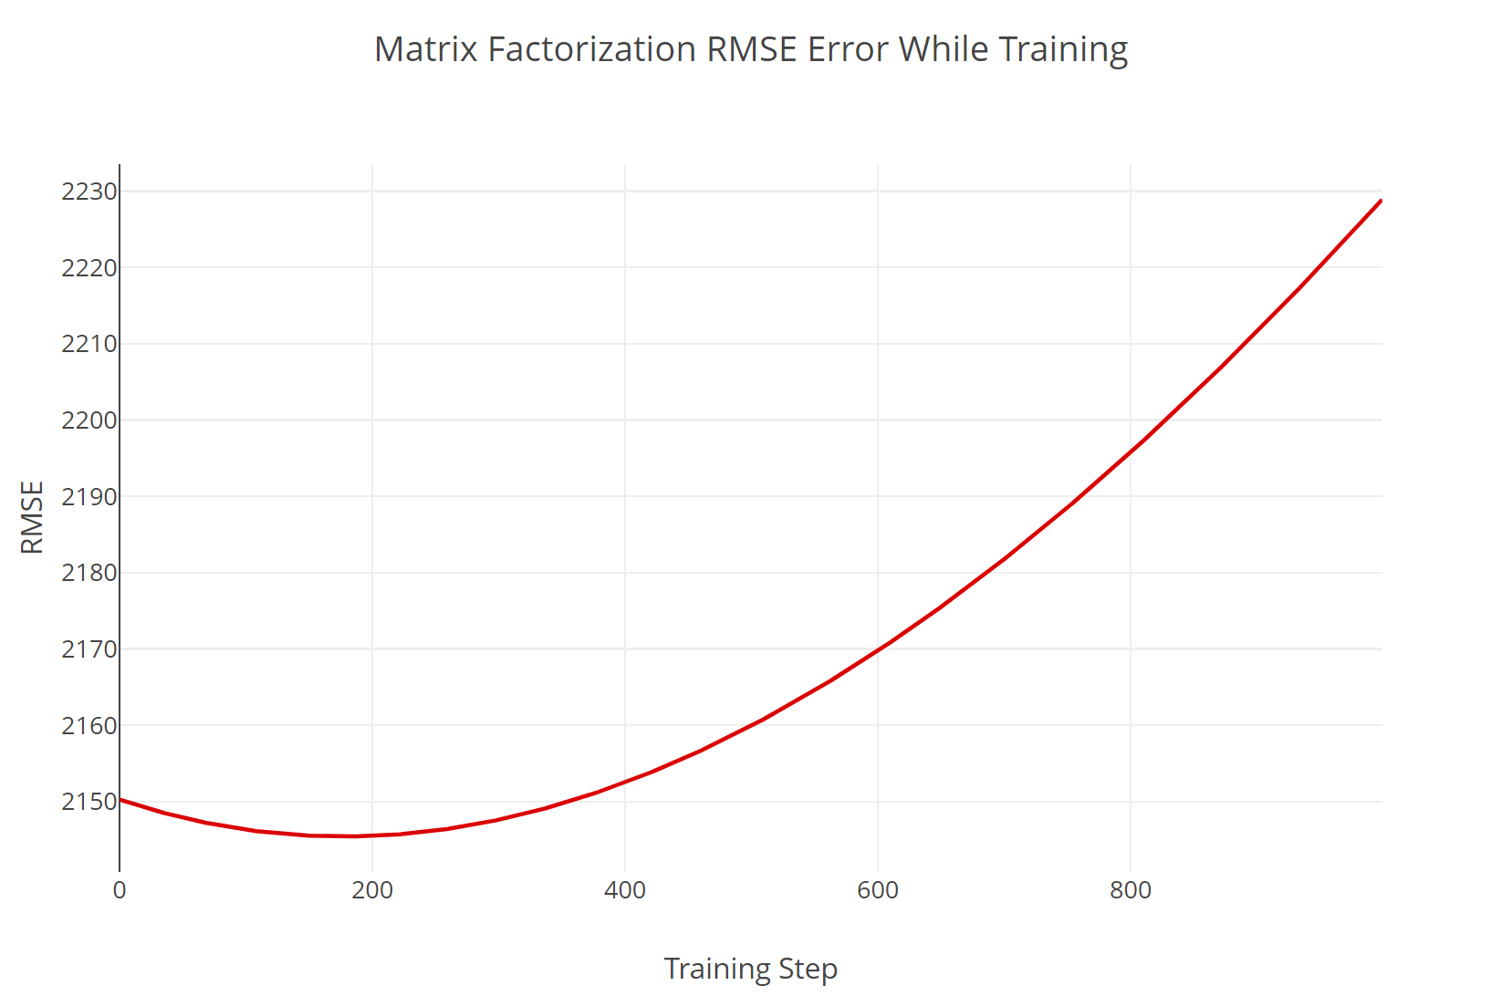
Figure 32: RMSE Error.

Deep Hybrid system
Deep learning is a broad and large science that cannot be summarized in all its aspects in a few lines, but the main idea is that the DL is a subset of machine learning, a technique invented by humans in order to try to imitate the way the human mind works [163] based on a neural network consisting of many layers represented by three or more layers, which allows learning from even large data, while a single-layer neural network can still make approximate predictions, and additional hidden layers help improve accuracy and efficiency [164], and Pinnapareddy [165] described the formula of the neural network predictive model as:
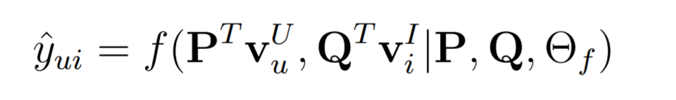
As discussed in the literature review section " 2.4.3.4", the hybrid system is combined two or more different recommendation strategies in several ways to achieve as much as possible from their complementary advantages. Where Deep learning recommendation models aim to model interactions between variables and embeddings to handle categorical variables and these models rely on techniques that already exist like matrix factorization[165].
Which the embedding is a learned vector of numbers that represents the features of an entity so that similar entities have similar distances in the vector scope like (items or users)[166]. For instance, based on user and item interactions with a neural network, a DL technique to collaborative filtering learns user and embeddings (latent feature vectors).
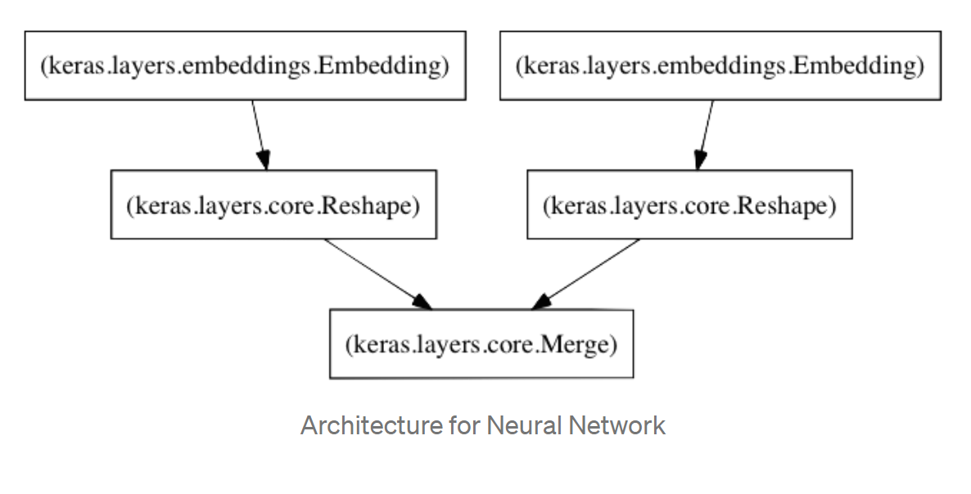
Figure 33: The architecture of neural network used.
So, in this scenario, the idea of using deep learning is somewhat similar to the one used in the previous model in the matrix factorization, so after setting up the mapping for user id and movie id, it required creating a text comparison matrix which needs to shorten the description of all movies to a sparse vector which It can be achieved by using TF-IDF through the data overview attribute.
And by using deep learning and matrix factorization, it can create a model that can learn how to merge the data with the embedding of the move id and user-id.
On the embeddings side, there are two separate embeddings created Figure (34) the first one is for the users and the second one is for the movies with an output dimension of "10" for both of them, and the same input dimension of the user-id and movie-id.
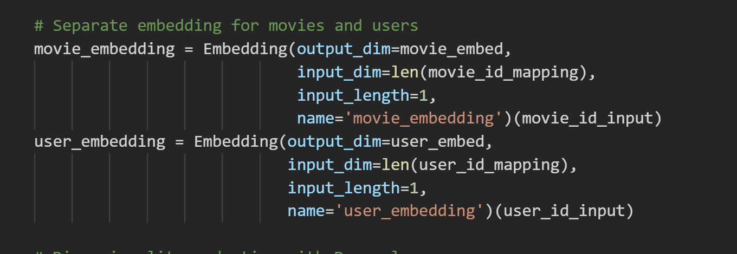
Figure 34: Setting embedding for movies and users on Deep Hybrid system.
for the dimensionality reduction for the vectors, a "relu" activation function has been used, and then reshaping the embedding layers for the user and movie.
Creating and compiling the model has been set by assigning Mean Squared Error “mse” as loss function and "Adam" optimizer to accelerate the algorithm.
Validation split has set to "%10" in the training and testing the network with the ability to shuffle the data Figure (35).
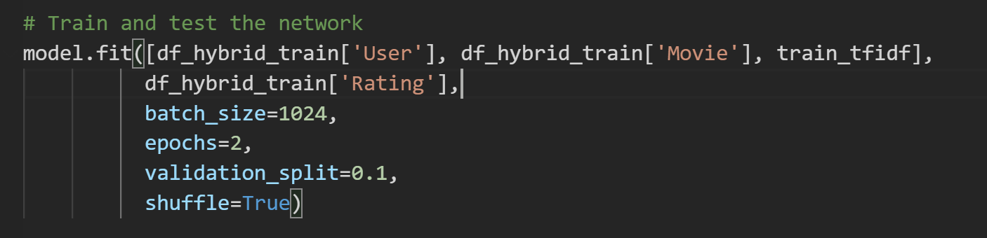
Figure 35: Setting the train and test network in a Deep Hybrid system.
As quick a test for the evaluation in Deep Hybrid system, a Mean Squared Error function has been created to check it, and the result was 0.9581 MEA.

Conclusion
In this section, there is an application of the movie recommendation system that was applied using a few data sets to give the ability to apply different approaches, and a wide explanation was made in terms of data pre-processing and how to make the data ready to work with an explanation of the data, its environment and its suitability for the project, and then this section touched on how to apply the models, techniques and algorithms used in addition to the techniques used when building the system to get good results,
In the next section, these models will be evaluated and the results that they were able to achieve will be explained with a comparison of these results in several ways.

Evaluation
In terms of evaluating the models, there are several different methods/metrics for finding how accurate the model is, and according to some research[167][168], the best and most popular metrics that are used for recommender system is Root Mean Squared Error which is known by RMSE.
This metric is the most used in evaluating the accuracy of predicted ratings and has become hugely popular because it is the same one that used in the Netflix Prize Contest. It calculates the square root of the mean square of all errors between actual ratings and predicted ratings[169] and is defined as:
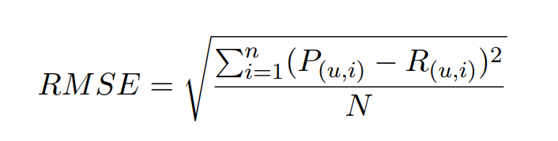
The “RMSE” scale is suitable for cases where small prediction errors are acceptable, for example, prediction of a value of 3 instead of 4 is acceptable, but 4 instead of 0 is rejected because when some values ​​of individual errors increase, the value of “RMSE” increases as one large error increases the value of “RMSE” significantly. Thus, given a test set of 4 hidden items, the "RMSE" scale will prefer a system that erroneously scores 3 over only one assessment and does not base an error on the remaining three assessments[170].
So, in this scenario, as shown in Figure (36) the mean_squared_error build-in function has been used, which this function provided by the scikit-learn library to be used to calculate the square root "sqrt", to get the RMSE to be evaluated and validated metric for the solutions above.
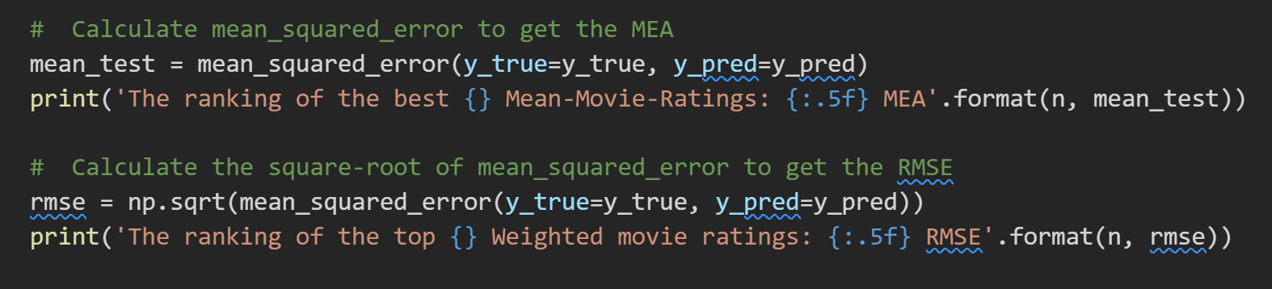
Figure 36: MEA & RMSE calculation.

Mean Rating:
During implementation, an initial evaluation was made by calculating the mean squared error whose result was 0.9653 which is a good result to achieve, so in this part, another test has been done by applying RMSE to check the performance of this model.
The results of calculating the square root of mse were very good as well which is 0.99598 RMSE Figure (37), and accordingly, it can be said that the ranking of the top 10 movie ratings shown in Figure (38) is quite accurate, which means that the recommendation process is good for a user who has no history or history about the favourite movies or as it is known by cold start.
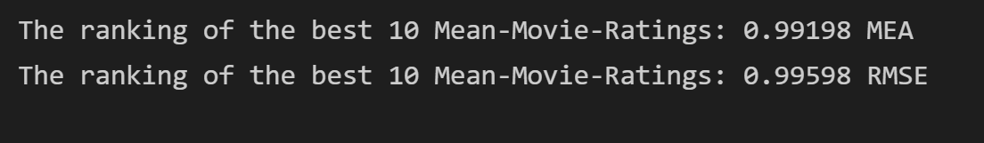
Figure 37: MEA & RMSE results of Mean Rating.

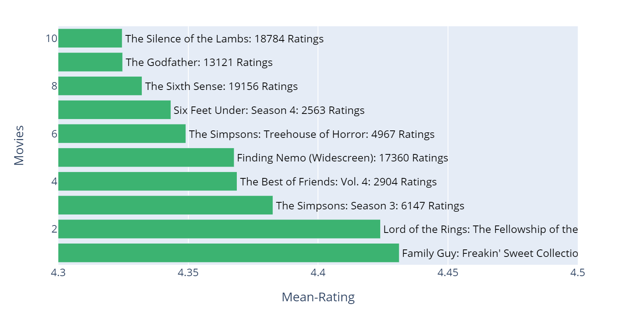
Figure 38: The ranking of the best 10 Mean-Movie-Ratings:

Weighted Mean Rating
In this model and after calculating the weighted mean rating by using RMSE, the result achieved is 0.99622 RMSE as shown in Figure (39) which is pretty good to recommend the user the ranking of the top n Weighted-movie-Ratings,
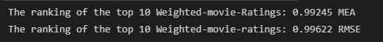
Figure 39: MEA & RMSE results of Weighted Mean Rating
which n can be seen as regularizing parameter. where this recommender can provide a general recommendation for all users Figure (40) and not related to an interest or history of a user, which can be helpful for the cold start issue as well, and unfortunately will not be helpful to recommend what the user's preference
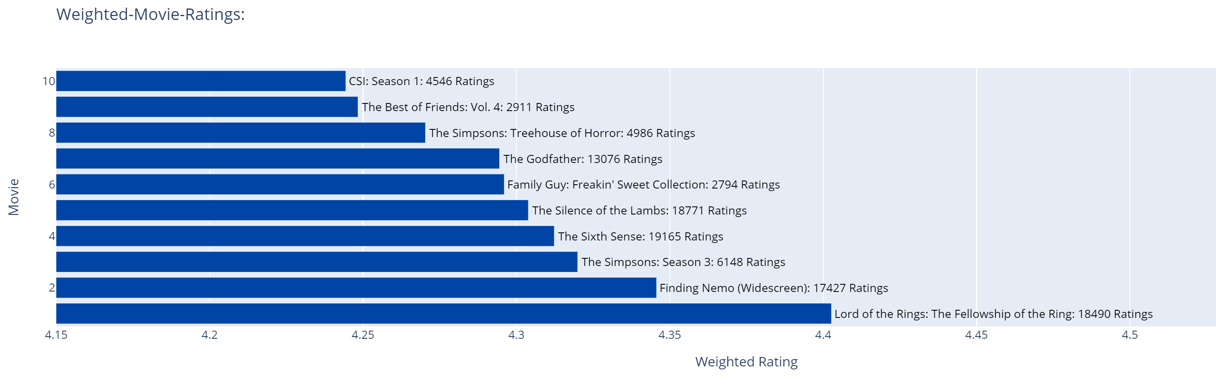
Figure 40: Output of the best 10 movies based on Weighted Mean Raring.

Cosine Similarity User-User
In this model while calculating the similarity for the user-user recommendation the results were not acceptable which we have 1.3360 RMSE Figure (41).
Figure 41: MEA & RMSE result of Cosine Similarity.
The issue with this way is that the number of users is a lot compared with ratings which can be ending up with a spares matrix and use large resources.
This way can be used to find similar items by calculating item-item similarity which can be better for a different type of recommendations.

TF-IDF and Cosine Similarity
This approach works well and gives us recommended movies that are similar to what we are looking for, and for example and as shown in Figure (42), if we try to find a similar movie called “Batman” it will give us a recommendation for the same movies based on the description of the movie that data contain.
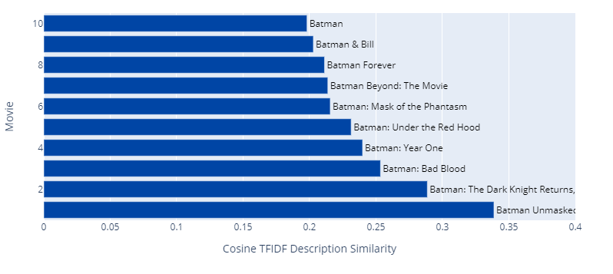
Figure 42: Result of top movies using TF-IDF & Cosine similarity.
The Issue that has faced during the implementation is that:
When trying to get a calculation of the cosine similarity between the descriptions of all movies, an error appears in Figure (43) and states that there is a lack of memory.
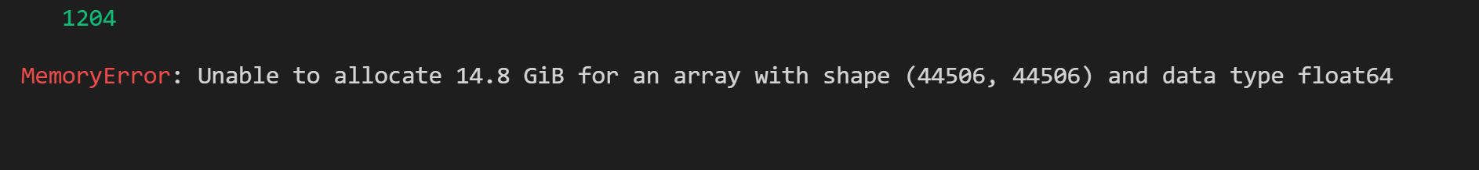
Figure 43: Lack of memory error in TF-IDF
So, the issue with this method uses lots of memory, and in each single change in the code it needs to clear the memory by restarting the whole Kernel and running everything again, which that takes more time, and is considered kind of wasting time, but for sure there is some solution that can help to manage to go around this issue.

Matrix Factorization & Gradient Descent
The result of using the matrix factor was very good compared to the other models implemented above, which can be demonstrated by achieving better accuracy when calculating the Root Mean Squared Error, which it is achieved 0.9312 RMSE as Figure (44) shows:
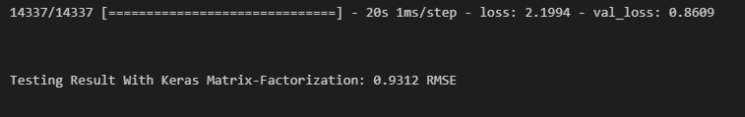
Figure 44: Matrix Factorization & SGD RMSE result.
As predicting ratings is a critical move when making personalized recommendations and the applied algorithms predict the ratings with satisfactory accuracy, especially the scalability and sparsity are considered as big challenges for the recommender system, as the matrix factor can solve this issue by decomposing the original scattered matrix into low dimensional matrices with fewer variance factors and latent factors. As well as the using of SGD was a simple to implement and learned models quickly. So as a result Figure (45) the ranking of the best movies that are recommended to the user.

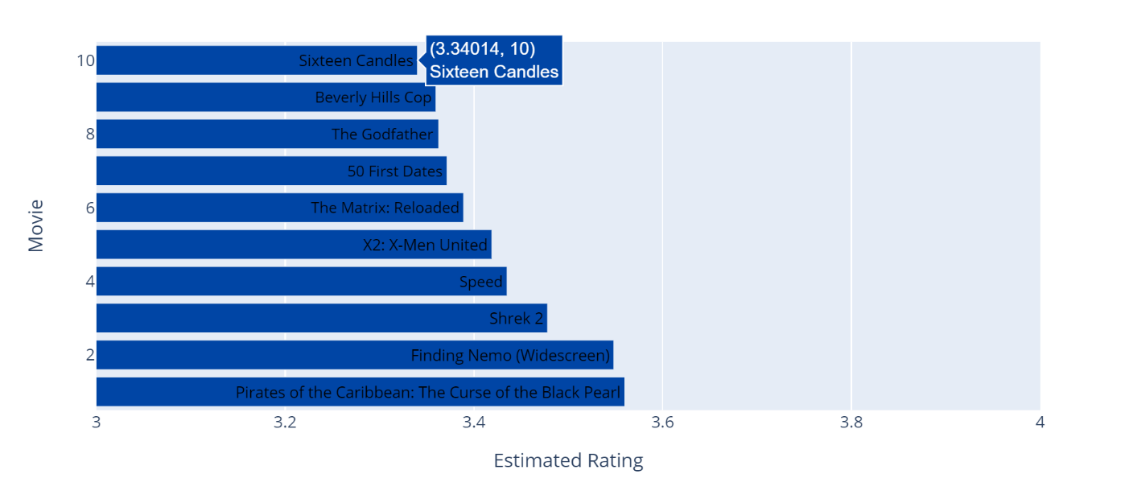
Figure 45: Based on Matrix Factorization the ranking of the best movies recommended to the user.

Deep Hybrid system
Using this approach was quite useful to introduce combine features especially the ability to leverage from existing techniques and companies between them such as matrix factorization and TF-IDF produced better recommendation results, as well as this model concatenates categorical and continuous features into ID embeddings and makes latent features of items and users stronger.
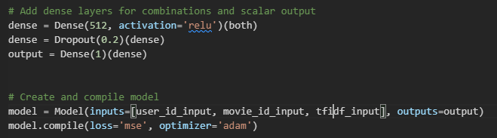
Figure 46: Adding dense layers in Deep Hybrid system.
The result of implementing this approach and adding several layers Figure (46) for combinations and scalar output and splitting the data with %10, that produced good result with 0.9759 RMSE Figure (47).
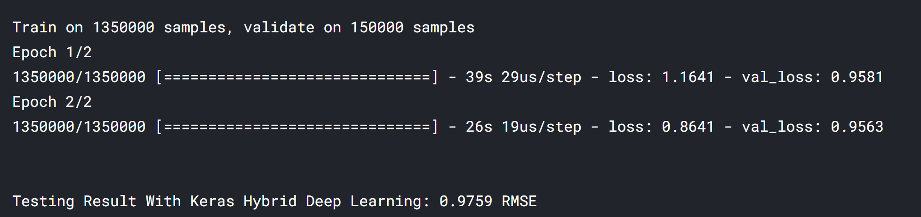
Figure 47: Result of RMSE using Deep Hybrid system.

Comparison of models
Comparing all the models implemented in the previous section will be based on their results when calculating the Mean Squared Error (MSE) and Root Mean Squared Error (RMSE) in turn to evaluate the accuracy of each model.
Classifier | MSE | RMSE | Comments
Mean Rating | 0.98677 | 0.99336 | - Works good for new users  - Cannot recommend movies based on preferences
Weighted Mean Rating | 0.98712 | 0.99354 | - Can recommend general movies only
Cosine Similarity U-U | 1.76578 | 1.3288 | - Can recommend movies based on similar users’ ratings
TF-IDF Cosine Similarity | N/A | N/A | - Produced quite accurate results between similar movies.  - Issue with lack of memory
Matrix Factorization & SGD | 0.8572 | 0.9258 | - Can predict ratings and produce
Deep Hybrid System | 0.9581 | 09563 | - Can work in both ways
Table 2: Comparison of models results.
As It shows in Table (2) the best accuracy has achieved is in Matrix factorization & SGD as this approach works very well in term of accuracy and processing time which was a bit fast comped to other modes.

Research Question
- For the first question in the business question, if data mining can be the best solution for creating a recommender system, we can say yes, data mining is the best aspect to consider, because without data mining and data science there will be no recommender system, which that will affect Users before companies, as the ability to work with data to know user' needs, and what users prefer can give successful use of this system.
- Also, data mining can provide a recommendation based on the user's previous views as mentioned above, a recommendation system can make a recommendation based on the user's history and preferences or seen before and create a recommendation based on that which has already been tried when performing cosine similarity modelling.
- The first and second models implemented can prove that the recommendation system works well and recommend movies to users without knowing their preferences or interests, as these recommendations will be general and based on the popularity of the movie.
- The ability that was discussed while implementing the TF-IDF with cosine similarity by analysing the movie description and find similar movies based on their content that can proof the recommender system is able to predict a user’s preference of an item or movies.
- It is difficult to say which model was the best because each one of them can be used in different sides or different needs, but mainly the author can see the Deep Hybrid system is better than other techniques that can be used in recommender system which gives us the ability for several algorithms in one time, and in term of the processing time the Matrix Factorization with Stochastic Gradient Descent were a bit faster than other models.

Conclusion
In this section, the evaluation of the implemented models was discussed including the results obtained for each of them and what issues occurred during the implementation, which all the results were fully acceptable to meet the objectives of this project and can show the ability to use data mining as the best solution to implement the recommendation system and how these models can provide accurate results for recommending users their favourite items or movies in term similarity and popularity, as well as discussing the best algorithms used in the model and their performance.
In the next section, there will be a conclusion of the implementation of this project and a recommendation that can be made for its improvement in the future.

Conclusions and Recommendations
In this project, the author has done research that covered most of the aspects related to the main idea of recommender systems in brief to convey a simple idea about the process of these sciences. Where this project began with a literature review on the main matters of the origins from which the recommendation system arose, where the literature review was structured on a hierarchical basis, apparent in the main idea, which is machine learning, from which many of the sciences and techniques are currently used, and then included in the second part the natural language processing. The third part was Sentiment Analysis, which is one of the very important techniques for many companies, as this research permeated the meaning of sentiment analysis, history, and the techniques used with its challenges. In the last part of the literature research, which is considered the important section, a broad explanation of the recommendation system has been included and ​how it works, what its tools are, and what this system depends on, in addition to its types and the problems it faces.
The second section of this project included the methodology used in all aspects and what strategies will be applied, in addition to explaining the project development methodology in practice, in addition to the tools required for its implementation.
In the third section, it included about the practical aspect of the project, the exploration questions, the data used and their cleaning, the modelling methods, the approaches, the algorithms that were used, and how to apply them, through a simple explanation of each approach, including what techniques have been used to implement it.
To evaluate the project from a practical point of view, the fourth section included the results achieved by this project in each of the approaches applied in the third section and some of the problems that appeared during implementation and a comparison between them to show the best approach implemented in this project.
In terms of recommendation, the author noted that several aspects can be added to the project to be more useful, as there are many research directions that can be followed to improve the capabilities of recommender systems and make them applicable to wider areas of applications. For example, the recommendation system must consider the possibility of changing the perception of elements over time, which means that a user who prefers comedy movies may change his preferences after a period of time to become romantic films or action films and this applies to other things such as the unhealthy person It is possible to change his preferences and foods to healthy foods. Also, the use of language as a factor of recommendation, which means the dependence of this feature on the community or the user,
In the end, the author believes that the system must adopt more than one approach and algorithm to implement its recommendations for this recommendation to reach the largest possible number of accuracies.

Reflection
With the increase in data in a huge amount, recommendation systems become valuable sources for companies and users who are trying to get what they care about from this data, as it generally aims to alleviate the problem of information overload and provide users with suggestions and recommendations of items so that they are of a personal nature and useful to them, these suggestions can help users to make better decisions when choosing products or services that are likely to be of interest or relevant to their needs.
Because this project has covered several aspects in the literature review, it has given greater benefits and the ability to search more in details in some areas, which was very interesting to dive into those research by reading their history, what they are, how they work and other important sides, as the author noted that there are many ways to implement this project in the practical side and using available built-in functions and libraries, which on its part can provide a complete algorithm in just a few lines such as “surprise” library and others. and during the implementation of this project, the author has discovered many useful techniques in terms of data pre-processing which can help to reduce time and give better cleaning of noise data.
Through the experiments that were conducted, the author was also able to simulate the current reality through the data that These experiments applied to her, as some of the experiments were rather tiring but ultimately satisfying. Where it was found that each model differs from the other and provides different recommendations for the other approach, but the most interesting models were the ones that collected more than one method at the same time and through which they can be applied to many fields not limited to films only.
Understanding how the recommendation system works was a very interesting side for the author, as he was able to know how those systems works and those advertisements or emails, he receives based on what, and how they know how to include important things for users, or even when watching a movie or following something specific on social media. How the recommendation system recommends many things that are related to the things the author was looking for. with this project, the author has the ability to understand it and the ability how to implement it or use it on different sides.

References
[1] A. Smith, “Gig Work, Online Selling and Home Sharing,” Pew Res. Cent., Nov. 2016.
[2] C. Bădică et al., “Sentiment analysis of tourist reviews: Data preparation and preliminary results,” in Proceedings of the 10th International Conference Linguistic Resources And Tools For Processing The Romanian Language, ConsILR, 2014, pp. 135–142.
[3] C.-J. Wang, M.-F. Tsai, T. Liu, and C.-T. Chang, “Financial Sentiment Analysis for Risk Prediction,” Proc. Sixth Int. Jt. Conf. Nat. Lang. Process., no. October, pp. 802–808, 2013.
[4] A. Ligeza, Artificial Intelligence: A Modern Approach, vol. 9, no. 2. Malaysia; Pearson Education Limited, 1995.
[5] E. Rocha, “Sophia Exploring the Ways AI May Change Intellectual Property Protections Case Notes & Comments,” DePaul J Art Tech Intell Prop L, vol. 28, no. 2, pp. 126–146, 2018.
[6] J. Retto, “Sophia, First Citizen Robot of the World,” no. November, p. 9, 2017.
[7] M. Learning, Machine Learning, vol. 45, no. 13. 2017.
[8] J. Shavlik and T. G. Dietterich, Readings in Machine Learning. 1990.
[9] K. Kapitanova and S. H. Son, “Machine learning basics,” in Intelligent Sensor Networks: The Integration of Sensor Networks, Signal Processing and Machine Learning, 2012, pp. 3–29.
[10] M. Awad and R. Khanna, “Machine Learning in Action: Examples,” in Efficient Learning Machines, 2015, pp. 209–240.
[11] A. L. Samuel, “Studies in machine learning using the game of checkers,” IBM J. Res. Dev., vol. 44, no. 1–2, pp. 207–219, 2000.
[12] F. Kohavi, R. & Provost, “Glossary of terms: Machine Learning,” Mach. Learn., vol. 30, pp. 271–274, 1998.
[13] Steve Algieri, “Clarity on Artificial Intelligence, Machine Learning and NLP.”
[14] K. Srinivasan and D. Fisher, “Machine Learning Approaches to Estimating Software Development Effort,” IEEE Trans. Softw. Eng., vol. 21, no. 2, pp. 126–137, 1995.
[15] T. S. Guzella and W. M. Caminhas, “A review of machine learning approaches to Spam filtering,” Expert Systems with Applications, vol. 36, no. 7. Pergamon, pp. 10206–10222, 01-Sep-2009.
[16] M. T. Jones, “Models for machine learning – IBM Developer,” IBM Developer, 2017. [Online]. Available: https://developer.ibm.com/articles/cc-models-machine-learning/. [Accessed: 30-Sep-2021].
[17] M. Mohri, A. Rostamizadeh, and A. Talwalkar, “Foundations in Machine learning,” in SpringerBriefs in Computer Science, vol. 0, no. 9783319056050, 2014, pp. 39–44.
[18] E. Alpaydin, Introduction to Machine Learning (Adaptive Computation and Machine Learning series). 2009.
[19] S. B. Kotsiantis, I. D. Zaharakis, and P. E. Pintelas, “Machine learning: A review of classification and combining techniques,” Artif. Intell. Rev., vol. 26, no. 3, pp. 159–190, Nov. 2006.
[20] I. Muhammad and Z. Yan, “SUPERVISED MACHINE LEARNING APPROACHES: A SURVEY,” ICTACT J. Soft Comput., vol. 05, no. 03, pp. 946–952, 2015.
[21] S. B. Kotsiantis, “Supervised machine learning: A review of classification techniques,” Informatica (Ljubljana), vol. 31, no. 3. pp. 249–268, 2007.
[22] B. Rajoub, “Supervised and unsupervised learning,” in Biomedical Signal Processing and Artificial Intelligence in Healthcare, M. W. Berry, A. Mohamed, and B. W. Yap, Eds. Cham: Springer International Publishing, 2020, pp. 51–89.
[23] H. Sibyan, W. Suharso, E. Suharto, M. A. Manuhutu, and A. P. Windarto, “Optimization of Unsupervised Learning in Machine Learning,” in Journal of Physics: Conference Series, 2021, vol. 1783, no. 1, p. 012034.
[24] M. Usama et al., “Unsupervised Machine Learning for Networking: Techniques, Applications and Research Challenges,” IEEE Access, vol. 7, pp. 65579–65615, 2019.
[25] D. H. Fisher, M. J. Pazzani, and P. Langley, Concept formation : knowledge and experience in unsupervised learning. 1991.
[26] Z. Ghahramani, “Unsupervised learning,” Lect. Notes Comput. Sci. (including Subser. Lect. Notes Artif. Intell. Lect. Notes Bioinformatics), vol. 3176, pp. 72–112, 2004.
[27] Z. Wen, “Examples of Supervised Learning (Linear Regression) and Unsupervised... | Download Scientific Diagram,” 2019. [Online]. Available: https://www.researchgate.net/figure/Examples-of-Supervised-Learning-Linear-Regression-and-Unsupervised-Learning_fig3_336642133. [Accessed: 30-Sep-2021].
[28] X. Goldberg, “Introduction to semi-supervised learning,” Synth. Lect. Artif. Intell. Mach. Learn., vol. 6, pp. 1–116, Jun. 2009.
[29] X. Zhu and Computer, “Semi-Supervised Learning Literature Survey,” Eur. Sp. Agency, (Special Publ. ESA SP, vol. 2, no. 604, pp. 1–59, 2005.
[30] R. S. Sutton, “Introduction: The Challenge of Reinforcement Learning,” in Reinforcement Learning, Springer, Boston, MA, 1992, pp. 1–3.
[31] Richard S. Sutton, “Reinforcement Learning,” 1992.
[32] Jordi TORRES, “A gentle introduction to Deep Reinforcement Learning | by Jordi TORRES.AI | Towards Data Science.”
[33] D. Waugh, “Learning to play the game chees,” CMAJ, vol. 145, no. 3. p. 252, 1991.
[34] H. Abu Alhaija, S. K. Mustikovela, L. Mescheder, A. Geiger, and C. Rother, “Augmented Reality Meets Computer Vision: Efficient Data Generation for Urban Driving Scenes,” Int. J. Comput. Vis., vol. 126, no. 9, pp. 961–972, Sep. 2018.
[35] P. M. Nadkarni, L. Ohno-Machado, and W. W. Chapman, “Natural language processing: An introduction,” Journal of the American Medical Informatics Association, vol. 18, no. 5. Oxford Academic, pp. 544–551, 01-Sep-2011.
[36] P. Bhattacharyya, Machine translation. 2015.
[37] N. Indurkhya and F. J. Damerau, Handbook of natural language processing, second edition. 2010.
[38] G. G. Chowdhury, “Natural language processing,” Annu. Rev. Inf. Sci. Technol., vol. 37, no. 1, pp. 51–89, Jan. 2003.
[39] J. A. Bateman, J. Hois, R. Ross, and T. Tenbrink, “A linguistic ontology of space for natural language processing,” Artif. Intell., vol. 174, no. 14, pp. 1027–1071, Sep. 2010.
[40] A. Ami Podrebarac, “Introduction to Natural Language Processing,” in Fragmentation of the Photographic Image in the Digital Age, 2019, pp. 204–211.
[41] E. D. Liddy, “SURFACE SURFACE Center for Natural Language Processing School of Information Studies (iSchool) 2001 Natural Language Processing Natural Language Processing Natural Language Processing 1,” 2001.
[42] A. K. Joshi, “Natural language processing,” Science (80-. )., vol. 253, no. 5025, pp. 1242–1249, Sep. 1991.
[43] K. S. Jones, “Natural Language Processing: A Historical Review,” in Current Issues in Computational Linguistics: In Honour of Don Walker, 1994, pp. 3–16.
[44] E. Kumar, Natural Language Processing - Ela Kumar - Google Books. 2013.
[45] K. S. Jones, “Natural Language Processing: A Historical Review,” in Current Issues in Computational Linguistics: In Honour of Don Walker, 1994, pp. 3–16.
[46] B. J. Grosz, “Natural language processing,” Artif. Intell., vol. 19, no. 2, pp. 131–136, 1982.
[47] S. J. Young and L. L. Chase, “Speech recognition evaluation: A review of the U.S. CSR and LVCSR programmes,” Comput. Speech Lang., vol. 12, no. 4, pp. 263–279, Oct. 1998.
[48] M. Bates, “Models of natural language understanding,” Proc. Natl. Acad. Sci. U. S. A., vol. 92, no. 22, pp. 9977–9982, Oct. 1995.
[49] J. Bateman and M. Zock, “Natural Language Generation,” in The Oxford Handbook of Computational Linguistics, vol. 9780199276, Oxford University Press, 2012.
[50] S. Sun, C. Luo, and J. Chen, “A review of natural language processing techniques for opinion mining systems,” Inf. Fusion, vol. 36, pp. 10–25, Jul. 2017.
[51] M. B. Hoy, “Alexa, Siri, Cortana, and More: An Introduction to Voice Assistants,” Med. Ref. Serv. Q., vol. 37, no. 1, pp. 81–88, Jan. 2018.
[52] O. Ormandjieva, I. Hussain, and L. Kosseim, “Toward a text classification system for the quality assessment of software requirements written in natural language,” in SOQUA’07: Fourth International Workshop on Software Quality Assurance - In conjunction with the 6th ESEC/FSE Joint Meeting, 2007, pp. 39–45.
[53] M. Thangaraj and M. Sivakami, “Text classification techniques: A literature review,” Interdiscip. J. Information, Knowledge, Manag., vol. 13, pp. 117–135, 2018.
[54] R. Dzisevic and D. Sesok, “Text Classification using Different Feature Extraction Approaches,” in 2019 Open Conference of Electrical, Electronic and Information Sciences, eStream 2019 - Proceedings, 2019.
[55] S. Singh, “Natural Language Processing for Information Extraction,” Jul. 2018.
[56] B. Gunter, N. Koteyko, and D. Atanasova, “Sentiment analysis: A market-relevant and reliable measure of public feeling?,” Int. J. Mark. Res., vol. 56, no. 2, pp. 231–247, Mar. 2014.
[57] E. Brill, “Transformation-Based Error-Driven Learning and Natural Language,” Comput. Linguist., vol. 21, no. 4, 1995.
[58] L. Deng and Y. Liu, Deep learning in natural language processing. 2018.
[59] K. B. Cohen, “Natural Language Processing for Online Applications: Text Retrieval, Extraction and Categorization (review),” Language (Baltim)., vol. 80, no. 1, pp. 178–178, 2004.
[60] A. Korhonen, Y. Krymolowski, and T. Briscoe, “A large subcategorization lexicon for natural language processing applications,” in Proceedings of the 5th International Conference on Language Resources and Evaluation, LREC 2006, 2006, pp. 1015–1020.
[61] A. D’Andrea, F. Ferri, P. Grifoni, and T. Guzzo, “Approaches, Tools and Applications for Sentiment Analysis Implementation,” Int. J. Comput. Appl., vol. 125, no. 3, pp. 26–33, 2015.
[62] B. Pang and L. Lee, Opinion Mining and Sentiment Analysis: Foundations and Trends in Information Retrieval, vol. 2, no. 1–2. 2008.
[63] S. Saumya and J. P. Singh, “Detection of spam reviews: a sentiment analysis approach,” CSI Trans. ICT, vol. 6, no. 2, pp. 137–148, May 2018.
[64] M. Koppel and J. Schler, “The importance of neutral examples for learning sentiment,” in Computational Intelligence, 2006, vol. 22, no. 2, pp. 100–109.
[65] B. Agarwal, N. Mittal, P. Bansal, and S. Garg, “Sentiment analysis using common-sense and context information,” Comput. Intell. Neurosci., vol. 2015, Jan. 2015.
[66] M. V. Mäntylä, D. Graziotin, and M. Kuutila, “The evolution of sentiment analysis—A review of research topics, venues, and top cited papers,” Computer Science Review, vol. 27. Elsevier, pp. 16–32, 01-Feb-2018.
[67] R. Stagner, “The Cross-Out Technique as a Method in Public Opinion Analysis,” J. Soc. Psychol., vol. 11, no. 1, pp. 79–90, 1940.
[68] V. Hatzivassiloglou and K. R. McKeown, “Predicting the semantic orientation of adjectives,” 1997, pp. 174–181.
[69] B. Pang, L. Lee, and S. Vaithyanathan, “Thumbs up?,” 2002, pp. 79–86.
[70] P. D. Turney, “Thumbs up or thumbs down?,” 2001, p. 417.
[71] R. Prabowo and M. Thelwall, “Sentiment analysis: A combined approach,” J. Informetr., vol. 3, no. 2, pp. 143–157, Apr. 2009.
[72] V. A. Ho et al., “Emotion Recognition for Vietnamese Social Media Text,” in Communications in Computer and Information Science, 2020, vol. 1215 CCIS, pp. 319–333.
[73] P. J. Stone, D. C. Dunphy, D. M. Ogilvie, and M. S. Smith, The General Inquirer: a Computer Approach to Content Analysis. [By] Philip J. Stone, Dexter C. Dunphy, Marshall S. Smith, Daniel M. Ogilvie, with Associates. 1966.
[74] W. Medhat, A. Hassan, and H. Korashy, “Sentiment analysis algorithms and applications: A survey,” Ain Shams Eng. J., vol. 5, no. 4, pp. 1093–1113, Dec. 2014.
[75] A. L. Maas, R. E. Daly, P. T. Pham, D. Huang, A. Y. Ng, and C. Potts, “Learning word vectors for sentiment analysis,” in ACL-HLT 2011 - Proceedings of the 49th Annual Meeting of the Association for Computational Linguistics: Human Language Technologies, 2011, vol. 1, pp. 142–150.
[76] F. Neri, C. Aliprandi, F. Capeci, M. Cuadros, and T. By, “Sentiment analysis on social media,” in Proceedings of the 2012 IEEE/ACM International Conference on Advances in Social Networks Analysis and Mining, ASONAM 2012, 2012, pp. 919–926.
[77] P. Gonçalves, M. Araújo, F. Benevenuto, and M. Cha, “Comparing and combining sentiment analysis methods,” in COSN 2013 - Proceedings of the 2013 Conference on Online Social Networks, 2013, pp. 27–37.
[78] M. Niepert, H. Stuckenschmidt, and M. Strube, “Fine-Grained Sentiment Analysis with Structural Features,” Proc. 5th Int. Jt. Conf. Nat. Lang. Process., pp. 336–344, 2011.
[79] E. Guzman and W. Maalej, “How do users like this feature? A fine grained sentiment analysis of App reviews,” in 2014 IEEE 22nd International Requirements Engineering Conference, RE 2014 - Proceedings, 2014, pp. 153–162.
[80] U. Doshi, V. Barot, and S. Gavhane, “Emotion detection and sentiment analysis of static images,” in 2020 International Conference on Convergence to Digital World - Quo Vadis, ICCDW 2020, 2020.
[81] A. S. Imran, S. M. Daudpota, Z. Kastrati, and R. Batra, “Cross-cultural polarity and emotion detection using sentiment analysis and deep learning on covid-19 related tweets,” IEEE Access, vol. 8, pp. 181074–181090, 2020.
[82] A. Bagheri, M. Saraee, and F. De Jong, “Sentiment classification in Persian: Introducing a mutual information-based method for feature selection,” 2013 21st Iran. Conf. Electr. Eng. ICEE 2013, 2013.
[83] H. H. Do, P. W. C. Prasad, A. Maag, and A. Alsadoon, “Deep Learning for Aspect-Based Sentiment Analysis: A Comparative Review,” Expert Systems with Applications, vol. 118. Pergamon, pp. 272–299, 15-Mar-2019.
[84] M. Pontiki et al., “SemEval-2016 Task 5: Aspect Based Sentiment Analysis,” SemEval 2016 - 10th Int. Work. Semant. Eval. Proc., pp. 19–30, Jan. 2016.
[85] S. Agarwal, “Deep Learning-based Sentiment Analysis: Establishing Customer Dimension as the Lifeblood of Business Management:,” https://doi.org/10.1177/0972150919845160, Jul. 2019.
[86] D. Yuan, Y. Zhou, R. Li, and P. Lu, “Sentiment analysis of microblog combining dictionary and rules,” in ASONAM 2014 - Proceedings of the 2014 IEEE/ACM International Conference on Advances in Social Networks Analysis and Mining, 2014, pp. 785–789.
[87] sudhanshu naithani, “A Study on Sentiment Analysis: Methods and Tools,” Int. J. Sci. Res., vol. 4, no. 12, pp. 287–292, 2015.
[88] C. S. Yang and H. P. Shih, “A rule-based approach for effective sentiment analysis,” in Proceedings - Pacific Asia Conference on Information Systems, PACIS 2012, 2012.
[89] P. Ray and A. Chakrabarti, “A Mixed approach of Deep Learning method and Rule-Based method to improve Aspect Level Sentiment Analysis,” Appl. Comput. Informatics, 2019.
[90] S. M. Mohammad, “Sentiment Analysis: Detecting Valence, Emotions, and Other Affectual States from Text,” in Emotion Measurement, Woodhead Publishing, 2016, pp. 201–237.
[91] E. Boiy, P. Hens, K. Deschacht, and M. F. Moens, “Automatic sentiment analysis in on-line text,” in Openness in Digital Publishing: Awareness, Discovery and Access - Proceedings of the 11th International Conference on Electronic Publishing, ELPUB 2007, 2007, pp. 349–360.
[92] A. Srivastava, V. Singh, and G. S. Drall, “Sentiment analysis of twitter data: A hybrid approach,” Int. J. Healthc. Inf. Syst. Informatics, vol. 14, no. 2, pp. 1–16, 2019.
[93] O. Appel, F. Chiclana, J. Carter, and H. Fujita, “A hybrid approach to the sentiment analysis problem at the sentence level,” Knowledge-Based Syst., vol. 108, pp. 110–124, Sep. 2016.
[94] B. Erşahin, Ö. Aktaş, D. Kilinç, and M. Erşahin, “A hybrid sentiment analysis method for Turkish,” Turkish J. Electr. Eng. Comput. Sci., vol. 27, no. 3, pp. 1780–1793, May 2019.
[95] D. Tufi, “PROCEEDINGS OF THE 10 TH INTERNATIONAL CONFERENCE ‘ LINGUISTIC RESOURCES AND TOOLS FOR PROCESSING THE ROMANI AN LANGUAGE ’ 18-19 SEPTEMBER 2014,” no. September, 2014.
[96] H. Siqueira and F. Barros, “A Feature Extraction Process for Sentiment Analysis of Opinions on Services,” Proc. III Int. Work. Web Text Intell., 2010.
[97] S. R. Ahmad, A. A. Bakar, and M. R. Yaakub, “A review of feature selection techniques in sentiment analysis,” Intelligent Data Analysis, vol. 23, no. 1. pp. 159–189, 2019.
[98] A. sharma and S. Dey, “Performance Investigation of Feature Selection Methods,” Artic. Int. J. Comput. Appl., pp. 975–8887, 2013.
[99] A. Sharma and S. Dey, “A comparative study of selection and machine learning techniques for sentiment analysis,” in Proceeding of the 2012 ACM Research in Applied Computation Symposium, RACS 2012, 2012, pp. 1–7.
[100] A. Abbasi, H. Chen, and A. Salem, “Sentiment analysis in multiple languages: Feature selection for opinion classification in Web forums,” ACM Trans. Inf. Syst., vol. 26, no. 3, Jun. 2008.
[101] “Identify the need for data solutions - Learn | Microsoft Docs.” [Online]. Available: https://docs.microsoft.com/en-us/learn/modules/explore-core-data-concepts/2-identify-need-data-solutions. [Accessed: 30-Jun-2021].
[102] P. Chen, Z. Sun, L. Bing, and W. Yang, “Recurrent attention network on memory for aspect sentiment analysis,” in EMNLP 2017 - Conference on Empirical Methods in Natural Language Processing, Proceedings, 2017, pp. 452–461.
[103] K. L. Liu, W. J. Li, and M. Guo, “Emoticon smoothed language models for twitter sentiment analysis,” in Proceedings of the National Conference on Artificial Intelligence, 2012, vol. 2, no. 1, pp. 1678–1684.
[104] R. Coomber, “Using the internet for survey research,” Sociol. Res. Online, vol. 2, no. 2, Sep. 1997.
[105] R. M. Tamim, R. M. Bernard, E. Borokhovski, P. C. Abrami, and R. F. Schmid, “What forty years of research says about the impact of technology on learning: A second-order meta-analysis and validation study,” Review of Educational Research, vol. 81, no. 1. SAGE PublicationsSage CA: Los Angeles, CA, pp. 4–28, 01-Mar-2011.
[106] M. Anderson and J. Jiang, “Teens, Social Media & Technology 2018 | Pew Research Center,” Pew Research Centre. p. 1, 2018.
[107] M. Kanakaraj and R. M. R. Guddeti, “Performance analysis of Ensemble methods on Twitter sentiment analysis using NLP techniques,” in Proceedings of the 2015 IEEE 9th International Conference on Semantic Computing, IEEE ICSC 2015, 2015, pp. 169–170.
[108] U. Yaqub, V. Atluri, S. A. Chun, and J. Vaidya, “Sentiment based Analysis of Tweets during the US Presidential Elections,” in ACM International Conference Proceeding Series, 2017, vol. Part F1282, pp. 1–10.
[109] L. Yue, W. Chen, X. Li, W. Zuo, and M. Yin, “A survey of sentiment analysis in social media,” Knowl. Inf. Syst., vol. 60, no. 2, pp. 617–663, Jul. 2019.
[110] Comscore, “Online Consumer-Generated Reviews Have Significant Impact on Offline Purchase Behavior - http://www.comscore.com/Insights/Press_Releases/2007/11/Online_Consumer_Reviews_Impact_Offline_Purchasing_Behavior,” Comscore, pp. 5–7, 2007.
[111] F. Kooti, K. Lerman, L. M. Aiello, M. Grbovic, N. Djuric, and V. Radosavljevic, “Portrait of an online shopper: Understanding and predicting consumer behavior,” WSDM 2016 - Proc. 9th ACM Int. Conf. Web Search Data Min., pp. 205–214, Feb. 2016.
[112] comScore, “Online Consumer-Generated Reviews Have Significant Impact on Offline Purchase Behavior: Study Conducted by comScore and The Kelsey Group Reveals that 24 Percent of Online Local Service Review Users Purchase Service,” Study Conducted by comScore and The Kelsey Group Reveals that 24 Percent of Online Local Service Review Users Purchase Service, 2007. [Online]. Available: https://www.comscore.com/Insights/Press-Releases/2007/11/Online-Consumer-Reviews-Impact-Offline-Purchasing-Behavior. [Accessed: 24-Aug-2021].
[113] C. A. Gomez-Uribe and N. Hunt, “The netflix recommender system: Algorithms, business value, and innovation,” ACM Trans. Manag. Inf. Syst., vol. 6, no. 4, Dec. 2015.
[114] C. Goodrow, “On YouTube’s recommendation system,” 2021.
[115] O. Theobald, Machine Learning: Make Your Own Recommender System (Machine Learning From Scratch Book 3). .
[116] P. Singh, Machine Learning with PySpark. With Natural Language Processing and Recommender Systems, vol. 12, no. 1. APRESS, 2019.
[117] J. J. P. Arias, A. F. Vilas, and R. P. D. Redondo, “Recommender systems for the Social web,” Intell. Syst. Ref. Libr., vol. 32, 2012.
[118] S. Berkovsky, I. Cantador, and D. Tikk, Collaborative Recommendations. WORLD SCIENTIFIC, 2018.
[119] E. Rich, “User modeling via stereotypes,” Cogn. Sci., vol. 3, no. 4, pp. 329–354, 1979.
[120] M. Sanderson and W. B. Croft, “The history of information retrieval research,” in Proceedings of the IEEE, 2012, vol. 100, no. SPL CONTENT, pp. 1444–1451.
[121] P. Resnick, N. Iacovou, M. Suchak, P. Bergstrom, and J. Riedl, “GroupLens: An open architecture for collaborative filtering of netnews,” in Proceedings of the 1994 ACM Conference on Computer Supported Cooperative Work, CSCW 1994, 1994, pp. 175–186.
[122] R. Sharma and R. Singh, “Evolution of recommender systems from ancient times to modern era: A survey,” Indian J. Sci. Technol., vol. 9, no. 20, May 2016.
[123] M. Nilashi, K. Bagherifard, O. Ibrahim, H. Alizadeh, L. A. Nojeem, and N. Roozegar, Collaborative filtering recommender systems, vol. 5, no. 16. 2013.
[124] B. Sarwar, G. Karypis, J. Konstan, and J. Riedl, “Item-based collaborative filtering recommendation algorithms,” in Proceedings of the 10th International Conference on World Wide Web, WWW 2001, 2001, pp. 285–295.
[125] X. Su and T. M. Khoshgoftaar, “A Survey of Collaborative Filtering Techniques,” Adv. Artif. Intell., vol. 2009, pp. 1–19, Jan. 2009.
[126] Y. Koren, “Factorization meets the neighborhood: A multifaceted collaborative filtering model,” in Proceedings of the ACM SIGKDD International Conference on Knowledge Discovery and Data Mining, 2008, pp. 426–434.
[127] D. Goldberg, D. Nichols, B. M. Oki, and D. Terry, “Using collaborative filtering to Weave an Information tapestry,” Commun. ACM, vol. 35, no. 12, pp. 61–70, Dec. 1992.
[128] J. A. Konstan, B. N. Miller, D. Maltz, J. L. Herlocker, L. R. Gordon, and J. Riedl, “Applying Collaborative Filtering to Usenet News,” Commun. ACM, vol. 40, no. 3, pp. 77–87, Mar. 1997.
[129] W. Hill, L. Stead, M. Rosenstein, and G. Furnas, “Recommending and evaluating choices in a virtual community of use,” in Conference on Human Factors in Computing Systems - Proceedings, 1995, vol. 1, pp. 194–201.
[130] E. M. Altmann, J. H. Larkin, and B. E. John, “Display navigation by an expert programmer,” 1995, pp. 3–10.
[131] G. Linden, B. Smith, and J. York, “Amazon.com Recommendations.”
[132] P. Resnick, N. Iacovou, M. Suchak, P. Bergstrom, and J. Riedl, “GroupLens: An open architecture for collaborative filtering of netnews,” Proc. 1994 ACM Conf. Comput. Support. Coop. Work. CSCW 1994, pp. 175–186, Oct. 1994.
[133] D. Das, L. Sahoo, and S. Datta, “A Survey on Recommendation System,” Int. J. Comput. Appl., vol. 160, no. 7, pp. 6–10, 2017.
[134] M. Deshpande and G. Karypis, “Item-based top-N recommendation algorithms,” ACM Trans. Inf. Syst., vol. 22, no. 1, pp. 143–177, Jan. 2004.
[135] H. Yildirim and M. S. Krishnamoorthy, “A random walk method for alleviating the sparsity problem in collaborative filtering,” in RecSys’08: Proceedings of the 2008 ACM Conference on Recommender Systems, 2008, pp. 131–138.
[136] A. Hernando, J. Bobadilla, and F. Ortega, “A non negative matrix factorization for collaborative filtering recommender systems based on a Bayesian probabilistic model,” Knowledge-Based Syst., vol. 97, pp. 188–202, Apr. 2016.
[137] M. Yan, W. Shang, and Z. Li, “Application of SVD technology in video recommendation system,” in 2016 IEEE/ACIS 15th International Conference on Computer and Information Science, ICIS 2016 - Proceedings, 2016.
[138] N. J. Belkin and W. B. Croft, “Information filtering and Information retrieval: Two Sides of the Same Coin?,” Commun. ACM, vol. 35, no. 12, pp. 29–38, Dec. 1992.
[139] G. Adomavicius and A. Tuzhilin, “Toward the next generation of recommender systems: A survey of the state-of-the-art and possible extensions,” IEEE Transactions on Knowledge and Data Engineering, vol. 17, no. 6. pp. 734–749, Jun-2005.
[140] C. Basu, H. Hirsh, and W. Cohen, “Recommendation as classification: Using social and content-based information in recommendation,” in Proceedings of the National Conference on Artificial Intelligence, 1998, pp. 714–720.
[141] “Learn about Content-based Filtering - Content-based suggestion method (Part 1) - ITZone.” [Online]. Available: https://itzone.com.vn/en/article/learn-about-content-based-filtering-content-based-suggestion-method-part-1/. [Accessed: 03-Nov-2021].
[142] J. Bennett and S. Lanning, “The Netflix Prize,” 2007.
[143] J. Bennett, C. Elkan, B. Liu, P. Smyth, and D. Tikk, “KDD Cup and workshop 2007,” ACM SIGKDD Explor. Newsl., vol. 9, no. 2, pp. 51–52, Dec. 2007.
[144] B. Kumar, “Approaches, Issues and Challenges in Recommender Systems: A Systematic Review,” Indian J. Sci. Technol., vol. 9, no. 1, pp. 1–12, 2016.
[145] F. Ricci, B. Shapira, and L. Rokach, “Recommender systems: Introduction and challenges,” in Recommender Systems Handbook, Second Edition, Springer, Boston, MA, 2015, pp. 1–34.
[146] S. Khusro, Z. Ali, and I. Ullah, “Recommender systems: Issues, challenges, and research opportunities,” in Lecture Notes in Electrical Engineering, 2016, vol. 376, pp. 1179–1189.
[147] B. Lika, K. Kolomvatsos, and S. Hadjiefthymiades, “Facing the cold start problem in recommender systems,” Expert Syst. Appl., vol. 41, no. 4 PART 2, pp. 2065–2073, Mar. 2014.
[148] N. F. Al-Bakri and S. H. Hashim, “Reducing Data Sparsity in Recommender Systems,” J. Al-Nahrain Univ. Sci., vol. 21, no. 2, pp. 138–147, Jun. 2018.
[149] L. S. Zaremba and W. H. Smoleński, “Optimal portfolio choice under a liability constraint,” Ann. Oper. Res., vol. 97, no. 1–4, pp. 131–141, 2000.
[150] B. Sarwar, G. Karypis, J. Konstan, and J. Riedl, “Application of Dimensionality Reduction in Recommender System A Case Study Technical Report CS-TR 00-043,” Comput. Sci. Eng. Dept., Univ. Minnesota, 2000.
[151] J. L. Herlocker, J. A. Konstan, A. Borchers, and J. Riedl, “An algorithmic framework for performing collaborative filtering,” in Proceedings of the 22nd Annual International ACM SIGIR Conference on Research and Development in Information Retrieval, SIGIR 1999, 1999, pp. 230–237.
[152] G. Guo, H. Qiu, Z. Tan, Y. Liu, J. Ma, and X. Wang, “Resolving data sparsity by multi-type auxiliary implicit feedback for recommender systems,” Knowledge-Based Syst., vol. 138, pp. 202–207, Dec. 2017.
[153] T. Hofmann, “Latent semantic models for collaborative filtering,” ACM Trans. Inf. Syst., vol. 22, no. 1, pp. 89–115, Jan. 2004.
[154] Z. Huang, H. Chen, and D. Zeng, “Applying associative retrieval techniques to alleviate the sparsity problem in collaborative filtering,” ACM Trans. Inf. Syst., vol. 22, no. 1, pp. 116–142, Jan. 2004.
[155] J. Shoop, S. Spence-Wilcox, and I. Chan, “Research Methods and Strategies Chapters 8-12,” in Research Methods and Strategies, 2006, pp. 43–75.
[156] IMDb, “IMDb | Help,” 2019. [Online]. Available: https://help.imdb.com/article/imdb/track-movies-tv/weighted-average-ratings/GWT2DSBYVT2F25SK?ref_=helpsect_pro_2_8#. [Accessed: 31-Oct-2021].
[157] J. Otterbacher, “Gender, writing and ranking in review forums: A case study of the IMDb,” Knowl. Inf. Syst., vol. 35, no. 3, pp. 645–664, 2013.
[158] C. M. (Charles M. Grinstead and J. L. (James L. Snell, “Introduction to Probability: Second Revised Edition,” J. Am. Stat. Assoc., vol. 92, no. 439, p. 1226, 1997.
[159] J. Han, M. Kamber, and J. Pei, “Getting to Know Your Data,” in Data Mining, Elsevier, 2012, pp. 39–82.
[160] N. Muthurasu, N. Rengaraj, and K. C. Mohan, “Movie recommendation system using term frequency-inverse document frequency and cosine similarity method,” Int. J. Recent Technol. Eng., vol. 7, no. 6, pp. 86–90, 2019.
[161] R. Banik, Hands-On Recommendation Systems with Python: Start building powerful and personalized, recommendation engines with Python. Packt Publishing Ltd, 2018.
[162] A. Blum, J. Hopcroft, and R. Kannan, Foundations of Data Science. 2020.
[163] T. Amaratunga, “What Is Deep Learning?,” in Deep Learning on Windows, 2021, pp. 1–14.
[164] M. Çakır, Ş. G. Öğüdücü, and R. Tugay, “A Deep Hybrid Model for Recommendation Systems,” in Lecture Notes in Computer Science (including subseries Lecture Notes in Artificial Intelligence and Lecture Notes in Bioinformatics), 2019, vol. 11946 LNAI, pp. 321–335.
[165] S. Scholarworks and N. Reddy Pinnapareddy, “Deep Learning based Recommendation Systems CORE View metadata, citation and similar papers at core.ac.uk provided by SJSU ScholarWorks.”
[166] V. Vekariya and G. R. Kulkarni, “Hybrid recommender systems: Survey and experiments,” in 2012 2nd International Conference on Digital Information and Communication Technology and its Applications, DICTAP 2012, 2012, pp. 469–473.
[167] W. Wu, L. He, and J. Yang, “Evaluating recommender systems,” in 7th International Conference on Digital Information Management, ICDIM 2012, 2012, pp. 56–61.
[168] M. Goyani and N. Chaurasiya, “A Review of Movie Recommendation System: Limitations, Survey and Challenges,” Electron. Lett. Comput. Vis. Image Anal., vol. 19, no. 3, pp. 18–37, 2020.
[169] R. Nagamanjula and A. Pethalakshmi, “A novel scheme for movie recommendation system using user similarity and opinion mining,” Int. J. Innov. Technol. Explor. Eng., vol. 8, no. 4S2, pp. 316–322, 2019.
[170] F. Zhang, T. Gong, V. E. Lee, G. Zhao, C. Rong, and G. Qu, “Fast algorithms to evaluate collaborative filtering recommender systems,” Knowledge-Based Syst., vol. 96, pp. 96–103, Mar. 2016.
[171] I. Sommerville, Software engineering (10th edition). 2016.

Appendix

- Mind map.
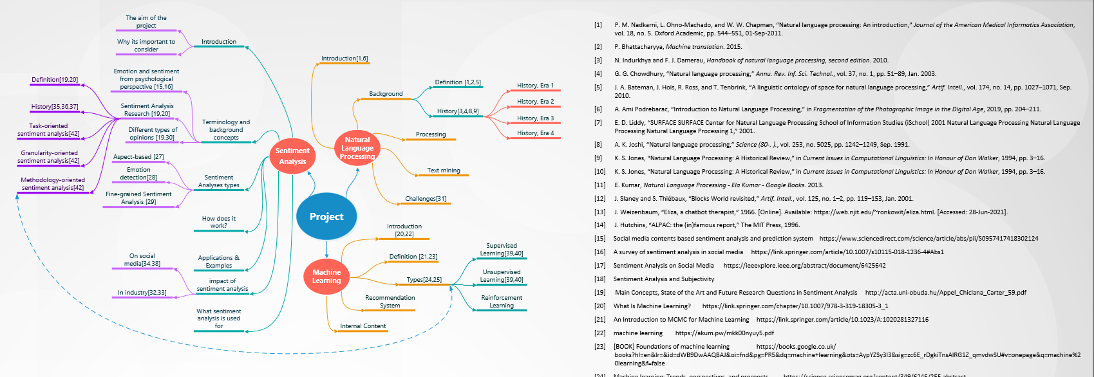

- Data preparation steps:

Initial Data
Row data
Evaluation
Data Preparation
Cleaning & Validate
Modelling
Handling missing values
Dropping columns/rows
Renaming values
Converted data type
Remove duplicated rows
Clean Values
‘ “ ? , %
Data Exploration
Data frame
- Data attribute descriptions
Attribute | Data type | Description
adult | Boolean | Shows which movie is for adult or not
belongs_to_  collection | Categorical | Has id of the movie, name and poster link
budget | Number | How much the movie has cost
genres | Categorical | Contain the genre of each movie such as comedy, action, romantic, Animation and so on.
homepage | Categorical | The actual link for each movie
id | Number | The identification number of the movie in the file
imdb_id | Categorical | The id that used in imbd
original_languag | Categorical | The original language in which the film was made
original_title | Categorical | The original movie title
overview | Categorical | A brief description of the movie
popularity | Number | The popularity of each movie
poster_path | Categorical | The link for the movies’ poster
production_companies | Categorical | Which company has produced the movie
production_countries | Categorical | In which country the production was
release_date | Date | The date of releasing the movie
Revenue | Number | How much revenue each movie has got
runtime | Number | How long does the movie can take
spoken_languages | Categorical | Which languages the movie available
status | Categorical | If the movie released or not
tagline | Categorical | That use mostly in social media as tags to indicates some values
title | Categorical | Actual name or advertising name
Video | Boolean | If the movie has any trailer video
vote_average | Number | The votes averages for each record
vote_count | Number | Number of votes for each record

- Collaborative filtering:
Film 1
Film 1
Like
Like
Jon
Mark
Like
Like
Film 2
Film 2
Like
Predict
Film 3

