
BMSW4002
Effective Team Work and Communication Assessment 2 (Group Presentation)
Name: Adelina Angelova
ID: 2132900

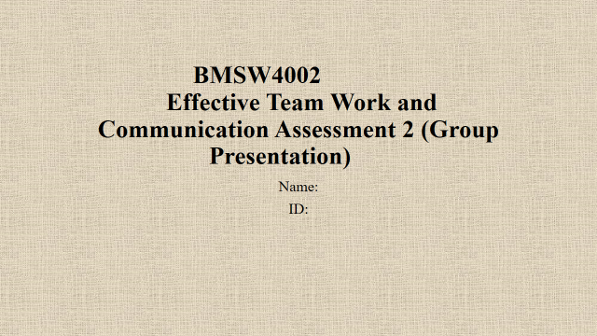
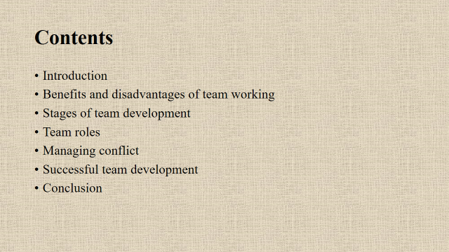
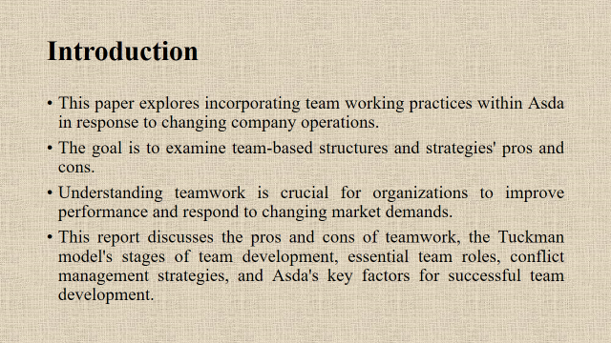
The purpose of this research is to investigate the incorporation of team working practices within Asda as a response to changing corporate operations. The objective is to investigate the benefits and drawbacks associated with team-based structures and techniques. It is essential for businesses to acquire an understanding of cooperation in order to boost performance and adapt to shifting needs in the market. The Tuckman model's stages of team growth, necessary team roles, and tactics for conflict management, and Asda's critical variables for effective team development are all discussed in this paper, along with the benefits and drawbacks of working in teams.
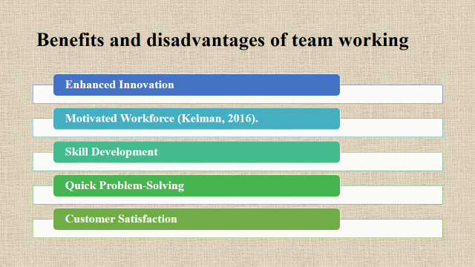
The incorporation of collaboration into Asda's operational procedures is expected to result in a number of positive outcomes. Innovation is boosted when multiple viewpoints and skills are brought together (Kelman, 2016). A creative solution to a difficult problem in retail may be found by teams with a variety of skills and expertise, providing those teams an advantage over their competitors. Workers are more likely to be motivated by teamwork, which in turn improves job satisfaction and engagement. A rise in morale can have a positive effect on productivity and the success of a company. People's capabilities can be improved as a result of the sharing of their knowledge and expertise, which is made possible through teamwork (Frazer and Oswald, 2019). Because the teams at Asda make choices and solve problems more quickly, the company is able to respond swiftly to the requirements of its customers. Because of its collaborative nature, effective cooperation leads to improvements in customer service and retention rates.
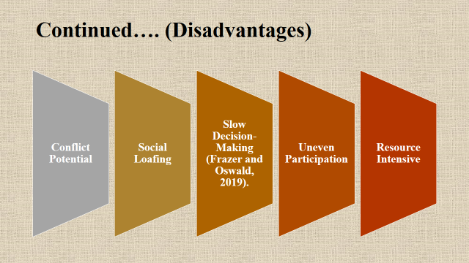
Although working together in a team offers many advantages, Asda needs to be aware of its disadvantages. The varied perspectives held by members of the team could result in arguments. These arguments, if not addressed properly, have the potential to impede the output and work of the team. The technique of members over-relying on their fellow workers, known as social loafing, decreases accountability and leads to uneven labor participation (Frazer and Oswald, 2019). The inclination of team conversations to seek consensus may slow down decision-making, which may not be desirable in a retail environment that operates at a high pace. Inconsistent participation from team members may make this problem even worse, leading to imbalances in both workload and performance. In conclusion, the administration and coordination of a team require an investment of time and resources, which needs to be weighed against the anticipated benefits.
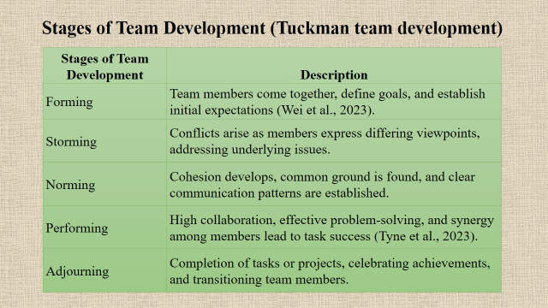
The maturation process of teams is made easier to understand by the Tuckman model of team growth. Because Asda is thinking about working together, these actions are quite significant.
In the first step, which is referred to as "Forming," members of the team will meet one another, get to know one another, and define goals. In this phase, gaining clarity on goals and expectations helps set the foundation for future collaboration (Wei et al., 2023).
When members of a team voice differing opinions and compete for influence during the "Storming" stage, the teams may come into conflict with one another. During this challenging period, teams must address issues, establish traditions, and strengthen relationships.
The "Norming" stage promotes teamwork. Members are able to form alliances, communicate effectively, and come to an understanding. This stage is necessary for Asda to encourage cooperation and goal-setting (Tyne et al., 2023).
For the "Performing" stage, cooperation, problem-solving, and coherence are necessary. Asda might anticipate good teamwork and contribution at this point.
During the "Adjourning" stage, all projects or duties assigned to the team are finished. Asda may celebrate achievements, recognize members of the team, and give those employees new responsibilities or initiatives.
By having an awareness of these stages, Asda is better able to solve challenges, encourage productive teamwork, and make seamless transitions across teams as they mature, adapt, and make contributions to the success of the organization.
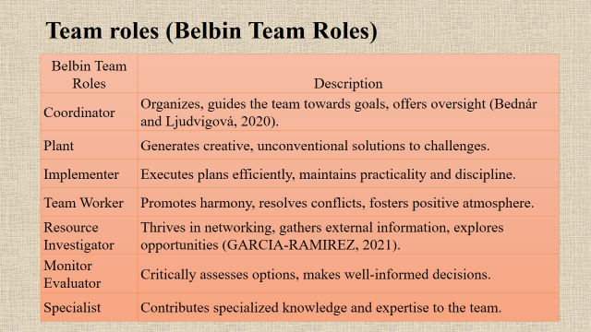
Asda can benefit from incorporating teamwork into its business operations by first gaining an understanding of the insights provided by the Belbin Team duties model regarding the inherent responsibilities of team members. Each of the nine team tasks that belong to Belbin contributes in some way to the dynamics of the team (Bednár and Ljudvigová, 2020). The "Coordinator" job is particularly effective at organizing and directing the team towards its goals, in addition to providing oversight and direction. The "Plant" function encourages creative thinking and the pursuit of alternate solutions to problems. The "Implementer" is responsible for carrying out plans in an efficient and thorough manner while maintaining discipline. The "Team Worker" finds solutions to challenges and helps the team feel more cohesive. The "Resource Investigator" job is particularly strong in areas such as networking, the acquisition of external information, and the research of opportunities (GARCIA-RAMIREZ, 2021). The "Monitor Evaluator" analyses available options and decides which ones are best. The "Specialist" function contributes extensive specialized knowledge to the team.
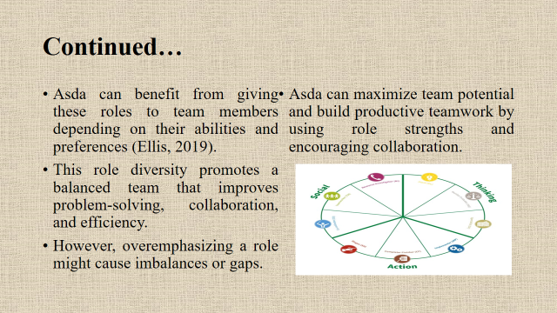
It would be beneficial for Asda to assign these responsibilities to members of the team based on their skills and personal preferences. This variety of roles contributes to the development of a balanced team, which in turn increases problem-solving, collaboration, and productivity. Nevertheless, placing an excessive amount of attention on a function may result in gaps or imbalances (Ellis, 2019). By playing to each member's skills and fostering collaboration, Asda will be able to leverage the potential of the team and develop productive teamwork.
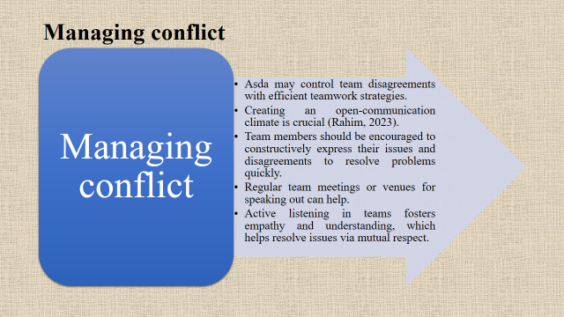
Using effective tactics for teamwork, Asda may be able to manage arguments within the team. It is of the utmost importance to foster an environment of open communication. To facilitate a speedy resolution of conflicts, members of the team should be encouraged to constructively communicate their concerns and points of contention (Rahim, 2023). It can be helpful to have regular team meetings or other forums for speaking up. When teams engage in active listening, it cultivates empathy and understanding, which in turn helps difficulties to be resolved via mutual respect.
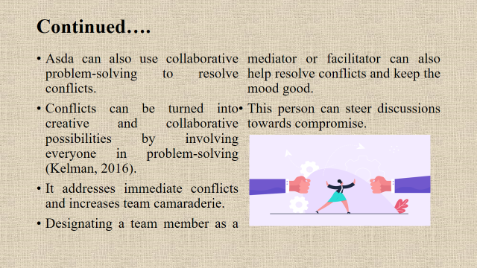
Conflicts that arise at Asda can also be resolved through collaborative problem-solving. When everyone contributes to finding solutions to an issue, disagreements can be transformed into opportunities for creativity and teamwork. It solves urgent problems while also boosting the team's sense of camaraderie. It may also be helpful in resolving problems and maintaining a positive attitude to designate a member of the team to act as a mediator or facilitator. This individual has the ability to guide talks towards a compromise (Kelman, 2016). By integrating the aforementioned strategies for conflict management into its team working structure, Asda will be able to successfully handle conflicts, enhance relationships within the team, and cultivate a culture that values communication and collaboration. This not only makes operations simpler but also demonstrates Asda's commitment to maintaining a peaceful and productive work environment.
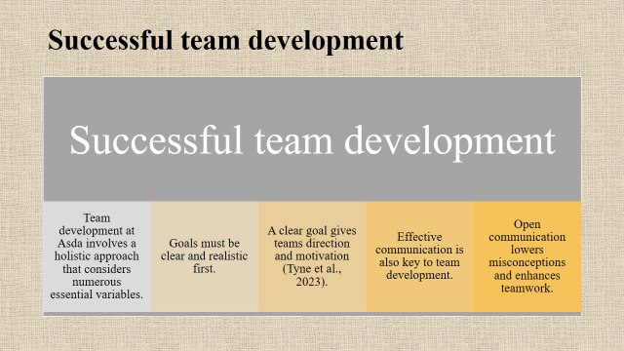
The process of developing teams at Asda requires taking a holistic approach that takes into consideration a large number of important factors. Before everything else, goals need to be lucid and attainable (Tyne et al., 2023). A well-defined objective provides teams with both direction and motivation. The formation of a strong team also relies heavily on clear and concise communication. Open communication helps reduce misunderstandings and improves the effectiveness of teamwork.
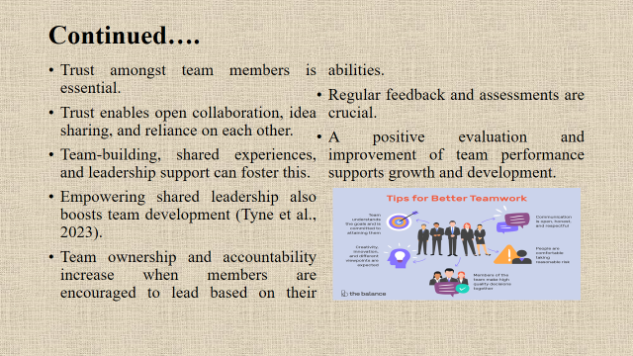
It is critical for members of the team to trust one another. The ability to trust one another is necessary for open collaboration, the exchange of ideas, and mutual dependence. Developing a cohesive team, having shared experiences, and receiving support from leadership can all help to create this? Providing opportunities for shared leadership also contributes to the growth of teams. When members are encouraged to lead based on their strengths, there is an increase in both team ownership and individual accountability (Tyne et al., 2023). Consistent evaluation and feedback are quite important. The growth and development of an organization are both supported by a good appraisal and an enhancement of the performance of the team. If Asda incorporates these qualities into its approach for working in teams, it will be able to establish a formidable workforce. This approach improves the overall performance of teams while also fostering innovation, collaboration, and individual development in the workplace.
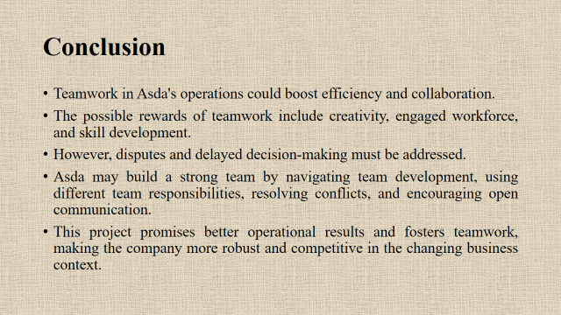
Efficiency and collaboration could both be improved through the use of teamwork in the operations of Asda. Creativity, an engaged workforce, and the development of skills are all potential benefits that might result from working together in a group. Nevertheless, disagreements and a sluggish decision-making process need to be addressed. It is possible that Asda will be able to construct a powerful team through managing team development, utilizing a variety of team roles, resolving disagreements, and fostering open communication. Because of this project's promise of improved operational results and because it encourages teamwork, the organization will become more resilient and competitive in the shifting business situation.
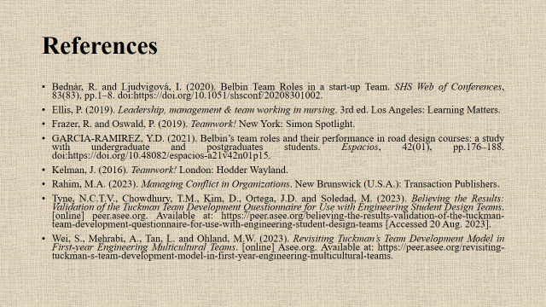
References
Bednár, R. and Ljudvigová, I. (2020). Belbin Team Roles in a start-up Team. SHS Web of Conferences, 83(83), pp.1–8. doi:https://doi.org/10.1051/shsconf/20208301002.
Ellis, P. (2019). Leadership, management & team working in nursing. 3rd ed. Los Angeles: Learning Matters.
Frazer, R. and Oswald, P. (2019). Teamwork! New York: Simon Spotlight.
GARCIA-RAMIREZ, Y.D. (2021). Belbin’s team roles and their performance in road design courses: a study with undergraduate and postgraduates students. Espacios, 42(01), pp.176–188. doi:https://doi.org/10.48082/espacios-a21v42n01p15.
Kelman, J. (2016). Teamwork! London: Hodder Wayland.
Rahim, M.A. (2023). Managing Conflict in Organizations. New Brunswick (U.S.A.): Transaction Publishers.
Tyne, N.C.T.V., Chowdhury, T.M., Kim, D., Ortega, J.D. and Soledad, M. (2023). Believing the Results: Validation of the Tuckman Team Development Questionnaire for Use with Engineering Student Design Teams. [online] peer.asee.org. Available at: https://peer.asee.org/believing-the-results-validation-of-the-tuckman-team-development-questionnaire-for-use-with-engineering-student-design-teams [Accessed 19 Aug. 2023].
Wei, S., Mehrabi, A., Tan, L. and Ohland, M.W. (2023). Revisiting Tuckman’s Team Development Model in First-year Engineering Multicultural Teams. [online] Asee.org. Available at: https://peer.asee.org/revisiting-tuckman-s-team-development-model-in-first-year-engineering-multicultural-teams.

