Exploring the Impact of Remote Work on Employee Productivity and Organisational Culture: A Study of UK-based Technology Companies
Research Methods for Business (LCLM6004_BIRM)
Student: Nicolae-Bogdan Ghita 2246392
Lecturer: Dr Ashikul Alam Khan
Table of Contents

Identification of a Business Problem 2
Research Aim, Objectives and Questions 2
Research Questions 4
Justification of Research Focus 4
Preliminary Literature Review 5
Research Methodology and Design 5
Business Relevance and Practical Implications 6
Work and Time Schedule 7
References 9

Identification of a Business Problem
Since the COVID-19 forced offices to shut their doors remote work has shed its emergency-only label and settled in as a lasting business practice. In the United Kingdom tech companies have been especially eager rolling out hybrid schedules and remote setups with palpable enthusiasm. While these models bring perks—greater flexibility, trimmed operating costs and a healthier work–life balance—they also stir concerns, about how teams collaborate keep communication flowing and protect the organisation’s cultural fabric. Managers and business leaders are increasingly sounding the alarm about keeping employee engagement, innovation and a sense of cohesion alive across distributed teams. Doumbia’s 2025 study and Singh Cauhan and Bajpai, 2022 outlook both hint that while remote work can lift short-term productivity it may also erode the exchanges and shared values that hold strong organisational cultures together. Consequently, getting a grip on the long-term repercussions of work for both productivity and culture has turned into a crucial issue, for managers. The discussion remains split. A cohort of scholars—Bloom et al. (2015). Choudhury et al. (2021) for instance—maintain that working from home boosts output by cutting down on interruptions and offering flexibility. In contrast researchers such as Felstead and Reuschke (2023) argue that remote arrangements fray bonds and hamper teamwork. With this expanding literature only a handful of studies have looked at how these opposing forces play out in UK-based technology companies, in the post-pandemic era. By tackling that shortfall organisations can craft hybrid-work strategies that are both more sustainable and neatly aligned with their performance goals and cultural ethos.

Research Aim, Objectives and Questions
The main goal of this study is to explore how remote‑work practices affect employee productivity and organisational culture at technology companies based in the UK especially as the post‑pandemic business landscape unfolds. The research hopes to weave together an integrated understanding of how flexible work arrangements shape not only operational efficiency but also the social fabric of these companies.
Beyond measuring outcomes, the study seeks to uncover the hidden mechanisms through which remote work reshapes employee behavior, team dynamics and managerial effectiveness (Barreto, A., 2025). By probing the interplay of autonomy, digital communication, collaboration and organisational values the research aims to deepen insight while also offering practical guidance, for companies navigating the hybrid future of work.
Moreover, the research seeks to craft recommendations that enable organisations to sustain top‑level performance and keep employees engaged while nurturing a tight‑knit forward‑thinking culture (Tahlyan, et.al., 2024). Ultimately the aim is to feed into decisions about workforce planning, leadership development and organisational design, across the technology sector.
In pursuit of the study’s goal the inquiry is steered by five interwoven aims, each intended to yield a nuanced insight into how remote‑working practices shape both productivity and organisational culture across UK‑based technology companies.
The first aim is to estimate how remote work shapes employee productivity in on measures like self‑reported performance, overall work efficiency, ability to concentrate and the level of innovation (Hagedoorn and Cloodt, 2003). This entails probing whether flexible arrangements deliver lasting productivity gains or whether they give rise to hurdles, around motivation and task management.
The second aim sets out to map the shifting tapestry of culture as it settles into remote and hybrid work realms. Particular attention will be paid to how the threads of communication, trust, collaboration and employees’ sense of belongings are rewoven when the approach of physical proximity loosens (Sachs, P., 1995). In doing the inquiry hopes to tease out how virtual workspaces stitch together cultural cohesion and the emergence of a shared collective identity.
Spurred by those insights the aim sets out to tease out managerial and leadership maneuvers that ignite engagement, accountability and a thread of social connection among teams scattered across far‑flung locales. In this context leadership. Managerial behavior acts as decisive variables that shape the bridge, between remote work and employee performance anchoring this issue as a core strand of the research.
The fourth aim seeks to unpack the relationship between the tech tools in use the autonomy granted to employees and the performance results they produce probing how the digital infrastructure can either empower or limit collaboration (Poth, et.al., 2020). It highlights technology’s role in easing communication, tracking productivity and preserving team cohesion in remote settings.
In the end the fifth goal calls for crafting down‑to‑earth guidance that helps UK technology organisations shape hybrid‑work policies that're both sustainable and sensible (Liao and Huang, 2019. This guidance should weave together the push for flexibility and employee autonomy with the need to preserve culture, foster innovation and keep productivity strong, over the long haul.

Research Questions
In line with the research objectives, this study seeks to explore how remote work practices affect productivity and organisational culture in UK-based technology organisations. It will examine how remote work influences employee performance and how organisational culture has changed under remote and hybrid models. The study will also investigate which management and leadership practices best support engagement, collaboration, and sustained productivity in distributed teams. Additionally, it will analyse how digital tools and employee autonomy interact to shape teamwork and performance outcomes. Finally, the research will identify strategies that enable organisations to balance flexibility with the preservation of a cohesive and innovative organisational culture.

Justification of Research Focus
Because of the quick changes in work models in the technology sector after the COVID-19 pandemic, the selected research topic is relevant and timely. Although UK-based tech companies are leading the way in new hybrid and remote work models, many still struggle to sustain a solid organisational culture and steady productivity (O’Mahony, 2022).
As a result, this study adds to both academic literature and managerial practice by occupying the nexus of organisational behaviour, human resource management, and strategic leadership. It seeks to close the gap between theoretical knowledge and real-world business application by incorporating ideas from leadership studies, productivity theory, and cultural dynamics.
The findings will be particularly relevant to senior managers, HR practitioners, and policymakers seeking to build resilient, high-performing, and culturally cohesive organisations in an increasingly digital economy.

Preliminary Literature Review
Research on remote work and productivity is all over the map. Back in 2015, Bloom and his team said remote work actually boosted productivity—fewer distractions, more freedom to work your own way. But things have changed. Lately, studies like Doumbia’s 2025 report show that those early gains don’t always last. People start to feel worn out by too much screen time, nonstop messages, and missing out on quick, in-person chats that spark ideas. Organisational culture, basically the shared values and habits that shape how people act at work, as Schein put it in 2017, runs into some real hurdles when everyone’s working remotely. Without those face-to-face moments, the little offhand conversations fade, and it gets harder to keep everyone on the same page (Felstead and Reuschke, 2023). So, building and holding onto a strong culture takes extra effort from managers, especially when people feel a bit cut off from the bigger company.
Hybrid work is catching on as a real answer to today’s workplace challenges. Research from Choudhury et al. (2021) and Jones, S., (2024) shows that when companies back up flexibility with good digital tools, trust from leadership, and open communication, people can actually work together better. Still, most studies do not really look at how productivity and company culture fit together, especially in the UK tech scene after the pandemic. This study digs into that missing link and shares practical ideas leaders can use right now.

Research Methodology and Design
This research will adopt a mixed-methods approach, combining quantitative and qualitative data to achieve a comprehensive understanding of the issue. Quantitative data will be collected through an online survey distributed to employees in selected UK technology organisations, with approximately one hundred participants expected to respond (Nardi, 2018). The survey will measure self-perceived productivity, engagement, and satisfaction using validated instruments such as the Utrecht Work Engagement Scale
Qualitative data will be obtained through semi-structured interviews with ten to twelve managers and team leaders, focusing on their experiences of keeping organisational culture and productivity in remote or hybrid teams. Secondary data, including company reports and industry publications, will be used to triangulate findings and strengthen validity (Barriball and While, 1994).
Purposive sampling will be employed to select small and medium-sized technology organisations running in the UK that have implemented remote or hybrid work arrangements. Data will be analysed using both descriptive and inferential statistical methods for the quantitative part, and thematic analysis for the qualitative part, allowing patterns and relationships to appear from the data.
Ethical considerations will be strictly seen. Participants will provide informed consent, confidentiality and anonymity will be supported throughout, and all data will be securely stored following institutional ethical guidelines. Ethical approval will be sought before the commencement of data collection (Stafford and Stafford, 1993).

Business Relevance and Practical Implications
Findings from this research will be significant to business executives, human resource managers, as well as policymakers wishing to adapt to changes that characterise today’s world of work because of technological advancements. It is pertinent to note that technology companies based in the UK continue adopting flexible work environments, and thus there is a great need for them to comprehend the relationship that may exist between employee productivity and organisational culture as a means of maintaining a competitive edge and innovation within organisations (Brewster, et.al., 1994).
Findings of this research will help decision-making in any of these areas, namely human resource development, leadership development, and managing performance. Business leaders will be reminded that structures and methods of leadership need to be altered and improved if they and their organisations are going to stay aligned, build and sustain trust, and remain responsible and accountable, despite changes and technological advancements that have allowed more people to work from home, away from their leaders’ immediate observation and physical presence.
HR practitioners will receive help from this research as it will provide them with valuable advice on structuring and implementing telework and teleconference policies that can help keep employee motivation, inclusion, and organisational culture integrity. HR departments can use this research advice on employee onboarding, employee communication, and employee-building techniques that can be applied as virtual settings (Spratt, 1997) Additionally, advice on virtual collaboration platforms and engagement platforms will enable HR practitioners to create a community sense of belonging, irrespective of geographical locations.
Secondly, this research has wider implications concerning resilience within organisations. With accelerating digital transformation, technology development and human aspects of work—empathy, trust, and shared values—need equal emphasis. Organisations can adapt resilient cultures and be initiative-taking about market changes, technology evolution, and employee expectations through this research study, as this research will help them develop resilient cultures that can thrive in a state of uncertainty (Trenerry, et. all., 2021).
From a policy point of view, this research can help offer relevant evidence that can be used by governments and other organisations that aim towards fostering sustainable job practices and sustainable working environments within a post-Covid world (Pataki-Bittó and Kapusy, 2021). Researchers can use this study as a point of reference and develop policies and initiatives that balance innovation and employee welfare.
In a wider theoretical framework, this research will be of great contribution towards the ongoing debate on organisational behavior, the effectiveness of telework, and the future of human resource management as a discipline. It will help shed light on the complex relationship between technology, autonomy, and culture, giving a more nuanced view of their combined effect on telework effectiveness (Athanasiadou and Theriou, 2021). Ultimately, through connecting theory and practice, this research can help enable organizations running within the UK market to develop ‘practical’ ways of remaining ‘competitive and resilient and ‘culturally cohesive’ within an increasingly ‘digital and globalised’ business environment.

Work and Time Schedule
The study will run for twenty weeks. Week one and two will be used for finalising a topic and final approval of a research proposal outline. Weeks three through six will be used for conducting a comprehensive literature review and formulation of a conceptual framework. Research design and application for ethical approval will be completed during weeks seven and eight. Conducting data collection methods, such as conducting surveys and interviews, will be done in weeks nine through twelve. Analysis of findings and interpretations will be done during weeks thirteen through fifteen, as will drafting research findings and discussions in weeks sixteen through eighteen. Final editing and giving the research project will be completed in weeks nineteen through twenty, and a Gantt Chart may be added then for visualisation of research details.
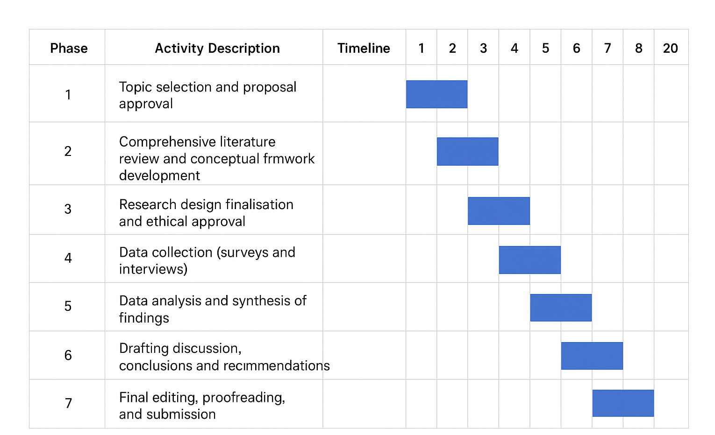

References
Anamika Singh Cauhan and Bajpai, N. (2022) Review of parameters for identifying the impact of hybrid work model on employee performance & satisfaction’, NeuroQuantology, 20(9), p. 7540. Available at: https://doi.org/10.48047/nq.2022.20.9.nq44880
Athanasiadou, C. and Theriou, G. (2021) Telework: Systematic literature review and future research agenda’, Heliyon, 7(10).
Barreto, A. (2025) ‘The impact of hybrid work models on employee performance and well-being post-pandemic’, The Journal of Academic Science, 2(5), pp. 1383–1393.
Barriball, K.L. and While, A. (1994) ‘Collecting data using a semi-structured interview: A discussion paper’, Journal of Advanced Nursing-Institutional Subscription, 19(2), pp. 328–335.
Bloom, N., Liang, J., Roberts, J. and Ying, Z.J. (2015) Does working from home work? Evidence from a Chinese experiment’, The Quarterly Journal of Economics, 130(1), pp. 165–218.
Brewster, C., Hegewisch, A. and Mayne, L. (1994) ‘Flexible working practices: The controversy and the evidence’, in Policy and Practice in European Human Resource Management: The Price Waterhouse Cranfield Survey, pp. 35–49.
Choudhury, P., Foroughi, C. and Larson, B. (2021) ‘Work-from-anywhere: The productivity effects of geographic flexibility’, Strategic Management Journal, 42(4), pp. 655–683.
Doumbia, M. (2025) Employee perception of organizational commitment and culture during the COVID-19 pandemic (Doctoral dissertation, Walden University).
Felstead, A. and Reuschke, D. (2023) ‘A flash in the pan or a permanent change? The growth of homeworking during the pandemic and its effect on employee productivity in the UK’, Information Technology & People, 36(5), pp. 1960–1981.
Hagedoorn, J. and Cloodt, M. (2003) ‘Measuring innovative performance: Is there an advantage in using multiple indicators?’, Research Policy, 32(8), pp. 1365–1379.
Jones, S. (2024) Investigation into how facilities management has evolved to support the hybrid and remote workplace trends.
Liao, Y. and Huang, G. (2019) A hybrid predictive sequencing control for multi-chiller plant with considerations of indoor environment control, energy conservation and economical operation cost’, Sustainable Cities and Society, 49, p. 101616.
Nardi, P.M. (2018) Doing survey research: A guide to quantitative methods. New York: Routledge.
O’Mahony, A. (2022) Working remotely in the UK automotive industry during the Covid-19 pandemic: A managerial perspective (Doctoral dissertation, Dublin, National College of Ireland).
Pataki-Bittó, F. and Kapusy, K. (2021) ‘Work environment transformation in the post COVID-19 based on work values of the future workforce’, Journal of Corporate Real Estate, 23(3), pp. 151–169.
Poth, A., Kottke, M. and Riel, A. (2020) ‘The implementation of a digital service approach to fostering team autonomy, distant collaboration, and knowledge scaling in large enterprises’, Human Systems Management, 39(4), pp. 573–588.
Sachs, P. (1995) ‘Transforming work: Collaboration, learning, and design’, Communications of the ACM, 38(9), pp. 36–44.
Spratt, M.F. (1997) ‘HR as a source of shareholder value: Research and recommendations’, Human Resource Management, 36(1), pp. 39–47.
Stafford, M.R. and Stafford, T.F. (1993) ‘Participant observation and the pursuit of truth: Methodological and ethical considerations’, Market Research Society Journal, 35(1), pp. 1–16.
Tahlyan, D., Mahmassani, H., Stathopoulos, A., Said, M., Shaheen, S., Walker, J. and Johnson, B. (2024) ‘In-person, hybrid or remote? Employers’ perspectives on the future of work post-pandemic’, Transportation Research Part A: Policy and Practice, 190, p. 104273.
Trenerry, B., Chng, S., Wang, Y., Suhaila, Z.S., Lim, S.S., Lu, H.Y. and Oh, P.H. (2021) ‘Preparing workplaces for digital transformation: An integrative review and framework of multi-level factors’, Frontiers in Psychology, 12, p. 620766.

