Origins
Within this report I will attempt to provide a comprehensive overview of both the Six Sigma methodology, and the Lean Manufacturing principles which preceded it. The key concepts of both continuous improvement models will be discussed with a brief history of the origins also covered. As per the briefing above, time will also be dedicated to outlining the means by which both Six Sigma and Lean techniques and tools are implemented in the workplace, with a particular focus on how such processes have been carried out within TATA Steel; and the Morfa Coke Ovens more specifically.

Before examining either of the methodologies in depth, I believe that it is useful first to examine the origins of the Six Sigma and Lean models. Both owe their origin(s) to big business, with the earlier Lean Manufacturing model a creation of the Toyota Production System (TPS) back in the 1940s, and the Six Sigma model, itself inspired by the Lean system, owing its own creation/design to the American Motorola firm in the 1980s. Both systems, intrinsically tied together by the desire for incessant improvement, can trace their origins back through Shigeo Shingo’s work around ‘fool-proofing’ or ‘Poka-Yoke’, as well as the work carried out by Henry Ford in his realisation of mass-manufacturing. Whilst these companies represented early proponents of business/process improvement, it is widely accepted that modern companies simply must embrace such methods if they wish to succeed. This is a point mirrored by Rama Shankar, who states that ‘in order to stay competitive, organisations need to continuously improve their processes’.
Essentially, the drive behind both Six Sigma and Lean Manufacturing is, as already discussed, continuous process improvement. The key principle behind Lean is the systematic removal of waste (or Muda) from the process, whilst Six Sigma, building upon this foundation, puts the customer at the forefront of the business and its performance, seeking as it does to ‘find and eliminate the causes of mistakes or defects in business processes by focussing on outputs that are of critical importance to customers’. For Six Sigma practitioners, true value can only be defined by the customer, a point that we will now examine in more depth.
Six Sigma
In essence, Six Sigma is, like the Lean system that foreshadowed it, a systematic approach to business improvement which focuses upon defect reduction. Its success across the business world can be seen by looking at case-studies including Allied Signal and General Electric in the United States, where billions of dollars have been generated as a result of Six Sigma being deployed across all levels of the business.
The appeal of Six Sigma to big businesses is clear to see. In an essay written for Quality Progress, Mikel J. Harry referred to the methodology as ‘an aggressive campaign to boost profitability, increase market share, and improve customer satisfaction’, whilst R.D. Snee suggested that an effective embrace of Six Sigma would see improved process performance, higher customer satisfaction and a significant impact on the bottom line through both cost savings and increased revenue. Greater numbers of consumers will be attracted to a product that they know to be quality, there is a direct correlation between a high quality product/process, free from defects, and a significant market share – Apple is a good example of this. Customers do not want to have to pay for anything that is not intrinsically value-adding, and why should they?
So, how does Six Sigma work? As touched upon above, the aim of Six Sigma is to remove defects caused by variation in order to provide a better product/process for the customer. This is done through a close examination of the available data through the use of statistical tools (more on which to follow). The goal is to reduce defects to as low as practicably possible – in some cases 99.9% success rate is not enough. The common understanding of what constitutes a Six Sigma process is one that only allows for 3.4 DPPM (defective parts-per-million).
Again, we will look to Mikel J. Harry here for a breakdown of the Six Sigma principle. Harry states that the ‘average product, regardless of how simple or complex, has a quality performance value of Four Sigma’. It is not unreasonable then, to suggest that if only four of the six Sigma are being realised, then that ‘average product’ is only ~66% of the quality that it could be. A truly world class operation would be operating at a much higher level, somewhere around the 99.9996% mark – this, according to Harry, would represent a true realisation of Six Sigma. The differences in terms of profit for companies operating at this level is tremendous; Motorola themselves have claimed that working to a Six Sigma level has led to a saving of around $17 billion since its development.
When looking to discuss the components that make up a successful Six Sigma project, it is perhaps best to turn to these companies that have embraced the associated techniques. General Electric themselves, quoted by J.S. Ramberg, perhaps best summarise what Six Sigma stands for – ‘Six Sigma is a disciplined methodology of defining, measuring, analysing, improving and controlling the quality in every one of the company’s products, processes and transactions’. These five stages of deployment – defining, measuring, analysing, improving and controlling, form one of the integral strategies used within the Six Sigma template – DMAIC. Described by Snee as a process that ‘emphasises rapid project completion’, the DMAIC method ‘takes a problem that has been identified by the organisation and utilizes a set of tools and techniques in a logical fashion to arrive at a suitable solution’. The next section of this report will provide a breakdown of DMAIC and the associated techniques.
DMAIC
As mentioned above, the idea of installing a Six Sigma-level of operation quickly is key to DMAIC. This five-stage process was designed to allow for progress to be made and tracked in a logical and systematic way – like most Lean Manufacturing processes, which this essentially is remember, DMAIC creates a disciplined framework under which to operate.
Define: The first stage of the DMAIC process, the ‘Define’ step, is used to help ensure that the problem or process that has been selected for attention as part of the improvement project is both truly connected to the organisations priorities and has the support of management. This is supported by Rama Shankar, who says that the phase ‘starts with identifying a problem that requires a solution and ends with a clear understanding of the scope of the problem and evidence of management support’. One of the best means of carrying out such an exercise is to directly ask your customers of their opinions. A ‘Voice of the Customer’ style feedback system can be particularly useful in highlighting areas in need of improvement. Putting the emphasis on the views and needs of the customer fits in with the Six Sigma ethos and allows for a real reflection of performance to be gathered. This type of data collection is particularly popular with call centre-type businesses, with almost every interaction with such organisations being followed by a ‘customer survey’ or something similar being sent out for completion. Havin worked in a call-centre environment, I have seen how this collated information then goes towards influencing future projects or procedural changes.
Measure: As suggested by the name, the ‘Measure’ phase of the DMAIC process is designed to establish the current performance rate(s) of the product/process being investigated. This can often become a rather time-consuming stage of the process, asking as it does for a significant input of information. Shankar argues that an understanding of this ‘baseline information’ is critical in achieving a successful Six Sigma undertaking. After all, how can one ensure improvement if the previous levels were not known to begin with? In terms of the tools that can be used in completing the ‘Measure’ phase, graphs and charts are probably the most effective means of displaying relevant information. A Pareto Chart, allowing for a series of data to be displayed simultaneously would be particularly useful in this regard. Here at TATA, our iFix computer system used for tracking performance on the By-Products plant in particular is a useful tool for supplying such information. Tracking trends in real time, the program allows for data to be carried out for use in graph/chart creation.
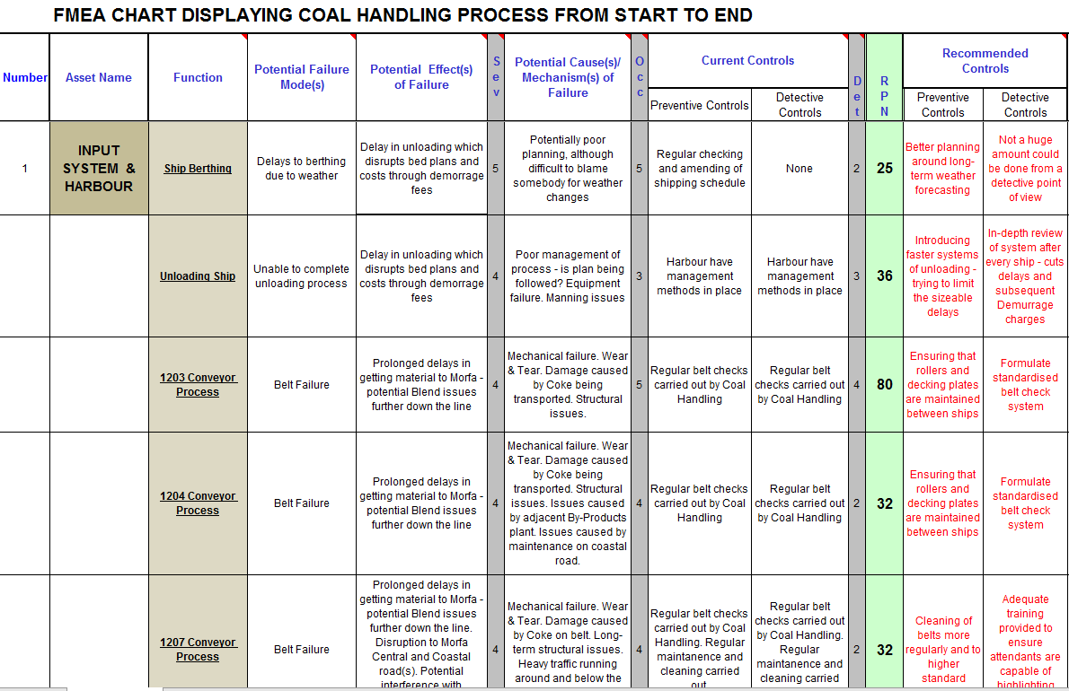
Analyse: The third stage, ‘Analyse’, will see the improvement team look to focus upon what have been designated the key metrics following the ‘Measure’ stage. As part of a Six Sigma project, there shouldn’t be too many key metrics because this would slow the process down. Instead, the team would look to investigate the data pertinent to these factors. Close study of this data should allow for informed decisions to be drawn regarding the root cause(s) and contributing factors behind the defects. Cause and Effect diagrams (or Ishikawa diagrams) are often used to assist at this stage, as is the 5 Why method of root analysis. A Failure Mode & Effect Analysis chart, or FMEA, is also useful in this regard. Below I have included a screenshotted section of such a document I have previously prepared for the Coal Handling plant at Morfa:

Improve: Once the analysis has been carried out, the improvement team can then look to put their ideas into action. The ‘Improve’ stage will see the team seek to implement changes to eliminate or control the issues that are leading to the defects. A thorough risk assessment should be carried out prior to making any changes and, as is the case at TATA, a Management of Change procedure would need to be initiated if changes were to interfere with regular service, even if it should only be temporarily. It is at this stage that we should start to see the changes in quality that are to be expected with a Six Sigma initiative. Geoffrey Tennant argues that these changes can be made to one or each of three areas – the customer, the process and the employee. Simply put, Tennant hypothesises that there are key improvements that can be made in each area, they are as follows:
- The Customer: A better understanding of what the customer wants is crucial – effective interaction with your customers is key to this
- The Process: Cutting down in defects and in wastes, in line with LEAN principles, is the key improvement to be considered when looking at the process
- The Employee: Improvements are only possible, and perhaps most significantly – only sustainable, if the workforce is committed to continuous improvement

The ways in which this can happen can differ dramatically depending on the working environment. Here at Morfa we have recently completed a period of intense ‘business improvement’ wherein the way that we work as a department was examined and subsequently changed significantly. For us, a move towards a more visual management style of work across each of the three plant areas has proved successful, allowing for key parameters to become the focus (each of the Team Leaders offices has now become a hub of pertinent data). Following the putting down of BF5 for essential maintenance work around the same time, we have also amended our production program to fall more in line with a KANBAN system of working (meaning that we only act when dictated by the customer). In our case, this has meant a move towards producing what the Furnaces require, not just for the sake of it.

Control: The final stage of DMAIC is arguably the most important. Once the changes have been made and proven to be effective, it is now time to standardise them and then look for further means to continuously improve moving forward. The improvement team will be tasked with installing systems to prevent back-tracking on the progress that has already been made. There are a number of means of ensuring this, perhaps the most effective is also the simplest – auditing. Regularly checking on new systems of work and/or equipment is key to our work at Morfa. New procedures in particular, will be exposed to a period of stringent auditing following going live. A further means of ensuring control is to create a standard work order, or control plan. Again, this is something that we look to use here within the department, perhaps the best example of such a document is the control plan in place for the By-Products plant:

PTO

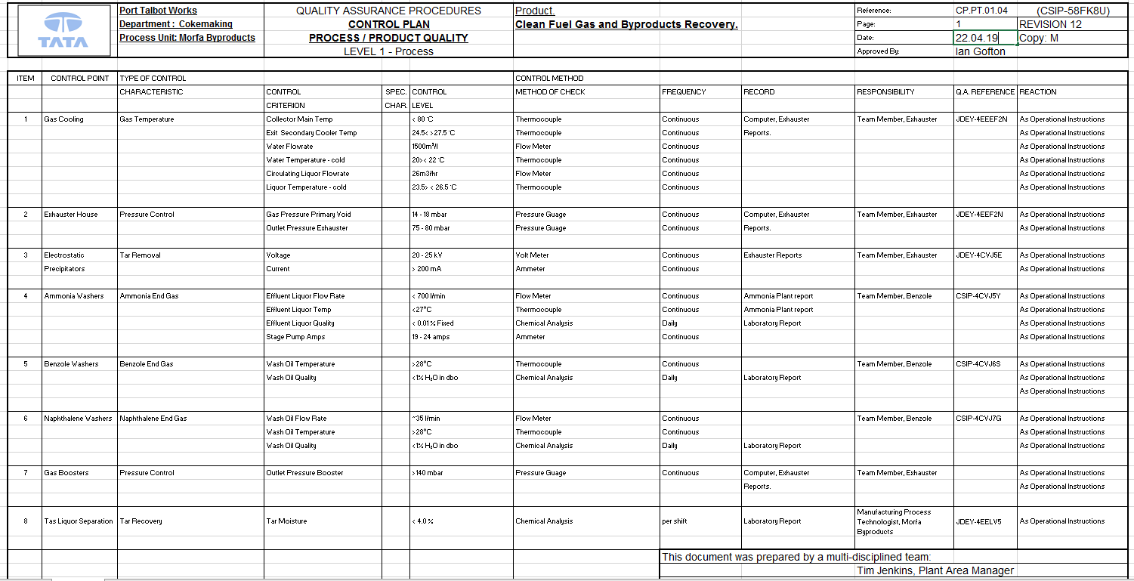
LEAN

The final section of this report will now cover the principles of the Lean methodology. As discussed, so-called ‘Lean production’, the name put forward by Womack, Jones and Roos in their The Machine That Changed the World, originated in Japan as part of the Toyota Production System (TPS) before being adopted by several other large automotive manufacturers, namely Ford and General Motors in the United States. The purpose of the system is straight forward – to remove ‘wastes’ from a process. Wastes, or Muda, are anything that does not add value to the process. Value, within the Lean methodology, is ‘related to customer requirements, and it will be the customer who ultimately decides what constitutes value’. Therefore, any steps or aspects of the manufacturing process which do not directly represent a step towards the completion of the product to customer specification can be considered a waste, this could subsequently take in transportation and defects for example. It is widely accepted that there are seven wastes within the Lean methodology, they are as follows:
- Defects
- Inventory
- Motion
- Over-processing
- Overproduction
- Transportation
- Waiting

In adopting an approach that makes use of the Lean principles, more on which to follow, companies can hope to significantly reduce the time/money wasted as a result of the above factors, as well as ensuring that ‘value’ is enhanced, with only ‘value-adding’ stages remaining. Defects in particular, represent a major issue for many large-scale manufacturers. The ‘Pareto Principle’, put forward by Joseph Juran, states that 80% of problems within any manufacturing process are caused by just 20% of defects present – subsequently, the benefits of removing these defects would represent a significant benefit to businesses. Indeed, Michael Cusumano has stated that an effective embrace of the Lean principles would lead to ‘high productivity as well as high quality in engineering and manufacturing, resulting in high price-performance in the value of products delivered to the customer’. So, what are these principles?

THE PRINCIPLES OF LEAN

There are five stages, or ‘principles’, that form the Lean process, they are as follows:
- Identify Value
- Map the Value Stream
- Create Flow
- Establish Pull
- Seek Perfection

Since the inception of the methodology, this systematic approach has proved successful; indeed, Cusumano has stated that ‘these practices made it possible for Toyota and other firms that followed its approach to achieve extremely high levels of quality (few defects) and productivity in manufacturing’.

Here we will run through a brief explanation of what is meant by each of these principles, before moving on to discuss a handful of Lean implementation techniques and how they have been used within my own working area. The first principle to be discussed is ‘Identify Value’.

Identify Value: The first of the Lean principles is an important one. Establishing what the customer quantifies as being of value, or value-adding, is crucial when looking to improve your processes. A process can only truly be considered as being of value if the customer is willing to pay for it, or if the activity is necessary to the completion of the product (i.e. it significantly changes the product or adds intrinsically important components). For example, when looking at the Coke-making process within my department, the Blast Furnace as our primary customer is only concerned with the creation of the product – the heating process is value adding as it directly results in the creation of the product, the transportation of coal in the stockyards prior to heating is not (although it could be argued that it is does represent an ‘essential non-value adding’ step)

Map the Value Stream: Once you have identified the end point of the process – that stage where the value manifests itself, Lean then suggests that you put together a ‘value stream’. Essentially, what we are talking about here is a process flow of sorts, albeit one which includes each of the stages or processes involved in the manufacturing process. So, for Morfa, we’d be looking at a ‘value stream’ that displays the movement of the raw material – in this case coal, through the preparatory stages and finally to the point where the coke reaches the quencher, as is then ready for use. Once this has been mapped out, the improvement team can then look into the possibility of re-engineering the process – identifying wasteful stages and attempting to either remove or correct them.

Create Flow: The mid-point when looking at the Lean principles, the ‘Create Flow’ stage, will see the improvement team looking to ‘put back together’ the manufacturing process, so to speak. Following the re-engineering work done at the previous stage, we must then be able to re-establish a flow following the removal of any wasteful activities. The aim here is to ensure that the process can move smoothly from start to finish. Again, a process flow-style document would need to be prepared to allow for issues to be identified – such as any remaining bottlenecks.

Establish Pull: The fourth of the principles, ‘Establish Pull’ is crucial in overcoming the overproduction and inventory wastes mentioned above. Following the re-engineering and re-establishing of the manufacturing flow carried out in the previous two principles, the time in which the product can reach the customer should be improved. If this is in fact the case, then the possibility of establishing a ‘just in time’ manufacturing process is opened up. If established, this style of production will allow for customers to place orders as and when required, safe in the knowledge that it will be provided when requested. This subsequently cuts down on the need to stockpile produce in large quantities.

Seek Perfection: The final of the Lean principles is undoubtedly the most important. Whilst reaching this point is in itself a success, what is important is to remember that Lean is a continuous improvement exercise; one that requires ‘deep commitment’ and ‘impacts the organisation at all levels’. Therefore, building a culture wherein all employees are committed to delivering perfection is imperative. Once the business has been put through the systematic stages of the principles it is not finished, rather, there needs to be a drive to continue the process, again and again. Only then will a truly Lean system of operative be achieved.

LEAN TECHNIQUES IN THE WORKPLACE

The final section of the report will cover three different Lean techniques and how they have been used within my Works’ area. Whilst there are many tools that can be used, I have decided to concentrate on the following:
5S: This technique, used for improving workplace organisation so to allow for more efficient working, is a simple yet effective Lean technique that is used regularly within our workshops. Made up of five steps, the process is as follows:
- Sort
- Set In Order
- Shine
- Standardise
- Sustain

Here at Morfa, the process is carried out around every 3-4 months and will see the Shift Engineer carry out he inspections with members of the craft teams. All equipment within the area is sorted into sections and then a decision is made regarding where it should be? Is it necessary? Etc. Necessary equipment is retained whilst the rest is discarded. The remaining kit is reorganised and stored accordingly. A thorough clean of the area is then carried out. The standardise stage (above) will only really be used here if changes are needed to be made to Safe Working documentation as a result of the process (this is rare).
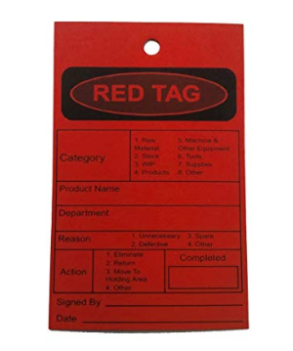

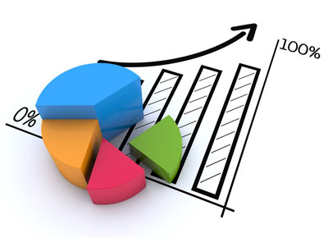
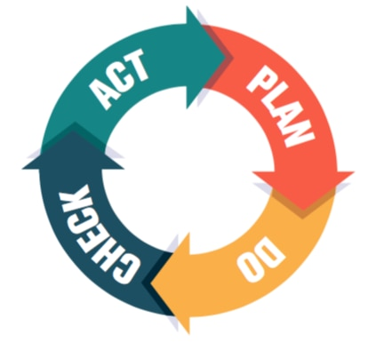
KPIs: Key Performance Indicators are a key tool when looking to drive continuous improvement initiatives. Visual representation of data being readily available and updated for all to see helps keep targets in the minds of those within the area. KPIs will often represent the areas in which the management will be looking to improve most – so maybe an area in which there is the opportunity for money to be made.
Following a Continuous Improvement initiative being launched at Morfa at the start of 2018, KPIs have been reviewed, amended and given greater importance within the department.
The By-Products Shift Co-Ordinator’s office has now become a hub in terms of performance indicators. Updated twice over a 24hr period, the visual management boards within the office display information covering a range of factors, such as End Gas quality, Tar Make, Tar Quality, Pressures and Temperatures and Benzole make.
These represent the factors that have been allocated high importance at the time of writing and having the information readily available reinforces this.
PDCA: Plan, Do, Check, Act (or PDCA) is a key component to our operation at Morfa, across each of the three operational areas. The principal is straight forward and allows for a systematic approach to be taken when carrying out work on plant. We hold a weekly PDCA meeting where the Works Manager sits down with the senior trio to discuss a number of issues. The basic structure behind PDCA is as follows:
- Plan (What is to be done? Outline the desired outcome)
- Do (Carry out the activity)
- Check (Carry out routine checks on progress of the activity)
- Act (Review the success of the initiative. Do it again if/as necessary)

Following this structure here allows for new ideas to be tested effectively and quickly. Regular reviews mean that initiatives are not soon forgotten and a proactive approach to innovation is reinforced through the regular presence of senior management in problem solving activities and meetings.

BIBLIOGRAPHY

Articles
Best, M., Neuhauser, D., ‘Joseph Juran: Overcoming Resistance to Organisational Change’, Quality and Safety in Health Care, Vol.15 (2006)
Cusumano, M.A., ‘The Limits of Lean’, MIT Sloan Management Review, Vol.35, Issue 4 (1994)
De Most, J., ‘An Analysis of the Six Sigma DMAIC Method from the Perspective of Problem Solving’, Internal Journal of Production Economics, Vol.139, Issue 2 (2012)
Harry, M.J., ‘Six Sigma: A Breakthrough Strategy for Profitability’, Quality Progress, Vol.31, No.5 (1998)
Ramberg, J.S., ‘Six Sigma: Fad or Fundamental?’, Quality Digest, Vol.7 (2000)
Snee, R.D., ‘Impact of Six Sigma on Quality Engineering’, Quality Engineering, 12, No.3 (2000)
Teich, S.T., Faddoul, F.F., ‘Lean Management – The Journey From Toyota to Healthcare’, Rambam Maimaides Medical Journal, Vol.4, Issue 2 (2013)

Books
Shankar, R., Process Improvement Using Six Sigma: A DMAIC Guide, Milwaukee (2009)
Shingo, S., Zero Quality Control: Source Inspection and the Poka-Yoke System, Portland (1986)
Tennant, G., Six Sigma: SPC and TQM in Manufacturing and Services, Aldershot (2001)
Womack, J.P., Jones, D.T., Roos, D., The Machine That Changed the World, New York (1990)

Websites
About Motorola University (n.d), accessed 16/05/2019 http://www.motorola.com/content/0,,3071-5801,00.html
5 Lean Principles Every Engineer Should Know (March 2016) accessed 20/05/2019 https://www.asme.org/engineering-topics/articles/manufacturing-design/5-lean-principles-every-should-know

S. Shingo, Zero Quality Control: Source Inspection and the Poka-Yoke System, Portland, 1986, pp.22-23; J.P. Womack, D.T. Jones, D. Roos, The Machine That Changed the World, New York, 1990, pp.17-22
R. Shankar, Process Improvement Using Six Sigma: A DMAIC Guide, Milwaukee, 2009, p. xv
R.D. Snee, ‘Impact of Six Sigma on Quality Engineering’, Quality Engineering, 12, No.3 (2000), p.2
Snee, ‘Impact of Six Sigma on Quality Engineering’, p.1
M.J. Harry, ‘Six Sigma: A Breakthrough Strategy for Profitability’, Quality Progress, Vol.31, No.5 (1998), p.60; Snee, ‘Impact of Six Sigma on Quality Engineering’, pp.3-4
Harry, ‘Six Sigma’, p. 60
About Motorola University (n.d), accessed 16/05/2019 http://www.motorola.com/content/0,,3071-5801,00.html
J.S. Ramberg, ‘Six Sigma: Fad or Fundamental?’, Quality Digest, Vol.7 (2000), p.2
Snee, ‘Impact of Six Sigma on Quality Engineering’, pp.4-5; Shankar, Process Improvement Using Six Sigma, p. xvi
J. De Most, ‘An Analysis of the Six Sigma DMAIC Method from the Perspective of Problem Solving’, Internal Journal of Production Economics, Vol.139, Issue 2 (2012), p.33
Shankar, Process Improvement Using Six Sigma, p.1
Shankar, Process Improvement Using Six Sigma, pp.11-12
G. Tennant, Six Sigma: SPC and TQM in Manufacturing and Services, Aldershot, 2001, pp.9-12
Tennant, Six Sigma, pp.10-13
S.T. Teich, F.F. Faddoul, ‘Lean Management – The Journey From Toyota to Healthcare’, Rambam Maimaides Medical Journal, Vol.4, Issue 2 (2013), p.2
Teich, Faddoul, ‘Lean Management’, p.2
M. Best, D. Neuhauser, ‘Joseph Juran: Overcoming Resistance to Organisational Change’, Quality and Safety in Health Care, Vol.15 (2006), pp.380-382
M.A. Cusumano, ‘The Limits of Lean’, MIT Sloan Management Review, Vol.35, Issue 4 (1994), p.27
5 Lean Principles Every Engineer Should Know (March 2016) accessed 20/05/2019 https://www.asme.org/engineering-topics/articles/manufacturing-design/5-lean-principles-every-should-know
Cusumano, ‘The Limits of Lean’, pp.27-28
5 Lean Principles Every Engineer Should Know, accessed 20/05/2019
As above.
Teich, Faddoul, ‘Lean Management’, p.3

