

Assignment Title: Developing Workplace Critical Thinking

Student Name: Dorathy Nkenta Duru
Student No: 1706805
Module Code: BMSK5001

Abstract
Critical thinking enables the formation of judgment through the analysis of facts. It is the ability make a reasoned judgment by analysing information objectively. Critical thinking means evaluating sources such as facts, data, researching findings and observable phenomenon to draw reasonable conclusions that enables solving a problem or making decision discriminating between useful and less useful details (Glaser, 2017).
Generally, people interchangeably use words such as attitudes, values and belief, but their meaning and usage are quite distinct. These factors are very important in our daily activities tending to shape the way we do think and do things including our perception of the environment around us. In the workplace, employees with positive attitude and positive thinking are more productive and well appreciated by employers. Positive attitudes determines how well others perceive you and influences how well you get your project done. Since managers have the duties of managing and leading different types of people with different beliefs and values, the impact their own beliefs, values and attitudes will have on their employees depends on their management style.
In an organisation mission statement and outcome assessment, critical thinking is a common component. For example, Sugarman Health & Wellbeing made the transformation of the way recruitment is delivered globally a mission to accomplish by offering their customers a unique and superior service (Sugarmanhealth.com, 2019).

Table of Contents

1.0Introduction 4
1.1 Company background of Sugarman Health & Wellbeing 4
1.2 Critical thinking 5
2.0 Beliefs, attitudes and values – conceptual framework 6
2.1 The Importance of Belief in the Workplace 6
2.2 The Importance of Attitude in the Workplace 7
2.3 The Importance of Values in the Workplace 8
2.4 Summary of the importance of Beliefs, attitudes and values in the Workplace 9
2.5 Relationship between Organisational Behaviour and Culture 10
2.6 How organisational culture affects corporate productivity 11
3.0 Management theories 11
4.0 Critical Analysis of human relation and equity management theories. 14
5.0 Critical assessment beliefs, attitudes and values on management theory. 16
6.0 Conclusion 17
7.0 Recommendations 17
8.0 References 18

Introduction

Generally, people interchangeably use words such as attitudes, values and belief, but their meaning and usage are quite distinct. These factors are very important in our daily activities tending to shape the way we do think and do things including our perception of the environment around us. The intention of this paper is to explain their differences and critically assess how attitudes, value and belief critically impact our workplace behaviours. The paper will further investigate the relationship between culture, workplace behaviour, management theories and the importance of attitudes, values and belief in the workplace.

1.1 Company background of Sugarman Health & Wellbeing

Sugarman Health and Wellbeing is one of the UK’s biggest providers of healthcare services with head office in London. The company was established about 30 years ago and specialised in healthcare recruitment in both private and public sector. They enjoy the trust of their customer due to the quality services they offer as a result of practical experience acquired over many years. Sugarman uses their expertise to match the right skills to available roles from temporary assignments to permanent contracts.
Sugarman is a part Cordant Group, the largest social enterprise in UK with the mission of making a positive impact on the society. In providing a professional service, the company is flexible in their approach and completely reliable to ensure a first-rate continuos support and care.
Although Sugarman is a family business, it embraces an extended business parthners and community collegues.
Sugarman mission: “To transform the way recruitment services are delivered around the globe, offering customers a unique and superior service” (Sugarmanhealth.com, 2019).
Sugarman Values:
Candour – “We will be open and honest with ourselves and others.
Collaboration – We will work as a team and succeed together.
Opportunity – We will inspire, support and invest in our people who will share in our success.
Relentlessness – We are driven to be the best.
Disruptive Innovation – We will continually challenge convention” (Sugarmanhealth.com, 2019).

1.2 Critical thinking

Critical thinking enables the formation of judgment through the analysis of facts. It is the ability make a reasoned judgment by analysing information objectively. Critical thinking means evaluating sources such as facts, data, researching findings and observable phenomenon to draw reasonable conclusions that enables solving a problem or making decision discriminating between useful and less useful details (Glaser, 2017).
Critical thinking is one of the desirable skills by employers, a worker that can use logical thought to evaluate a situation and suggest the best solution. An employee with critical thinking skills can be trusted to make own decisions and does not requires constant supervision or handholding. A critical thinker tries to get updated with current information and base his or her judgment on the credibility of the information sources. To be a good critical thinker, it is essential to have the spirite of be open-mindedness and mindful of alternatives. A good critical thinker has the ability to identifies reasons, conclusions and assumptions.
A good critical thinking manager is able to do a good judgment of the quality of an argument. A critical thinking manager not only understands the quality of an argument but accepts its reasons, assumptions and evidence. He has the ability to ask appropriate clarifying questions to develop and defend reasonable position. In management leadership, critical thinking skill is very essential for managers to be able formulate plausible hypothesis and draws conclusion when warranted with caution (Ennis, 2011). According to Ennis, critical thinkers are responsible of making sure that their belief be true and decision is justified. They are also liable to care to present clearly an honest position, the dignity and worth of every individual.
In an organisation mission statement and outcome assessment, critical thinking is a common component. For example, Sugarman Health & Wellbeing made the transformation of the way recruitment is delivered globally a mission to accomplish by offering their customers a unique and superior service (Sugarmanhealth.com, 2019). For an organisation to effectively achieve their goal, they need skilled workforce more especially, to be able to provide best care quality to their customers, the managerial skills and strategies are very essential for the achievement of their objectives. Critical thinking not only ensure the health and wellbeing of the organisation but also the health and safety of all the stakeholders of the organisation.

2.0 Beliefs, attitudes and values – conceptual framework

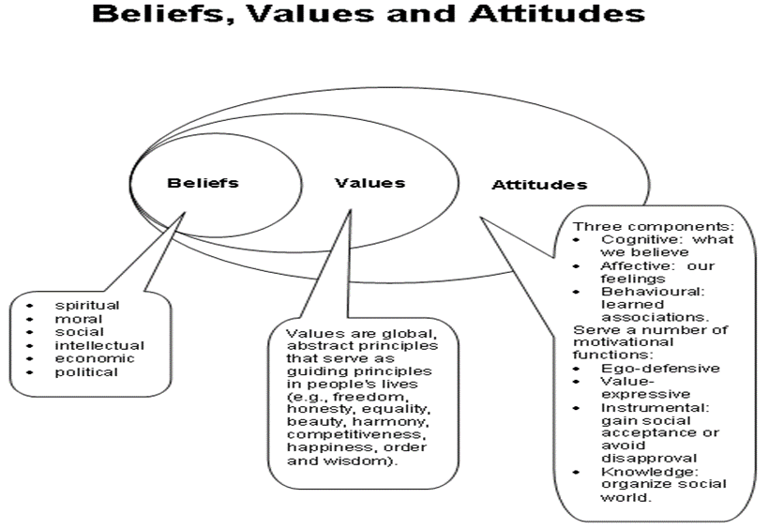
(Modelled from owlcation.com, 2019)

2.1 The Importance of Belief in the Workplace

Beliefs are not necessarily based on logic or fact but on our previous experiences and convictions. For an individual to change his/her belief, it needs a strong evidence. Organisations and customers have their respective beliefs that have a strong influence on how they make decisions and choices (Career Success for Newbies, 2019). For example, religious , social and cultural beliefs can influence how an individual dresses and behaves. An organisation that is committed to support diversity have productive employees that enable the good performance of its activities. Recognising and accepting diversity is a key element of an inclusive workplace. According to Acas.com (2019) in the workplace fairness and good job performance are directly related because they go hand in hand. This makes it imperative for organisations to tackle discrimination because a workplace that is free of discrimination attracts, motivates and retains highly skilled workforce and enhances the performance of the organisation.
All said above, it is critically important for managers to understand their personal values and beliefs and how important it is that they should not affect their working relationships with their employees. It is very essential that managers should remain professional by not allowing their individual values to interfere with the employee or customer relationship. This implies that employees and customers must make their own decisions basing on their individual values and beliefs without the influence of the management (Career Success for Newbies, 2019).

2.2 The Importance of Attitude in the Workplace

Belief is based on experience expressed by an individual through his attitude. A person expresses his attitude through words and behaviour. In every workplace, there are different types of employees having different types of attitudes such as positive attitude, very diplomatic attitude or negative mind set. In a workplace, the employees that are not working with the motives of the organisation exhibit negative attitudes .
“Attitude can materialize in a positive or negative evaluation regarding objects, phenomena, activities or ideas present in one’s environment” (Doob, 1947). For example, specialists’ through learning process and practicals form their attitudes. As an individual evolve, his or her attitudes changes based on life time experience. Although, some individuals tend to maintain a particular attitude in time. The theory of Katz (1960) is that sometimes attitude serves instrumental or ego-defensive, knowledge or value-expressive functions
In the workplace, employees with positive attitude and positive thinking are more productive and well appreciated by employers. Positive attitudes determines how well others perceive you and influences how well you get your project done. An employees might be intelligent with an excellent communication skills but lacks good attitude would definitely fail create good personal impression making other employees to be reluctant interacting with him. Good attitude in the workplace has some advantages Katz (1960) such as:
Increased Opportunities
Generally speaking good attitude brings opportunities in ones life, for example, in the workplace employees with positive attitudes in tackling their work without hesitation stand out as stellar employees and gain promotions easily. They are the first to be considered for special projects and promotions.
Increased Productivity
Employees with good attitudes are more productive because they recognise motives of the organisation and carry out their duties helping the organisation to achieve its aims and objectives. A good attitude allows an employee to be confident, energized and more productive in the workplace.
Contribute to a Positive Environment
Positivity or negativity can be contagious, for example, a positive or negative attitude displayed by an employee can impact positively or negatively on their co-workers. In a workplace where majority of the employees have workplace positive attitude, the workplace environment is pleasant thereby, making the organisation prosperous and a pleasant place to work.
Job Security
When employers are forced to scale down in difficult times, good attitude serve as job security for employees. For example, if an employer wants to sack, the start from considering their skills but when the employees have the same skills the next consideration is based on personality (Career Success for Newbies, 2019).

2.3 The Importance of Values in the Workplace

Value measures what we experience when we reflect or analyse our obligations, actions and our purpose of life, the sense of what I have done write or wrong. An individuals ethical and moral standards are based on his values, the core concepts and ideas of what he or she considers to good or bad. The things that worth sacrificing for.
Organisations achieve their core mission through value alignment. Value alignment allow people to work towards the same goal, same intention of achieving the same goal. Employers seek for employees that understand their workplace values (Mindtools.com, 2019).
Values are important in the workplace because it is linked intrinsically with recruitment and retention of employees. A organisation that wants to build a high performing team must consider its value propositions. Organisational decision-making is influenced by values. For example, if a value is centred on attention to detail, there’s a benchmark to assess everyone’s work by and employees know what they are being measured against. In the workplace value allows employees to gauge their standard. It allows employees to know what to prioritise in the work they carry out. Valus is important is shaping our learning and development. For example, in an organisation where the core value is honesty, the minimum standard for behaviour will based on honesty.
Values are crucial for leadership because employees will work towards different goals, different intentions and different outcome in an organisation without values. This will have a notable negative impact on job satisfaction, productivity and a damaging working relationship. Values guide how individuals interact with each other.

2.4 Summary of the importance of Beliefs, attitudes and values in the Workplace

Nowadays, the business environment has become very complex and the relationship between employee’s motivation with beliefs, values and attitudes has become very essential in the workplace because they are linked with performance. In the twenty first century, the evolution of employees is related with professional development choices for the most remunerable career. In this context, organisations must learn to develop strategies that tend to improve employees’ motivation. Managers must consider multiple variables that have the capacity of influencing the process of different layers of motivation.
Since managers have the duties of managing and leading different types of people with different beliefs and values, the impact their own beliefs, values and attitudes will have on their employees depends on their management style. For example, an autocratic manager will force his beliefs, values and attitude on his subordinates while a participative leader will seek the opinion of his subordinates to contribute to the welfare of the organisation based on their beliefs, values and attitudes.

2.5 Relationship between Organisational Behaviour and Culture

Usually, an individual’s behaviour is directly linked to his culture and culture is related beliefs, values and attitudes. According to Hofstede (2001), culture is the collective social programming of the mind. Company culture defines the personality of the company and the variety of elements such as environment in which they work, their mission, ethic values, the company’s expectations and the goals and how to achieve them.
Due to the close relationship between culture and behaviour, it can be assumed that they have an important influence on the formation of an employee’s personal and professional behaviour. They way we behave in the workplace is influenced by culture and philosophies that we are grown with. In different scenarios, people tend to behave differently towards others because culture is unique in terms of beliefs, values and attitudes.
In this context, culture makes customers to perceive service quality in different ways. For example, people from nations with high individualism or lower uncertainty avoidance cultures have the tendency of switching easily and engaging in negative word of mouth. They easily complain when the quality of is according to their judgment poor, but they do not have the tendency of praising an organisation that gives them superior quality service.
Since, culture defines how customers behave having a high-performance culture is a critical success factor for the good performance of an organisation. In an organisation, their culture is manifested by the way their employees behave, a characteristic set of behaviours. For an organisation to achieve a sustainable competitive advantage, they need to develop the right organisational culture.
There are three factors that outline an organisational high-performance culture:
Organisational strategy is aligned with organisational culture: This is very essential for organisations in building capabilities and attaining of goals. The alignment of culture with strategy will enable organisations to achieve strategic goals while a divergent culture will lead to an undesired outcome.
High employees work engagement: It is certain that organisations with high employee’s engagement achieve high performance because engaged employees are ready to go the required extra mile in helping the organisation in achieving their goals. The factor that measure employee engagement are inspiration, accountability, ambition, pride, and support.
The organisational context support reinforces the culture: Organisational environment, is one the main drivers of employee behaviour. Therefore, the management of organisations must have leadership behaviours should be aligned to achieve the desired organisational culture.

2.6 How organisational culture affects corporate productivity

An organisation’s productivity and longevity depend on the cultural traits such as fair competition, free speech, hard work, mutual respect and open feedback. Any organisation that adopts a culture that permits free speech without any fear of repercussion about issues and opportunity attains high performance. In such organisation new employees that are considered mediocre by their former employers become stars in the new organisation with open speech culture because they have have gotten the chance to perform fairly. Culture have the capacity of boosting productivity and creativity because it gives employees to talk about opportunities for innovative ideas. Apart from enhancing employee engagement, culture also enhance customer satisfaction. Culture boosts customer trust because a satisfied customer is a happy customer and when employees are happy, they sign psychological contract that makes them go extra mile in making customers happy.

3.0 Management theories

To succeed in the workplace, it is very essential to posses skills such as technology knowledge, managerial skills and similar expertise necessary to increase the service quality and organisational productivity. Managers must be conversant with most of management theories in other to form their management style. Although, managers do not implement one method of management theory while executing strategies in the office. For an effective organisation management, managers use a combination of concepts depending on the workforce and purpose. For managers to understand if a theory will be suitable or not to the circumstances at their organisation, they must have a good understanding of the management theories.
Managerial activities in the office are based on several management theories. Lewin (2010), identified three management leadership styles: autocratic type of leadership style, democratic type of leadership style, and laissez-faire type of leadership style. In any case, the most popular theories to manage workplace by managers are discussed as follows:
- Contingency Theory
Contingency approach focuses on the structure of the organisation and the systems that are contingent on the current environment of the organisation. This method favours the organisation in the acknowledgment of the business environment and a versatile business structure that can be modelled according to the changes in the industry. The problem is the ability of choosing the most appropriate contingency plan and there is no stipulated procedure of operation to adhere to.
- Systems Theory
System theory gives managers possibility of observing the events and patterns in their office space. System theory enables managers to understand the influence different systems have on their employees and how the how employees affect the system. System theory is made of various parts that function together that helps managers to to achieve the organisational aims and objectives matching up programs to perform as a combined whole for the complete mission.
- Theory X and Theory Y
One of the management theories that addresses strategies for motivating an employee to increase productivity is theory X and theory Y. Managers adopt a management theories that are subjective to the beliefs about the attitudes of their subordinates. Managers tend to adapt theory X when they believe that their employees are lacking the natural ambition and that employees need some incentives to increase productivity. While theory Y is adopted by managers that believe that their employees have the natural capacity of taking responsibility to increase productivity. Managers that embrace the autocratic style tend to use theory X while participative style leaders use theory Y to inspire their employees to participate in the achievement of the organisational goal.
- Human Relations Theory
The human relation theory lays emphasise on the importance of human capacity, abilities and attitudes as regards to organisational effectiveness. This theory deals with evolving social issues with a more enlightened treatment of employees. Human relation theory recognises the fact that employees are not motivated only by extrinsic motivators like monetary incentives but also intrinsic social factors such as praise or a feeling of achievement, a sense of belonging and pride in one's work.
- Scientific Management
Scientific theory focuses mainly on employee’s work-task efficiency (Frederick Taylor: Taylorism). According to Mitcham (2005) scientific management method enables managers to analyse and synthesize workflow and the method has the objective of improving an organisation’s economic efficiency, particularly the productivity of its labour. “Scientific management is a systematic method of determining the best way to do a job and specify the skills needed to perform it” (Buchanan and Huczynski, 1997).
The main advantages of this theory are it enables organisations to increase the efficiency of production and improves employee performance through selection of employees with skills that required to do the task. Although, this method increases production efficiency, but it does not match work with rewards. Employees do more work for the same pay that leads employee dissatisfaction and fewer job opportunities are created.
- Bureaucratic Management
This theory focuses mainly on the structure of the organisation and the role of the manager (Henri Fayol). The important benefit of this method is that everyone in the organisation knows his position, a very clear reporting order, a well-defined role of managers. Bureaucracy increases efficiency of the structure of the organisation and effectiveness of administration, but minimal consideration for employees’ feelings. Bureaucracy is an organisational structure that is characterised impersonal interactions between employees. This type of management style has many rules, procedures and it requires a very meticulous division of labour and responsibility, number of desks, standardised processes and clear hierarchies. Organisations that practice bureaucratic management have various levels of authority in reference to the levels above and below it.

- Equity Theory
Organisational managers use equity theory as the most suitable management method for employee motivation because it clearly indicates that an employee will be motivated if he/she compares himself with his co-workers and discovers a fair result. The equity theory considers both both individuals and the factors in individuals that may motivation through comparison. An employee will be less motivated if he compares and finds that he has been rewarded less than his equals. An unfair or unequal treatment between colleagues tend to be less motivating in the workplace. The principle of Equity Theory is based on motivation through seeming fairness.

4.0 Critical Analysis of human relation and equity management theories.

Managers can adopt different management methods given the right circumstances to successfully lead individuals or teams working in their organisation. The human relation theory focuses mainly on employee motivation and productivity including employees attitudes towards managers. The method recognises and appreciates the contributions of employees to the organisation, a high consideration of their well-being. This method enables the management to build a relationship manager and his subordinates. Organisations should control the limitations such as oversimplification of human behaviour that leads employees to believe that one way works for all. This theory focuses mainly. All employees have different personalities, so workplace behaviour will be difficult to predict.
What made Sugarman Health and Wellbeing one of the UK’s biggest providers of healthcare services with head office in London is the recognition of employees as the most valuable asset of any organisation. Human relation theory focuses more on the workforce of the organisation and recognising that employees are more important than rules, procedures and processes, this has led Sugarman to be trusted by its employees. The human relation theory allows managers of Sugarman to interact with employees to help make organisational decisions. Sugarman employees are exposed to motivational and emotional tactics so as to increase productivity. The main objective of human relation management method is creating a fulfilled productive employee and to help them invest in a company.
Human relation managers allow their employees to be involved in decision making, while autocratic leaders dictate what needs to be done, they make decision without consulting their employees. The equity theory considers both individuals and the factors in individuals that may motivation through comparison. An employee will be less motivated if he compares and finds that he has been rewarded less than his equals. An unfair or unequal treatment between colleagues tend to be less motivating in the workplace. According to the behavioural theorist, a good understanding of human behaviour such as motivation at work improves productivity. For example, in my place of work, my manager gave me a pay rise because of the effort I put in doing my duty because I was elected the employee of the month for three consecutive times. The pay rise was given because the employee went an extra mile to achieve a higher level of performance and the manager recognised the potential of the worker. The manager supported me in my studies, the company gave me the chance of developing personal and professional growth through further studies because staff performance influences organisation’s performance.
The principle of Equity Theory lies in the sense of motivation through seeming fairness. While human relation management theory create leaders that encourage, motivate and support their employees by involving them in the decision-making process. The leaders Sugarman focus on the future of the organisation, where the organisation is heading. They communicate the vision of the organisation to the employees and the employees trust them for their integrity, their clear vision of tomorrow. Since, this type of leadership involves suppressing own in-built natural style, it is the most difficult type of leadership to master. They have clear knowledge of how to achieve their objectives with motivational goals and targets.
What makes human relation method desirable among employees is because managers closely work with employees in the creation of a vision and identity change. For this type of leadership to be effective, managers should understand the strengths and weaknesses of their employees coordinating tasks with techniques.
In big organisation with variety of employees with different beliefs, values and attitudes and cultural differences can be a very big challenge. Experienced managers recognise the importance of reward system as a motivational factor to encourage their employees for rendering good services to the organisation. They constantly give word of encouragement to their subordinates for doing a great job. The best strategic leadership to achieve organisational goal is by genuinely showing respect and concern for employees. A good critical thinking manager knows that there is always a solution to any and every problem.
The limitation of human relation management style is the risk of employees becoming too social. There is the danger of employees to be easily swayed by personal opinions and emotions to make decisions instead of basing their decisions on facts and figures. The human relation management method makes it a bit difficult to reprimand employees for poor performance or terminate their employment once they have become invested in the organisation.
In spite of these risks, human relations management method is one of most efficient methods to increase productivity and employee retention rates. The more employees feel to be one of the important components of the organisation, the more they go extra mile investing in that company and its greater good.

5.0 Critical assessment beliefs, attitudes and values on management theory.

No matter how hard we try, own belief, values and attitudes tend to interface with how we relate with others both in our family and in the workplace. We unconsciously have better relationship with those that share the same core values and beliefs with us. The key to make a successful personal and professional relationship is through harmonisation of our value system.
If an individuals wants to be a good manager, he must combine critical thinking and creative thinking skills in order to be a good thinker. A manager that has these skills possesses the right value and belief system. These two skills have influence on motivation, intention and task engagement. An employee needs a positive attitude to be motivated and engaged in a task. Management theory has the task of making an employee more productive. However, management theory not only trains managers on to have good relationship with their employees, it also teaches them the strategies of how to inspire their workers to be more productive. Management theory shows managers how best method in dealing with administrative problems and the suitable method to improve and maintain a stable level of productivity.

6.0 Conclusion

In conclusion, it has to be restated that managers must be conversant with most of management theories in other to form their management style. People interchangeably use words such as attitudes, values and belief, although, their meaning and usage are quite distinct. These factors are very important in our daily activities tending to shape the way we do think and do things including our perception of the environment around us. Manager must combine critical thinking and creative thinking skills in order to be good thinker. A manager that has these skills possesses the right value and belief system. These two skills have influence on motivation, intention and task engagement.
Among the management theory, human relation method is desirable among employees because managers closely work with employees in the creation of a vision and identity change.

7.0 Recommendations

It is necessary to state that managing activity is the most important part of any organisation. Therefore, it is highly recommended that organisations like Sugarman should train their managers to have the capability to create a favourable output-input ration within a specific time period. Some of the managers of Sugarman must combine critical thinking and creative thinking skills in order to be good thinkers. Since, these two skills have influence on employee motivation, intention and task engagement, Sugarman employees need positive attitudes to be motivated and engaged in their task. Finally, Sugarman is an organization, an open system that operates within and interacts with the environment, it is recommendable to adopt a sustainable management system in its operations.

8.0 References
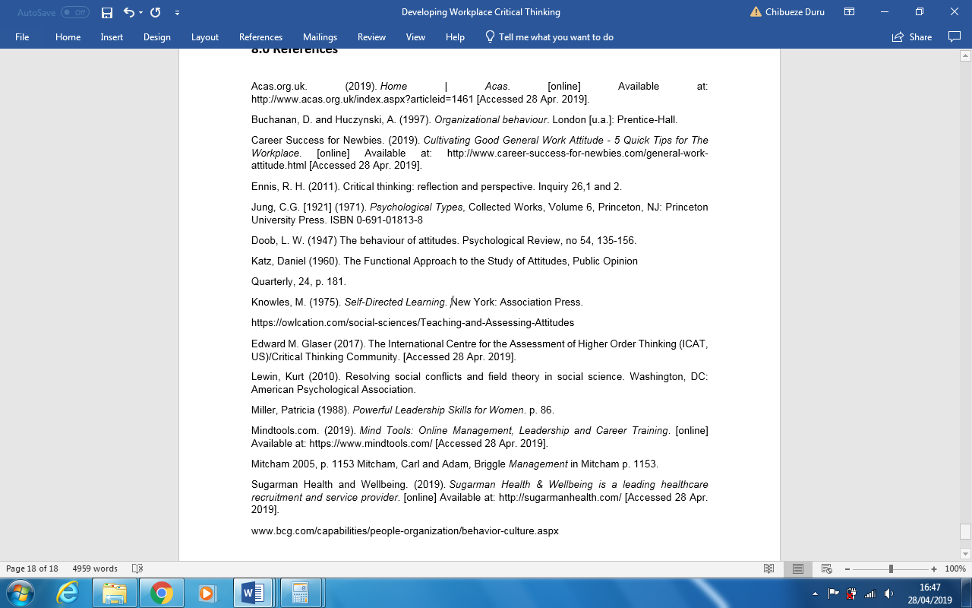
Hofstede, G. (2001). Culture's Consequences: Comparing Values, Behaviors, Institutions and Organizations across Nations. Thousand Oaks CA: Sage.

