Programme: BSc Built Environment
Module: Law for the Built Environment
Module Code: M4X01311
Assignment Title: Legal Issues within Construction Projects
Student: Andrew Brewer 174105

Legal Issues within a Construction Project

Table of Contents
Introduction 1
Construction Projects – Why Contracts Are Critical 1 & 2
Issues arising if a contract is not fully discharged 3
Essential elements of a contract 4,5,6,7&8
Scenario – Outcomes and ramifications of the following incidents
Burn Waste on site without a Licence 8 & 10
Site break-in with materials being disturbed/Removed 11
Perpetrator injuring themselves on breaking-in 12

Legal Issues within a Construction Project
Introduction
A description of the essential elements of a contract and the reasons why they are critical for construction projects.
Scenario outcomes and ramifications of the following incidents –
- A contractor deciding to burn waste on site without a license
- The site is broken into and materials are removed or disturbed
- Whilst the site is broken into, the perpetrator injures themselves

Construction Projects – Why Contracts Are Critical.
A contract within the construction industry can be seen as an essential tool that outlines the roles and responsibilities in the delivering a project of both employer (Employers Agent or Specifier) and the contractor. The key factors outlined in a contract will generally be centred around quality assurance, time, cost and resources.
“The essence of a construction contract is that a contractor agrees to supply work and materials for the erection of defined building or other works for the benefit of the employer. The detailed design of the work to be carried out is often supplied by or on behalf of the employer, but may also be supplied in whole or in part by the contractor.”
(Uff, 2009, p268).
As construction contracts are carried out within the built environment, provisions referred to as ‘variations’, may need to be factored into the contract as work proceeds. These variations can occur during both the design and construction phase of the project. A variation is the term used to describe alterations, additions or omissions from a project and its contract due to unforeseen or unaccounted for states of for example, the land on which construction is to take place, or the condition of a structure to be renovated. A contractor is not bound, without express provision, to execute more than the works set out in the contract.
As variations, ‘Extra’s’ are another item that are duties, services and/or materials that have been excluded from the original design brief, and therefore not included in the scope of works that makes up the contract. These ‘extra’s’ may be essential acts that need to be completed to finish a project. Payment for extras are contractual and will usually be covered when written orders to carry out the works are produced, but as the cases bellow outline, this is not always the case.
“The mere doing of extra work, or doing work in a way different from that specified, does not bind the employer to pay for extras.”
(Uff. 2009. P286)
In the case of Molloy v Leibe (1906) although extras were not included in the contract, nor was there a written order to complete them, the court ruled that the employer had knowledge of the extra works and witnessed them being completed while being aware that they were not part of the contract and knew that the builder expected payment for them.
In the case of William v Roffey Bros (1990), Williams had under-priced a contract and was therefore asking for further payments for work on a contract that was no more than they were initially contracted to carry out. The court ruled that consideration had been given by Williams to the fact that his actions had allowed Roffey Bros to avoid a late completion penalty for the works.

“Contracts are critical for construction projects as “A standard form of building or construction contract is a binding agreement between the employer for the building project and the building contractor who is responsible for carrying out the construction work. They include full details of the costs and provision of labour, materials and services as well as plans, specifications, drawings, a schedule for completion, and any changes which have been agreed. The construction work including the cost and time-scale must comply with the contract.”
(RICS, 2104)

Issues arising if a contract is not fully discharged.
“Discharge is a general term for the release of a contractual obligation”
(Uff. 2009. P205)
Contracts exist as means to protect all parties individually, from any illegal, wrong or loss caused by the other parties included in that contract.
There will be a number of constraints or obligations that need to be met within a contract for it to be fully discharged. There may be financial penalties for either party for not fulfilling these obligations. Items within a contract that may cause a contractor to be penalised can include: time scales of project delivery; occupancy date; quality; and specification. Contractors not meeting the obligations of the contractor or causing detrimental services to an employer can also be removed and replaced without payment.

Essential elements of a contract
A contract is a written or verbal agreement enforceable by law and made between two or more parties in regard to fulfilling an obligation in return for consideration.
“The law of contract is based on the mutual exchange of obligations, in that each side must contribute something to the agreement to make it binding. The only exception to this principle is a contract made by deed.”
(Uff, 2009. P175)
Contracts generally apply and are enforceable in the following circumstances –
- Employment (including sub-contractors)
- Sale (Goods, materials and services etc.)
- Lease (Vehicles, plant, tools etc.)
- Tenancy (Premises, right to occupy etc.)
- Projects (Scope of works, materials, methods & time)
A contract must contain a number of elements to make it valid and enforceable.
- Agreement – (Offer & acceptance) An offer of entering into a contract by one party to another for consideration on a specific event. Offers do not remain open indefinitely and may be revoked at any time prior to acceptance as long as communicated. Acceptance is an unequivocal agreement to the offer. Should negotiation of the offer take place the initial offer will be seen to be rejected and the offeree will then become the offeror and any acceptance will be on the newly negotiated terms. (An example case of an offer being revoked (Dickinson v Dodds (1876)) and a case where negotiation has therefore rejected the original offer (Hyde v Wrench (1840)))

- Consideration – For a contract to be binding, each party must provide consideration. Forms of consideration are payments of money, provision of goods or services. Consideration can also be an act that benefits one party at the detriment of the other (i.e. the completion of one task or job in return for the completion of another task or job, or the completion of a task or job in return for settling an outstanding debt.).
There are a number of key elements to the consideration part of a contract to make it contractual.
- Consideration cannot be historic or have already happened. As in McArdle (1951) where past consideration was deemed invalid.
- Consideration must have a value, but need not be adequate. For example, Chappell v Nestle (1960). The courts will not judge the value of the contract as to whether it is of market rate, a good deal or not.
- Consideration must move from the promissee for enforcement to be valid. As in Tweddle v Atkinson (1861)
- Acting in public duty will not amount to a valid contract as in Collins v Godfrey (1831). Going above and beyond the normal public duty will amount to a valid contract as in Glasbrook Bros v Glamorgan County Council (1925)
- Performance of an existing contractual duty is not good consideration, as in Stilk v Myrrick (1809)
- Payment of a lesser sum than the amount due will not discharge the debt for a greater sum, as in Foakes v Beer (1883-84)

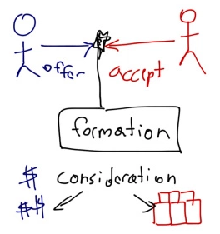 | 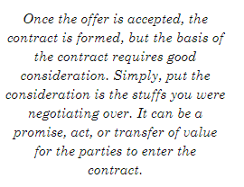

- An intention to be legally bound
“In commercial agreements there is naturally a strong presumption that there was an intention to create legal relations”
(Uff, 2009. P183.)

In the business world, contracts and standard terms of companies are generally legally binding on the acceptance of the terms of sale or service.
In more informal environments and especially where an agreement between family members is involved, an intention to create legal relations can be difficult to enforce and is therefore presumed not to create legal relations.

Further factors to consider
- Battle of the forms – Both parties imposing their standard terms & conditions to the contract e.g. An offering to purchase goods from B using their T&C’s, B accepts the offer on the basis of its T&C’s.

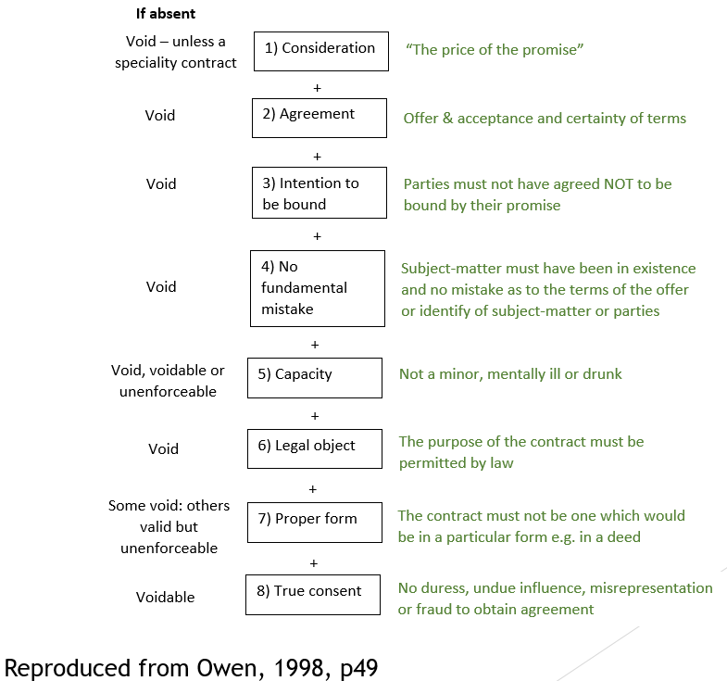

Scenario – Outcomes and ramifications of the following incidents
Burn Waste on site without a Licence
“Construction, demolition and refurbishment accounts for around 100 million tonnes
of waste in the UK each year.”
(BRE Construction Waste Report)
As to reduce the amount of waste from construction sites the industry and its supporting and legislative bodies are consistently looking at ways to reduce waste, safely dispose of waste and to recycle.
Burning waste on site has strict laws in both domestic and commercial cases. Commercial, industrial or construction sites have tighter laws relating to what they can burn on site than domestic. Whilst the Tort of Nuisance (anything that interferes with the enjoyment of life or property including odours, smoke or fumes.) applies to all (for example smell - Wheeler v JJ Saunders [1995]) commercial, industrial and construction sites are also subject to the Clean Air Act 1993 and strict waste management regulations.

Estimated total annual waste arisings, by sector United Kingdom (2006)
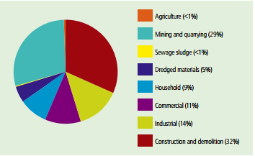
Source: Defra, ODPM, Environment Agency, Water UK

There are some exceptions to burning waste on a construction site as the table below outlines. These exceptions include the product that can be burned, the source, amount of the material and its location. These waste exceptions are only legal if a D7 burning waste in the open exemption has been registered with the environment agency.
Waste exemption: D7 burning waste in the open
Types of waste you can treat
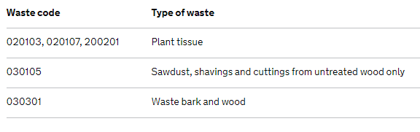
Quantity of waste you can treat
- burn up to 10 tonnes of waste in any 24-hour period
- store up to 20 tonnes of waste at any one time
- store waste for up to 6 months before burning, to allow certain wood waste to dry out
Key conditions
The burning must take place on open land, not in an incinerator or a building.
You should be careful to position the bonfire where it will not cause nuisance to neighbours through excessive smoke or odour.
The burning must take place only at the place where the waste is produced.

(Environment Agency, Waste Exemptions: disposing of waste April 2104)

In the case of the contractors used, the ramifications for burning waste on site without a license would potentially result in financial penalties for breaching environmental legislation. Between the environmental regulators including local authorities, the Environment Agency and Natural Resources Wales, this case could expect penalties ranging from enforcement notices, clean-up notices, fines and imprisonment.
Breech of environmental law is a criminal offence.

Site break-in with materials being disturbed/Removed
In this scenario there are a number of factors to consider, who is liable for the loss (contractor or sub-contractor), insurance, Health & Safety and potential loss of earnings related to the disturbance of materials.
With a perpetrator breaking-in to a site and removing or disturbing materials this can be classed as a ‘Nuisance’(Private).
Private nuisance may be defined as an unlawful interference with the use or enjoyment of another person’s land.
Uff. 2009. P482

Perpetrator injuring themselves on breaking-in
In this scenario, the ‘law of tort’ and particularly ‘negligence’ are the key factors which could arise should legal proceedings take place. The basis of this derived from the case of Donoghue v Stevenson (1932). The building contractor would need to hold public liability insurance to cover a claim in these circumstances.
As established from the Donoghue v Stevenson (1932) case, the company (in this case the building contractor responsible for the site) must show a ‘duty of care’ to all individuals that enter the premises, whether invited, or not. Any person injuring themselves on the site has a potential claim for breach of that duty.
The case of Donoghue v Stevenson (1932) created a judicial precedent for future cases of negligence. This occurs when the facts of a previously decided case are used to support and reference future cases.
Judicial precedent is based on the Latin phrase ‘Stare decisis’ short for ‘Stare decisis et non quieta movere’ which translates to ‘Stand by decided matters’

Bibliography













