  Relective portfolio  Professional career development | Student name: Sanah Ellahi  Student ID: 2019343  Module code: BMSW4005  Lecturer name: Yohan Mendis

Table of Contents
Introduction 2
Swot analysis 3
Personal development plan 4
Skills to become an effective manager
Communication 5
Organization 5
Problem solving 5/6
Relationships and team building dynamics 6
Concepts of learning
Setting goals and objectives 6/7
UK employment law 7/8
Learning theories 8
Self-awareness 8/9
Appendix 10
References 11

Introduction

In this report I will be auditing my own skills and competences using the analysis tools learned in lessons. I will be using SWOT analysis and personal development plan (PDP). I will analyse all skills that require to be an effective manager in health and social care nursing home. I will discuss how my skills acquired and why they are important to me. I will access concepts I learned from the modules by setting goals, using self-awareness methods and employment law. With each of these concepts I will explain why they will be useful to me and reflect on how my understanding has developed me professional.
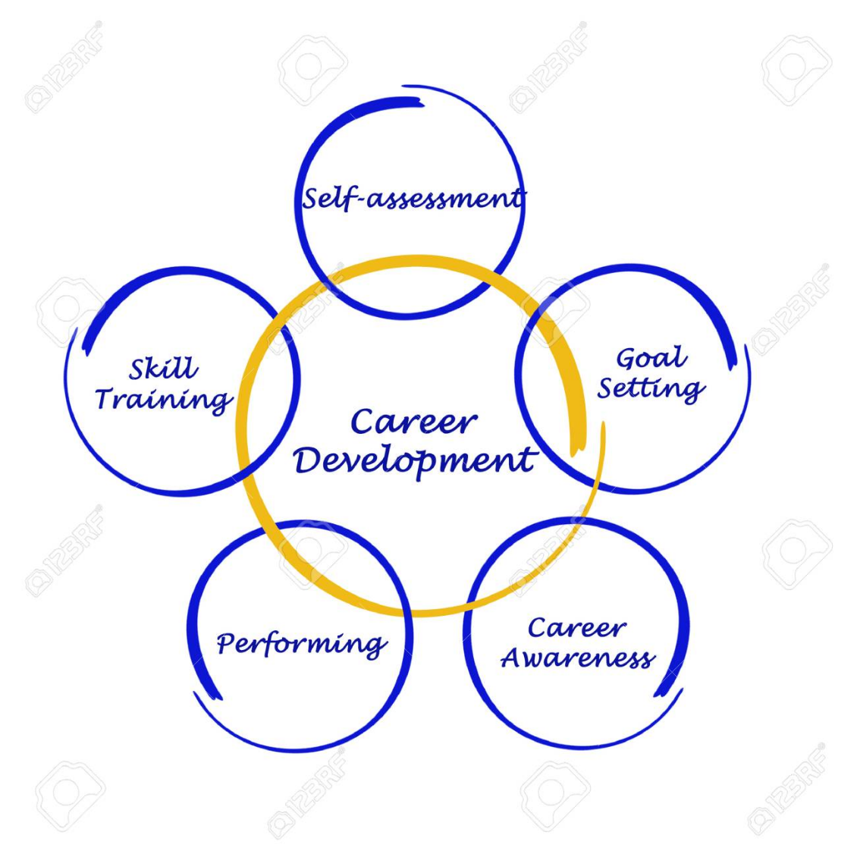

(123RF Stock Photos, n.d.)

SWOT Analysis
Swot analysis is a root cause of a problem in a company. Defining strengths, weaknesses, opportunities, and threats. It helped me understand the cause of the problem and what to do to achieve better and how to identify it by developing strategic planning. Using each element of SWOT to access my performance and completive risks in the business as a health care assistant to progress into a manager.

Strengths  - Good attitude/work ethics – always have a positive mind frame.  - People skills – able to work well with different backgrounds and environment.  - Willing to gain skills and experiences.  - Up for challenges | Weaknesses  - Cannot focus well on independent work – not confident enough  - Ineffective written communication  - Poor time management  - Fear of being under pressure – leads to stress  - Regular directions in tasks.
Opportunities  - Senior or manager leaving soon.  - Offers to improve communication skills and time management.  - Pay rise.  - Training – develop my skill sets to progress further | Threats  - Other colleagues interested in the new position available.  - Time management needs improvement so performance may not go well  - Position may involve independent work
.

Personal development plan
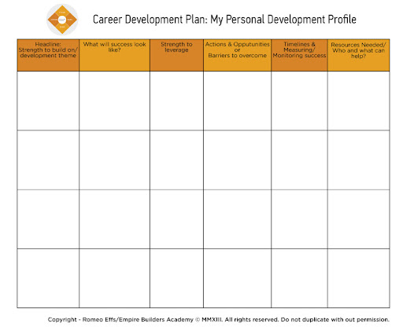

Work on till 2021
Achieve by 2025
Keeping track of progress
Monitoring and evaluating achievements
Identifying accomplishments

Set up email alerts to receive about building my skills and opportunities
Look for ways to keep the company and show how passionate I am in improving and show casing my skills
No be late for work
Look for ways of improvement (research, advertisements, interviews)
Complete assignments on time
Public speaking
Time management
Decision making
Online research
Demonstrating compassion
Open to feedback
Adaptability and flexibility
Understanding of key issues affecting my institution
Being able to contribute in a meaningful way to border discussion
Seek feedback and consider
Attend all training
Completing the right qualifications

What do I need to do to become a health care assistant and progress into management?

- Keep up to date with development in higher education (managing self and personal skills, organisation aspects).
Guidance on how to write CVs academically online.
Get advice from senior/management
Use websites to learn to build skills up
Training to help with communication and management skills

Lecturers and career advisers
Skills to become an effective manager

Communication
To become a skilful effective manager in a nursing home you would need to use your own skills and build on the skills. To be able to develop these skills you can join student societies by gaining leaderships and volunteering prioritising what skills and gathering information and advice from professionals for it to look good on your CV. Volunteering as a mentor is a great way to show case the skills and improve them and its beneficial as experience. You could study for professional skills as part time to help develop and learn practical managerial skills.
Communicating effectively is probably the most important skill a manager should have. It would be very difficult to properly manage those who are under you supervision unless you are able to communicate effectively. When you face and deal with wide variety of management tasks you will need to express your opinions, expectations and needs clearly by communication. A good leader should be able to communicate effectively on all levels including written and verbal and having good listening skills. As a manager you will be the link of between frontline staff and management. The position requires to communicate with variety of other people to including entry level employees, department heads, CEOs using an array of communication means including emails, social media, phones, presentations, meetings, and private notes.
Organisation
As a manager you will be required to be organised is all aspects. To be an effective manager the position will require you to develop a plan, schedule and organise and implement to succeed in the role. This will also include understanding the companies process and rules. Being on track of things and predicting what could happen next. You will need to manage your own workload and oversea work of other employee’s, carry out appraisals and review company policies so a lot of these responsibilities you will need to show and have great organisation skills to adhere to things. This skill will future reduce stress, save time, and ensure important deadlines are met. Organising provides a sense of control that increases productivity that’s why is in important to have. Managing others will involve setting priorities and allocating them according to the skills and achieves confidence and control in the workplace setting a great example as an effective manager.
Problem solving and decision making
Working in managerial position you will need to identify and solve problems daily. The ability to remain calm under pressure and paying attention to detail is essential for this position. You may need to think on your feet when difficult problems arise. By having a creative attitude, you will need to be able to find innovative solutions that minimise the impact of your team and company. Making an informed decision based on quick analysis of the pros and cons of the situation is essential to be an effective manager. The skill is important to have because to make decisions for the benefit of your team or company a manager should take a logical structured approach to decision making. If employee’s is exhibiting behavioural or performance issues you as a manager would need to have the confidence to step in and solve the problem by critically thinking and decision making to find out were the problem lies, analysing the risks and exploring ethical considerations.
Relationships and team dynamic building
It is important than anything else to cultivate positive relationships with your employees. It will be easier to get the best out of your team if they are able to work together effectively, feel more comfortable having conversations and enjoy spending time with each other. As a manager you would understand how your team feels about their trust levels with you and their colleagues as a manager you can use skills and tools to achieve this if you have this skill. Understanding what motives employee’s, triggers and what needs they have by taking time to learn about them and building relationships is important as a manager to build their confidence and skills in the company. Studies also suggests that employee’s manage conflict better and reduce risks of flare ups when good relations are built with managers. The relationship between manager and employee has the power to either make or break employee’s experience and performance. Employees want to work with people they enjoy working with building trust, motivation, and respect in the workplace. (Ryba,2019)
Concepts of learning
Setting goals and objectives
The SMART model helped me set my goals and objectives for me to have effective goals I would need to be specific and understand what needs to be accomplished, who is responsible and what steps to take. This helped me understand how and where to get started. The gaols I put in place, so I know when they needed to be completed by keeping track of my progress. I know how to take actions and achieve the goals effectively. In the future I will avoid overwhelm and unnecessary stress and frustrations by making the goals more realistic and using timebound to help me stay motivated throughout and look at my goals to work towards them by setting dates to achieve them by I learned this in lesson as part of the PDP.
Establishing clear objectives and creating a plan of action helped me allocate my time and resources especially in my interview. When I set my objectives, I included each of the SMART steps according to my goals to achieve before, during and after the interview. In class I set milestones along the way to help me for this interview such as preparing CV. I applied for other jobs to be able to get more interviews skills and see potentials in all areas. I practised and took notes in class. To achieve my goals for this role I updated my CV and resume to the relevant qualifications, I used the help of lecturers in class on how to achieve this. My lectures and online research also helped me understand what types of questions employers may ask, what they look for in CV’s and how to make you a potential successful candidate. I read the jobs description properly and fitted my skills, experiences, and qualifications as the main priority related to the role. By setting these goals I want to show case my skills not only for the role but to move further with It in the field of health care by being determined that I will work towards NVQ’s, management skill training, volunteering or other options that are available to build my career as a health social care worker in the future.
UK employment law
In class I learnt that the UK employment law ensures that its minuses the discrimination risks when recruiting employees, that arrangements for interview are not putting people in particular advantages for them such as disability access.
A contract outlines the responsibilities of employers, what employers can expect from them and what their rights are at work. The employment law has helped me professional to understand my rights as an employee and what employers expect from me.
From the very start of the recruitment phase understanding the key legal issues to be vary of are discrimination and immigration compliance. I understand that it is unlawful to discriminate or be discriminated against in relation to characteristics such as race, gender, maternity leave, disability etc. (The Equality Act 2010).
The contract of employment is fundamental to the UK employment law (Employment Rights Act 1996) a written statement should be issued containing terms and conditions of employment like job description, hours of work, payment details, sick pay, pensions, holiday pay entitlement, place of work, details of disciplinary, grievance procedure, name of employer and employee and terms and conditions can be added to protect the business. The act shows what is agreed between me and the employer.
The Data Protection Act 2018 is a safeguarding important information and making sure it is used properly and legally. As an employer I must be aware of my legal duties, as for the penalties for breaking the rules can be severe.
As an employer I am also entitled to 28 days a year or 5.6 weeks as holiday leave. This is covered by The Working Time Regulations 1998. The working hours is covered by this regulation too giving me the right to paid leave and specified rest breaks.
Health and Safety at Work 1974 (HSWA) is also very important for both parties in work protecting and making sure I am safe in a working environment. But as an employer health and safety obligations care carried out such as risk assessments, policies, representatives and providing training and information.
Compliance with relevant legislations.is important to ensure hiring, dismissals, and work environment process for both employer and employee protection. It helped me understand the laws and how to fight discrimination and promote equal opportunities at work.
Learning Theories
Using Driscoll stem cycle of model of reflection theory, I analysed my experience in class. The theory gave me a better understanding of what to expect. This was a useful way of self-reflection on things and helped me improve personal efficacy. As part of my interview, I reflected on Driscoll’s using the 3 questions firstly the ‘what?’ which is the purpose of the situation and the purpose for me was being successful in the interview for the job as a health care assistant. The interviewer and I were involved, and I was answering the question asked. The next question I asked myself was ‘so what?’ I felt I did good, but I could have done a lot better with answering the questions in more details and as part of my feedback this was addressed. I noticed that I understood my performance will after the interview. I was motivated to work on the feedback I received and ready to take measure for it by practising and building my skills more for future jobs and interviews. My lessons in class helped me to improve my interview on how to look for jobs and face interviews. The next question was ‘now what?’ in the feedback I was told that I needed to improve on answering question in more detail and organising and formatting my CV better. I will look at examples of CV’s online and practise answering interview question in more details on how to do so by getting advice from university lecturers.
Self-awareness
The component of self-awareness is focusing attention of self-processing both public and private information on yourself. Public self-awareness is adhering to social norms and knowing we are being watched by showing behaviours that are accepted. By private awareness you are becoming aware of traits yourself.
A sense of self awareness played a vital role on how I understand myself and how I can relate to others. I evaluated myself in relations to other and become more aware of my traits, behaviours and feelings on my own learning style and development.
Using tools to improve my learning style such as the personality test give me and in sight of what type of personality I have and what job role fits best in that type of trait. From the tests the job best suited for me upon doing my own research was found to be behaviour specialist and community health worker which is what I am looking to achieve.
I have learned that I am motivated to reach my goals and ready for challenges and desire to put all my effect to achieve my goals. I also learnt I am motivated by financial reward having a long-term reward for personal investment to put in my career. My insight for the self-awareness test shows that I am a pleaser and that I am high in external self-awareness and have room to improve it which I will change about myself. In lessons I have learnt I am a visual learner I am attracted to colour and spoken language and to improve my learning for the future I will visualise things that I hear, write down key words, colour code and avoid distractions.
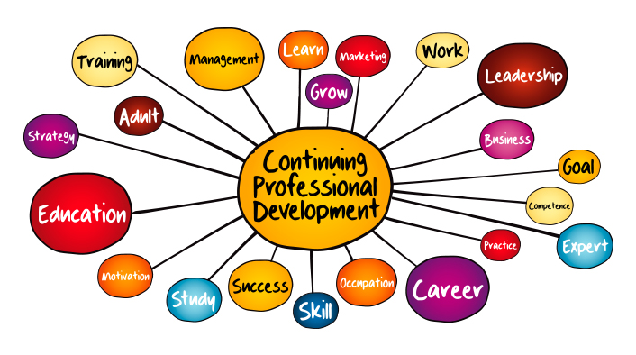

(er.educause.edu, n.d.)
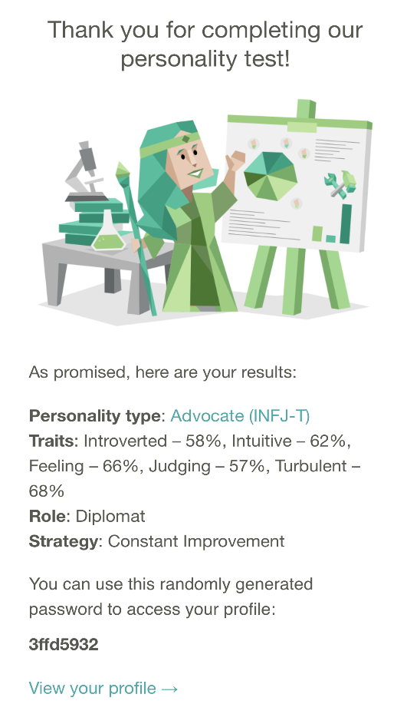
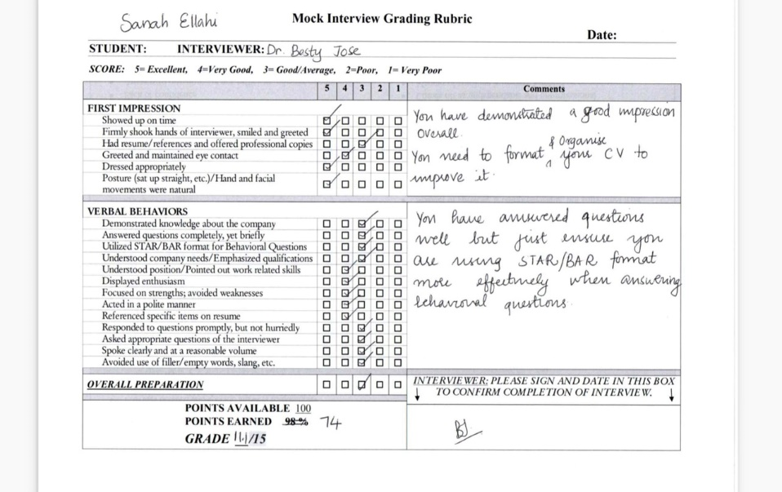
Appendix

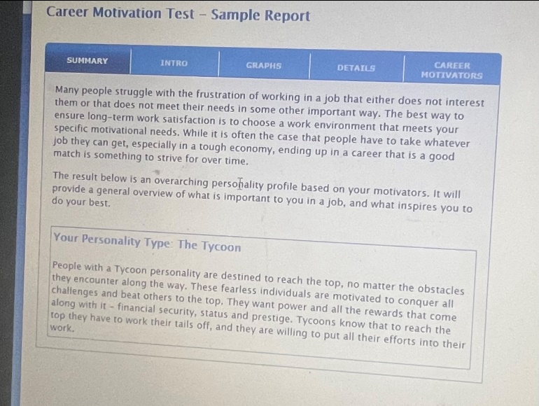
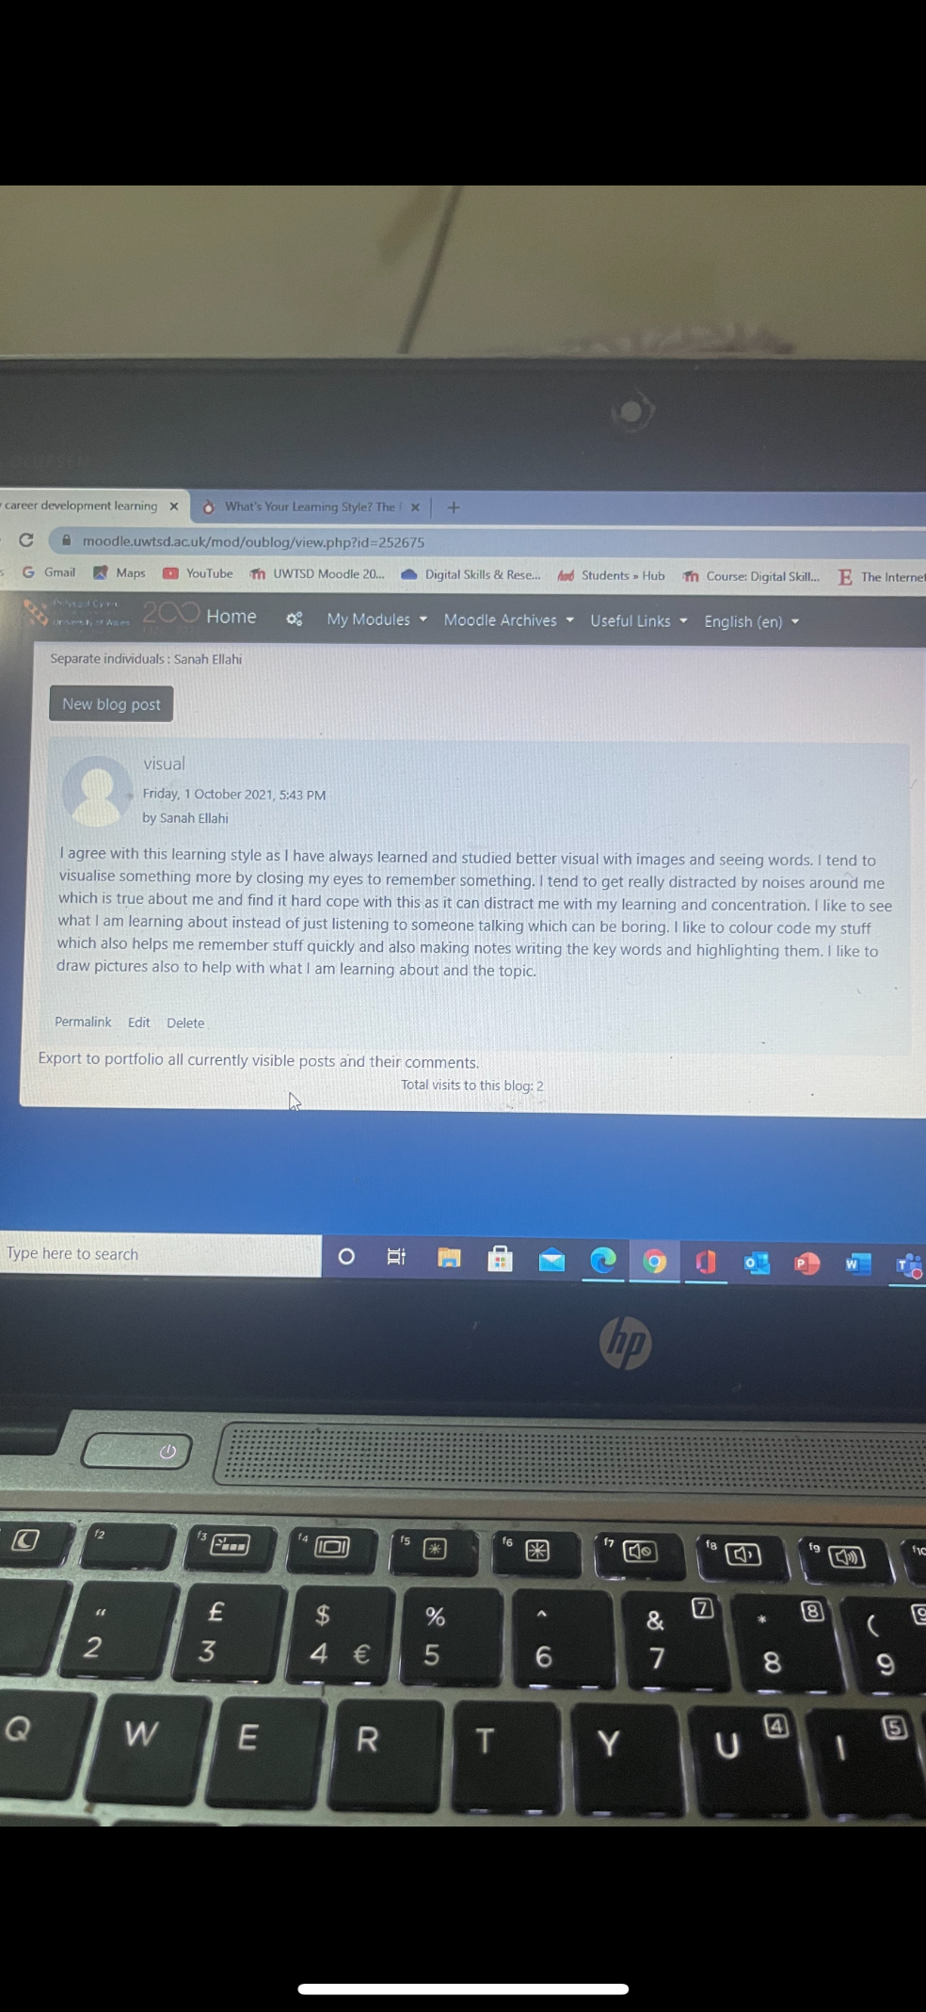
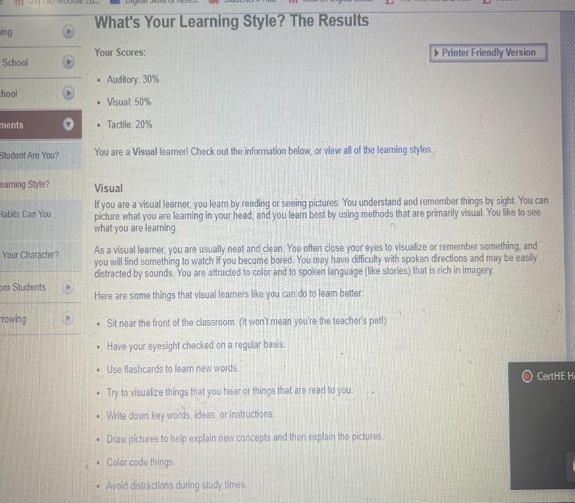
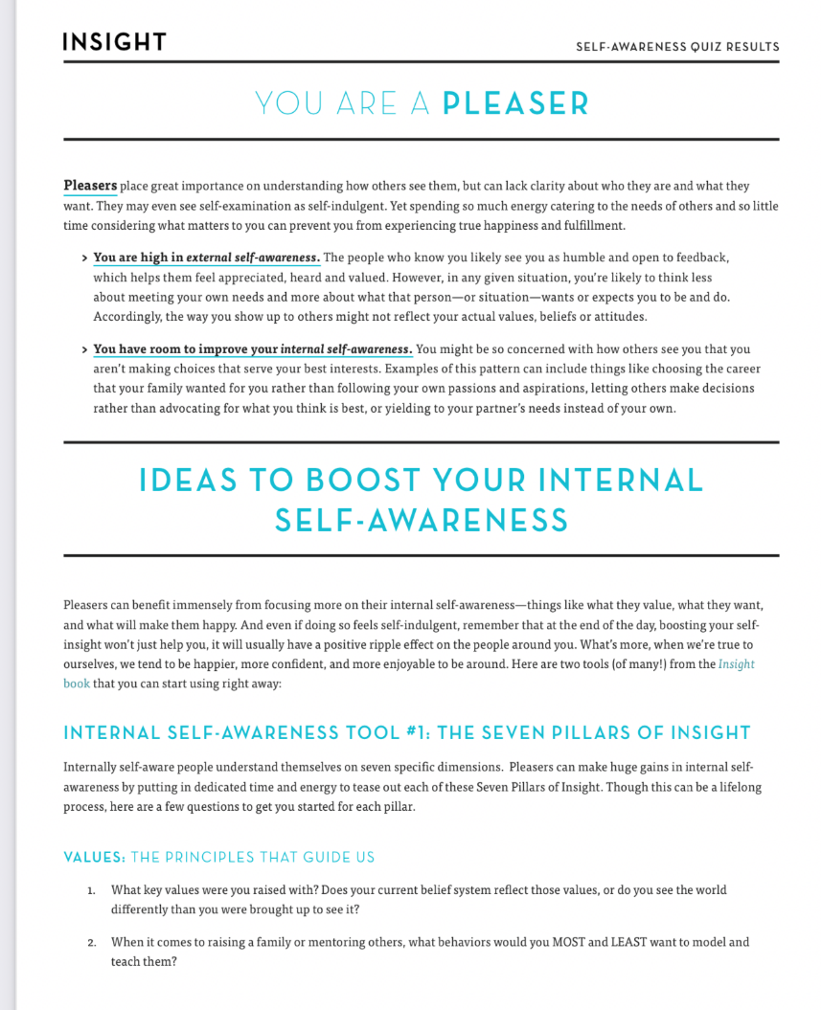
References
Cherry, K. (2014). What Is Self-Awareness? [online] Verywell Mind. Available at: https://www.verywellmind.com/what-is-self-awareness-2795023.
Eby, K. (2019). The Essential Guide to Writing S.M.A.R.T. Goals. [online] Smartsheet. Available at: https://www.smartsheet.com/blog/essential-guide-writing-smart-goals.
Informi (2019). What legislation covers the employment relationship? | Informi. [online] Informi. Available at: https://informi.co.uk/legal/what-legislation-covers-employment-relationship.
Kenton, W. (2021). Strength, Weakness, Opportunity, and Threat (SWOT) Analysis. [online] Investopedia. Available at: https://www.investopedia.com/terms/s/swot.asp.
NursingAnswers.net (2018). Driscoll model of reflection. [online] NursingAnswers.net. Available at: https://nursinganswers.net/reflective-guides/driscoll-model-of-reflection.php.
Perkbox. (2019). The ultimate personal development plan guide + free templates. [online] Available at: https://www.perkbox.com/uk/resources/blog/the-ultimate-personal-development-plan-guide-free-templates.
Ryba, K. (2019). Building Relationships at Work: Why It Matters. [online] www.quantumworkplace.com. Available at: https://www.quantumworkplace.com/future-of-work/building-relationships-at-work.
Small Business - Chron.com. (n.d.). What Are the Benefits of Mastering Organizational Skills? [online] Available at: https://smallbusiness.chron.com/benefits-mastering-organizational-skills-278.html.
Smith, J. (2020). 7 skills for a successful management career | Prospects.ac.uk. [online] Prospects.ac.uk. Available at: https://www.prospects.ac.uk/jobs-and-work-experience/job-sectors/business-consulting-and-management/7-skills-for-a-successful-management-career.

