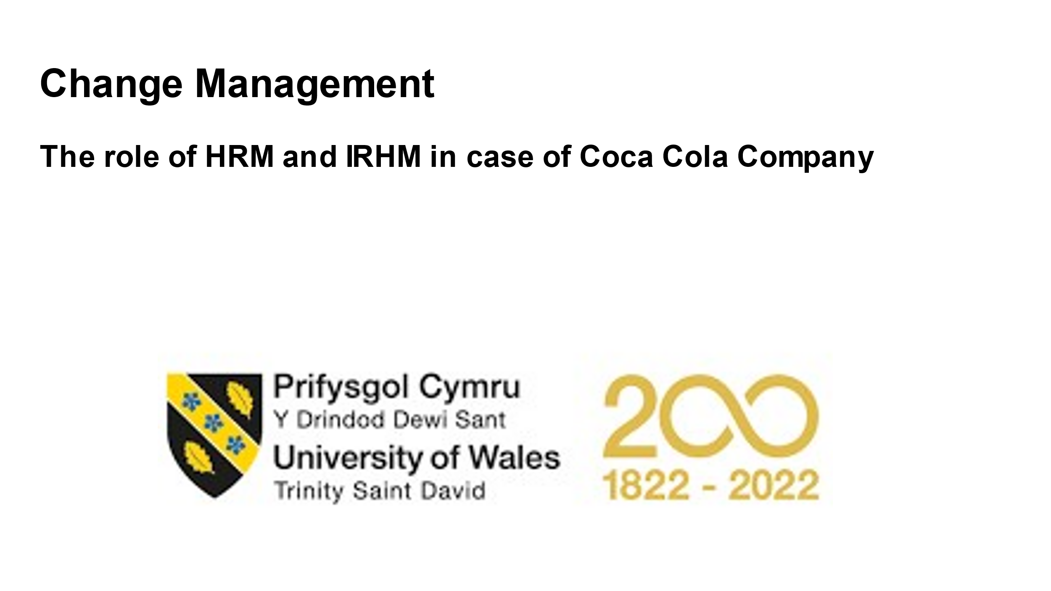
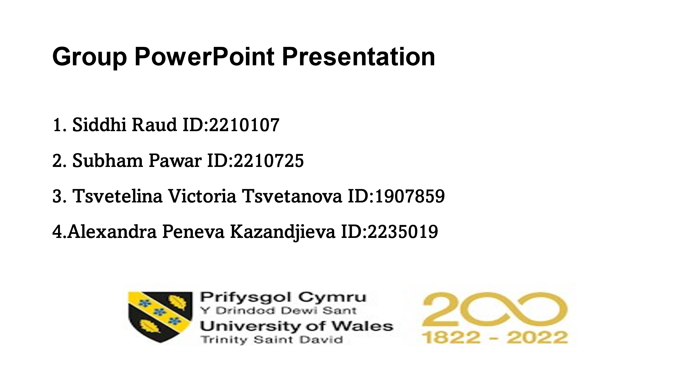
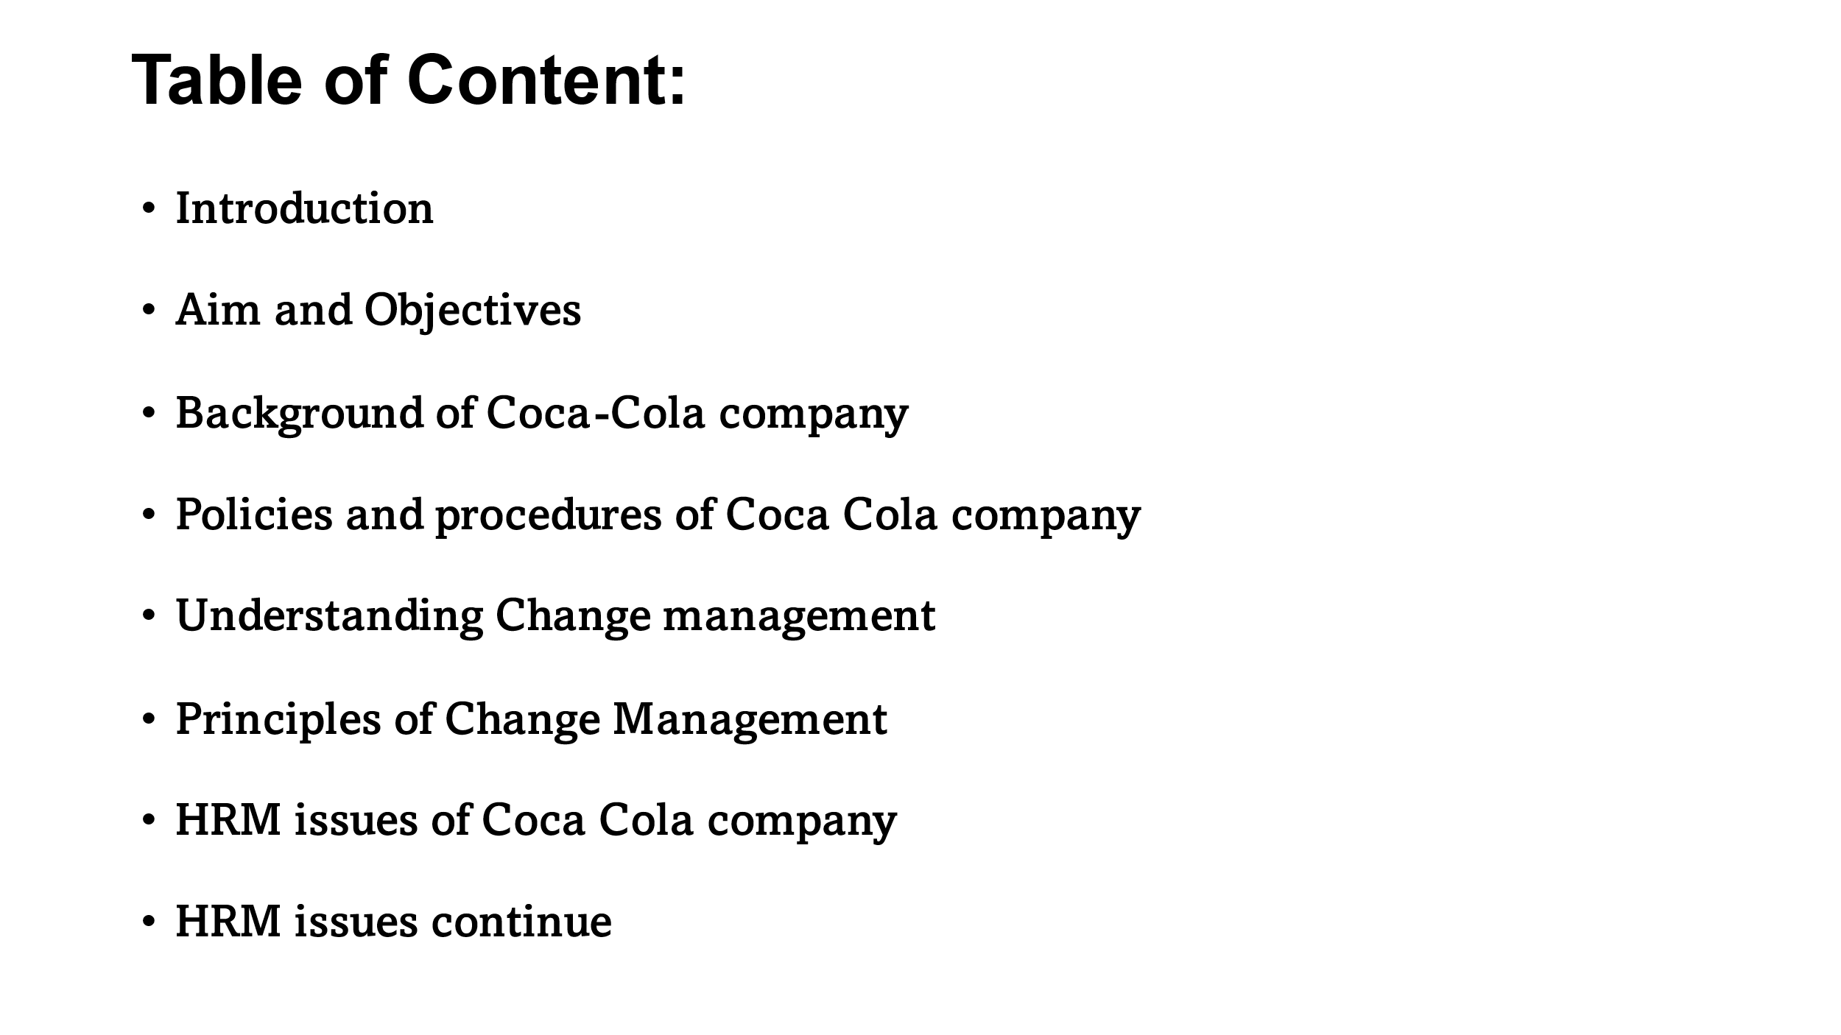
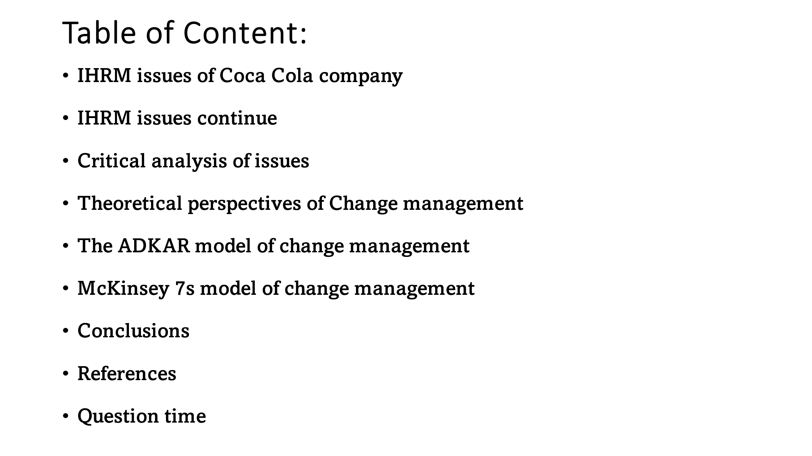
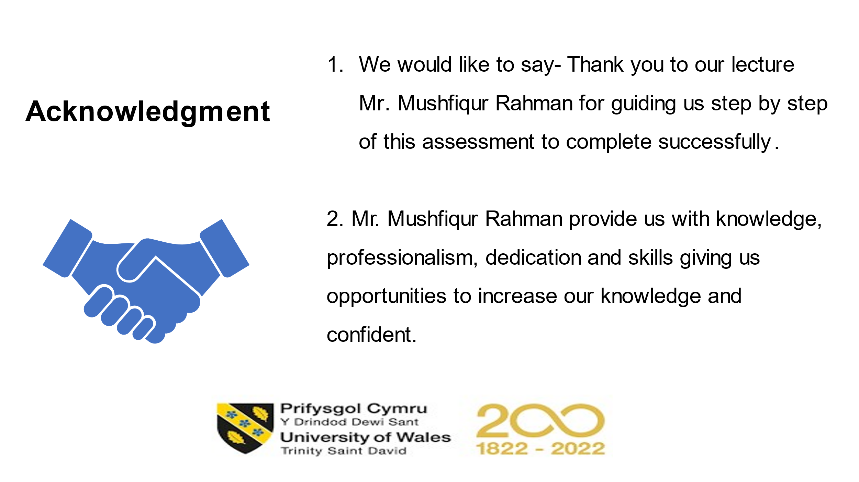
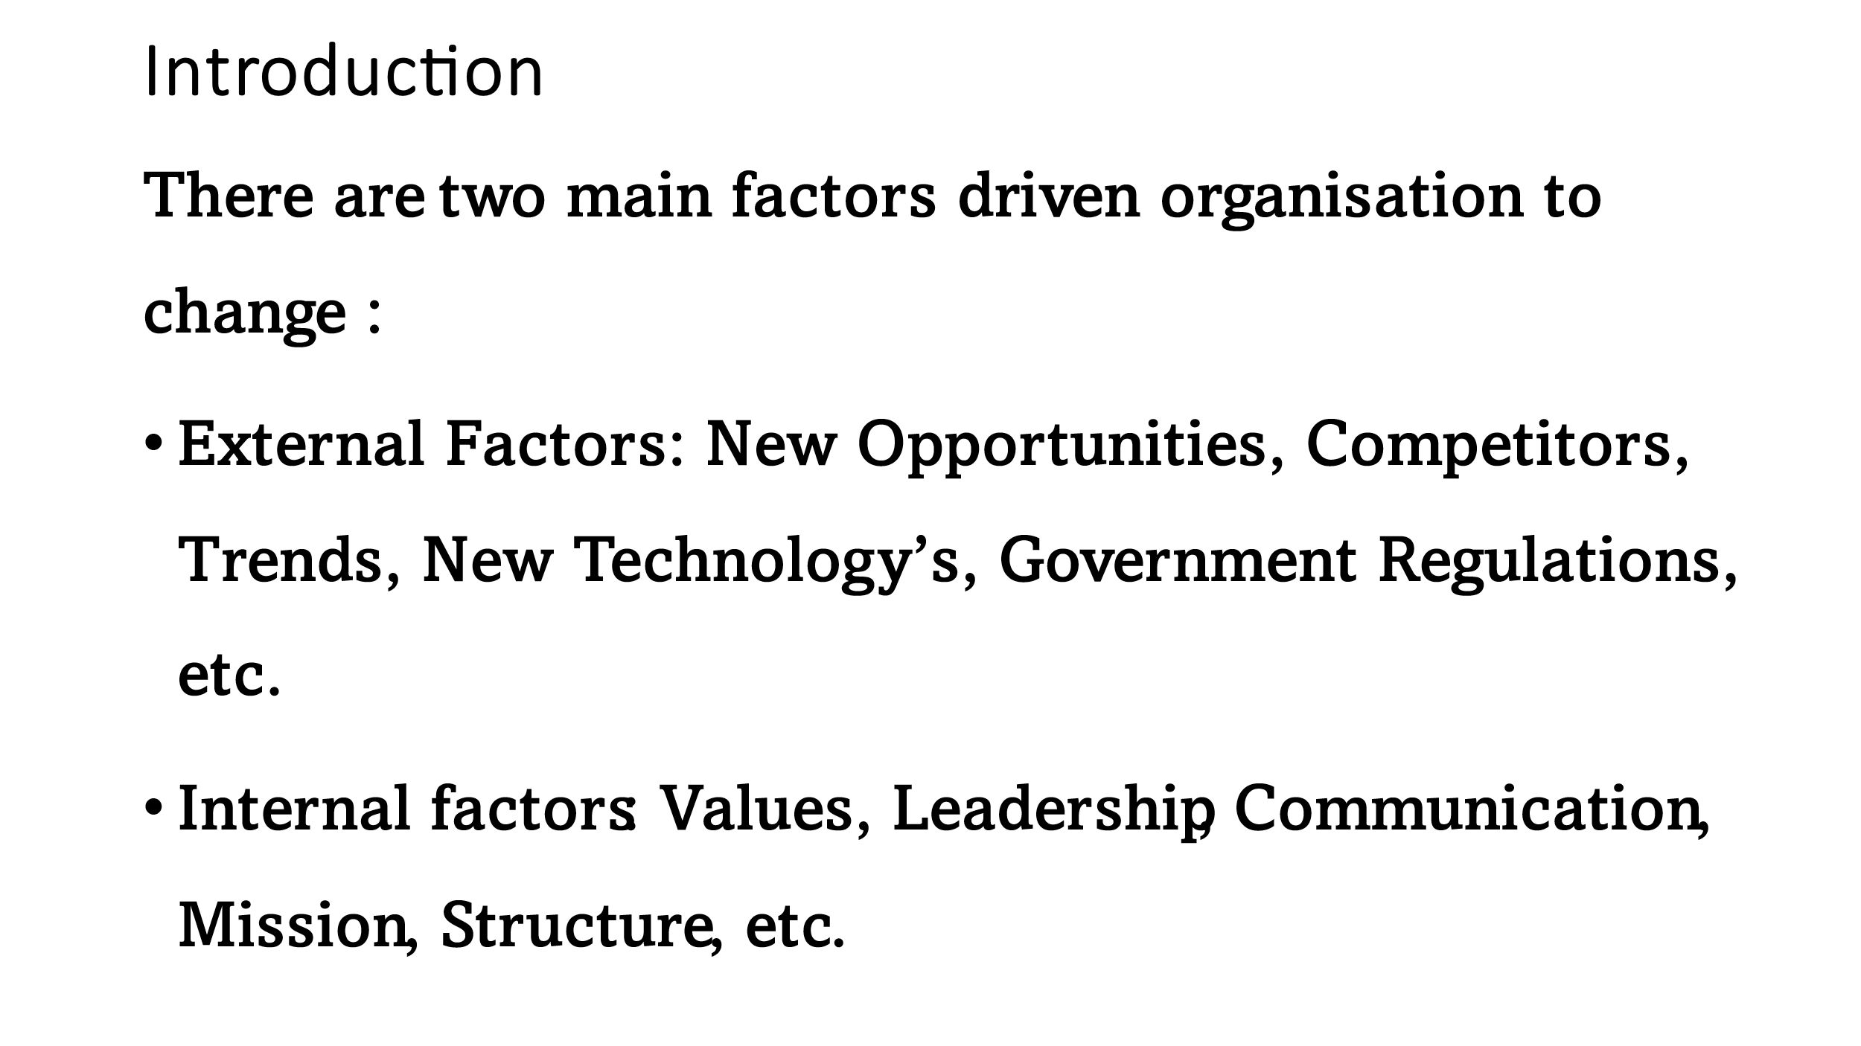
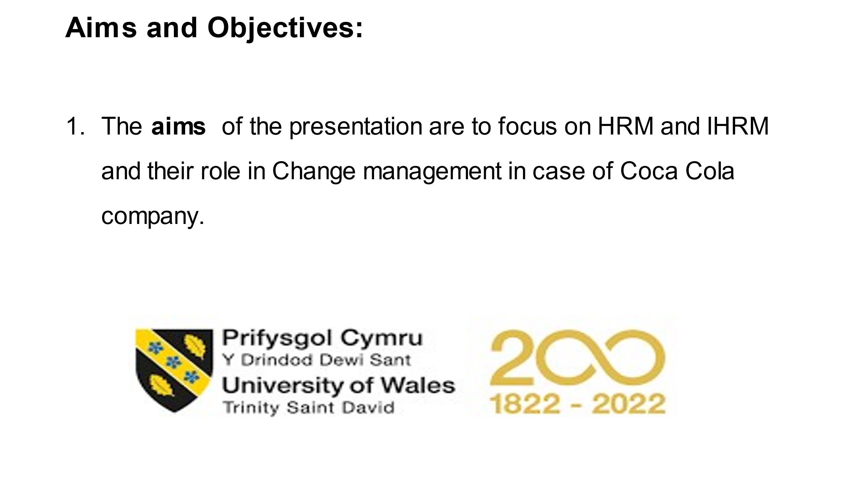
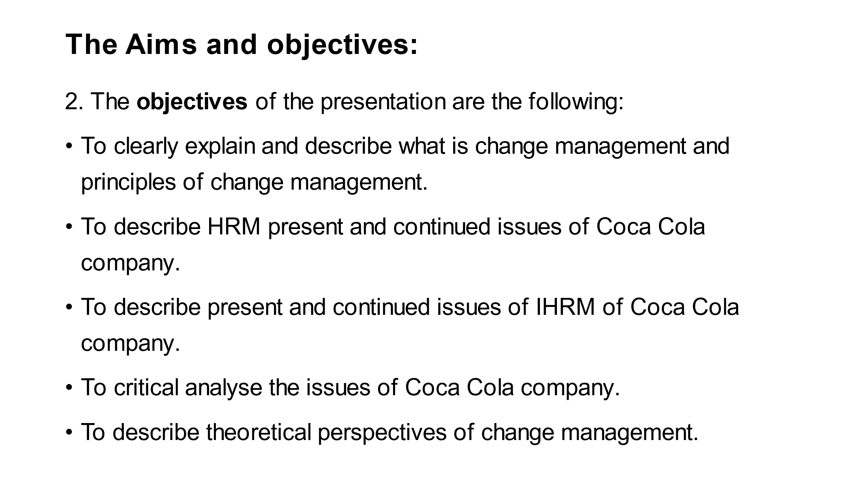
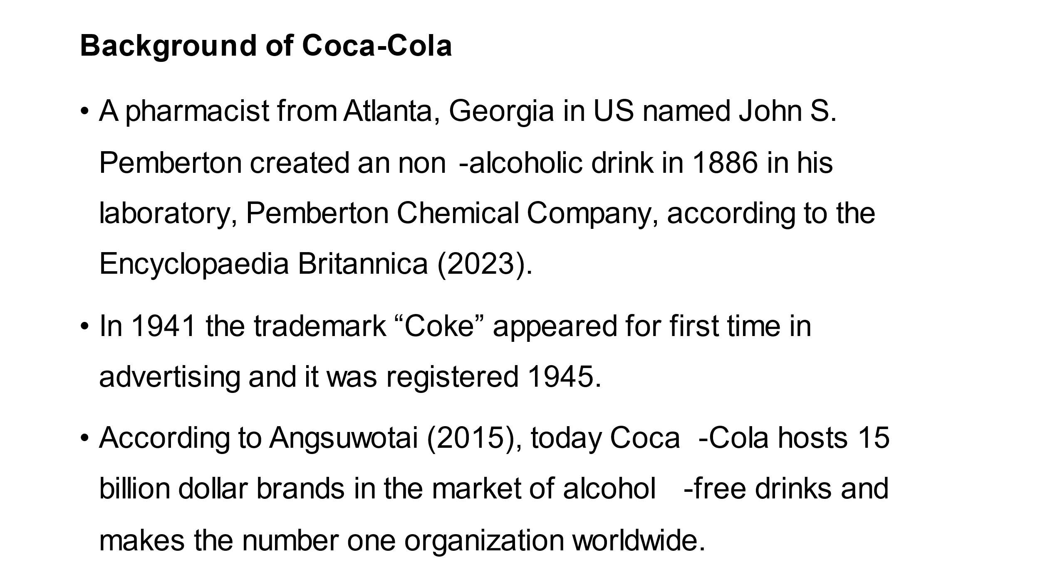
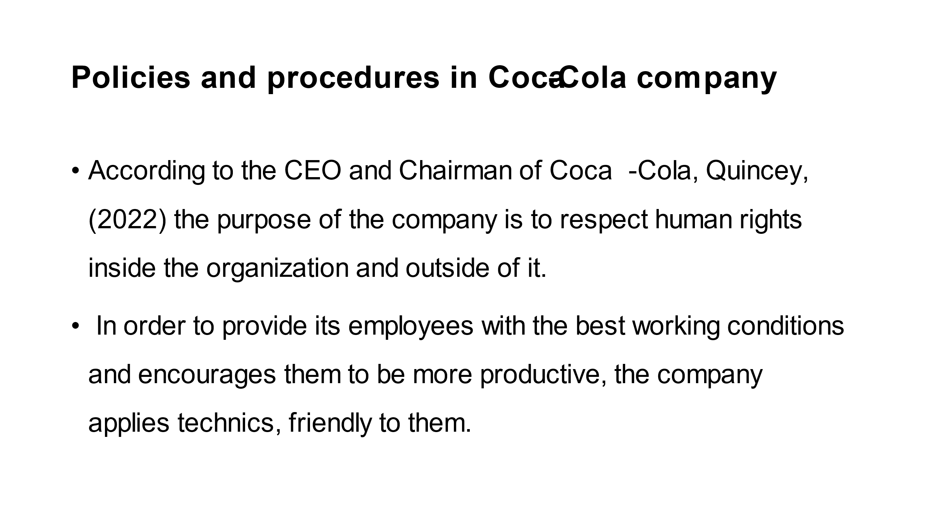
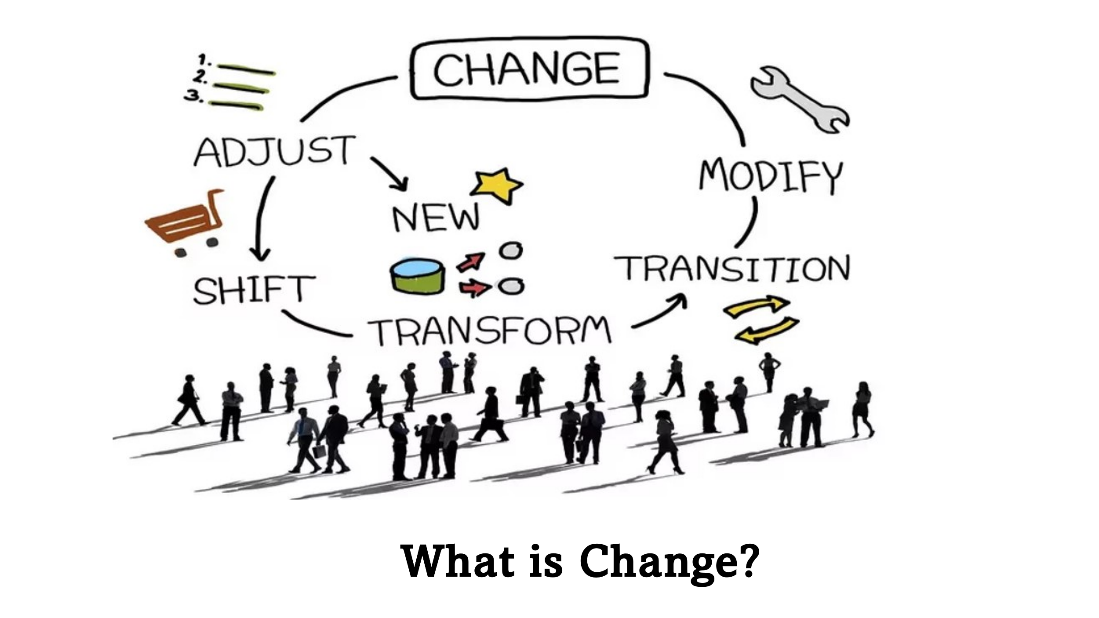
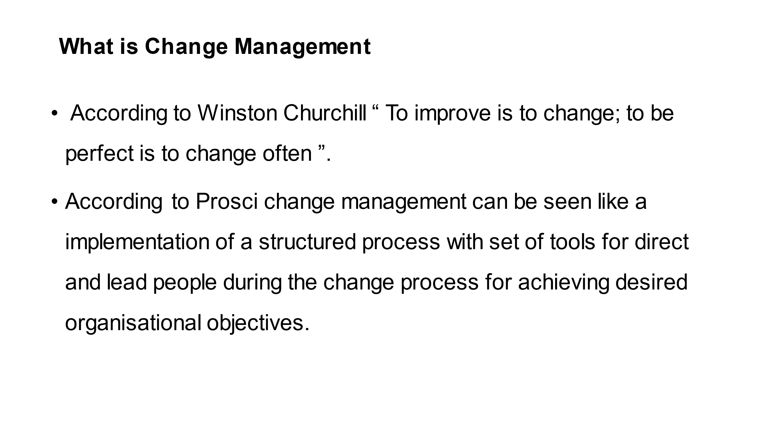
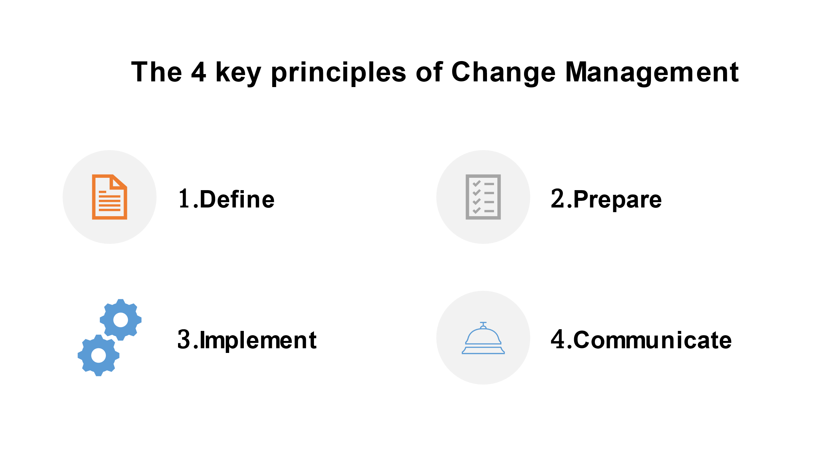
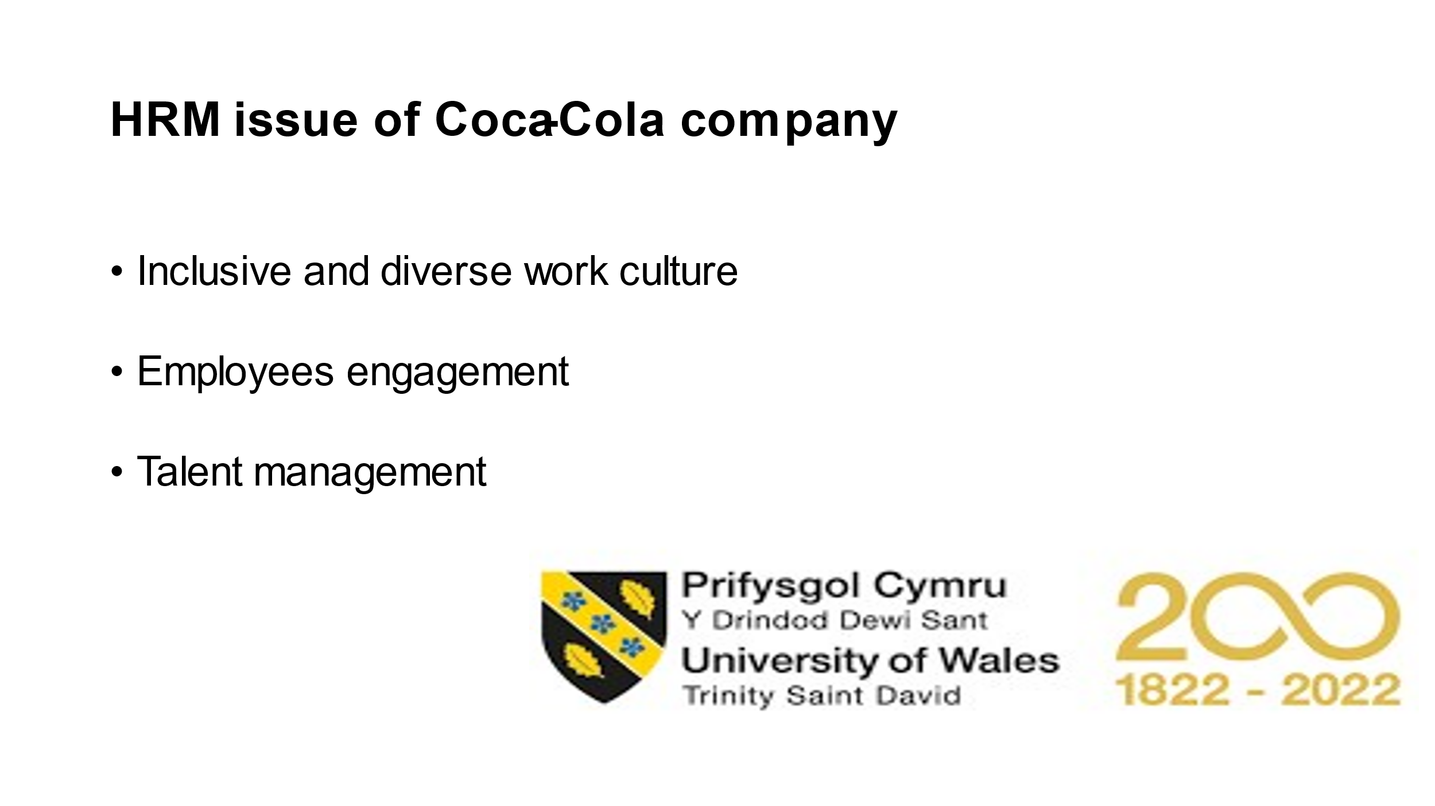
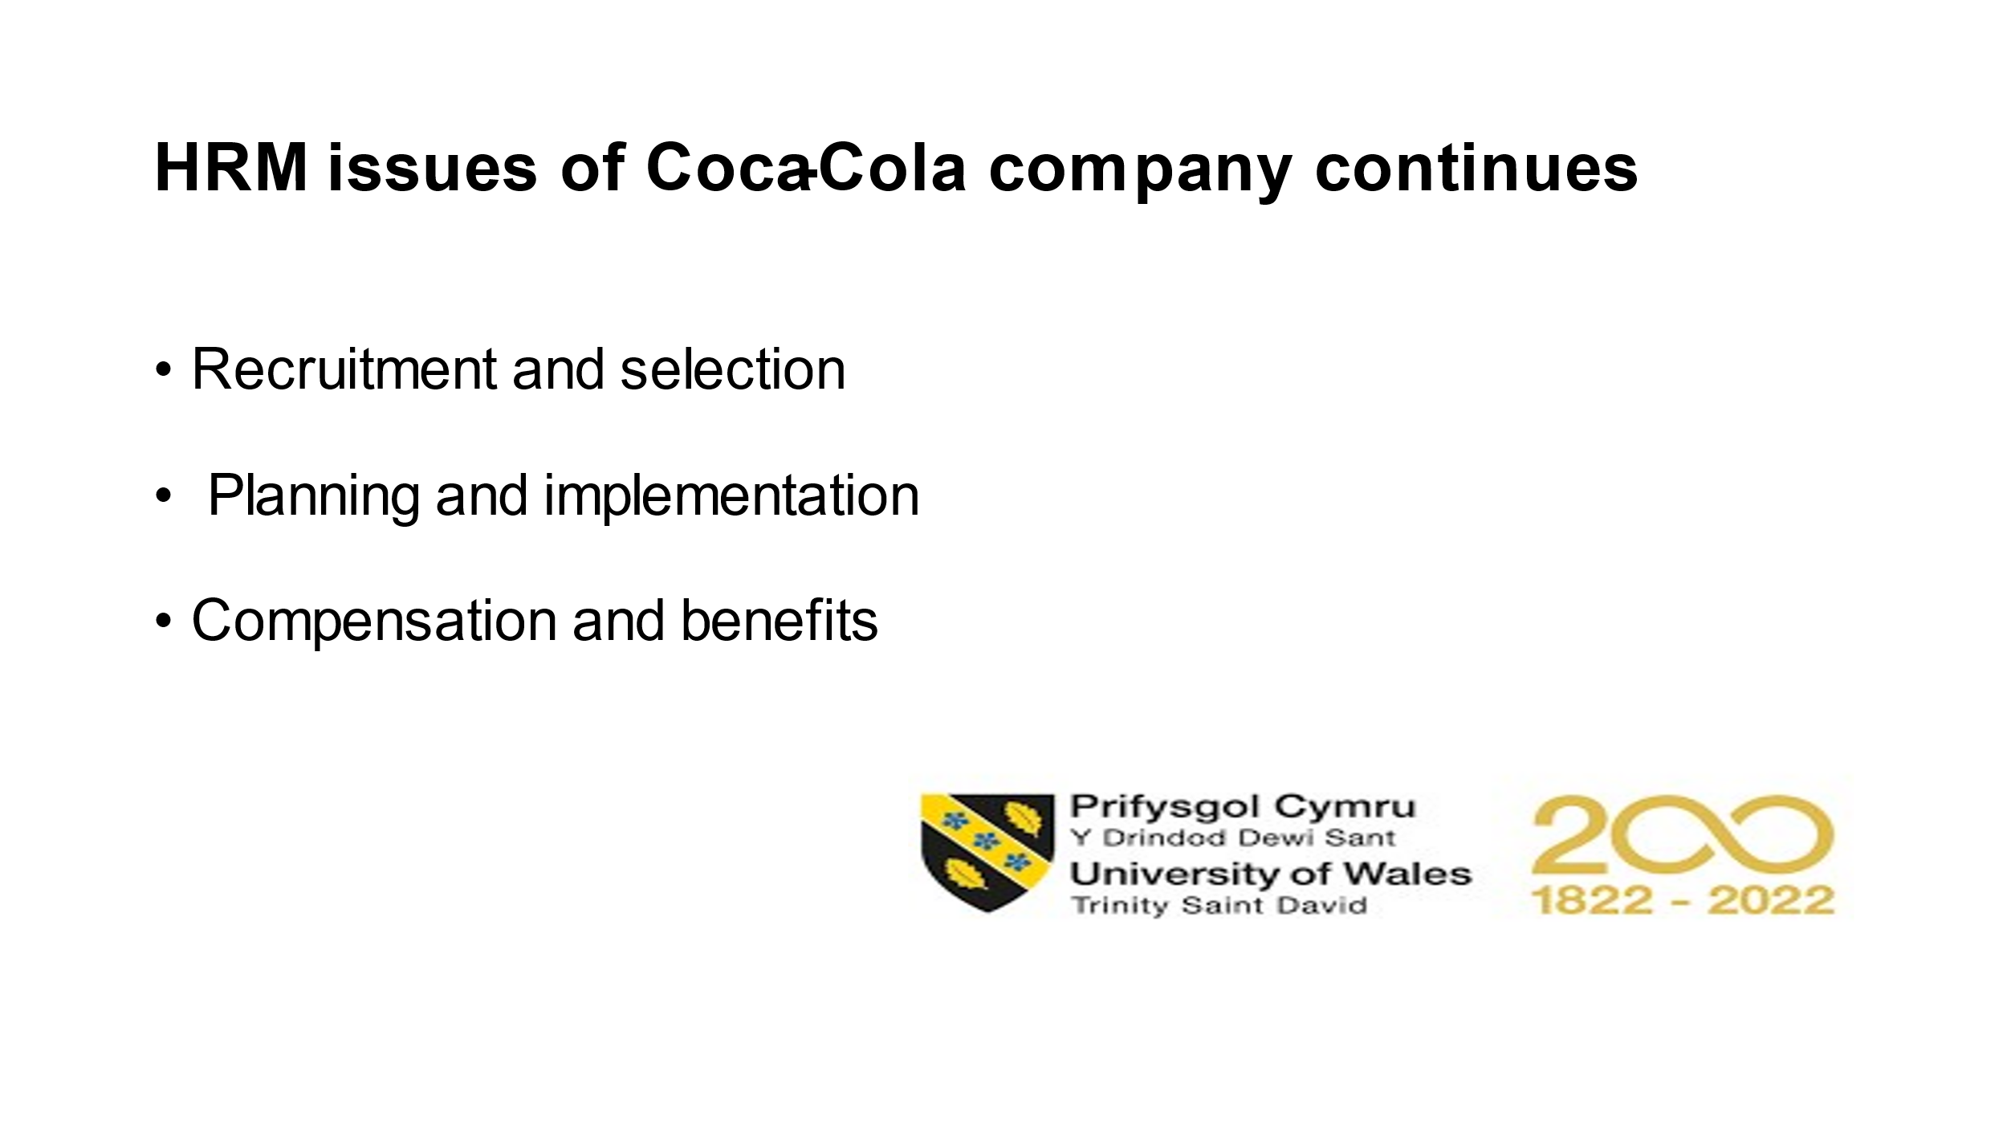

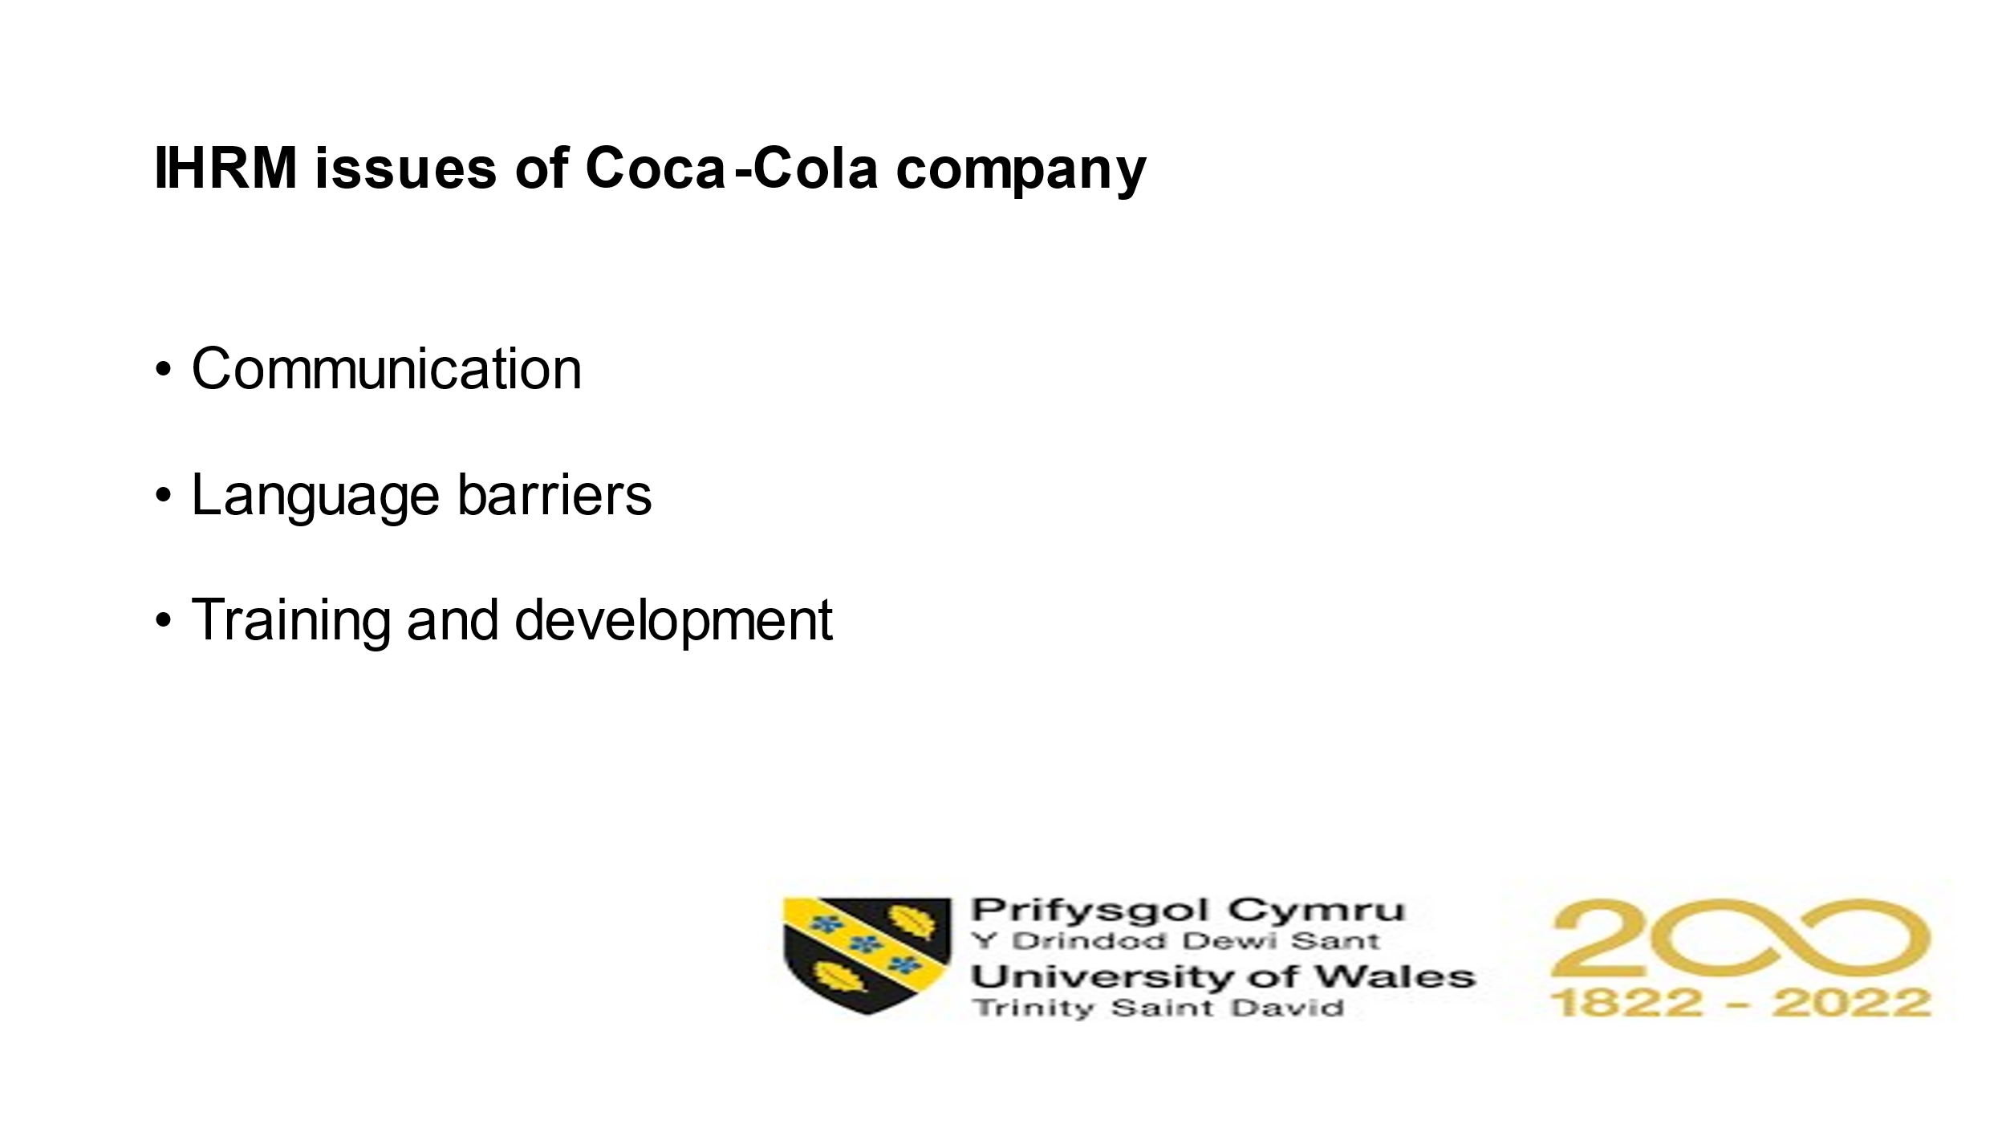

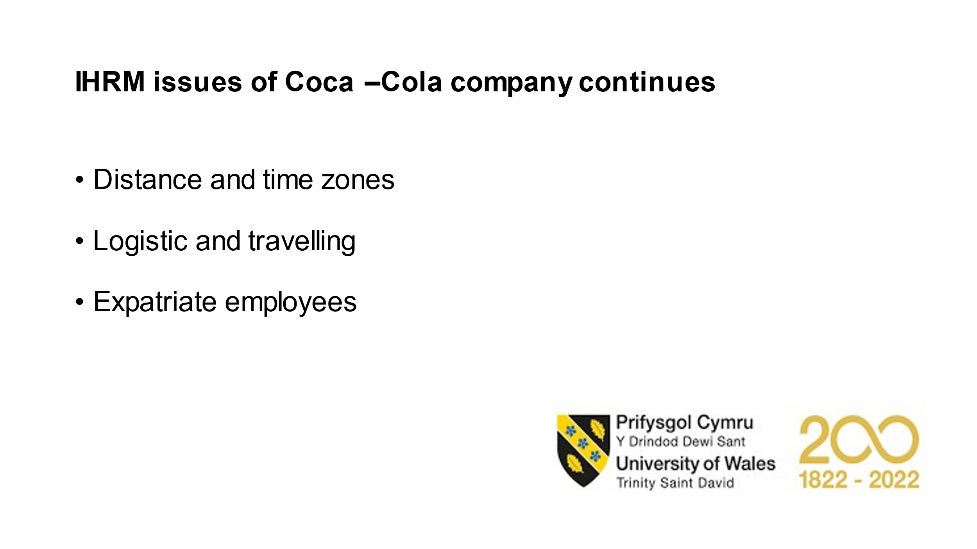
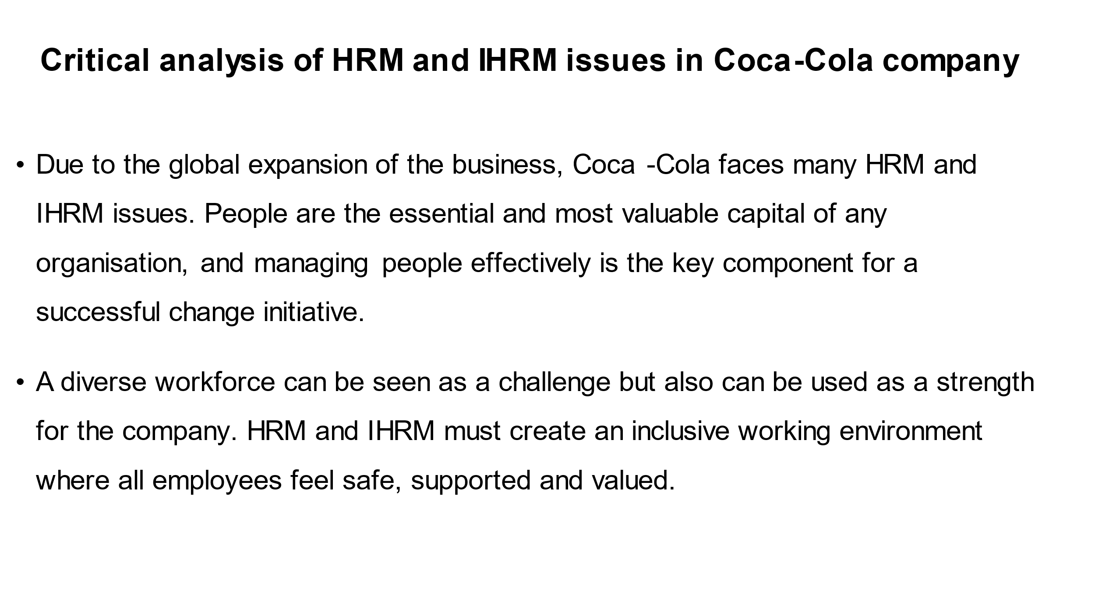

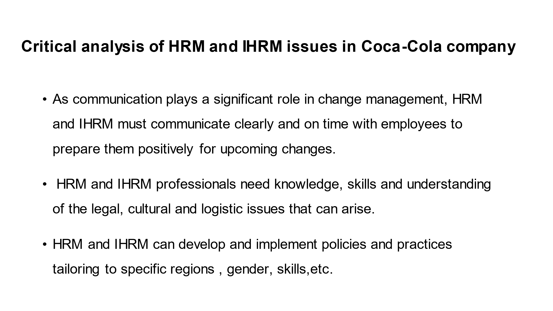
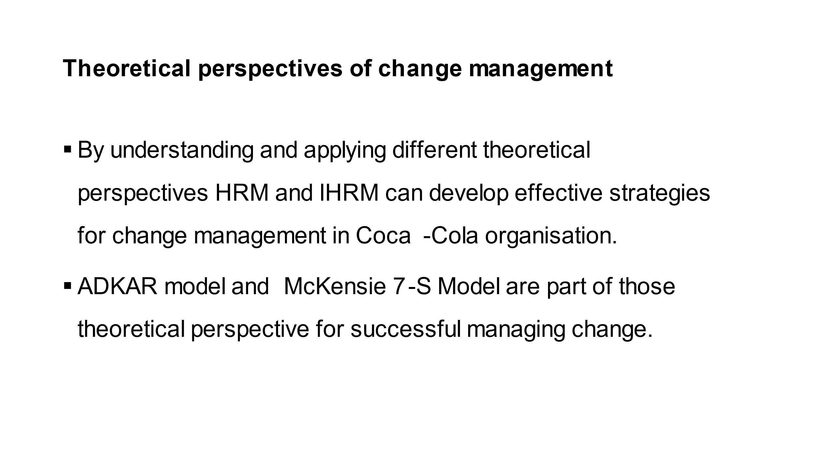
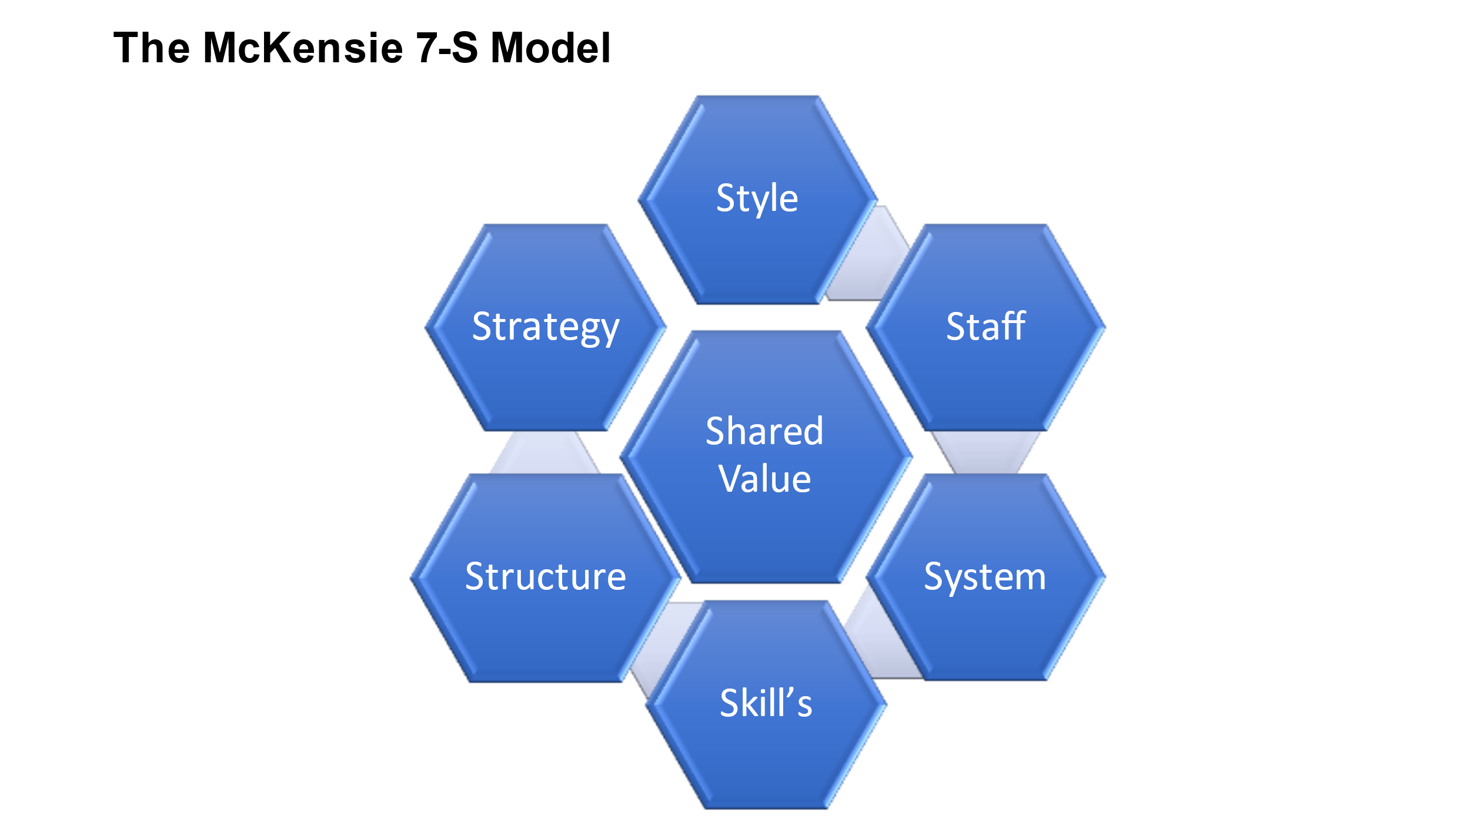

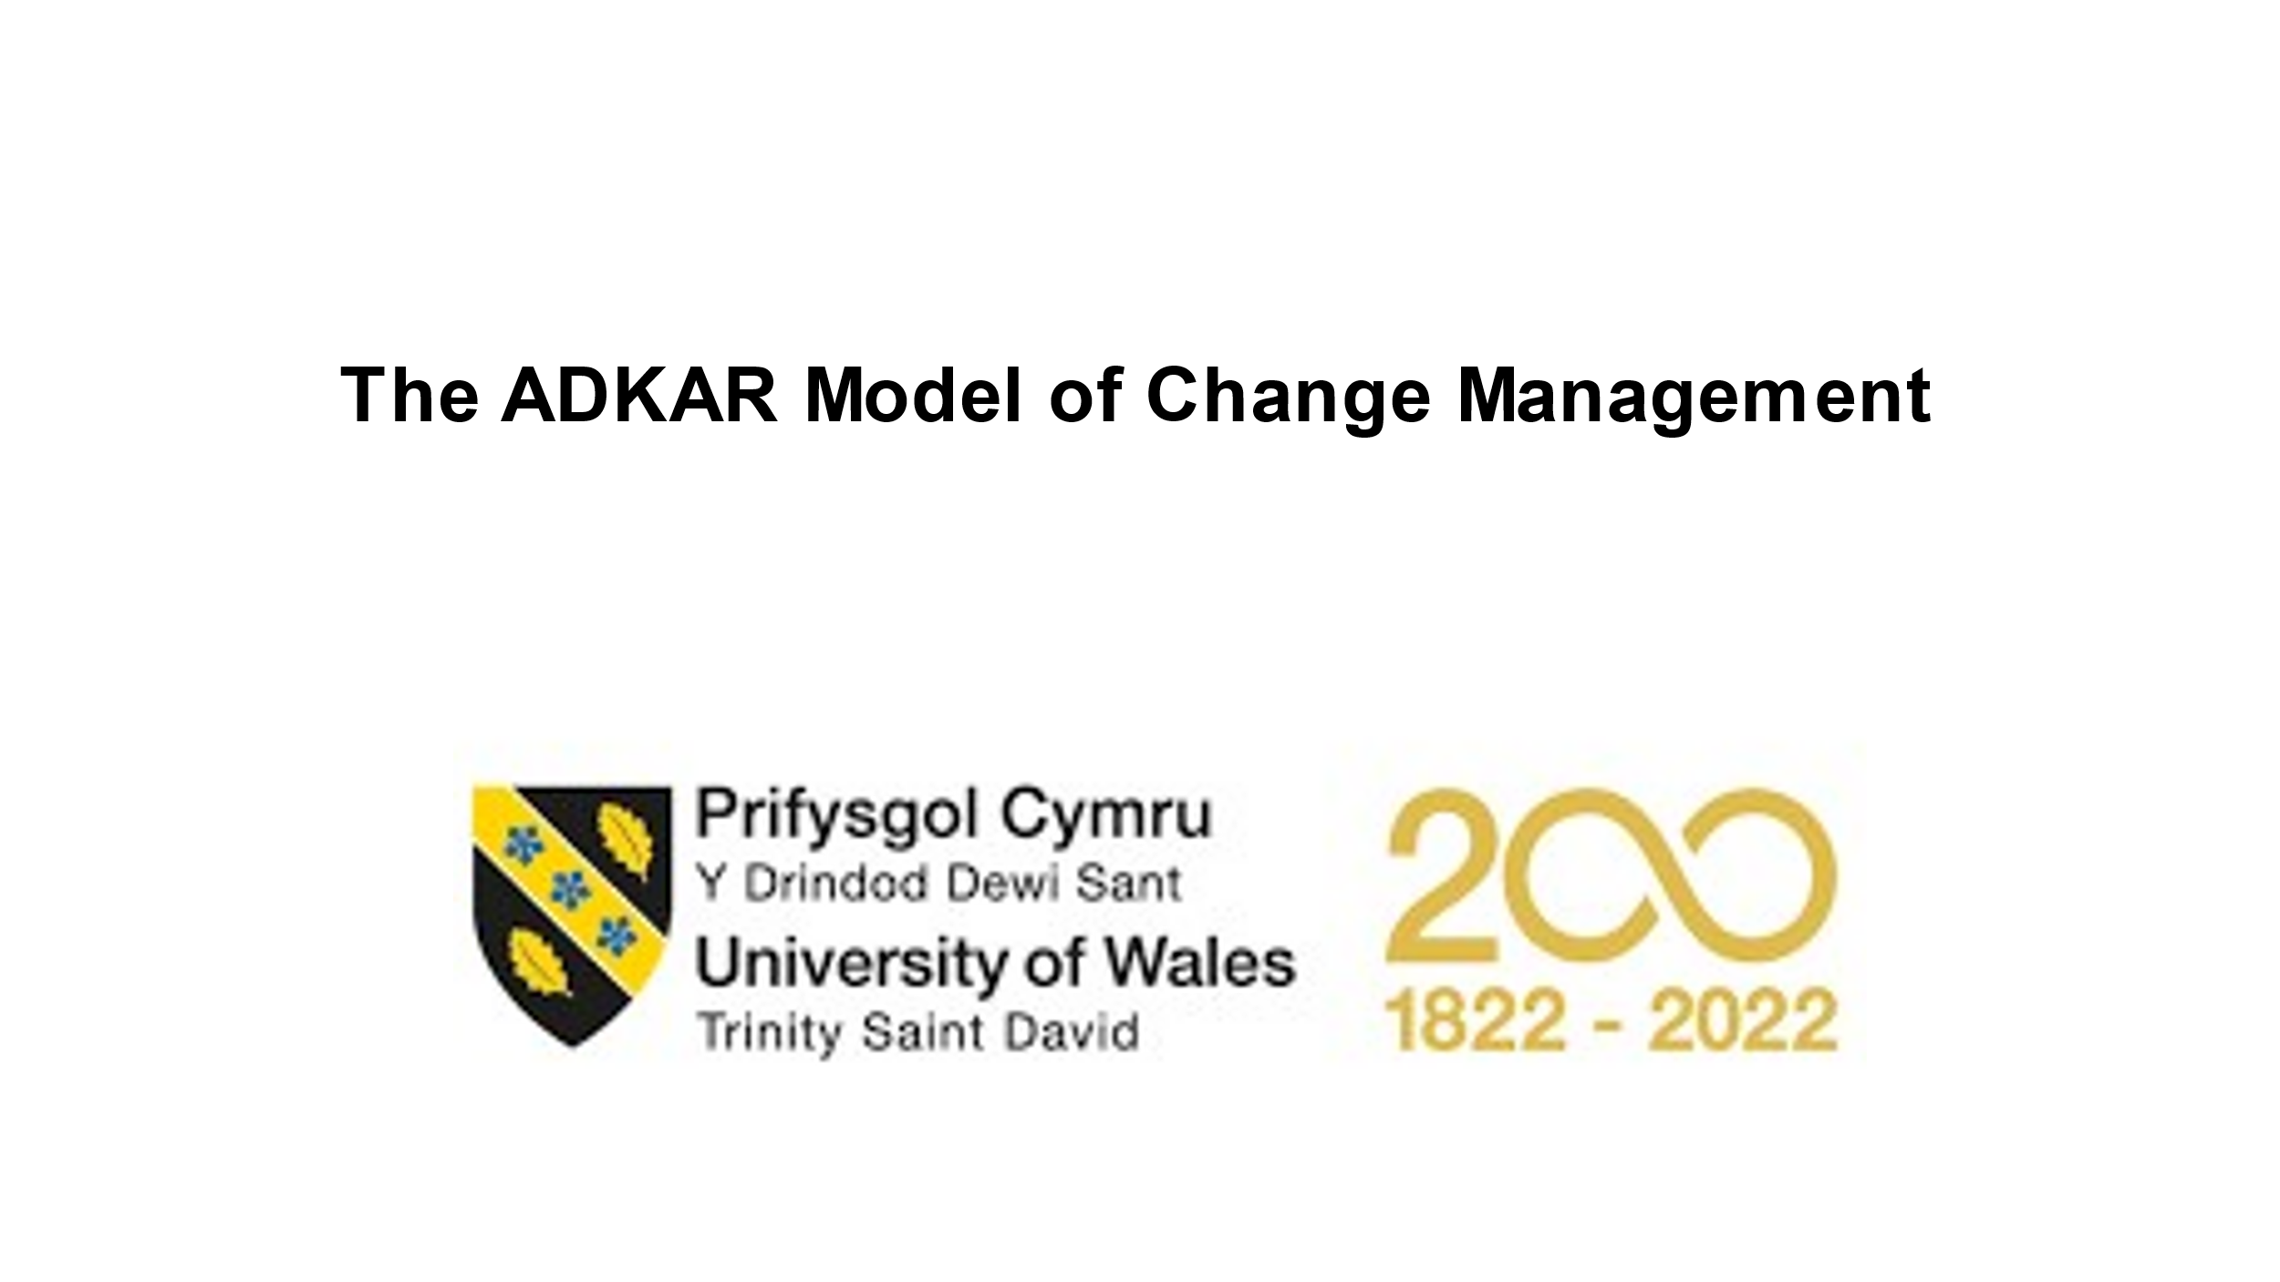

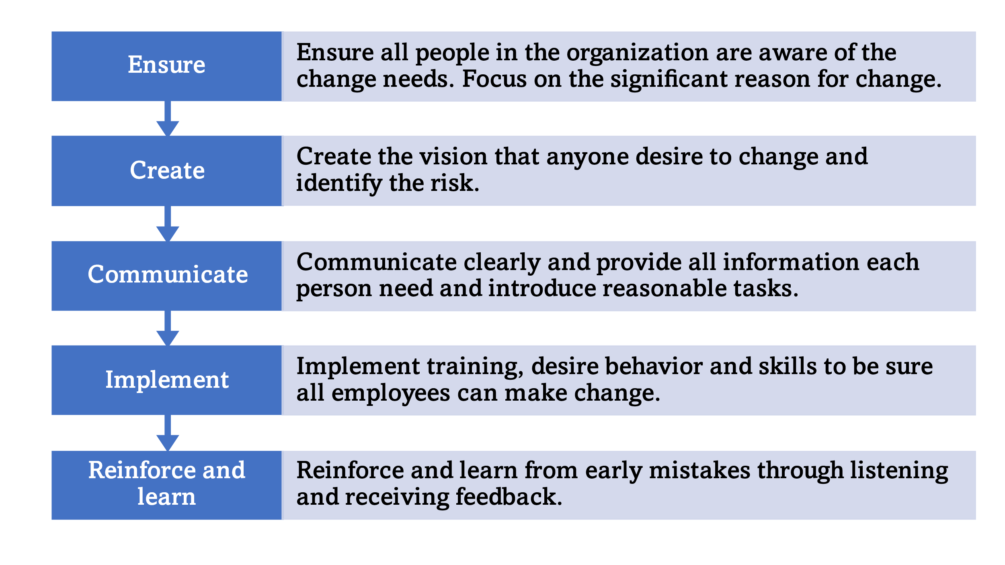

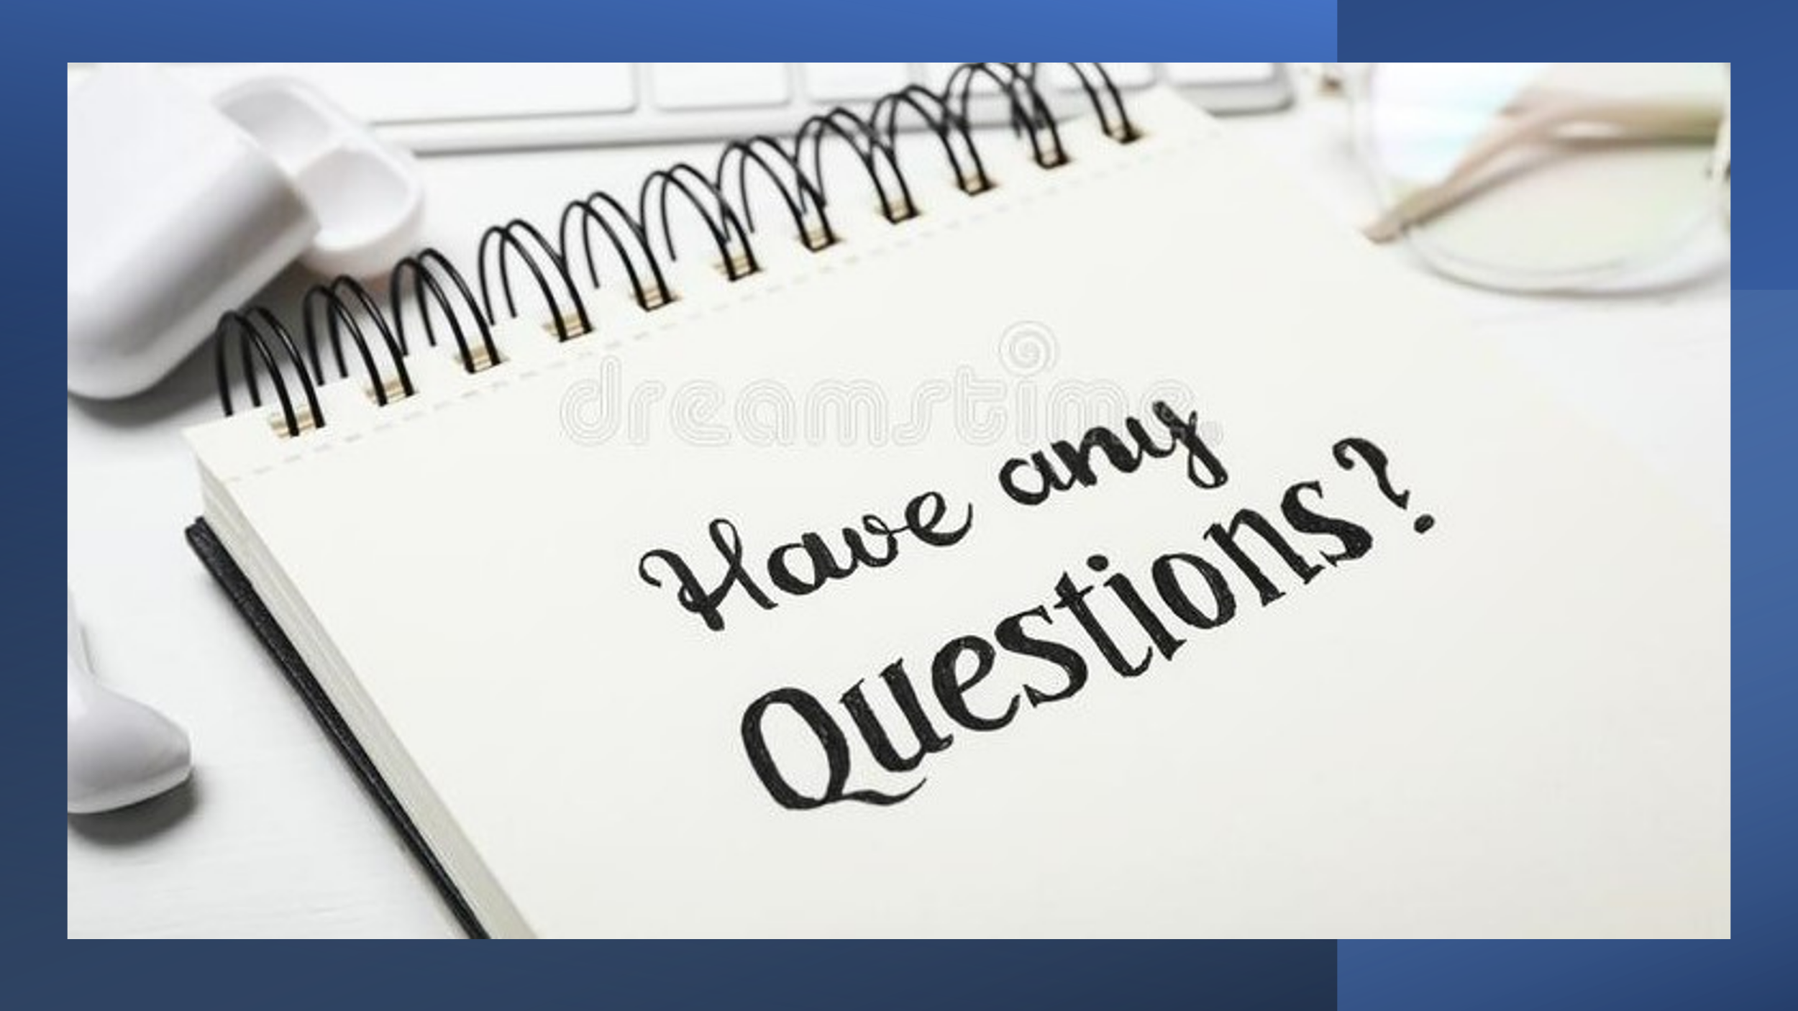


1000 WORDS: Alexandra Kazandjieva ID: 2235019
Many internal or external factors are the reason for organisations to make a change. Internal factors include leadership changes when the new CEO implements a new organisational vision with a change in the culture and structure of the organisation. We live in a technology era, and companies must adopt new technologies directly required with changes in operations and strategy.
Customer preferences and country regulations are external reasons for organisational change.
Human Resource Management (HRM) and International Human Resource Management (IHRM) are essential to change management in any global organisation, helping businesses move forward and achieve strategic objectives.
The following presentation aims to show the role of Human Resource Management (HRM) and International Human Resource Management (IHRM) in the Coca-Cola company's change management.

Human Resource Management (HRM) issues of Coca-Cola Organisation.
The central role of Human Resource Management is to effectively motivate and engage employees in the organisation and align them with short- and long-term organisational goals and objectives.
According to Statista, Coca-Cola is the world leader in the beverage industry, with more than 200 partners worldwide and 45% market share in the USA and a value of more than $74 billion (Ridder, 2023). Like any multinational organisation, Coca-Cola's HRM faces issues through the change management process. Some of the issues are:
- Employee engagement is one of the common issues because of motivation and creating instructing values in employees. Dedication to employees is crucial for organisational performance, and HRM can help by providing support and resources to employees to make them feel more engaged in the change management process. IHRM in Coca-Cola must consider attracting more skilled and knowledgeable people for the required position.
- Inclusive and diverse work culture is another fundamental issue HRM faces. Coca-Cola operates in 200 different countries worldwide, and HRM must take in all those employees from different religions, culture, background, gender, etc. feels valued and included in the organisation.
- HRM must ensure that the right employees are correctly positioned to support organisational change by efficiently managing talent. Through various strategies, HR can attract and keep top talent employees using benefits packages, competitive compensations and providing career opportunities for talent.
HRM ISSUES OF COCA-COLA COMPANY CONTINUE
- In some countries where Coca-Cola operates, education is deficient, predisposing to severe problems with recruiting and selection processes. Many employees have no experience working in multinational companies, and HRM needs a very selective program when employing staff. Also, if someone has been successful in one company does not mean is a good selection for a required position in the Coca-Cola organisation. Recruitment selection is a very complex process for this multinational organisation.
- People like change, but organisations face resistance to change when choosing to implement new strategies, and HR needs strictly control those processes because of the possibilities of implementation failure and delays. HR often operates with a limited budget and lacks human resources with the required knowledge, skills, and attitude, making it difficult to implement plans effectively.
- Many external factors also can affect planning and implementation, such as changes in regulations involving employees, benefits, and compensation; if HR fails to comply with the regulation, that can damage Coca-Cola organisation reputation. HR must consider existing organisational culture when discussing planning and implementation; lack of trust is another stumbling stone for the implementation effort.
IHRM issues of Coca-Cola
- Communication is the main key element in any organisation. Communication helps IHRM define and set clear objectives and necessary actions for achieving the desired outcome. Poor communication directly leads to the employees' refusal of collaboration and lack of interest. Managing a global team can increase the awareness of the efficiency of IHRM in the Coca-Cola organisation. IHRM must overcome time and geographical differences and offer 24/7 transparent communication—feedback needs to be on time and specific to the related subject. IHRM must set regular meetings and conferences across borders, creating challenges.
- When companies operate worldwide, language barriers can be the main issues for successful organisational change management. Language barriers badly impact organisational performance, employee engagement, training, etc. Coca-Cola needs to develop multi languages training programs. Language barriers can easily affect communication, and IHRM will be challenging to monitor feedback and collect data across various locations.
- How we see training and development are strongly connected with language barriers and communication processes in the Coca-Cola organisation. IHRM must invest in multilingual staff; all training and support materials must be in multiple languages. IHRM need to understand the diverse culture of employees, provide training support, and promote collaboration across all those language differences.
IHRM issues continue.
- Managing employees across different locations and world time zones can be challenging for coordinating work, scheduling business meetings and timely communication.
- Logistics and travelling require tremendous planning to provide safety, efficient support, and resources. IHRM must overcome those challenges by using new technologies and developing new strategies for flexible working arrangements.
- Expatriate employees are another significant challenge for IHRM. Sending employees to work in another country is a massive challenge as IHRM must consider pre-departing training, language barriers, and cultural adjustment and offer support for employees' family needs.
Conclusion
Due to the global expansion of the business, Coca-Cola faces many HRM and IHRM issues. People are the essential and most valuable capital of any organisation, and HRM and IHRM recognise that managing people effectively is the critical component for a successful change initiative.
A diverse workforce can be seen as a challenge but also can be used as a strength for the company. HRM and IHRM must create an inclusive working environment where all employees feel safe, supported, and valued.
As communication plays a significant role in change management, HRM and IHRM must communicate clearly and on time with employees to prepare positively for upcoming changes. HRM and IHRM professionals need knowledge, skills and understanding of the legal, cultural, and logistic issues that can arise. HRM and IHRM can develop and implement policies and practices tailoring them to specific regions.
During all these years Coca -Cola strongly proves that embracing change is more profitable than resisting change. For a bright organisational future and to successfully achieve strategic organisational objectives, HRM and IHRM must comply with regulatory and legal law, attract, and keep top talent, promote cultural understanding, and focus on distance and language barriers.

1000 words
Tsvetelina Victoria Tsvetanova ID:1907859
Coca Cola
Background
In the US, a pharmacist from Atlanta, Georgia, named John S. Pemberton, created a non-alcoholic drink in 1886 in his laboratory, Pemberton Chemical Company, according to the Encyclopedia Britannica (2023). Frank Robinson was his bookkeeper at the time. He produced the idea for the beverage's name, officially becoming a Coca-Cola trademark. According to the same source, Pemberton launched his product initially as a solution for common ailments. It was based on cola nut extract, rich in caffeine and coca leaf, rich in cocaine, for faster relief. However, in about 1903, the ingredient of cocaine was removed from the product's formula. Coca-Cola as a trademark was registered in 1893 in the US Patent Office after Asa Griggs, another pharmacist from Atlanta, got the business owners in 1891, exchanging some property rights and the total amount of $2.300. He incorporated the company the following year.
In 1890 the sales of the beverage were about 9,000 gallons. By 1900 the sales increased to 370,877 gallons, thanks to the Candler's leadership. The product-making plants were established in the same decade in every state of the US and even Canada. In 1899, an independent bottling manufacturer signed the first contract for Coca-Cola. This company was allowed to buy the original drink, bottle it, and deliver the Coca-Cola alcohol complimentary beverage.
The base was formed for this kind of unique distribution system by licensing contracts, and nowadays, most American soft-drink companies follow this system. After incorporation in 1892, Coca-Cola was evaluated at $100,000. The company was sold in 1919 for $25 million. The buyer was an investor team, and the team leader was a successful Atlanta businessperson Ernest Woodruff. The organisation's president was his son Robert Winship Woodruff, and he led the company with great success for over three decades, from 1923 until 1955.
In 1941 the trademark "Coke" appeared in advertising for the first time and was registered in 1945. In Germany, a soft drink was developed named Fanta, and in 1946 Coca-Cola purchased the rights for it. In 1960 was registered the textured bottle was registered first in 1916. The company also created Sprite, a lemon soft drink, in 1961, and diet coke and Sugar-Free Tab in 1963. In 1960 the company purchased Minute Maid Corporation and entered the citrus juice market. In 1966 Fresca was added to the company. In China, in 1978, Coca-Cola was the only company allowed to sell bottled soft drinks. In April 1985, the company created a new flavour after statistics showed a decline in the market in general. The customers did not receive this new taste of the beverage very well, and in July of the same year, Coca-Cola promoted the original formula, Coca-Cola Classic. The company discovered new markets in 1990 and 1993 in East Germany and India. The organisation was the first to introduce the great innovation of a part made from a recycled plastic bottle.
During that time, Coca-Cola faced allegations, such as pollution and human rights. Many American universities banned the sale of Coca-Cola's products after allegations from the International Labor Rights Fund and Steelworkers of America in 2000.
Coca-Cola Zero was launched in the market in 2007, and a new product was zero-calories and tasted the same as the original. Later this year, the company joined the group of organisations developing responses to human rights, Leader Initiative on Human Rights, Britannica encyclopedia, (2023). According to Anguloid (2015), Coca-Cola hosts 15 billion-dollar brands in the alcohol-free drink market today, making it the number one organisation worldwide.

HRM policy of the organisation
According to the CEO and Chairman of Coca-Cola, Quincey (2022), the company's purpose is to respect human rights inside and outside. To provide its employees with the best working conditions and encourage them to be more productive, the company applies technics, friendly to them. Flexible summer working hours and pensions are some of them, according to FZE, BB (2023). The company claims that its essential for the employee's work-life balance and increases their performance. CCGB has developed friendly and efficient procedures to motivate performance individually. One of them is training and development. It is essential to qualify stuff and give a motive for better performance.
The technique of training has multiplied benefits. Commitment, confidence, and motivation are some of them. To provide staff with the necessary training, the company has developed an approach system planned. It is based on who should be trained and why. The following essential elements are who will provide the training and evaluate the results. The company's culture is based on diversity. It has committed to attracting diverse staff and is proud of the percentage of women in crucial positions. It claims that the team mirrors society, so each staff member is respected for their diversity. One more critical point is age awareness. It is in the truck with today's legislation. Coca-Cola GB uses techniques such as surveys. One is related to discrimination and diversity.
Another point is anti-competitive behaviour and corruption. These points are included in the Business Conduct Code. The handbook of the code is introduced to all employees, and the staff reserves training on the law of competition.

1000 WORDS
Siddhi Raut ID:2210107
- What is Change?

Customer behaviour, market conditions, technologies, buyer preferences, and input costs change. Change is crucial in any organisation when discussing meeting and satisfying market needs. Organisations and people working in an organisation must change to survive in the 21st century and be highly competitive in this interconnected and globalised world.
Change differs from a problem or incident, including all improvement activities while minimising disruptions.
When we talk about organisational change, we mean big, strategic, significant change where most employees will be affected.
The very important is that people like change but do not want to be changed. However, we need to change because there are always opportunities for improvement.
There can be many reasons for change. Change means transforming, switching, restructuring, and adopting new rules, working models, and directions for some departments or whole organisations to achieve the desired outcome. We must also consider the cultural change where customer behaviours, attitudes and values change.
Also, companies that do not change in response to the operational environment will fail. One example is Blackberry. Blackberry did not change to the new touch screen technologies; they did not indicate that change was necessary, and as a result - Blackberry lost its leading position in the market just because it fell to move from its comfort zone and innovate in future technologies.
Change in the organisation can be internal or external, and all external factors for change are out of our control—for example, the Covid pandemic and wars.
Any internal change involving a minor or significant change in the working process, any new technology implementation or innovation plays a significant role in the employee's daily work.
The main reasons organisations change are:
- The organisational change includes an organisation's culture, process, and structure. For example, changes in existing behaviour patterns, traditions and rituals that already exist in the organisation.
- Strategy renewal includes market, product, and business model. For example, we are extending the business to a new market or developing a new product. Another example is changing the entire organisational business model.
- Environmental change includes customer behaviour, politics and regulations, technologies, and climate change. For example, how the product or service are delivered to the market?
Implementing change is difficult because organisations cannot stop doing what they are doing and adapt, but change is mandatory for achieving sustainable competitive advantages.
According to John Kotter, "In a change process, you have to win the hearts and minds of the people" because change is about people as the essential capital in any organisation.
What is change management?
According to Machiavelli (The Prince), "There is nothing more difficult to plan, more doubtful of success, nor more dangerous to manage than the creation of a new system" (Mike Bourne, 2012).
In a few words – Change management means leading and navigating people through all change processes that happen in the organisation by reducing confusion, uncertainty, and human fear. Most of the time, fear of change can occur because of poor organisational communication or employee uncertainty.
Good change management can help all processes to go smoothly and everyone in the organisation to adapt to and accept the change using some of the following:
- Choosing the right time for action is one of the most challenging parts of change management.
- Involving the team in the decision-making process (when possible).
- Minimising uncertainty through using all communicational channels.
- Celebrating together any success in moving towards the target.
- Repeating the reason for the change.
- Avoid a communication vacuum. Try to be as transparent as possible.
- The four key principles of change management.
During organisational transforming time, understanding change-why is needed and what impact will have been critical for any organisation. For any change in the organisation, no, matter small or big, the significant responsibilities are on the HR department.
- Understanding of the change includes:
- Why do we need the change? The reason for the change.
- Which departments or processes need change?
- How will it impact the organisation?
- Planning for all different situations and scenarios that can occur is one of the main steps of HR and an essential step in the change process. HR needs to consider all factors that play a significant role in change:
- Do the company need external resources to design and implement the change or have internal professionals?
- How to achieve good change results? Who is going to be involved in the change process?
- Who is going to need training/ support to meet the change required?
- How to assess the impact of change?
- Implementing the change means which strategy the organisation is going to use. We know we can use many different strategies to implement change, and in this stage, people need to invest in the new approach fully.
- HR professionals must ensure that all employees involved in the changes understand and know what needs to happen.
- HR needs to identify and address all training needs.
- Be aware that everyone involved in the change is supported.
- Communication is an essential factor in the change management plan.
- The tone of communication must be appropriate, clear, and relevant so that all employees understand what is coming on their way. Various communication channels, such as Intranet, individual employee meetings, workshops, posters, conferences, etc., can be used.
- In this stage, organisations must change their mission and vision statement to inspire and help people see a giant picture of the future.
- For better understanding and support, the right message must be sent to the right people at the right time.
- To communicate better in this stage of change management, HR professionals can use the ADCAR change management model.
How individuals in the organisation embrace and adopt the change depends on the success of the organisational initiative. More possibilities and positive outcomes exist for organisations that apply well to excellent change management.
1000 words Shubham Pawar
Student ID:2210725
The ADKAR model is a popular framework used for managing change in organisations. Developed by Jeffery Hiatt, the model is focused on the individual employee and how they experience change. Change management is preparing, supporting, and helping individuals, teams, and organisations make changes that achieve business outcomes or objectives. ADKAR is a powerful tool for achieving effective change management.

It is essential to understand that change management is not a one-size-fits-all process. The ADKAR model helps to address this by focusing on five critical areas of personal change: Awareness, Desire, Knowledge, Ability, and Reinforcement. Each of these stages must be addressed to manage the change process effectively.

Awareness is the first stage of the ADKAR model. In this stage, employees must become aware of the change. This requires clear communication about the nature of the change and its impact on the organisation. Employees need to understand why this change is necessary and what benefits it will bring.

Desire is the second stage of ADKAR. Once employees know the change, they must be motivated to support it. There must be a clear understanding and buy-in of the benefits of the change, both on a personal and organisational level. This stage involves addressing any resistance to the change and making a compelling case for it.

Knowledge is the third stage of the ADKAR model. Once employee desires change, they must then know how to achieve it. In this stage, employees must understand what is required to make the change, including training, support, and resources. Without sufficient knowledge, employees may struggle to implement the change effectively.

Ability is the fourth stage of the ADKAR model. Once employees know to implement the change, they must be able to do so. This requires providing the necessary resources and support, such as tools, processes, and structures. Employees must feel supported in their efforts to make the change.

Reinforcement is the final stage of the ADKAR model. Once the change has been implemented, it is vital to provide ongoing support and reinforcement. This includes recognising and rewarding the efforts of employees who contributed to the change, and it also includes ongoing training and support to maintain the change over the long term.

In conclusion, the ADKAR model is an effective tool for change management. Organisations can effectively manage change and achieve their desired outcomes by focusing on the individual employee and addressing their awareness, desire, knowledge, ability, and reinforcement. Applying the ADKAR model in change management requires clear communication, understanding, involvement, and vision. When all stages of change management are addressed, the organisational changes can occur smoothly and flexibly, leading to increased employee engagement, productivity, and bottom-line results.
The McKinsey 7S model is a framework for organisational analysis and change management. It is based on the premise that an organisation comprises seven interconnected elements, which must be aligned and balanced to achieve success. The model was developed in the early 1980s by Tom Peters and Robert Waterman, two consultants at McKinsey & Company.

The seven elements of the model are strategy, structure, systems, style, staff, skills, and shared values. These elements can be considered the building blocks of an organisation, with each one playing a critical role in achieving business objectives. An organisation can achieve greater efficiency, productivity, and profitability when these elements are aligned.

Change management is the process of planning, implementing, and monitoring changes in an organisation. It involves modifying existing processes, structures, and strategies to achieve better performance or to respond to changing market conditions. The McKinsey 7S model is closely linked to change management because it helps identify areas of an organisation that need to be altered or improved to achieve the desired outcome.

For example, if an organisation is experiencing declining sales, the McKinsey 7S model can be used to identify the root cause of the problem. Is the strategy still relevant in the current market? Does the structure of the organisation support the strategy? Are the systems in place to effectively implement the strategy? Is the style of leadership driving the right behaviours? Do staff members have the necessary skills to execute the strategy? Do shared values support the desired outcomes?

Once areas for improvement are identified, a change management plan can be developed to address the gaps. This may involve revising the strategy, changing the organisational structure, implementing new systems, or developing new skills among staff members. The McKinsey 7S model helps ensure that changes are made holistically, with consideration given to each element of the organisation.

One of the key benefits of the McKinsey 7S model is that it provides a common language for discussing organisational performance. By identifying the seven elements and their interrelationships, team members can quickly understand where the organisation stands and what needs to be done to achieve better outcomes. This can be especially valuable in large, complex organisations where communication can be challenging.

In summary, the McKinsey 7S model is a powerful tool for change management, and it helps identify areas of an organisation that need to be improved and provides a framework for implementing changes holistically. An organisation can achieve greater efficiency, productivity, and profitability by aligning the seven elements.

References:

- Angsuwotai, B. (2015) Company overview: Coca cola, Academia.edu. Available at: https://www.academia.edu/13447855/Company_Overview_Coca_Cola (Accessed: March 14, 2023).
- The Coca-Cola Company (2023) Encyclopedialike Britannica. Encyclopedialike Britannica, inc. Available at: https://www.britannica.com/topic/The-Coca-Cola-Company (Accessed: March 18, 2023).
- Quincey, J. (2022) Company policies, practices & reports, The Coca-Cola Company. Available at: https://www.coca-colacompany.com/policies-and-practices (Accessed: March 18, 2023).
- FZE, BB (2023) HRM in Coca Cola, Great Britain, Essays. UK Essays. Available at: https://www.ukessays.com/essays/business/human-resource-management-in-coca-cola-great-britain-business-essay.php?vref=1 (Accessed: March 18, 2023).

References
Anon., n.d. [Online].
Ridder, M., 2023. Coca-Cola Company - statistics & facts. [Online]
Available at: https://www.statista.com/topics/1392/coca-cola-company/#topicOverview
[Accessed 10 Apryl 2023].
Team, O., 2022. The most pressing challenges of international HR (and how to solve them). [Online]
Available at: https://www.oysterhr.com/library/the-most-pressing-challenges-of-international-hr-and-how-to-solve-them
[Accessed April 19 2023].

