

Data Analysis and Visualizations
ACCB4002
Assignment 2 – t-Test

BSc Cloud Computing
London Campus
Koushik Modak
By Adrian Petru State
Student ID:2030021
Level 4 Term 1
3rd of September 2021

Contents
Introduction 3
Descriptions of the data set 6
Visualization of the dataset 7
Analysis Results of the Covid-19 infection rate between White and BAME communities in the UK. 8
Factors affecting Hypotheses testing 11
Conclusion 12
Bibliography 13

Introduction
When comparing the means of two groups, this sort of statistical test is employed to compare. This is a statistical hypothesis that is commonly seen in the realm of pain research [1]. Parametric and non-parametric statistical inference methods are the two types of statistical inference methods available. Statistical metric techniques are a family of methodological procedures used to define probability distributions and infer the parameters of such distributions. A non-parametric technique is used when it is not possible to calculate a probability distribution using conventional methods. In statistical analysis, T-tests are a parametric technique used to examine normal samples with equal variance and independence [2]. T-tests are classified into two categories. Alternatively, when the two groups being assessed are independent of one another, the Independent Test is used; otherwise, when the two groups being evaluated are dependent on one another, the Paired T-Test is used, and so on. For example, when experimental individuals are split into two groups, the T-test is commonly employed. As a result, A is assigned to one group while B is assigned to another. The technique was used in this instance. For example, scientists might come up with two different types of outcomes [6].
In addition, there are pre-B and post-B. It is possible to use a third-party test. Comparing the inter-group connections between groups A and B, for example, is an excellent exercise. Alterations have been made to the inter-group comparisons between the pre-B and post-B and pre-B and A (post-A and pre-A) groups. Pair-wise T-tests, on the other hand, are employed in a wide variety of experimental settings. Take, for example, the test subjects. A is not split into two groups and B is not divided into two groups. This is followed by the computation of the differences between each topic. When comparing identical people, the amount of change between A and B is compared [4].
The field of statistics is largely concerned with the concept of probability. No one criterion can be used to determine if two groups differ considerably or insignificantly from one another. When a patient is suspected of having a certain illness, a clinical test is performed to evaluate whether the patient truly has the condition in question. Patients will be diagnosed with the condition if their test results are higher or lower than predicted, regardless of whether they have the disease in question [3].
Considering that such test results in healthy persons are statistically uncommon, it is possible to infer with better statistical validity if the patient is affected rather than saying that the patient is an outlier in a population of healthy individuals. Before results may be classified as statistically abnormal, it is necessary to comprehend the test findings and the probability distribution underlying them. They were developed based on data collected from the entire community or a suitably large population sample. When we look at the distribution of a clinical indication, we may notice that it is quite uniform. The mean is, and the default value is two [5]. The patient's laboratory test results are statistically aberrant, in contrast to the established criteria (e.g., 5 or 1 per cent). In a probability distribution, the surface area of the distribution curve represents the likelihood of occurrence of a given event.
The z score given to the margins is either 5 per cent or 1 per cent, depending on the case in question. The mean of the distribution is used as a reference value in this case. The following are the test results: To identify a statistically uncommon number, one must first determine a value that is closer to the extremes of the distribution than the z score. It is possible to compare the clinical indication value of a single individual. As a result, the mean of a sample group (which may include many individuals) cannot be compared to the mean of the entire population in this situation. A fascinating question emerges in this context: Another comparison that would be useless would be the process by which the two groups are being compared. It is, therefore, possible to make inferences regarding the distribution of clinical indicators across a community and a sample that is representative of the population.
There are two types of statistical hypotheses: (1) those that are based on data and (2) those that are not. Hypothesis H0 asserts no statistically significant differences between a parameter and a certain value in the data set (or between two parameters). Statistical hypotheses that two parameters differ or do not vary are referred to as alternative hypotheses (H1). The indication under examination and the probability distribution of the indicator must be understood before we can identify a statistical possibility. It is necessary to know the mean and distribution of the sample [6]. By studying the distribution of the means, we can estimate how much the sample's mean deviates from the population mean in terms of standard deviation. When it comes to the relationship between two or more variables, a hypothesis is an informed estimate. Researchers create or formulate a hypothesis to guide the investigation [1]. The research may realize that the outcomes of their testing are in direct opposition to their original hypothesis. Whenever researchers publish their results and suggestions, they may also raise the possibility of alternative options that may be investigated further in future studies.
That is why we begin with the assumption that it is true and look for evidence to demonstrate that it isn't. The alternate explanation is more likely to be accepted than the original explanation. If the null hypothesis is rejected, it follows that the alternative hypothesis must also be accepted. Keep in mind that the indication of H0 will remain constant during the game (and sometimes a less than or larger than symbol, depending on the alternative hypothesis). There are values in the alternative hypothesis that are different from the values in H0 .
In this analysis, both the null and alternative hypotheses and their supporting evidence will be analyzed.

Descriptions of the data set
Let us consider the null hypothesis, which states that there is no difference in infection rates between white and BAME people in the United Kingdom, and the alternative hypothesis, which states that infection rates do differ between white and BAME people, to test H0:h1=h2 vs HA:h1not equal to h2, where h1 and h2 are the mean infection rates in the white and BAME populations, respectively. Consider the null hypothesis, which states no difference in infection rates between White and BAME.
The descriptive statistics generated from a sample of white and BAME people of size 50 are as follows: X1=36.58, X2=60.04, S1=143.514, and S2=547.182, respectively. The two data sets were subjected to a normality test [3]. Because n=50 is a high sample size, the sample mean may be considered to be normal in BAME (normal probability plot), whereas White is skewed (skewed probability plot) (central limit theorem). Between the two data sets, there are no statistically significant differences .

Visualization of the dataset
The scatter graph below represents the distribution of the infection rates of a sample of patients from the white community vs those from the BAME community.
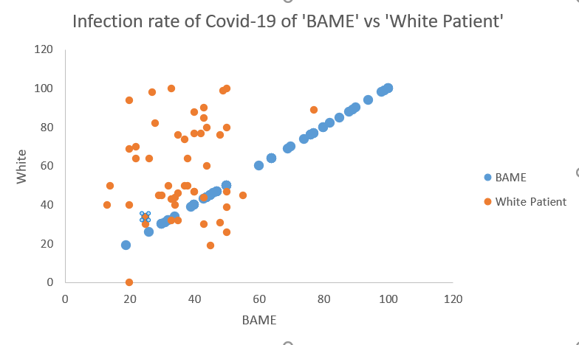
As witnessed in the graph above, there is very little association between the 2 sets of data. One cannot tell whether the relationship is positive or negative. The scatter points appear to be randomly distributed. One of the outliers from the data is the point whereby a patient from the white community recorded an 80% infection rate which is significantly higher than the average infection rate of this group. Such outliers are random and are not likely to interfere with the outcome of the t-test.

Analysis Results of the Covid-19 infection rate between White and BAME communities in the UK.
1. Formulation of the hypotheses:
Null hypothesis H₀: There is no significant difference between the mean Covid-19 infection rate in the white community and the BAME community
Alternative hypothesis H_{a}: There is a significant difference between the mean infection rate of the White community and the BAME community.
The summary output of the t-test at a significance level of 0.01
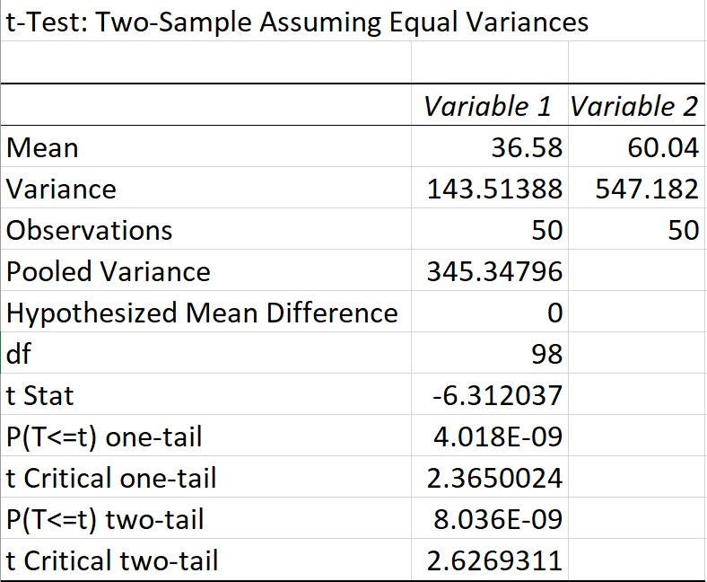

2. Analyzing the results
The mean infection rate of the sample patients from the white community is 36.58% at a standard deviation of 11.98. The mean infection rate of the sample patients from the BAME community is 60.04% at a standard deviation of 2.39. The calculated T statistic of -6.31 is less than the t critical of 2.63 indicating a difference in the means. The two-tailed p-value of this is significantly less than the confidence level of 0.01 as shown above. Based on this, we reject the null hypothesis.
Based on the evidence obtained above we can conclude that at a 99% confidence level there is a significant difference in the means of the infection rate of patients from the white community and those from the BAME community. The mean infection rate among patients from the BAME community is significantly higher than that of the white community.
The summary output of the t-test at a significance level of 0.02
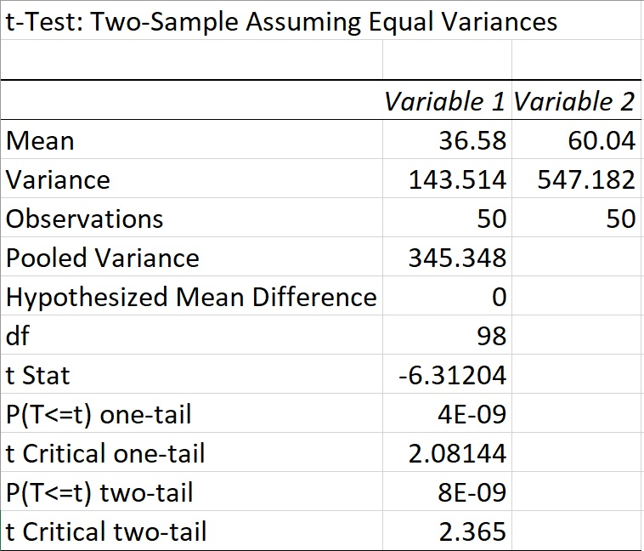
Analysis of the results
The calculated T statistic of -6.31 is less than the t critical of 2.36 indicating a difference in the means. The two-tailed p-value of this is significantly less than the confidence level of 0.02 as shown above. Based on this, we reject the null hypothesis.
Based on the evidence obtained above we can conclude that at a 98% confidence level there is a significant difference in the means of the infection rate of patients from the white community and those from the BAME community. The mean infection rate among patients from the BAME community is significantly higher than that of the white community.
The summary output of the t-test at a significance level of 0.1
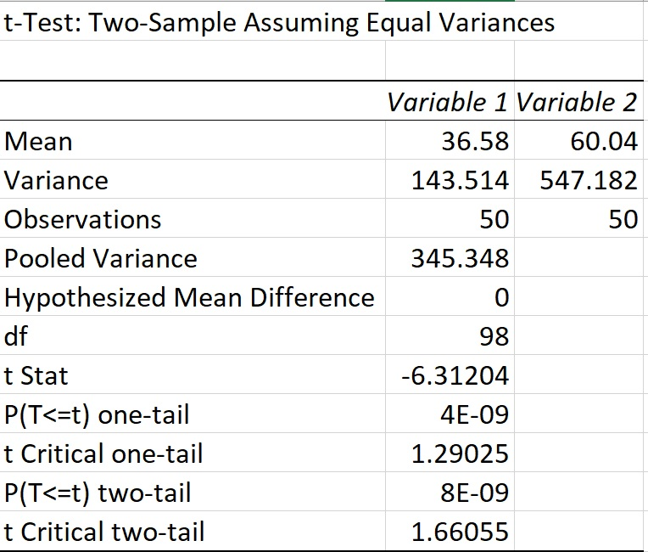
Analyzing the results
The calculated T statistic of -6.31 is less than the t critical of 1.66 indicating a difference in the means. The two-tailed p-value of this is significantly less than the confidence level of 0.1 as shown above. Based on this, we reject the null hypothesis.
Based on the evidence obtained above we can conclude that at a 90% confidence level there is a significant difference in the means of the infection rate of patients from the white community and those from the BAME community. The mean infection rate among patients from the BAME community is significantly higher than that of the white community.

Factors affecting Hypotheses testing
An important factor to consider is the occupation of the respondents. It has been proven that some occupations are more likely to contract the virus than others. This is because some of the occupations require consistent direct interaction with people thus increasing their susceptibility. An example of such an occupation is the frontline health workers. If the sample from the BAME was collected predominantly from people who work in health services, the mean is likely to be higher thus affecting the outcome. It is for such reasons whereby the analyst should ensure that the samples are truly random and representative of the entire population.

Conclusion
The t-test is a good measure of whether a significant difference exists between the means of the 2 datasets. According to the tests performed herein, one can conclude that indeed there is a significant difference between the infection rate of white citizens and those in the BAME community. The government through the relevant ministries should therefore formulate policy and action to control the infection rate in the BAME community.

Bibliography

[1] Aguas, R., White, L., Hupert, N., Shretta, R., Pan-Ngum, W., Celhay, O., ... & Coutinho, R., Modelling the COVID-19 pandemic in context: an international participatory approach, BMJ global health, 5(12), 2020.
[2] Chadeau-Hyam, M., Bodinier, B., Elliott, J., Whitaker, M. D., Tzoulaki, I., Vermeulen, R., ... & Elliott, P., Risk factors for positive and negative COVID-19 tests: a cautious and in-depth analysis of UK biobank data. International journal of epidemiology, 49(5), 1454-1467,2020.
[3] Jaspal, R., Fino, E., & Breakwell, G. M., The COVID-19 Own Risk Appraisal Scale (CORAS): Development and validation in two samples from the United Kingdom, Journal of Health Psychology, 2020.
[4] Leng, T., White, C., Hilton, J., Kucharski, A., Pellis, L., Stage, H., & Davies, N. G., The effectiveness of social bubbles as part of a Covid-19 lockdown exit strategy, a modelling study. Wellcome open research, 5. 2020
[5] Razvi, S., Oliver, R., Moore, J., & Beeby, A., Exposure of hospital healthcare workers to the novel coronavirus (SARS-CoV-2). Clinical Medicine, 20(6), e238, 2020.
[6] Townsend, M. J., Kyle, T. K., & Stanford, F. C., Outcomes of COVID-19: disparities in obesity and by ethnicity/race, 2020.

