BMMB7012-MBA Marketing Management-Assignment 2 Report

Critically Evaluate the Roles and Activities of the Marketing Department within Ford Electric Vehicles

2233452 - Xue Sun（Chelsea）

Executive Summary
Based on a critical discussion of marketing concepts, Ford's electric vehicle marketing campaign is evaluated, and recommendations are made. In terms of environmental analysis, macro- and micro-environmental analysis shows that the transformation of traditional automakers to electric vehicle manufacturers is the general trend. In the fierce industry competition, cost-effective electric vehicles are more popular. Target market analysis shows that young people with environmental awareness may become the main buyers of Ford electric vehicles. And Ford's marketing mix is designed to drive down prices, develop battery technology, sell through multiple channels, and promote sales through price cuts and advertising. In terms of media selection, Ford uses the interaction of social media and Internet marketing. This model can expand popularity and promote sales to a certain extent. However, Ford currently has a bad impression in the minds of consumers in terms of quality and sales channels. Therefore, this article suggests that Ford should improve its offline marketing model, open up new promotion channels, and focus on high-cost performance in the next step of marketing.

CONTENTS:

Critically Evaluate the Roles and Activities of the Marketing Department within Ford Electric Vehicles 1
Executive Summary 2
1. Introduction: 5
2. The Concept of Marketing 5
3. Environmental Analysis 6
3.1 Macro-environment analysis—PESTEL 6
3.1.1 Political 6
3.1.2 Economic 6
3.1.3 Social and Cultural 6
3.1.4 Technology 6
3.1.5 Environment 7
3.1.6 Legal 7
3.2. Micro-environment Analysis 7
3.2.1. SWOT 7
3.2.2. Porter's Five Forces 8
4. Target Market 9
4.1. STP analysis 9
4.1.1. Segmentation 9
4.1.2. Targeting 10
4.1.3. Positioning (Figure 3). 10
5. Media Selection 10
6. Measure Success. 11
6.1. Marketing Mix Analysis—4P 11
6.1.1. Price 11
6.1.2. Places 11
6.1.3. Products 12
6.1.4. Promotion 12
6.2. measurement and assessment 13
7. Conclusions 13
8. Recommendations 14
References List: 16
Appendix: 20

1. Introduction:
Founded in the United States in 1903, Ford has become a world-renowned multinational company with industries in more than 30 countries (Rubenstein, 2002). Under the characteristics of the new era, the marketing of Ford Motor Company is facing new opportunities and challenges. The purpose of this paper is to critically analyze Ford Motor Company's marketing activities based on the current market environment and to provide new ideas for relevant marketing practice. This article first explains the concept of marketing and its importance. Secondly, this paper analyses their impact on marketing strategies from the perspective of macro and micro marketing environments. Third, the paper explores Ford Motor Company's target market and its effectiveness. Fourth, this paper analyses Ford's choice of marketing media and its effectiveness. Fifth, the paper develops possible measures of success. Finally, based on the above analysis results, this paper puts forward relevant improvement suggestions for the next marketing strategy of Ford Motor Company.

2. The Concept of Marketing
A market is the sum total of potential customers, which, depending on one's product, can be the entire population. As for the concept of marketing, academic circles have various understandings. Theodore Levitt (1960) believes that marketing is the process by which management provides value and satisfaction to customers. Fahy & Jobber (2012) defined marketing as the process of achieving business goals by better meeting and exceeding customer needs. In general, scholars' understanding of marketing mainly focuses on the process by which companies satisfy customers' needs by understanding the market, creating value, and building relationships. Based on this point of view, Fahy & Jobber (2019) further summarized the concept of marketing as the process by which enterprises perceive and respond to the market with a customer-centric approach. Actively discussing the experience and methods of marketing can improve the marketing quality of enterprises and help them seize market share. Ford has invested a lot of money and energy in marketing and carried out product design, price positioning, and channel optimization from the perspective of customers. This means that the company has invested a lot of time in market research and a lot of money and human resources in technology research and development and improving marketing strategies.

3. Environmental Analysis

3.1 Macro-environment analysis—PESTEL

3.1.1 Political
The United States has a very complete protection system for the local auto industry, especially after the pandemic. In order to support the development of the local auto industry, especially the electric vehicle industry, the U.S. government strictly controls imported cars and raises tariffs (Liu et al., 2021). At the same time, the United States has implemented tax cuts for electric vehicles and reduced restrictions on such products (Ou et al., 2018).

3.1.2 Economic
Since the outbreak of COVID-19, the U.S. economy has fluctuated. Residential demand for cars has also declined significantly as per capita disposable income has decreased due to widespread segregation and job losses (Figure 1 shows unemployment among Americans during the pandemic).

3.1.3 Social and Cultural
In the automobile consumption structure in the United States, salaried people mainly buy cars, so the sales volume of middle- and low-end cars is the highest (Riedy & Diesendorf, 2003). At the same time, when people buy a car, they value personalization, quality, functionality, safety, and after-sales conditions the most. It is worth noting that with the increase in oil prices caused by the Ukrainian-Russian War, consumers' demand for electric vehicles, hybrid electric vehicles, and small-displacement vehicles is increasing.

3.1.4 Technology
At present, in terms of electric vehicles, the battery technology and charging technology of the United States are at the forefront of the world. A new charging technology can charge electric vehicle batteries to more than 90% in 10 minutes without lithium plating or cathode cracking (Wang et al., 2022). This means that the charging speed of electric vehicles is expected to be on par with the refueling speed. At the same time, with the development of the charging pile network of industry giant Tesla, a unified charging standard has been formed in the industry, providing ordinary consumers with more convenient charging opportunities (Li, 2019).

3.1.5 Environment
Since sustainable development has become a topic of common concern to people all over the world, people have paid more and more attention to the impact of automobile exhaust on the environment. Conventional vehicle exhaust is the culprit that exacerbates the greenhouse effect (Obebe et al., 2021). In response to this situation, the United States has taken many measures, including limiting vehicle exhaust emissions, limiting industrial emissions, building clean energy, and implementing energy efficiency standards (Doris et al., 2009).

3.1.6 Legal
The Lower Inflation Act of 2022 in the United States also includes a $7,500 personal tax credit for new electric vehicles (Slowik et al., 2023).
The results of PESELE show that the current development of traditional cars has been restricted by macroeconomic policies, and Ford's production and R&D focus needs to be transformed to environmentally friendly cars. At the same time, due to factors such as the economic environment and international relations, models with lower prices and more complete functions may be more popular with consumers. This means that Ford needs to develop cheaper, better-quality models to grab market share.

3.2. Micro-environment Analysis

3.2.1. SWOT
Strengths: First of all, Ford Motor Company is one of the most valuable brands in the United States. Its brand awareness is very high, and it has a huge market base. Secondly, Ford Motor Company has product diversity. Ford Motor Company has produced many different types of cars, and it provides diverse choices for consumers of different age groups and incomes. Finally, Ford Motor Company has been manufacturing strength and a competitive advantage in the field of automobile manufacturing by consistently using a cost-effective manufacturing model (Alizon et al., 2008).
Weaknesses: First of all, in the field of electric vehicles, Ford Motor Company started late, and its technical capabilities are relatively backward. Second, Ford's sales have fallen sharply in recent years due to economic volatility caused by the impact of the pandemic. Lastly, Ford has issues with product quality. The large-scale recall accident in 2018 seriously affected consumers' trust in the brand (Bahety et al., 2018).
Opportunities: First, the global EV market is expanding due to the need for sustainable development (Ballinger et al., 2019). Secondly, as an emerging industry, self-driving cars have a lot of market space. Finally, the process of globalize provides a feasible path for Ford to expand its market.
Threats: First, the electric vehicle market is highly competitive, and technologically advanced competitors such as Tesla are difficult to surpass. Second, uncertainties in the global auto market due to factors such as trade wars, political risks, and market turbulence may become a huge threat (Sheng & do Nascimento, 2021). Finally, the continuous influx of low-priced new brands quickly seized most of the market share.
The results of SWOT show that the competition in the electric vehicle industry is relatively fierce at present, but the industry has great potential for development. Therefore, Ford needs to use its own R&D and manufacturing advantages to strive to improve quality and develop electric engine technology to seize market share. The specific TOWS analysis is shown in Figure 2.

3.2.2. Porter's Five Forces
Threat of new entrants: The current product life cycle of electric vehicles is still in the growth stage (Lukas et al., 2017), and the technical requirements for new entrants are strict (battery technology, control system, lightweight requirements) (Arora, 2018). At the same time, the cost of product research and development is high, and it is difficult to disrupt the existing price order. Therefore, the threat of new entrants is relatively small.
Threat of substitutes: Traditional industries are mature, large-scale, fiercely competitive, and their prices are more easily accepted by the public. Therefore, the threat of substitution is high.
Bargaining power of suppliers: The industry of traditional component suppliers is mature, with fierce competition and limited bargaining power. However, the specific components of electric vehicles (such as batteries, etc.) often have high prices due to their technical complexity and scarcity of resources, and they have strong bargaining power (Pohlmann & Opitz, 2013).
Bargaining power of buyers: Even with state subsidies, the core technology requirements of electric vehicles are high, the cost is high, and the price remains high (Zeng et al., 2019). Therefore, consumers are price-sensitive and have strong bargaining power.
Competition in the industry: At present, the competition in the electric vehicle industry has tended to monopolize, and the market share of industry giant Tesla is 71.4% (Rishi & Singh, 2023). At the same time, BMW, Volkswagen, and other brands have also launched their own electric vehicle products. Competition within the industry is mainly technological competition and price competition.
The results of Porter's five forces analysis show that the current competition in the US electric vehicle industry is mainly technological. Therefore, Ford Motor Company should deepen its transformation, increase investment in technology and talents, and launch more high-quality electrified products and services to seize market share.

4. Target Market

4.1. STP analysis

4.1.1. Segmentation
Geographical environment: There is a large gap between the rich and the poor in the United States. There are many job opportunities in the Northeast region, including in New York, Boston, and areas around San Francisco. People generally live affluent lives and like commercial electric vehicles (Florida, 2010). At the same time, consumers here like to pursue fashion and prefer models with personality. People here have a high demand for electric vehicles. However, the economic development in the Midwest and the South is slow, and people's economic conditions are slightly worse (Gordon, 2014), and their acceptance of electric vehicles is even lower.
By Consumer Psychology: According to consumer psychology and behavior, the U.S. electric vehicle market can be divided into entrepreneurs, environmentally conscious young people, and elderly groups. Successful entrepreneurs prefer models that can prove their success and status. They may include environmentalists, office workers, students, etc. They like products with lower energy consumption, novel styles, and complete functions. At the same time, they are more sensitive to price. Seniors tend to prefer vehicles that are durable, functional, and valuable.
By purchase purpose: The electric vehicle market is divided into individual customers who usually buy family cars and corporate consumers who buy taxis.

4.1.2. Targeting
As a growing product, electric vehicles are fashionable, expensive, and not easily accepted by the elderly (Manzetti & Mariasiu, 2015). Therefore, the target customers of Ford's new energy vehicles are young people who pay attention to environmental protection. They pay more attention to environmental protection and health. At the same time, they are very sensitive to prices and are willing to pursue individualization. Therefore, they have a high degree of recognition for electric vehicles with lower prices, more novel styles, and lower energy consumption.

4.1.3. Positioning (Figure 3).
Ford's electric vehicle market positioning is mainly aimed at future market development trends and enterprise differentiation. First, with strong government support and many consumers paying more attention to environmental protection and energy savings, choosing electric vehicles has become a fashionable trend (Xie et al., 2022). Ford's original low-cost strategy can provide consumers with lower-priced choices in the production and manufacture of automobiles. Therefore, the positioning of Ford's electric vehicle market should be as a cost-effective, trendy electric mobility tool.

5. Media Selection
The main communication channels used in the marketing of Ford Electric Vehicles are primarily internet marketing and social media. In terms of Internet marketing, Ford often advertises through its official website and car-related websites. These advertisements are not limited to promotional activities but also include new product announcements, public service announcements, event announcements, etc. (Beattie et al., 2021).
In terms of social media, Ford is keen to generate discussion by posting relevant topics on social networks. Ford once released on Share the Road to emphasize the safety of drivers and cyclists on the road and arouse people's attention to road safety (Figure 6). In this channel, people had a lively discussion, and more than 60% of the participants changed their behavior when driving or cycling on the road (Redshaw, 2008).

6. Measure Success.

6.1. Marketing Mix Analysis—4P

First of all, it is necessary to further take stock of the company's existing marketing strategy based on the 4Ps model, so as to support the subsequent evaluation.

6.1.1. Price
The pricing of Ford's electric vehicles follows the characteristics of a cost-leadership strategy. Due to the large demand elasticity of electric vehicles in the market, products with lower prices usually have higher sales (Xing et al., 2021). Therefore, Ford tends to seize market share by choosing a price strategy of small profits but high sales, thereby expanding small traffic and increasing profits. At the same time, since electric vehicles are still in the growth stage, product sales have increased and market competition has intensified (Zheng et al., 2021). Moreover, Ford's long-term large-scale production and market reputation for cost-effective can support the company's decision to implement a low-price strategy to maintain a competitive advantage. Doing so also reduces the competition risk caused by entering the market to a certain extent.

6.1.2. Places
Ford's sales channels are mainly offline. Currently, directly-operated stores, third-party 4S stores, and authorized dealers are the main sales channels for Ford's new electric vehicles (Charan, 2021). Some countries support online APP car selection, but so far there has been no global promotion. It is worth noting that, due to the large number of Ford models, the sales system once became chaotic. This adds a lot of time and cost to consumers when choosing and viewing cars. At the same time, because the marketing is too scattered, it will also greatly increase Ford's own operating costs.

6.1.3. Products
In terms of product design, Ford Motor Company has been trying to overcome the technical problems of electric vehicles in recent years. First of all, Ford invested a lot of money and manpower in the research and development of new products. Ford has launched several electric models, including the famous all-electric Ford Mustang Mach-E. The electric car has a trendy appearance, a long cruising range, fast charging, is equipped with an intelligent system, and the price is at the middle-lower level among electric cars in the same field (Ulrich, 2020). Secondly, Ford’s products have not ignored corporate social responsibility while considering profitability, trying to reduce carbon emissions of electric vehicles through technological upgrades (Mali et al., 2021).

6.1.4. Promotion
At present, the promotion strategy for Ford electric vehicles is mainly to promote products and lower prices. In terms of product promotion, Ford is good at using the power of traditional media. Whenever a new car is about to be launched, Ford will hold competitions and other means to attract media coverage and enhance product awareness (Abernathy & Clark, 1985). At the same time, Ford will launch large-scale TV advertisements, parking lot advertisements, airport and hotel advertisements, and distribute promotional materials to expand publicity (Schor, 2014) (Figure 4). In this way, the target consumers are more likely to be exposed to new product information, and they can also learn about the characteristics, appearance, and price of the product for the first time and then make a purchase decision.
In terms of price promotions, Ford is very good at price wars. The latest model, the Mustang Mach-E, has dropped $900 for the lowest-spec version, with the latest starting price at $45,995 (Kane, 2023). The price of the Tesla Model 3 is maintained at around US$25,000 (Bauer et al., 2021). In contrast, Ford electric vehicles are very cost-effective (Figure 5 is the 2021 US electric vehicle price ranking). At the same time, Ford has also reached an agreement with cooperative banks to provide more convenient loan services for consumers who take out loans to purchase this model. On the one hand, consumers can enjoy the lowest car loan interest rate. On the other hand, consumers can also change the payment date or postpone payment for up to 90 days (Haralayya, 2021). For Ford's target consumers, these offers are very attractive.

6.2. measurement and assessment
A key metric for measuring campaign effectiveness is market share. It refers to the percentage of a particular firm's sales in an industry (Ravenscraft, 1983). In 2023, Ford's electric vehicle market share increased from 4.6% a year ago to 5.2% in the first quarter of this year (autonews.com, 2023). Based on this result, the marketing strategy is effective. Ford controlled marketing by impressing consumers through continuous low-price strategies and technological development. According to the plan, by the end of 2023, Ford Motor Company will produce 600,000 electric vehicles per year, and by the end of 2026, the annual production of electric vehicles will exceed 2 million. It is estimated that by 2030, Ford Motor Company's electric vehicles will account for half of its global sales.

7. Conclusions
Marketing is the process of meeting customer needs by understanding the market, creating value, and building relationships. Judging from the macro and micro environments, the current competition in the electric vehicle industry is very fierce, and the barriers to entry are high. At the same time, policy support is the main factor promoting the development of the industry. Economic fluctuations may affect people's purchasing needs. This means that price strategy is very important to grab market share. The target market for Ford's electric vehicles is young people who are environmentally conscious. Therefore, Ford's product positioning is an environmentally friendly, cost-effective electric vehicle. From the perspective of the marketing mix, Ford electric vehicles are good at seizing market share through price strategies and are committed to technological upgrades. However, a chaotic sales system can lead to poor marketing and buying decisions. In terms of publicity, the combination of offline media, advertising, online marketing, and social media helped Ford successfully promote new products. Market share serves as an effective measure to show the future development potential of the enterprise.

8. Recommendations
Based on the analysis of Ford's marketing activities, this paper believes that Ford should change its marketing strategy in the following three aspects to achieve its overall goal:
Firstly, Ford needs to improve its offline marketing model. The current offline marketing model is too chaotic. Ford's multiple series of models are sold in different stores, making it difficult for consumers to quickly and accurately find the correct store to buy the ideal model. This not only increases the cost of internal management and easily causes confusion, but also leaves a bad impression on consumers. Therefore, in order to improve the chaotic marketing model, Ford needs to integrate multiple offline sales channels so that direct stores, third-party 4S stores, and authorized dealers share a sales system. In other words, all stores that have the right to sell Ford cars can buy a full range of Ford cars, and they can coordinate in the same city when they are out of stock. This not only facilitates management and reduces costs but also provides consumers with more convenient services.
Secondly, Ford needs to open up new channels of publicity. With the rapid development of the Internet age, Ford had to consider focusing on digital marketing. Ford's current marketing model tends to use traditional media and offline advertising. However, this model may not work well for the target consumers of new products. Because young people are getting information on a large scale through social media, email, and search engines instead of offline advertisements, Therefore, Ford should develop more publicity channels to capture the attention of target consumers. This includes frequently posting relevant topics for discussion on social media platforms, placing paid search ads online, etc.
Finally, Ford needs to make high-cost performance the focus of its marketing in the next step. Considering that Ford once had a large-scale recall in the country due to car quality problems, this caused a huge response at the time and had serious adverse effects. Today, some people still associate Ford Motors with keywords such as "bad quality". This can seriously affect consumers' purchasing decisions. Therefore, Ford should position the key information of the next marketing campaign as high-cost performance. This means lower prices and higher quality. Ford can gain the trust of consumers by including the working scene of the automobile factory in the advertisement or issuing a quality inspection report and after-sales service information.

References List:

Abernathy, W.J. and Clark, K.B., 1985. Innovation: Mapping the winds of creative destruction. Research policy, 14(1), pp.3-22.
autonews.com. 2023. New EV registrations: GM, Ford, Rivian chip away at Tesla's share. Automotive News. https://www.autonews.com/retail/gm-ford-rivian-chip-away-teslas-share-new-ev-registrations
Ballinger, B., Stringer, M., Schmeda-Lopez, D.R., Kefford, B., Parkinson, B., Greig, C. and Smart, S., 2019. The vulnerability of electric vehicle deployment to critical mineral supply. Applied Energy, 255, p.113844.
Bauer, G., Hsu, C.W. and Lutsey, N., 2021. When might lower-income drivers benefit from electric vehicles? Quantifying the economic equity implications of electric vehicle adoption. Work. Pap, 6, pp.1-21.
Beattie, G., Durante, R., Knight, B. and Sen, A., 2021. Advertising spending and media bias: Evidence from news coverage of car safety recalls. Management Science, 67(2), pp.698-719.
Charan, R., 2021. Rethinking Competitive Advantage: New Rules for the Digital Age. Currency.
Fahy, J. and Jobber, D. 2012. Foundations of Marketing, 4th ed., London, McGrawhill.
Fahy, J. and Jobber, D., 2019. Ebook: Foundations of marketing, 6e. McGraw Hill.
Florida, R., 2010. The great reset: How new ways of living and working drive post-crash prosperity. Random House Canada.
Goodwin, A. 2022. Ford Plans to Build 600,000 EVs Annually by 2023, Over 2 Million by 2026. CNET. https://www.cnet.com/roadshow/news/ford-electric-vehicle-battery-production-plan-2026/
Gordon, R.J., 2014. The demise of US economic growth: restatement, rebuttal, and reflections (No. w19895). National Bureau of Economic Research.
Haralayya, B., 2021. Effect of Branding on Consumer Buying Behaviour at Vijay Bharat Motors Pvt Ltd, Bidar. Iconic Research And Engineering Journals, 4(12), pp.207-222.
Kane, M. 2023. 2023 Ford Mustang Mach-E: Effectively It Starts At $39,995. InSIDEEVs. https://insideevs.com/news/653906/2023-ford-mustang-mache-price-range/
Li, J., 2019. Compatibility and investment in the us electric vehicle market. Unpublished manuscript, MIT.
Liu, S.Q., Huang, X., Li, X., Masoud, M., Chung, S.H. and Yin, Y., 2021. How is China’s energy security affected by exogenous shocks? Evidence of China–US trade dispute and COVID-19 pandemic. Discover Energy, 1, pp.1-23.
Lukas, E., Spengler, T.S., Kupfer, S. and Kieckhäfer, K., 2017. When and how much to invest? Investment and capacity choice under product life cycle uncertainty. European Journal of Operational Research, 260(3), pp.1105-1114.
Mali, V., Saxena, R., Kumar, K., Kalam, A. and Tripathi, B., 2021. Review on battery thermal management systems for energy-efficient electric vehicles. Renewable and Sustainable Energy Reviews, 151, p.111611.
Manzetti, S. and Mariasiu, F., 2015. Electric vehicle battery technologies: From present state to future systems. Renewable and Sustainable Energy Reviews, 51, pp.1004-1012.
Obebe, S.B., Kolo, A. and Yusuf, P.P., 2021. Automotive emissions: sources, environmental effects, and control measures. Int. J. Innov. Sci. Res. Technol., 6(4), pp.288-293.
Ravenscraft, D.J., 1983. Structure-profit relationship at the line of business and industry level. The Review of Economics and Statistics, pp.22-31.
Rishi, B. and Singh, H., 2023. Tesla Inc.: Entering the Indian Electric Car Market. Asian Case Research Journal, pp.1-27.
Schor, J.B., 2014. Born to buy: The commercialized child and the new consumer cult. Simon and Schuster.
Sheng, L. and do Nascimento, D.F., 2021. Love and trade war: China and the US in historical context. Springer Nature.
Slowik, P., Searle, S., Basma, H., Miller, J., Zhou, Y., Rodríguez, F., Buysse, C., Minjares, R., Kelly, S., Pierce, L. and Orvis, R., 2023. Analyzing the impact of the Inflation Reduction Act on electric vehicle uptake in the United States. Energy Innovation and International Council on Clean Transportation.
Theodore, L., 1960. Marketing myopia. Harvard business review, 38(4), pp.45-56.
Ulrich, L., 2020. Top 10 tech cars: The scramble for electric dominance has begun. IEEE Spectrum, 57(4), pp.30-39.
Wang, C.Y., Liu, T., Yang, X.G., Ge, S., Stanley, N.V., Rountree, E.S., Leng, Y. and McCarthy, B.D., 2022. Fast charging of energy-dense lithium-ion batteries. Nature, 611(7936), pp.485-490.
Xie, R., An, L. and Yasir, N., 2022. How Innovative Characteristics Influence Consumers’ Intention to Purchase Electric Vehicle: A Moderating Role of Lifestyle. Sustainability, 14(8), p.4467.
Zeng, X., Li, M., Abd El‐Hady, D., Alshitari, W., Al‐Bogami, A.S., Lu, J. and Amine, K., 2019. Commercialization of lithium battery technologies for electric vehicles. Advanced Energy Materials, 9(27), p.1900161.
Zheng, Z., Lin, Y., Yu, X. and Liu, X., 2021. Product market competition and the cost of equity capital. Journal of Business Research, 132, pp.1-9.
Rubenstein, J.M., 2002. The changing US auto industry: A geographical analysis. Routledge.
Riedy, C. and Diesendorf, M., 2003. Financial subsidies to the Australian fossil fuel industry. Energy Policy, 31(2), pp.125-137.
Alizon, F., Shooter, S.B. and Simpson, T.W., 2008, January. Henry Ford and the Model T: lessons for product platforming and mass customization. In International Design Engineering Technical Conferences and Computers and Information in Engineering Conference (Vol. 43291, pp. 59-66).
Redshaw, S., 2008. In the company of cars: Driving as a social and cultural practice. Ashgate Publishing, Ltd.
Doris, E., Cochran, J. and Vorum, M., 2009. Energy efficiency policy in the United States: overview of trends at different levels of government.
Pohlmann, T. and Opitz, M., 2013. Typology of the patent troll business. R&D Management, 43(2), pp.103-120.
Arora, S., 2018. Selection of thermal management system for modular battery packs of electric vehicles: A review of existing and emerging technologies. Journal of Power Sources, 400, pp.621-640.
Bahety, S., Moffitt, B., Pruchnik, W. and O’Rourke, J.S., 2018. Honda motor company: communication and the takata airbag crisis. The Eugene D. Fanning Center for Business Communication, Mendoza College of Business, University of Notre Dame.
Ou, S., Lin, Z., Qi, L., Li, J., He, X. and Przesmitzki, S., 2018. The dual-credit policy: Quantifying the policy impact on plug-in electric vehicle sales and industry profits in China. Energy Policy, 121, pp.597-610.
Xing, J., Leard, B. and Li, S., 2021. What does an electric vehicle replace?. Journal of Environmental Economics and Management, 107, p.102432.

Appendix:
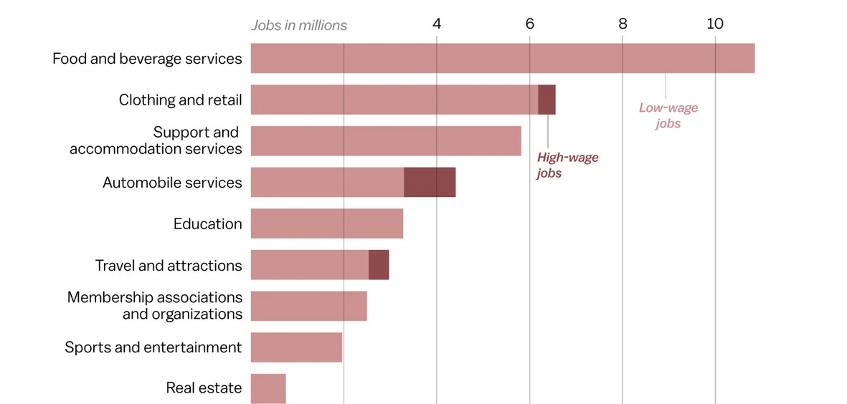
Figure 1: American unemployment due to pandemic
Source: https://www.vox.com/2020/4/10/21207520/coronavirus-deaths-economy-layoffs-inequality-covid-pandemic

TOWS Analysis | External Opportunities  - The global electric vehicle market is expanding  - As an emerging industry, self-driving cars have a lot of market space  - The process of globalization provides a feasible path to expand the market | External Threats  - The competition in the electric vehicle market is fierce, and it is difficult for competitors with leading technologies to be surpassed.  - Uncertainty in the global auto market  - The continuous influx of low-priced new brands has quickly seized most of the market share
Internal Strengths  - One of the most valuable brands in the United States, with high brand awareness and a huge market base  - Have product diversity  - Possess manufacturing strength | Strengths-Opportunity strategy  Vigorously develop electric vehicle technology based on brand strength and popularity. | Strengths-Threats strategy  Develop high-quality electric vehicles and carry out corporate image promotion.
Internal Weaknesses  - Late start, relatively backward technical ability  - Sales have fallen sharply in recent years  - Not trusted when it comes to product quality | Weakness-Opportunities strategy  Develop low-cost EVs based on brand strength for market penetration. | Weaknesses-Threats strategy  Find new market segments.
Figure 2: TOWS Analysis
Source: by author

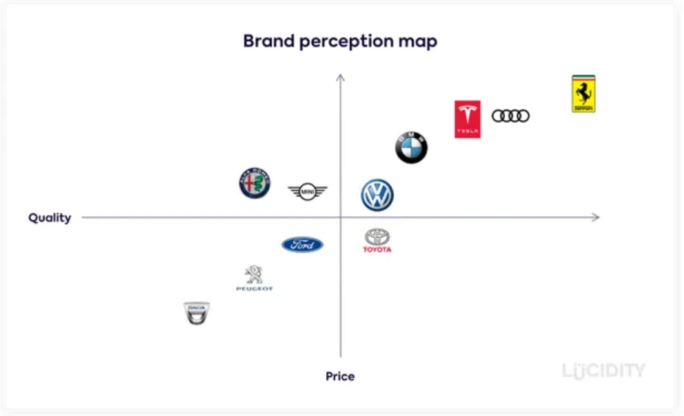
Figure 3: Brand perception map
Source: https://anupambajra.medium.com/using-perceptual-mapping-for-competitive-analysis-9aae239ec736

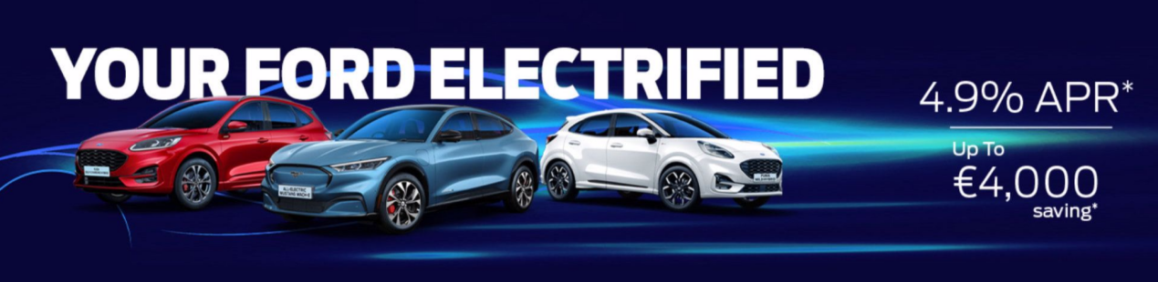
Figure 4: Ford's electric car ad
Source: https://www.finlayford.com/page/250/your-ford-electrified

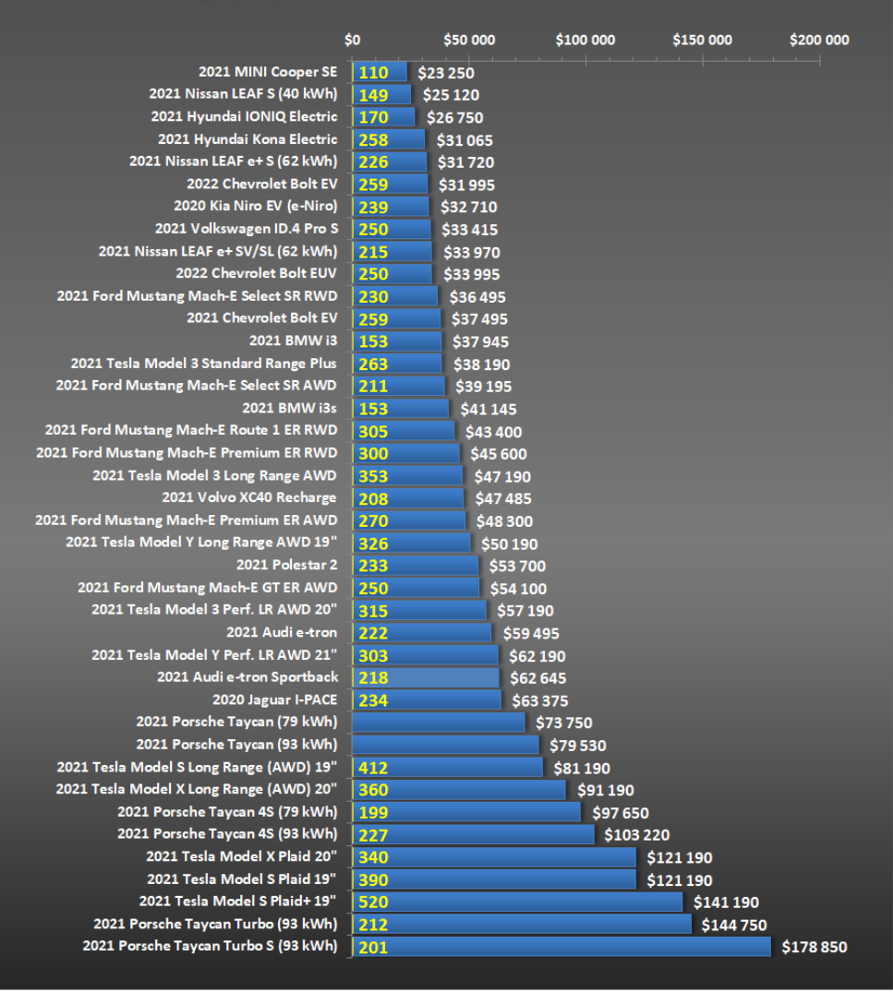
Figure 5: All-Electric Vehicle Comparison-U.S.
Source: https://insideevs.com/news/490438/electric-car-price-comparison-us-20210224/
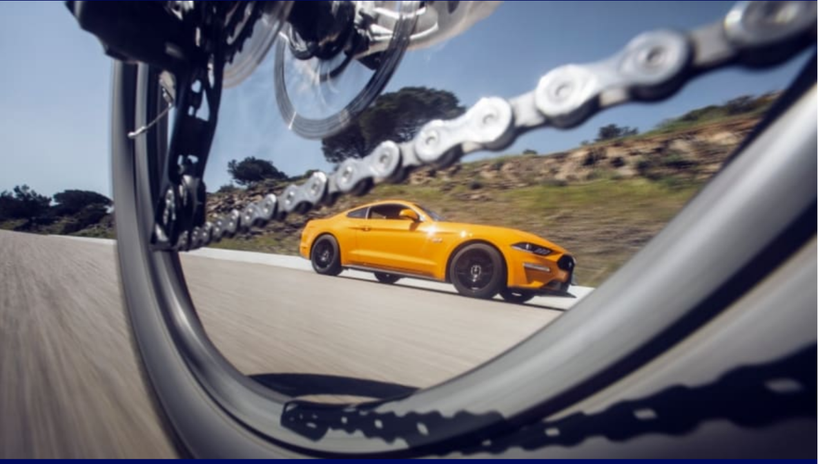
Figure 6: post details
Source: https://media.ford.com/content/fordmedia/feu/en/news/2018/05/24/ford-calls-on-drivers--cyclists-to-share-the-road--virtual-reali.html

