University of Wales Trinity Saint David
School of Engineering

Mathematical Principles of Thermodynamics Applied to Ideal Gases and Heat Engines and Their Cycles

Thermo-fluid Mechanics
ACMA5011

Shanjidah Ahmed
2309702
15/01/26
Contents
1 Calculations 1
1.1 Question 1 1
1.2 Question 2 2
1.3 Question 3 3
1.4 Question 4 4
1.5 Question 5 and 6 5
1.6 Question 7 and 8 6
2 Carnot’s Heat Engine 7
2.1 Concept 7
2.1.1 Step 1 - Isothermal Expansion 7
2.1.2 Step 2 - Adiabatic Expansion 8
2.1.3 Step 3 – Isothermal Compression 9
2.1.4 Step 4 – Adiabatic Compression 9
2.2 Efficiency 10
2.3 Heat pump and Refrigerator 11
2.3.1 Coefficient of Performance (COP) 11
2.4 Contradictions and Reality 12
3 Ideal Gas vs Real Gas 13
4 Kinetic Theory – Temperature of Gas vs Kinetic Energy 15
5 Derivation of Graham’s Law of Diffusion 17
6 Conclusion 19
7 References 20

Figure 1 - Isothermal Expansion Graph (Unacademy, no date) 7
Figure 2 - Isometric Vs Adiabatic Expansion Graph (Deniszczyz, 2025) 8
Figure 3 - Carnot Cycle and Thermodynamics Diagram (StressMan Engineering, 2023) 9
Figure 4 - Schematic of Carnot Heat Engine (Aleksic, 2011) 10
Figure 5 - Schematic of Heat Pump and Refrigerator (Bahrami, 2009) 11

Equation 1 - 1st Law of Thermodynamics 8
Equation 2 - Efficiency Equation 10
Equation 3 – Simplified Efficiency Equation 10
Equation 4 – Carnot Maximum Theoretical Efficiency Cycle - (Winterbone, 1997) 10
Equation 5 - Coefficient of Performance - Refrigerator 11
Equation 6 - Coefficient of Performance - Heat Pump 11
Equation 7 - COP - Rearranged Heat Pump 12
Equation 8 - COP Heat Pump and Refrigerant Relationship 12
Equation 9 - COP - Refrigerator – Temperature Values 12
Equation 10 - COP - Heat Pump – Temperature Values 12
Equation 11 – Boyle’s Law - Relationship between Pressure and Volume 13
Equation 12 - Pressure and Volume Constant 13
Equation 13 - Charles' Law - Relationship between Volume and Temperature 13
Equation 14 - Volume and Temperature Constant 13
Equation 15 - Pressure Law - Relationship between Pressure and Temperature 13
Equation 16 - Pressure and Temperature Constant 13
Equation 17 - Combined Gas Law Equation 14
Equation 18 - Ideal Gas Equation 14
Equation 19 – Real (Non-Ideal) Gas Equation (Ellgen, 2014) 14
Equation 20 - Microscopic Pressure Equation 17
Equation 21 - Intermediate Stage Graham's Law 17
Equation 22 - Proportionality of Density and Average Velocity 17
Equation 23 - Rearrangement of Ideal Gas Equation 17
Equation 24 - Density Equation 17
Equation 25 - Rearrangement of Density Equation (Eq 18) 17
Equation 26 – Ideal and Density Rearrangements 18
Equation 27 - Density as Subject 18
Equation 28 - Proportionality of Density and Molar Mass 18
Equation 29 - Proportionality of Molar Mass and Average Velocity 18
Equation 30 - Graham's Law of Diffusion 18

Calculations

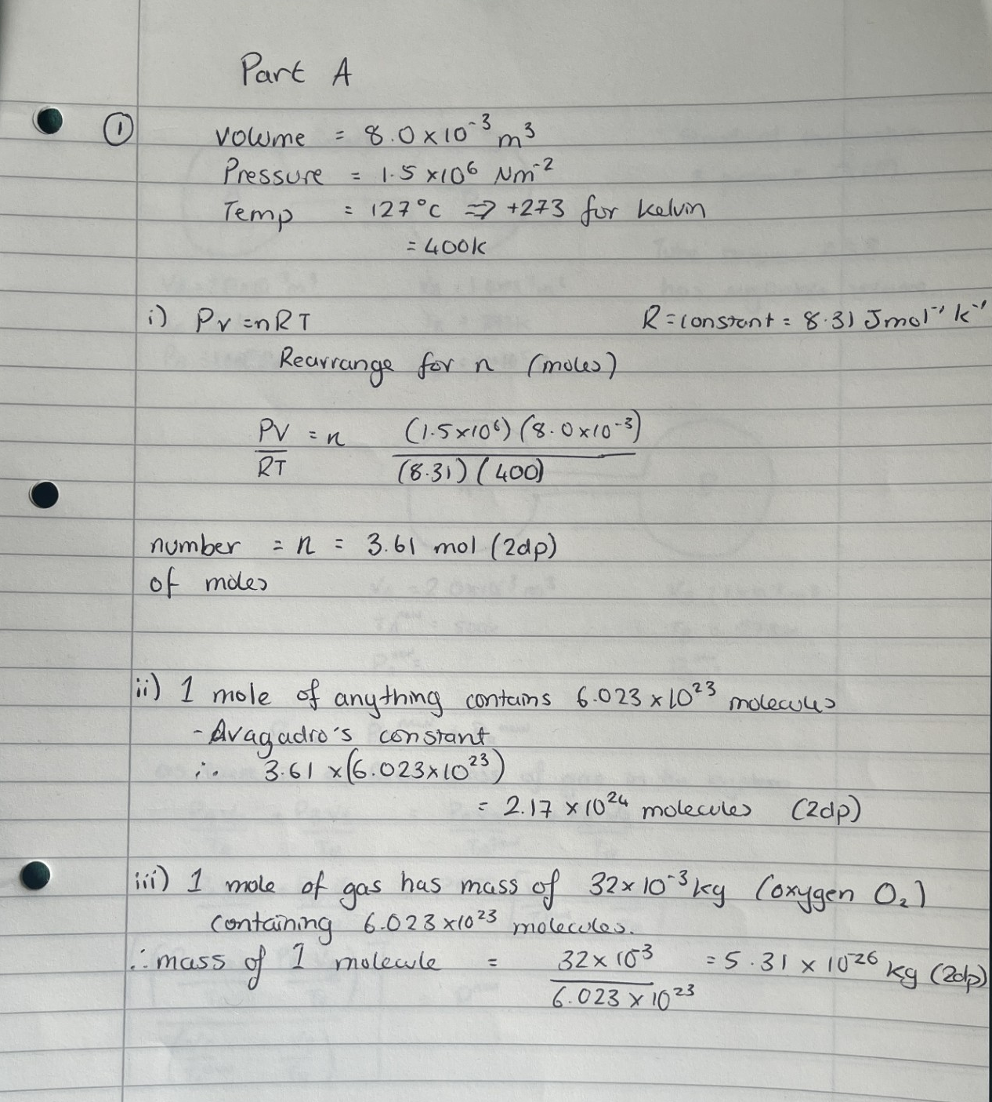
Question 1

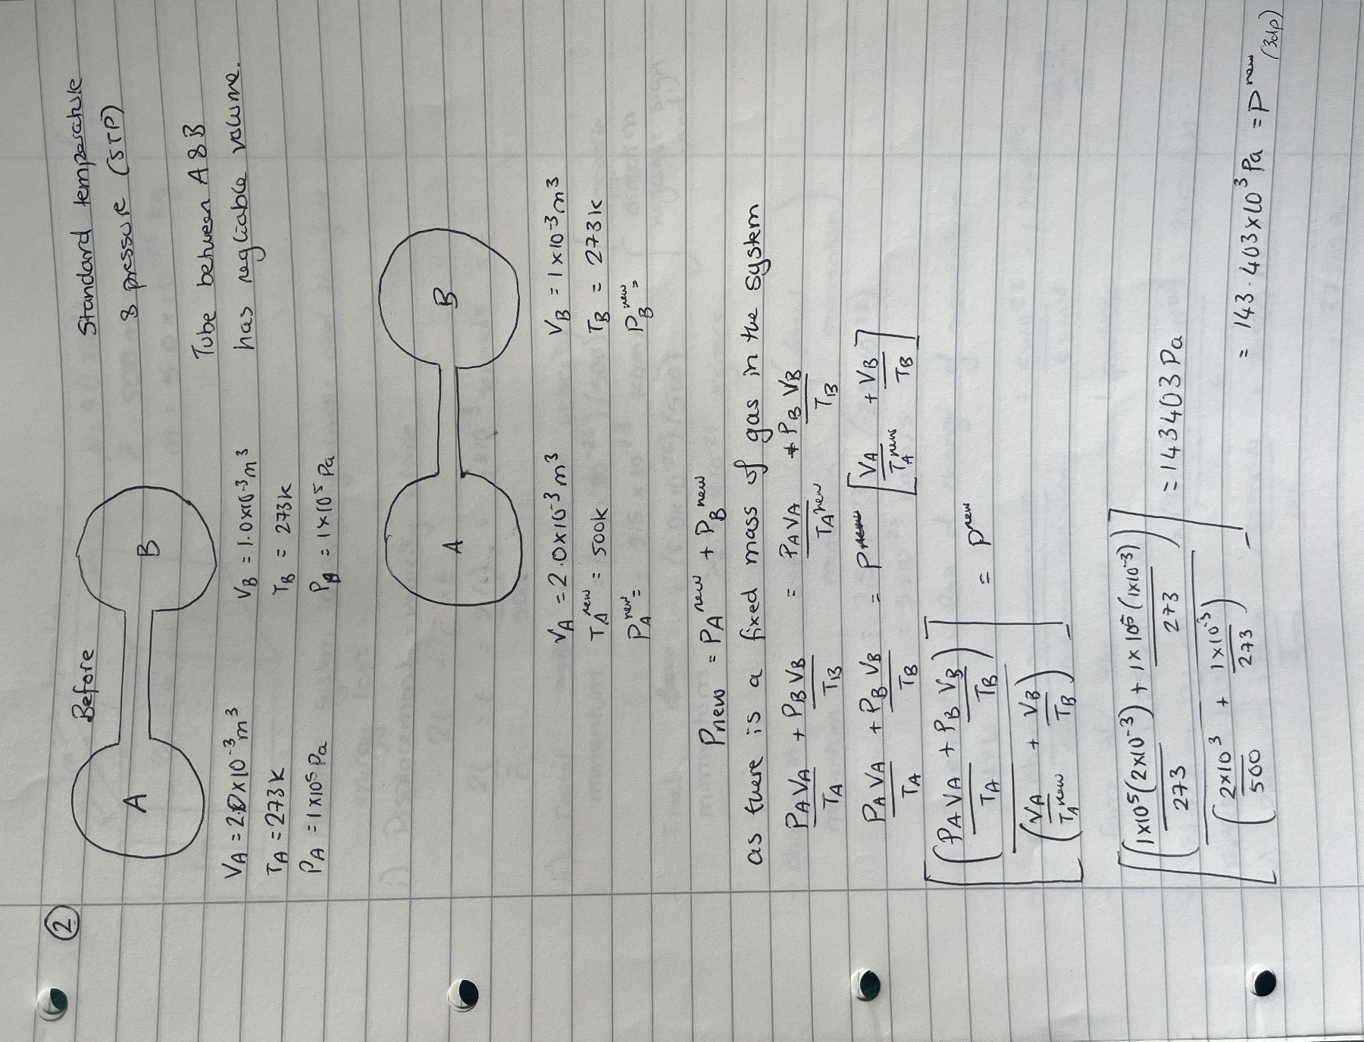
Question 2

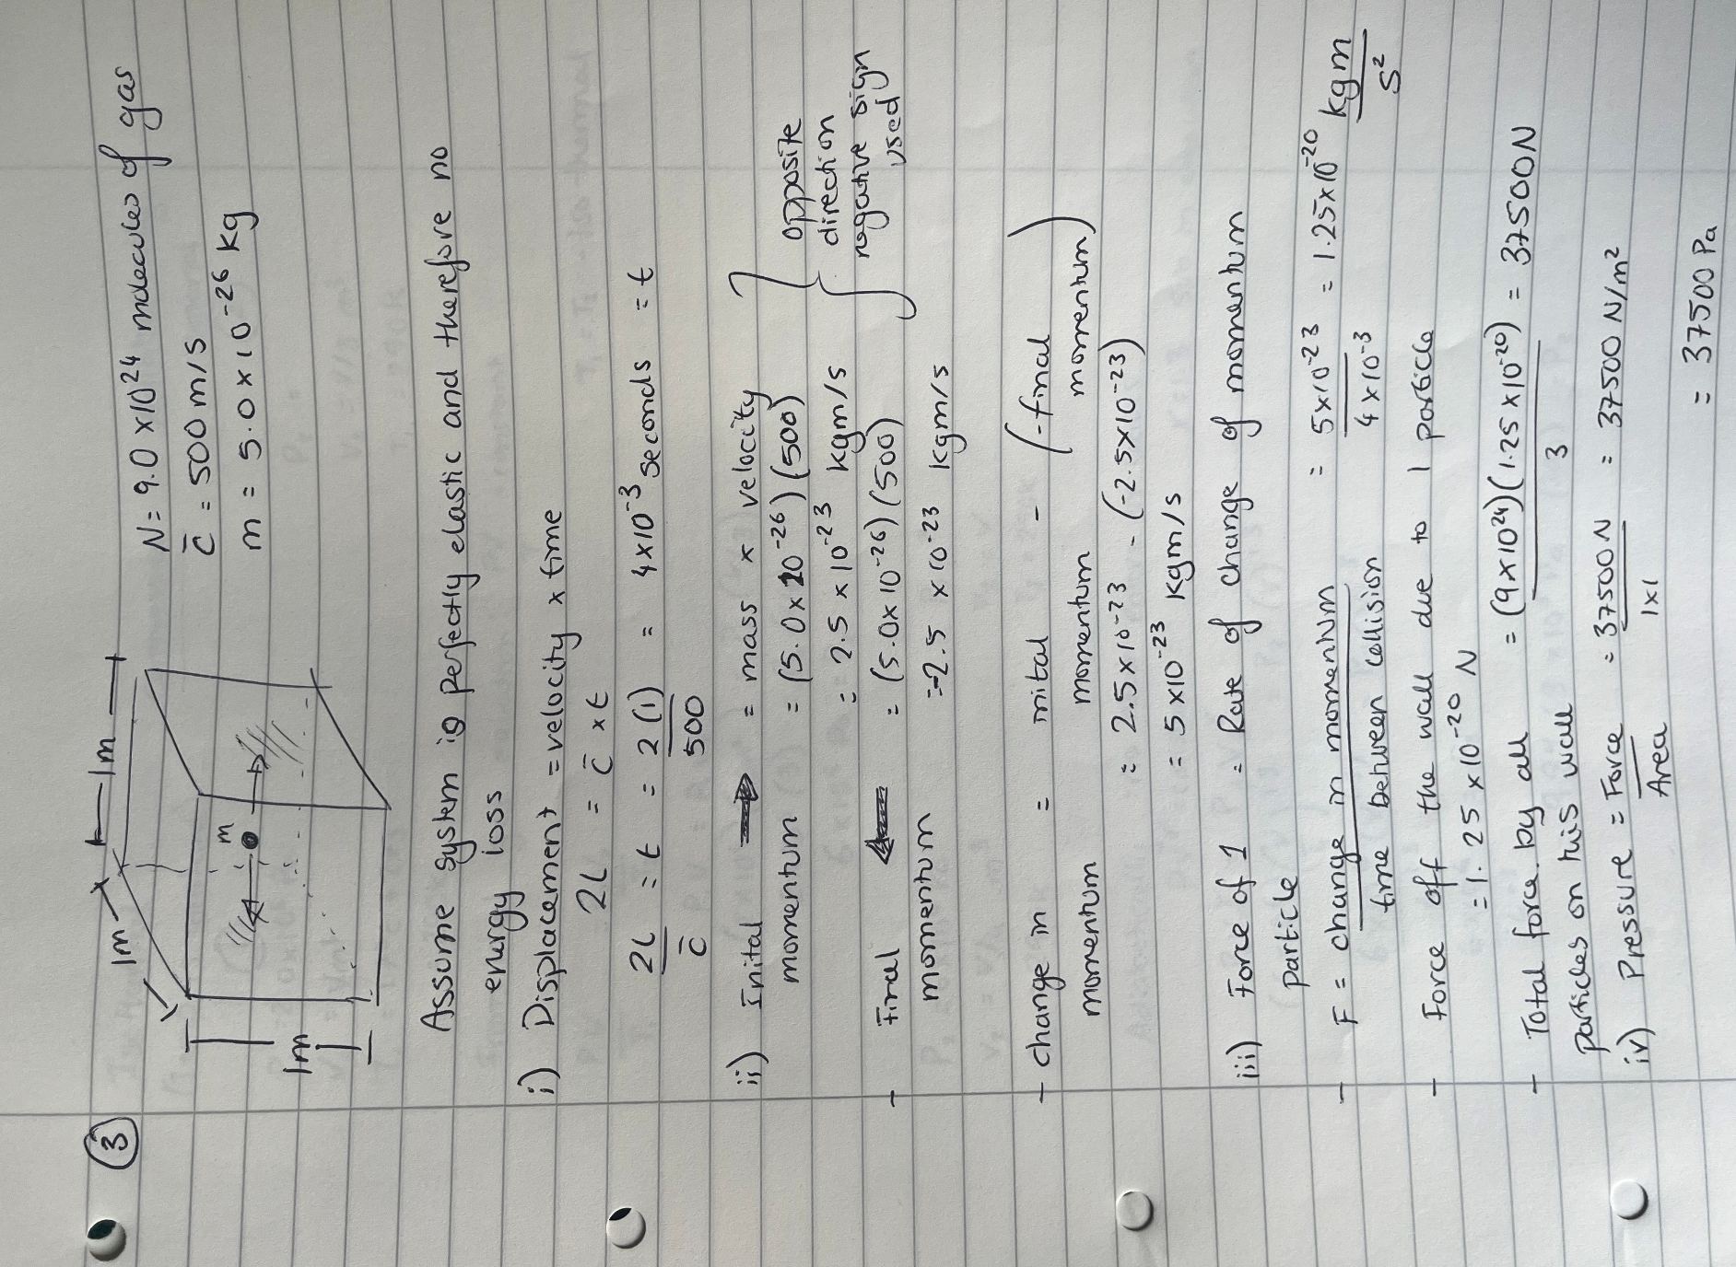
Question 3

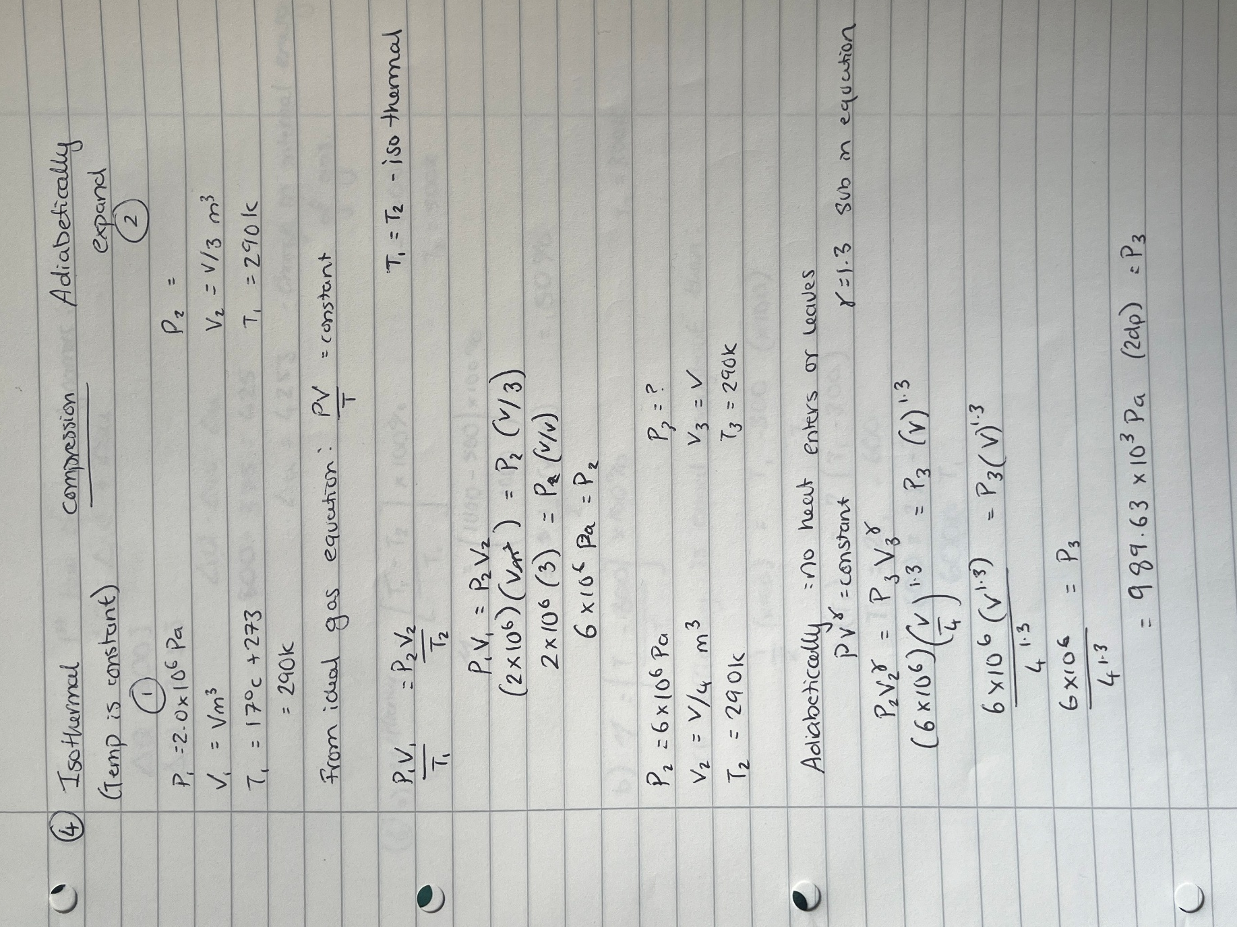
Question 4

Question 5 and 6
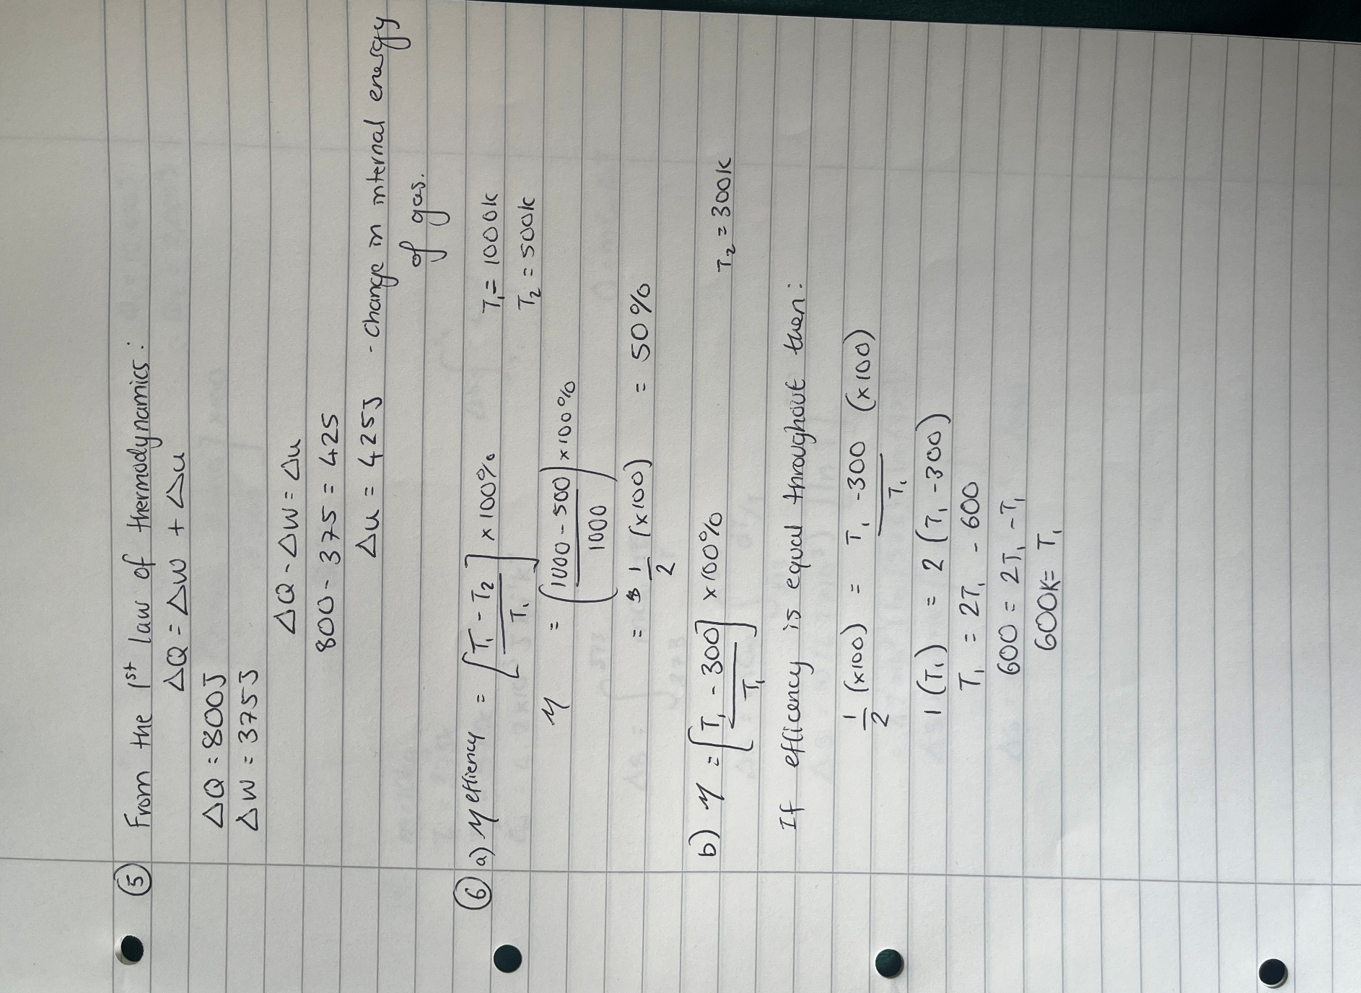

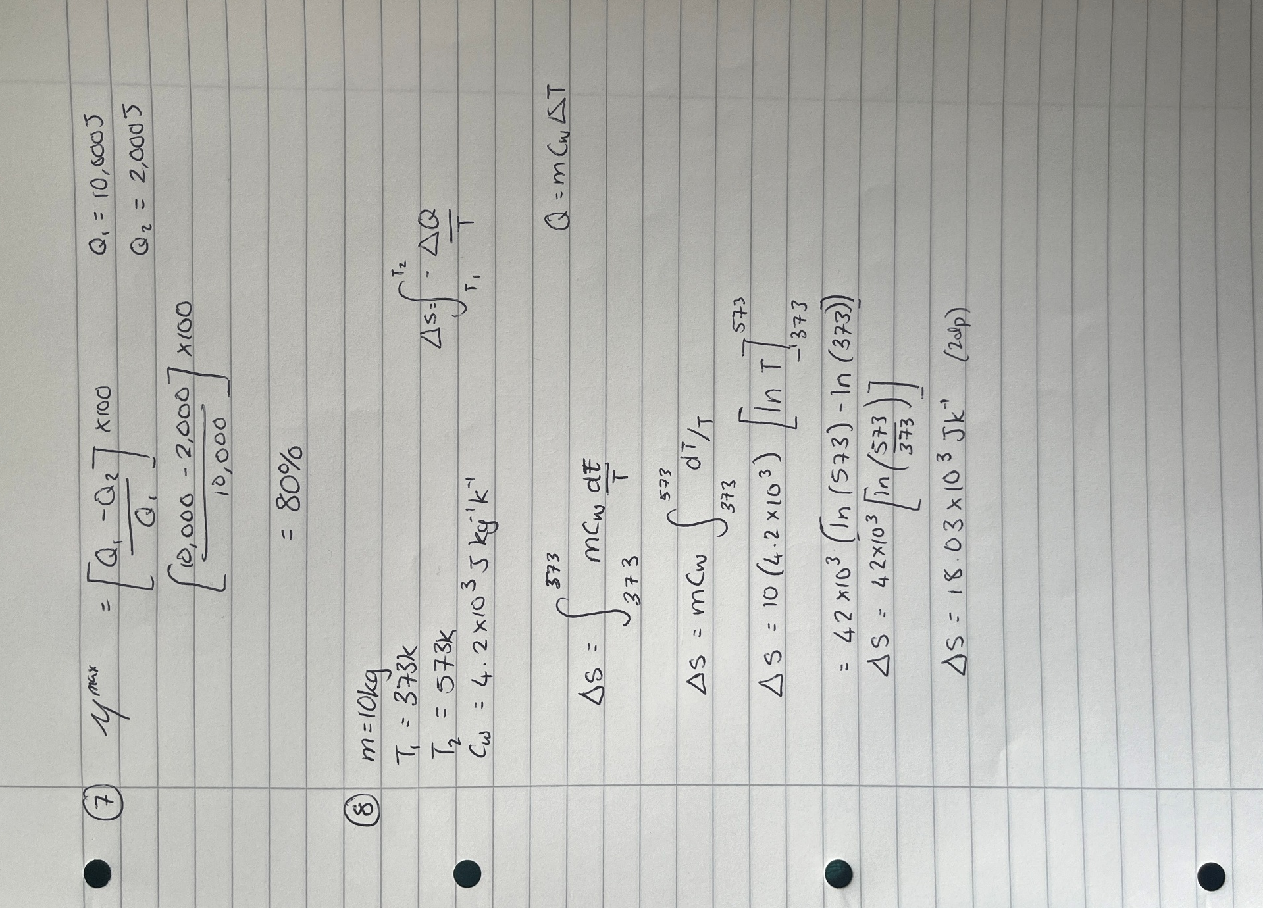
Question 7 and 8

Carnot’s Heat Engine

Concept
The Carnot cycle was developed by Sadi Carnot in 1824, its application related to the second law of thermodynamics, stating that entropy cannot decrease (Zohuri, McDaniel and Nezam, 2022). However, with regards to reversible processes entropy can remain constant (Zohuri, McDaniel and Nezam, 2022). It gives rise to the fundamental notion that heat energy will flow from a hotter region to cooler region. Carnot created an engine that illustrates a reversible system often depicted as a piston seen within an enclosed cylinder, driving movements comprising of both isothermal and adiabatic processes (StressMan Engineering, 2023).
Carnot’s cycle uses a hot and cold reservoir to compress and expand a volume of gas, to determine the most efficient engine (BYJU’S, no date), had external factors such as friction been avoidable.

Step 1 - Isothermal Expansion
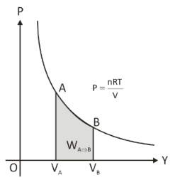
This step uses a heat source at the head of the piston to expand the volume within the cylinder; however, the temperature will stay at a constant rate as any input in energy will result in the expansion of the piston. This process will reduce the pressure and expand the volume as seen in figure 1. Where the coordinates of A and B are seen to reduce in pressure and increase in volume, it is generally slow as heat transfer to gas molecules occur continuously in order to prevent regions of temperature differences (Kirkey, 2019).

Figure 1 - Isothermal Expansion Graph (Unacademy, no date)

From the first law of thermodynamics equation 1 is known. Where Q represents the heat energy supplied or removed from the system, U is the internal energy and W is the work done or by the system. Therefore, with regards to isothermal expansion it is seen to be the case that the heat energy applied is equal to that of the work done on the piston to expand the volume.
$$∆Q=∆U+ ∆W$$
Equation 1 - 1st Law of Thermodynamics

Step 2 - Adiabatic Expansion
The next step is initiated once the piston has reached its capacity of W from the input of Q. The system is then adiabatic preventing any heat loss or addition; therefore, Q is equivalent to 0 (Kirkey, 2019). Due to the removal of a heat source the pressure within the system will reduce and cool, more rapidly than step 1. Figure 2 implies the gradient difference between both isothermal and adiabatic systems, again emphasising the change in pressures throughout.
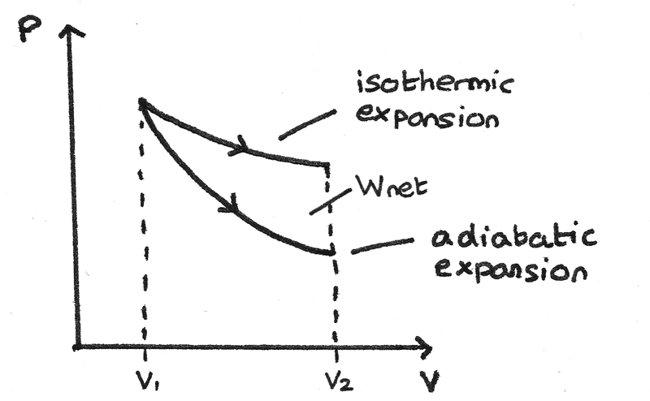

Figure 2 - Isometric Vs Adiabatic Expansion Graph (Deniszczyz, 2025)

Step 3 – Isothermal Compression
Isothermal compression generates heat energy as it compresses the volume within the cylinder, this is due to the fluid being in contact with a colder medium (heat sink). Which in turn rejects heat energy to heat sink enabling piston to contract (StressMan Engineering, 2023). Figure 3, again shows the relationship between the volume and pressure of the system referring to points 3-4. Illustrating a decrease in volume and an increase in pressure, again all at a constant temperature due to its energy supplied and work done ratio being equal to one another.

Step 4 – Adiabatic Compression
This process, as it is adiabatic involves no heat transfer to surroundings, therefore any work done on the system will increase the internal energy (Question Solutions, 2023). This is due to the removal of the heat sink and the assumption that Q is equivalent to 0, thus any external force increases pressure and reducing volume seen in figure 3, back to step 1, creating a cyclical process.
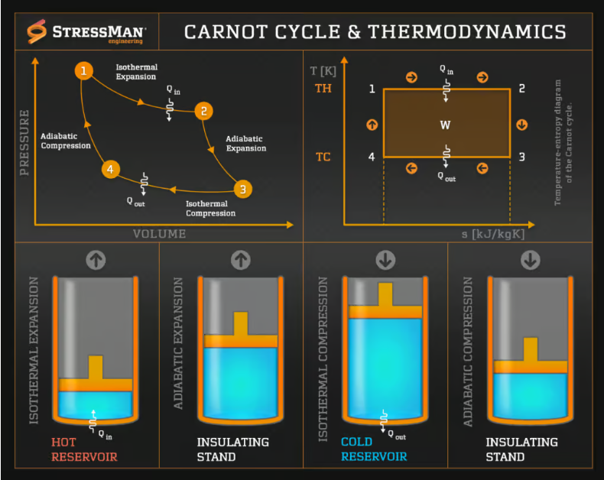
Figure 3 shows each step of the Carnot cycle with Q elements signifying heat in (Q_{H}) and heat out (Q_{C}) of system.

Figure 3 - Carnot Cycle and Thermodynamics Diagram (StressMan Engineering, 2023)

Efficiency
The efficiency of the engine is directly related to work done over heat input, seen in equation 3. Simplified to heat absorbed from hot reservoir minus the heat rejected (again seen in equation 2).

$$η= \frac{W}{Q_{H}}= \frac{Q_{H}-Q_{C}}{Q_{H}}$$
Equation 2 - Efficiency Equation
$$η=1-\frac{Q_{C}}{Q_{H}}$$
Equation 3 – Simplified Efficiency Equation

Carnot deduced that T_{c} and T_{h} corresponded with equation 2 and 3 and thus could be rewritten as equation 4 in terms of Carnot efficiency. Depending primarily on the temperature, therefore with an increase in heat, efficiency will also increase. Similarly with a decrease in temperature supplied to the cold reservoir the efficiency of heat dispersion is higher. With heat engine schematic illustrated in figure 4.
$$η=1-\frac{T_{C}}{T_{H}}$$
Equation 4 – Carnot Maximum Theoretical Efficiency Cycle - (Winterbone, 1997)
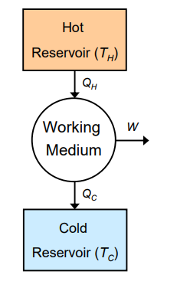
Figure 4 - Schematic of Carnot Heat Engine (Aleksic, 2011)

Heat pump and Refrigerator
The premise of heat pumps and refrigerators use similar methods however due to the second law of thermodynamics, heat can only move naturally from a region of heat to a cooler environment. Refrigerant and heat pumps however use applied energy to move heat from cooler region to areas of heat, thus are less energy efficient and require a larger input to defy the natural laws of thermal fluids (Bahrami, 2009). This is seen in figure 5 below with W representing the work done to the system in order to produce necessary outcomes.
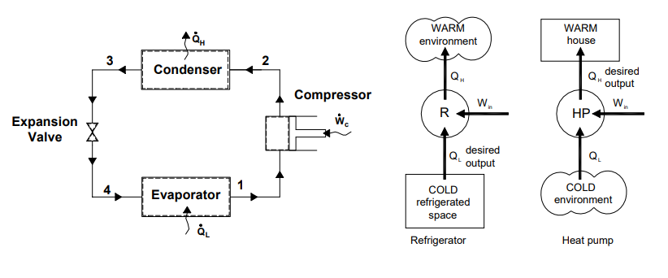
Figure 5 - Schematic of Heat Pump and Refrigerator (Bahrami, 2009)

Coefficient of Performance (COP)
This concept helps to indicate the energy consumption of a system and thus the efficiency. A higher value suggesting a greater efficiency achieved (Holley, no date). The desired outcome for a refrigerant is a cooler atmosphere; thus, the COP is relatively this and the work input. Similarly, the heat pump sees the desired output as Q_{H}, with equations 5 and 6 listed below.

$${COP}_{R}= \frac{Q_{L}}{W}= \frac{Q_{L}}{Q_{H}-Q_{L}}$$
Equation 5 - Coefficient of Performance - Refrigerator

$${COP}_{HP}= \frac{Q_{H}}{W}= \frac{Q_{H}}{Q_{H}-Q_{L}}$$
Equation 6 - Coefficient of Performance - Heat Pump
From the first Law of thermodynamics Q_{H} can be rewritten (equations 7), Thus deriving equation 8, suggesting that a heat pump is equivalent to that of the refrigerant with an addition of an input in work (Microsoft, 2025).

$${COP}_{HP}= \frac{Q_{H}}{W}= \frac{Q_{L}+W}{W}= \frac{Q_{L}}{W}+1$$
Equation 7 - COP - Rearranged Heat Pump
$${COP}_{HP}= {COP}_{R}+1$$
Equation 8 - COP Heat Pump and Refrigerant Relationship

With regards to Carnot’s evaluation of temperature in relation to Q_{L} and Q_{H,} equations 9 and 10 are as follows.
$${COP}_{R}= \frac{T_{L}}{T_{H}-T_{L}}$$
Equation 9 - COP - Refrigerator – Temperature Values
$${COP}_{HP}= \frac{T_{H}}{T_{H}-T_{L}}$$
Equation 10 - COP - Heat Pump – Temperature Values

Contradictions and Reality
Although Carnot system is the most efficient engine cycle, there are numerous worldly conditions that prevent such operations from high efficiency. This include the removal of frictional losses during contractions and expansion as well as the need to achieve a cold reservoir of absolute zero to attain the highest level of efficiency, which would produce further complications to the system and would be impossible to achieve naturally (LibreTexts Physics, no date).
Due to the fact that friction and heat dissipation are seen within heat engines (which do not aid towards the work performed) the efficiency rates of such operations will reduce the theoretical values proposed by Carnot, and thus increase internal entropy (Bister et al., 2011). Similarly, the material choices selected will have varying heat transfer properties which can both hinder and aid the process. However, will ultimately result in lower efficiency rates due to its inability to produce an adiabatic environment (LibreTexts Physics, no date).

Ideal Gas vs Real Gas
The ideal gas law sees point masses with no fixed volume, moving in a fluid motion. They are known to be perfectly elastic and so therefore generate no loss in energy (e.g sound or heat) (Tenny and Cooper, 2025). It is also assumed that there are no attractional forces between the molecules within the space, thus all acting independently of one another, relying solely on the input of pressure, temperature and volume (Tenny and Cooper, 2025).
The combined gas law looks at the relationship between Charles’ Law, Boyles Law and the Gay-Lussac’s pressure law, these all corresponding to key elements. For example, Boyles found that for a fixed mass of gas at a constant pressure would equate to a pressure inversely proportional to the volume, as seen in equation 11.
$$P ∝ \frac{1}{V}$$
Equation 11 – Boyle’s Law - Relationship between Pressure and Volume
As temperature is constant and iso-temp is generated, and a constant is introduced to produce the following equation (12). With K representing a common constant and thus can be equated to one another to calculate the values within a similar body.
$$PV=K$$
Equation 12 - Pressure and Volume Constant
Similarly, Charles deduced the importance of volume in relation to temperature. As seen in equation 13 and 14.
$$V ∝T$$
Equation 13 - Charles' Law - Relationship between Volume and Temperature
$$\frac{V}{T}=K$$
Equation 14 - Volume and Temperature Constant
Gay-Lussac’s pressure law states that pressure is proportional to that of the temperature (Tenny and Cooper, 2025) . As seen in equations 15 and 16.
$$P ∝T$$
Equation 15 - Pressure Law - Relationship between Pressure and Temperature
$$\frac{P}{T}=K$$
Equation 16 - Pressure and Temperature Constant
With these combined the equations for a fixed mass of gas is often used (equation 17), again K representing a constant.
$$\frac{PV}{T}=K$$
Equation 17 - Combined Gas Law Equation

The gas equation was adapted to include both Avogadro’s constant (number of molecules per mole, 6.023x10²³ mol⁻¹) with regards to the number of moles per substance (n), this demonstrates the amount of substance within the system (Speight, 2011). Linking the macroscopic parameters and the collective laws, as well as the universal Gas Constant (R) 8.31J mol⁻¹ K⁻¹. As seen below in equation 18.
$$PV=nRT$$
Equation 18 - Ideal Gas Equation

This ideal gas concept is useful for theoretical purposes, however due to the natural disposition of gas, perfect elasticity is rarely seen, and forces between molecules are a common occurrence, such as Van der Waals’ forces. Therefore, with the addition of these elements equation 19 is comprised.
$$\left(P+\frac{a}{V^{2}}\right)\left(V-b\right)=RT$$
Equation 19 – Real (Non-Ideal) Gas Equation (Ellgen, 2014)

Where “a” represents the attractive forces, thus reducing pressure and “b” represents the molecular volume thus redefines the available volume. If strong attractive forces are seen between molecules the pressure will reduce due to its nature to coincide with one another, as opposed to the ideal gas law that assumes all gas is independent of one another. Both “a” and “b” are constants depending on the gas, thus when calculations are derived these will need to be attained (Ellgen, 2014).
Although the real gas law equation is significant in high precision cases, the ideal gas (equation 18) is more commonly used. This is due to its behaviour under low pressures and moderate temperature ranges, acting similar to that of a real gas. Therefore, deriving figures within a reasonable range compared to that of equation 19 (Microsoft, 2025).

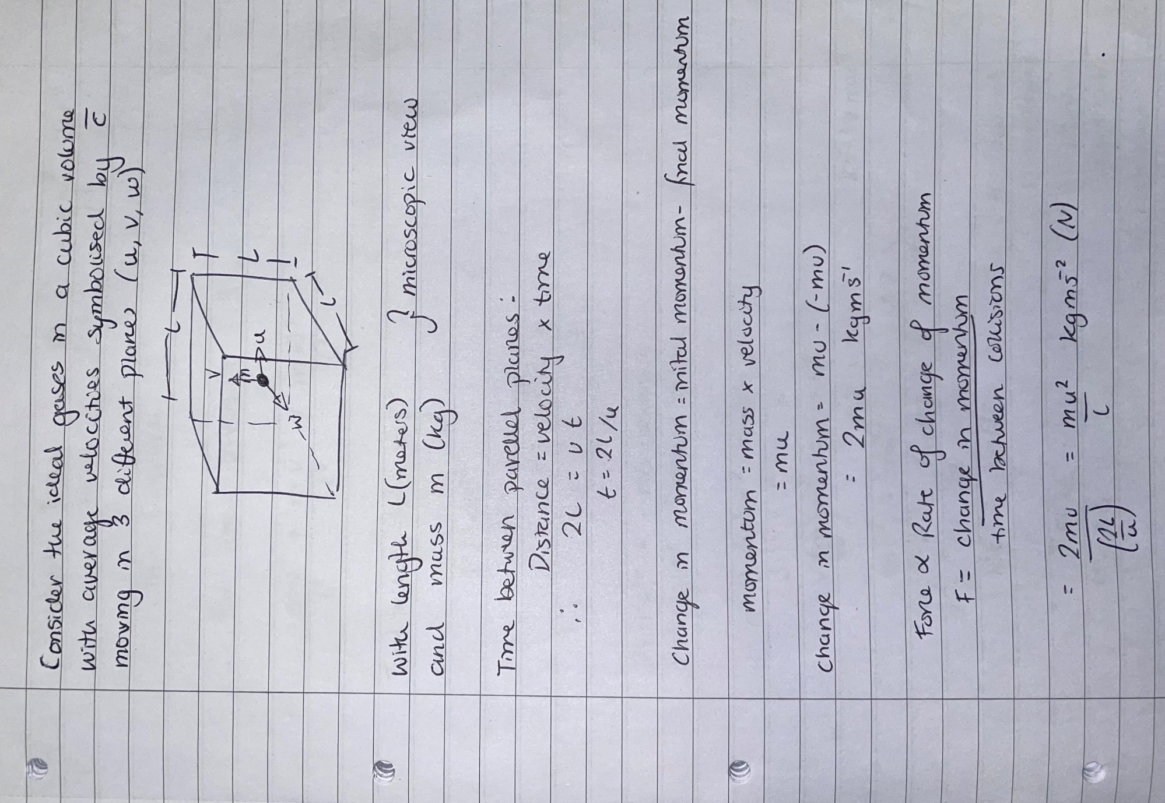
Kinetic Theory – Temperature of Gas vs Kinetic Energy
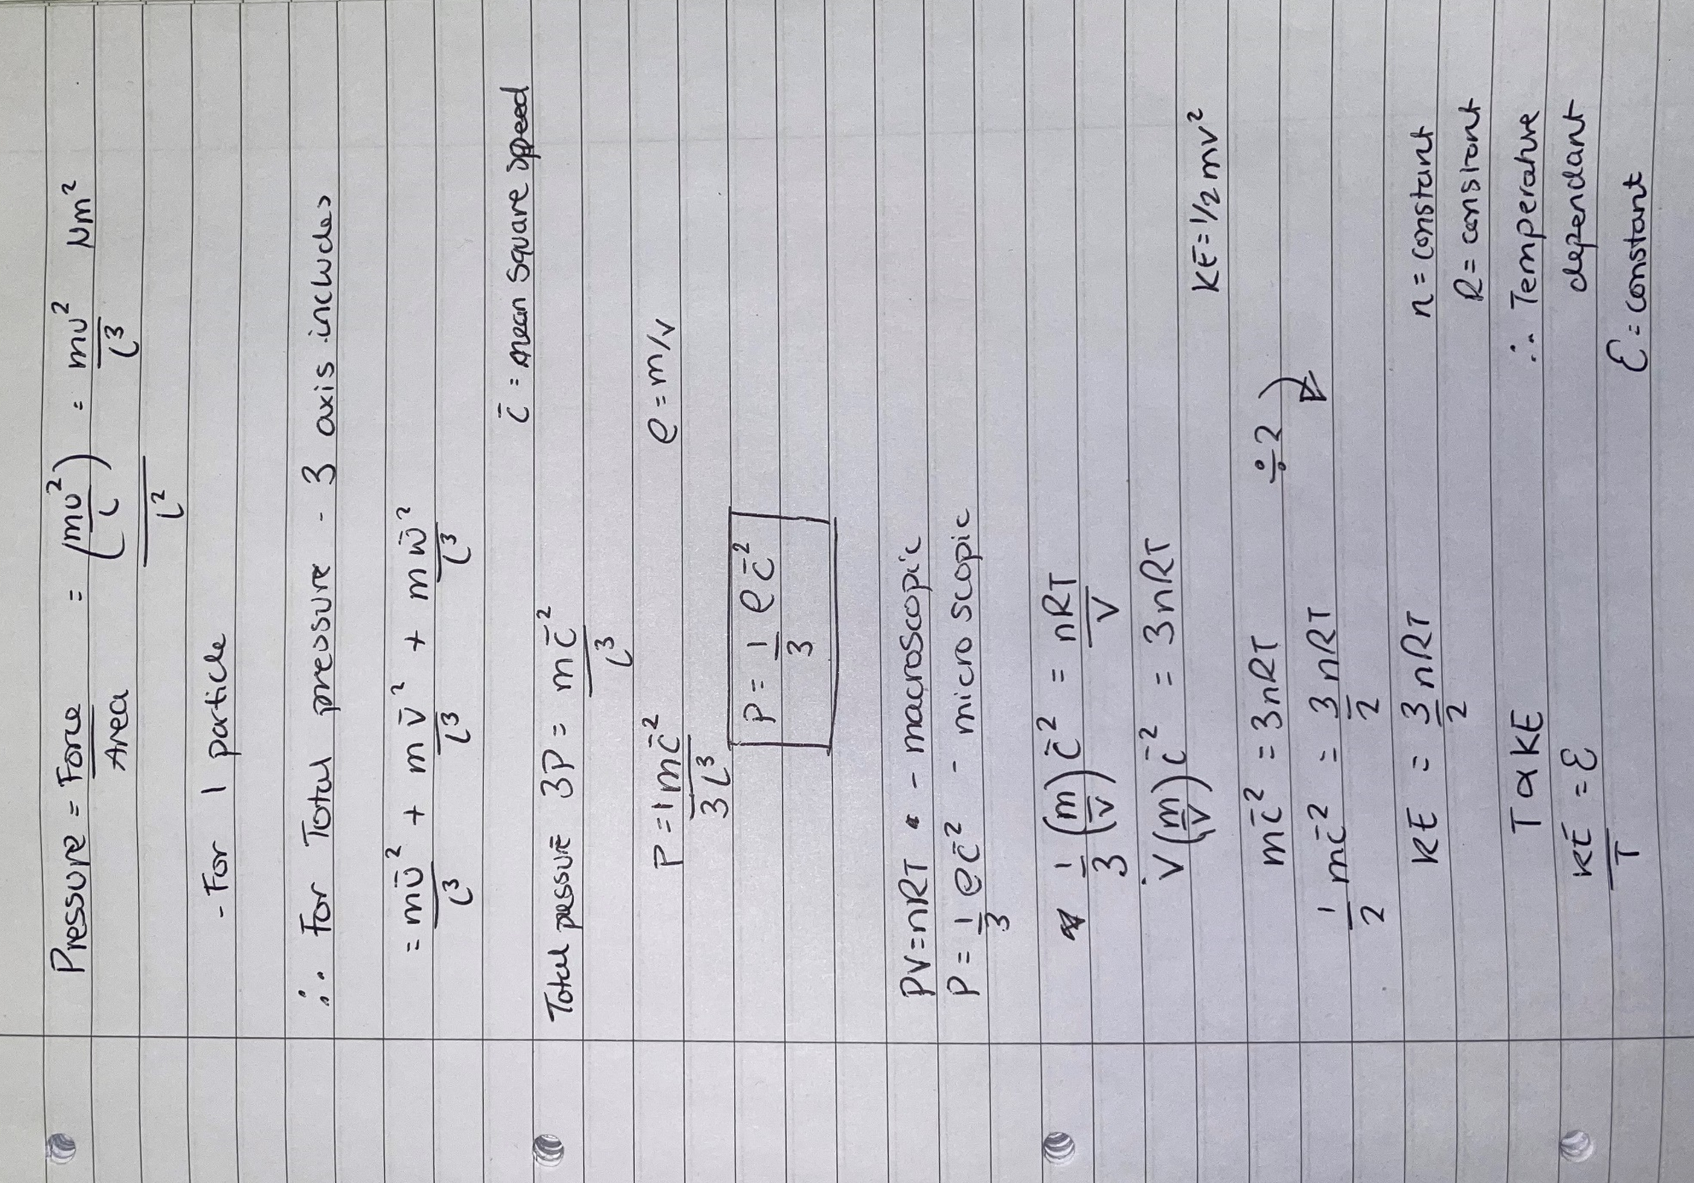

Derivation of Graham’s Law of Diffusion
As it is known that pressure is related to the density, seen in equation 20 below. It can be assumed that the pressure is a constant (K) and thus the average speed is proportional to one over the square root of the density (as seen in equations 20-22). Again, this constitutes with the Kinetic Energy equation, however it is assumed that mass is in relation to molecular weight and velocity is the diffusion rate (Desai Rishi, 2013).
$$P=\frac{1}{3}ρ{\overline{c}}^{2}$$
Equation 20 - Microscopic Pressure Equation
$$3K=ρ{\overline{c}}^{2}$$
Equation 21 - Intermediate Stage Graham's Law
After removal of constants, equation 22 is formed.
$$\frac{1}{\sqrt{ρ}}∝\overline{c}$$
Equation 22 - Proportionality of Density and Average Velocity

The diffusion rate of a gas is inversely proportional to the square root of its density, therefore corresponding to the notion put forth through Graham’s law (Wisniak, 2013). This can be written in terms of molar mass and rate. With rate corresponding to the c̄, and molar mass corresponding to the density, this is due to its proportionality when pressure is at a constant rate (as seen in equation 23-24). From equation 18 (ideal gas equation) the below equation is rearranged.
$$\frac{P}{RT}=\frac{n}{V}$$
Equation 23 - Rearrangement of Ideal Gas Equation
$$ρ=\frac{Mn}{V}$$
Equation 24 - Density Equation
Equation 24 stating the density equation with Mn representing the molar mass of the compound.
$$\frac{ρ}{M}=\frac{n}{v}$$
Equation 25 - Rearrangement of Density Equation (Eq 18)
Equation 23 and 25 are now equal and can be rewritten as equation 26 and simplified to equation 27 to make density the subject.

$$\frac{P}{RT}=\frac{ρ}{M}$$
Equation 26 – Ideal and Density Rearrangements
$$\frac{MP}{RT}=ρ$$
Equation 27 - Density as Subject

Therefore, with pressure (P), temperature (T) and gas rate (R) being constant, density is proportional to the mass/ molar mass of the substance and can be written in a similar fashion. Seen in equations 28-29.
$$ρ∝M$$
Equation 28 - Proportionality of Density and Molar Mass
$$\frac{1}{\sqrt{M}}∝\overline{c}$$
Equation 29 - Proportionality of Molar Mass and Average Velocity

Due to the relationship seen with rate of diffusion with regards to the average velocity (Desai Rishi, 2013), Graham’s Law can be defined (equation 30).
$$\frac{r_{1}}{r_{2}}=\sqrt{\frac{M_{2}}{M_{1}}}$$
Equation 30 - Graham's Law of Diffusion

Graham’s law suggests that with an increase in density or mass (molar mass) the rate at which diffusion (relating to c̄ and its velocity), is seen to be slower than that of a substance with lower density. Primarily due to the fact that the density of a substance is lighter, thus will provide a higher rate of movement (Desai Rishi, 2013). In varying applications this knowledge can be used to separate gas mixtures taking advantage of this known fact.

Conclusion
Carnot’s cycle assumes zero entropy which is impossible to achieve with a working engine (Zhao, 2025). Irreversible reactions are seen within systems such as heat dispersion and friction, all contributing to the energy loss and thus impact the efficiency of system (LibreTexts Physics, no date). Both adiabatic and isothermal processes are seen, displaying contraction and expansion within the system. Isothermal processes are exposed to a hot or cold reservoir to enable optimum movement, with Q representing the energy supplied or rejected (StressMan Engineering, 2023). It was concluded that to produce high efficiency the larger the difference in heat supplied and heat accrued would optimise such operations. However, when compared to real world situations, issues such as natural heat dissipation to the atmosphere is seen, due to the inability to insulate the system to a degree of absolute containment during the adiabatic movements. Similarly, friction is a common occurrence thus disorder and loss of energy is seen (Bister et al., 2011). This Identifies why the Carnot cycle although theoretically correct cannot be sustained in the natural environment.
Refrigerant and heat pumps use a similar method however due to their need to move heat from cooler regions to regions of heat, they require large amounts of energy input and thus are less efficient in their need to oppose thermodynamic heat laws (Bahrami, 2009).
Ideal gas law assumes perfect elasticity with no energy loss and point masses with no fixed volume. Thus equation 18 is derived, however due to the reality of elements and their attractions as well as their fixed volume, equation 19 is seen. Van der Waals’ forces playing a crucial role in reducing volume and pressure seen within a fixed body.
Temperature is directly proportional to the Kenetic Energy as seen in section 5. The macroscopic calculations see the relationship between pressure, temperature and volume with regards to the gas constant and moles. Whereas the microscopic calculations conclude the importance of density (ρ) of the elements and average velocity (𝑐̄) when deriving an answer. From this the kinetic energy equation can be obtained, highlighting the mass (density equation) and velocity, corresponding to the Kinetic Energy equation, (section 5). Due to numerous parameters such as the gas constant (R), moles (n) representing a constant these are negated, thus proving that Kinetic Energy is proportional to temperature.
Graham’s Law sees the importance in relationship between kinetic energy of individual particles assuming average velocity is 𝑐̄, with the diffusion rate of the gas within a body. Both of which relate to the density and molar mass of the substance. Thus, it is seen that a denser molecule will move at a slower rate than that of a smaller molecular weighted substance (Desai Rishi, 2013).

References
Aleksic, S. (2011) Thermodynamic Aspects of Communication and Information Processing Systems, International Conference on Transparent Optical Networks. Available at: https://doi.org/10.1109/ICTON.2011.5970913.
Bahrami, M. (2009) Second Law of Thermodynamics. Available at: https://www.sfu.ca/~mbahrami/ENSC%20388/Notes/Second%20Law%20of%20Thermodynamics.pdf (Accessed: December 25, 2025).
Bister, M. et al. (2011) “Comment on Makarieva et al. ‘A critique of some modern applications of the Carnot heat engine concept: the dissipative heat engine cannot exist,’” Proceedings: Mathematical, Physical and Engineering Sciences, 467(2125), pp. 1–6. Available at: http://www.jstor.org.ezproxy.uwtsd.ac.uk/stable/40998074.
BYJU’S (no date) What is a Carnot Engine? Available at: https://byjus.com/physics/carnot-engine/ (Accessed: December 22, 2025).
Deniszczyz, A. (2025) First Law and p-V Diagrams, Revise.im. Available at: https://revise.im/physics/unit-5C/first-thermodynamics (Accessed: December 23, 2025).
Desai Rishi (2013) Graham’s law of diffusion. Khan Academy. Available at: https://www.khanacademy.org/science/health-and-medicine/respiratory-system/gas-exchange-jv/v/graham-s-law-of-diffusion (Accessed: January 8, 2026).
Ellgen, P. (2014) 2.12: Van der Waals’ Equation, LibreTexts. Available at: https://chem.libretexts.org/Bookshelves/Physical_and_Theoretical_Chemistry_Textbook_Maps/Thermodynamics_and_Chemical_Equilibrium_(Ellgen)/02%3A_Gas_Laws/2.12%3A_Van_der_Waals’_Equation (Accessed: December 31, 2025).
Holley, D. (no date) Understanding Coefficient of Performance (COP) in Refrigeration Systems, AppliancesFirst. Available at: https://appliancesfirst.com/what-is-cop-refrigeration/ (Accessed: January 15, 2026).
Kirkey, J. (2019) Physics 1108 Physics for the Life Sciences. Department of Physics and Astronomy at Douglas College and OpenStax. Available at: https://pressbooks.bccampus.ca/physicsforlifesciences1phys1108/chapter/15-2-the-first-law-of-thermodynamics-and-some-simple-processes/ (Accessed: December 23, 2025).
LibreTexts Physics (no date) 15.4: Carnot’s Perfect Heat Engine- The Second Law of Thermodynamics Restated, The LibreTexts. Available at: https://phys.libretexts.org/Bookshelves/College_Physics/College_Physics_1e_(OpenStax)/15%3A_Thermodynamics/15.04%3A_Carnots_Perfect_Heat_Engine-_The_Second_Law_of_Thermodynamics_Restated (Accessed: December 21, 2025).
Microsoft (2025) Microsoft 365 Copilot.
Question Solutions (2023) The Carnot Cycle Animated | Thermodynamics | (Solved Examples). YouTube. Available at: https://www.youtube.com/watch?v=0wn0R9qWbiQ (Accessed: December 21, 2025).
Speight, J.G. (2011) “Chapter 1 - Chemistry and Chemical Technology,” in J.G. Speight (ed.) Handbook of Industrial Hydrocarbon Processes. Boston: Gulf Professional Publishing, pp. 1–41. Available at: https://doi.org/https://doi.org/10.1016/B978-0-7506-8632-7.10001-5.
StressMan Engineering (2023) The Carnot Cycle. Available at: https://stressman.no/the-carnot-cycle/ (Accessed: December 22, 2025).
Tenny, K.M. and Cooper, J.S. (2025) Ideal Gas Behavior. StatPearls Publishing LLC. Available at: https://www.ncbi.nlm.nih.gov/books/NBK441936/ (Accessed: December 31, 2025).
Unacademy (no date) Isothermal Expansion. Available at: https://unacademy.com/content/jee/study-material/physics/isothermal-expansion/ (Accessed: December 23, 2025).
Winterbone, D.E. (1997) “5 - Efficiency of Heat Engines at Maximum Power,” in D.E. Winterbone (ed.) Advanced Thermodynamics for Engineers. Oxford: Butterworth-Heinemann, pp. 85–99. Available at: https://doi.org/https://doi.org/10.1016/B978-034067699-8/50007-7.
Wisniak, J. (2013) “Thomas Graham. II. Contributions to diffusion of gases and liquids, colloids, dialysis, and osmosis,” Educación Química, 24, pp. 506–515. Available at: https://doi.org/https://doi.org/10.1016/S0187-893X(13)72521-7.
Zhao, B. (2025) “Power–effectiveness and power–entropy transfer efficiency tradeoffs for Carnot heat engines with external and internal irreversibilities,” Energy, 334, p. 137685. Available at: https://doi.org/https://doi.org/10.1016/j.energy.2025.137685.
Zohuri, B., McDaniel, P. and Nezam, Z.Z. (2022) “Fundamentals of Second Law Energy Analysis,” in L.F. Cabeza (ed.) Encyclopedia of Energy Storage. Oxford: Elsevier, pp. 99–111. Available at: https://doi.org/https://doi.org/10.1016/B978-0-12-819723-3.00125-6.

