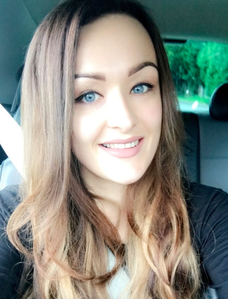

Name: Sara Gray

Student number: 1600029

Student email address: 1600029@student.uwtsd.ac.uk

Contact number: 07712281303

Shortly after leaving school I began working with an insurance company and have continued to do so for the past 7 years. Along the years I worked my way up, but knew it wasn’t what I wanted to do forever and that I wanted to make the most of my potential and build a career in an area that I am enthusiastic about.

As a keen CrossFit athlete and Olympic weightlifter, I have had exposure to many different types of sport related injuries, both first hand and through my peers. I always found it interesting looking at how individuals had injured themselves and what they were doing as part of a rehabilitation programme. From this interest, I began volunteering on the physiotherapy wards in Moriston hospital and shadowing a physiotherapist within a rugby team.

Having exposure to the same occupation in two very different environments made it clear to me that physiotherapy within the NHS was not the avenue I wanted to pursue. I had far more interest in shadowing the physiotherapist within the team, being first on the scene and having the exposure to sport related injuries and rehabilitation. Looking at what it takes to get an injured player back to their best and how to keep them there. That’s where I began looking in to Sport Therapy. After looking at the content of the degree and career prospects after I knew this is what I wanted my profession to be. After attending an open day and learning a bit more about the course I knew this was the avenue I have been looking for the and the opportunity towards beginning to build a new career, doing something I love.

