Knowledge and Information Management Skills for the Workplace

BMSW 5106

By Laszlo Peter Molnar

Student ID: 2113314

Lecturer: Dr. Tovin Adisa

Report

Executive summary

The concept of knowledge management has come to the attention of economic and social actors during the last few decades. In this sense, it is surrounded by natural uncertainty, since on the one hand, due to the short time horizon, and on the other hand, due to the technological development that significantly affects the flow of knowledge, it shapes the approach and practice at a significant speed by posing new challenges. This report finds it especially necessary to focus on the use and importance of knowledge management.

Table of content
Executive summary 2
Introduction 4
Organisation background – NHS 4
Section 1. Knowledge and Information Management 5
NHS Knowledge Management: 5
Participants for NHS KM system: 6
KM approaches 6
The importance of knowledge management for companies 7
Section 2: Evaluation of Knowledge and Information Management Models/theories 8
Knowledge and Information Management Models/theories 8
Nonaka theory 8
Karl Wiig theory 9
Nonaka's tacit and explicit conversion and decision-making model for NHS 9
Section 3: Investigating of KM techniques used by NHS 10
Knowledge mobilisation framework 11
Evaluation Framework 12
Focus on explicit knowledge: 13
Recommendations to promote knowledge sharing within the NHS; 13
In a knowledge-based NHS that can meet today's challenges. 13
Conclusion 14
References 15

Better Knowledge, Better Care
Building a knowledge enabled NHS for the future

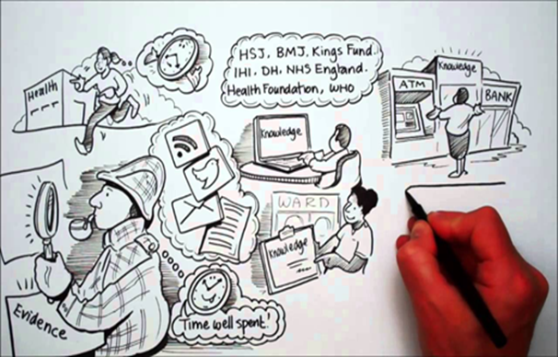

Introduction

In this report, it will be about understanding how the knowledge management process works. With the help of the chosen organization, I will present what opportunities companies can gain by using the appropriate KM system.

Organisation background – NHS

The creation of the NHS in 1948 was the result of years of hard work and the motivation of various individuals who felt that the current healthcare system was inadequate and needed to be revolutionized.
Since then, the NHS has undergone many changes, developments, upgrades and modernisations.
As the years went by, more changes occurred, and in 1974, a reorganization occurred as the period of economic optimism that characterized the previous decade waned. By the 1980s and the Thatcher government, modern management methods were introduced.
Today, the NHS faces an even greater crisis. The issue of funding and demand continues to rise, and for many, the possibility of free healthcare is an ongoing debate.
Nevertheless, over seventy years mark an important moment in British history. Established in 1948, the NHS was created through hard work and commitment by those who truly believed in new ideas about services, health, medical ethics and society in general. During its more than seventy years of operation, NHS has faced crisis, economic downturn, periods of prosperity, growth and much more. (Brain, 2021)

Section 1. Knowledge and Information Management

What is knowledge management? Today, a person encounters more information in one day than in the middle Ages in an entire year. The accelerating world, the amount of advertising, new and new research and the news feed updated every minute generate a lot of data that needs to be systematized, processed and passed on.
Every company must strive to gather and interpret the information most important to it, and turn it to its own advantage by forming knowledge according to the hierarchy of wisdom.
The knowledge management definition:
The purpose of knowledge management is to increase the intellectual capital of an organization.
The point is to create databases that can manage knowledge: they make different knowledge available to a community within thematic frameworks.
The concept of knowledge management actually covers a process that regularly, more and more economically and quickly, almost automatically lists the accumulated knowledge and defines the steps of how knowledge should be shared. (SKOLL, 2021)

NHS Knowledge Management:

NHS principles are key points of knowledgeable management:
~We managed money and buildings, people and energy. Now we have to manage the most valuable commodity of the 21st century - knowledge and know-how. And peer review; learning and self-directed development that reflects the fundamental desire of all doctors, nurses and managers to do a better job for their patients ~ (Gray, 1998)
The NHS has an increasing need to reduce costs in order to continue to provide and fund high-quality, effective care for patients with a range of co-morbidities. There are challenges due to a growing and aging population and a shortage of trained clinicians, but also opportunities to improve health outcomes arising from advances in medicine. In addition, the health service must address unjustified variation to improve quality, productivity and efficiency, ensuring a 'right first time' approach.
Evidence and knowledge are key to a successful transition to place-based care that focuses on keeping people healthy and taking advantage of new digital technologies. (Day & Goswami, 2020)

Participants for NHS KM system:

The Knowledge Management (KM) team within Connecting for Health (NHS CFH), is part of the Department of Health Informatics Directorate (DHID). This team has developed a Knowledge Transition Toolkit to support the NHS capture and share learning as it transitions to the future state.
NHS boards, their staff, students, patients and the public. The library service plays the biggest role in this. The methods of health librarians and the management of their resources contribute to the organization's strategic goals.

Information-driven health care gives librarians the opportunity to enhance their role and provide not only information services, but KM services to other members of the hospital community. (Gray, 1998)

KM approaches

~…the right knowledge to the right people at the right time …to be translated into action to improve the organisational performance.~ (C & CJ, 1998)

KM approaches can support the sharing and replication of great ideas and the adoption of innovative approaches to improve care and services. Each of these components requires effective knowledge sharing and learning.
Each of these components requires effective knowledge sharing and learning. The rapid adoption of successful methods will result in the spread of innovation and create a more efficient, safer, and more responsive service which is an important driver of current and future development and transformation of the NHS.

The importance of knowledge management for companies

Special knowledge that contributes to competitiveness can be created through the knowledge processes implemented in the organization. The corporate internal environmental factors of knowledge sharing are organizational culture, trust, communication, technology, organizational structure, and management style.
Competitiveness-related research and international reports (World Economic Forum) point to the importance of knowledge, as bridging knowledge gaps can provide companies with a sustainable competitive advantage.
Human knowledge has always played an important role in the lives of individuals and communities, but while in the past only a few could possess it, today it is accessible to anyone in developed societies and has become one of the main sources of empowerment. In a rapidly changing environment, knowledge is not enough to be acquired, but must be constantly renewed and expanded.

The operation of organizations is built around integrated business processes that cross the boundaries of corporate functions and form value-creating chains. Companies combine the specialized knowledge of functions (sales, procurement, and development) with the efficiency and quality of integrated business processes.

For customers, the value of the products/services is largely represented by the added value:

- the quality of customer relations,
- the level of service,
- customization of products/services,
- After purchase support.
Most of the added value comes from the knowledge possessed by the organization.

The ability to acquire new knowledge and organizational learning - which is a new way of approaching organizational change processes - become an indispensable source of competitiveness, similar to financial instruments, the resources of companies to be activated.

Section 2: Evaluation of Knowledge and Information Management Models/theories

Every economic organization strives to increase its competitiveness, which enables it to secure its stable market position in the long term. Competitiveness is determined by three main factors. The high quality, the consumer-friendly price, and the availability of the product/service for the demand.

For the sake of their future development, organizations must recognize what characteristics strengthen their market position. As a result of technological development, information, and knowledge can be called one of the biggest market values. While companies try to meet the expectations of demand, it is important to exploit the potential inherent in their organization. Recognizing and acquiring knowledge is also a difficult task, but keeping it and using it effectively also entails several challenges. The issue of employees' openness, attitude, and even distrust towards knowledge sharing cannot be ignored either.
What are the solutions and methods by which managers approach optimal operation? How can the utilization of the information and knowledge inherent in the workforce be achieved? What tools can be used to implement and exploit the cooperation of companies? Answering all these and more questions does not clearly mean achieving economic success, but it creates the possibility for companies to operate economically and efficiently.

Knowledge and Information Management Models/theories

Nonaka theory

Nonaka's theory (Nonaka, 1994) on the creation of organizational knowledge is one of the most influential theories in knowledge management literature. Following Plato, Nonaka defines knowledge as "reasonably true beliefs". When explaining the definition, he contrasts the static, absolute, human-independent approach to knowledge with the dynamic, personal be In terms of the perceptibility and grasp ability of knowledge, the literature distinguishes between tacit (hidden) and explicit (displayed) knowledge. In this sense, it is important to distinguish present but not displayed (tacit) knowledge from (explicit) knowledge displayed in some fixed form. An important feature of this in terms of successful knowledge management is that they can transform into each other, and if we want to influence this consciously, it is very useful to know the Nonaka matrix and use it for conscious efficiency life-based approach.

Karl Wiig theory

Karl Wiig (Wiig, 1997) highlights the methods by which authentic knowledge can be found. It lists five typologies that can be placed along five dimensions
1. Conceptual dimension: automatic and goal-setting knowledge,
2. Manifestation: from the knowledge found in the brains of individuals to the encoded knowledge - machines, technologies, procedures,
3. Information dimension: from signal transmission - to wisdom - transmission medium, signal, data information, knowledge, wisdom,
4. Detail: knowledge atom and knowledge domain – regions, sections, cases, elements, details,
5. Competence: beginner-grandmaster - beginner, advanced, competent, masters.

Nonaka's tacit and explicit conversion and decision-making model for NHS

The use of technology and communication technologies is essential for the effective management of the company's explicit and implicit knowledge. The prerequisite for choosing the right technological solution is the precise definition of the organization's strategic and other goals. The introduction of knowledge management processes, even in a well-functioning company, is not expected to work successfully by itself thanks to the provided technological background. The main component of successful knowledge management is the human resources present in the company, as they are the executors and implementers of the established knowledge management strategy. The innovation and development of the organization is influenced by the ability of individuals, groups, and organizations to share knowledge and learn.
Nonaka's theory in the context of the NHS. The most important element of learning is socialization, which is the result of schooling and joint exercises. Equally important is internalization, as a result of which, in the case of medical work, they actually act without thinking or deeper analysis. The combining form can also be done well. The condition of externalization is the recognition of the existence of knowledge, one of the possible ways of which is the mapping and transfer of knowledge. (Nonaka, 1994)

Section 3: Investigating of KM techniques used by NHS

In a fast and constantly changing environment, organizations need to react constantly and in time in order to remain competitive in the market. The current market environment is characterized by the presence of new entrants, constant innovation competition, shortening of product life curves, the appreciation of the role of strategic networks and alliances, the diversity of cultural characteristics, knowledge-based products and services, and the ever-growing information avalanche.
The importance of personnel work, finding employees with decisive knowledge, and matching them to their abilities career planning, adequate training of nurses, doctors and other employees is extremely important and indispensable for the NHS.
The available resources are mobile and can be transferred between companies, so differences in resources can only be temporary.
The NHS is a complex health system with an increasing need to reduce costs in order to deliver and finance high-quality, efficient care for patients with a range of co-morbidities. The challenges are very strong due to the growing and aging population and the lack of trained clinicians, but the opportunities arising from the development of medicine seem possible to improve health outcomes. In addition, the health service must address unjustified variation to improve quality, productivity, and efficiency, ensuring a 'right first-time' approach.
Knowledge is key to a successful transition to care that focuses on keeping people healthy and taking advantage of new digital technologies.

Knowledge mobilisation framework

The NHS has launched a program to help people develop and apply the skills to effectively mobilize knowledge in their organizations - to help them learn before, during, and after everything they do, to avoid pitfalls, and to replicate best practices. (NHS, 2023)

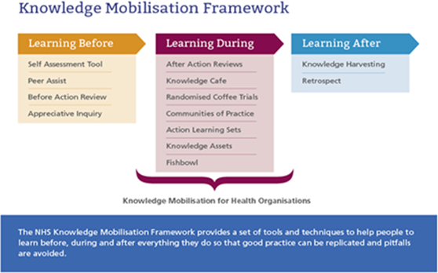Figure 1 NHS Mobilisation framework

Program details:
Before learning, it's about considering what we know and what we don't know and identifying knowledge gaps. This is knowledge expressed in knowledge, such as tools, insight and experiential knowledge. The techniques presented can help an organization or team get started on a project or work quickly and efficiently by providing access to the learning and experience of those who have done the same or similar work before.
After studying, you deal with taking a break to think about a work activity. The next step is to record, build, and finally share the knowledge base of the work area with those who are interested. This knowledge can be shared with direct colleagues, different departments, or organizations.
During studying; there is a balance between pre- and post-learning learning activities: it deals with new knowledge requirements and provides insight and experience to lay the foundation for the next job. (NHS, 2023)

Evaluation Framework
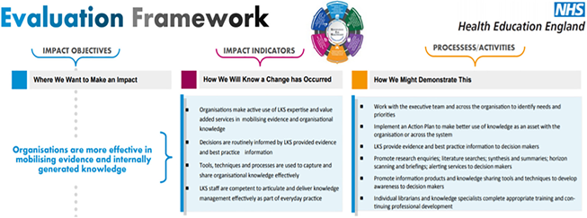

The purpose of the assessment framework is to provide a mutually reinforcing framework for your assessment. It looks at what you want or should do in a service, then works to determine how you'll know you're going to get there and what you need to do to make it likely. In the Evaluation framework, the general emphasis is on achieving results.

The Evaluation Framework was developed to assess health education's progress towards achieving the Knowledge for Healthcare vision and demonstrate the significant contribution of knowledge services. (NHS, 2023)
The framework enables knowledge service evaluation, which provides data to demonstrate impact, ensure service quality, measure performance, and improve services. The Evaluation Framework is a good tool to support the development of services and your own service.

Focus on explicit knowledge:

Within the NHS, the focus has historically been on explicit knowledge, such as journals and reports, rather than experiential practice. The result was that NHS staff associated KM with information and data and did not appreciate the value of shared expertise.

It is important for the NHS to keep learning: The importance of learning from mistakes and sharing knowledge has been reinforced by several recent reports that have responded to failures in patient care. The NHS must continuously reduce harm to patients by adopting an ethics of learning. The NHS must become a learning organization. Its leaders need to create and support the capacity to learn and therefore make a big difference within the NHS. (Gray, 1998)

Recommendations to promote knowledge sharing within the NHS;

• UNIQUE MEASURES: trainings, workshops, seminar series.
• TECHNOLOGY: repository of knowledge resources. Discussion forums platform.
• FRAMEWORKS: KM process maps and knowledge maturity mapping.
• CULTURE: trusting and open, shared values. Strong management support.
• MEASURED VALUE: examples of KM benefits for businesses.
• COMMUNITIES: virtual or face-to-face, goals aligned with business goals.
• APPROACH: KM measures implemented and supported by champions. (Gray, 1998)

In a knowledge-based NHS that can meet today's challenges.

Development of knowledge sharing and learning skills:
Build skills and practical examples for sharing evidence and expertise and learning from evidence.
Incorporating KM skills into NHS staff skill sets: Linked to organizational development to focus on culture and behaviour.
Support KM enthusiasts within the business rather than creating a KM 'structure'.
Introducing KM with relationships and learning; KM is often associated with personnel data and information. Use of appropriate language, which is also understood by employees. : showing "What does this mean to me?" It illustrates the benefits of KM in healthcare with stories and case studies.
Encourage managers to support a culture and behaviour of knowledge sharing:
Encouraging top management support: promote appreciation of the value of tacit knowledge that helps build collective knowledge capital.
Embedding KM activities in the implementation of development programs. These programs are attractive to NHS staff and there is an opportunity to embed KM activities into development and transformation programmes. (NHS, 2023)

Conclusion

This report was about understanding how the knowledge management process works. With the help of the NHS organization, I presented what opportunities companies can get by using the right KM system. Apart from this, I presented how the NHS works and what KM strategies are used and I made recommendations regarding how the NHS KM system could be improved.

References
Brain, J., 2021. Historic UK. [Online]
Available at: https://www.historic-uk.com/HistoryUK/HistoryofBritain/Birth-of-the-NHS/
[Accessed 10 08 2023].
C, O. & CJ, G., 1998. If only we knew what we know: identification and transfer of best practices. s.l., Free Press.
Day, A. & Goswami, L., 2020. Sage Journal. [Online]
Available at: https://doi.org/10.1177/0266382120909240
[Accessed 02 08 2023].
Gray, S. J. A. M., 1998. Where’s the Chief Knowledge Officer?. BMJ, Issue 317.
NHS, 2023. Health Education England. [Online]
Available at: https://library.hee.nhs.uk/quality-and-impact/evaluation-framework/evaluation-framework-faqs
[Hozzáférés dátuma: 22 08 2023].
NHS, 2023. The NHS Constutition. [Online]
Available at: https://www.e-lfh.org.uk/programmes/knowledge-mobilisation-framework/
[Accessed 20 08 2023].
Nonaka, I., 1994. A Dynamic Theory of Organizational Knowledge Creation.. 5 ed. s.l.:Organization Science.
SKOLL, 2021. SKOLL Learning Technologies LTD. [Online]
Available at: https://skoll.hu/tudasmenedzsment/
[Accessed 11 08 2023].
Wiig, K., 1997. Knowledge Management: Where Did It Come from, and Where Will It Go?. In Expert Systems With Applications, ISSN 09574174.(13), pp. 1-14.

