Survey
Ask your classmates how many people are in their families and find out how many brothers and sisters they have. Record the information in the box.
enw/name | rhif/number | gēge  哥哥 | jiějie  姐姐 | dìdi  弟弟 | mèimei  妹妹
* Note: use 两(liǎng) instead of 二(èr) for counting

sentence builder 1a
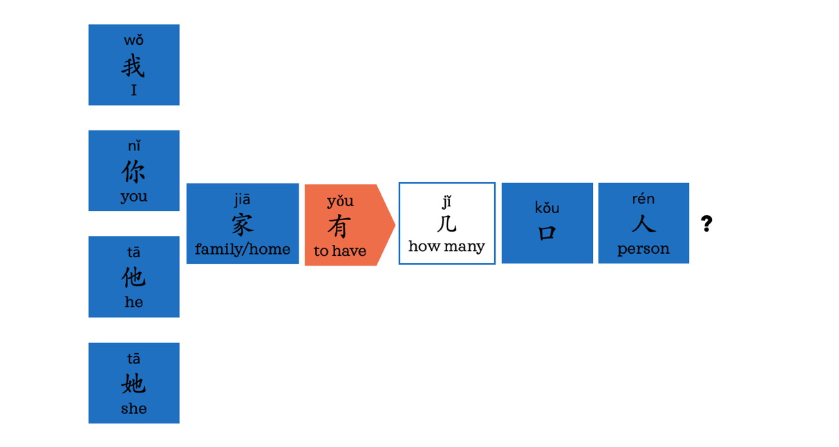
sentence builder 1b
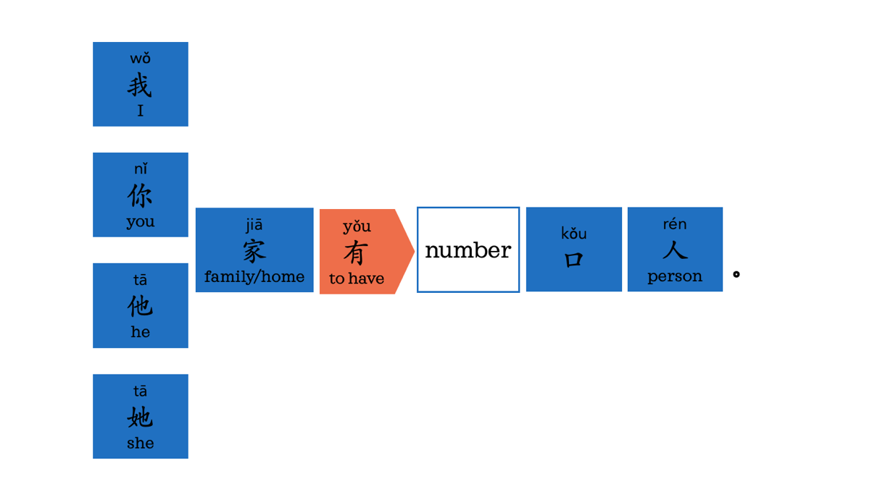

sentence builder 2a
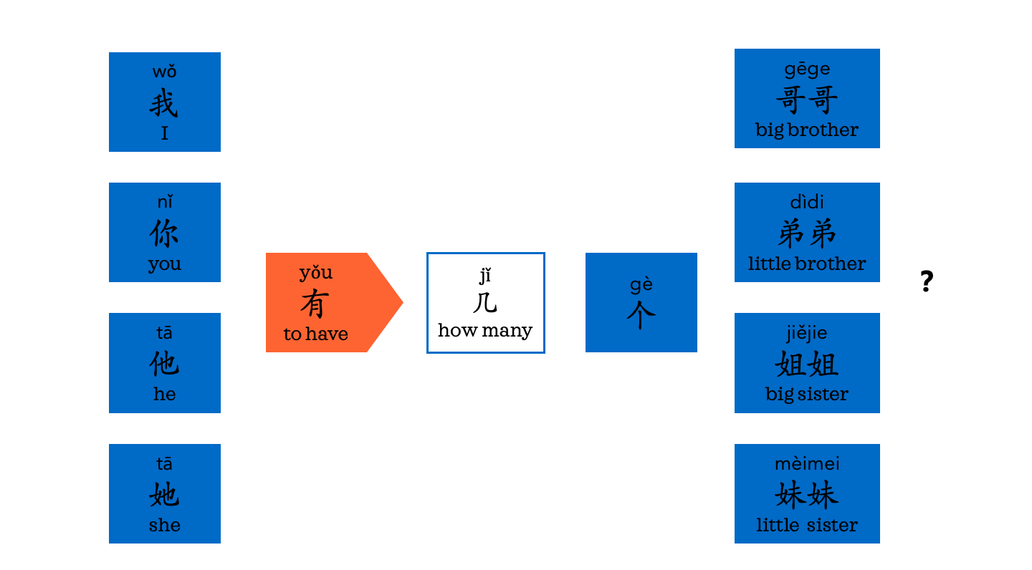
ge
个
Sentence builder 2b
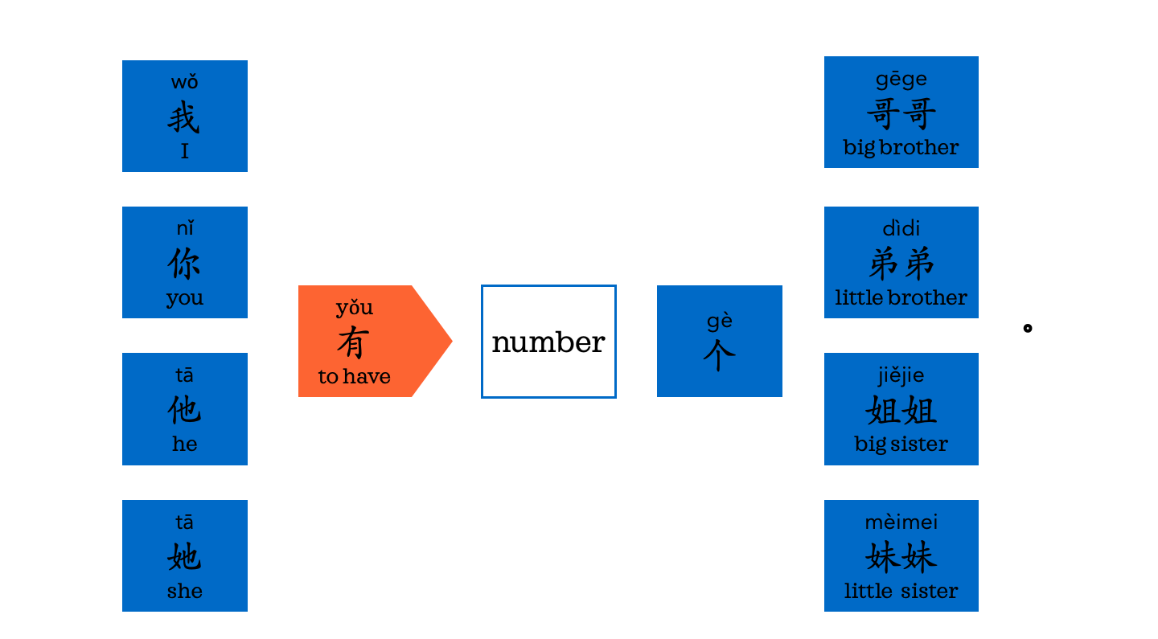
ge
个

Sentence builder 3


