k


Student name: | Ana Cunjuca | Student ID number: | 2511184
Programme: | CertHE Computing Skills for Workplace
Module: | Software Solutions for Business
Module Code: | ACCA4026
Lecturer: | Osman Elgawi
Assignment Title: | Component 1- Coursework: Portfolio

Table of Contents

Task 1: e-Commerce Website Builders / Software Solutions 1
Introduction to e-Commerce Website Builders 1
Shopify as a Modern e-Commerce Solution 1
Ecwid by Lightspeed as an Integrated Selling Platform 1
Task 2: Mind Mapping of Contemporary Software Applications 3
Understanding Mind Mapping in Business Contexts 3
Mind Map of Contemporary Software Applications Supporting Business Operations 3
Task 3: Office Applications for Creating, Storing, Presenting and Analysing Information/Data 5
Introduction 5
Office Software Solutions for Business Operations 5
Microsoft Word 5
Microsoft PowerPoint 7
Microsoft Excel 8
Microsoft Access 9
Test of Two Excel features Practically 10
VLOOKUP Function Practical Test Practical Test 10
Practical Test of Pivot Table 12
Conclusion 14
Task 4 – Communication and Collaboration Applications 15
Communication Application – WhatsApp 15
Introduction to WhatsApp 15
Key Features 15
Benefits for Business 16
Limitations 16
Collaboration Application – Microsoft Teams 16
Microsoft Teams Overview 17
Key Features 17
Benefits for Business 17
Limitations 18
References 19

List of Figures
Figure 1: Microsoft Word 6
Figure 2:Microsoft PowerPoint 7
Figure 3: Microsoft Excel 8
Figure 4: Microsoft Access 9
Figure 5: Data Setup for VLOOKUP 11
Figure 6: Entry of Formula and Final Result 11
Figure 7: Raw Data 12
Figure 8: Pivot Table Creation 13
Figure 9: Final Pivot Table 13
Figure 10: WhatsApp 15
Figure 11: Microsoft Teams 17

Task 1: e-Commerce Website Builders / Software Solutions

Introduction to e-Commerce Website Builders
E-commerce website builders are online tools enabling companies to design, administer and operate online stores without any extensive technical skills. An efficient e-commerce system needs to be developed with user interfaces, databases, transaction processing systems, and security measures to facilitate stable online business activities (Ullah, Alauddin and Zaman, 2016). The contemporary e-commerce developers make these technical demands less complicated by offering cloud-based, one-stop solutions to support business analytics, sales, and marketing. Such platforms improve the productivity levels in a workplace by automating transactions, simplifying communication with customers, and facilitating the process of making decisions based on data.

Shopify as a Modern e-Commerce Solution
Shopify is an internationally known online store that allows companies to create fully hosted online stores. It offers help in creating customisation, payment gateways, inventory and performance analytics in one ecosystem. The platform eliminates the existence of advanced knowledge of programming and enables businesses to focus on strategic expansion instead of technical care.
To illustrate a simulated workplace, a small fashion retailer can utilise Shopify to establish an online store and choose a pre-designed theme, add product descriptions and images, set up shipping options and use secure payment processing. The dashboard enables the managers to track the level of sales, customer behaviour, and stock in real time at Shopify. This leads to efficiency in the workflow by decreasing manual administrative services and automating the process of order confirmation, issuing invoices, and updating stocks. Moreover, email marketing and discount code among other integrated marketing tools, enhance customer engagement and communication. Strategic decision-making is aided by the possibility to analyze sales information and enhancing forecasting and financial planning.

Ecwid by Lightspeed as an Integrated Selling Platform
Ecwid is not similar to standalone site builders since it can be used to integrate with other existing websites and digital platforms. When used on websites created on the platforms like WordPress or Wix, Ecwid can be deeply integrated into the websites, which means that businesses can add the e-commerce functionality to their websites without having to reconstruct their websites. This is flexible enough to favour organisations with an online presence and wants to venture into online sales.
As part of a simulated consultancy business, Ecwid would be incorporated into a pre-existing corporate site to sell digital training content and event tickets. The system handles secure payments, digital downloads and order tracking automatically. It is also on social media and online market places where Ecwid also facilitates multi-channel selling and boosts market reach and organisational visibility. This integration brings advancement in communication as it centralises customer transactions and offers one sales management interface. Moreover, analytics tools enable the manager to gauge the performance of products and customer trends, which can be used to make decisions based on evidence.
Altogether, Shopify and Ecwid show how modern e-commerce software can boost organisational efficiency with the help of automation, integration, and data analytics, which is consistent with the systematic development principles developed by Ullah, Alauddin and Zaman (2016).

Task 2: Mind Mapping of Contemporary Software Applications

Understanding Mind Mapping in Business Contexts
Mind mapping is the visual method that is applied to the organisation of ideas around central idea whereby related themes are extended out in a systematic manner. It encourages non-linear thinking and makes one see the connections between ideas more clearly. Studies posit that mind mapping enhances a better understanding, imagination and memorisation of information since the mind mapping resembles the associative thinking of the brain (Kustian, 2021). The method is assisted in educational and professional settings that allow structuring the analysis and conducting brainstorming (Buran and Filyukov, 2015).
Mind mapping can be used to improve planning, project management, and strategic analysis in business operations. Managers are able to use mind maps to visualise organisational structures, workflows or software ecosystems. This enhances interaction between teams since intricate systems are displayed in a simplified graphical manner. Further, mind mapping aids in decision making because the leader is able to see the relationship among the various operational fields like finance, marketing and customer management.

Mind Map of Contemporary Software Applications Supporting Business Operations
The grand idea of this mind map is the Business Operations. It is based on this central node that a number of major branches are the major functional areas that are facilitated by modern software. One of the branches is communication tools, which include Microsoft Teams and Zoom. These systems help in collaboration among employees within a company, meetings over a distance, and instant messaging to enhance the coordination of workflow and lessen delays in communication. The other branch is concerned with project management software like the Trello and Asana. The applications allow assigning tasks, tracking deadlines, and monitoring performance, making them more accountable and making their operations more transparent. Another branch emphasizes financial management tools such as QuickBooks which automates invoicing, payroll, and financial reporting. This enhances precision and compliance to financial regulations. Another key branch is customer relationship management systems like Salesforce. CRM systems consolidate customer information, promote marketing harmonisation, and promote service provision, which helps to build improved customer relationships.

Finally, the data analytics tools such as Microsoft Power BI are used in decision making by transforming raw data into visual reports and dashboards. Managers can compare trends, monitor performance indicators and make good strategic decisions. Digital mind-mapping software may help a business manager draw the following mind map as a visual representation of how these systems interact in a simulated application. As an illustration, CRM data can become the input of analytics software, and communication tools will facilitate coordination in project management. This interdependency facilitates organisational insight, boosts efficiency in the working process, and facilitates strategic planning, which is compatible with the cognitive and collaborative advantages revealed by Kustian (2021) and Buran and Filyukov (2015).

Task 3: Office Applications for Creating, Storing, Presenting and Analysing Information/Data

Introduction
Office applications are computer programs that are created to support the creation, maintenance, and exchange of electronic data in business and personal fields. These applications offer critical applications used in creation of text documents, presentations, spreadsheets and databases that enable organisations to streamline operations, improve productivity and keep accurate records. Wilson (2016) explains that Microsoft Office 365 includes a package of interconnected applications that are used in various business operations, allowing users to carry out various activities in a single digital platform. The role of digital office tools in business is overestimated. They enable the workers to standardise their documentation, automate their calculations, visualise data and store information in a secure manner. These tools also facilitate cross-team work, minimize the number of manual mistakes, and speed up the process of decision-making. The given report is devoted to four popular office packages Microsoft Word, Microsoft PowerPoint, Microsoft Excel, and Microsoft Access. Microsoft Word is a word-processing software that is mainly applied to write professional papers. The creation of visually interactive presentations can be done using Microsoft PowerPoint. Microsoft Excel is an Excel spreadsheet that is used in data analysis, calculations, and reporting. Microsoft Access is a database management system which assist in storing and retrieving data in a structured manner efficiently.

Office Software Solutions for Business Operations

Microsoft Word
Microsoft word is a complete word-processing application that is commonly used in business, education and administration where it is used to create, edit, and format textual documents. It offers a wide range of tools that enable users to make professional reports, memos, letters, contracts, and official correspondence. As pointed out by Rahmah et al. (2024), one of the most common areas where the Microsoft word is used is in the mining or manufacturing industry to maintain records, create reports, and adhere to organisational standards. The fact that it can be integrated with all other Microsoft Office applications has added more relevancy to its use in business operations because it smoothes out workflow in terms of data importation and document sharing.

Figure 1: Microsoft Word
Source: Author
Microsoft word has its key features, which are advanced formatting options that regulate font outlay, paragraph separation, title page, and footpage, and alignment of the document. The templates and themes make sure that there is consistency and time saved in the process of creating multiple documents. The Mail Merge helps in automating the process of creating individualised letters, invoices and reports using data that are obtained in external formats like Excel spreadsheets. Track Changes can be used to work with other people by letting the users propose changes and get a list of the changes. Table and charts, referencing tools, and insertion of images enable a user to arrange and present information in the best format (Sugiyanto and Pinandita, 2025).
The advantages of Microsoft Word to business are that it provides a good presentation of documents, is more productive due to automation and has a great deal of collaboration in the editing part. Nonetheless, the software does not lack limits. It is not suitable to complex numerical analysis, does not offer any database management facilities and can be subject to formatting inconsistencies when documents are shared between different platforms or versions. Irrespective of these shortcomings, Word is a crucial part of keeping the accurate and professional records in any business environment.

Microsoft PowerPoint
Microsoft PowerPoint is an effective presentation software that enables a user to convey ideas in a manner that is easy to understand. It is common in business conferences, sales presentations, educations and in educational institutions. The application gives a platform to present complex information in a well structured and interactive format. According to Hasanah et al. (2025), PowerPoint is an important element in conveying knowledge and corporate communication because it helps to integrate text and images with other interactive features, which increase learning results and understanding. PowerPoint can also be used with other Microsoft Office applications; hence, it is easy to incorporate data and graphics in PowerPoint with the use of Excel or Word.
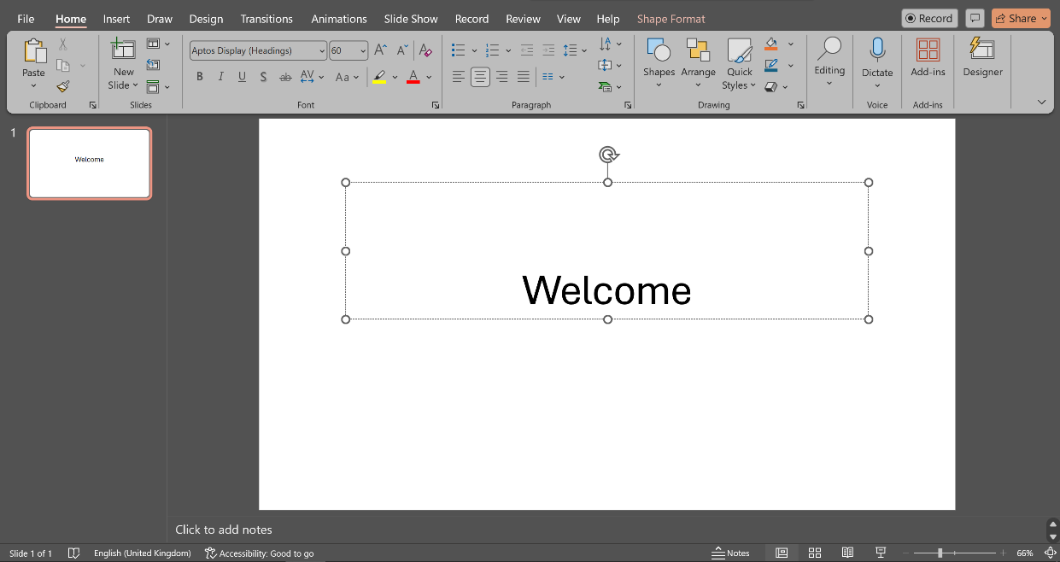
Figure 2:Microsoft PowerPoint
Source: Author
The most important features of PowerPoint are slide layouts, templates and themes which standardize presentation design. The visual content is improved with animation and transition, and the graphic material of SmartArt, charts, and tables helps to visualize the data in a clear manner. Images, videos and audio can be embedded using multimedia support which makes presentations more interactive. The Presenter View option helps a speaker to refer to notes and follow time during the presentation so that the delivery can be smooth and professional (Shodiyevich, 2025).
The advantages of Microsoft power point in business are that it enables easy and well organised communication, enhanced interaction with the audience and that it aids in corporate branding by offering customised templates. It reduces complicated ideas through graphics and facilitates training and learning processes in organisations. Nonetheless, excessive use of slides may distract the viewers, and unsuccessful decisions in design can decrease the efficiency of the communication. The data analysis of PowerPoint is also limited and it has to be combined with other tools like excel in order to perform more analytical work. In general, PowerPoint is an essential tool to present the information in a business-like and attractive way.

Microsoft Excel
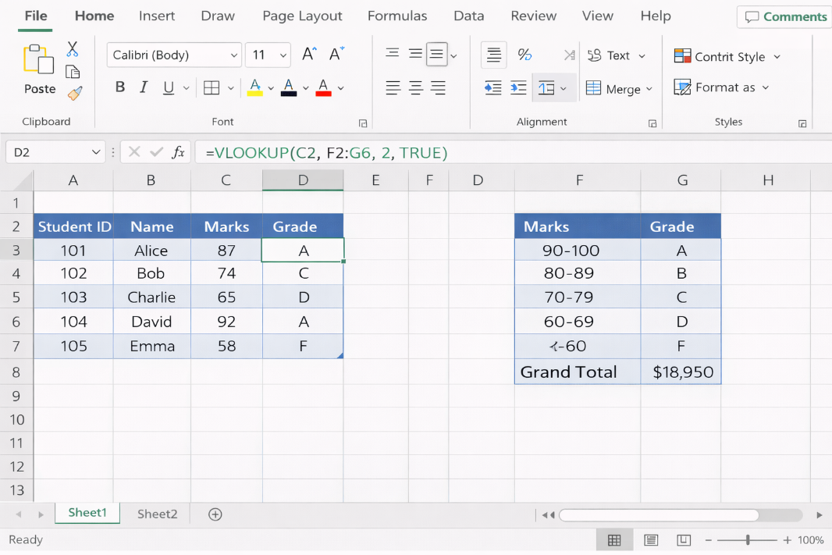
Figure 3: Microsoft Excel
Source: Author
Microsoft Excel is a general spreadsheet software that helps business to arrange, compute, examine, and illustrate data effectively. It finds extensive application in finance, accounting, inventory management, project tracking and business analytics. As per Al Maruf et al. (2022), Excel is essential in informed decision-making because it enables the analysts to handle massive data, calculate intricate information, and produce insights that can be used to plan their strategies. Its connection with other Microsoft office solutions enables transfer of data between applications with ease thereby facilitating efficiency in operations.
The significant elements of Excel are that it has a variety of formulas and functions that perform calculations automatically and minimize errors, including IF, SUM, AVERAGE, and VLOOKUP. Pivot tables enable users to summarize, filter and analyze large volumes of data in a short period of time, and charts and graphs help users obtain a visual representation of trends and patterns. Conditional formatting draws important data items, sorting and filtering features allow only users to manage the data and analyze it efficiently. Excel is also capable of data validation and macro to enable the automation of repetitive processes, which enhances accuracy and efficiency in any business process.
The Excel advantages are that it has increased productivity, more accurate, and makes decisions based on the analysis of the data. It facilitates the financial modelling, reporting, and scenario analysis and hence it cannot be done without in the business planning. Its drawbacks are its complexity to novice users, the possible error of formulas on its results, and limits with very huge datasets. In spite of this, Excel is still a fundamental tool of analytic and reporting in the business domain as it offers a balance between accessibility and functionality.

Microsoft Access
Microsoft Access is a database management system that is a relational database management system to store, arrange and retrieve structured business data in an efficient manner. Small to medium sized businesses mostly use it to control inventory, payroll, customer information, and operational history. According to Jamaluddin et al. (2024), with the help of Access, business functions are optimised, and organisations can store the most accurate possible data and create detailed reports. It can be easily exported to Excel and word, therefore making it easy to report and further analyze the data.
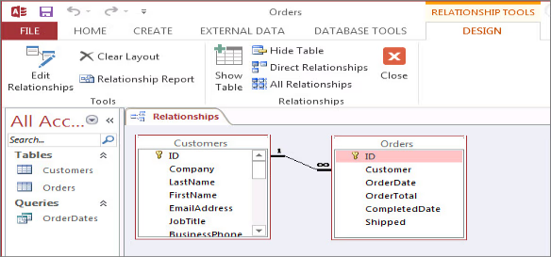
Figure 4: Microsoft Access
Source: Jamaluddin et al. (2024)
The key characteristics of access are the structured data storage tables, queries to retrieve a particular information, user friendly data input in forms, and summarisation and presentation of information through reports. Table relationships provide data integrity and reduce redundancy. The business data can be analysed and complex queries can be constructed by users, as well as, automated business reports can be generated and multi-user access can be used to manage data collectively. The macros and VBA programming also enable custom automation to boost operational efficiency with the help of Access.
The advantages of Access are that it provides a better organisation of data, a central repository of the data, data integrity, and generation of a detailed and accurate report. It minimizes the number of mistakes made manually and enables teamwork among multiple individuals, where teams will have access to and be able to update information at the same time. This has weaknesses such as a steeper learning curve than excel, scalability to enterprise level systems and the requirement of database design skills to make the most out of the product. Nevertheless, regardless of these shortcomings, Access is a helpful app to organized data management in a small and medium enterprise.

Test of Two Excel features Practically

VLOOKUP Function Practical Test Practical Test
VLOOKUP is a dynamic function in Microsoft excel that is utilized to seek a particular value within the first column of a table and gives a corresponding value within another column. It is also popular in business to automate the process of data retrieval, minimize the number of manual errors and maximize efficiency of reporting and decision-making. Mwangi (2023) states that VLOOKUP with the help of the Power Query and Excel functions will enable users to browse complicated data, do precise lookups, and maximise productivity.
This practical activity involves creation of a student marks dataset where columns were created, which included Student ID, Name, and Marks. A secondary table had to be made that chronicled the numerical marks to letter grades. The VLOOKUP formula = VLOOKUP(C2, F2:G6, 2,TRUE) was used in the Grade column. In this case, C2 is the look-up value which represents the marks of a student, F2:G6 is the reference table, which contains grade limit, 2 is the second column of the table that will be used to get the result and TRUE is to indicate an approximate match.
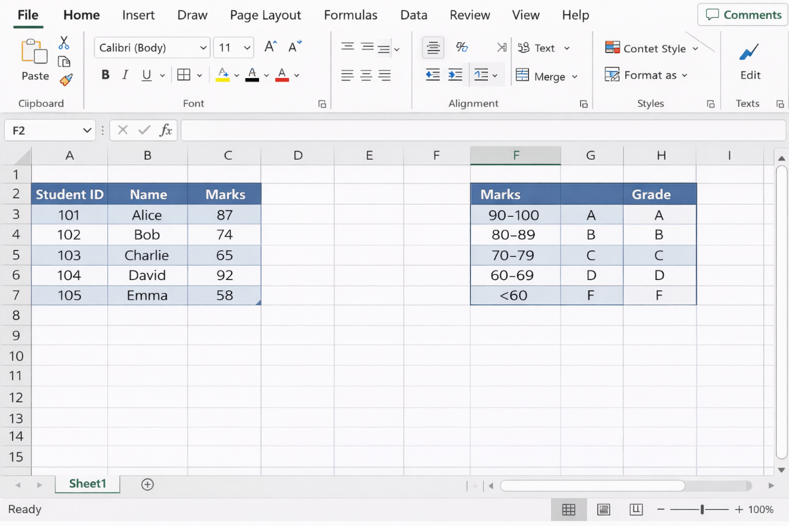
Figure 5: Data Setup for VLOOKUP
Source: Author
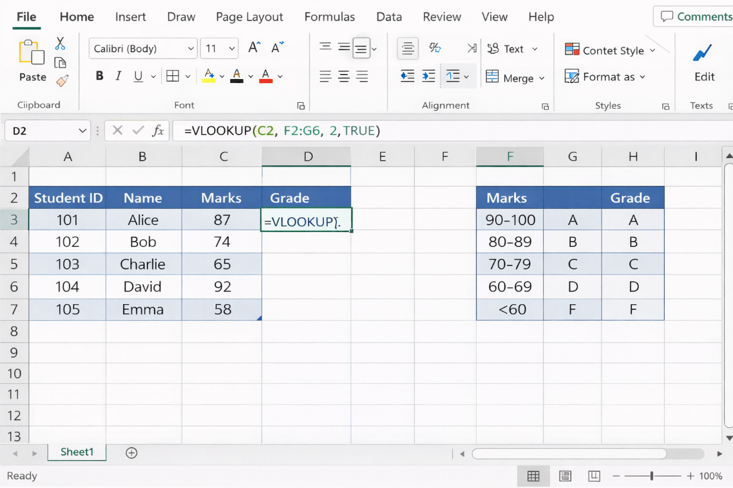
Figure 6: Entry of Formula and Final Result
Source: Author
The result proves that the grades of all the students were computed automatically on the basis of their marks. This automation saves time and lessens the level of human error in comparison to the manual grading. It is also a clear indication of the use of VLOOKUP in actual business and teaching situations, whereby similar tables are employed in the performance evaluation, payroll categorisation, and management of customer data. According to Chapke and Chandankhede (2024), VLOOKUP automation enhances efficiency in operations and allows making the right choices based on data.

Practical Test of Pivot Table
Pivot Table Pivot Table is a data summarisation tool that enables the user to analyse massive data fast and readily in Microsoft Excel. Pivot Tables allow one to aggregate the data, filter and sort the information in a way that creates meaningful summaries to make business decisions. Selwyn (2022) emphasises that Pivot Tables offer an effective method of visualising trends and patterns in the data to assist an efficient reporting and analysis within an organisation.
In this practical exercise, a sales data was developed containing the columns as follows; Date, Salesperson, Region, Product, and Sales Amount. Pivot Table was prepared to analyze the data to enable calculation of the total sales per region. The data was then selected using the Insert - PivotTable functionality and the Pivot Table was inserted to a new worksheet.
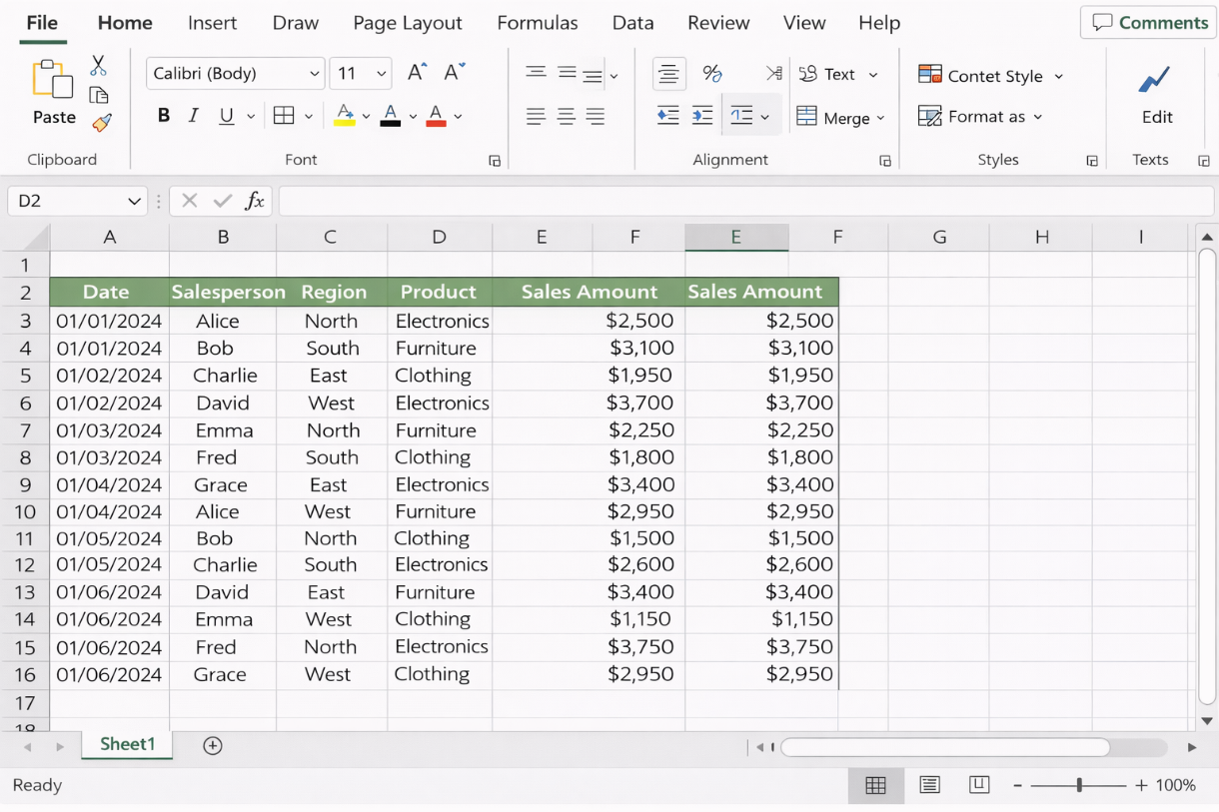
Figure 7: Raw Data
Source: Author

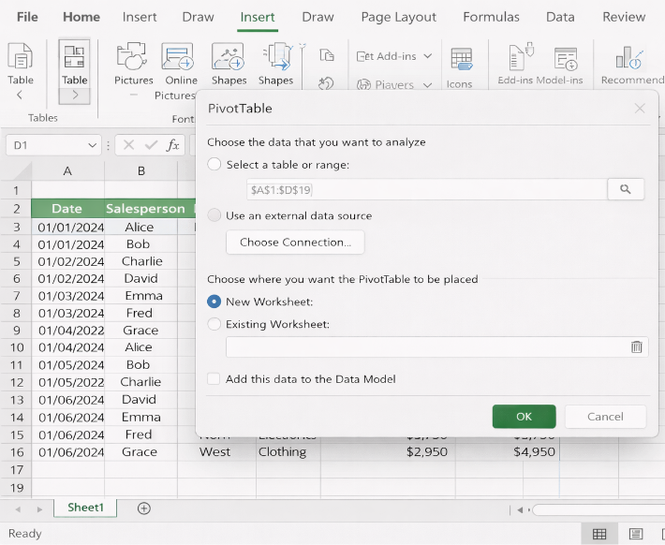
Figure 8: Pivot Table Creation
Source: Author

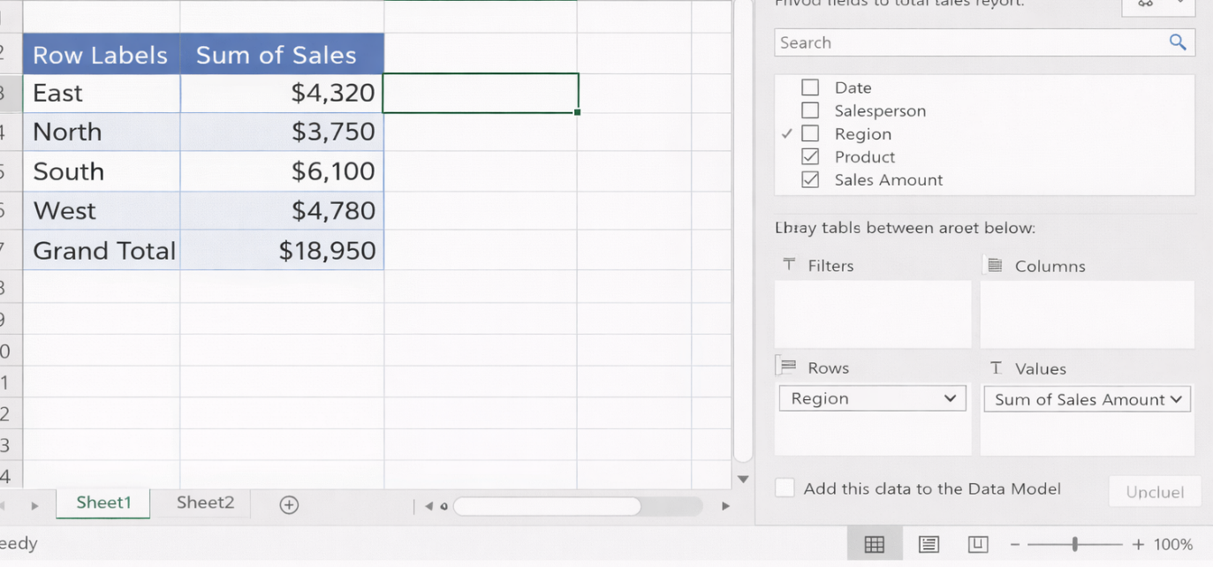
Figure 9: Final Pivot Table
Source: Author
The resulting Pivot Table summarised the total sales in each region with precision, which has indicated that Excel has the potential of converting raw data into something which can be acted upon. This enables businesses to monitor performance and recognize areas of high performance as well as make a strategic decision. Pivot Tables are thereby quite useful to managers who need to analyze a large amount of data quickly without having to manually sum up numbers or write numerous equations.

Conclusion
Finally, Microsoft Word, power point, excel and access offer the necessary facilities of creating, storing, presenting and analysing business information. Word, PowerPoint contribute to improving the professional communication and presentation, and also Excel and Access allow to analyze the data and organize the information in a structured manner. The real-world application of the Excel functionality such as VLOOKUP and Pivot Tables proved automation, accuracy and effective summarisation of complex data. All the applications are used to enhance productivity, aid in making decisions based on data, and assist organisations to be accurate and consistent in their activities. Office software has not lost its place in the lives of the modern businesses that need efficiency and reliability.

Task 4 – Communication and Collaboration Applications

Communication Application – WhatsApp

Figure 10: WhatsApp
Source: Author

Introduction to WhatsApp
WhatsApp is a modern communication technology that has to a large extent been embraced in the present day business world to support instant messaging, group conversations and notification. It works on both mobile and desktop platforms making sure that employees can be in touch anywhere around the world. Yankah et al. (2023) state that WhatsApp helps to improve the work of team members, who are able to interact in real time with the help of the convenient interface. According to Hussein et al. (2022), the technology is easy to use and cross-platforms, which are why the technology is a favorite of small and large organizations, especially in cooperation with remote teams.

Key Features
WhatsApp has a variety of features that facilitate in the effective communicative process. The major characteristics of WhatsApp are text messages and voice messaging that assist in effective communication, video calls that aid in having a face-to-face discussion, group message and broadcasting that aids in making announcements or communicating media-related messages, and the ability to share files including images, videos, documents, and PDFs that makes the application the most suitable to use when sending a report or communicating about a specific media related issue. Status updates assist businesses to make significant announcements or updates to all the contacts in an effective way. End-to-end encryption assists in the process of securing all communication making business information sensitive. In the case of medium and large-sized businesses, the WhatsApp Business API allows the integration with the customer service applications, which has assisted in having automated responses, chatbots, and CRM integration (Hussein et al., 2022).

Benefits for Business
Fast communication and high response time are the most significant benefits of using WhatsApp as a business tool. The distance work and global cooperation is aided by WhatsApp, and it assists the employees to organize the work effectively regardless of where they are located globally. WhatsApp is a cheap communication tool as compared to SMS and phone calls. WhatsApp is also useful in conveying a message to clients and stakeholders with the help of quick replies, broadcasts, and sharing of media. WhatsApp has security features that facilitate business information not to be hacked, and features of group communication help to coordinate tasks well among team members (Hussein et al., 2022).

Limitations
WhatsApp also has some limitations when used for business purposes. The transfer of files is limited in size, which makes it difficult for the transfer of large documents. Security is only as good as the security of the device. Moreover, it is not used for document collaboration or project management.

Collaboration Application – Microsoft Teams
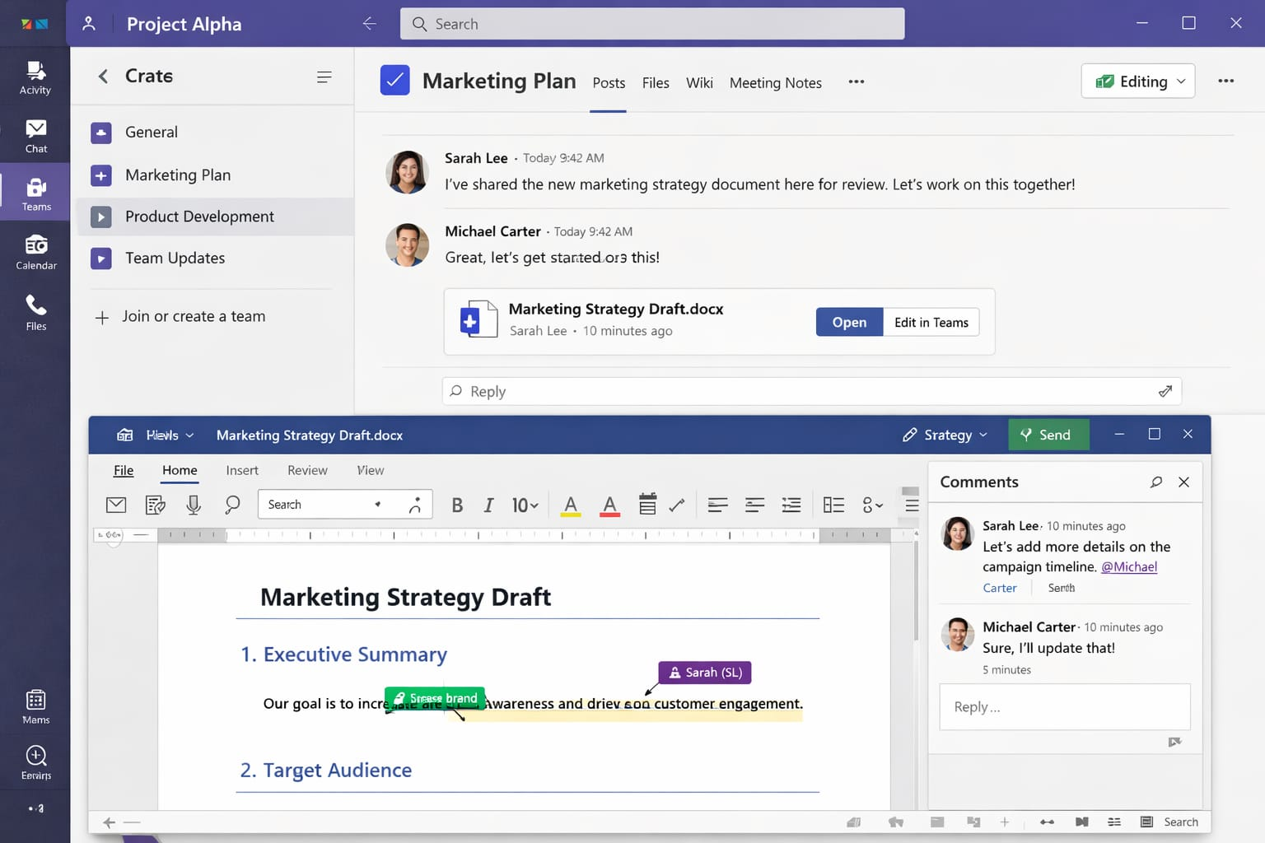
Figure 11: Microsoft Teams
Source: Author

Microsoft Teams Overview
Microsoft Teams is an emerging web-based collaboration tool that aims at improving business productivity through the provision of real-time communication, collaboration of documents and managing tasks. The solution will be integrated with Microsoft Office 365 that will enable users to work on Word, Excel, and PowerPoint documents in real-time right within the solution. Microsoft Teams is available on the desktop and mobile platforms, and this means every employee can work and interact with others regardless of their locations. As stated by Ilag and Sabale (2022), Microsoft Teams provide a centralized way of communication thanks to the combination of chat, video conferences, and files storage in the same interface. According to Wang et al. (2025), Microsoft Teams provides smooth project collaboration, as the use of email does not exist, and the collaboration within the document is also available along with task and workflow management functionality.

Key Features
Microsoft Teams has several features that are essential for collaboration on a business level. Chat channels allow teams to engage in conversations in an organized way, while direct messaging allows teams to engage in private conversations. File storage and sharing allow teams to collaborate on documents, with the capability of not overwriting each other’s work. Microsoft Teams has integration with Word, Excel, and PowerPoint, which allows real-time co-authoring and automatic updating of the team. Video and audio conferencing allow teams to hold meetings, train employees remotely, and make presentations. Task and project management is made possible through integration with Planner, which allows the assignment of tasks, management of deadlines, and tracking of progress. Notifications, mentions, and tags allow team members to be notified and held accountable in the team (Khidir et al., 2022).

Benefits for Business
Teams also promotes productivity through centralisation of communication and documents which minimise the overload of emails. Remote and hybrid teams have the advantage of collaborating immediately, having video conferencing, and added task monitoring. It enhances visibility of the project, accountability and workflow control that facilitate quicker decision making. The co-authoring capabilities avoid version conflicts and notifications and tagging assist in prioritising tasks. Rajaram et al. (2022) note that Teams facilitates an organised team activity, simplifies the functioning of a team, and boosts the overall organisational performance, which means that it is a key business tool that current businesses cannot afford to ignore.

Limitations
There are several channels and notifications that make teams overwhelming. It would need a steady internet connection to be used on the real-time functionality. The only limitation is that a new user would need to have a learning curve to get to the full functioning of the system, and too much creation of a channel can cause overload of information just in case not managed properly.

References
Al Maruf, A., Paul, R., Imam, M.H. and Babar, Z., 2022. A Systematic Review of The Role Of SQL And Excel In Data-Driven Business Decision-Making For Aspiring Analysts. American Journal of Scholarly Research and Innovation, 1(01), pp.249-269.
Buran, A. and Filyukov, A., 2015. Mind mapping technique in language learning. Procedia – Social and Behavioral Sciences, 206, pp.215–218.
Chapke, D. and Chandankhede, P., 2024. Maximizing Data Management Efficiency: Utilizing VBA Macros and VLOOKUP Automation in Excel. Grenze International Journal of Engineering & Technology (GIJET), 10.
Ecwid by Lightspeed, 2024. E-commerce solutions for small businesses. Available at: https://www.ecwid.com
Hasanah, M., Rahmatullah, M. and Fazrin, M., 2025. The Influence of Using Microsoft PowerPoint Learning Media on Learning Outcomes in Business Law Courses. Tepian, 5(1), p.568761.
Hussein, N.H., Yaw, C.T., Koh, S.P., Tiong, S.K. and Chong, K.H., 2022. A comprehensive survey on vehicular networking: Communications, applications, challenges, and upcoming research directions. Ieee Access, 10, pp.86127-86180.
Ilag, B.N. and Sabale, A.M., 2022. Microsoft Teams overview. In: Troubleshooting Microsoft Teams: Enlisting the Right Approach and Tools in Teams for Mapping and Troubleshooting Issues, pp.17-74. Berkeley, CA: Apress.
Jamaluddin, J., Pratiwi, A.D. and Arhas, S.H., 2024. Effectiveness of Using Payroll Application with Microsoft Access. Pinisi Journal of Education and Management, pp.10-18.
Khidir, M.L.B.M., Sa’ari, S.N.B. and Mohammad, A.S.B., 2022. Effectiveness of online learning with Microsoft Team applications in Polimas. EPRA International Journal of Environmental Economics, Commerce and Educational Management, 9(5), pp.29-33.
Kustian, N.G., 2021. Penggunaan metode mind mapping dalam meningkatkan hasil belajar siswa. ACADEMIA: Jurnal Inovasi Riset Akademik, 1(1), pp.30–37.
Mwangi, C., 2023. Ultimate Excel with Power Query and ChatGPT: Master MS Excel's Dynamic Lookup Functions, Generative AI, and Power Query to Navigate Data, Solve Complex Tasks and Optimize Productivity. Orange Education Pvt Limited.
Rahmah, N.F., Faisal, M.I., Hikmah, N., Saputra, A., Fajri, M. and Arham, M., 2024. The Utilization of Microsoft Word and Excel in Mining Business. SMARTLOCK: Jurnal Sains dan Teknologi, 3(1), pp.1-5.
Rajaram, A., Olory, C., Leduc, V., Evaristo, G., Coté, K., Isenberg, J., Isenberg, J.S., Dai, D.L., Karamchandani, J., Chen, M.F. and Maedler-Kron, C., 2022. An integrated virtual pathology education platform developed using Microsoft Power Apps and Microsoft Teams. Journal of Pathology Informatics, 13, p.100117.
Selwyn, N., 2022. ‘Just playing around with Excel and pivot tables’-the realities of data-driven schooling. Research Papers in Education, 37(1), pp.95-114.
Shodiyevich, R.S., 2025. Microsoft Power Point in the Field of Tourism Place. TA’LIM, TARBIYA VA INNOVATSIYALAR JURNALI, 1(2), pp.59-62.
Shopify, 2024. E-commerce website builder and online store platform. Available at: https://www.shopify.com
Sugiyanto, S. and Pinandita, T., 2025. Pelatihan Pembuatan Laporan Keuangan di Microsoft Word Bagi Mitra UMKM Pemula: Training on Creation of Financial Reports in Microsoft Word for Beginner UMKM Partners. Jurnal Pengabdian Kepada Masyarakat (JUDIKA), 6(1), pp.21-25.
Ullah, S.E., Alauddin, T. and Zaman, H.U., 2016. Developing an E-commerce website. In: 2016 International Conference on Microelectronics, Computing and Communications (MicroCom). IEEE, pp.1–4.
Wang, F., Zhang, Z., Zhang, X., Wu, Z., Mo, T., Lu, Q., Wang, W., Li, R., Xu, J., Tang, X. and He, Q., 2025. A comprehensive survey of small language models in the era of large language models: Techniques, enhancements, applications, collaboration with LLMs, and trustworthiness. ACM Transactions on Intelligent Systems and Technology, 16(6), pp.1-87.
Wilson, K., 2016. Microsoft Office 365. In: Using Office 365: With Windows 8, pp.1-14. Berkeley, CA: Apress.
Yankah, J.E., Adjei, K.O., Bonney, S.O., Kotey, S. and Tieru, C.K., 2023. Appraisal of mobile apps for communication and collaboration among construction project teams. African Journal of Applied Research, 9(2), pp.144-170.

