Defining the events and festivals industries
event and festivals in context
Chloe-may Southway (1802257)
2018

(Bowden et al 2006) “Each year, events occur throughout the United Kingdom. They dominated the media, fill transport system, hotel and venues meet business objectives, motive, committees and create a positive and negative impact”. The events sector is on an increase over the years with over 85million event attendees over a numerous of events such as corporate, festival and cultural, music and sporting events. (BVEP, 2018) “The British events sector is valued around £39.1 billion with conference and meetings generating the most with £19.9 Billion and outdoor and what is the event sector festivals and culture events generating £1.1 billion”. This essay will discuss how the events sector has helped private, not for profit and public organisations and also what and how people are motivations to the attend the events. The essay will also include a background on the event sector and how the sector has been categorised into scale and type.

Events are often the result of tragedy, celebration or to connect with others for a common cause such as charitable runs, festival and sporting events. As technology has advanced the way events are planned and hosted has changed. Event has been happening for decades with the first known event planner Cleopatra holding extravagant and lavish meetings to meet her companions with one meeting Cleopatra entered by sailing down the river Nile on a boat filled with candles. Cultural festivals have also been a part of the event history by gathering the community to celebrate is culture such as the Eisteddfod dating back to the late sixth century. After the industrial revolution the need for meetings and events expanded beyond parties for the rich and Royal. The industrial revolution increased businesses it was more of a must to hold meetings and events in order to collaborate and make new contacts in order for the business’s to succeed. Sporting events play a part of the history of the event with the first televised event being the Olympics in 1936 in Berlin.

Since the economic down turn in 2008 there is a huge demand and motivation for events with less people spending money on houses, holidays etc. and more people spending money for events. The range of motives impacts upon event attendance have been split in to four categories by (McDonnell et al (1999) “social motives, organisational motives, physiological motives and personal motives” Social motives include creation of community spirit and status or recognition of achievement an example of this is Cancer research reindeer run in Cardiff where the community and wales participants have a since of community spirit but also a recognition of achievement by getting a medal at the end of the run. Organisation motives are the need to make sales and sponsorship or community spirit for example Cancer research Reindeer run in Cardiff is held in order to raise awareness. The physiological motives is to eat, drink or be entertained and exercise or physical challenge such as Abergavenny food festival. Personal motives include seeking new experience, learning and educating and the fulfilment of an ambition an example of this is going to an Abergavenny food festival because they are seeking new experiences. An event is based on motives of the attendees Burch (1969) States that “the personal motivational drives of individuals are modified and readdressed by their workmates, family or friends” event attendees are driven to an event by these motives and as event marketers they insure that these motives are reach so that the attendees don’t question their motives. The motivations of the attendees can impact on whether they go to an event it’s called the Push and Pull motives. Push motives include benefits of attending the events, the escape from everyday life and also the intrinsic, the pull factor is what’s making the decision so the alternatives such as leisure, social motives. Motivations have been categorised by (Raj,2009) “needs, motives, expectations of benefits , alternatives and constraints” with makes the decision making process for events the needs including, self-esteem , needs for others and physical. The motives including seeking or escaping, expectations of benefits past experience or communication. The alternatives, stay at home, other leisure choices, constraints , time and money ,knowledgement.

There is two main categories that events are split in which are size and type of event. Size of an event is split into local, hallmark, major and mega. Hallmark events are recurring event with a permanent destination an example of this Wimbledon, Sydney Chinese New Year and London fashion week. Hallmark events can impact on the destination for example Glastonbury in Somerset that was well-known for its mystic town now is the permanent destination for the famous music festival which put the town on the map with “the festivals capacity of 120,000 sold out in 25minutes in 2016” (consultancy.uk, 2018). The largest scale events by size and also by the amount of media coverage are named major events. London Marathon ,Coachella and Met Gala are good examples of major events. Major events can start as small events an example of this is ( Wiley , 2005) “The Super Bowl in 1967 had 30,000 tickets unsold” In 2018 The Super Bowl sold out the bank statement stadium with the capacity 75,000 but also had a 103.4million viewers watching at home. Local events are events planned by communities mainly for local’s entertainment, social and fun value. The local events are held in aid to bringing a community together or celebrate a local or communities achievements such as London Pride an event in aid to celebrate as a community gay rights. Local events are mainly created by volunteers of locals or from the community. Mega events are large events that impact economically and impact on the media (Getz, 2005) “the volume should exceed 1 million visits and capitally cost $500million” example of mega events are The Olympics, Commonwealth games and the Royal wedding these events can be one off events or events that reoccur. The Olympics 2012 in London impacted on the UK bringing economically “£28 billion of economic impact” (GOV, 2013) and a Media impact of “The Olympics Closing Ceremony was watched by a peak audience of 26.3m.” (BBC, 2016). Apart from size of the event, events also get split into type of events such as cooperate events, sporting event and Festival events. Festival events contribute to social and culture factors, Music events such as Glastonbury and Coachella have a wide target audience and is streamed to all parts of the world with huge artists such as The Rolling Stones and Beyoncé headlining the events These events impact socially with the event attendees camping for 3night+ making new friends and also getting to meet up with old friends with the same interest as them. Sporting Events are competitions held by teams or individual athletes, example of these events are The Olympics, Rugby World Cup and Fifa world cup. Wales are known for its love of rugby and events such as The autumn internationals and the six Nations selling out months in advance an example of this is Scotland vs Wales in the Principality stadium in 2016 in February being sold out by October, these events benefit the economy with small business of wales such as hotels and Pubs by screening the events and spectators from all around the world attending the matches.

The events sector is split into three sectors Private, not- for profit and Public sector. The not for profit sector is seen as events mainly produced by charities in aid to raise awareness for the subject an example of this sector is save the children that is a London based charity that help children in poverty thrive regardless of their background from places such as the UK and South Africa. This organisation holds event’s such as the Santa run on the 2nd of December which is the London’s largest Santa run the charities is funded by donations and by doing these events it helps got more donations. Not for profit sector events are also produced by communities with funding’s from the government. Public events are generated by the government, Sport Wales and Public spaces like National Trust. An example of a public sector event is Abergavenny food festival which is a two day event showcasing local products from local businesses this event is held by the council and in aid to attract people from all areas of the world to go and enjoy local products and visit the country and the small town. Public sector events are held in order to generate to the local economy and also publicity for the small towns or huge cities, According to (Abergavenny Food Festival, 2018) “Each year we attract more than 30,000 visitors to our small, Welsh town, with the Festival generating an estimated £4 million impact for the local economy.” The private sector events are held in order to get profit for the business such as media, entrepreneurs or companies and corporate organisations these companies do this type of events for promotion, product launches and coverage. An example of a business that does this is Victoria Beckham in order to promote a product launch the Victoria Beckham brand holds a fashion show. The brand hold fashion shows in London, Paris and New York. The Fashion shows raise huge media coverage with celebrities such as Ann Winter, Kate Moss along with Journalists all there to see the brands product launch. Another example of an private sector event is Concerts such as Spice Girls selling out their London leg of the tour in 38seconds this is an example of a private sector event because the event is profiting business’ such as Ticketmaster and sponsors of the stadium

During an event it is important to meet the needs of the stakeholders. Stakeholders includes attendees, local business’, media, shareholders and performers are a few on a huge list of stake holders. By engaging with stakeholders the more likely of the local community is to support the event.(Reid, 2006) categorized a range of event stakeholders by Primary and secondary. Primary including the likes of employees, volunteers and participant and secondary including government, general business, media and emergency services Reid based this on the perception of risk to the event. (Bowdin, 2006) “people and organisations with legitimate interest in the outcomes of the event “The stakeholders of the event play a huge part of an event without stakeholders the event doesn’t happen for example without the performers and audience Glastonbury wouldn’t be a successful event but also without including local business’ and support from the locals the event also doesn’t happen. Stakeholder become a sort of timberline weed situation without one stakeholder an event can’t happen. The engagement of stakeholders leads to an successful event but also helps towards making pre event decision to help towards the outcome of the event that will help to making a lasting change in the legacy. According to (Bowdin, 2006) image underneath all the stakeholders that makes an event successful gives something into the event in order to get something out of it for example the media promotes the event and after and during the event advertises the success
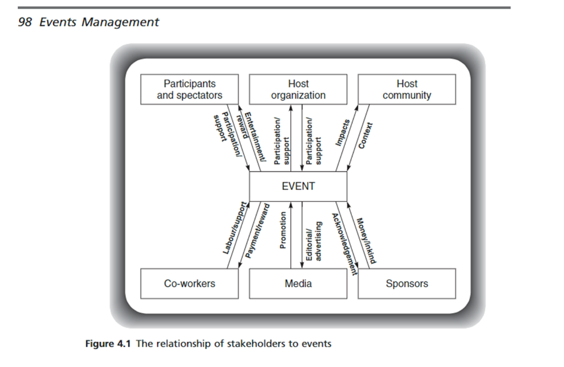

To conclude events is a part of history with milestone events happening everyday such as birthdays, funerals and cooperate .Events such as Festivals, Sporting and music events boosting the economy (Gov,2015) “ the creative economy now worth £79.9billion a year” with the events sector being £39.9 billion towards this. As we look through the essay the motives of an events being cultural and social with many more people going to the events for a since of community. Today events isn’t only impacting on the economy but also the destination such as Glastonbury bring people from all around the world to the town. We also have seen that stakeholders pay a huge role on an event if they don’t attend the event doesn’t happen and also impacting on the legacy left behind after the event such as Children in needs annual fundraising that is televised to over 8.3million raising £50,000 by the help of stakeholders.

Reference list

Abergavenny Food Festival. (2018). The Festival - Abergavenny Food Festival. [online] Available at: https://www.abergavennyfoodfestival.com/about-us/the-festival/ [Accessed 23 Nov. 2018].
Bbc.co.uk. (2018). BBC - London 2012 Olympics deliver record viewing figures for BBC - Media Centre. [online] Available at: https://www.bbc.co.uk/mediacentre/latestnews/2012/olympic-viewing-figs.html [Accessed 21 Nov. 2018].
Bowdin, G.A., McDonnell, I., Allen, J. and O'Toole, W., 2001. Events management. Oxford: Butterworth-Heinemann.
Bowdin, G.A., O'Toole, W.J. and Nelson, K.B., 2005. Towards an international event management body of knowledge (EMBOK). Event Management, 9(4),
Businessvisitsandeventspartnership.com. (2018). Britain for Events Report final. [online] Available at: http://www.businessvisitsandeventspartnership.com/epub/bfe/#/4/ [Accessed 23 Nov. 2018].
Getz,D 2005, Events management and event tourism , cognizant communication corporation, New York
GOV.UK. (2018). Creative Industries now worth £8.8 million an hour to UK economy. [online] Available at: https://www.gov.uk/government/news/creative-industries-now-worth-88-million-an-hour-to-uk-economy [Accessed 23 Nov. 2018].
GOV.UK. (2018). Olympic Games legacy boosts economy by billions. [online] Available at: https://www.gov.uk/government/news/olympic-games-legacy-boosts-economy-by-billions [Accessed 23 Nov. 2018].

