Site Investigation Case Study

Contents
1.0 Overview 3
1.1 General 3
1.2 Proposed Development 3
1.3 Scope of Works 3
2.0 The Site 4
2.1 Site Location and Description 4
2.2 Surrounding Land Use 4
3.0 Site History 5
6
4.0 Site Environmental risks 7
4.1 Geology 7
4.2 Groundwater Flooding 8
4.3 Sewer Flooding 8
4.2 Coastal Flooding 9
4.3 Potential Contamination 9
4.4 Utility Constraints 10
4.5 Effects of Trees 10
4.6 Structure Constraints 10
5.0 Risk Assessment 11
5.1 Risk Assessment Framework 11
6.0 Ground Conditions 11
6.1 Borehole Logs 11
7.0 Results and Interpretation 15
8.0 Applicable Codes and Building Regulations 15
9.0 Recommendations 15
References 17

Site Investigation Case Study

1.0 Overview

1.1 General
“A site investigation is generally carried out using the two following methods: a desktop study, involving a document search of pre-existing information and a site survey, involving firstly a walkover survey where reconnaissance of the site is undertaken, followed by the use of detailed subsoil investigation by means of trial pits and borehole records” (Chudley, 2011, p. 24).
The purpose of this preliminary desk study is to source relevant information regarding the proposed site to complete a report highlighting potential risks and provide recommendations for the brief/contents of a detailed site investigation to be carried out by a specialist consultant, while also stating the relevant building regulations and codes of practice.
The brief is to provide a preliminary desktop study based on a review of historical information, an initial analysis of that information, integration with the relevant Building Regulations and Codes of Practice and an initial proposal for the potential foundation required.
One of the outputs of the desk study will be an initial conceptual site assessment to satisfy the current best practice BS1017:2001+A2:2017 that will form the basis of the intrusive investigation works and follow the risk management framework provided in CLR II, Model Procedures for the Management of Land Contamination.

1.2 Proposed Development
The site is intended to be developed for both commercial and residential purposes and sits adjacent to an existing car park. The proposal is to construct a new, two storey, restaurant, and ice-cream parlour with manager’s accommodation on behalf of on behalf of City and County of Swansea and Marriot Hotels.

1.3 Scope of Works
The scope of works for this preliminary desktop study is restricted to:
- Review of historic maps/plans for this location
- Review of historic reports for this location
- Observations and recommendations for inclusion within the Brief
- Review of and comparison with relevant Building Regulations and Codes Practice
- Potential foundation design for the project

2.0 The Site

2.1 Site Location and Description
The site is located off Dunvant Place, Swansea, adjacent to and between Swansea County Hall and the Marriot Hotel. National Grid Reference of SS 65400, 92283.
The boundaries of the site are defined by existing commercial properties, with associated car parking and landscaped areas, to the North and Northwest. South of the site is immediate coastal foreshore and coastal path. Access to the site is gained from the north from the main Oystermouth Road (A4067).
The site has variable levels with the highest point an approximate elevation of 36ft above sea level and the lowest point being 29ft above sea level. There is a combination of concrete areas and grass banked areas within the site boundaries. There are also heavily vegetated areas to the North West of the site. As seen in figure one (Google, 2020).
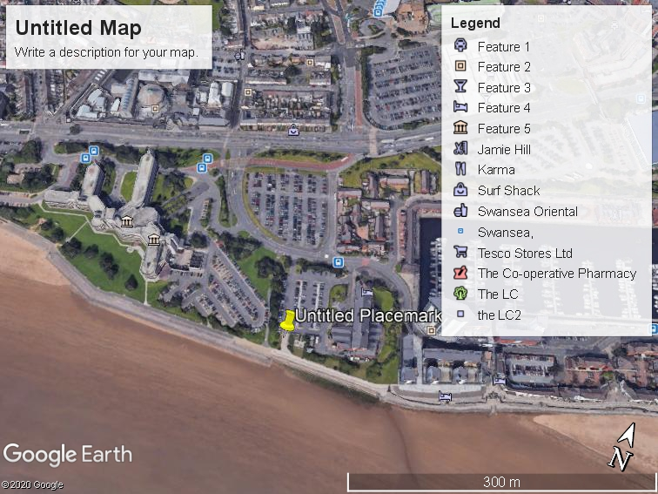

Figure 1.

2.2 Surrounding Land Use
The area surrounding the site is a mixture of commercial and domestic dwellings with varying low/high rise buildings. The site is near Swansea City Centre and the construction of a new high-rise building is to the North East of the site. A docks, marina, prison, and supermarket are all in close proximity to the site. The area surrounding the site is congested with a large amount of traffic.

3.0 Site History
The recent history of the site has been traced with the aid of historical maps which are listed below:
Historical maps:1970, 1910, 1950
Map Scale Dates: 1:1250, 1:2500, 1:1800 respectively
The earliest edition of the map dated 1870 indicates the site to be largely undeveloped. An old hospital sat to the west of the site with a traveling crane and timber yard to the north. Swansea (Victoria) station was opened to passengers in1867 (the nearby goods station was opened in 1866) by the Llanelly Railway (Coflein, 2009). Railway lines run off the main central line NPRN 291119 through the site that continued to the docks from west to east. See figure two. Progressing through the timeline between 1870 and 1890, evidence shows the construction of a timber yard to the north east and an engine shed constructed adjacent to the site.
Between 1890 and 1910 the timber yard was redeveloped into a canister works. Evidence on the map shows additional train tracks have also been introduced and an engine shed constructed during these years. Evidence also indicates that a mainline sewer runs through and adjacent to the site from north to south. See figure three.
Between 1910 and 1950 saw the construction of a wagon repair works situated within the parameters of the proposed site. The configuration of the of the buildings to the north of the site changed during these years with the addition of a small paint factory to the north of the site. See figure four.
The last historical map dated 1960 showed evidence of the removal or burial of all railway lines and engine sheds and wagon repair building.
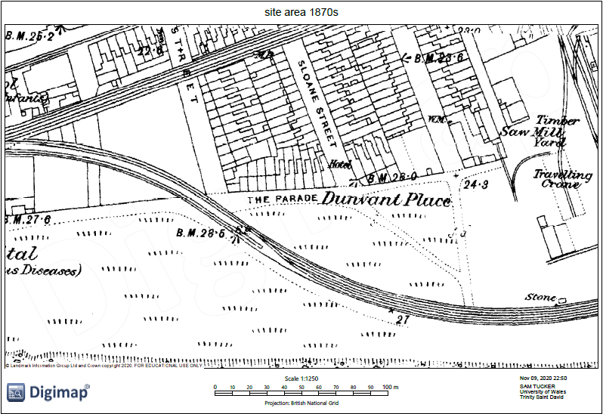

Figure 2. (Digimaps, 2020).

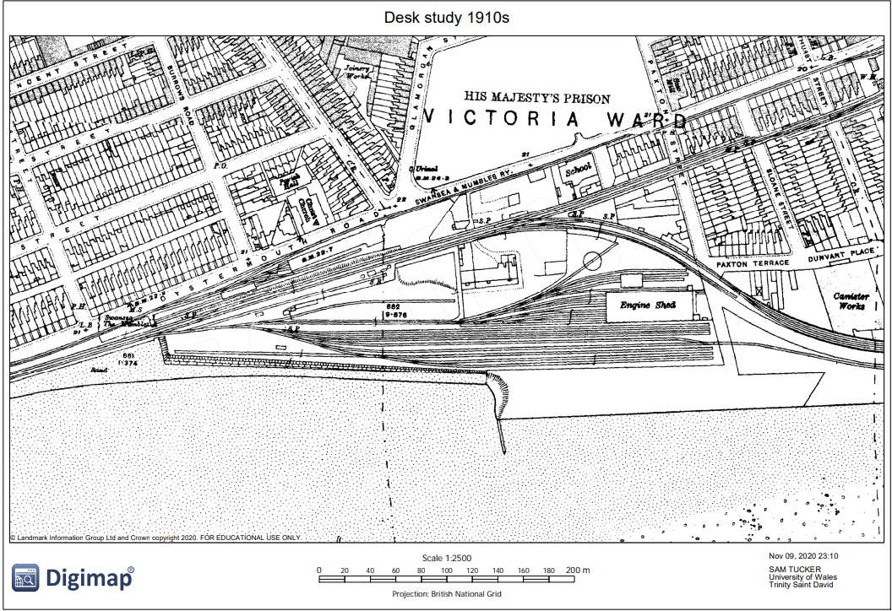

Figure 3. (Digimaps, 2020)
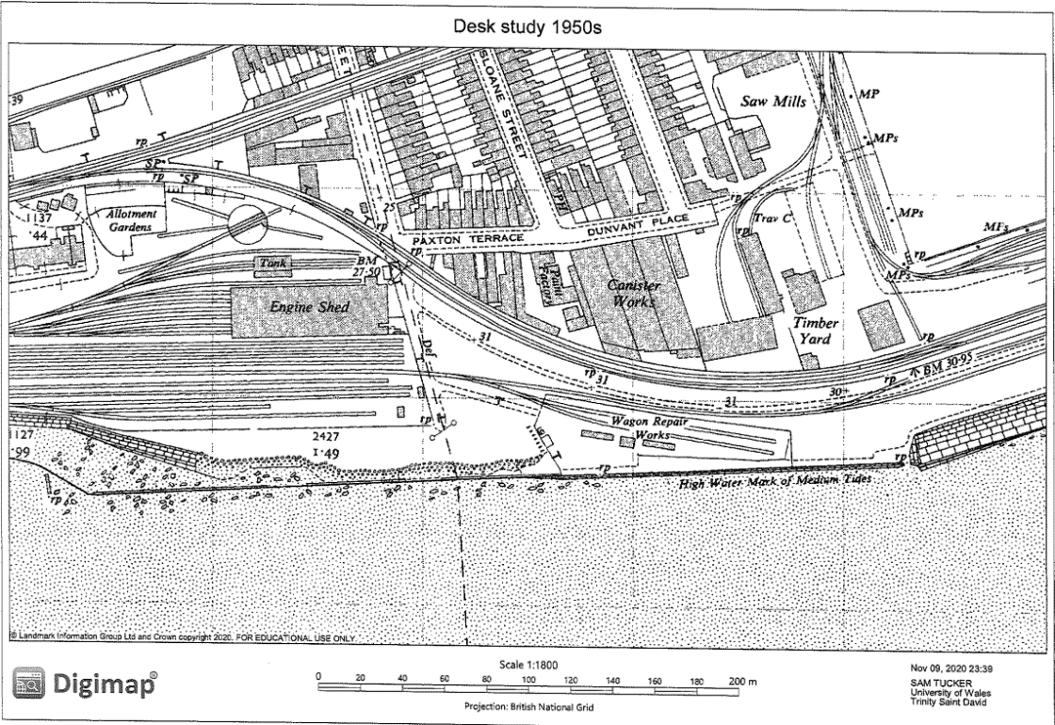

Figure 4. (Digimaps, 2020)

4.0 Site Environmental risks

4.1 Geology
Evidence from Geological Map Data BGS, 1:50,000 scale geological map of the area on 10/11/2020 , see figure five. described the ground conditions as being;
- Landscaped Ground (Undivided) - Unknown/ Unclassified Entry (LSGRUKNOWN) Made Ground (Undivided) - Artificial Deposit (MGRARTDP) Infilled Ground - Artificial Deposit (WMGR-ARTDP)
- Blown Sand – Sand (BSA-S)
- South Wales Middle Coal Measures Formation Mudstone, Siltstone and Sandstone (SWMCMMDSS)

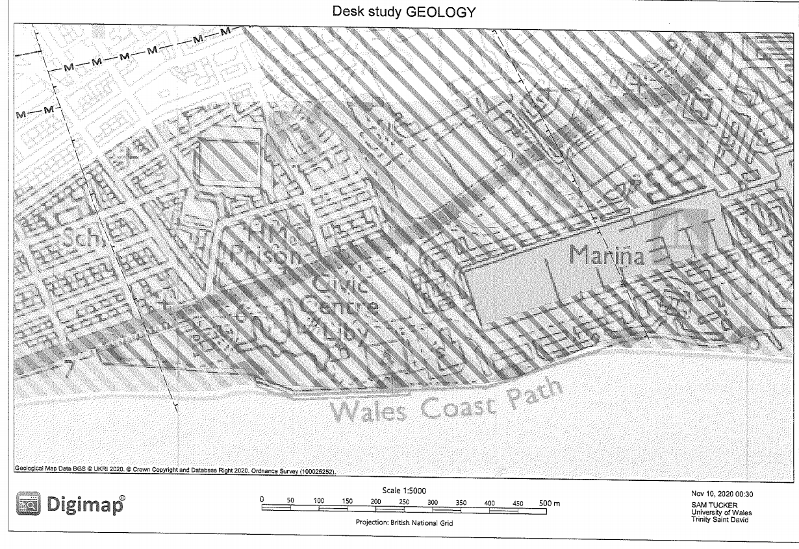
Figure 5. (Digimaps, 2020).

4.2 Groundwater Flooding
“Groundwater flooding occurs when the level of groundwater increases sufficiently so it rises above the level of the ground and causes flooding. It is often dependant on the underlying geology of an area and occurs following heavy rainfall. Groundwater flooding within the majority of South Wales is typically a greater risk in areas with significant coal mining. However, the majority of the former coal mining areas within the City and County of Swansea are believed to be fully recovered and therefore do not present a significant risk of flooding Historically, there are no records of any Groundwater Flooding in the City and County of Swansea in the vicinity of the site which can be considered to have significant consequences” (Council, 2011). Potential risks could appear if there is a change in topography and removal of vegetation within the design of the new build which could cause the groundwater level to rise. This along with seasonal rainfall , could become a potential risk.

4.3 Sewer Flooding
“Sewer systems are typical to all urban locations within the study area. Modern sewer systems are typically designed to accommodate storm events with a 3.3% annual probability (1 in 30-year return period) and are normally separated into foul and surface water systems. Older sewer systems were designed to convey both foul and surface water flows in combination and these systems were generally designed to a lesser standard. Consequently, it is expected that sewer flooding will occur in the City and County of Swansea during a storm event which is less severe than a 1 in 30-year event” (Council, 2011). See figure six

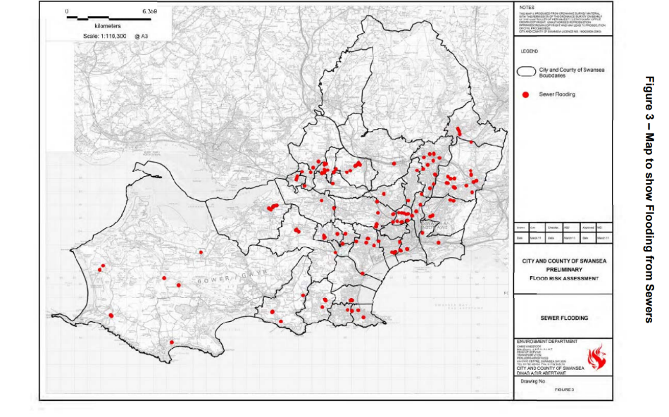

Figure 6 (Council, 2011)

4.2 Coastal Flooding
The site sits on Swansea coastal front but there are no records to show of coastal flooding in the area with sea defences in place. Considerations may need to be taken for any failure of sea defence systems that could occur or any potential rise in high tide levels due to global warming.

4.3 Potential Contamination
Based on the historical maps seen in figure two and three above, it could be concluded that the site would fall into a category of made ground also known as Anthropogenic ground. This could indicate the possibility of contaminated land. There could be potential ground or water resource contamination from varying factors such as asbestos, metals, semi metals, nonmetals, polycyclic aromatic hydrocarbons, within the site due to the nature of previous uses of the land, buildings structures, railway infrastructure and machinery that inhabited the site and surrounding areas. Reprofiling of the topography which may have included imported materials also needs to be taken into account as a possible risk.
“Where land is affected by contamination or land stability issues, under the planning system, it is the developer’s responsibility for securing safe development. As a minimum, land should not be capable of being determined as contaminated land under Part 2A of the Environmental Protection Act 1990” (Council, 2010).

4.4 Utility Constraints
The underground services which could be encountered include electrical cables, gas pipes, sewers, water pipes and telecommunication cables. There are three basic elements to a safe system at work: planning, detecting, identifying, and marking underground services and safe excavation/safe digging practice. You would need to obtain plans or other suitable information about all underground services in the area where the work is being planned (HSE, 2014).
In my desktop investigation I was unable obtain any underground service drawings in the proposed development in the form of utility plans ,However, from aerial photographs ,see figure one, I can determine that there is electrical carpark lighting and electrical infrastructure within the site boundaries. Overhead utilities by the means of phone lines and pylons also need taking into account during the planning of the construction which could cause ingress and egress constraints. Further investigation is recommended in accordance with and following specification PAS 128:2014 for underground utility detection, verification, and location. Guidance on site safety issues to be addressed in any investigation involving contaminated land or gas affected sites should be obtained from BS 10175 and industry guidance from BS ISO 10381-3.​

​

4.5 Effects of Trees
Ground heave and subsoil dehydration and sinkage would be the main two types of effects regarding the foundation detail for the site. The removal of trees within the immediate footprint could cause the subsoil to expand and swell with the additional ground moisture content. Figure one shows trees within the site as well as along the boundary .The height of the trees within and around the site would also need to be taken into account as the species of tree along with the height would determine the water demand that would affect the strata. (Chudley, 2011, p. 106).
Tree protection orders also need to be checked via the local conservation officer within the local authority prior to any removal of trees and hedgerows. Section 192 of the Planning Act 2008 made further amendments to the 1990 Act which allowed for the transfer of provisions from within existing Tree Prevention Orders to regulations.

4.6 Structure Constraints

With the presence of the two high rise buildings adjacent to the site there could be extra consideration needed for any structural elements, basements or reinforced walls that extend beyond the apparent footprint of the two buildings. Stability of existing structures could be jeopardised with any intrusive works near that could cause settlement. The stability of existing structures for instance, retaining walls, tunnels and pipes should be​ adequately assessed before undertaking any ground investigation. Access to the site may need a traffic management plan put in place with authorisation from the ownership of the car park.

5.0 Risk Assessment

5.1 Risk Assessment Framework
The land contamination risk assessment is broken down into three tiers. Preliminary risk assessment which develops the initial conceptual site model to establish whether there are any potentially unacceptable risks. Generic quantitative risk assessment where generic assessment criteria and assumptions estimate risk and a detailed quantitative risk assessment where site specific information estimates risk. A preliminary risk assessment must always be completed first, this will establish if there are any potentially unacceptable risks that could arise from contaminations at the site (Government, 2020).

6.0 Ground Conditions

6.1 Borehole Logs
A historic Bore hole log has been obtained from the BSG website. Findings within the bore hole log clearly show evidence of Anthropogenic ground to a depth of 5m and water table at 5.7m. The drilling was conducted to a depth of 22m with various layers of soil types. Potential risks regarding this ground could be that of contamination from the made ground and also ground movement from any impeding loads due to at depth levels of sands and gravels. See figures seven, eight and nine. Evidence shows;
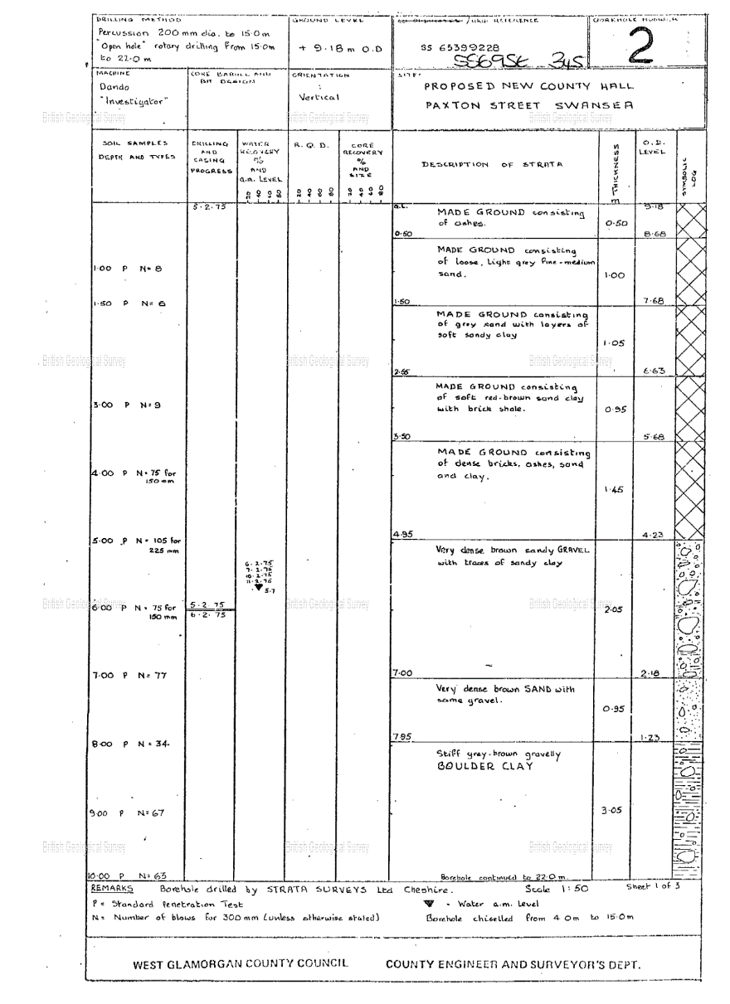
Figure 7 (BGS, 2020).

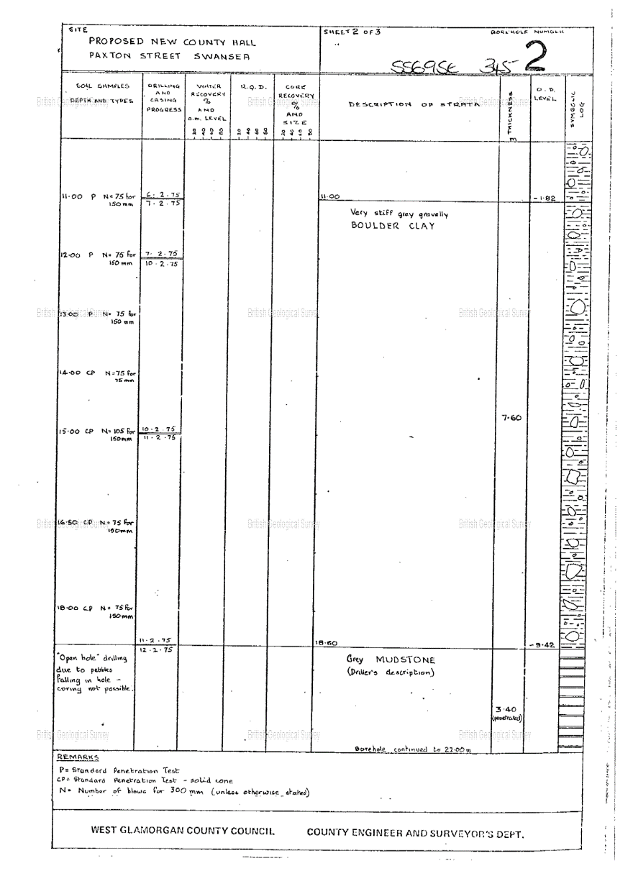
Figure 8 (BGS, 2020).

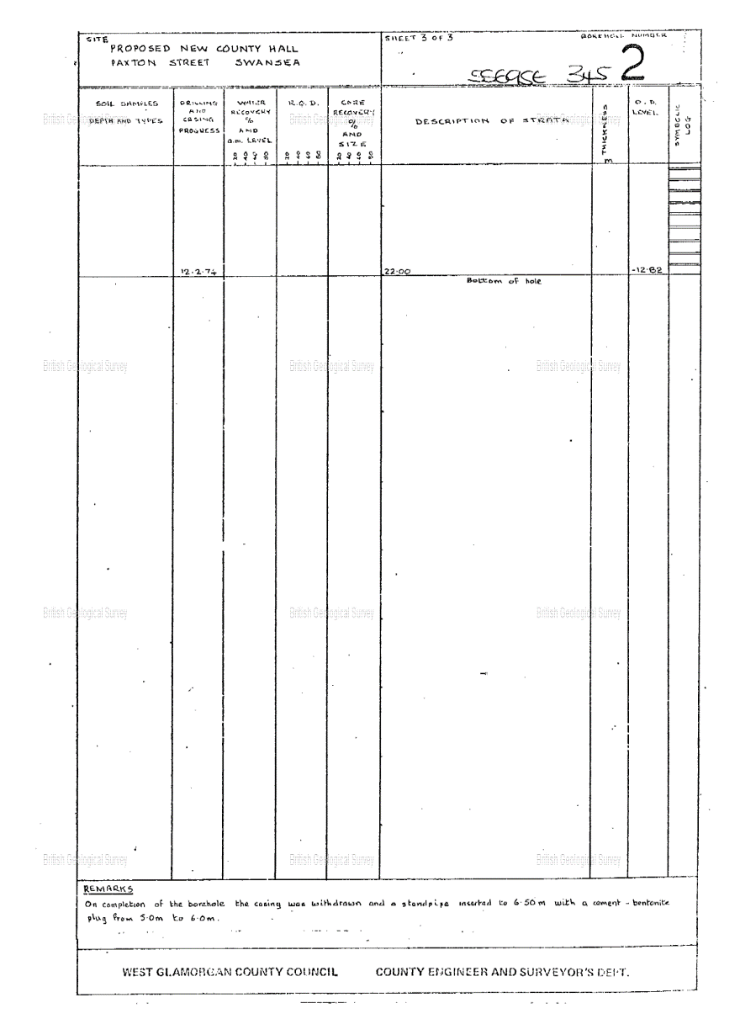
Figure 9 (BGS, 2020).

7.0 Results and Interpretation
From the data within this desk top study my research has identified that the ground conditions are mainly that of Anthropogenic ground. The bearing capacity could be weak due to the layers of ground strata consisting of varying soil types, which includes coarse grained soil in gravels and sand, to various traces of finely grained soil types like clay. These can also be called cohesive and non- cohesive. The permeability of this strata can be classed as highly permeable due to its variety of sand and gravel content. With the bearing capacity being weak given the soils analysed, the bearing pressure may have the potential to cause settlement. There is also a layer of boulder clay within the ground at 7.95m which could have the potential of shrinkage or swelling due to the possible removal of trees and shrubs. Intense climate changes from freezing or high temperatures could have the potential for soil movements. The study also makes us believe that the ground is more then likely contaminated due to the usage of land in previous years and the top 5 meters of recorded strata as being Made Ground from the geological mapping.

8.0 Applicable Codes and Building Regulations
All works should comply with Approved Document C, Site preparation and resistance to contaminants and moisture 2010 Edition with 2013 Amendments . The site investigation needs to be designed in accordance with BS5930+A2:2010, the Code of Practice for Site Investigations, BS10175:2011, the code of practice for investigation of potentially contaminated sites, and ‘Development of Land Affected by Contamination: A Guide for Developers’ prepared by Welsh Local Government Association (WLGA)/Natural Resources Wales (NRW) Land Contamination Working Group, 2017. While planning the foundation detail, Approved Document A for structure will need adhering to.

9.0 Recommendations
It would be prudent to allow for supplementary trial pits to be excavated on the site, these investigation points should be spaced out in accordance with BS EN 1997-2:2007 Annex B. This would allow for the ground conditions to be confirmed and for additional samples of ground to be sampled and tested to confirm and refine the recommendations provided within this report. Trail pits and trenches should not be entered without risk assessments. Due to the Anthropogenic ground, additional boreholes may be required in order to confirm the depth, nature, and strength of any underlying bedrock as an aid to the bore hole log already found during the desk top study, as to confirm any change in soil characteristics over several locations within the site due to the uncontrol and possible variation in soil character and quality which could be random due to its nature. Bore holes should always be fully cased through uncontrolled made ground to avoid contamination of the natural groundwater and underlying strata. Field strength testing should also be carried out to determine soil strength. Permeability In situ testing using a Peizometer or stand pipe to gain accurate permeability results is advised to know the full extent of the coefficient permeability of the ground. All ground investigations or testing should be carried out in accordance with BS EN-2 and BS EN1997-1. The recommendations and the requirements for any remedial mitigation measures should be reviewed following completion of these recommended further works. It is recommended that additional reports are obtained during the site investigation and these include:

- SSSI (sites of special specific interest) report
- A Radon Report obtained from the British Geological Survey
- A Coal Authority Mining Report
- Ground gas risk assessment
- Risk to vegetation
- Human health risk assessment
- Utility plans

Based on the data sourced within the bore hole log and geological extractions within this report, the recommendation for a foundation detail would be that of frictional piling due to the depth of suitable end bearing ground at to far of a depth to practically bore to. It is recommended that due to the location of the site being adjacent to buildings that a replacement method is used instead of displacement as to not cause vibrations which could cause ground movements affecting surrounding foundations or utility services. As the ground is mostly Made Ground ,the use of a supporting casing as to stop any falling should be used. See figure ten.
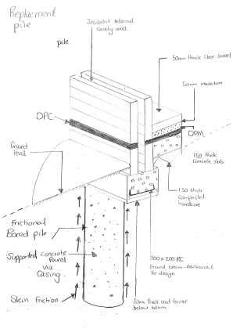

Figure 10.

References
BGS, 2020. Geoindex. [Online]
Available at: https://www.bgs.ac.uk/information-hub/borehole-records/​
[Accessed 12 Novemeber 2020].
Chudley, R. e. a., 2011. Construction Technology. 5th ed. Essex: Pearson Education Limited.
Coflein, 2009. Swansea Victoria Railway Station. [Online]
Available at: https://coflien.gov.uk/en/site/34874/details/swansea-victoria-railway-station-victoria-road-swansea#archive
[Accessed 11 November 2020].
Council, C., 2010. Development of Potentially Contaminated Land. [Online]
Available at: https://www.carlisle.gov.uk/Portals/0/Documents/Residents/Planning/Brownfields_Developers_Guide.pdf
[Accessed 10 November 2020].
Council, S., 2011. Preliminary Flood Risk Assessment. [Online]
Available at: file:///C:/Users/home/Downloads/Preliminary_Flood_Risk_Assessment.pdf
[Accessed 11 November 2020].
Digimaps, 2020. Geology Roam. [Online]
Available at: https://digimap.edina.ac.uk/roam/map/geology
[Accessed 10 November 2020].
Digimaps, 2020. Historic Roam. [Online]
Available at: https://digimap.edina.ac.uk/roam/map/historic
[Accessed 9 November 2020].
Government, U., 2020. LCRM: Stage 1 risk assessment. [Online]
Available at: https://www.gov.uk/government/publications/land-contamination-risk-management-lcrm/lcrm-stage-1-risk-assessment
[Accessed 11 November 2020].
HSE, 2014. Avoiding danger from underground services. [Online]
Available at: https://www.hse.gov.uk/pubns/priced/hsg47.pdf
[Accessed 11 November 2020].
Google (2020). Available at: https://earth.google.com/web/search/swansea/@51.61438678,-3.94042291,11.56525419a,2353.77532949d,35y,0h,0t,0r/data=CigiJgokCQKTfLvuSThAEfx5NJs5GjDAGbGybbcDyERAIeMoNOQ-HVDA (Accessed: 11 November 2020)

