Kallum Doyle
2237962@student.uwtsd.ac.uk
Due Date
August 2025
Project Management & Innovation
Changemakers: Creativity and Value Creation

Contents
Figures 2
Introduction 3
Task 1 | Project Management 4
Project Management & Planning 4
Project Scope 4
GANTT Chart 6
Software Development Method 6
Project Design 7
Requirements Specification 7
Storyboards 8
Task 2 | Innovation 10
PEST & SWOT Analysis 10
PEST Analysis for Jisc 10
SWOT Analysis for Jisc 10
Legal & Ethical Considerations for Jisc 11
Practical Implementations 11
Task 3 | Project Reflection 13
How will this project improve skills? 13
How will these new skills impact and contribute to society? 13
What risks / challenges could the project face? 13
Technical Risks 13
Project & User Risks 14
Conclusion 15
References 16

Figures
Figure 1: A flowchart demonstrating how the data would flow in the application. 4
Figure 2: A GANTT chart created using teamgantt.com showcasing the timeline of each project phase. 6
Figure 3: An image showcasing the iterative Agile scrum process that would be undertaken for the project. 7
Figure 4: An image demonstrating the useful visualisation aspect of storyboarding. [10] 9
Figure 5: An image demonstrating a basic storyboard for this project. 9
Figure 6: A diagram demonstrating the CI/CD pipeline 12

Introduction
The higher education landscape is undergoing a significant transformation as of 2025, driven by technological advancement and the increasing demand for data-driven decision making. Educational institutions are under increasing pressure to enhance the learning experience while also streamlining their administrative processes to ensure efficiency, accuracy, and compliance. The administrative burden on universities is a complex issue, and changes to the process can sometimes lead to increasing workloads and costs for the institution. [29] This project serves to propose a technological solution to a critical challenge faced by many universities: the manual and often error-prone process of managing student data.
This report outlines a project to design and implement an automated system for importing student qualification data from the UK Government’s Learner Record Services (LRS) API directly into a university’s internal database. Quality data from higher education institutes is highly important, as inaccuracies can lead to reputation damage and poor strategic decisions. [30] By utilizing modern software engineering practises such as agile methodologies and a DevOps culture, this project aims to significantly reduce administrative workload, improve data integrity for data returns and allow staff to focus on higher-value activities.
The project will navigate API integration, data security and stakeholder management to showcase how targeted innovation can create substantial value. This is an essential component of the project as the sector currently grapples with the digital era, with many institutions recognizing the need for clear digital strategies that meet the ambitions of the institute while managing evolving student expectations. [31] This document details the project’s scope, technical architecture, and management strategy, before delving into a critical analysis of its theorized impact, the challenges that may arise, and opportunities it creates for both professional development and societal contribution.

Task 1 | Project Management

Project Management & Planning

Project Scope
This project aims to automate the process of importing missing student qualification data from the UK Government’s Learner Record Services (LRS) API into the university’s own database. The integration aims to improve processes within the HESA student data return by minimizing manual effort and reducing data errors.
The solution will utilize the programming language of C# utilizing their ASP.NET Core platform and will be hosted within the university’s infrastructure. The application will retrieve data from the API such as student unique learner numbers (ULNs) and their qualifications. At each stage it will validate and map the data to the university’s database schema, with informative logging along the way.
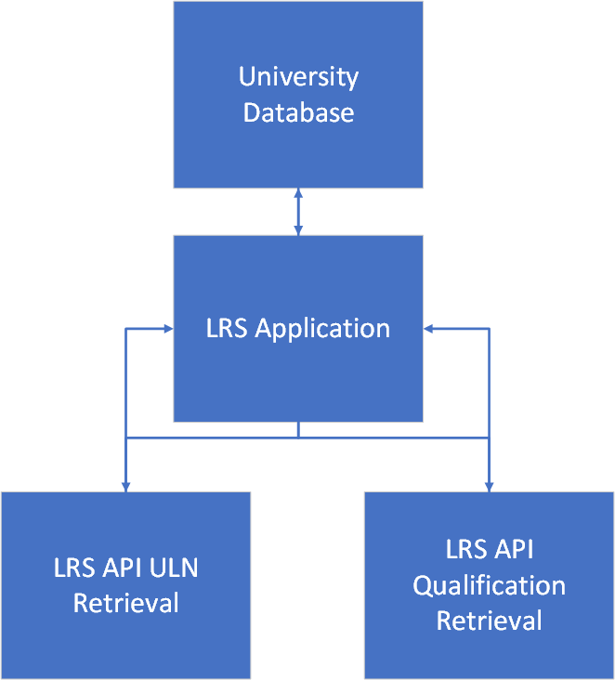
Figure 1: A flowchart demonstrating how the data would flow in the application.

Technologies and Resources
Language: C#
API Integration: UK Government LRS API
Testing Frameworks: xUnit
Database: Microsoft SQL Server (existing)
Project Management Tools: Azure DevOps
[1-2][5]

Timelne and Schedule
The below timeline and schedule demonstrate an estimate of the time it will take to complete each phase of the project that will be undertaken.
Phase | Duration (Weeks)
Project Planning | 2
Baseline Analysis | 2
Requirements Planning | 1
Requirements Confirmation | 1
Reviewal of Project Planning | 1
API Researching | 1
Project Prototyping | 2
Database Design | 1
Software Design | 1
Software Coding | 6
Internal Testing | 2
Integration Testing | 2
User Testing | 2
Final Evaluation and Documentation | 2
[3]

Constraints
- The LRS API requires an application form to be submitted before any action is undertaken.
- Mapping qualifications from the LRS API to internal qualifications may require manual intervention depending on the formatting of the data.
- Development of the LRS application requires reviewal from the LRS team, and there are tight deadlines for returns when this application will be the most utilized.
[8]

GANTT Chart
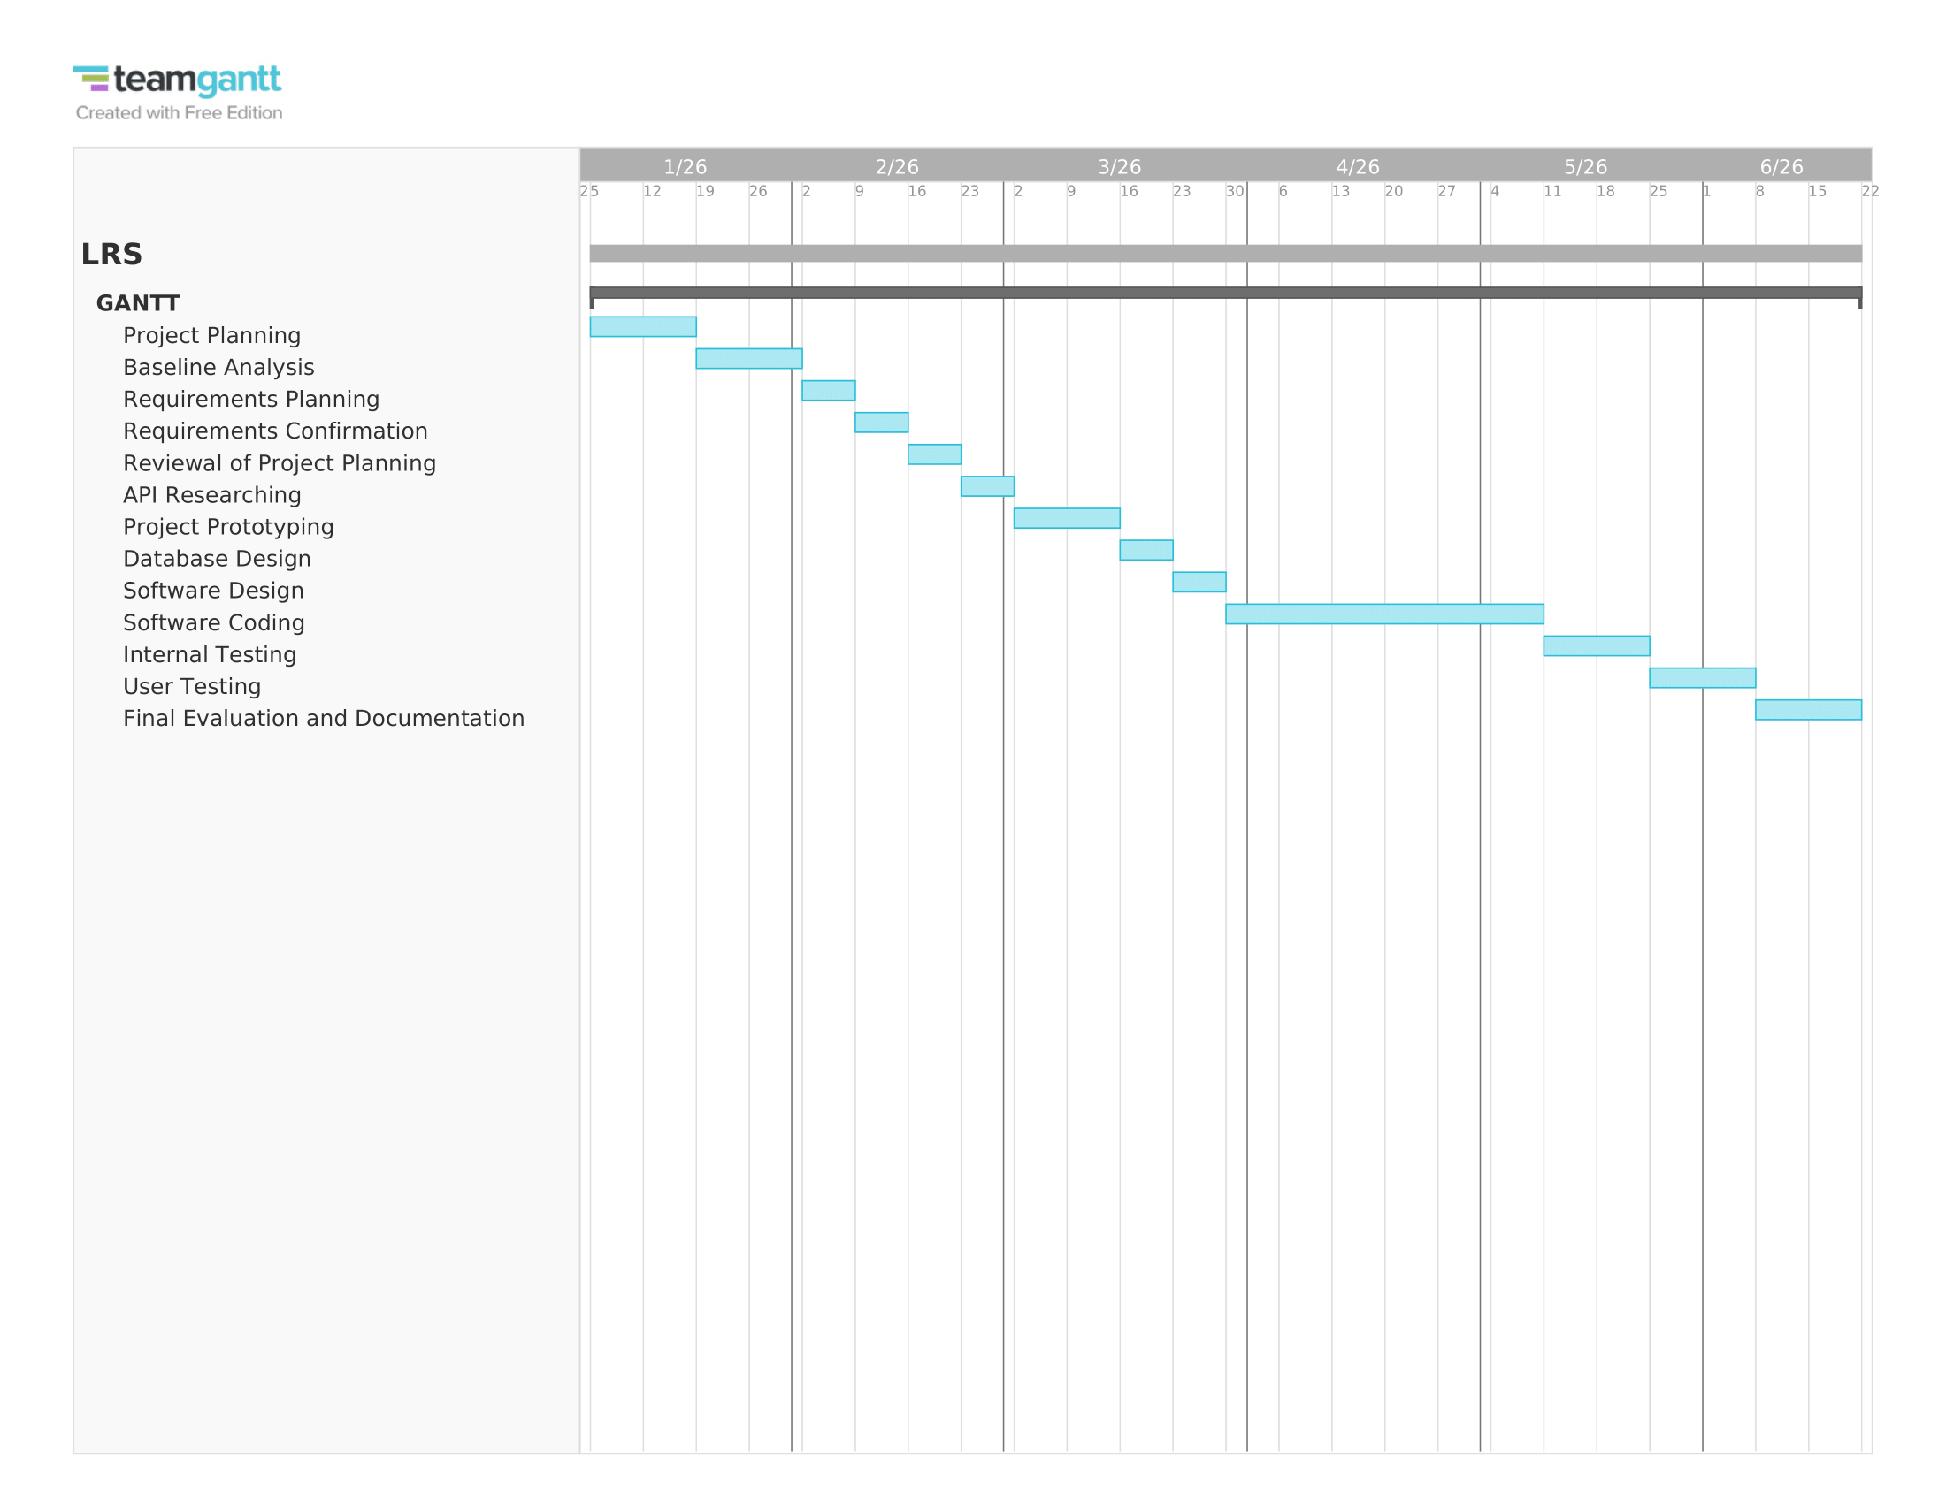
Figure 2: A GANTT chart created using teamgantt.com showcasing the timeline of each project phase.

Software Development Method
For this project, the agile scrum methodology will be implemented as the primary software development method. It will be facilitated by the usage of Azure DevOps boards and work will be executed in three-week sprints. The sprints will contain of reviews and planning sessions to coordinate track progress and ensure adequate planning. The scrum methodology is well suited for adaptive development and enables iterative delivery.
Progress will be monitored through daily scrum meetings which will prioritize the reviewal of completed tasks, the current priorities and anything blocking progress. To the end of the sprint, a sprint retrospective will be conducted to evaluate the performance in the sprint and adapt the planning of the project if necessary.
The team will also consist of the lead developer leading on this project and the developer manager who will lead the scrum meetings as the scrum master. Altogether, this approach supports continuous improvement and prioritizes a reliable evolution of the system across iterations, alongside the preservation of visibility and traceability across the 26-week development period. [4]
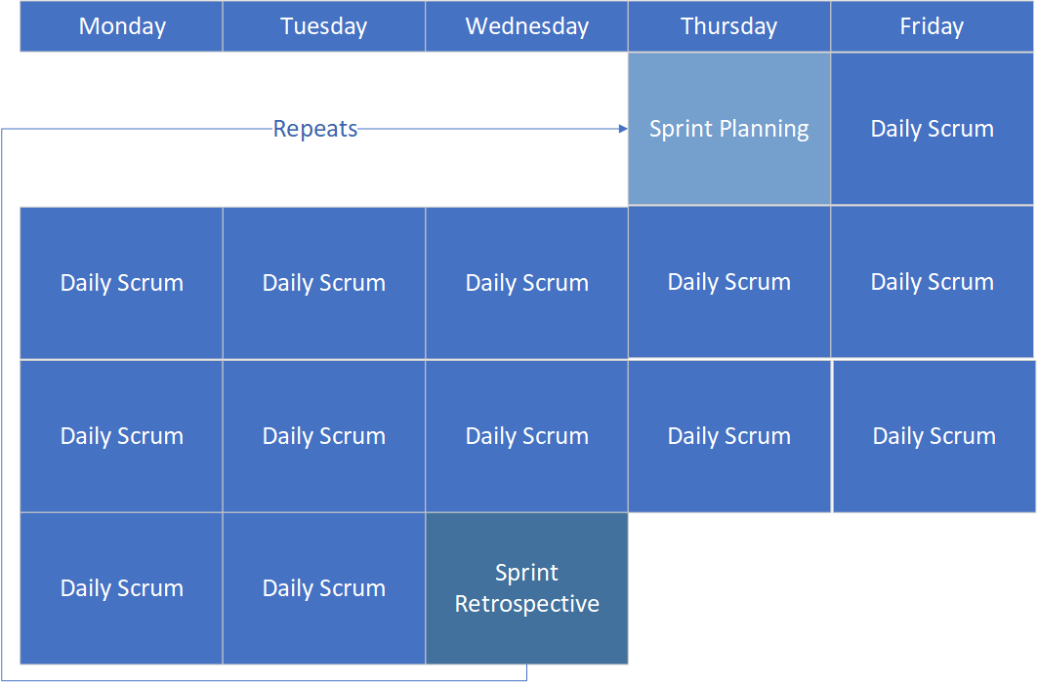
Figure 3: An image showcasing the iterative Agile scrum process that would be undertaken for the project.

Project Design

Requirements Specification
The requirements specification is a structured, and constantly evolving design element that documents the agreed system behaviours and constraints between stakeholders and the development team. The specification serves as a reference point for all forthgoing development. This documentation aims to mitigate challenges that surface in the sourcing of requirements, including incomplete requirements, ambiguities, and traceability gaps via its prioritization of a structured, unambiguous, and validated design.
In the instance of the proposed project, requirements are represented in Azure DevOps through a multi-level hierarchy that compromises of epics, features and user stories. These components help achieve a high quality break down of system requirements.
Core components of the requirement specification would include:
- Functional requirements: Detailed descriptions of expected behaviour, such as automated retrieval and verification of qualifications from the LRS API.
- Non-functional requirements: Security constraints such as GPDR compliance and other system reliability expectations that are usually lacking in specification.
- Acceptance Criteria: Clear success conditions for each user story, which reduce ambiguity and implement requirements validation.
- Traceability Links: Connections established between each requirement and its associated development task, test activity or documentation piece.
[6][9]

Storyboards
Storyboards are a visual structure that narrate how users will engage with a system, making a seamless transition from abstract processes to clear and humanized actions and components. Storyboarding is an important design element as it acts as a bridge between conceptual and practical implementation, that serves the goal of enhancing understanding and stakeholder involvement. Elements of storyboarding such as logical sequencing, visual clarity and contextual clues assist in aligning the software design with what the users expect from the application. Simultaneously, storyboarding promotes shared ownership between developers and stakeholders, which makes storyboarding a vital communication, engagement and change management tool in Agile development.
The image below demonstrates the concept of storyboarding perfectly, demonstrating how the required components of an online retailing service can be broken down into iterative pieces of work that are clear and concise. [7]
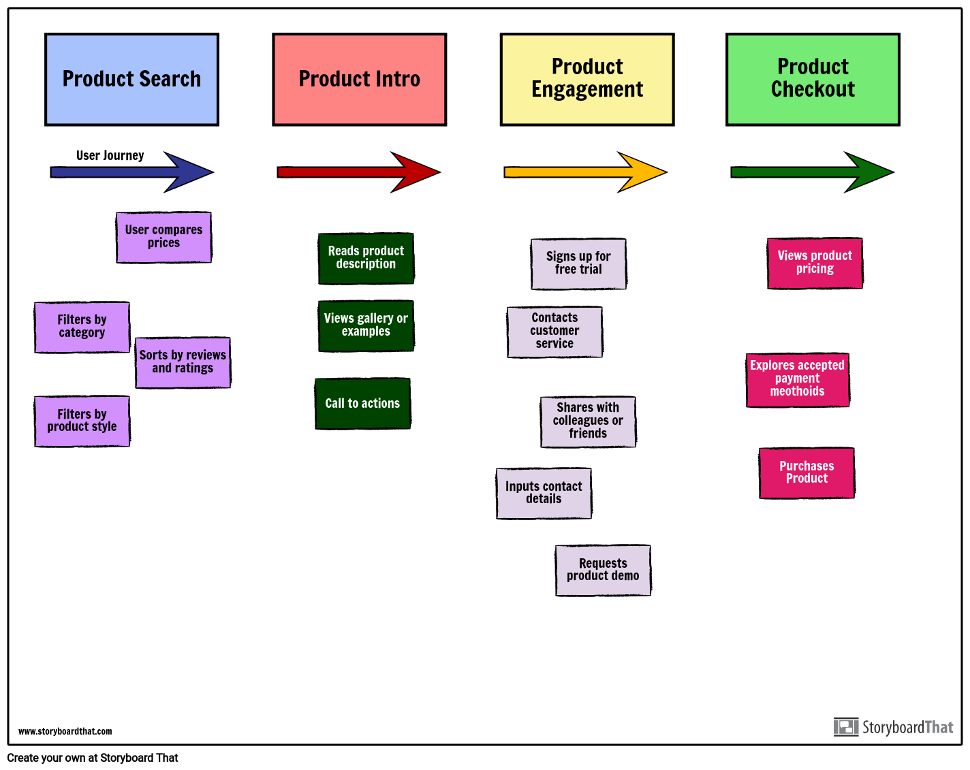
Figure 4: An image demonstrating the useful visualisation aspect of storyboarding. [10]

Additionally, the below image demonstrates a very simplistic and beginner storyboard for this project.
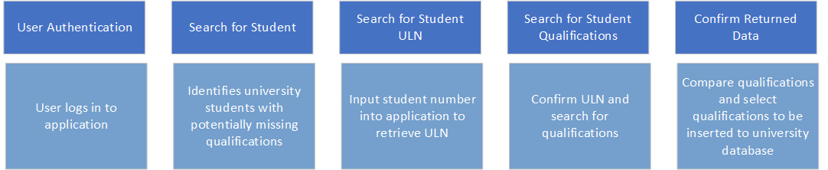

Figure 5: An image demonstrating a basic storyboard for this project.

Task 2 | Innovation

PEST & SWOT Analysis
A PEST analysis is a useful framework that can be used to identify and analyse some key factors that can impact an organization positively or negatively. These factors are:
- Political: Examines how government regulation, legal and political statuses affect the business’ operations.
- Economic: Examines how economic conditions such as economic growth, inflation rates and public funding can influence how the business operates.
- Social: Examines how societal trends such as public attitudes or lifestyle changes can influence business activities.
- Technological: Examines how evolution and innovation of technology impacts the business’ operations. [11]
In line with PEST analysis, a SWOT analysis serves to analyse internal the strengths and weaknesses of businesses in comparison to the competition or their partners. [12] For the purpose of this report, a PEST and SWOT analysis will be applied to Jisc, a not-for-profit business with the aim to harness the power of technology and data in UK education. [19]

PEST Analysis for Jisc

Political
Jisc’s operations are heavily influenced by the UK government higher education policy, the various ways UK universities receive funding and data regulations such as the general data protection regulation (GDPR). [13]

Economic
Jisc’s services can provide services that addresses issues that the higher education sector is currently facing, such as significant financial pressures, inflation, and tuition fee freezes. [14]

Social
Demand is increasing for universities to implements forms of digital learning into their courses, alongside the traditional teaching techniques. This mirrors trends in the wider digital economy and means it is essential for universities to invest in robust digital infrastructure.

Technological
Generative AI and cloud computing are rapidly evolving. As a result, cyber security threats are becoming ever more present. These threats provide opportunities for innovation but also give rise to challenges for the higher education sector that Jisc is aiming to address. [15]

SWOT Analysis for Jisc

Strengths
Jisc is an established and trustworthy digital partner in the higher education sector while simultaneously being owned by the higher education sector. The organization possesses a deep, specific knowledge of educational and research needs.

Weaknesses
Given it is a large and established body, Jisc must work continuously to remain flexible and responsive in the sector due to the rapidly changing and evolving technological landscape.

Opportunities
Higher education institutes have an increasing demand for data analytics to inform their strategy for the academic year. This demand alongside the drive for digital transforming provide an opportunity for institutes to consult Jisc and utilize their services. [15]

Threats
Jisc is facing a growing and competitive landscape in educational technology and must help the UK higher education sector defend against the evolving threat of cybersecurity challenges. [14]-[15]

Legal & Ethical Considerations for Jisc
Jisc must comply to significant legal and ethical obligations given its position in the education sector. Jisc must be a leader in complying with UK GDPR, across its own operations and the services it provides when assisting institutions in meeting their statutory duties. [20] Jisc also upholds a position of trustworthy built on the pillars of transparency and fairness. When the organization is developing services such as a learning analytics platform, Jisc must design their services to prevent any bias in the algorithm and to ensure that student data is being used responsibly across the sector. [21]

Practical Implementations
For this project’s implementation, it would be highly indicative of a DevOps culture, utilizing an Agile methodology to manage iterative development and to facilitate easy adaptation to any changes made to the external government API. [16]
The workflow of the project would be managed in Azure DevOps to allow easy visualisation of progress. The software development would revolve around test-driven development (TDD). Given the project will be coded in C#, the xUnit testing tool would be utilized to carry out necessary tests. The code will be hosted and managed in Azure Repos (Git), where continuous integration (CI) pipelines will automatically compile the solution and run the test suite upon every commit. This process will ensure that the code is constantly in a stable state while providing immediate critical feedback to developers. [17]
A continuous deployment (CD) pipeline would then deploy integrated builds that work successfully to a test environment to allow the clients to perform user acceptance testing. For the code to be promoted to the live environment, a manual approval process in the pipeline would be utilized after the code is deemed truly stable and reliable. After launch, Azure monitor would provide real time performance and error tracking that would feed any issues or enhancement requests back into the Azure DevOps backlog for future sprints. This entire process creates a cycle of maintenance and evolution with the goal of ensuring the system’s long-term success, while promoting adherence to the service management principles. [18]
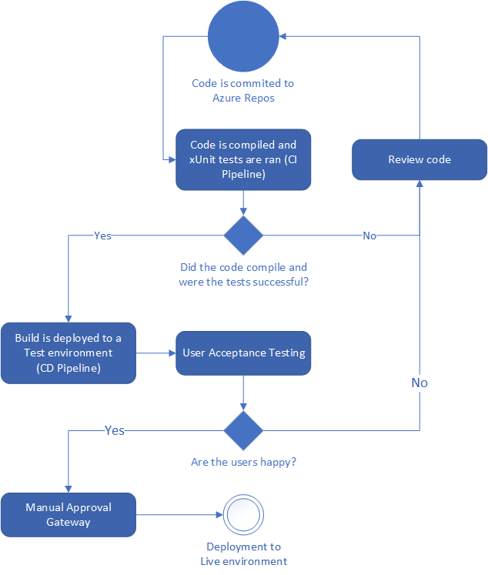
Figure 6: A diagram demonstrating the CI/CD pipeline

Task 3 | Project Reflection
The project presents an opportunity for personal and professional development with tangible benefits that extend to society. This reflection outlines the project’s facilitation for the potential of skills development and societal impact, alongside the key risks and challenges associated.

How will this project improve skills?
This project will serve as a foundation for transitioning theoretical knowledge into applied expertise in several key areas of software engineering. Given a foundational knowledge of C#, the project will require advanced components of the language, such as dependency injection and asynchronous programming, to perform to an expected level of modern-day performance that is robust and ready for a production environment.
Mastering secure and resilient API integration is an important skill that will be built upon in the development of the project. There are two great areas of improvement in this project. One is the transformation from a simple data retrieval process with little security or no fail-safe implementation to an advanced process that will authenticate ingoing and outgoing requests and include resilience patterns. [22] The second is the utilization of Azure DevOps to apply a DevOps culture. The goal is to progress from a simple user of the platform to an experienced practitioner who can implement tools such as a full CI/CD pipeline. [27]
[23]
Conclusively, the project is an ideal environment for honing essential professional skills required to be a software developer. The project requires engaging with non-technical stakeholders to gather requirements and manage expectations, which provides invaluable practise in stakeholder management. Furthermore, the utilization of an Agile framework will provide experience in iterative development, sprint planning and customer communication, which is critical factor in the success of a project. [24]

How will these new skills impact and contribute to society?
This project aims to improve the efficiency and data quality within the higher education sector. Although the product will be developed for one university, it can be applied to other universities that face the same issue which would contribute to a higher level of data quality in the higher education sector. By automating a manual and error-prone process, the project frees up the workload of administrators and allows for the prioritization of higher-value activities. This contributes to operational efficiency and financial sustainability of public institutions which is a cause of concern in the current economic climate. [15]
Accurate and high-quality data is a core component for creating evidence-based educational policy and for informing strategic institutional planning. Data must be high quality to properly support decision-making. [25]
Finally, the project addresses key ethical concerns in the management of data. The removal of manual transcription will reduce the potential for human error or unconscious bias that could affect a student’s record, which promotes fairness and equity. The skills developed in this project would apply to future projects and contribute to more applications that are technologically sound and ethically responsible. [21]

What risks / challenges could the project face?

Technical Risks
Due to the project’s reliance on the external LRS API, there are possibilities that the API could be reliable or experience changes to its schema with little or no notice, or the API could have strict usage limitations. As described previously in the report, the application will be designed with resilience as a core element that implements automated retries for errors and includes a circuit breaker pattern to prevent total system failure during API outages. [22]
Another technical risk is the potential for a security breach that could lead to the exposure of sensitive student data. To mitigate this risk, security will be another core element of the application design. API keys will be secured securely in an application such as the Azure Key vault, which will enforce the secure management of credentials and enforce the principle of least privilege on database access. [26]

Project & User Risks
There are potential issues with user adoption that stems from a perceived low ease of use or low usefulness of the new technology. These influences can be compounded by other user-related factors such as the varying levels of technological expertise. To mitigate this, the developed system must meet user requirements from the very first development stage to ensure successful implementation. By coordinating with administrative staff utilizing the Agile development method, stakeholders and developers can co-design a solution that positively influences the perception of usefulness and ease of usage. A positive influence of ease of usage can further be driven by comprehensive training and documentation on how to use the application. In terms of the project itself, managing the time it takes to develop the project is another major concern. This can also be mitigated by utilizing the Agile methodology and prioritizing important items in the backlog.
[24][28]

Conclusion
This project has far-reaching implications for both the individual and wider higher education community. The development of an automated data integration system with the LRS API is as strategic as it is a technical exercise with the aim to enhance operational efficiency and improve data accuracy while promoting the ethical handling of data. Through its practical application of C# programming, secure API integration and detailed DevOps workflow, the project offers an opportunity to develop a sophisticated skill set that directly transfers to the modern-day technological sector.
By successfully implementing this system, it creates opportunities beyond a singular institution to improve data quality in the higher education sector, assisting greater policy and strategic planning. A core component of the project is to reduce risks associated with manual data entry, and by doing so the project promotes fairness and equity in the management of student records. Anticipated challenges such as API reliability and user adoption have documented countermeasures to mitigate these risks, by methods such as the agile framework and risk mitigation strategies. Conclusively, this project serves as an innovative demonstration of how thoughtful and well-executed technological innovation can address problems encountered in the real world, while fostering a mindset of continuous improvement and delivering value to a broader society.

References
[1]
M. T. S. Ragupathi, Learning ASP.NET Core MVC programming : learn the fundamentals of ASP.NET MVC and build real-world web applications using ASP.NET Core MVC, 1st edition. Birmingham, England ; Packt Publishing, 2016.
[2]
J. C. Andersson, Learning Microsoft Azure. Sebastopol, UNITED STATES: O’Reilly Media, Incorporated, (pages 266-269) 2024. [Online]. Available: http://ebookcentral.proquest.com/lib/trinity/detail.action?docID=30957614
[3]
Y. Ren and J. Li, ‘Research on Software Project Schedule Planning Technology Based on the Integration of PERT and CPM’, Procedia Computer Science, vol. 228, pp. 253–261, 2023, doi: https://doi.org/10.1016/j.procs.2023.11.029.
[4]
A. Srivastava, S. Bhardwaj, and S. Saraswat, ‘SCRUM model for agile methodology’, in 2017 International Conference on Computing, Communication and Automation (ICCCA), 2017, pp. 864–869. doi: 10.1109/CCAA.2017.8229928.
[5]
Zaripova, Rimma, Kuznetsov, Maxim, Kosulin, Valery, Perukhin, Marat, and Nuriev, Marat, ‘Principles of autonomous testing of high-performance .NET application’, E3S Web of Conf., vol. 531, p. 03014, 2024, doi: 10.1051/e3sconf/202453103014.
[6]
M. Tukur, S. Umar, and J. Hassine, ‘Requirement Engineering Challenges: A Systematic Mapping Study on the Academic and the Industrial Perspective’, Arabian Journal for Science and Engineering, vol. 46, no. 4, pp. 3723–3748, Apr. 2021, doi: 10.1007/s13369-020-05159-1.
[7]
M. Minella, "The art of storyboarding: Transforming communication in organization," ISAR J. Econ. Bus. Manage., vol. 3, no. 4, pp. 24–27, 2025.
[8]
‘LRS: web services for management information system developers’, GOV.UK. [Online]. Available: https://www.gov.uk/government/publications/lrs-web-services-for-management-information-system-developers
[9]
K. Hasani, ‘Integrating DevOps checklist and pilot sample project’, Politecnico di Torino, 2022.

[10]
C. P. LLC, ‘Storyboard That: Agile User Story Mapping’, Storyboard That. [Online]. Available: https://www.storyboardthat.com/journey-map/story-map-agile-development
[11]
T. Sammut-Bonnici and D. Galea, "PEST analysis," in Wiley Encyclopedia of Management, 2015, pp. 1–2.
[12]
S. Ghazinoory, M. Abdi, and M. Azadegan-Mehr, "SWOT Methodology: A State-of-the-Art Review for the Past, A Framework for the Future," Journal of Business Economics and Management, vol. 12, no. 1, pp. 24–48, 2011, doi: 10.3846/jbem.2011.02.
[13]
Higher Education and Research Act 2017, Legislation.gov.uk, 2017. [Online]. Available: https://www.legislation.gov.uk/ukpga/2017/29/contents/enacted.
[14]
Office for Students, "Financial sustainability of higher education providers in England," OfS, Bristol, UK, Rep. 2024/05, May 2024. [Online]. Available: https://www.officeforstudents.org.uk/publications/financial-sustainability-of-higher-education-providers-in-england-2024/
[15]
‘Higher education strategy 2021-2024: powering UK higher education - Jisc’, Jisc. [Online]. Available: https://beta.jisc.ac.uk/reports/higher-education-strategy-2021-24-powering-uk-higher-education
[16]
J. E. Lwakatare, A. Kuvaja, and P. Oivo, "Dimensions of DevOps," in Software-Intensive Business: Start-ups, Ecosystems and Platforms, M. Cusumano, Ed. Springer, 2018, pp. 91–105. doi: 10.1007/978-3-319-94363-2_7.
[17]
M. Shahin, M. Ali Babar, and L. Zhu, "Continuous Integration, Delivery and Deployment: A Systematic Review on Approaches, Tools, Challenges and Practices," IEEE Access, vol. 5, pp. 3909–3943, 2017, doi: 10.1109/ACCESS.2017.2685629.
[18]
S. Marrone and T. Gacenga, "IT Service Management and ITIL: A literature review," in Proceedings of the 17th International Conference on Computer Systems and Technologies, 2016, pp. 247-254, doi: 10.1145/2983468.2983502.
[19]
‘Jisc’, Jisc. [Online]. Available: https://beta.jisc.ac.uk
[20]
Information Commissioner’s Office, "Guide to the UK General Data Protection Regulation (UK GDPR)," ICO, Wilmslow, UK, 2024. [Online]. Available: https://ico.org.uk/for-organisations/guide-to-the-general-data-protection-regulation-gdpr/
[21]
S. Slade and A. Prinsloo, "Learning analytics: Ethical issues and dilemmas," American Behavioral Scientist, vol. 57, no. 10, pp. 1510–1529, 2013, doi: https://doi.org/10.1177/0002764213479366
[22]
M. T. Nygard, Release It!: Design and Deploy Production-Ready Software, 2nd ed. The Pragmatic Programmers, 2018.
[23]
J. Humble and D. Farley, Continuous Delivery: Reliable Software Releases through Build, Test, and Deployment Automation. Addison-Wesley Professional, 2010.
[24]
T. Dingsøyr, S. Nerur, V. Balijepally, and N. B. Moe, "A decade of agile methodologies: Towards explaining agile software development," Journal of Systems and Software, vol. 85, no. 6, pp. 1213-1221, 2012, doi: 10.1016/j.jss.2012.02.033. [Online]. Available: https://doi.org/10.1016/j.jss.2012.02.033.
[25]
R. Y. Wang and D. M. Strong, "Beyond accuracy: What data quality means to data consumers," Journal of Management Information Systems, vol. 12, no. 4, pp. 5-33, 1996, doi: 10.1080/07421222.1996.11518099. [Online]. Available: https://doi.org/10.1080/07421222.1996.11518099.
[26]
A. Shostack, Threat Modeling: Designing for Security. Wiley, 2014.
[27]
M. Shahin, M. Ali Babar, and L. Zhu, "Continuous Integration, Delivery and Deployment: A Systematic Review on Approaches, Tools, Challenges and Practices," IEEE Access, vol. 5, pp. 3909–3943, 2017, doi: 10.1109/ACCESS.2017.2685629. [Online]. Available: https://doi.org/10.1109/ACCESS.2017.2685629.
[28]
E. C. Ling, I. Tussyadiah, A. Tuomi, J. Stienmetz, and A. Ioannou, ‘Factors influencing users’ adoption and use of conversational agents: A systematic review’, Psychology & Marketing, vol. 38, no. 7, pp. 1031–1051, 2021, doi: https://doi.org/10.1002/mar.21491.
[29]
W. Peter, ‘Administrative burden in higher education institutions: a conceptualisation and a research agenda’, Journal of Higher Education Policy and Management, vol. 45, no. 4, pp. 409–422, 2023, doi: 10.1080/1360080X.2023.2190967.
[30]
Deloitte, "HESA Data Futures: the data quality challenge," Deloitte UK, Jul. 18, 2023. [Online]. Available: https://www.deloitte.com/uk/en/services/consulting-risk/blogs/2023/hesa-data-futures-the-data-quality-challenge.html
[31]
Jisc, "Taking digital transformation forward in your organisation," Jisc, Apr. 17, 2025. [Online]. Available: https://www.jisc.ac.uk/taking-digital-transformation-forward-in-your-organisation

