
APPENDIX GA36c

LEVEL 6 ASSESSMENT SPECIFICATION

Student name: | Louise Victoria White | Student ID number: | 1803375
Programme: | Primary
Module: | Principles of Pedagogy
Module code: | M6X01438/C | Contribution to Overall Module Assessment (%): | 100%
Lecturer: | Siân Brooks | Internal Verifier: | Siân Brooks
Assignment Title: | ‘Describe a learning event which has happened during your recent school experience. Reflect upon what took place, connecting events to theories of learning and teaching. Make recommendations about how you could improve your own practice in the light of this. Produce a poster to illustrate how you would develop the elements of an effective learning environment.’ | Word count (or equivalent): | 5,000 or equivalent.
Submission deadline: | 17/10/18 (23.59) | Return date of provisional marks & written feedback: | 14/11/18
Submission method: | All written assessments, where practical and possible, must be submitted via Turnitin unless otherwise instructed by the Lecturer. (Please DO NOT put this assessment specification into Turnitin or it will match many similarities with other students’ submissions.)  Alternative submission method (if applicable):  Late submission of the assessment will result in a late penalty mark. Penalties for late submission: Up to one week late, maximum mark of 40%. Over one week late, 0%. Only the Extenuating Circumstances Panel may approve a change to submission dates.
Academic honesty / referencing: | Academic honesty is required. In the main body of your submission you must give credit to authors on whose research and ideas your work is based. Append to your submission a reference list that indicates the books, articles, etc. that you have used, cited or quoted in order to complete this assessment.

Module Learning Outcomes
(from module syllabus)
1. understand, synthesise and evaluate the main theories that underpinning learning, behaviour and assessment in the primary school
2. reflect critically on how learning theories inform the planning and provision of high quality learning environments, demonstrating a clear understanding of how theory and practice are interrelated
3. organise knowledge and learning through the use of a range of information sources, and present work appropriately.

Describe a learning event which has happened during your recent school experience. Reflect upon what took place, connecting events to theories of learning and teaching. Make recommendations about how you could improve your own practice considering this.
Produce a poster to illustrate how you would develop the elements of an effective learning environment.
In accordance with BERA Guidelines (2018), ethical considerations have been contemplated for this assignment, therefore names of learners, practitioners, and schools will be omitted, thus protecting anonymity.

School X is situated in the City and County of Swansea and has 481 pupils on roll. There are 16 single year classes, and 21% of the pupils at the school are entitled to Free School Meals (FSM) - 3% higher than the National Welsh average (Estyn, 2018.) 34% of learners have been identified as having an Additional Learning Need (ALN). The school is a pioneer school focussing on health and wellbeing with the aim to develop, trial, and implement aspects of the new curriculum due to be implemented in Wales from 2022 as a result of Professor Donaldson’s report ‘Successful Futures’ (2015).

Throughout this essay the focus will be on Assessment for Learning (AfL), of which key elements will be discussed. Pedagogical theories related to it will be looked at, as well as key research. AfL is an incredibly broad term that covers a wide range of assessment techniques. Only two elements that are intrinsically linked will be considered in this essay, those being self and peer assessment. To help examine these techniques we must first understand the research and theory associated with them.
The National Foundation for Education Research carried out an investigation in 1984. The investigation discovered that policies related to AfL in schools generally related to marking learners’ work and the need to maintain records of results (James, 1998). It was in 1987 that the Task Group on Assessment and Testing (TGAT) coined the phrases formative and summative regarding assessment in schools (James, 1998). For clarity at this point, formative assessment is assessment that takes place during learning, whereas summative assessment occurs at the end of learning and the results are recorded in a systematic manner. Both summative and formative assessment are necessary, and each have their own place in education. Summative assessment is necessary to identify what knowledge learners have obtained over a period of time, whereas formative assessment is more informal and is used by practitioners to assess any strengths or weaknesses learners may have, modifying their teaching and planning as a result to help with the progress and achievement of learners.

In 1998, there was major research conducted into the uses of classroom assessment undertaken by Paul Black and Dylan Wiliam. They argued that the current systems in place in schools treated classrooms as if they are a ‘black box.’ Teachers must take many aspects into consideration that go beyond the teaching and educating of children, referred to as ‘input’ into the black box, examples of which include policy and the requirement of high test scores (Black & Wiliam, 1998). What then is the ‘output’ from the black box? Ideally it is learners that have obtained knowledge and who can achieve high test results (Black & Wiliam, 1998). The question that Black and Wiliam ask is what happens inside the box, and is it good enough? The research undertaken looked upon formative assessment and whether it could be used effectively to improve standards in schools. They felt that a major element was pupil self-assessment with feedback on work being an essential aspect to the improvement of learning, and this could be seen from the observation in School X.

The observation took place in an upper key stage two class in School X where learners had been working on a narrative piece of writing, the learning objective (LO) being ‘To write a story starter from a character’s perspective’. The classroom practitioner had asked the class what they thought the success criteria (SC) should include, and it was decided after a ‘think, pair, share’ discussion that writing in the present tense, writing in the first person, accurate use of capital letters and full stops, and accurate spelling were what should be focussed on. It is important that when having these discussions about criteria that children are exposed to the technical language to talk about their work (Dean, 2000), they are then aware - and understand – the criteria the practitioner will use when marking their work.

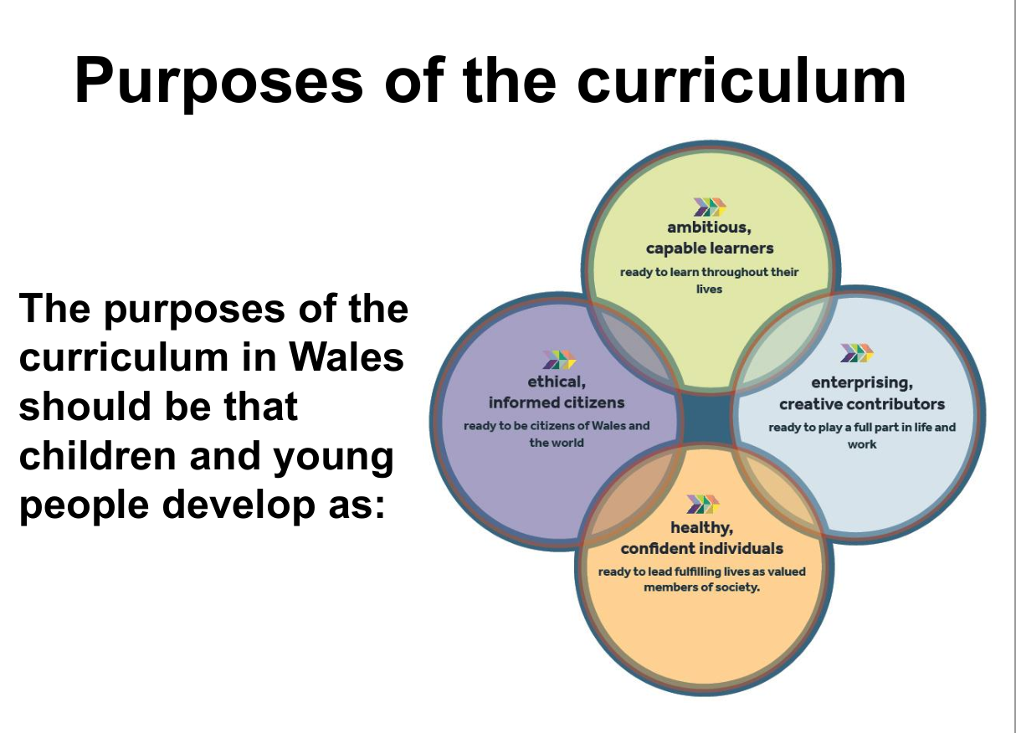
By discussing the SC with pupils, the learner is explicitly aware of what is required of them and how they can achieve it (Hall & Burke, 2003) which is essential to their learning. By having a clear goal, learners develop the ability to take ownership of their learning (Black et al, 2003) therefore practitioners should be advocating this in their classrooms for learners to get more out of the lesson, instead of being told what to do and not being sure of what they are achieving and how they are to achieve it. It could be argued that the classroom practitioner in the observation could have provided learners with a list of the SC by displaying them on the board/interactive white board, or by providing a check list. By doing this, learners can frequently refer to them without asking the practitioner to remind them and are therefore able to work with increasing independence. The fact that that learners discussed and created their own SC means that they are working towards being ambitious, capable learners, and enterprising, creative contributors, two of the four core purposes of learning as set out by Professor Graham Donaldson in his new curriculum for Wales (Figure 1).

Learners carried out the task and when completed they began the process of self-assessing their work, an essential tool of formative assessment in the opinion of Black and Wiliam (1998) in the development of standards within schools.
Figure 1 – Four Core Purposes.
Self and peer assessment are formative assessment tools that are used throughout School X in all lessons, being used in differing ways dependent on the subject being taught. In the instance of the literacy lesson the learners began by self-assessing their work using blue pen, the classroom practitioner having reminded learners of the SC. Any grammatical or spelling errors that they could identify were corrected, some learners also drew a pair of scissors next to words or phrases that they wanted to remove and drew a magnifying glass on any words or phrases that needed to be expanded on, writing any additional information as required. Learners then wrote a sentence detailing one thing that they thought they had done well, and one aspect of their work that they felt needed improvement. Next, it was the turn of a ‘critical friend’ to peer assess the work using the same methods but using a purple pen so that it is clearly discernible as to who has carried out the assessment. What was interesting was that learners did not automatically ask those from their own social groups to assess their work. Clearly the classroom environment was one where they felt that they could rely on any person in the class to assess their work accurately. Peer-assessment not only motivates learners to place more care and attention on their work, but also it results in dialogue in language that learners would use (Black et al., 2003).

Learners read and reflected on the comments that had been made by their peer and moved on to the next stage of the self-assessment process. This involved taking into consideration any edits that the learner had made in addition to any edits and comments that the peer had made. Using this information, the learner then judged their work using a traffic light system of green (achieved the SC with few errors), orange (achieved most of the SC with some errors), or red (achieved few of the SC, with many errors). In the observation, the learners were very honest in the evaluative process, and chose the colour that accurately reflected the quality of their work.

This traffic light system of self-assessment is beneficial to the classroom practitioner. It provides the practitioner with an immediate visual cue as to where the learner thinks they are at in their own learning. This helps address any misconceptions learners may have and the classroom practitioner can use this information to inform future planning. It could be argued that there could be potential for the learner to assess their work as ‘green’ in a bid to please the classroom practitioner, however by frequently carrying out this method of formative assessment, learners realise that mistakes are acceptable and can be learnt from. Not only this but the practitioner can use this information to group pupils, they can pair greens and ambers to work together, whilst working with the reds themselves to address any misconceptions (Black et al, 2003).

Having spoken to learners about their thoughts on the benefits of self and peer assessment, the consensus was that it made them feel a sense of pride in the work they had completed especially when they felt they had achieved the SC or when a peer had written a positive comment. When the peer had written about aspects of the work that needed to be improved on, learners felt that it was useful that the peer had drawn their attention to an aspect that they may have overlooked, and that receiving criticisms from peers was not as disparaging as receiving a criticism from a teacher.

The visual colour coding of the traffic light system is beneficial for feedback as it enables both the practitioner and learner to engage in dialogue thus enabling the practitioner to provide the help and support that that learner may require. It also means that the feedback provided to the learner is meaningful. By the practitioner giving feedback that relates to the SC, the learner can see that they have achieved the task at hand. If the SC is not achieved and the learner has identified that, it shows the practitioner that the learner has acknowledged it and realises what their next steps in learning are.

What is essential is that as learners become more independent, taking control of their own learning, they are also developing the ability to self-monitor. At this stage it doesn’t mean that the teacher refrains from giving feedback, meaningful feedback will always be necessary whenever there is the introduction of a new topic, theme or success criterion (Harlen, 1994). Regarding the comments made by the learner and their peer on the piece of work, it gives the teacher insight into the analytical and evaluative skills of the learners, important if practitioners are to raise standards and to help develop pupils as life-long learners (Weeden et al, 2002).

John Hattie conducted research over a period of 15 years into effective classroom practices. Entitled Visible Learning, it details the practices that show the effect that have visible impact on achievement. Referred to as effect size, Hattie discovered many practices which yielded a high effect size, whereas some practices had little to no impact on effect size at all. Hattie was not suggesting that the practices that yielded a lower effect size should be discontinued from classroom use, rather effect size should be used as a starting point for discussion as opposed to using them to make decisions on practices to include or not include within the classroom environment (Hattie, 2009).

Heeding this caution then, there are a few elements from the research that can be taken into consideration regarding the formative assessment examples witnessed during the observation at School X. Hattie discovered that student feedback helped to make learning visible (Hattie, 2009) and in terms of effect size, positive feedback between students and their teachers produced an effect size of over 0.7, namely over 7 months of ‘value added’ learning. It should be noted here that practices that yielded an effect size of over 0.4 (4 months of value added learning) is what should be desired to show impact. Hattie argues that student to teacher feedback is far more powerful than teacher to student (Hattie, 2009). By using the self-assessment comments, the practitioner can ensure that the feedback provided is meaningful to the student, thus moving their learning forward. The research also indicated that peer influences yielded an effect size of over 0.5 (5 months). Peer influences does not only refer to friendship, but also encompasses providing feedback too, as was being demonstrated and utilised in the observation at School X. Of course, self and peer assessment can only work if the learner understands what was expected of them and that the learning environment is supportive and open, where pupils feel comfortable and safe in sharing thoughts and ideas (Grigg, 2015).

Though Hattie’s work is useful as a basis for discussion on aspects of teaching and learning that will bring about improvement, Petty argues that effect size does have flaws as the studies often ignored context, that the studies carried out were often short term, and it assumes learners are all identical (Petty, 2014).

Pedagogical Theories
To be a successful classroom practitioner, it is essential to have an understanding of the theories and philosophies that underpin the reasons for practice in teaching, then use these theories to develop a personal pedagogical approach. There are three main learning theories that will be discussed in this essay, these are: behaviourism, constructivism and social constructivism. Some are more useful than others in developing effective formative assessment within the classroom, aspects of each of the theories will be discussed and evaluated regarding their usefulness in developing AfL in the classroom.

Behaviourism has its origins in the early 20th Century as a result of experiments conducted on animals as it was thought that this could predict and explain how humans behave and learn. One of the influential theorists of behaviourism was Ivan Pavlov, a Russian physiologist. In experiments using dogs, and the rate which they salivated when presented with food, Pavlov discovered that dogs could be conditioned to salivate even when no food was presented by ringing a bell. The dogs had been conditioned to associate hearing the bell with receiving food, when the bell was sounded, and no food presented, the dogs salivated anyway. He therefore determined that learnt behaviours were difficult to disassociate from (Gray & Macblain, 2015). Psychologists such as B. F. Skinner and Edward Thorndike did not focus on the classical conditioning as Pavlov had, rather they looked at operant conditioning whereby positive reinforcement would result in a similar response in a future occurrence, and a punishment would result in the opposite (Grigg, 2015). Many classroom environments use operant conditioning to change unwanted behaviour in children. The work of Pavlov and other behaviourists such as John Watson has been criticised for the use of animals to predict human behaviour, but the theory that developed from the work in educational terms suggests that by the practitioner giving a stimulus, and then reinforcing the correct response (and discouraging incorrect responses) that learning by association of response and reinforcement occurs (Reece & Walker, 2007).

Can formative assessment work in a behaviourist classroom? Provided the practitioner gives clear instructions of what they want the learner to achieve by the end of the lesson (LO and SC), it is possible. Learners will know that by responding correctly to this stimulus they will be rewarded, for example by going out to play on time. Behaviourist classrooms are teacher led, so adversely there is not much room in these environments for children to take control of their own learning. Though self and peer assessment are possible in this environment, there are other environments to which they are better suited.

Constructivism (also known as Cognitivism) occurred through dissatisfaction with the ways of behaviourism, where knowledge is given to learners, to the theory that knowledge exists in construction by interacting and engaging with the environment. Jean Piaget was the forefather of constructivism who, by observing his own children was able to research and develop ideas on cognitive development for which he is best known (Gray & Macblain, 2015). He emphasised the importance of active learning and felt that knowledge was obtained by learners exploring their environment and making sense of it themselves. Learners then use this information to build upon their existing knowledge. There is assimilation and accommodation of new material into their existing cognitive structure, and Piaget developed 4 stages of cognitive development. There has been criticism of this and the rigidity of learning occurring in four distinct stages. In this environment it is the role of the practitioner to facilitate learning, and guide learners to make their own discoveries based on existing knowledge. Self-motivation is encouraged in constructivism, and learners monitoring their own learning has been suggested (Cremin & Arthur, 2014).

In this environment, self-assessment can occur. If learning is active and knowledge is obtained through enquiry, then the practitioner can set problem solving challenges, and link new learning to prior knowledge. By self-assessing their work, learners can identify any errors made based on their existing knowledge. Constructivism encourages metacognition which is when learners are aware of their own knowledge, know how they learn and their ability to monitor performance. Hattie identified metacognitive strategies as having an effect size of over 0.6 (6 months), arguing self-questioning and awareness of inconsistencies as being most beneficial (Hattie, 2009) hence self-assessment being a vital classroom tool.
According to Piaget’s cognitive development stages, peer-assessment has the potential to be difficult as the second stage (ages 7-11, the age of the learners in the observation) is one where children will accept the thoughts of others but are more inclined to follow their own intuition (Grigg, 2015). However, Piaget does advocate peer collaboration and felt that problems could be solved by shared learning and that peers can model skills – essential if a child does not understand a particular concept.

Lev Vygotsky, a Russian psychologist advocated learning as a social process and that all learning is based on real life experience, the environment in which learning takes place, and the social interaction involved in these environments. Like Piaget he identified various stages of learning, the difference being he felt that as learners’ thoughts matured they would move between the stages both forwards and backwards (Gray & Macblain, 2015). Vygotsky suggested that learning a new skill involves receiving guidance from an adult or more skilled child who can model it (later referred to as scaffolding by Jerome Bruner), and that this new learning is achieved in the Zone of Proximal Development (ZPD) – see figure 2. As the knowledge of the learner increases the ZPD widens (Boyd & Bee, 2014). The ZPD is frequently referenced however in his own work Vygotsky mentions it only briefly.
Studies conducted by Freund discovered that learning in the ZPD led to better performance than taking a Piagian approach of working alone (Gray & Macblain, 2015).

Not yet able to carry out tasks
Able to carry out tasks with support
Able to carry out tasks unaided
Zone of Proximal Development (ZPD)

Figure 2 – Zone of Proximal Development

Social constructivism, like constructivism believes that children are active learners but where Vygotsky differs from the like of Piaget is that Vygotsky places emphasis on those involved in the environment to enable learning, and also the idea of knowledge being passed down through generations. He was concerned with culture and interaction through cultural tools such as art and symbols. In a social constructivist classroom, peer assessment can work effectively as there is social collaboration thus knowledge can be transferred freely, and learners can use this knowledge within future self -assessment. If this is difficult for them then they can work with an adult or peer in the ZPD to develop the skills required through scaffolding.

As stated previously, assessment has a place in education and with Donaldson’s new curriculum, set to be implemented in schools by 2022, it will be interesting to see what role summative assessment will play. Self and peer assessment are incredibly useful tools for both learners and classroom practitioners and this will be utilised more frequently in schools within the new curriculum. There is an emphasis on metacognition in the new curriculum, as Successful Futures advocates the development of critical thinking skills (Donaldson, 2015). However, the critical skills needed for self and peer assessment are not skills that will come naturally – they will need to be taught, nurtured, and developed during the educational journey of the learner. As practitioners it is essential to provide a learning environment where there is an ethos of quality over quantity with regards to work, and an environment where learners are encouraged to, and feel safe in, trying new things. Learners should be made to feel comfortable in realising that mistakes are acceptable, provided something can be learnt from it as a result. This will help practitioners to develop resilient, life-long learners. In agreement with Geoff Petty, AfL is essential in developing active and independent learning, and practitioners should strive to develop a culture of AfL in classrooms (Petty, 2014).

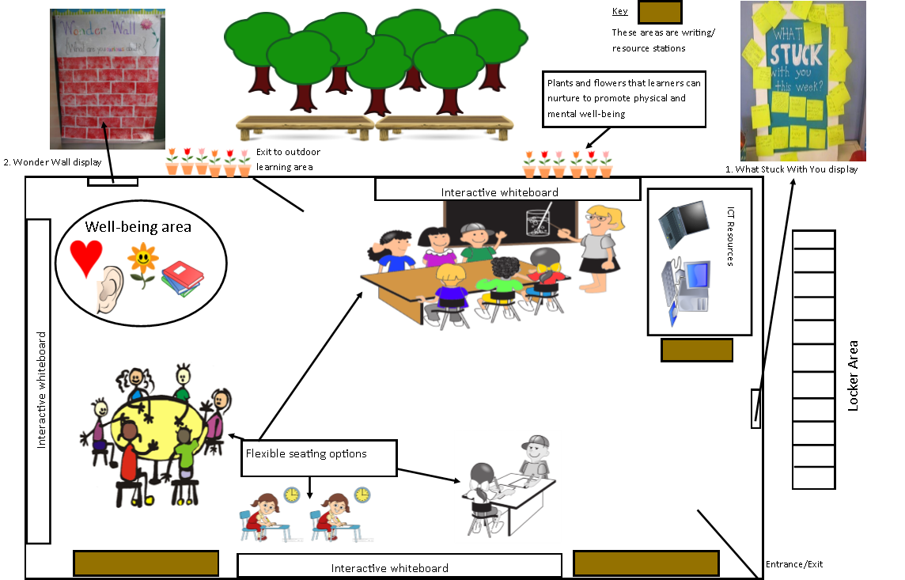
Learning Environment

Learning Environment

The ideal learning environment would encompass elements of social constructivism (Vygotsky et al), where learners are challenged and motivated to reach their full potential in an environment that encourages collaboration with adults and peers. It must be a safe and supportive space that is accessible and inclusive, and where expectations are high for all learners. There would be a positive atmosphere in the learning environment where success is celebrated and the work ethic is strong.
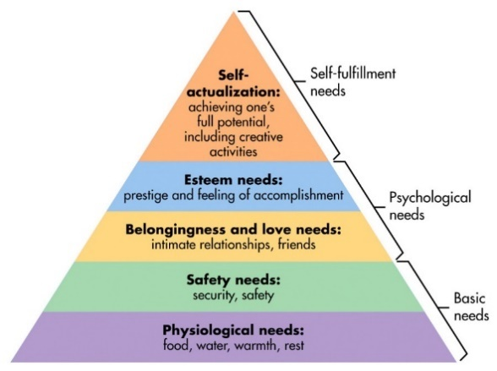
It is essential that Maslow’s Hierarchy of Needs (Figure 3) is observed within the learning environment as if the basic needs of learners are not met, they will not be able to achieve the higher elements thus creating a barrier to learning.
Figure 3 – Maslow’s Hierarchy of Needs

Within new the curriculum, health and well-being will be one of the six areas of learning and experience (Donaldson, 2015). Worrying statistics have been revealed about mental health problems in young people, with an estimated 40,000 children having mental health issues (Public Health Wales Observatory, 2013). As practitioners it is essential to provide learners with the appropriate coping strategies or help that they may require.

In addition to being calm and nurturing, the ideal learning environment will feature a specific well-being area. This area would have soft furnishings to promote relaxation, learners are then able to remove themselves from stressful situations to this area, or utilise it in times of anxiety. The area would feature posters with inspirational quotes and various useful coping strategies, as well as literature that can be used to aid and inform on various issues. Staff within the environment would be trained to provide emotional support to learners who require it and would also be ACE’s (Adverse Childhood Experiences) trained to understand the reasons why learners may encounter difficulties in their learning.

Displays within the classroom would showcase the work of learners as celebrating success is important but they would not be too colourful or contain too much stimuli as classrooms that are overly decorated may cause learners to become distracted (Weinstein et al, 2019). There would however, be specific displays such as a Wonder Wall. When a new topic is introduced, learners can use post-it notes to write what they would like to learn about the topic, then stick these to the Wonder Wall display. The classroom practitioner can then use these to inform planning. By using these ideas, learners will feel involved in the planning process and are therefore more likely to be engaged in the learning process. There would be a small What Stuck With Me display near the classroom exit. This would be an area where learners are able to reflect and can write down an aspect of learning that has interested them in some way. This could be carried out after a lesson, or on a daily or weekly basis. Again, the practitioner could use this to inform planning or identify any misconceptions that learners may have.

Donaldson’s review into the Welsh curriculum identified the need to develop digital competency across the curriculum. It is essential that the learning environment gives learners the opportunity to use, explore, and be exposed to, various technology. Therefore, the ICT Resource area would feature both laptops and iPads, but learners would also learn about various aspects of technology including coding to develop both understanding and interest. There would be large interactive white boards around the classroom so that all learners, regardless of where they are sitting will be able see the LO and SC for each activity.

The seating arrangement would be flexible dependent on the activity being carried out and on individual preference. Research carried out in Australia discovered that open plan classrooms with flexible seating arrangements had an overall better effect on not only learning but on well-being too (Kariippanon et al.). Within the learning environment there would be focus areas where a practitioner can work with a group of learners, but there would also be round tables so that learners are able to work collaboratively with peers. In addition, there would be tables where learners can work in pairs, and tables where learners can work individually depending on learner preference. Workstations or various heights would be placed within the learning environment for the learners who do not want to sit during an activity as this could encourage engagement.

To develop capable, ambitious learners, who are creative contributors (Donaldson, 2015), it is important to teach and develop higher level thinking skills. Though the definition of the term thinking skills is blurred, researchers have argued that they are required for effective learning (Cremin & Arthur, 2014).
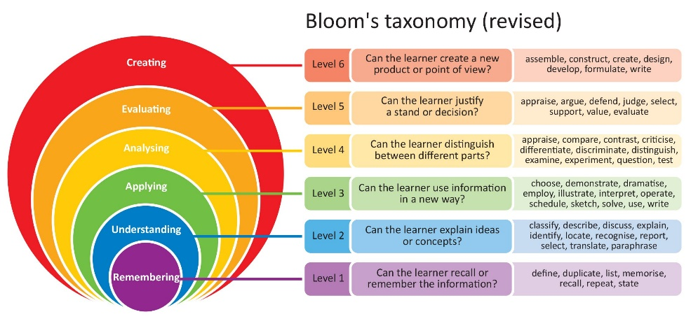
Figure 4 – Bloom’s Revised Taxonomy

Bloom’s taxonomy was published in 1956, building on previous work by Piaget and Vygotsky, Bloom identified the need for challenge to develop deeper thinking. The taxonomy was revised in 2001 by Lorin Anderson and David Krathwohl who redefined the original concepts. Figure 4 demonstrates the revised taxonomy and the various levels of questioning that the practitioner can use. These skills are essential, and practitioners need to equip learners with skills for the future. Research has indicated that providing cognitive challenge while the brain is still growing in early years of childhood, is more beneficial than when the brain is fully grown (Cremin & Arthur, 2014). It is therefore logical to use the time that learners are in school effectively.

Practitioners must also help learners develop metacognitive strategies as discussed previously, and learners should be given time to reflect upon their learning to hone these skills. Learners need to become self-aware and begin to realise that there is always room for improvement. The importance of AfL has already been discussed, the ideal learning environment therefore would promote formative assessment skills such as self and peer assessment for learners. Learners are then able to develop critical thinking skills, strive for independence, and take control of their own learning.

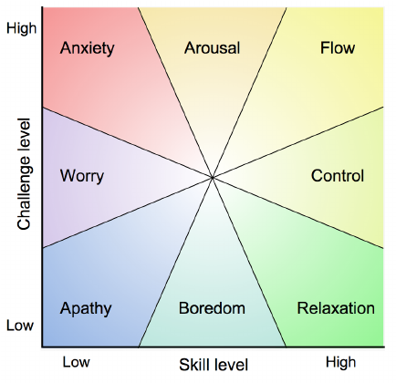
Professor Mihaly Csikszentmihalyi is known for his theory of flow in relation to high engagement within tasks. Flow is often described as being lost in an activity, yet many schools find achieving this quite challenging. Figure 5 shows a graph to demonstrate how to achieve flow within the learning environment. It is evident that there is a requirement of high skills use along with high challenge to achieve flow. If the skill and challenge are too low, then boredom can occur. There are six elements that need to be involved in getting the learning environment into a state of flow, these include: clear and worthwhile goals; appropriate challenges; tasks that are motivating; ensuring the learners have the necessary skills required for the task; providing feedback; and ensuring that teach input is minimal (Griffith & Burns, 2012). These elements can easily be implemented by using the Wonder Wall to help plan activities that the learners have suggested, this will engage and motivate them in the activity. By providing a LO and by discussing and creating their own SC, learners are aware of goals and how to achieve them. As for providing a task that is appropriately challenging, differentiation will of course be necessary. The practitioner will be aware that all learners will be working at different levels and will need to make sure that the skills being used match the learners’ capabilities otherwise flow will not occur. The activity would also need to be structured in such a way that learners can discuss and explore elements with peers, therefore effective planning is crucial. Learners can use AfL techniques for feedback and develop independence from the practitioner. All elements of flow are relatively simple, it is the combination of the elements that could prove challenging if they are not correctly addressed.
Figure 5 – Elements to achieve flow

The ideal learning environment would have an outdoor area with lots of trees and plants. Though outside areas are utilised mostly within the Foundation Phase, learners at Key Stage 2 should have the same access, therefore, the ideal learning environment would encompass this element. The benefits of having an outdoor learning area are numerous: well-being is improved, fine motor skills are developed, social skills are improved, and learners take an active role in learning (Bento & Costa, 2018). With having an outdoor area, there is an element of risk involved, however learners need to independently manage and assess these risks. The outdoor area would have an assortment of plants and flowers that learners could take responsibility for, nurturing them whilst enjoying watching them grow. To develop learners that recognise the importance of healthy eating and its benefits, they could grow fruit and vegetables within the outdoor area. Due to the increased amount of space, learners have the freedom to move around more which can only be beneficial to physical health. With large seating areas and work spaces outside, learning does not have to be contained to a classroom. It is essential that the outdoors - this free and ever-changing resource - is utilised.

The ideal learning environment then, does not just rely on physical aspects, it also relies on an understanding of, and the effective implementation of various learning theories too. The positive attitude and ethos of practitioners as role models also contributes to the ideal learning environment.

Bibliography
Bento, G. & Costa, J. A. (2018) Outdoor play as a mean to achieve educational goals - a case study in a Portuguese day-care group, Journal of Adventure Education and Outdoor Learning, 18:4, 289-302, DOI: 10.1080/14729679.2018.1443483
British Educational Research Association [BERA] (2018) Ethical Guidelines for Educational Research, fourth edition, London.
Black, P. et al. (2003) Assessment for Learning: Putting it into practice. England: Open University Press.
Black, P. and Wiliam, D. (1998) Inside the Black Box. North America: GL Assessment.
Boyd, D. G. and Bee, H. L (2014) The Developing Child. 13th Ed. Essex: Pearson Education Limited.
Cremin, T. and Arthur, J. (2014) Learning To Teach In The Primary School. 3rd Ed. Oxon: Routledge.
Dean, J. (2000) Improving children’s learning. Oxon: Routledge.
Donaldson, G. (2015) Successful Futures: Independent Review of Curriculum and Assessment Arrangements in Wales. Caerdydd: Llywodraeth Cenedlaethol Cymru.
Estyn (2018), A report on Pontarddulais Primary School: June 2018.
Gray, C. and Macblain, S. (2015) Learning Theories in childhood. 2nd Ed. London: Sage Publications Ltd.
Griffith, A. and Burns, M. (2012) Outstanding Teaching: Engaging Learners. Wales: Crown House Publishing.
Grigg, R. (2015) Becoming an outstanding primary school teacher. 2nd Ed. Oxon: Routledge.
Harlen, W. (1994) Enhancing quality in assessment. London: Paul Chapman Publishing Ltd.
Hall, K. and Burke, W. (2003) Making formative assessment work. England: Open University Press.
Hattie, J. (2009) Visible Learning: A synthesis of over 800 meta-analyses relating to achievement. Oxon: Routledge.
James, M. (1998) Using Assessment for School Improvement. Oxford: Heinemann Educational Publishers.
Kariippanon, K.E., Cliff, D.P., Lancaster, S.L. et al. Learning Environ Res (2018) 21: 301. https://doi.org/10.1007/s10984-017-9254-9
Petty, G. (2014) Evidence-based Teaching: A practical approach. 2nd Ed. Oxford: Oxford University Press.
Public Health Wales Observatory (2013) Health of Children and Young People. Available at: http://www.publichealthwalesobservatory.wales.nhs.uk/child-profile-wales-report (Accessed October 2018)
Reece, I. and Walker, S. (2008) Teaching, Training & Learning: A Practical Guide. 6th Ed. Tyne & Wear: Business Education Publishers.
Weeden, P., Winter, J., and Broadfoot, P. (2002) Assessment: What’s in it for schools? Oxon: Routledge.
Weinstein, Y. et al (2019) Understanding How We Learn: A Visual Guide. Oxon: Routledge .

Figures
Figure 1 – Donaldson’s Four Purposes – Image available at http://pantyrhedyn.weebly.com/adroddiad-donaldsondonaldson-report.html (Accessed September 2018)
Figure 2 – The Zone of Proximal Development – self produced. Information taken from: http://www.innovativelearning.com/educational_psychology/development/zone-of-proximal-development.html (Accessed October 2018)
Figure 3 – Maslow’s Hierarchy of Needs – Image available at https://www.simplypsychology.org/maslow.html (Accessed October 2018)
Figure 4 – – Bloom’s Revised Taxonomy - Image available at https://www.niallmcnulty.com/2017/11/blooms-digital-taxonomy/ (Accessed October 2018)
Figure 5 – A graph representing the response to various combinations of skill and challenge in relation to flow - Image available at https://www.researchgate.net/figure/Csikszentmihalyis-Flow-mode-Mihaly-1997_fig4_263047439 (Accessed October 2018)

Learning Environment pictures
- ‘What stuck with me’ display – available at https://www.pinterest.co.uk/pin/124974958387674584/ (Accessed October 2018)
- ‘Wonder Wall’ Display – available at https://www.pinterest.co.uk/pin/377246906260124800/ (Accessed October 2018)
- All other pictures obtained from Clipart stock.

