

Independent Project

Amazon's delivery system and returns policy

Student Name: Constantin Alexandru Petrescu
Student ID: 2227903
Module Cod: LCLM6005
Lecturer Name: Mohamed Rahman

Table of Contents
Element 1: Dissertation document 6
Chapter 1: Introduction 6
1.1 Introduction 6
1.2 Background of the study 6
1.3 Organisational Overview 6
1.4 Problem Statement 7
1.5 Research Rationale 7
1.6 Research Aim 7
1.7 Research Objectives 7
1.8 Research Questions 8
1.9 Structure of the study 8
1.10 Summary 9
Chapter 2: Literature Review 10
2.1 Introduction 10
2.2 Review of Academic Evidences 10
2.2.1 The issues of operational and financial activities that are faced by the owners of small business for the easier return policy of ecommerce industries 10
2.2.2 The impact of return policy on the consumer behaviour and the annual performance of sales of SMEs that has been observed in the ecommerce platforms. 11
2.2.3 Several strategies that are implemented by the small companies of the e-commerce industry to overcome return-related process to ensure higher percentage of profit 12
2.3 Theoretical Framework 13
2.4 Literature Gap 13
2.5 Summary 14
2.6 Conceptual Framework 15
Chapter 3: Methodology 16
3.1 Introduction 16
3.2 Research Onion 16
3.3 Research Philosophy 16
3.4 Research Approach 17
3.5 Research Design 17
3.6 Research Method 17
3.7 Data Collection Tools and Analysis 18
3.8 Time Horizon 18
3.9 Ethical Considerations 18
3.10 Conclusion 18
Chapter 4: Results and Discussion 19
4.1 Introduction 19
4.2 Qualitative analysis 20
4.2.1 Objective 1: Financial and operational issues faced by small business owners due to the easy return policy of Amazon 20
4.2.2 Objective 2: Influences of Amazon's return policy on consumer behaviour and affects the annual sales performance of the small businesses 25
4.2.3 Objective 3: The process by which small businesses of Amazon can deal with return-related issues while ensuring a high profit percentage on Amazon. 30
4.3 Discussion 34
4.4 Summary 36
Chapter 5: Recommendations, Conclusion and Limitations of the research 37
5.1 Conclusion 37
5.2 Recommendations 37
5.3 Limitations of the study 38
5.4 Scope for further study 39
References 40
Element 2: Research Process Reflection 46
Introduction 46
Kolb’s Learning Cycle 47
Conclusion 48
References 49
Element 3: Methodology Poster 50
Introduction 51
Chosen methods and strategies 52
Key findings 53
Conclusion 54
References 55
Appendix – Gantt Chart 56

Element 1: Dissertation document

Chapter 1: Introduction

1.1 Introduction
The first part of this study is the ‘Introduction’ which offers a detailed description of the whole project. This context helps to provide different elements on the topic and evaluate the impacts. The background of the subject and the main issue will also be investigated in this section. Aim, questions and objectives will be prepared for progressing the research. It will provide a brief description of the business and its offerings in this part. It is required to identify the significance of the study which will also be included in this chapter. The structure of the entire project will be mentioned in this portion.

1.2 Background of the study
An easy return policy permits consumers to return their items within a limited timeframe (Ecoffet et al., 2021). It can be performed within conditions such as the product being in its same conditions with the tags attached. Different key components encompass clear instructions for producing a return. Various organisations have terms and conditions for conducting the process. It also requires proof of purchase and original packaging for returning any item. According to information 65% of the UK online shoppers have stated that the return should be free (supplychainbrain, 2024). These statistics have proved that it has influenced consumer behaviour significantly. A hassle-free return to activities lowers the perceived threats and makes the audience feel safer. Such action has impacted the consumers’ purchasing behaviour and enhanced satisfaction (Margono and Gantino, 2021). This context maximises the sales and leads to higher return volumes. A fair policy builds trust and attracts a huge number of audiences towards the business.

1.3 Organisational Overview
Amazon is a well-recognised organisation that offers e-commerce services and sells online products to its customers. It was founded in the year 1994 by Jeff Bezos and its headquarters are in Washington. The organisation is a global leader in cloud computing, e-commerce, AI and digital streaming (amazon, 2025). Such a business operates in diverse key divisions including Amazon retail, Prime Video, web services and devices. The mission of this organisation is to become the earth’s most consumer-centric business that concentrates on affordability, innovation and efficiency. It has operated in nearly 20 countries and has more than 300 million audience worldwide. Introducing a global digital structure helps the business to reinforce its roles.

1.4 Problem Statement
In recent years Amazon’s easy return policy has been designed to foster consumer satisfaction. This context has highlighted some operational and financial issues for small businesses selling items on the platform. The sellers have experienced problems due to a rise of returns and the maximised cost of logistics (Frei et al., 2022). Due to the profit margin reductions and inventory losses have decreased its selling capacity on the platform has decreased. On the other hand, fluctuations in return volumes also limit its operational efficiency. This context has disrupted its business functions and led to losses. Small businesses have experienced an imbalance of accountability that reduce consumer satisfaction in the business (Williams, 2025). It has disrupted the cash flow stability and decreased the sales performance. This study needs to evaluate some solutions which may help to mitigate the problems.

1.5 Research Rationale
This project is essential for realising the influence of Amazon’s return policy on small businesses. Different policies play a crucial role in developing consumer trust and experience (aboutamazon, 2024). Such actions have unintentionally built operational inefficiencies and monetary strains. It has lowered the profit and magnified the challenges significantly. The following study will explore various issues that the business is experiencing in the present situation. It has also incorporated with positive outcomes which impact the consumer’s confidence (Wickham, 2025). This study has value as it can identify the impacts of the easy return policy at Amazon. Analysing these aspects, it will develop some tactics that may assist small businesses in gaining profit. The investigator will prepare new models or improve the existing ones to enhance customer satisfaction.

1.6 Research Aim
To examine the influence of Amazon’s easy return policy on small business owners listed on the platform.

1.7 Research Objectives
To analyse the financial and operational issues that small business owners encountered in the last 12 months because of the easy return policy of Amazon.
To explore the Amazon’s return policy that has influenced consumer behaviour, along with affecting the annual sales performance of the small businesses listed on the platform.
To evaluate the process in which small businesses of Amazon can deal with return-related issues while ensuring a high profit percentage on Amazon.

1.8 Research Questions
1. What are the financial and operational issues that small business owners encountered in the last 12 months because of the easy return policy of Amazon?
2. How does Amazon’s return policy influence consumer behaviour, along with affecting the annual sales performance of the small businesses listed on the platform?
3. How can the listed small businesses of Amazon deal with return-related issues within six months while ensuring a high profit percentage on Amazon?

1.9 Structure of the study
Chapters | Description
Introduction | The first chapter of this study indicates different parts that help in introducing the subject. Background, problem statement, objectives and aims are included in this chapter. The justification of selecting this subject is also mentioned in this portion.
Literature review | It offers a detailed explanation of the topic using existing literature. Three objectives are described in this portion utilising secondary resources (Ritterbusch and Teichmann, 2023). The theoretical framework and the literature gap are explored in this part.
Methodology | A detailed choice of progressing the whole study will be discussed in this portion. Different approaches including strategy, philosophy, data collection, design and ethics will be included in this part.
Findings and Discussion | The findings’ part will describe the outcomes which have been gained from diverse sources. Using themes the answers will be offered. A detailed discussion of the perspectives will also be explored in this chapter.
Conclusion and recommendations | The last chapter of this study is ‘conclusion and recommendations’ which represents a key summarisation of the research. Recommendations will be presented to mitigate the issues highlighted in this portion.

1.10 Summary
This chapter has presented a short description of the subject which is vital before progressing with the entire study. The main context of the problem statement has been highlighted in this portion. Objectives, aims and objectives have also been mentioned to find out the answers. It will include a detailed structure of the entire project. The rationale of the study will be discussed in this chapter to understand the subject more accurately.

Chapter 2: Literature Review

2.1 Introduction
The comprehensive evaluation of existing theories, research and various scholarly works will be done in this section of the study. Here, the scholarly works will be done because of the impact of product return terms on the owners of SMEs in the ecommerce industry. The policy of returning the product has a huge impact on the confidence of consumers and it helps to build a huge clientele easily. The section will show the ways paved out by the business entities to gain competitive advantages with such a condition. It will discuss various operational constraints along with economic challenges the SMEs faced in recent times in the chosen industry. After establishing the arguments with various journals, here another strong argument will be presented that will show the effect of this certain organisational procedure on consumer behaviour. Some potential strategies will also be represented to overcome those constraints with the utmost precision. Some theoretical frameworks will also be delivered in this context, which have absolute relevance with the variables of the study. The drawbacks of the used scholarly journals will be drafted precisely to enhance the credibility of the study and at last, this section will be concluded with a conceptual framework.

2.2 Review of Academic Evidences

2.2.1 The issues of operational and financial activities that are faced by the owners of small business for the easier return policy of ecommerce industries
Loss of revenue for multiple fraudulent returns
According to Merlano et al. (2024), fraudulent returns have made a huge impact on the revenue streams of small business houses in the retail industry. The customer-centric policy of larger entities of the ecommerce sector has made room for abusing the return rules of customers. As per these authors, with the increasing omnichannel business, the return of fraudulent products has been increasing simultaneously. Using two critical frameworks, such as planned behaviour and fraud triangle, they also argued that this kind of abuse of the return terms plays a critical role in distorting the ecosystem of goods return. Small business owners face a severe impact on revenue generation to a great extent. In the same way, Magano et al. (2024) also claim that the manipulation of the return of the goods and different false claims increase the operational costs. They also claim that in such cases, the companies are forced to make full refunds of the money to the consumers.

Challenges of reverse logistics and inventory
Reverse logistics can affect the income of a company that is very small in size in the chosen sector. However, it comparatively makes a lesser impact in the big companies, and this creates one of the most crucial operational burdens for the entities. According to O'Sullivan (2025), reverse logistics has become one of the most crucial reasons behind the erosion of profit marketing. As per the opinion of the author, this process is more complicated than forward logistics. While the process of return of products starts then such complication is increased by multiple times. The owners of the company must allocate additional resources for this purpose, which requires the engagement of an extra workforce in the organisation. Through making qualitative research, the author due to this reason their carbon footprint is also increased which harms their sustainable image. On a different note, Elia et al. (2024) also claim that due to having loopholes in the sorting system, small business houses the returned items sometimes mix with new inventory.

Problems in stock forecasting and stock management
Karl (2024) opines that due to returning the product, different types of issues are faced by the shopkeepers in the ecommerce industry while they manage their stocks. According to this investigator, in such a dynamic market, returning of commodities not just indicates the issue of consumer demand. It also creates the same constraints in the supply side. While the process of return of the commodity is introduced, companies must engage employees to inspect and repackage items. This makes the restocking and procurement of commodities very tough. During conducting this study, the author followed the PRISMA guideline effectively and by incorporating that method, it becomes understood that segmentation issues can be generated while items are returned. Additionally, Kmiecik (2024) also states that due to a lack of capital, it becomes harder for the small sellers to integrate returns and sales data. This leads to a potential mismatch between stock counts to a great extent.

2.2.2 The impact of return policy on the consumer behaviour and the annual performance of sales of SMEs that has been observed in the ecommerce platforms.
Effect on brand loyalty
Lysenko-Ryba et al. (2021) state that lenient return policy of different items makes the image of the commercial entities more customer-friendly. It can easily influence the recognition of the brand to a huge extent. With the lenient regulations of returning faulty items, companies of the selected industry can signal to customers that the entity is extremely trustworthy and consumer oriented. This kind of attitude plays a critical role in attracting new clients in a very short time and delivers competitive advantages significantly. The quantitative empirical approach of this study has given the authors a huge scope to establish that such lenient conditions can be used as a positioning tool.

Change in average order value
The frequent returning of different commodities makes a huge impact on the changes in average order value. Gustafsson et al. (2021) indirectly claims that due to a flexible returning policy, consumers of the small organisations show their bracketing behaviour. Showing such behaviour, they order many items in expectation of returning some. This kind of attribute of consumers directly increases over orders significantly, which impacts the gross order size of the company. During the exchange of the product, the companies of this concerned industry also get an opportunity to upsell the premium alternatives, which can increase repeat transactions. However, by reducing the rate of returns with the support of digital fitting retailers can improve consumer satisfaction and trust.

Strain in Working Capital
The policy of exchanging or replacing different items also creates severe strain on the working capital in the small enterprises of the chosen industry. According to Joukamo (2025), due to such exchange of goods, the days of inventory outstanding are increased in the company, which creates strain in liquidity. On a different note, such a practice can easily lengthen the cycle of conversion of cash and this also create strain in liquidity. Incorporating the quantitative research, the author also ratifies that while the exchange of items is processed then SMEs must face a disproportionate cost of logistics. This kind of cost directly makes a negative impact on the operational expenditure.

2.2.3 Several strategies that are implemented by the small companies of the e-commerce industry to overcome return-related process to ensure higher percentage of profit
Enhancing product visualisation and commodity information
Using multiple case studies, Frei et al. (2022) state that enhancing visualisation of goods is one of the best approaches that can be adopted by SME owners to reduce item exchange. As per the authors, this strategy is very effective in increasing the consumer expectation to a larger extent. With the assistance of enhanced visualisation of commodities, the mental model of customers can be developed. Such development of mental models is also very significant from the perspective of the drop in the probability of return. On a different note, product mismatch is one of the primary reasons for returning the items. Javornik et al. (2021) also say that with the help of augmented visualisation of commodities the rate of mismatch returns can be reduced.

Automated return management system
From the study of Kembro and Norrman (2022), it becomes very evident that integrating automation systems in the return management of products can decrease the return rate of items. The smart warehousing system can easily reduce errors in the handling of goods. It can also easily improve the real-time visibility of the exchanged items. This type of system will help to overcome issues such as the shipping of wrong items. Using the exploratory survey, in this study, the author has ensured that with the support of automation systems, the labour costs of the warehouse can be scaled, and the burden of expense can be removed significantly.

Working Capital Management Model
Diiashvili (2025) claims that the working capital management model is the most fit attribute in the context of curtailing the rate of returned product to the retailers. With the incorporation of this model, the demand of consumers can be forecast more accurately. It can also help retailers in optimising the safety stock and help to mostly mitigate the over-ordering issues. As per Tudor, (2022), this management tool has ample potential in investing in various pre-sale tools such as quality checks, virtual fittings and item’s visualisation. Leveraging these scopes plays a crucial role in reducing returns of goods to a significant limit.

2.3 Theoretical Framework
According to Manuere et al. (2022), the Howard Sheth Model of consumer behaviour is the most efficient theoretical attribute for this study. This model can help the small shoppers of the concerned sector to create a positive initial perception among consumers. Through this model, it becomes easier for the entities to mention the refund conditions. On the other side, Wilhelm (2023) also states that this framework has ample potential to manage expectations through using visual aid and helps to shape positive perception and encourage repeat purchases. The incorporation of this theory will help the companies in using AI-regulated chatbots that can assist in developing a positive brand attitude,

2.4 Literature Gap
There are several useful insights that are gained through the scholarly journals about the impact of the replacement strategies of the product on the business owners of SMEs. However, there are some loopholes that are noticed in those journals. For example, the research of Merlano et al. (2024) shows that fraudulent returns of products make a huge impact on retailers. Here, the authors have conducted only the supply-side research. They did not do any type of research on the consumer-demand side. There is also a requirement for a framework that can easily integrate both consumer behavioural theory and fraud theory, which is very effective in e-commerce retail. Besides that, O'Sullivan (2025) has also depicted the issues associated with reverse logistics that are faced in the retail industry through various methods. However, the academic investigations of the author have not investigated inter-party vulnerabilities in such cases. On a different note, Lysenko-Ryba et al. (2021) has stated about the benefits of lenient returns of components that are widely used by shoppers while they newly enter the market. In this literature, the academic investigators have treated such procedures of commodity return from an operational perspective. However, there is no detailed study about these attributes from a marketing perspective. This literature had to emphasise the e-commerce sector to make this study more specific.

2.5 Summary
The above discussion of this chapter has delivered a detailed insight in different aspects of the conditions of returning goods. It has helped a lot to establish a strong foundation for the entire research through delivering a sound concept of the topic. Apart from investing in different kinds of scholarly works, it has also indicated some loopholes in the journals. Moreover, the prime variable of the study has been justified with the help of a theoretical framework. The development of the theory has also been clarified by a conceptual model.

2.6 Conceptual Framework
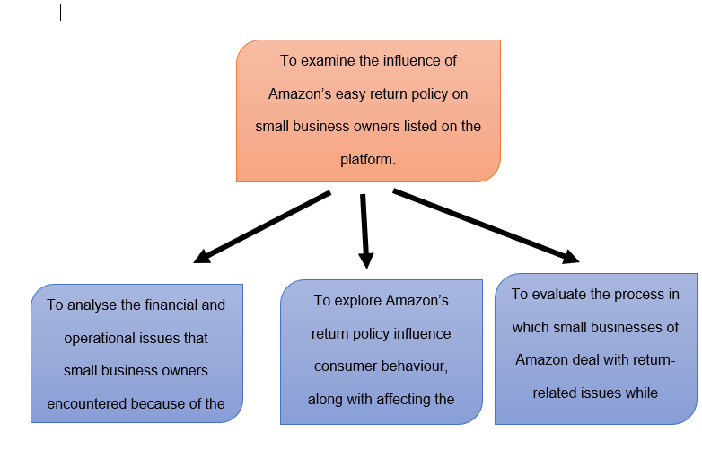

Chapter 3: Methodology

3.1 Introduction
This chapter will explain the information related to the selected methodology technique and its potential benefits that can be experienced. A Saunders Research Onion methodology will be applied due to the different advancements and its easy applicability by the researcher. All the layers included in the structure will be presented and analysed for justification of the choices made for conducting this investigation.

3.2 Research Onion
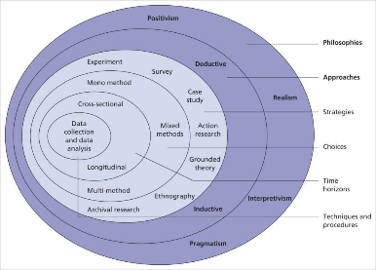
Figure: Saunders Research Onion
Source: (Denny and Weckesser, 2022)
A suitable model was made by Professor Mark Saunders and his team for getting a systematic view of the processes included in the research. It helps the individuals perform their investigation and make assumptions based on a continuous approach to the respective choices (Denny and Weckesser, 2022). This method is considered very useful in exploring on insight and rigor to the study. It helped with the presentation of a constant and clear research design outline. It is also essential to enhance the simplicity and flexibility of the investigation (Köhler et al., 2022).

3.3 Research Philosophy
A research philosophy is a set of opinions and expectations that would influence the understanding and gathering of information to define the body of knowledge. Four main types exist positivism, realism, interpretivism and pragmatism (Hendren et al., 2023). Other decisions that are made in this field are also known to affect the design and the action that is taken in the investigation. An interpretivism research philosophy has been used within the project to complete the various operations. The ability to produce high-quality outcomes of the gathered data and information was useful in adding subjectivity (LaMarre and Chamberlain, 2022). This option has also been vital to gaining comprehensive insight into the problems as per the social dynamics.

3.4 Research Approach
It is an overall plan which includes the various activities, including collection, analysis and appropriate interpretation of the required data. The three primary types of this layer of methodology are deductive, inductive and abductive. This investigation has been conducted using the inductive research approach to gather and analyse the appropriate information to create new results (Stewart, 2022). It helps increase the flexibility and adaptability of the methods and measures taken for successfully completing this investigation. This technique is also known to add rich and detailed insights to adapt the approach as they are implemented throughout processes (Van der Weele and Bredewold, 2021).

3.5 Research Design
The complete blueprint of the strategy for a study to be conducted to outline the different operations for grouping, measurement and evaluation of the information (Ezer and Aksüt, 2021). It has acted as a master plan for the successful completion of the relevant actions and activities with the provided structure. Experimental, descriptive and exploratory are the various types of research designs that can be included in an investigation as per the requirements (England, 2022). An exploratory technique has been selected for the conduct of different processes and methods in this study. It adds a better understanding of the related themes and context to the project deliverables.

3.6 Research Method
There is a selection of specific techniques and tools that are used to derive the different approaches to data collection and interpretation. Mono, mixed and multi are the three types of measures as per the suitability of the derivable on qualitative or quantitative data. A mono-method has been selected due to the various benefits that can be gained for data gathering in this investigation (Tracy, 2024). It is a single process method that is easy to apply and track the respective activities. Thus, the chances of incurring biased and irrelevant information have been reduced to a significant extent. Other factors, such as cost efficiency and methodical simplicity, are gained by the research as well.

3.7 Data Collection Tools and Analysis
Many strategies and methods are available for gathering and grouping the essential information related to the selected topic. Thematic analysis has been chosen for successful data collection and interpretation in the scope of this investigation (Brennen, 2021). It helped add more insights and details to the context of the study in relation to the various themes and concepts. Thus, a positive impact can be gained in generating relevant outcomes and conclusions from the undertaken research. A suitable application of essential strategies has been made to assess the versatility of the design and derive content to add credibility (Silverman and Patterson, 2021).

3.8 Time Horizon
This layer of the research onion is known to showcase the length of time taken for the study to be completed effectively. There are mainly two types of time horizon that are distinguished as cross-sectional and longitudinal. It represents the timeline that involves data collection and performing the other tasks within a limited timeframe or a specific moment (Dumitrica and Jarmula, 2022). The study has been subject to a faster and cheaper way to conduct the operations and functions with the involvement of this choice. It also helped the researcher to gather data on multiple variables and contexts simultaneously, which reduced the time and resources used.

3.9 Ethical Considerations
It is observed that an effective maintenance of all the ethical norms and regulations that are essential for conducting research has been done (Stapley et al., 2022). The list of all guidelines stated by the authorities of the University has been followed as well for the successful completion of this project. All the sensitive content in relation to the informed consent from participants in selected evidence has been verified and evaluated (Newman et al., 2021). Similarly, the reliability and credibility of the investigation and its developed context have been retained as well.

3.10 Conclusion
All the choices made in this chapter have been supported with proper justification and comparison with the other options. There has been added a Gantt Chart to keep track of the various activities included in the successful completion of this chapter. A focus was made on maintaining all the ethical principles and norms throughout the coordination of the activities.

Chapter 4: Results and Discussion

4.1 Introduction
The findings and discussion chapter is a vital part as the core information related to the return policy of the Amazon platform. Secondary thematic analysis will be conducted here, collecting various insights from relevant sources. Online publications, Google Scholar and reviews on the policies from the sellers will be considered. Based on each objective, some themes will be made related to the context for detailed analysis. The financial and operational complexities for small businesses because of Amazon’s easy system of returning items will be disclosed here. Further, the influence of the policy on shifting consumer conduct will be described with the depiction of core themes. Based on the challenges, strategies will be proposed for small sellers to overcome the problems related to sales performance, loss and operational issues. The entire findings from thematic analysis will be compared to the literature review that led to an ultimate discussion of the overall context.

4.2 Qualitative analysis

4.2.1 Objective 1: Financial and operational issues faced by small business owners due to the easy return policy of Amazon
Theme 1: Reasons for destroying returned items
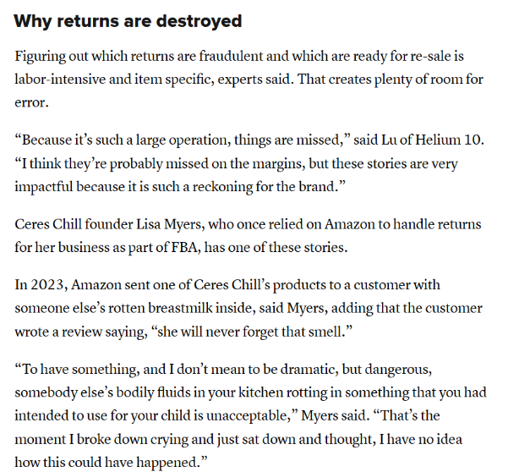
Figure: The intention of destroying return items by small sellers
Source: (Tarasov, 2025)

Analysis
Returned products on Amazon are sometimes destroyed due to the complex and highly expensive processing system. Also, damaged goods cannot be resold, and the only option is to discard them by the sellers. The increased economic as well as logistical pressure forces businesses to make such decisions that induce loss (Tarasov, 2025). Small business owners cannot balance the expenses of inspection, repackaging and relisting the returned goods as the long-term procedure exceeds the actual value of the products. The damaged, unpacked, and used items are not eligible for reselling and are then discarded. Additionally, the intact returned products need time and labour to verify the condition, repacking, restocking and delivering. To avoid the lengthy process of low-priced items, sellers prefer to destroy them. The CNBC article depicts that Amazon’s return policy is designed for the well-being of its customers, and careless returns are accepted. Despite sellers' complaints about used or swapped returns, Amazon continues its automated return system without prioritising the shoppers’ concerns. For example, one seller claimed to have received a box full of rocks instead of the original items and was still being forced to refund that customer. This kind of issue is under the context of abuse that drives shoppers to take drastic steps (Rintamäki et al., 2021). As a result, many small businesses prefer to dispose of items rather than follow the recovery process, which is more costly and complicated. Additionally, sometimes, Amazon’s own warehouse operations destroy returned items when the storage costs are high.

Theme 2: High return rates and revenue losses
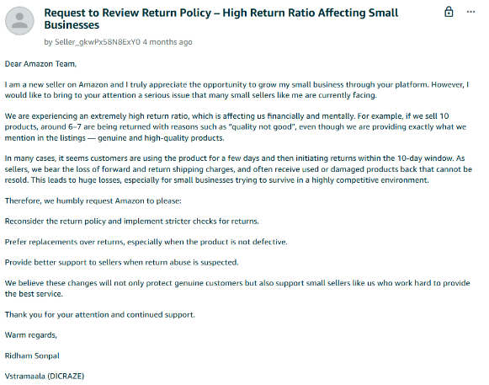
Figure: Request from the seller to the Amazon Team for reviewing the return policy
Source: (Sellercentral, 2025)

Analysis
The return policy of Amazon is easier to meet the demand of customers and satisfy them (García‐Dastugue et al., 2024). However, this has increased complications for small business owners who use the platform for selling their products. The above evidence shows the complexities faced by the ventures, and thus, they are requesting Amazon's teams to review the policy. By affecting their financial and operational activities, the policy overall hinders revenue generation. The flexible approach allows customers to return items frequently without any return charges. No specific details or cause are required for this activity, and due to the lack of inspection, huge returns are noticed. This causes uncertainty of sales for the small businesses, and they face a loss. The break of cycles or patterns of sales affects their operations, which limits revenue generation. Additionally, some customers return used products in damaged condition, which creates trouble in reselling them to other customers (Sellercentral, 2025). Therefore, the cost of the items, their shipping and packaging is absorbed by the business owners, which indicates potential financial loss. Products which are returned in good condition can be sold further; however, the expenses on restocking and repackaging increase operational costs. Also, the process is more time-consuming, and the additional resources affect a small business’s growth. Due to the unpredictability of returns, managing inventory becomes complex, and the cash flow is affected. This forces sellers to maintain higher stock to manage potential returns and provide new customers with their desired items. The modifications in the system require more space and time, which limits the companies’ focus on key operational factors. Another complexity involves making a proper plan and forecasting the demand; thus, it becomes difficult to invest significantly. Customer service demand increases while such businesses handle disputes efficiently and allow returns easily. Amazon does not provide necessary support to the small ventures on their potential loss or operational burdens.

Theme 3: Return fraud and product swapping
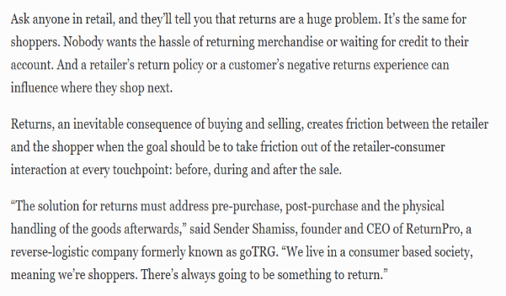
Figure: Complexities caused by fraud in returns
Source: (Danziger, 2025)

Analysis
According to the online publication, retailers find it challenging to get returns of products from customers. Shoppers of Amazon thus experience the trouble and are further affected by fraud in returns and swaps. The e-commerce platform is dedicated to satisfying global customers, and to avoid negative reviews, it gives them such facilities. Return fraud is mainly done in the form of product swapping, which is a growing concern for independent sellers on the company’s marketplace (Danziger, 2025). The process involves purchasing items by customers and returning different or damaged pieces which have less value in the market. These returned products are non-functional, most of the time, though they are claimed as original. As the return system of Amazon is automated and its prime intention is customer convenience, the fraudulent procedure is increasing without proper inspection. It has negative implications for sellers as they have to bear the entire costs. For small businesses which are operating on definite margins, it is detrimental. They receive unsellable items in return for fresh ones, which makes the loss double. Sometimes, sellers complain of receiving empty boxes or boxes filled with waste that causes huge losses for them. They do not want to be associated with any legal trouble by complaining against those customers, and the tendency to avoid burdens forces them to face such issues on a regular basis. Fraud during returns disrupts the businesses’ inventory tracking systems, sales data and thus creates challenges for the logistics department (Dupuis et al., 2023). The small ventures find themselves vulnerable, and due to a lack of support from Amazon, running their activities becomes difficult. They are supposed to follow the rules set by the marketplace despite potential losses. It also affects their trust in the platform, and the relationships between the sellers and Amazon are hampered.

4.2.2 Objective 2: Influences of Amazon's return policy on consumer behaviour and affects the annual sales performance of the small businesses
Theme 4: Effects of Amazon’s return policy on customer purchasing behaviour
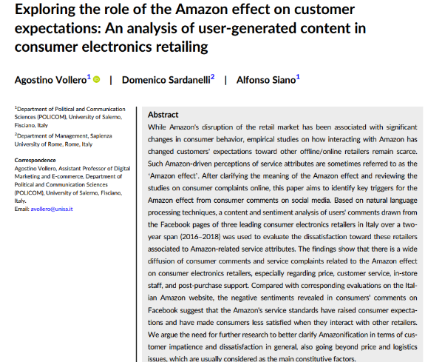
Figure: Impact of “Amazon effect” on consumer expectations and attitudes
Source: (Vollero et al., 2023)

Analysis
Return policy by Amazon has shaped customer purchasing behaviour by creating a culture of trial-based buying, convenience, and this has increased service expectations throughout the retail field. The journal explores how Amazon’s operational model in the seamless return system has influenced consumer demands significantly (Vollero et al., 2023). Their performance has been improved to experience any services and return them in case of dissatisfaction (Amazon, 2025a). The policy designed by Amazon that allows customers to send back products has altered their perspective from commitment to trial-based buying. Clienteles have the power to test products for increasing their level of satisfaction. This process reduces the threat of losing customers however, it led to development of temporary purchasing behaviour. It drives individuals’ perception of purchasing goods for temporary use and returning them within the mentioned deadline. The ease of the return process allows them to think this way and try products without thinking carefully about the colour, size and quality of products before ordering. This kind of mentality is beneficial for consumer satisfaction; however, it creates inconvenience for sellers as they face a loss. The effect of Amazon’s system has changed consumer shopping attitudes, along with redefining their consideration for accepting services. The current social media commentary and customer reviews indicate the increasing impatience of people, their lack of consideration and morale. Sellers who cannot fulfil the standards or practices of Amazon’s return policies properly face severe criticism, which also highlights individuals' poor tolerance. Negative reviews spread faster and increase restocking expenses, which is a complex procedure for small sellers.

Theme 5: Amazon’s responsibility for product recalls
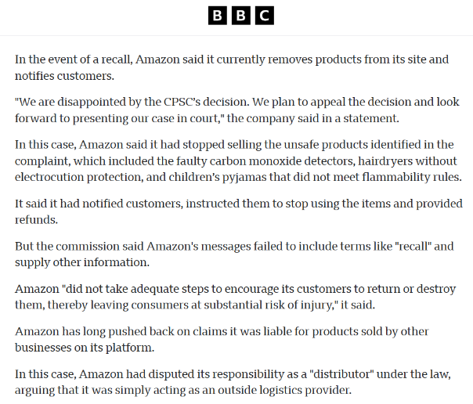
Figure: Accountability of Amazon for product recall
Source: (Sherman, 2024)

Analysis
Amazon is accountable for product recalls, specifically for unsafe or disputed items sold to customers through its platforms (Martin, 2021). It highlights the company’s dedication to maintaining consumer protection laws and regulatory compliance. The company positions itself as an intermediary between third-party sellers and buyers globally. It is also famous for giving consumers the right to return unused products due to their defects or other reasons. In the BBC article, it is clearly mentioned that Amazon is fully responsible for recalling unsafe products sold on its online site. Thus, the decision taken by the platform meets consumer protection law and highlights dedication to customers. The CPCS criticised it due to the inconsistency of the recall system for the items of false carbon dioxide detectors (Sherman, 2024). Its failure to inform customers about the cautiousness of hazardous people causes severe reputational loss. Amazon then conducted a robust plan to manage recalls and ensure customer protection. Along with confirming this, the organisation has given more advanced chances for buyers that are affecting the sellers. Though the intention is pure and convenient, many customers use the facility in the wrong way. The decision of Amazon to give customers the power to return is adverse for small businesses, which must be addressed. Additionally, the increased accountability of recalling causes more operational costs for the organisation, which affects its revenue streams as well. Still, implementation of a suitable plan for supporting sellers can increase their motivation, and a robust plan to reduce unnecessary returns is needed.

Theme 6: Effects of Amazon’s return policy on small businesses’ sales performances
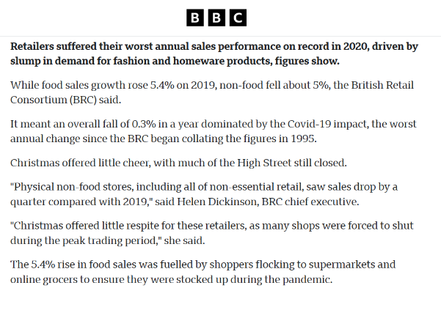
Figure: Impacts of Amazon’s return system on sales performance of small online retailers Source: (BBC, 2021)

Analysis
The return policy set by Amazon has a notable impact on small businesses’ sales performances by affecting profit margins, increasing operational costs and reducing customer trust. The BBC article highlights that the company's customer-centric return system is convenient for buyers; however, it creates challenges for small sellers. Many small businesses have lodged complaints that due to the easy policy, impulsive buying and careless returns are increasing. The frequent returns lead to unpredictable sales patterns that are detrimental to managing business activities (BBC, 2021). This affects the revenue of the ventures and creates complexities in inventory management. Thus, maintaining cash flow in a consistent form is challenging for small enterprises that utilise Amazon’s platforms for sale. Sellers found themselves surrounded by a cycle of selling, returning and reselling or disposing at a loss and the entire process forced them to reduce profitability. The article highlights that some retail businesses have experienced significant drops in their net sales due to the high rate of returns, specifically in the categories of fashion, electronics and home accessories. Along with financial streams, the policy affects sellers’ ratings as dissatisfied customers give poor ratings or reviews about the returned products. This has a negative effect on the visibility of the online retailers on the platform, as reviewing the comments, other customers show a lack of interest. Returned items change consumers’ perception about buying, and it indicates poor performance metrics that, in turn, decrease sellers’ opportunities of appearing in top search lists (Doherty, 2023). The loss of visibility impacts the sales volume and growth of the small businesses directly. To deal with that situation, sellers try to invest more time and resources into their customer service and resolving disputes, which further limits their budget. It causes increased operational costs that indirectly affect the sales margin.

4.2.3 Objective 3: The process by which small businesses of Amazon can deal with return-related issues while ensuring a high profit percentage on Amazon.
Theme 7: Significance of returnees refunds at Amazon
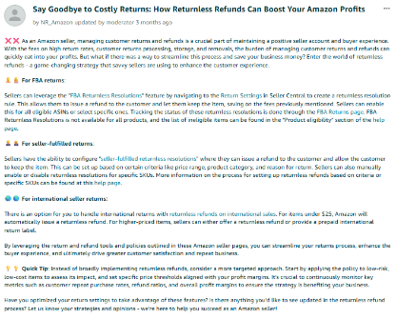
Figure: Importance of returnless refunds to promote Amazon profits
Source: (Amazon, 2025b)

Analysis
This theme is properly aligned with the third objective to identify several strategies for Amazon regarding its return-related issues. These factors are a major concern for the sellers of this company. Small businesses with tight margins in this context face this problem the most during operations. This figure highlights returnees refunds as a key strategy to reduce the overall logistical costs. The entire customer satisfaction will also be boosted through this initiative in the market. This aspect allows sellers to issue refunds without the requirement of the return procedure. Saving on shipping, restocking, and processing fees are some major approaches in this segment. However, sellers should apply this technique selectively to avoid abuses in this context (George, 2024). Amazon also offers a ‘Returnees Resolutions’ feature for fulfilled by Amazon (FBA) shoppers to achieve its goals properly. This factor can also be configured for specific AINs in the process. Similarly, seller-fulfilled businesses set rules based on product category and price range. Return reasons are also considered in the process to ensure its success properly. The company will also target low-cost and low-risk items for this procedure to prevent significant losses. These are some major examples of effective strategies for this company in mitigating the challenges regarding the return processes. This theme has pointed out some major issues in this technique, which can affect the operations significantly. Return fraud and abuse are some major factors in this area. The mitigation of this situation has necessitated some vital concerns. Listed small companies of Amazon should track the overall return pattern and limit this practice based on verification.

Theme 8: Several strategies for Amazon listings to boost sales
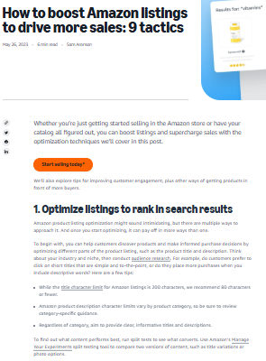
Figure: Tactics to drive the overall sales of Amazon listings in the market
Source: (Aronson, 2023)

Analysis
This theme is also a major portrayal of the third objective in this process, to offer a proper idea regarding the strategy for small businesses of Amazon. The company’s guide outlines nine actionable tactics for the improvement of product visibility and conversion. These efforts are also effective in mitigating the overall loss regarding the return issues. Listening optimisation is the first technique for this section. Sellers should craft concise and informative descriptions based on the assessment of customer preferences. An effective utilisation of Amazon’s ‘manage your experiments’ tool will allow these small businesses to run A/B tests for the determination of best best-performing content. Images, titles, and descriptions are evaluated in this section to execute the plan properly. Advertising also plays a significant role in this area. The company’s listings will also gain positive profit from the market with this technique. Sponsored brands and sponsored display campaigns allow sellers to target keywords in the market. This initiative is also effective in promoting brand identity through the boosted reachability among customers. These cost-per-click ads significantly enhance the sales of these businesses. A major role of these tactics has been evaluated in this assessment. Amazon’s use of discounts and reviews is a major strategy in the market. There are some other methods in this process to allow the company to achieve its goal in the approach. Inventory management, price automation, and listing enhancement are the portrayals of this section. Amazon should focus on these areas strongly during its operations to boost the profits of its small businesses (Johansson, 2021). The overall return-related issues are mitigated through these initiatives in the market.

Theme 9: Plannings of Amazon to mitigate its excessive return issue
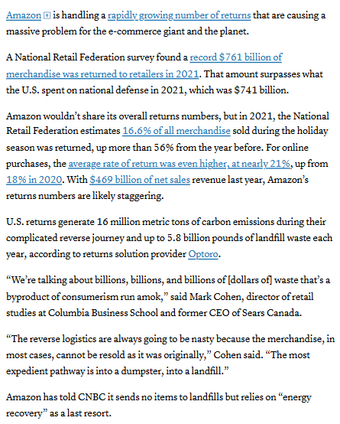
Figure: Major plans of Amazon to fix its overall issues regarding massive returns
Source: (Tarasov, 2022)

Analysis
This theme in the qualitative analysis supports the third objective of this study properly. The major focus of this part is to offer an effective strategy for the mitigation of return-related challenges reflects its alignment with the goal. Sustainable resale strategies have been prioritised in the figure to offer a great insight into the listings of Amazon. The growing concern over this company’s massive return problem is strongly highlighted through the writing. A billion dollars of losses occur with this issue, which necessitates its mitigation in the market. The overall problem significantly contributes to environmental waste during the operations. Amazon is also expanding its resale and donation programmes to achieve its goal of zero product disposal properly. Small businesses of the firm can align with this strategy by reselling returned items through Amazon Warehouse. Third-party liquidation platforms will also help these organisations streamline their operations. This method also turns potential losses into revenue streams. Another effective tactic in these operations is the application of Amazon’s returnless refund features for low-cost items (Baldauf, 2024). The method avoids reverse logistics costs through the enhancement of customer satisfaction. However, sellers also apply this process very selectively to reduce the chance of fraud. Optimised product listings and tracking return patterns are some other suggestions for this organisation to achieve its goals properly.

4.3 Discussion
This part of this entire study is crucial to generate the main outcome of this topic for real-life application. An effective alignment between the literature review and findings is conducted through this area to achieve the major goal. The comparative assessment of these two chapters offers a great insight into the subject. Three results from the three objectives of this observation are the desired factors from this process. As per Merlano et al. (2024), various issues are faced by the owners of small businesses due to the easier return policy of the e-commerce industry. The authors have strongly focused on the loss of revenue for several fraudulent returns. This aspect negatively affects these businesses during their operations. O'Sullivan (2025) also discussed some other challenges in this field. Issues of reverse logistics and stock forecasting are some major factors regarding the approach. The result of the literature review is like the qualitative assessment. Themes 1, 2, and 3 have focused on this objective to provide a proper insight into the goal. As per the first figure of this section, sellers of Amazon sellers are led to destroy all the return products due to the high cost of refurbishment of damaged items. This is a portrayal of the companies’ loss of revenue during the operations. Theme 2 has also prioritised a similar fact regarding the issue. The frequent returns are the vital reason for high return rates and revenue loss. Despite the fulfilment of customers’ expectations from easier return policies, listings of Amazon listings face some additional costs for the restocking procedure. Repackaging and inventory approaches intensify the situation for these small businesses in the market. There is also a huge chance of return fraud in this entire operation. This factor is also recognised in the third theme to offer a proper insight into this area. As per this figure, product swapping by consumers is a common issue in the return process. This aspect is a portrayal of businesses’ major loss in the market. This situation also occurs with the middlemen in the process of items. Several times, a lack of a proper tracking feature has significantly misguided the entire operations. Limited inspection by Amazon regarding the problems also negatively affects the sellers. This entire assessment reflects that due to the easier return policy in this chosen platform, small businesses face a loss of revenue. The second objective of this study has strongly prioritised various impacts of return policy on consumer behaviour and the annual performance of sales of small organisations. As per Lysenko-Ryba et al. (2021) in the literature review, this policy of e-commerce companies strongly affects the brand loyalty among customers. This initiative is directly connected to user-oriented approaches with their proper expectations. An effective fulfilment of their need with this effort boosts their overall trust in the market. Gustafsson et al. (2021) have also focused on some other areas of these influences. Change in average order value and strain in working capital are the portrayals of this factor. Themes 4, 5, and 6 have also focused on the same area to offer a proper result regarding the practice. Dissatisfaction of users during the product misalignment and fraud has been analysed in the fourth theme. This is a negative approach for the overall brand image of Amazon. However, the easy return policy of the company boosts their satisfaction level. They get the opportunity to avoid any type of fraud and product misalignment in the operations. This result is like the first point of the literature review. Amazon’s lack of responsibility in offering a proper product range among consumers is reflected in theme 5. The firm’s decision to maintain the customer protection law has been discussed in the process. An overall spread of unsafe items in the market by this firm has changed the average order value for small businesses. This outcome of the theme is also like the points of the literature review. Their compatibility in the context of easy return is the portrayal of both its positive and negative impacts on consumer behaviour. Various effects of this situation on small businesses have been mentioned in the sixth theme of the process. Profit margins of these sellers are negatively affected by the policy of Amazon. Enhancement of operational costs and reduction of user trust are some vital impacts of the operations. They struggle to maintain their competitive edge in the market. Frei et al. (2022) have offered some strategies in the literature review to achieve the goals of the third objective significantly. The authors described that the enhancement of product visualisation is one of the most vital tactics to address the challenges of small businesses in the e-commerce industry. A major on automated return and tiered return has been highlighted in this area. Organisations will benefit from these initiatives in the market during their operations. Themes 7, 8, and 9 have been conducted based on the prioritisation of the third objective. Various strategies for Amazon in mitigating various issues regarding the return policy are pointed out in these parts. A major role of returnless refunds in the workplace is discussed in the seventh figure of the study. This initiative ensures the profitability of small businesses with tight margins. Theme 8 also mentions a total of 9 tactics for Amazon to drive sales of its small businesses. Listing optimisation and detailed information are some key areas of this entire result. This fact is very close to the outcomes of the literature review. Theme 9 is a part of Amazon’s plan to fix these types of excessive returns. Resale of items is one of the most vital techniques for this organisation to mitigate the problem. Additionally, the significance of returnless refund has been evaluated in this area. The application of these methods by small companies allows them to run A/B tests during operations. An effective prioritisation of the strategies in the overall business procedure will allow the company to maintain its proper competitive edge.

4.4 Summary
This entire chapter has conducted a detailed assessment regarding the topic of Amazon’s delivery and return policy. A thematic approach has played a core role in offering proper insight in this context. Three objectives of the study have been assessed in this section for the generation of outcomes regarding the procedure. Various themes from Amazon’s websites and some other authentic resources have been used in this section to complete the entire part. The major role of Amazon’s delivery and return policy on its listed small businesses has been evaluated in this entire process. Various challenges with their solutions have also been discussed in this section to ensure a proper result. A discussion part has been presented in this chapter. This portion has played a vital role in linking findings with the literature review. A comparative analysis in this area has highlighted the major outcome of the topic.

Chapter 5: Recommendations, Conclusion and Limitations of the research

5.1 Conclusion
The following study mainly concentrates on the significance of Amazon’s return policy on consumer behaviour and small businesses. The findings have revealed that small companies experience different issues due to the ease of returns. It has led to financial losses and fraudulent returns. This action has maximised its refurbishment costs and hampers the quality of returned items. Here, in this portion the first objectives of the study have been met successfully. The second objective has discussed the effect of these policies on the brand and small shoppers. Outcomes of the research have indicated that this context fosters audience satisfaction and trust. It also increases sales and maintains operations. This context also offers dissatisfaction when any fraudulent actions happen. The dual effect can influence consumer behaviour and small enterprises. It has decreased the order value and weakened the policies. In addition, Amazon’s limited quality control policy has declined the contribution to changing the perception of the customers. Answering this the next objectives have also been determined. The third objective was about the tactics that businesses have incorporated to mitigate the following issues. The investigator has stated that reselling the goods and products may increase the profit level effectively. Enhancing item visualization and automating returns also assists in reducing unnecessary returns. These strategies may safeguard the small businesses and maintain the consumer satisfaction and trust.

5.2 Recommendations
Implementing data-driven return management
The small business owners must leverage data analytics in predicting and realising consumer return behaviours. The organisation may use sellers' central information or third-party analytical techniques for monitoring reasons, return frequencies and return patterns of the customers (Pantović et al., 2024). This context helps to determine the items which is returned frequently. Identifying the problems also assists in developing the products and enhancing consumer satisfaction. The small enterprises can take proactive steps to improve the quality of the item (Owusu, 2024). It minimises the issues and changes the perception of the audience. On the other side evaluating information may assist the shoppers in adjusting prices and maximising the sales. This action also permits to reduction of return-related losses from the business.
Strengthen product quality control
A significant return happens due to discrepancies among the received items and the consumer's expectations. It is suggested to invest in quality control measures to meet the requirements of the customers. Establishing pre-dispatch investigation protocols may minimise the item returns (Nugroho et al., 2022). This context assists in delivering positive results and increasing customer trust. Developing product listing accuracy through detailed descriptions of the items, transparent sizes and high-resolution images may reduce misunderstandings. The small businesses may align the customer expectations with the product reality by decreasing refund costs (Lysenko-Ryba and Zimon, 2021). This context offers better audience engagement and strengthens brand image.

Adopting flexible return approaches
Amazon has enforced an easy return policy; diverse small businesses may incorporate flexible parameters in their return policy. This action assists in minimising the rate of return items and fosters audience trust towards the company. It includes restocking and handling fees for categories (Espinosa et al., 2021). Promotional product exchanges also assist in delivering an easy return procedure effectively. It is essential to offer loyalty rewards and store credits can reduce the financial losses while purchasing any product. The small shoppers may utilise FBA refurbishment programmes to resell the items in good condition (Yamini and Gajanand, 2023). This action maximises the sales and helps to gain a huge profit. Such traditional return operations may reduce the financial strains and affirm transparency in front of the customers.

5.3 Limitations of the study
A structured methodology has been followed in the study to gain outcomes on a particular topic. The mono method with secondary data analysis has been performed by the investigator. However, some challenges have arisen while analysing the findings. There are various limitations that have been incorporated that affect the study negatively. Lack of specificity and relevance to the subject has prevented to accurate information. It has offered outdated information which may not be aligned with this context (Kumara, 2022). On the other side a lot of information has been gathered that confused the researcher. A lack of human contribution in the findings increased concerns about its validity and bias. Small details related to the subject have been ignored which can impact the whole study. The researcher lacks control over the data which raises concern about the collection procedure (McBurney and Kubas, 2022). Information might be inaccurate or incomplete due to problems with the original context. The investigator could take primary data collection to gather recent data and know more about human perspectives.

5.4 Scope for further study
The future study may reveal several aspects of the subject and offer operational efficiency to small businesses. It can be involved in exploring the long-term impact on small businesses and changing the behaviour of the customers. Further studies can evaluate the process in which frequent returns affect small shoppers’ inventory management, profitability and consumer trust (Hipólito et al., 2025). It will also examine the behavioural and psychological factors that may influence the audience's return policy. Developing strategies can contribute to mitigate the problems. Diverse comparative studies can highlight best practices on easy return policies and minimise unnecessary returns. Further it may reduce the repetitive outcomes and improve some policies to enhance customer satisfaction.

References
Aboutamazon, (2024). Amazon expands options for sellers to handle customer returns. [Online]Available at: https://www.aboutamazon.com/news/small-business/amazon-return-options-sellers [Accessed 22 October 2025].
amazon, (2025). Amazon. [Online]Available at: https://www.amazon.in/ [Accessed 22 October 2025].
Amazon, (2025a). About Our Returns Policies. [Online]
Available at: https://www.amazon.com.be/-/en/gp/help/customer/display.html?nodeId=GKM69DUUYKQWKWX7&language=en_GB
[Accessed 25 October 2025].
Amazon, (2025b). Say Goodbye to Costly Returns: How Returnless Refunds Can Boost Your Amazon Profits. [Online]Available at: https://sellercentral.amazon.co.uk/seller-forums/discussions/t/333d575c-8a12-4d41-bda0-a54a4d4eee77?postId=333d575c-8a12-4d41-bda0-a54a4d4eee77 [Accessed 25 October 2025].
Aronson, S., (2023). How to boost Amazon listings to drive more sales: 9 tactics. [Online]Available at: https://sell.amazon.com/blog/how-to-boost-amazon-listings [Accessed 25 October 2025].
Baldauf, C., (2024). Logistics and Customer Behavior in Online and Omnichannel Retail: A Systematic Review. Available at SSRN 4756771.
BBC, (2021). Retail sales in 2020 'worst for 25 years'. [Online] Available at: https://www.bbc.com/news/business-55625246 [Accessed 25 October 2025].
Brennen, B.S., (2021). Qualitative research methods for media studies. routledge.
Danziger, P. N., (2025). Retailers Flooded By Returns Need A Three-Pronged Fix. [Online] Available at: https://www.forbes.com/sites/pamdanziger/2025/01/21/retailers-flooded-by-returns-need-a-three-pronged-fix/ [Accessed 25 October 2025].
Denny, E. and Weckesser, A., (2022). How to do qualitative research? Qualitative Research Methods. Bjog, 129(7), p.1166.
Diiashvili, M.E., (2025). EFFICIENCY OF WORKING CAPITAL MANAGEMENT MODELS UNDER ECONOMIC UNCERTAINTY. Professional Bulletin: Economics and Management, (1), pp.3-9.
Doherty, B., (2023). Why more fashion retailers are charging return fees. [Online] Available at: https://www.bbc.com/worklife/article/20231004-why-more-fashion-retailers-are-charging-return-fees [Accessed 25 October 2024].
Dumitrica, D. and Jarmula, P., (2022). Teaching qualitative research methods in media and communication: The benefits and limitations of digital learning objects. Qualitative Report, 27(9), pp.1934-1951.
Dupuis, D., Smith, D. and Gleason, K., (2023). Old frauds with a new sauce: digital assets and space transition. Journal of Financial Crime, 30(1), pp.205-220.
Ecoffet, A., Huizinga, J., Lehman, J., Stanley, K.O. and Clune, J., (2021). First return, then explore. Nature, 590(7847), pp.580-586.
Elia, G., Ghiani, G., Manni, E. and Margherita, A., (2024). A system for anomaly detection in reverse logistics: an application into an e-commerce company. Measuring Business Excellence, 28(2), pp.222-242.
England, A., (2022). Quantitative and qualitative research methods. In Research for Medical Imaging and Radiation Sciences (pp. 71-96). Cham: Springer International Publishing.
Espinosa, J.A., Stock, J., Ortinau, D.J. and Monahan, L., (2021). Exploring an adaptability approach: how creative return processors impact firm performance. The International Journal of Logistics Management, 32(3), pp.790-820.
Ezer, F. and Aksüt, S., (2021). Opinions of Graduate Students of Social Studies Education about Qualitative Research Method. International Education Studies, 14(3), pp.15-32.
Frei, R., Jack, L. and Krzyzaniak, S.A., (2022). Mapping product returns processes in multichannel retailing: Challenges and opportunities. Sustainability, 14(3), p.1382.
García‐Dastugue, S.J., Nilakantan, R., Wallenburg, C.M. and Rao, S., (2024). On merchandise return policy, entrepreneurial internet retail, and customer reviews–Insights from an observational study. Journal of Business Logistics, 45(1), p.e12342.
George, A.S., (2024). The Hidden Cost: Understanding the Environmental Impact of Online Purchase Returns. Partners Universal Innovative Research Publication, 2(1), pp.132-149.
Gustafsson, E., Jonsson, P. and Holmström, J., (2021). Reducing retail supply chain costs of product returns using digital product fitting. International Journal of Physical Distribution & Logistics Management, 51(8), pp.877-896.
Hendren, K., Newcomer, K., Pandy, S.K., Smith, M. and Sumner, N., (2023). How qualitative research methods can be leveraged to strengthen mixed methods research in public policy and public administration? Public Administration Review, 83(3), pp.468-485.
Hipólito, F., Dias, Á. and Pereira, L., (2025). Influence of consumer trust, return policy, and risk perception on satisfaction with the online shopping experience. Systems, 13(3), p.158.
Javornik, A., Duffy, K., Rokka, J., Scholz, J., Nobbs, K., Motala, A. and Goldenberg, A., (2021). Strategic approaches to augmented reality deployment by luxury brands. Journal of Business Research, 136, pp.284-292.
Johansson, J., (2021). Launching a Product to Amazon Marketplace: Selling at Amazon. com.
Joukamo, A., (2025). Working capital management and sales growth patterns in retail SMEs: evidence from European markets.
Karl, D., (2024). Forecasting e-commerce consumer returns: A systematic literature review. Management Review Quarterly, pp.1-56.
Kembro, J. and Norrman, A., (2022). The transformation from manual to smart warehousing: an exploratory study with Swedish retailers. The International Journal of Logistics Management, 33(5), pp.107-135.
Kmiecik, M., (2024). Stock management in e-commerce by 3PL–case study. Zeszyty Naukowe. Organizacja i Zarządzanie/Politechnika Śląska, (192), pp.537-556.
Köhler, T., Smith, A. and Bhakoo, V., (2022). Templates in qualitative research methods: Origins, limitations, and new directions. Organizational Research Methods, 25(2), pp.183-210.
Kumara, A.S., (2022). Researching with Secondary Data: A brief overview of possibilities and limitations from the viewpoint of social research.
LaMarre, A. and Chamberlain, K., (2022). Innovating qualitative research methods: Proposals and possibilities. Methods in Psychology, 6, p.100083.
Lysenko-Ryba, K. and Zimon, D., (2021). Customer behavioral reactions to negative experiences during the product return. Sustainability, 13(2), p.448.
Lysenko-Ryba, K., Zimon, D. and Zatwarnicka-Madura, B., (2021). THE EFFECT OF LENIENT RETURN POLICY ON BRAND RECOGNITION. International Journal for Quality Research, 15(4).
Magano, J., Turčinkova, J., Santos, M.C., Correia, R. and Serebriannikov, M., (2024). Exploring apparel E-commerce unethical return experience: A cross-country study. Journal of Theoretical and Applied Electronic Commerce Research, 19(4), pp.2650-2672.
Manuere, H.T., Chikazhe, L. and Manyeruke, J., (2022). Theoretical models of consumer behaviour: A literature review. International Journal of Education Humanities and Social Science, 5(2), pp.105-112.
Margono, F.P. and Gantino, R., (2021). The influence of firm size, leverage, profitability, and dividend policy on firm value of companies in indonesia stock exchange. Copernican Journal of Finance & Accounting, 10(2), pp.45-61.
Martin, A., (2021). A gatekeeper approach to product liability for Amazon. Geo. Wash. L. Rev., 89, p.768.
McBurney, J. and Kubas, A., (2022). Limitations to success in academic data reference support. Journal of Librarianship and Information Science, 54(1), pp.121-131.
Merlano, E.F., Frei, R., Zhang, D., Murzacheva, E. and Wood, S., (2024). Consumer perspectives on interventions to combat fraudulent product returns in omnichannel fashion retail. International Journal of Physical Distribution & Logistics Management, 54(10), pp.969-1001.
Newman, P.A., Guta, A. and Black, T., (2021). Ethical considerations for qualitative research methods during the COVID-19 pandemic and other emergency situations: Navigating the virtual field. International journal of qualitative methods, 20, p.16094069211047823.
Nugroho, A., Christiananta, B., Wulani, F. and Pratama, I., (2022). Exploring the association among just in time, total quality and supply chain management influence on firm performance: evidence from Indonesia.
O'Sullivan, C., (2025). The impact of e-commerce fraud in reverse logistics.
Owusu, C.K., (2024). Cost Of Quality and Financial Performance Of Small And Medium Enterprises. Educational Administration: Theory and Practice, 30(2), pp.1433-1442.
Pantović, V., Vidojević, D., Vujičić, S., Sofijanić, S. and Jovanović-Milenković, M., (2024). Data-driven decision making for sustainable IT project management excellence. Sustainability, 16(7), p.3014.
Rintamäki, T., Spence, M.T., Saarijärvi, H., Joensuu, J. and Yrjölä, M., (2021). Customers' perceptions of returning items purchased online: planned versus unplanned product returners. International Journal of Physical Distribution & Logistics Management, 51(4), pp.403-422.
Ritterbusch, G.D. and Teichmann, M.R., (2023). Defining the metaverse: A systematic literature review. Ieee Access, 11, pp.12368-12377.
Sellercentral, (2025). Request to Review Return Policy – High Return Ratio Affecting Small Businesses. [Online] Available at: https://sellercentral.amazon.in/seller-forums/discussions/t/38f04d50-fbcf-4da3-a5ad-d7d286a19d68 [Accessed 25 October 2025].
Sherman, N., (2024). Amazon responsible for product recalls, says US. [Online] Available at: https://www.bbc.com/news/articles/c51yjz67rw0o [Accessed 25 October 2025].
Silverman, R.M. and Patterson, K., (2021). Qualitative research methods for community development. Routledge.
Stapley, E., O’Keeffe, S. and Midgley, N., (2022). Developing typologies in qualitative research: The use of ideal-type analysis. International Journal of Qualitative Methods, 21, p.16094069221100633.
Stewart, D.L., (2022). Performing goodness in qualitative research methods. International Journal of Qualitative Studies in Education, 35(1), pp.58-70.
supplychainbrain, (2024). ‘Serial’ U.K. E-Commerce Returners Responsible for One Quarter of Returns, Report Finds. [Online]Available at: https://www.supplychainbrain.com/articles/40528-serial-uk-e-commerce-returners-responsible-for-one-quarter-of-returns-report-finds#:~:text=U.K.%20shoppers%20who%20habitually%20return,Returns%20Policies%20Rife%2C%20Report%20Finds [Accessed 22 October 2025].
Tarasov, K., (2022). How Amazon plans to fix its massive returns problem. [Online]Available at: https://www.cnbc.com/2022/04/10/how-amazon-plans-to-fix-its-massive-returns-problem.html [Accessed 25 October 2025].
Tarasov, K., (2025). Easy returns cause big trouble for Amazon sellers, but return rates show signs of slowing. [Online] Available at: https://www.cnbc.com/2025/06/21/how-broken-amazon-returns-are-driving-sellers-to-leave-the-platform.html [Accessed 25 October 2025].
Tracy, S.J., (2024). Qualitative research methods: Collecting evidence, crafting analysis, communicating impact. John Wiley & Sons.
Tudor, C., (2022). Integrated framework to assess the extent of the pandemic impact on the size and structure of the e-commerce retail sales sector and forecast retail trade e-commerce. Electronics, 11(19), p.3194.
Van der Weele, S. and Bredewold, F., (2021). Shadowing as a qualitative research method for intellectual disability research: Opportunities and challenges. Journal of Intellectual & Developmental Disability, 46(4), pp.340-350.
Vollero, A., Sardanelli, D. and Siano, A., (2023). Exploring the role of the Amazon effect on customer expectations: An analysis of user‐generated content in consumer electronics retailing. Journal of Consumer Behaviour, 22(5), pp.1062-1073.
Wickham, N., (2025). Amazon Pushes Returnless Returns to Avoid the Hassle… For Themselves. [Online]Available at: https://myamazonguy.com/news/amazon-pushes-returnless-returns/ [Accessed 22 October 2025].
Wilhelm, C., (2023). Die Kaufentscheidung als Lernprozess: The Theory of Buyer Behavior von Howard und Sheth. In Schlüsselwerke der Werbeforschung (pp. 119-130). Wiesbaden: Springer Fachmedien Wiesbaden.
Williams, S., (2025). Impact of Poor Customer Service on Your Business. [Online]Available at: https://www.invensis.net/blog/poor-customer-service-impacts#:~:text=Negative%20service%20experiences%20are%20one,plan%20for%20long%2Dterm%20growth. [Accessed 22 October 2025].
Yamini, S. and Gajanand, M.S., (2023). Effect of manufacturer's flexible returns policy in a duopolistic competition. Benchmarking: An International Journal, 30(1), pp.256-280.

Element 2: Research Process Reflection

Introduction
The second section of the portfolio will show a critical understanding of the different skills and knowledge that are developed after completion of the dissertation project. Various stages of Kolb’s Learning Cycle will be applied to describe and analyse the information gathered while completing the previous element.

Kolb’s Learning Cycle
Concrete experience
It is the first stage of the reflective framework that includes a descriptive summary of the different activities involved and the overall process. The selection of the topic was made after taking notes from the lectures of the professor and help from the module teachers. I gathered relevant evidence and journals that discussed the delivery system and return policy of the Amazon company across different regions of the UK (Szenes and Tilakaratna, 2021). It has been followed by the evaluation of the collected data with the themes and context of relevance. At the end of the project, I collected all the information to form the conclusions and strategise a set of suitable recommendations.

Reflective observation
The beginning of this project has been the most challenging part for me, as I tend to get nervous easily and fail to make suitable decisions. However, with utmost encouragement from my friends and family, I started it. The notes from my previous classes and the module materials helped me a lot in reducing the pressure of making this assessment. Furthering in the different operations, I gained confidence upon receiving positive remarks after completing the proposal. It played an important role in conveying my confidence to perform better in developing this dissertation (Alt et al., 2022). Active team engagement and attention in the classes and lectures mostly helped me.

Abstract conceptualisation
The absolute evaluation of the experiences helped me realise that my skills and scope of adequate knowledge played a key role in streamlining the processes. An example can be taken from my lack of self-motivation and confidence led to a slower start of the project process. It also caused an issue in defining the background study and scope of the first chapter of the dissertation. However, my communication skills and the ability to pay attention to the details were able to help me manage these gaps and adjust them accordingly. I was able to present my project within the given deadline without compromising the content quality.

Active experimentation
It is the last stage of the cycle that helps me reflect on the different observations that I made about myself, as per my performance (Howell, 2021). I will undertake additional classes to develop my motivation skills and calm my tense personality. It can help me keep myself motivated to do the given assignments with enthusiasm and meet the deadlines. I am also aiming to enrol in other extracurricular activities, such as debate tournaments and public speaking seminars. This strategy can ensure I will be able to boost my self-confidence and represent myself efficiently.

Conclusion
An evaluation of the experiences gained during the development of the dissertation document has been provided in this element. Different transferable skills and knowledge that need to be exercised for academic and personal advancement have been included, too. It helped plan strategies to drive strategies that ensure own learning and self-management.

References
Alt, D., Raichel, N. and Naamati-Schneider, L., (2022). Higher education students’ reflective journal writing and lifelong learning skills: Insights from an exploratory sequential study. Frontiers in Psychology, 12, p.707168.
Howell, R.A., (2021). Engaging students in education for sustainable development: The benefits of active learning, reflective practices and flipped classroom pedagogies. Journal of Cleaner Production, 325, p.129318.
Szenes, E. and Tilakaratna, N., (2021). Deconstructing critical reflection in social work and business: Negotiating emotions and opinions in reflective writing. Journal of English for Academic Purposes, 49, p.100931.

Element 3: Methodology Poster
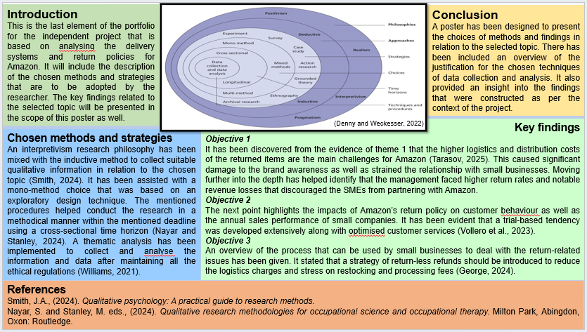

Introduction
This is the last element of the portfolio for the independent project that is based on analysing the delivery systems and return policies for Amazon. It will include the description of the chosen methods and strategies that are to be adopted by the researcher. The key findings related to the selected topic will be presented in the scope of this poster as well.

Chosen methods and strategies
Figure: Saunders Research Onion
Source: (Denny and Weckesser, 2022)
An interpretivism research philosophy has been mixed with the inductive method to collect suitable qualitative information in relation to the chosen topic (Smith, 2024). It has been assisted with a mono-method choice that was based on an exploratory design technique. The mentioned procedures helped conduct the research in a methodical manner within the mentioned deadline using a cross-sectional time horizon (Nayar and Stanley, 2024). A thematic analysis has been implemented to collect and analyse the information and data after maintaining all the ethical regulations (Williams, 2021).

Key findings
Objective 1
It has been discovered from the evidence of theme 1 that the higher logistics and distribution costs of the returned items are the main challenges for Amazon (Tarasov, 2025). This caused significant damage to the brand awareness as well as strained the relationship with small businesses. Moving further into the depth has helped identify that the management faced higher return rates and notable revenue losses that discouraged the SMEs from partnering with Amazon. Return fraud and product swapping during the delivery periods are identified to be quite common as well (Danziger, 2025). It has been responsible for developing a negative brand image of the company in the business environment of the UK and other regions.

Objective 2
The next point highlights the impacts of Amazon’s return policy on customer behaviour as well as the annual sales performance of small companies. It has been evident that a trial-based tendency was developed extensively along with optimised customer services (Vollero et al., 2023). Further, the management of Amazon has become liable for many functions, such as product recall and transparency maintenance. It helped the company meet their legal obligations and avoid legal obstructions from the end of the government (Sherman, 2024). Thus, major negative impacts have been experienced by small businesses with the development of unpredictable sales patterns.

Objective 3
An overview of the process that can be used by small businesses to deal with the return-related issues has been given. It stated that a strategy of return-less refunds should be introduced to reduce the logistics charges and stress on restocking and processing fees (George, 2024). There has also been listed several strategies that are subject to drive the sales performance of the small businesses engaged with Amazon. It included informative and attractive product descriptions and improved the product development tendencies through feedback.

Conclusion
A poster has been designed to present the choices of methods and findings in relation to the selected topic. There has been included an overview of the justification for the chosen techniques of data collection and analysis. It also provided an insight into the findings that were constructed as per the context of the project.

References
Danziger, P. N., (2025). Retailers Flooded By Returns Need A Three-Pronged Fix. [Online] Available at: https://www.forbes.com/sites/pamdanziger/2025/01/21/retailers-flooded-by-returns-need-a-three-pronged-fix/ [Accessed 25 October 2025].
Denny, E. and Weckesser, A., (2022). How to do qualitative research? Qualitative Research Methods. Bjog, 129(7), p.1166.
Nayar, S. and Stanley, M. eds., (2024). Qualitative research methodologies for occupational science and occupational therapy. Milton Park, Abingdon, Oxon: Routledge.
Sherman, N., (2024). Amazon responsible for product recalls, says US. [Online] Available at: https://www.bbc.com/news/articles/c51yjz67rw0o [Accessed 25 October 2025].
Smith, J.A., (2024). Qualitative psychology: A practical guide to research methods.
Tarasov, K., (2025). Easy returns cause big trouble for Amazon sellers, but return rates show signs of slowing. [Online] Available at: https://www.cnbc.com/2025/06/21/how-broken-amazon-returns-are-driving-sellers-to-leave-the-platform.html [Accessed 25 October 2025].
Vollero, A., Sardanelli, D. and Siano, A., (2023). Exploring the role of the Amazon effect on customer expectations: An analysis of user‐generated content in consumer electronics retailing. Journal of Consumer Behaviour, 22(5), pp.1062-1073.
Williams, H., (2021). The meaning of “Phenomenology”: Qualitative and philosophical phenomenological research methods. The Qualitative Report, 26(2), pp.366-385.

Appendix – Gantt Chart
Features | 1st week | 2nd week | 3rd week | 4th week | 5th week | 6th week | 7th week
Research Topic Selection
Setting aim
Setting Objectives
Choosing the research methods
Performing secondary research
Discussing the findings and results
Conclusion
Recommendations

APPLICATION FOR ETHICAL APPROVAL

RESEARCH STUDENTS
This form is to be completed by the student within SIX months for full-time students and TWELVE months for part time students, after the commencement of the research degree or following progression to Part Two of your course.

Once complete, submit this form via the MyTSD Doctoral College Portal at (https://mytsd.uwtsd.ac.uk).

This document is also available in Welsh.

RESEARCH STAFF ONLY
All communications relating to this application during its processing must be in writing and emailed to pgresearch@uwtsd.ac.uk , with the title ‘Ethical Approval’ followed by your name.

STUDENTS ON UNDERGRADUATE OR TAUGHT MASTERS PROGRAMMES should submit this form (and receive the outcome) via systems explained to you by the supervisor/module leader.

In order for research to result in benefit and minimise risk of harm, it must be conducted ethically. A researcher may not be covered by the University’s insurance if ethical approval has not been obtained prior to commencement.

The University follows the OECD Frascati manual definition of research activity: “creative work undertaken on a systematic basis in order to increase the stock of knowledge, including knowledge of man, culture and society, and the use of this stock of knowledge to devise new applications”. As such this covers activities undertaken by members of staff, postgraduate research students, and both taught postgraduate and undergraduate students working on dissertations/projects.

The individual undertaking the research activity is known as the “principal researcher”.

Ethical approval is not required for routine audits, performance reviews, quality assurance studies, testing within normal educational requirements, and literary or artistic criticism.

Please read the notes for guidance before completing ALL sections of the form.

This form must be completed and approved prior to undertaking any research activity. Please see Checklist for details of process for different categories of application.

SECTION A: About You (Principal Researcher)
1 | Full Name: |  | Constantin Alexandru Petrescu
2 | Tick all boxes that apply: |  | Member of staff: | ☐ | Honorary research fellow: | ☐
 | Undergraduate Student | ☒ | Taught Postgraduate Student | ☐ | Postgraduate Research Student | ☐

3 | Institute/Academic Discipline/Centre: | ICL London
4 | Campus: | London
5 | E-mail address: | 2227903@student.uwtsd.ac.uk
6 | Contact Telephone Number: | 07435293245
 | For students:
7 | Student Number: | 2227903
8 | Programme of Study: | BA (Hons) Leadership & Management in the Workplace
9 | Director of Studies/Supervisor: | Mohammad Rahman

SECTION B: Approval for Research Activity
1 | Has the research activity received approval in principle?  (please check the Guidance Notes as to the appropriate approval process for different levels of research by different categories of individual) |  | YES | ☒ | NO | ☐
 |  |  |  |  | Date
2 | If Yes, please indicate source of approval (and date where known): Approval in principle must be obtained from the relevant source prior to seeking ethical approval | Research Degrees Committee |  | ☐
2 |  | Institute Research Committee |  | ☐
2 |  | Other (write in) |  | ☐

SECTION C: Internal and External Ethical Guidance Materials
 | Please list the core ethical guidance documents that have been referred to during the completion of this form (including any discipline-specific codes of research ethics, location-specific codes of research ethics, and also any specific ethical guidance relating to the proposed methodology). Please tick to confirm that your research proposal adheres to these codes and guidelines. You may add rows to this table if needed.
1 | UWTSD Research Ethics & Integrity Code of Practice | ☒
2 | UWTSD Research Data Management Policy | ☒
3 | [List any other relevant documents here] | ☐

SECTION D: External Collaborative Research Activity
If there are external collaborators then you should gain consent from the contact persons to share their personal data with the university. If there are no external collaborators then leave this section blank and continue to section E.
1 | Institution
2 | Contact person name
3 | Contact person e-mail address
4 | Is your research externally funded? |  | YES | ☐ | NO |  | ☐
5 | Are you in receipt of a KESS scholarship? |  | YES | ☐ | NO |  | ☐
6 | Are you specifically employed to undertake this research in either a paid or voluntary capacity? | Voluntary | YES | ☐ | NO | ☐
7 |  | Employed | YES | ☐ | NO | ☐
8 | Is the research being undertaken within an existing UWTSD Athrofa Professional Learning Partnership (APLP)? | If YES then the permission question below does not need to be answered. | YES | ☐ | NO |  | ☐
9 | Has permission to undertake the research has been provided by the partner organisation? | (If YES attach copy)  If NO the application cannot continue | YES | ☐ | NO |  | ☐

Where research activity is carried out in collaboration with an external organisation
10 | Does this organisation have its own ethics approval system? | YES | ☐ | NO | ☐
 | If Yes, please attach a copy of any final approval (or interim approval) from the organisation (this may be a copy of an email if appropriate).

SECTION E: Details of Research Activity
1 | Indicative title: | A study of Amazon's delivery system and returns policy
2 | Proposed start date: | From 12 June 2025 | Proposed end date: | 19 December 2025
Introduction to the Research (maximum 300 words per section)
Ensure that you write for a Non-Specialist Audience when outlining your response to the points below:
- Purpose of Research Activity
- Proposed Research Question
- Aims of Research Activity
- Objectives of Research Activity
Demonstrate, briefly, how Existing Research has informed the proposed activity and explain
- What the research activity will add to the body of knowledge
- How it addresses an area of importance.
3 | Purpose of Research Activity  Discussion of the chosen issue  The easy return policy of Amazon creates significant challenges for small business owners who are selling their products on this platform. This policy of Amazon extends the return window, leading to an increased rate of returns, as well as financial losses because of the shipping costs of the returns. During the return process, damaged goods as well as the potential about to the systems by some customers also create challenges for the small business owners. Due to the easy return policy of Amazon, the customer can return products with ease, which leads to a larger volume of product returns. This impacts the small business owners disproportionately, as these organisations do not have the needed resources to absorb these extra costs (Maffettone, 2023). Small business owners are required to maintain a sufficient inventory to meet customer demands, mostly during the peak seasons.  (this box should expand as you type)
4 | Research Question  1. What are the financial and operational issues that small business owners encountered in the last 12 months because of the easy return policy of Amazon?  2. How does Amazon’s return policy influence consumer behaviour, along with affecting the annual sales performance of the small businesses listed on the platform?  3. How can the listed small businesses of Amazon deal with return-related issues within six months while ensuring a high profit percentage on Amazon?  (this box should expand as you type)
5 | Aims of Research Activity  • To analyse different digital marketing strategies used by H&M  • To evaluate the role of digital marketing in improving sales performance of the company  • To identify challenges and potential solutions faced in implementing digital marketing strategies to improve sales performance  To examine the influence of Amazon’s easy return policy on small business owners listed on the platform.  (this box should expand as you type)
6 | Objectives of Research Activity  To examine customers perception and satisfaction levels with Amazon return policy.  To evaluate how Amazon return policy affects customer loyalty and trust.  To compare Amazon return policy with competitor policies in terms of flexibility.  (this box should expand as you type)
Proposed methods (maximum 600 words)
Provide a summary of all the methods that may be used in the research activity, making it clear what specific techniques may be used. If methods other than those listed in this section are deemed appropriate later, additional ethical approval for those methods will be needed. You do not need to justify the methods here but should instead describe how you intend to collect the data necessary for you to complete your project.
7 | Research Method  The choice of research method shows the preferred data collection and interpretation tactics of the researcher for conducting a specific research work. For this specific research work, a mono-method will be followed. Mono-method is comparatively simple despite the risk of erroneous results due to the lack of cross-checking opportunities like mixed-method research (Nanthagopan, 2021). Hence, it is evident that the researchers' choice focuses on cost-effectiveness and ease of work.  Data Collection Tools and Analysis  The researcher’s choice of data collection and analysis method guides the nature of the required data, along with identifying the suitable interpretation tactics. For conducting this specific research work, secondary qualitative data will be collected from reliable sources, which will be processed through thematic analysis. Thematic analysis is a flexible and accessible option for processing qualitative data (Squires, 2023). In the case of this specific research work, this choice is suitable as evaluating the equations of diverse essential variables will be easier.  Time Horizon  The time horizon refers to the time invested in collecting data for a study. Here, a cross-sectional time horizon will be opted for in this business study. This depicts that data for the study will be acquired only a single time (Hunziker and Blankenagel, 2024). The utilisation of a cross-sectional time horizon will apparently help establish a relationship between multiple variables like e-commerce return policy, profitability of small sellers, and their operations as well. Besides, gathering information only once will contribute to making this study time effective along with inexpensive.  Ethical Considerations  While carrying out this business research, the credibility as well as integrity of the study will be taken into consideration by avoiding any illicit conduct. Besides, the inclusion of only secondary information will eliminate risks related to human volunteers like voluntary participation, informed consent, and many more. The researcher will appropriately cite the data sources throughout the work to protect the intellectual property of the original data collector. Additionally, the investigator needs to be concerned about the intentional or unintentional biases to ensure the reliability of the research outcomes.  (this box should expand as you type)
Location of research activity
Identify all locations where research activity will take place.
8 | London  (this box should expand as you type)
Research activity outside of the UK
If research activity will take place overseas, you are responsible for ensuring that local ethical considerations are complied with and that the relevant permissions are sought. Specify any local guidelines (e.g. from local professional associations/learned societies/universities) that exist and whether these involve any ethical stipulations beyond those usual in the UK (provide details of any licenses or permissions required). Also specify whether there are any specific ethical issues raised by the local context in which the research activity is taking place, for example, particular cultural and/or legal sensitivities or vulnerabilities of participants. If you live in the country where you will do the research then please state this.
9 | N/A  (this box should expand as you type)

10 | Use of documentation not in the public domain: Are any documents NOT publicly available? | NO | ☐
10 |  | YES | ☒
11 | If Yes, please provide details here of how you will gain access to specific documentation that is not in the public domain and that this is in accordance with the current data protection law of the country in question and that of England and Wales.  (this box should expand as you type)

 | Does your research relate to one or more of the seven aims of the Well-being of Future Generations (Wales) Act 2015? | YES | NO
12 | A prosperous Wales | ☐ | ☒
13 | A resilient Wales | ☐ | ☒
14 | A healthier Wales | ☐ | ☒
15 | A more equal Wales | ☐ | ☒
16 | A Wales of cohesive communities | ☐ | ☒
17 | A Wales of vibrant culture and thriving Welsh language | ☐ | ☒
18 | A globally responsible Wales | ☐ | ☒
19 | If YES to any of the above, please give details:
 | (this box should expand as you type)

SECTION F: Scope of Research Activity
 | Will the research activity include: | YES | NO
1 | Use of a questionnaire or similar research instrument? | ☒ | ☐
2 | Use of interviews? | ☒ | ☐
3 | Use of focus groups? | ☐ | ☒
4 | Use of participant diaries? | ☐ | ☒
5 | Use of video or audio recording? | ☐ | ☒
6 | Use of computer-generated log files? | ☐ | ☒
7 | Participant observation with their knowledge? | ☐ | ☒
8 | Participant observation without their knowledge? | ☐ | ☒
9 | Access to personal or confidential information without the participants’ specific consent? | ☐ | ☒
10 | Administration of any questions, test stimuli, presentation that may be experienced as physically, mentally or emotionally harmful / offensive? | ☐ | ☒
11 | Performance of any acts which may cause embarrassment or affect self-esteem? | ☐ | ☒
12 | Investigation of participants involved in illegal activities? | ☐ | ☒
13 | Use of procedures that involve deception? | ☐ | ☒
14 | Administration of any substance, agent or placebo? | ☐ | ☒
15 | Working with live vertebrate animals? | ☐ | ☒
16 | Procedures that may have a negative impact on the environment? | ☐ | ☒
17 | Other primary data collection methods. Please indicate the type of data collection method(s) below. | ☐ | ☒
 | Details of any other primary data collection method:  (this box should expand as you type) | ☐ | ☒
If NO to every question, then the research activity is (ethically) low risk and may be exempt from some of the following sections (please refer to Guidance Notes).

If YES to any question, then no research activity should be undertaken until full ethical approval has been obtained.

SECTION G: Intended Participants
If there are no participants then do not complete this section, but go directly to section H.

 | Who are the intended participants: | YES | NO
1 | Students or staff at the University? | ☐ | ☒
2 | Adults (over the age of 18 and competent to give consent)? | ☒ | ☐
3 | Vulnerable adults? | ☐ | ☒
4 | Children and Young People under the age of 18? (Consent from Parent, Carer or Guardian will be required) | ☐ | ☒
5 | Prisoners? | ☐ | ☒
6 | Young offenders? | ☐ | ☒
7 | Those who could be considered to have a particularly dependent relationship with the investigator or a gatekeeper? | ☐ | ☒
8 | People engaged in illegal activities? | ☐ | ☒
9 | Others. Please indicate the participants below, and specifically any group who may be unable to give consent. | ☐ | ☐
 | Details of any other participant groups:  (this box should expand as you type) | ☐ | ☐

Participant numbers and source
Provide an estimate of the expected number of participants. How will you identify participants and how will they be recruited?
10 | How many participants are expected? | 8-10 participants (interviews)  30-40 participants (survey/ questionnaire)  (this box should expand as you type)
11 | Who will the participants be? | Supervisor, Team Leder, Cashier  (this box should expand as you type)
12 | How will you identify the participants? | I will target individual who are customers Amazons  (this box should expand as you type)

 | Information for participants: | YES | NO | N/A
13 | Will you describe the main research procedures to participants in advance, so that they are informed about what to expect? | ☒ | ☐ | ☐
14 | Will you tell participants that their participation is voluntary? | ☒ | ☐ | ☐
15 | Will you obtain written consent for participation? | ☒ | ☐ | ☐
16 | Will you explain to participants that refusal to participate in the research will not affect their treatment or education (if relevant)? | ☒ | ☐ | ☐
17 | If the research is observational, will you ask participants for their consent to being observed? | ☐ | ☐ | ☒
18 | Will you tell participants that they may withdraw from the research at any time and for any reason? | ☒ | ☐ | ☐
19 | With questionnaires, will you give participants the option of omitting questions they do not want to answer? | ☒ | ☐ | ☐
20 | Will you tell participants that their data will be treated with full confidentiality and that, if published, it will not be identifiable as theirs? | ☒ | ☐ | ☐
21 | Will you debrief participants at the end of their participation, in a way appropriate to the type of research undertaken? | ☒ | ☐ | ☐
22 | If NO to any of above questions, please give an explanation
 | (this box should expand as you type)

 | Information for participants: | YES | NO | N/A
24 | Will participants be paid? | ☐ | ☒ | ☐
25 | Is specialist electrical or other equipment to be used with participants? | ☐ | ☒ | ☐
26 | Are there any financial or other interests to the investigator or University arising from this study? | ☐ | ☒ | ☐
27 | Will the research activity involve deliberately misleading participants in any way, or the partial or full concealment of the specific study aims? | ☐ | ☒ | ☐
28 | If YES to any question, please provide full details
 | (this box should expand as you type)

SECTION H: Anticipated Risks

Outline any anticipated risks that may adversely affect any of the participants, the researchers and/or the University, and the steps that will be taken to address them.

If you have completed a full risk assessment (for example as required by a laboratory, or external research collaborator) you may append that to this form.
1 | Full risk assessment completed and appended? |  | Yes | ☒
1 |  |  | No | ☐
2 | Risks to participants  For example: sector-specific health & safety, emotional distress, financial disclosure, physical harm, transfer of personal data, sensitive organisational information
 | Risk to participants:  - Customers (buyers) — people returning items.  - Sellers or vendors — who receive, or process returns.  - Amazon employees or logistics partners — handling, inspecting, or approving returns.  (this box should expand as you type) | How you will mitigate the risk to participants:  Reduce participant risks under Amazon's return policy by putting in place clear communication, thorough inspection procedures, data security safeguards, and continual training for those involved. Fairness, compliance, and participant safety are guaranteed throughout the return process via proactive fraud detection, safety protocols, and clear refund monitoring.  (this box should expand as you type)
3 | If research activity may include sensitive, embarrassing or upsetting topics (e.g. sexual activity, drug use) or issues likely to disclose information requiring further action (e.g. criminal activity), give details of the procedures to deal with these issues, including any support/advice (e.g. helpline numbers) to be offered to participants. Note that where applicable, consent procedures should make it clear that if something potentially or actually illegal is discovered in the course of a project, it may need to be disclosed to the proper authorities
N/A
(this box should expand as you type)
4 | Risks to the investigator  For example: personal health & safety, physical harm, emotional distress, risk of accusation of harm/impropriety, conflict of interest
 | Risk to the investigator:  Reputation or professional risk  Legal or ethical risk: collecting or using PII incorrectly; violating Amazon’s policies or local laws  Psychological or social risk  Data security risk: unauthorized access to case files, photos, PII  (this box should expand as you type) | How you will mitigate the risk to the investigator:  The hazards to the instigator in this research are minor. Analysis of publicly accessible data and, when appropriate, volunteer survey or interview responses are the main components of the study. Minor ethical or reputational problems brought on by incorrect data interpretation or unapproved information disclosure are examples of potential hazards. By maintaining anonymity, utilizing anonymised data, and abiding by institutional research ethical requirements, these will be reduced.  (this box should expand as you type)
5 | University/institutional risks  For example: adverse publicity, financial loss, data protection
 | Risk to the University:  (this box should expand as you type) | How you will mitigate the risk to the University:  (this box should expand as you type)
6 | Environmental risks  For example: accidental spillage of pollutants, damage to local ecosystems
 | Risk to the environment:  N/A  (this box should expand as you type) | How you will mitigate the risk to environment:  N/A  (this box should expand as you type)

 | Disclosure and Barring Service
 | If the research activity involves children or vulnerable adults, a Disclosure and Barring Service (DBS) certificate must be obtained before any contact with such participants. | YES | NO | N/A
7 | Does your research require you to hold a current DBS Certificate? | ☐ | ☒ | ☐
8 | If YES, please give the certificate number. If the certificate number is not available please write “Pending”; in this case any ethical approval will be subject to providing the appropriate certificate number.

SECTION I: Feedback, Consent and Confidentiality

1 | Feedback  What de-briefing and feedback will be provided to participants, how will this be done and when?
At the end of the activity, participants will receive a debriefing to go over the project's goals, go over the main results,
and give them time to ask questions or have a conversation. By doing this, participants will be guaranteed to comprehend how their participation or opinion influenced the ultimate goals.

(this box should expand as you type)
2 | Informed consent  Describe the arrangements to inform potential participants, before providing consent, of what is involved in participating. Describe the arrangements for participants to provide full consent before data collection begins. If gaining consent in this way is inappropriate, explain how consent will be obtained and recorded in accordance with prevailing data protection legislation.
A Participant Information Sheet explaining the project's goals, the nature of participation, the data being collected,
its use, storage, and protection, as well as the participants' right to withdraw at any time without facing any repercussions,
will be given to all prospective participants prior to their involvement. To make sure participants understand exactly what is expected of them, the information will be provided in an easy-to-understand manner.

(this box should expand as you type)
3 | Confidentiality / Anonymity  Set out how anonymity of participants and confidentiality will be ensured in any outputs. If anonymity is not being offered, explain why this is the case.
All participant-provided information will be handled with the utmost discretion. Names, contact information, and other
personally identifiable information will be eliminated or substituted with participant numbers to guarantee anonymity in
all documentation, analysis, and results.

(this box should expand as you type)

SECTION J: Data Protection and Storage

 | Does the research activity involve personal data (as defined by the General Data Protection Regulation 2016 “GDPR” and the Data Protection Act 2018 “DPA”)? | YES | NO
1 | “Personal data” means any information relating to an identified or identifiable natural person (‘data subject’). An identifiable natural person is one who can be identified, directly or indirectly, in particular by reference to an identifier such as a name, an identification number, location data, an online identifier or to one or more factors specific to the physical, physiological, genetic, mental, economic, cultural or social identity of that natural person. Any video or audio recordings of participants is considered to be personal data. | ☐ | ☐
 | If YES, provide a description of the data and explain why this data needs to be collected:
2 | (this box should expand as you type)
 | Does it involve special category data (as defined by the GDPR)? | YES | NO
3 | “Special category data” means sensitive personal data consisting of information as to the data subjects’ –  (a) racial or ethnic origin,  (b) political opinions,  (c ) religious beliefs or other beliefs of a similar nature,  (d) membership of a trade union (within the meaning of the Trade Union and Labour Relations (Consolidation) Act 1992),  (e) physical or mental health or condition,  (f) sexual life,  (g) genetics,  (h) biometric data (as used for ID purposes), | ☐ | ☐
 | If YES, provide a description of the special category data and explain why this data needs to be collected:
4 | (this box should expand as you type)

 | Will data from the research activity (collected data, drafts of the thesis, or materials for publication) be stored in any of the following ways? | YES | NO
5 | Manual files (i.e. in paper form)? | ☐ | ☒
6 | University computers? | ☐ | ☒
7 | Private company computers? | ☐ | ☒
8 | Home or other personal computers? | ☒ | ☐
9 | Laptop computers/ CDs/ Portable disk-drives/ memory sticks? | ☒ | ☐
10 | “Cloud” storage or websites? | ☒ | ☐
11 | Other – specify: | ☐ | ☒
12 | For all stored data, explain the measures in place to ensure the security of the data collected, data confidentiality, including details of backup procedures, password protection, encryption, anonymisation and pseudonymisation:
 | (this box should expand as you type)

 | Data Protection
 | Will the research activity involve any of the following activities: | YES | NO
13 | Electronic transfer of data in any form? | ☒ | ☐
14 | Sharing of data with others at the University outside of the immediate research team? | ☐ | ☒
15 | Sharing of data with other organisations? | ☐ | ☒
16 | Export of data outside the UK or importing of data from outside the UK? | ☐ | ☒
17 | Use of personal addresses, postcodes, faxes, emails or telephone numbers? | ☒ | ☐
18 | Publication of data that might allow identification of individuals? | ☐ | ☒
19 | Use of data management system? | ☒ | ☐
20 | Data archiving? | ☐ | ☒
21 | If YES to any question, please provide full details, explaining how this will be conducted in accordance with the GDPR and Data Protection Act (2018) (and any international equivalents, where appropriate):
 | (this box should expand as you type)
22 | List all who will have access to the data generated by the research activity:
The researcher and the supervisor

(this box should expand as you type)
23 | List who will have control of, and act as custodian(s) for, data generated by the research activity:
The researcher

(this box should expand as you type)
24 | Give details of data storage arrangements, including security measures in place to protect the data, where data will be stored, how long for, and in what form. Will data be archived – if so how and if not why not.
I`ll secure my info with encryption, access will only be available to approve user following strong authentication. I`ll keep the data on cloud services like Google Cloud in addition to on-site servers. When the is not longer required I will securely delete it or anonymise it in compliance with regulatory rules.

(this box should expand as you type)
25 | Please indicate if your data will be stored in the UWTSD Research Data Repository (see https://researchdata.uwtsd.ac.uk/ ). If so please explain. (Most relevant to academic staff)
 | (this box should expand as you type)
26 | Confirm that you have read the UWTSD guidance on data management (see https://www.uwtsd.ac.uk/library/research-data-management/) | YES | ☒
27 | Confirm that you are aware that you need to keep all data until after your research has completed or the end of your funding | YES | ☒

SECTION K: Declaration
The information which I have provided is correct and complete to the best of my knowledge. I have attempted to identify any risks and issues related to the research activity and acknowledge my obligations and the rights of the participants.

In submitting this application I hereby confirm that I undertake to ensure that the above named research activity will meet the University’s Research Ethics and Integrity Code of Practice which is published on the website: https://www.uwtsd.ac.uk/research/research-ethics/
1 | Signature of applicant: | Constantin Alexandru Petrescu | Date:  30 October 2025

For STUDENT Submissions:
2 | Director of Studies/Supervisor: | Mohammad Rahman | Date:  30 October 2025
3 | Signature: | Mohammad Rahman | Date:  30 October 2025

For STAFF Submissions:
4 | Academic Director/ Assistant Dean: |  | Date:  30 October 2025
5 | Signature: |  | Date:  30 October 2025

Checklist: Please complete the checklist below to ensure that you have completed the form according to the guidelines and attached any required documentation:
☒ | I have read the guidance notes supplied before completing the form.
☒ | I have completed ALL RELEVANT sections of the form in full.
☒ | I confirm that the research activity has received approval in principle
☒ | I have attached a copy of final/interim approval from external organisation (where appropriate)
☐ | I have attached a full risk assessment (where appropriate) ONLY TICK IF YOU HAVE ATTACHED A FULL RISK ASSESSMENT
☒ | I understand that it is my responsibility to ensure that the above named research activity will meet the University’s Research Ethics and Integrity Code of Practice.
☒ | I understand that before commencing data collection all documents aimed at respondents (including information sheets, consent forms, questionnaires, interview schedules etc.) must be confirmed by the DoS/Supervisor, module tutor or Academic Director.

RESEARCH STUDENTS ONLY
Once complete, submit this form via the MyTSD Doctoral College Portal at (https://mytsd.uwtsd.ac.uk).

RESEARCH STAFF ONLY
All communications relating to this application during its processing must be in writing and emailed to pgresearch@uwtsd.ac.uk , with the title ‘Ethical Approval’ followed by your name.

STUDENTS ON UNDERGRADUATE OR TAUGHT MASTERS PROGRAMMES should submit this form (and receive the outcome) via systems explained to you by the supervisor/module leader.

