Module name: Data Handling & Business Intelligence

Assignment 1
Module Code: LCBB5000

Name: Valentina Pituscanu
Student ID: 2124861

Lecturer: Amitave Banik

Table of Contents
Introduction 4
The CRISP-DM model 5
BUSINESS INTELIGENCE TRENDS 6
1. Advanced Analytics and Predictive Modelling 6
2. Data Visualisation 7
3. Artificial Intelligence (AI) and Machine Learning (ML) 7
4. Data Governance and Data Privacy 8
5. Augmented Analytics and Natural Language 9
Conclusion 9

TESCO PLC BUSINESS INTELLIGENCE TRENDS FOR THE LAST 5 YEARS

Introduction

In this report I am going to explain about business intelligence and why it is crucial for businesses to stay updated with emerging trends to ensure they stay competitive in the market.
Companies are considering making substantial investments in Business Intelligence (BI) theory and technology to maintain their competitive edge. BI enables the collection of various data from Virus sources are converted into useful information, allowing for more efficient and effective production.
Tesco, the renowned multinational retail corporation, has firmly established itself as a leader in the global retail industry. To maintain its competitive edge, Tesco recognizes the value of harnessing business intelligence (BI) improve decision-making, increase operational efficiency, and deliver superior customer experiences. I am going to explores five current business intelligence trends and emphasizes why implementing BI is crucial for Tesco's sustained success.

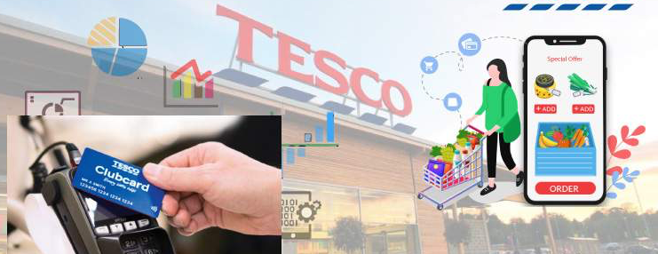
www.tesco.com

Regarding the CRISP-DM (Cross-Industry Standard Process for Data Mining) model, Tesco might adopt it as a structured approach for their BI projects. CRISP-DM involves six phases: Business Understanding, Data Understanding, Data Preparation, Modelling, Evaluation, and Deployment. It helps ensure a systematic and effective data analysis process.

CRISP-DM, which stands for Cross-Industry Standard Process for Data Mining, is a widely used and well-established methodology for data mining and data analytics projects. It provides a structured and iterative approach to guide organizations through the entire data mining process, from initial understanding to deployment and monitoring.

The CRISP-DM model

During this stage, data is collected, explored, and analysed to gain insights into its quality, structure, and potential usefulness. It involves data cleaning, data integration, and data transformation to prepare the data for modelling.

In this phase, the project objectives are defined, and the requirements for data mining or analytics are established. The focus is on understanding the business problem and determining how data mining can provide valuable insights or solutions.

This phase involves selecting the relevant data for analysis and preparing it for modelling. Tasks include feature selection, data transformation, handling missing values, and splitting the data into training and testing sets.

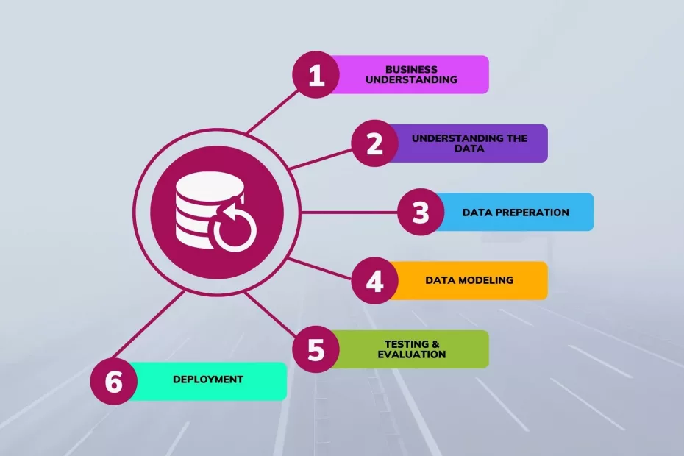
In this phase, various data mining techniques and algorithms are applied to the prepared data to build predictive or descriptive models. The models are evaluated and fine-tuned to ensure their effectiveness and reliability.

Once a satisfactory model is identified, it is deployed into the operational environment, allowing it to be integrated into the business processes. Monitoring mechanisms are set up to ensure the model's ongoing performance and effectiveness.

The models developed in the previous phase are rigorously evaluated against the business objectives and requirements. Performance metrics are used to assess the models' accuracy and generalization capabilities.

One of the key strengths of CRISP-DM is its iterative nature, allowing for continuous improvement and refinement throughout the data mining process. It promotes collaboration between business stakeholders, data analysts, and domain experts, ensuring that the final solution aligns with business needs.

CRISP-DM is a versatile and widely adopted framework that has been applied across various industries and domains for data-driven decision-making, pattern recognition, and predictive modelling. It’s clear and structured methodology helps organizations effectively manage data mining projects and extract valuable insights from their data.

BUSINESS INTELIGENCE TRENDS

1. Advanced Analytics and Predictive Modelling

One of the key BI trends is the adoption of advanced analytics and predictive modelling techniques. Tesco can utilize these tools to analyse vast amounts of customer data, such as purchase history, preferences, and browsing behaviour, to gain insights into consumer trends, optimize inventory management, and personalize marketing campaigns. By leveraging predictive analytics, Tesco can accurately forecast demand, optimize pricing strategies, and proactively address customer needs, thereby boosting sales and customer satisfaction.

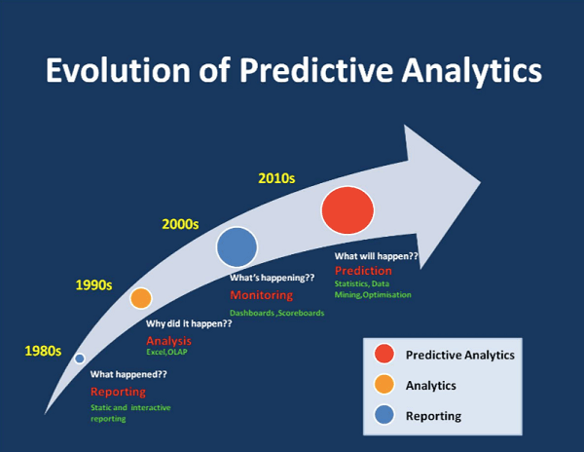
https://www.queppelin.com/predictive-analysis-services/ (Accessed on 30/07/2023)

2. Data Visualisation

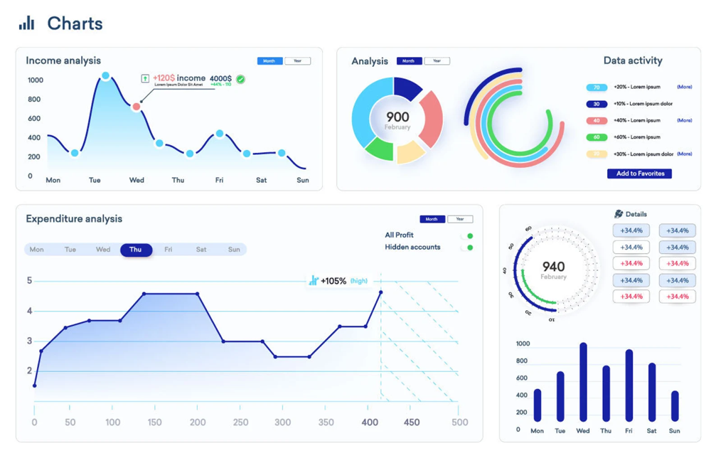
https://whatagraph.com/blog/articles/data-analytics-dashboard (Accessed on 30/07/2023)
The company using various data visualisation techniques and dashboard to present complex data in a user friendly and easily understandable format, facilitating better insights and decision-making. Data visualisation is an essential of their business intelligence strategy. Some common data visualisation practices used by Tesco are:
- Interactive dashboards
- Geographic mapping
- Line charts and bar graphs
- Heat maps

3. Artificial Intelligence (AI) and Machine Learning (ML)
https://www.datasciencecentral.com/machine-learning-ml-vs-artificial-intelligence-ai-crucial-differences/ (Accessed on 31/07/2023)
AI and ML technologies have revolutionized the business intelligence landscape. Tesco can leverage these technologies to automate data analysis, detect patterns, and generate actionable insights. For instance, ML algorithms can be used to segment customers, recommend personalized products, optimize pricing, and detect fraudulent activities. By incorporating AI and ML into their BI systems, Tesco can improve inventory management, deliver tailored marketing campaigns, and enhance overall operational efficiency.

4. Data Governance and Data Privacy

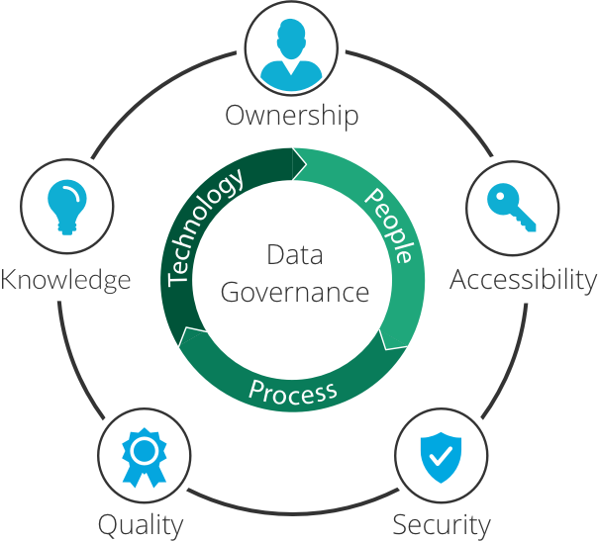
https://www.imperva.com/learn/data-security/data-governance/ (Accessed on 29/07/2023)

Data governance and data privacy have gained significant attention in recent years, fuelled by the growing need for stringent regulations and the increasing value of customer data. Tesco must prioritize data governance practices, establish clear data governance frameworks, ensure data integrity, and comply with regulations such as the General Data Protection Regulation (GDPR). By securing and protecting customer data, Tesco can build trust, maintain customer loyalty, and mitigate legal and reputational risks.

5. Augmented Analytics and Natural Language


https://www.springboard.com/blog/data-science/augmented-analytics/ (Accessed on 29/07/2023)
Business Intelligence (BI) has witnessed significant advancements in recent years, revolutionizing the way organizations gather, analyse, and utilize data. As the BI landscape continues to evolve, it is crucial for businesses to stay updated with emerging trends to ensure they stay competitive in the market.
Augmented Analytics refers to the integration of machine learning and AI technologies into BI systems to automate data analysis and generate actionable insights. By adopting augmented analytics, Tesco can streamline its data analysis processes, uncover hidden patterns, and gain deeper insights into customer behaviour, market trends, and operational performance. For example, Tesco can use augmented analytics to analyse customer data and identify specific buying patterns, enabling them to offer personalized recommendations and targeted promotions to customers. This can significantly enhance customer engagement and drive sales.

Conclusion

Customized BI tools and strategies are increasingly important for businesses in 2022 and beyond. By aligning BI solutions with their specific needs, organizations can maximize the value of their data, improve decision-making, increase productivity, and gain a competitive advantage. As technology continues to advance, BI’s role will likely become even more essential in shaping successful business strategies.

References:

https://en.wikipedia.org/wiki/Tesco#:~:text=Diversification,-The%20first%20self&text=The%20company%20started%20to%20expand,a%2035%25%20stake%20in%20GroceryWorks (accessed: 12 July 2023)

https://www.analyticssteps.com/blogs/5-ways-tesco-uses-big-data-analytics
(Accessed: 12 July 2023)

https://www.selecthub.com/business-intelligence/business-intelligence-trends/
(Accessed: 12 July 2023)

https://www.datapine.com/blog/business-intelligence-trends/
(Accessed: 14July 2023)

https://cio.economictimes.indiatimes.com/news/business-analytics/how-analytics-helped-tesco-improve-its-customer-satisfaction-amid-covid/85887530?redirect=1
(Accessed: 14 July 2023)

Maheshwari. (2015). Business intelligence and data mining. Business Expert Press.

Azevedo, A. and Santos, M.F. (2015) Integration of data mining in business intelligence systems. Edited by A. Azevedo and M.F. Santos. Hershey: Business Science Reference. Available at: https://doi.org/10.4018/978-1-4666-6477-7.

Business intelligence journal. (2003). Seattle, WA: 101communications.

Surma, J., Gee, P. and Górniakowska, M. (2011) Business intelligence : making decisions through data analytics. New York, N.Y: Business Expert Press.

