Review of Industry Skills

Student name – Polly Thomas

Student number – 1800171

Module – Academic and Industry Skills

Executive summary
The purpose of this report is to identify the key skills needed for the industry and to introduce and discuss the events industry overall. This discussion will be based on the key skills of the industry and the findings shown.

Table of contents

Page 1 – Cover page

Page 2 – Executive summary

Page 3 – Table of contents

Page 4 (1.0) – Introduction

Page 5 (2.0) – Main body – Content analysis

Page 6 (3.0) – Key skills needed

Page 7 – Graph and chart

Page 8 (4.0) – Conclusion

Page 9 + 10 – References

- Introduction

Events management is a diverse and fast-moving industry, comprising the
development and creation of events ranging in size and complexity, from large scale such as a music or literary festival, to those on a smaller scale such as a business meeting. The industry demands planning and organisation in order for the event to succeed. This would include scheduling, budgeting, arrangement of travel and accommodation and necessary permits or licences put in place. Each of these steps is important, and without even one of them, the event may not succeed. “Today, events are central to our culture as perhaps never before. Increases in leisure time and discretionary spending have led to a proliferation of public events, celebrations and entertainment”. (Events Management, 3rd Edition).

There are a huge variety of roles in the events industry. You could specifically be a wedding planner, an event tech expert, a social media coordinator, a digital concierge, a meeting designer, a conference architect, an event videographer, a digital analytics manager, a customer experience manager, a manager of event security, an event sustainability coordinator, an event reporter, a creative director, a live feedback manager, a sponsorship manager, a diversity coordinator, a creative event caterer or florist, or even a virtual event planner. So, the event industry offers numerous opportunities for a diverse range of jobs, and as the industry is continuously growing, new opportunities arise.

- Main body – Content analysis

The role I have chosen to analyse is the role of a social media coordinator. This job is critical to the industry, not only at a basic level to advertise an event and make people aware of what’s happening, but in the wider field to encourage word of mouth, and build excitement and anticipation around the event. Social networking has become such an important element in peoples’ lives and is so readily available to all age groups, that advertising through social media is accepted as one of the best ways to get any message out and to influence your target audience. It has developed incredibly fast over the past few years, and is something many people now feel they cannot live without. However, it is still vitally important that it is managed wisely, by someone who can direct the advertisement to the target audience in order for the social media to be effective.

A social media coordinator would have many duties in the workplace, including managing the company’s social media channels - Facebook, Twitter, Instagram, Snapchat, and even platforms such as Tumblr and LinkedIn. The coordinator would also work as part of a team to develop campaigns. The key is to communicate with people and share information quickly and efficiently.

It isn’t just a communications tool, but a useful way to market and increase brand awareness for a company. Social media plays a significant role in most companies nowadays, and when it’s done properly, it will bring a range of customers in, and let them know that the brand is active.
Advertisements for the role of a social media coordinator state that they are looking for someone with proven experience in the role, and are ‘skilled in producing content for social media campaigns’, such as ‘photography, graphics and copy’. (Indeed online website – 2018).

- Key skills needed
Key skills needed for the role of a social media coordinator would include: creativity, which means keeping up with the latest trends on social media and having a creative thought-process to provide the content that the client would be after. An understanding of how social media works in a fast-moving digital world. Social media amplifies whatever content is put out, choosing that content to suit each media platform takes a lot of skill to make sure it works for that particular niche. Being adaptable and flexible, as social media changes extremely quickly. Being willing to adapt your posts and attempt new features to suit the event or client. Keeping track of what’s trending, or the latest hashtag and updates on various social media apps. Another key skill is being decisive and driven and making sure decisions are made effectively. If a client needs your opinion, you will need to be able to think quickly and solve what issue they have. The same applies for social media complaints. A social media coordinator will need to respond fast and provide a solution to save further negative reviews etc. This links to communication skills and being able to respond, talk to and organise several people at the same time. Social media is everywhere and most people use it at some stage in their daily lives, and having the confidence and fluency to engage with people of all ages, all over the world would be another useful skill for this role.

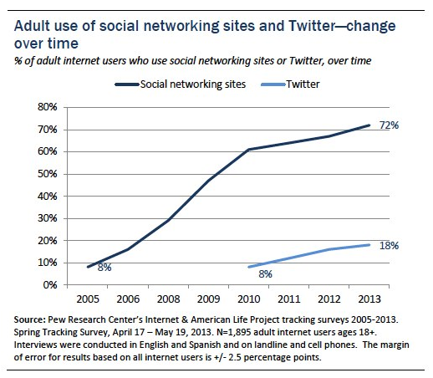
Graph of adult use of social media networking sites and Twitter, dramatic increase over the years is clear.

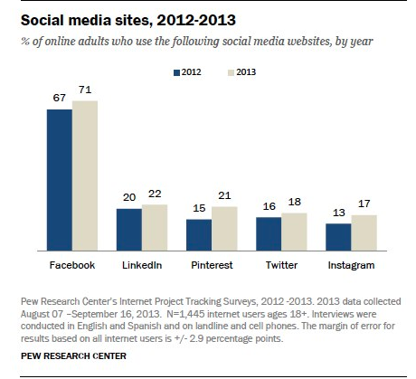
Chart to show the growth of social media sites between 2012 to 2013 including Facebook, LinkedIn, Pinterest, Twitter and Instagram.

Conclusion
In conclusion, social media is relevant, exciting, fast-moving, vital to any industry, and a part of everyone’s daily lives. In my report, I’ve examined the key requirements needed to take on the role of social media coordinator, and looked at the key skills that would be necessary to be successful in that role.

References
Events Management, 3rd Edition, Routledge (2012)
Event manager blog (2007-2018) -https://www.eventmanagerblog.com/emerging-roles-in-the-event-industry
Indeed online website (2018) - https://www.indeed.co.uk/Social-Media-Coordinator-jobs?vjk=748d67ac60de4e9a
Social media graph, Forbes online website (2005-2013) - https://www.forbes.com/sites/steveolenski/2013/09/06/social-media-usage-up-800-for-us-online-adults-in-just-8-years/#5c7e82b04237
Social media chart, Social media examiner online website (2012-2013) - https://www.socialmediaexaminer.com/instagram-platform-ripe-for-marketers-shows-new-research/
Marketing schools (2012) - http://www.marketing-schools.org/careers/social-media-coordinator.html
Kruse Control (2018) - https://www.krusecontrolinc.com/social-media-manager-job-description-complete-guide/
Blog Buffer (2018) - https://blog.bufferapp.com/social-media-manager-job-description
Entrepreneur (2018) - https://www.entrepreneur.com/article/289363
Growth Gurus (2018) - https://www.growthgurus.com/blog/business-brand-need-understand-importance-social-media/
Marketing Land (2018) - https://marketingland.com/social-media-2018-time-grow-get-236162
Social media today (2017) - https://www.socialmediatoday.com/smt-influencer/social-media-good-thing-or-bad-thing
Smart insights (2018) - https://www.smartinsights.com/social-media-marketing/social-media-marketing-trends-2018/

