

LEVEL 6

SEMESTER 1

MODULE CODE: SHSS6082
Landscape and Sustainable Recreation
aSSESSMENT TYPE: assignment
Assessment: 2

COMPONENT WEIGHTING: 50%

WORD COUNT: 2500WORDS

MODULE TUTOR: Dr Louise Emanuel

Reflective Fieldwork Journal
During this module you will visit a number of sites on fieldwork. At each site you should keep detailed notes relating to the following issues:

• Landscape Character
• Landscape Quality
• Designations
• Use
• Access
• Future Potential

These notes should subsequently be written up into a reflective and critical account of the landscape at each location, which incorporates relevant academic and policy related literature and provides suggestions sustainable approaches to recreational development at the site. Maps, sketches and photographic evidence should be used as appropriate. You should include details of two fieldwork sites in the main body of the work, and include the notes relating to the third in an appendix.

SUBMISSION DETAILS:

Submit by Turnitin on or before Friday 12th January 2018

Date feedback to be returned to student: On or before Friday 9th February 2018

School of Sport, Health & Outdoor Education

Assessment Feedback Sheet

Student No./Name: Paige Topliss 1501425
Module: Landscape and Sustainable Recreation
Module Code: SHSS6082

Personal Evaluation – to support your academic progress please complete the section below BEFORE submitting your work.
What do you consider to be the best aspects of this work? |  |  | The discussion of Dinefwr park
Which aspects do you consider could have been improved in this piece of work? |  |  | Using internal and external factors to discuss the relationship to landscape
What have you found most satisfying whilst undertaking this submission? |  |  | Using photos and diagrams to explain my time at the sites
ASSESSMENT CRITERIA | Learning  Outcomes |  | GRADE
ASSESSMENT CRITERIA |  |  | Poor  < 20% | Weak  20-29% | Unsatisfactory  30-39% |  | Satisfactory  40 – 49% | Good  50 – 59% | Very Good  60 – 69% | Excellent  70 – 84% |  | Exceptional  85– 100% | %
Your discussion of the nature of landscape within the context of the fieldwork locations | 1 |  |  |  |  |  |  | x |  |  |  |  | 20%
Your critical evaluation of external and internal influences that affect the perception, interpretation and use of landscape at the fieldwork sites. | 2 |  |  |  |  |  |  | x |  |  |  |  | 20%
Your critical discussion of the relationship between landscape and recreation and your suggestion of sustainable approaches to the interpretation and use of landscape for recreation. | 3 |  |  |  |  |  |  | x |  |  |  |  | 40%
Your identification and use of relevant academic and other material to help inform and develop your argument | 1,2,3 |  |  |  |  |  |  | x |  |  |  |  | 20%
It is expected that students will present work that is proof read, correctly referenced and adheres to the Assessment Checklist. Therefore a range of 0 – 10 marks will be deducted for non-completion of any of the points on the checklist below.
TUTOR COMMENTS:

Submission date:  via Turnitin |  | Return date:  (at least within 4 weeks) |  |  |  | Tutor: |  |  |  |  | Mark:

Assignment Checklist

- Please complete the Personal Evaluation section of the Assessment Feedback sheet, add your name and details, and paste the whole of this assignment document into the front of your assignment

- Submission is a single word file, clearly labelled with your name and module code
- Font style - Times New Roman, size -12 for text and 14 for headings
- Ink colour – black only
- Line spacing – 1.5 line spacing and 2cm- 2.5cm page margins
- Quotations more than three lines to be indented 1 line spacing
- One line space between paragraphs, paragraphs must be left aligned
- Pagination (your assignment should have page numbers)
- All tables and figures are internally referenced and have a title
- Word count checked and written at end of text (before references and any appendix)
- Assignment is within 10% of the word limit (excluding references and any appendices)
- All references in the text are included in the reference list
- Correct referencing following the Harvard style, as described in the Palgrave study skills book ‘Cite them Right’.
- Correct spelling using UK English
- Correct use of punctuation
- Grammar and syntax correct- double check anything that has a green line under it
- I have read my assignment out loud to myself and it makes sense and is easy to read
- Somebody else has read my work and it makes sense to him or her!
- I have checked and I have not plagiarised
Failure to follow these guidelines will cost you marks!
This critical reflection will reflect on the two fieldwork studies visited throughout our semester as well as, in the appendix a site I visited myself. The two sites we visited as a class is Three Cliffs Bay with Dryad Bushcraft and Dinefwr Park. All three sites allowed me to interpret individual landscapes in different ways and allowed me to gain a stronger relationship with the natural environment. I will reflect upon the landscape evaluating the external and internal factors that affect an individual’s perception of the landscape at the site. Also, incorporating current literature and sustainable policies related to the discussion. I will be using Gibb’s Reflective Cycle (1988) to allow me to reflect on the experiences with a structure to follow (see figure 1).
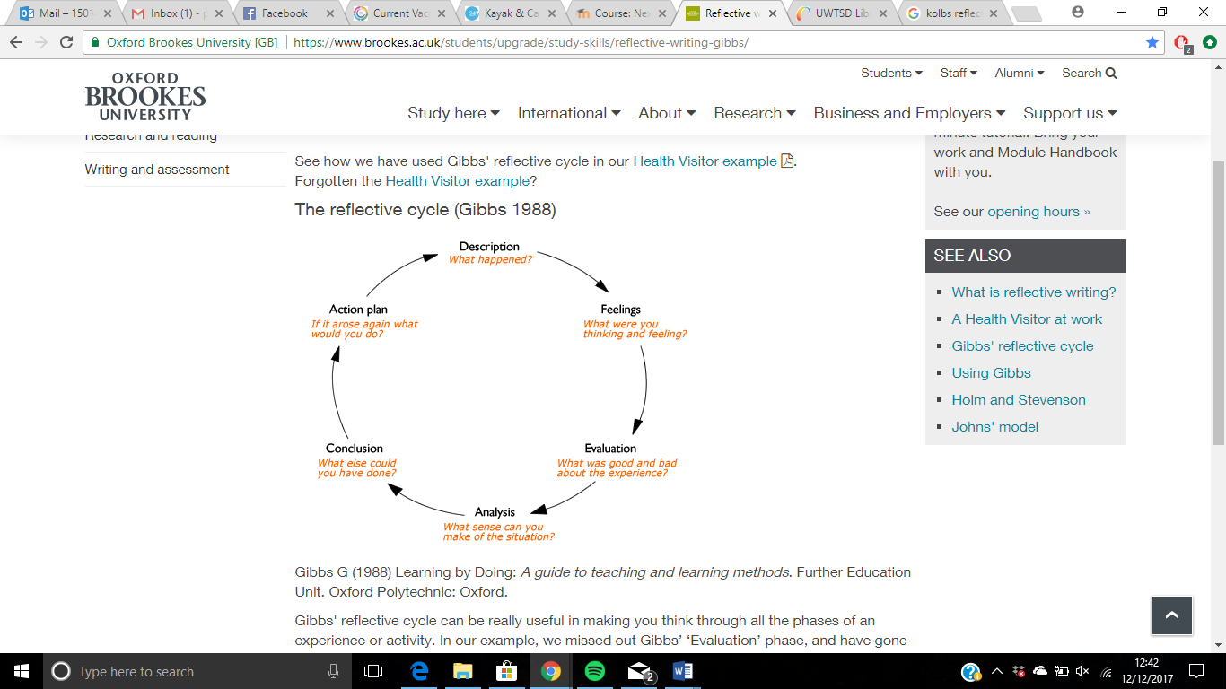

Figure 1: Gibb’s Reflective Cycle (1988)

Landscape is interpreted different to everyone. ‘Though they move through the same world, people see, understand, experience and value quite different things’ Strang (1997, p.4 cited in Stewart 2008, p.80). We see and understand what is in front of us in differently. Our sense of place and connection to the environment around us contributes to the relationships we have with the landscape. The internal and external factors we have to the landscape can change our perception and use of the landscape around us.
Site 1: Three Cliffs bay with the Dryad Bushcraft
On the 28th November 2017 we visited Dryad Bushcraft at The Gower Heritage Site. Due to the state of the forest from a previous course this week we walked to Three Cliffs Bay. The landscape was bursting with character. We explored the area on the way to the beach stopping at different flora and faunas that we can eat, use for medicines or even feed to live stock like they did in the cold months once in the past. Plants such as gorse bush flowers and hairy bitter cress are some of the products from the landscape we were able to try. Swansea Council (2017) explains that the ‘cliff faces are of particular importance for wildlife such as rare alpine plants, including yellow whitlow grass (the county flower of Swansea) and nesting birds including ravens and chough’.
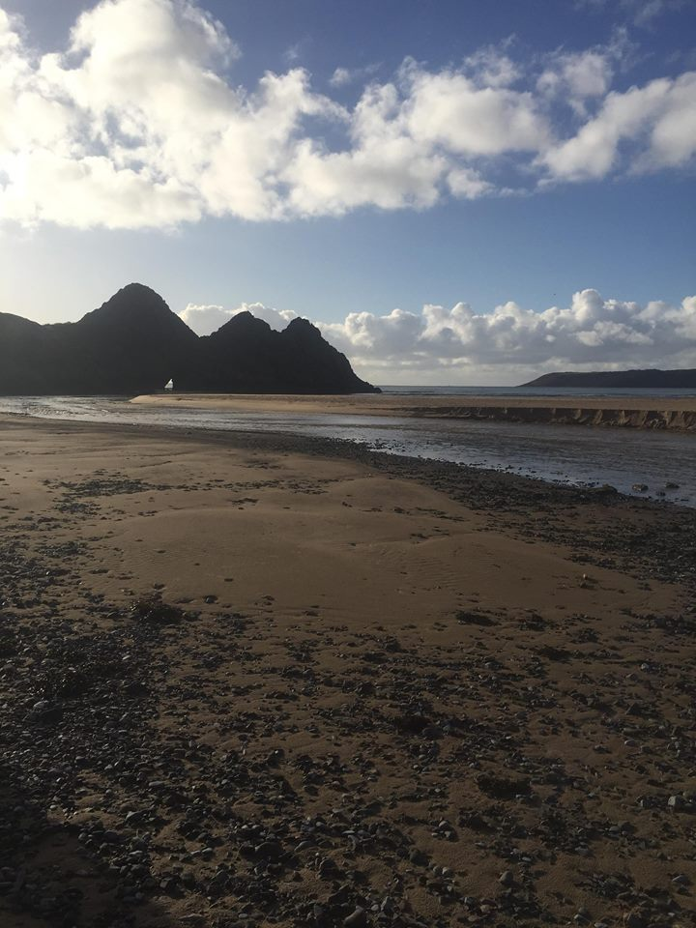
Figure 2: Three Cliffs Bay.

Figure 2 shows Three Cliffs bay. Dryad Bushcraft gave us the opportunity to experience the wide range of nature that was on offer and shared narratives and past tales they knew of the area.
The landscape was well preserved however, there is obvious wear and tear to the land. The impact of a high number of visitors has created erosion to the paths. Dryad Bushcraft is creating an important environment awareness to the area through the courses they run. The area is mainly owned by the National Trust (Swansea Council, 2017) however, it has multiple protections from different organisations that allow the landscape to be preserved for the future. The site falls within the Gower Area of Outstanding Beauty (AONB) as well as Site of Special Scientific Interest (SSSI), Heritage Coast and Scheduled Ancient Monuments (SAMs) (Swansea Council, 2017). All these organisations are helping to create a sustainable future.
The landscape is used for a variety of purposes. There are a variety of people using the area for walks and exploring as well as, take part in the Bushcraft days with Dryad Bushcraft. On the other hand, this area is a famous place to climb throughout the climbing community. This brings many climbers from all around to visit to climb this icon rock which has been found to be as old as 480 million years old. ‘Three Cliffs Bay beach offers a wilder experience. Picture a spectacular shoreline of sand dunes, salt marsh and of course, the signature three limestone cliffs’ Visit Swansea Bay (2017). The bay offers the perfect landscape to a variety of visitors however, they all return multiple times to be in this natural setting. A poem wrote at Three Cliffs Bay talks about the writer’s thoughts about his life while in this environment an extract from this poem stands out;
‘Hiding from scorching sun.
And doesn’t this describe my life?
Seeking a hiding place from
The unchangeable, unarguable elements.
The absolutes of life.’
Smith (no date)
The bay allowed the writer to reflect upon his life. In the description he writes ‘This was some time ago now, but I have never forgotten that morning by the sea’ Smith (no date). The natural environment allows us to escape from the life we live in modern society and bring us back to one with nature. It seems many people cherish this specific landscape and feel they have a special relationship like this poet does. Even though, he only visited once this night has created lasting memories and a sense of place with the landscape.
The area is a popular tourist spot. It has been suggested the tourist pressures have changed the cultural character (Natural Resources Wales, 2014, p. 3-4) of the landscape. The tourist industry brings in many people causing high congestion along the narrow lanes of the area. It is said that ‘On occasions this erodes the peaceful and remote qualities of the area’ Natural Resources Wales (2014, p.4). This is an understandable issue because, normally there will be few people using the landscape except for the local community. Figure 3 below shows the outstanding tranquil landscape of area around the bay.
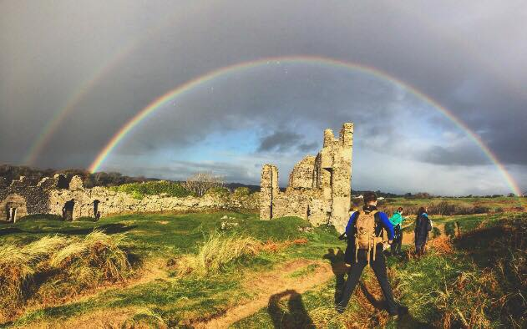
Figure 3: Pennard Castle.

Natural Resources Wales (2014, p.4) states that ‘the sense of place is one of a relaxed society in an unspoilt and well-protected landscape’. The landscape gives the sense of comfort soon as you are within the environment, figure 3 is an example of this. It came apparent the community is passionate about the area and want to sustain the beauty for the future.
While visiting the site even though, it was my first experience in the area I felt at home due to the comforting surroundings. I feel this is because, of the connection I have with natural environment. ‘According to the various interpretations, nature connectedness as a scientific construct is likewise applied as inclusion of nature in self, emotional affinity towards nature, nature relatedness or connectivity with nature’ Braun & Dierkes. (2017, p. 938). The connection to nature is developed through the internal and external factors that influence our relationship to nature. Internal factors such as memories, narratives of the area, the peaceful environment the landscape has and the distinctive nature. The external factors could be the activities that connect the individual to the area, a specific landmark, Pennard Castle and the specific flora and fauna that grows in the area. ‘While many authors underline the emotional base when defining the concept of nature connectedness (Mayer and Frantz 2004; Müller, Kals, and Pansa 2009; Nisbet, Zelenski, and Murphy 2009; Raudsepp 2005 cited in Braun & Dierkes. (2017, p. 938) another approach focuses on the role of the natural environment in a person`s identity (Clayton 2003 cited in Braun & Dierkes, 2017, p. 938). A relationship with nature can relate to when an individual connected to the environment. It has been found that it is important to create this relationship at a young age Brymer, Cuddihy & Sharma-Brymer (2010, p.23) found that opportunities to connect with nature when a child are important for the promotion of wellness for future adults. It is important to be surrounded by nature from a young age to create the memories and relationships with the environment to influence your personal internal and external factors to connect to the surroundings.
The area of Three Cliffs Bay offers multiple opportunities for different individuals of different interests. This can cause a huge erosion issue within the near future with visitors creating new paths therefore, damaging the landscape and not creating a sustainable future. ‘While most recreation takes place informally and without adverse impact, there is clear potential for certain activities to compromise the area’s special natural qualities, and for recreational users themselves to come into conflict’ Jones (2011, p.5). it is important for users of the land to understand the impacts caused by being there. Jones (2011) created a structure to help manage recreation on the Pembrokeshire Coast Line which I feel can help manage the area of Three Cliffs Bay. See figure 4 for an example:
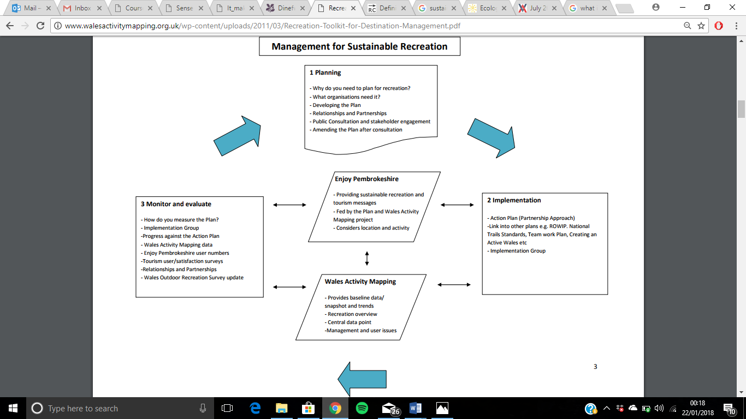
Figure 4: Diagram for sustainable recreation.
Having a plan will allow the structure to follow that will help improve a sustainable landscape. ‘Managing recreation sustainably will only be successful if all those involved can work together in partnership Jones’ (2011, p.5). With the area being a part of many organisations, it is important that we all work together to protect this well-loved area.

Site 2: Dinefwr Park
5th December we visited Dinefwr Park which is a part of the National Trust parks. We were shown around by the park ranger who talked about the different uses the park has in the present as well as, the deep history of the past. We looked at what they do to promote using the natural environment such as children’s clubs and Bushcraft days with schools or youth groups. The site is a Sight of Special Interest (SSSI) and is the only parkland that is a National Nature Reserve (NNR in wales. National Trust (No date) describes Dinefwr Park as a ‘microcosm of Welsh heritage and natural history’. This park is a representation of the traditional Welsh culture. It creates a sense of place to the community surrounding the park however, I feel it adds to the sense of place to the whole Welsh culture.
Dinefwr park is 800 acres of land however, the park ranger explained the park use to be 3000 acres of farmland. The site had many original features such as the slaughter house, medieval deer park, ponds, and castles. These landmarks can create a sense of place for the community around the park allowing them to connect to an object. Bird (2002) uses a narrative of a landmark as an example of a sense of place in the community like this one she explains ‘the site comes to define through story the values and cultural identities with which people choose to define who they are’ Bird (2002, p.525). Preserving the original features give the community an identity and allows them to come together and share their relationship with the landscape and create a SP as a community.
The landscape is used for a variety of reasons. It is a National Trust park therefore, many visitors come to view the site for the day or to walk their dogs. The do Bushcraft for school and youth groups as well as, have their own clubs outside of school hours. The park also does special events at different times of the year such as Christmas and Easter fairs. On the National Trust website, a quote explains ‘If you take a handful of the soil at Dinefwr and squeeze it in your hand, the juice that will flow from your hands is the essence of Wales’ Thomas (no date). I feel Dinefwr Park is the heart of the community and creates a sense of place to many that visit.
The site uses the land to its full potential. The Bushcraft days are utilised across the whole site such as nature walks, pond dipping, and using fires. They have created their own natural seating circle with a fire place in the middle which is located next to the slaughter house in the deer park. Figure 5 below is a personal drawing of an example of this area personally, I feel it is important to create these natural spaces to allow visitors and children to connect to the environment in a natural setting.
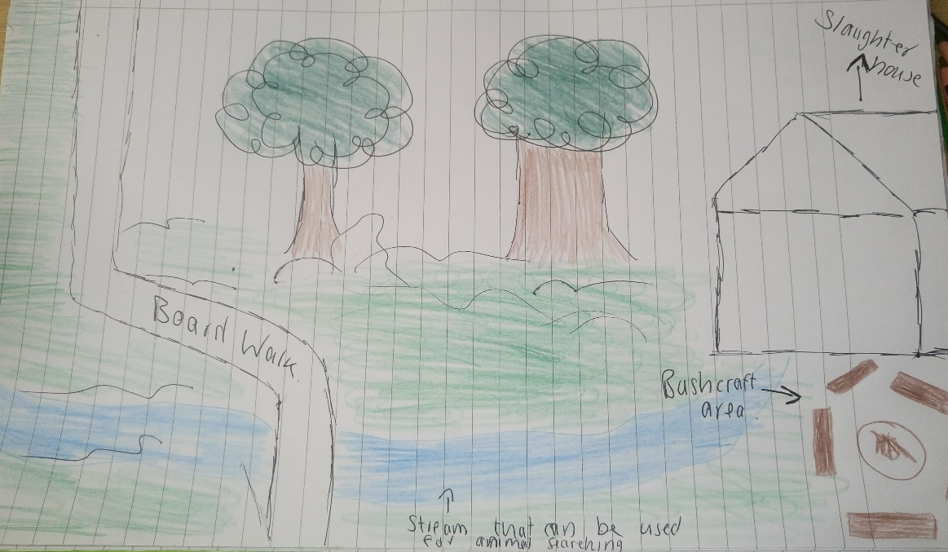
Figure 5: Personal drawing.

Braun & Dierkes (2017, p. 945) ‘referring to findings developmental research (Kuhn and Pease 2006) we think that the connection to nature of 7–9 year old students can be triggered by fascination and emotional concern which is not demonstrated to that extent by older students.’ I feel through the park is providing the aid to allow children to connect with nature and create a relationship with their local landscape. The Bushcraft is done in a natural setting which can create a more relaxed environment for a connection to nature. The overall experience will hopefully create a SP.
Visiting the park allowed me to be in my comfort zone surrounded by the natural environment. It was my third visit to the park and every visit has reminded me of similar landscapes to my home. There are many features in the park that can influence an individual’s internal and external feelings towards the landscape. The park has the oldest trees in Britain such as a 1000-year-old oak tree. Memories like this will create a deep connection to the landscape creating a positive mind-set to the park for the future. A different feature of the park in the pond at the end of the board walk. We were told by the ranger that it was created purely to see the reflection of the park. See figure 6 below:
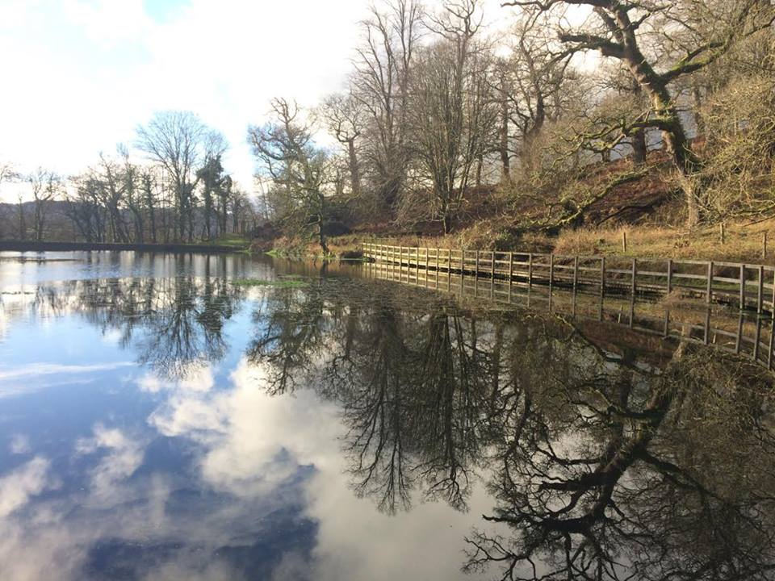
Figure 6: Reflection of the park.

The pond is like glass and makes a perfect reflection of the surroundings. It looks as if the silhouette is painted on to the lake like it was a canvas. Children use this for pond dipping as well as, many visitors and walkers will pass this area every day. This view will be looked upon and defined differently to everyone who sees it. ‘Our understanding of nature and of human relationships with the environment are really cultural expressions used to define who we were, who we are, and who we hope to be at this place and in this space’ Greider and Garkovich (1994, p.2). This example allows the visitors to connect to the landscape through different internal and external factors. For examples an internal factor could be the way the surroundings made the individual feel in that moment. The external factors could be the pond. These factors influence the visitors use of the landscape and create a SP to the area.
The large number of visitors on a regular basis unfortunately, have a lasting impact on the site. It was explained that the recent Christmas fair had 6500 people visit over two days as well as 100 stalls and staff therefore, there was close to 8000 people on the park at one time. There was a huge lasting impact on site from this demand on the landscape. It was explained to us that the committee want the park to reach an annual target of 100,000 visitors however, there was a struggle to gain funding to improve facilities in the park. To make the park more a sustainable area there is a need for modification and improvements to the facilities. This will allow for regular visitors to enjoy what the park offers without the negative affects to the landscape. The park ranger suggested ways to improve the landscape. Examples such as; Drainage in the fields that are used for over flow parking and promote the scanning of membership cards when parking so, the park receives funding. Figure 5 shows the three areas of sustainability that need to be considered to maintain the site for future.
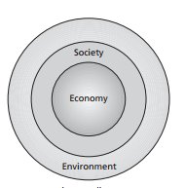

Figure 7: The green economics paradigm. Cato (2009, p.37)

The diagram shows that ‘society nestles inside the environment and the economy is a part of society. In this view, both society and economy are dependent on the environment.’ Cato (2009, p.37). Dinefwr Park has a plan that will allow them to protect the landscape of the park for the future. With the request of funding as well as, promoting the use of memberships so they can receive funding the park will be able to invest in their future. Adopting a sustainability framework can allow them to plan and have a constructive plan to help them on their journey to protect the landscape.
In conclusion, the two sites allowed me to understand the impact we create without realising. I feel it is important to incorporate everyone is the protection of the environment so, they are more likely to take care of the area in the future. A relationship to the environment is important for the individual to have the emotions to care for the landscape they are surrounded by because, I feel they have a bigger awareness of the impact they are causing. Therefore, it is vital to have a strong connection to the environment for the welfare of the landscape.
2741 words.

Reference list:
Bird, S. (2002). ‘It makes sense to us: Cultural identity in local legends of place’, Journal of Contemporary Ethnography, 31(5), pp.519–547.
Braun, T., & Dierkes, P. (2017). ‘Connecting Students to Nature--How Intensity of Nature Experience and Student Age Influence the Success of Outdoor Education Programs’, Environmental Education Research, 23(7), pp.937–949. doi: 10.1080/13504622.2016.1214866
Brymer, E, Cuddihy, T, & Sharma-Brymer, V. (2010). The Role of Nature-Based Experiences in the Development and Maintenance of Wellness. Asia-Pacific Journal of Health, Sport & Physical Education, 1(2), pp. 21-27
Cato, S., M. (2009) Green Economics: An Introduction to Theory, Policy and Practise. London: Sterling, VA.
Gibbs, G. (1988) Learning by Doing: A guide to teaching and learning methods. Further Education Unit. Oxford Polytechnic: Oxford.
Jones, D. (2011) Management for sustainable recreation in the Pembrokeshire Coast National Park. Available at: http://www.walesactivitymapping.org.uk/wp-content/uploads/2011/03/Recreation-Toolkit-for-Destination-Management.pdf (Accessed: 21 January 2018)
National Trust (No date) Dinefwr Park. Available at: https://www.nationaltrust.org.uk/dinefwr/features/dinefwr-park (Accessed: 21 January 2018)
Natural Resources Wales (2014) National Landscape Character: Gower. Available at: https://naturalresources.wales/media/682629/nlca39-gower-description.pdf (Accessed: 20 January 2018)
Ross, D. (No date) Pennard Castle. Available at: http://www.britainexpress.com/attractions.htm?attraction=503 (Accessed: 20 January 2018)
Sanger, M. (1997). ‘Viewpoint: Sense of Place and Education’, The Journal of Environmental Education, 29(1), pp. 4–8.
Stewart, A. (2008) ‘Whose place, whose history? Outdoor environmental education pedagogy as ‘reading’ the landscape’, Journal of Adventure Education and Outdoor Learning, 8:2, pp. 79-98. doi:10.1080/14729670801906125
Swansea Council (2017) Pennard Cliffs and Burrows (Three Cliffs Bay) Available at: https://www.swansea.gov.uk/pennardcliffs (Accessed: 20 January 2018)
Thomas, V., W. (No date) Dinefwr Park. Available at: https://www.nationaltrust.org.uk/dinefwr/features/dinefwr-park (Accessed: 21 January 2018)
Visit Swansea Bay (2017). Three Cliffs Bay Beach. Available at: https://www.visitswanseabay.com/listings/three-cliffs-bay-beach/ (Accessed: 27 December 2017)
Appendices
Appendix 1.
Fieldwork 3: Notes for Llandysul – water sports on Afon Teifi
Designations
- Sections of the river are SAC – special areas of conservation
- Reason for this is the life in the river: otters, salmon, bullhead, lamprey
- the area I am looking at is from Captain kids to Llandysul paddlers.…. This has different life in the area such as salmon, trout, otters.
- Llandysul paddlers own the rights to their section of water and take all costs to protect the land`
Landscape character
- River bank
- Rocky area
- Sandy area – Sides of the river is sand. One get out on the river is called ‘sandy beach’ by Llandysul paddlers and other users
Landscape quality
- The area is well thought of and cared for due to the sense of place of many
- The area has lots of memories for many people in the village or who are linked to Llandysul paddlers therefore, has many tales and narratives from so many
- It is a mystical place with different flora and fauna growing freely as well as dangling over the river
Internal and External that affect the perception and interpretation and use of landscape
Internal factors:
- The flow of the water
- Memories – progression and becoming better
- Distinctive nature around – jungle like when paddling down the river
External factors:
- Sport that can be done
- Kayaking
- Slalom
- Adventure element to the river because of the changing elements
- Training facilities
- Easy access to the river
- River features – jumps, rapids
Use
- Recreation
- Kayaking, canoeing, rafting, river swimming, slalom, slalom completions, education, nature walks along the river bank
- Personal and commercial
Access
- Llandysul paddlers own the section of their land – own access and fishing rights
- However, river left banks are owned by the house owners which makes the rock private land which shouldn’t be touched
- SAC site
- 73 miles long
Relationship between landscape and the recreation
- Sense of place through a large community childhood memories and enjoyment of water sports
- Enjoyment of a sport and the endless opportunity one river can create
- The connection to a section of the water where someone first did something – surf a wave, a trick, a slalom gate, difficult technical skill
- Connection for a bad memory such as; a capsize, a swim, getting stuck in a dangerous feature etc
Future potential (sustainable approaches for the future)
- Llandysul paddlers care for this section of Teifi
- The sense of place has created a community of paddlers
- Regularly get together to take care of the river banks, trees, rubbish, obstacles in the river itself
- They have made steps and concrete path to get in and out of the river to stop erosion
- They create sustainable/natural features in the river to create new rapids and waves etc. this carries on the site will become a world class paddling destination.
- It is already known for the training sit of the Welsh Slalom team squad
- Teifi tour ran by river legacy once a year – creates a lot of funding which is put in to Llandysul paddlers to keep the work going

