Setting Info.plist

By default, Apple insist that any URLs used should be https-based (secure). However, SSL is not always enabled on our webhosting. If this is the case, we can circumvent this by editing the project’s Info.plist. You’ll find it in the left-hand window:

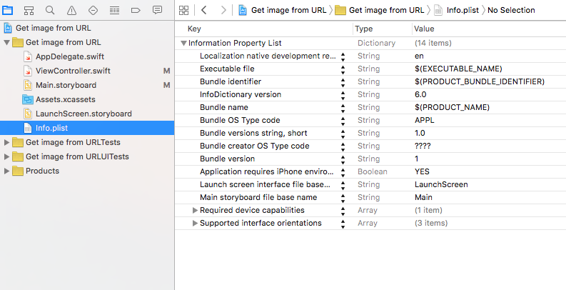

- Right-click on the right-hand window and select “Add Row”

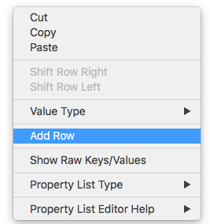

- Set the title of the new row as “App Transport Security Settings”

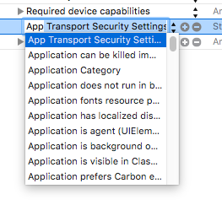

- Click so that arrow of App Transport Security Setting is pointing down, then click on the “+” and type in “Allow Arbitrary Loads”

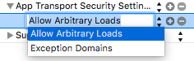

- Use the arrows to set the Boolean to YES

