Tesla LifeSync — A New Brand Concept for Tesla
Student Name: Modhvadiya Krishnaben Arbham
Student ID :2542897
Table of Contents
Element 1: Sustainable Brand Extension Poster Presentation 3
Element 2: Segmentation, Targeting, Differentiation, and Positioning (STDP) Analysis for Tesla eCycle 4
2.1 Introduction 5
2.2 Market Segmentation 5
2.2.1 Geographic Segmentation 6
2.2.2 Demographic Segmentation 6
2.2.3 Psychographic Segmentation 7
2.2.4 Behavioural Segmentation 7
2.3 Target Audience 8
2.4 Differentiation 8
2.4.1 Competitor Analysis 9
2.4.2 Sustainability Credentials 9
2.4.3 Direct Retail Model 9
2.5 Positioning 10
2.5.1 Positioning Statement 11
2.5.2 Perceptual Positioning Map 11
2.5.3 Alignment of Positioning with brand’s Overall Brand Identity 12
Element 3: Marketing Mix (7Ps) for Tesla eCycle 13
3.1 Introduction 13
3.2 Product 13
3.3 Price 14
3.4 Place 14
3.5 Promotion 15
3.6 People 16
3.7 Process 16
3.8 Physical Evidence 16
3.9 Alignment with the Sustainable Brand Extension Strategy 17
Element 4: Reflection 17
4.1 Introduction to the Reflective Process 18
4.2 Development of the Marketing Strategy 18
4.3 Poster Presentation Experience 18
4.4 Key Skills, Knowledge, and Insights Gained 18
4.5 Contribution to Personal and Professional Development 18
4.6 Areas for Future Improvement 19
Reference List 20

Element 1: Sustainable Brand Extension Poster Presentation
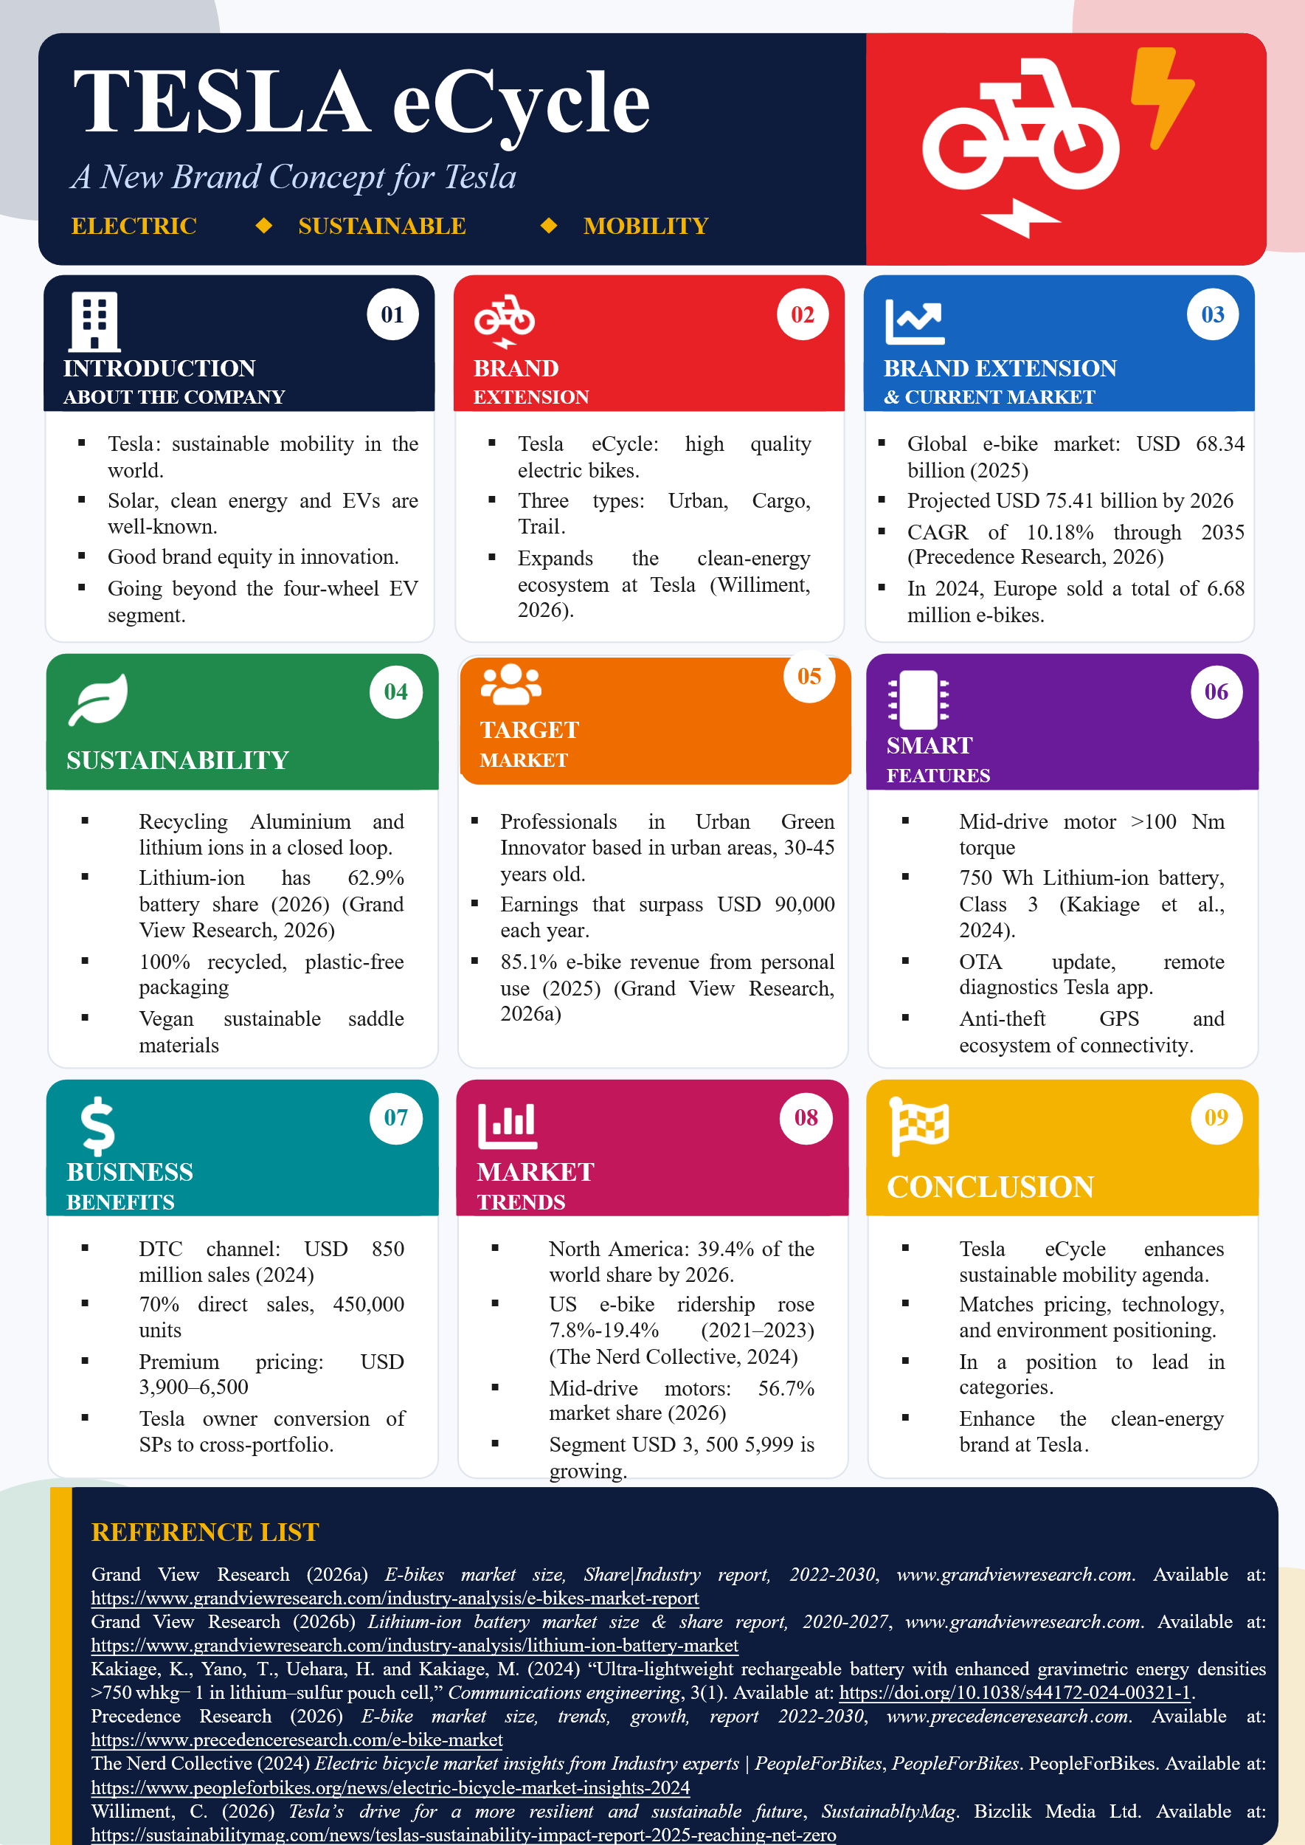

Element 2: Segmentation, Targeting, Differentiation, and Positioning (STDP) Analysis for Tesla eCycle

2.1 Introduction
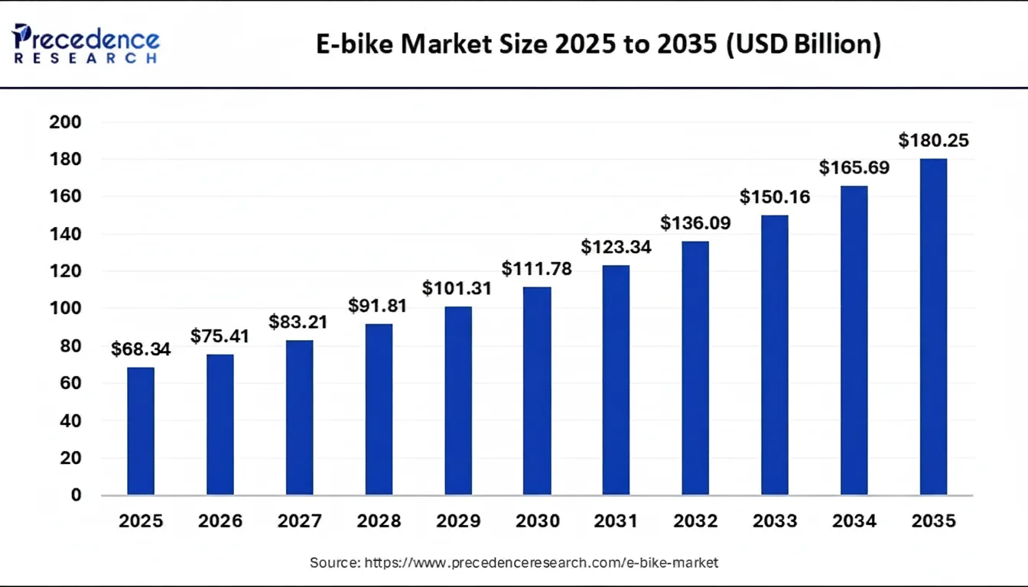
Figure 1: E bike Market Size
(Source: Precedence Research, 2025)
The introduction of the Tesla eCycle is the strategic diversification of the Tesla brand into personal electric mobility, and is an extension of the ethos of sustainable transportation under the Tesla brand beyond the four-wheel electric vehicle segment. The global e-bike market size was USD 68.34 billion in 2025 and is predicted to increase from USD 75.41 billion in 2026 to approximately USD 180.25 billion by 2035, expanding at a CAGR of 10.18% from 2026 to 2035 (Precedence Research, 2025). A keen STDP analysis is thus necessary in achieving competitive positioning of Tesla eCycle in this fast changing market.

2.2 Market Segmentation

2.2.1 Geographic Segmentation
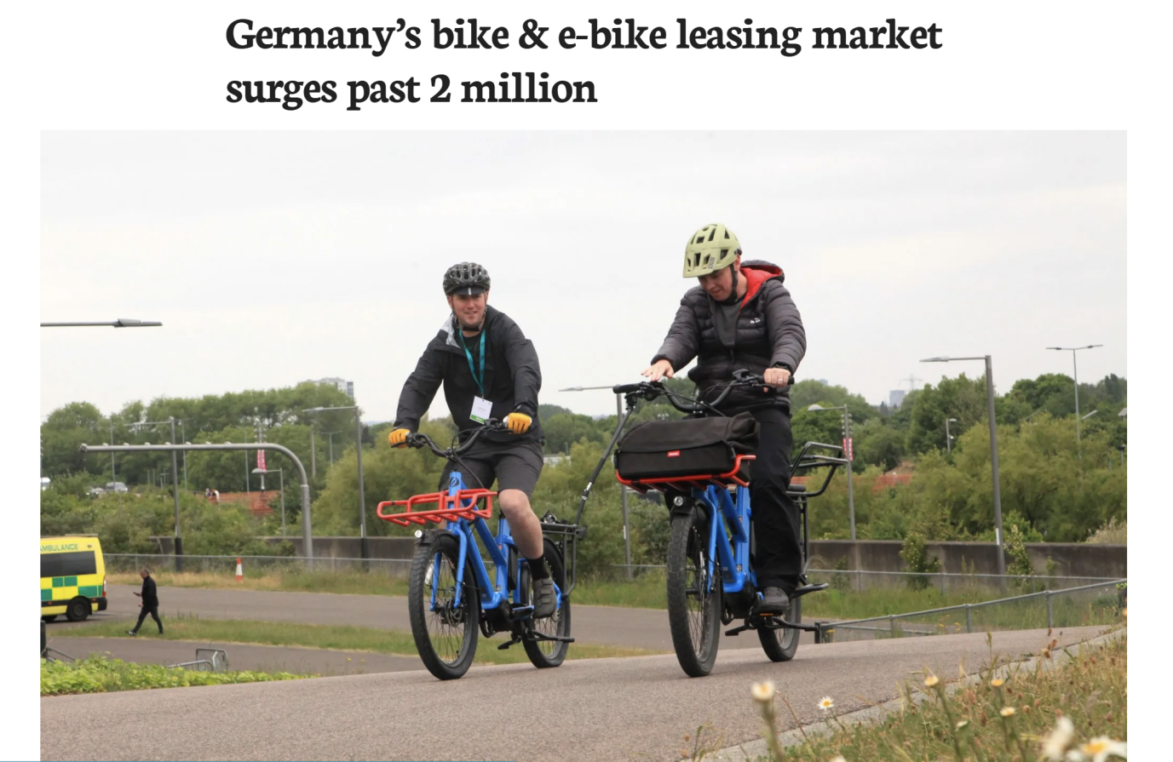
Figure 2: Rising Demand of e-cycles
(Source: Sutton, 2025)
The first rollout will be prioritised in urbanised parts of Western Europe (Germany, Netherlands, Denmark, United Kingdom) and Tier-1 cities in North America (San Francisco, New York, Portland, Vancouver). Europe was registered to have sold 6.68 million new e-bikes in 2024, with Germany registering 2.1 million e-bikes sold (Sutton, 2025). North America is expected to comprise 39.4% in the world market by 2026 expanding $4.46 billion today to $5.04 billion by 2026.

2.2.2 Demographic Segmentation
Tesla eCycle will focus on adults whose incomes are higher than $90,000 per year and at 28-50 years. The household-buyer focus was confirmed by the presence of 85.1% of e-bikes revenue by the personal-use segment in 2025. Education drives are biased between university-educated groups and intervening groups of Tesla vehicle owners. Gender segmentation is equalized and each product tier has unisex commuters, family cargo options, and performance eMTBs (Grand View Research, 2026).

2.2.3 Psychographic Segmentation
The psychographic profile will focus on consumers who are environmentally aware postulating clean-energy lifestyle and technological aspirations. Such consumers are ready to pay a premium price provided they are accompanied with ecological and technological excellence. The high-end model costing $3,500-5,999 has emerged as the main driver of growth in North America (Lu, Yin Junming and Aya, 2025).

2.2.4 Behavioural Segmentation
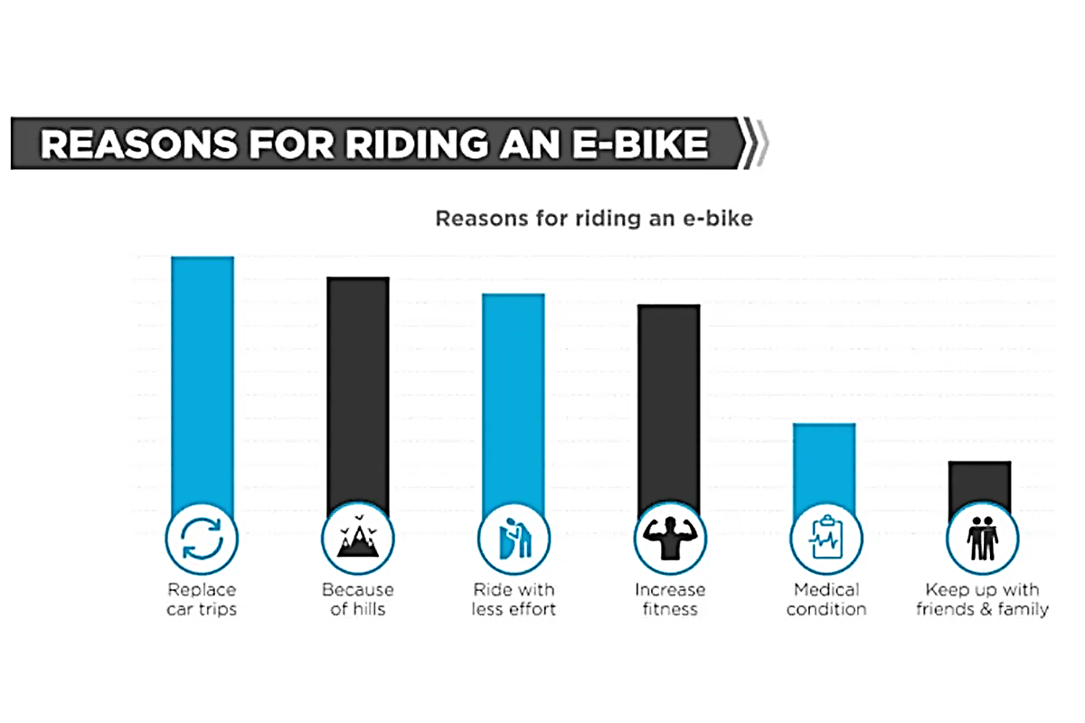
Figure 3: Reason for riding and E-Bike
(Source: Chocolatezhu, 2025)
On the behavioural level, the segment includes the daily urban commuters, recreational riders on weekends, and environmentally-conscious replacement buyers replacing second cars in the household. Consumer research indicates that 75% of e-bike riders experience that riding is better than driving, and 44% of e-bike riders gave environmental reasons. Smart (GPS anti-theft, app connectivity) and digital-first purchase experiences (Chocolatezhu, 2025).

2.3 Target Audience
Target Audience: The core target market is the "Urban Green Innovator" - professionals between age 30-45 years in city or suburban Europe and North America who earn more than the median of the nation and who exhibit a strong interest in embracing green consumption. This group of customers takes interest in the automotive and energy products of Tesla already.
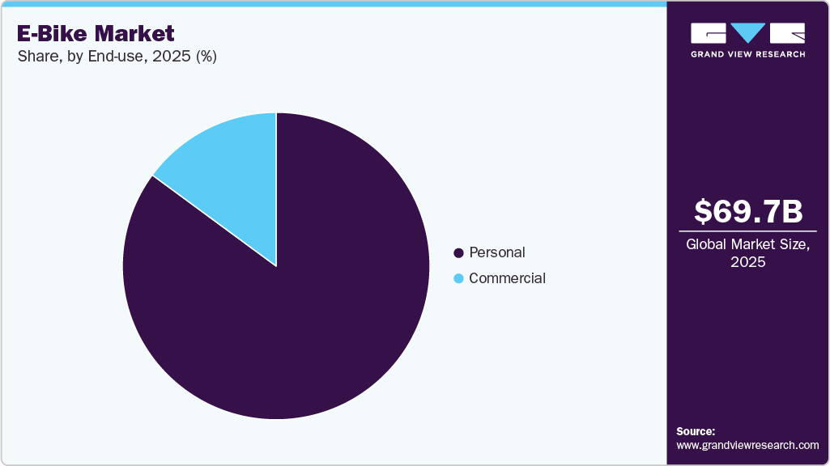
Figure 4: E Bike Market
(Source: Grand View Research, 2026)
Justification: The Urban green innovator can be explained by robust data congruency: 44 percent of e-bike purchasers mentioned e-greens reasons, the high-end $3,500-$5,999 category boosts sales in North America, and 85.1% of e-bikes sales were directed to personal usage in 2025 (Grand View Research, 2026). The current loyalty to the Tesla brand by this group of consumers increases the cross-portfolio conversion and lifetime value.

2.4 Differentiation

2.4.1 Competitor Analysis
Competitor | Key Strength | Weakness vs Tesla eCycle
Specialized Turbo | Premium build quality; strong brand loyalty | High price point (£4,000–£13,000); limited AI integration
Trek | Wide dealer network; diverse model range | Conservative design; minimal smart connectivity features
Riese & Müller | German engineering; superior cargo e-bikes | Niche appeal; prohibitively expensive for mass market
Giant | Cost-effective manufacturing; global scale | Perceived as mid-tier; lacks luxury brand positioning
Bosch-powered brands | Reliable motor systems; industry-standard tech | Dependent on third-party components; limited software ecosystem differentiation
Tesla eCycle's Edge: Brand cachet, proprietary AI-driven battery management, integrated Tesla app ecosystem, and autonomous safety features position it uniquely against incumbents prioritising traditional cycling engineering over technological innovation.

2.4.2 Sustainability Credentials
Tesla eCycle recycles aluminium and lithium-ion in closed loops (62.9% of the battery market stands in 2026, lithium-ion), and has vegan sustainable materials on the saddle, furthering a real-world recycling economy role (Grand View Research, 2026b). Additionally, the company partners with certified e-waste processors to ensure end-of-life components are responsibly recovered, targeting a 95% material reclamation rate by 2028, thereby reinforcing its commitment to circular economy principles and minimising landfill contributions across the entire product lifecycle.

2.4.3 Direct Retail Model
The sales are performed at Tesla stores and online configurators. The proportion of e-bikes sold via direct-to-consumer channels expanded to 70% in 2024, amounting to $850 million with 450,000 units sold - a time-tested strategy of which Tesla is uniquely capable.

2.5 Positioning

2.5.1 Positioning Statement
Tesla eCycle is a high-end, technology-based, environmentally friendly e-bike (comprising personal sustainable mobility) of the connected urbanized lifestyle. The positioning statement is: To those urban professionals who are sustainability-oriented and require innovation and design excellence (Mr Saurabh et al., 2025). Tesla eCycle is the smart electric bicycle that is easily incorporated in the Tesla clean energy ecosystem and that offers the performance uncompromised without environmental compromise.

2.5.2 Perceptual Positioning Map
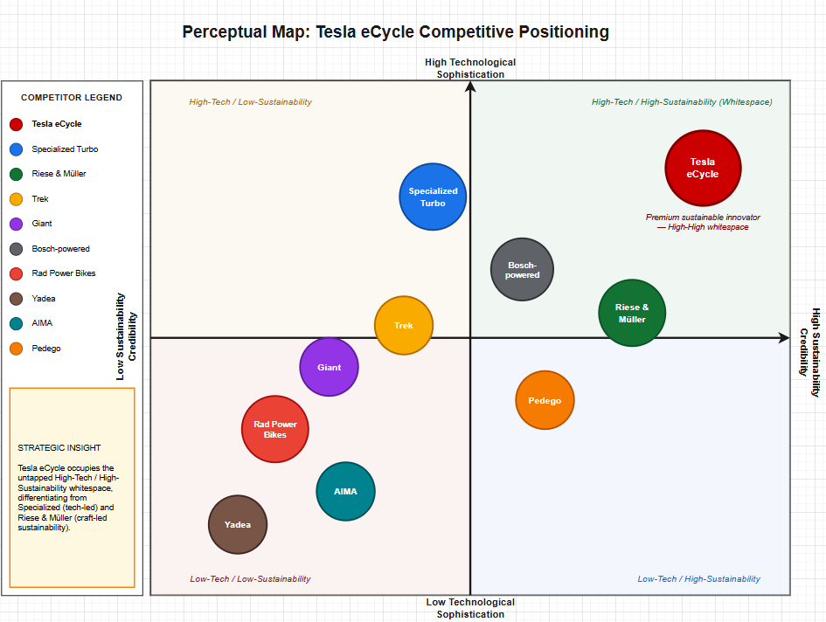
Figure 5: Perceptual Map
(Source: Self Created using Draw.io)
With a perceptual map of credibility versus technological sophistication Tesla eCycle would be represented by a high-high segment that shows no whitespaces between Specialized (high-tech, moderate sustainability) and higher end European brands including Riese & Muller (moderate tech, high craftsmanship).

2.5.3 Alignment of Positioning with brand’s Overall Brand Identity
The eCycle branding is a reflection of Tesla's overall identity of sustainable innovation, high-end design, and connected technology, that builds off the parent brand clean-energy mission of vehicles and solar into personal micro-mobility in a logical and seamless manner (Banad, Sharif and Rezaei, 2025).

Element 3: Marketing Mix (7Ps) for Tesla eCycle

3.1 Introduction
The 7Ps, which is also known as the extended marketing mix, is a holistic approach to operationalising the Tesla eCycle brand extension strategy. Since Tesla eCycle will be bridging hardware, connected software, in-store experience, and after-sales services, the traditional 4Ps model will not be suitable to critically analyze its market.

3.2 Product
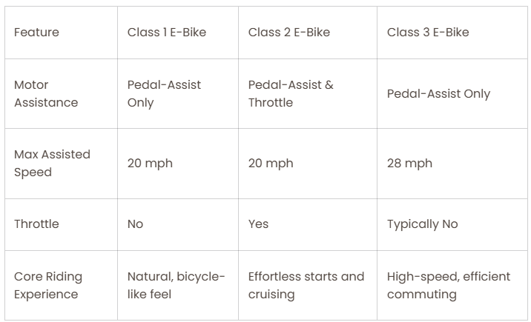
Figure 6: Class 1 vs. Class 2 vs. Class 3 E-Bikes
(Source: PUCKIPUPPY BIKES, 2025)
Tesla eCycle is introduced in three versions namely, eCycle Urban, eCycle Cargo and eCycle Trail. All models have a proprietary mid-drive motor with a torque of more than 100 Nm, which aligns with the estimated 56.7% size of the mid-drive motor market in 2026, and a 750 Wh lithium-ion battery. The chain drive design with 88.9% dominance in the 2025 market is carried over on Urban and Cargo models, and the Trail flagship is fitted with a belt drive to ensure high-end quietness (Grand View Research, 2026a). All versions will be Class 3 compliant, with a range of 45 km/h in allowed jurisdictions, and are UL 2849 safety certified - the standard that is to become a national requirement in the United States by 2027 (PUCKIPUPPY BIKES, 2025).

3.3 Price
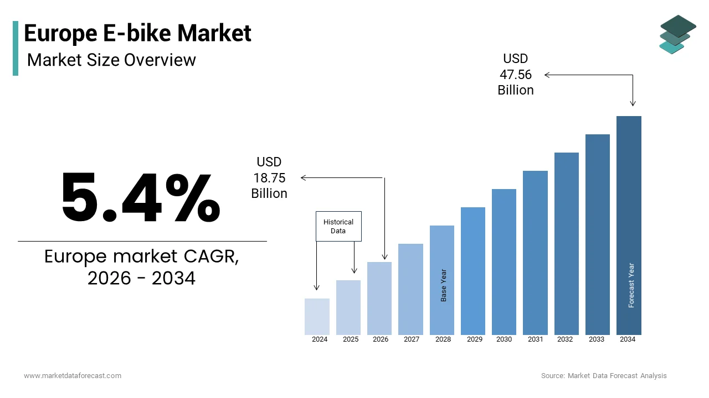
Figure 7: Europe E Bike Market
(Source: Market Data Forecast, 2025)
Tesla eCycle has a premium-value pricing approach. The retail pricing is $3,900 to eCycle Urban, and $6,500 to the flagship, the eCycle Trail, placing the product in the lay of North American fast-growing band which is $3,500 to $5,999. This is quite high compared to the European e-bike average of €2,242 and the global average of 711 which is also strategically used to enforce exclusivity (Market Data Forecast, 2025). Tesla Financial Services provides 0% APR in 24 months to diminish entry barriers and trade-in credits are offered on purchasing Tesla vehicles (Tesla, 2026). It is priced just above Specialized Turbo and Riese & Müller premium levels to indicate equality, and is highly priced in comparison with mainstream DTC competitors like Rad Power Bikes, which in 2025-2026 financial and operational troubles.

3.4 Place
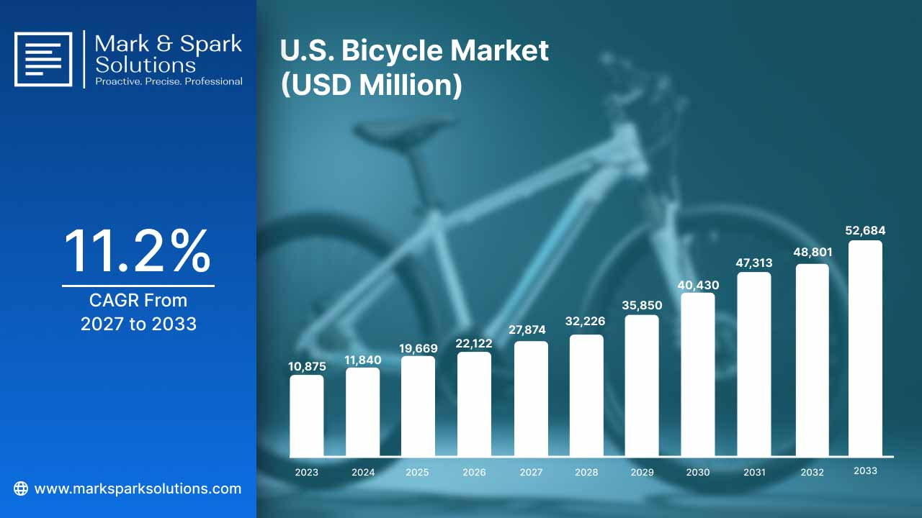
Figure 8: U.S. Bicycle Market
(Source: Spark Solutions, 2026)
Distribution will be performed using Tesla's current omnichannel system, avoiding the disorganized independent dealer system that is prevalent in conventional cycling stores. The DTC channel had contributed $850 million of e-bike sales in 2024 (70% of total) out of 450,000 bikes (Spark Solutions, 2026). Tesla has a DTC model that is only scale-able. Physical touchpoints include Tesla flagship stores, pop-up experiential stores at cycling events, and demonstrations hubs at Tesla service centres. Digital channel: Tesla online configurator allows custom configuration and home delivery. It will roll out to 12 countries in 2027, initially focusing on Germany (2.1 million e-bikes sold in 2024) as well as the Netherlands, the UK and the dominant US metropolitan markets, with 25 by 2029 (Mordor Intelligence, 2026).

3.5 Promotion
The promotional mix focuses on digital-first, communications which are aligned with the Tesla philosophy of minimal-advertising. Owned channels, which include Tesla web, mobile application, and email base are the Native channel through which the launch campaign is offered. The targeted digital retargeting and YouTube pre-roll are paid activities on sustainability and cycling digital content and Instagram creator partnerships are limited. Existing Tesla proprietors are granted $200 credit to every achievement eCycle referral (Swigonski, 2025). Authentic sustainability positioning is supported by sponsoring urban cycling infrastructure development. In the US, 19.4% of cyclists will be riding an e-bike as of 2023 compared to 7.8% in 2021, which suggests a rapid diffusion of mainstreams the campaign will speed up (Yang et al., 2025).

3.6 People
Services embedded within categories are highly dependent on the people factor. Tesla brings specialist eCycle advisors into flagship stores, which incorporate cycling knowledge with Tesla ecosystem knowledge. Mobile service technicians are also dual certified in Tesla vehicle and e-bikes servicing, which develops operational efficiency (Tesla, 2024). Frontline personnel are remunerated based on their customer satisfaction and not a sales commission as in the Tesla auto retail system. In-house, the R&D experience is pulled together out of proven e-bike engineering centers within Taiwan and Germany - the two geographies contributing most of the high-value motor and drivetrain innovation presented at CES 2026 - and battery knowledge is ported over to the Tesla Energy group (Cycling & Health Tech Industry, 2026).

3.7 Process
The digital-physical continuity is engineered in the customer process with frictionless continuity. Potential consumers design the eCycle online, reserve a test ride, sign the financing documents online and get home delivery in 7 days (Oyeyemi Olayode, Jamei and Justice Alex, 2024). Ownership automations provide software updates through the air, remote diagnostic tests, predictive maintenance, and service appointment, all via the Tesla application. The battery health and end-of-life collection are automated and built upon the principles of the operation of the circular economy, instead of symbolically. Registration of warranty is automatic and there is a certified pre-owned eCycle programme that facilitates second-hand resale in line with sustainability lifecycle (Habiburrahman et al., 2025).

3.8 Physical Evidence
The high quality sustainable positioning is supported by physical evidence. Store settings include recycled-material exposure, real-time carbon-offset monitors and interactive ecosystem simulators of solar-to-eCycle energy movement. Packaging: 100% recycled and plastic-free (Tesla, 2026a). The eCycle itself is sculpted to have a minimalistic industrial surface finish, including flushed battery packaging, smooth welds, and Tesla lightbar signature that provides visual continuity with Tesla vehicles (Malik, 2026). The Tesla application interface, design of delivery notification and service technician uniform stance are examples of digital physical evidence.

3.9 Alignment with the Sustainable Brand Extension Strategy
Each of the 7Ps promotes the cardinal strategic intention of Tesla eCycle: to diversify the Tesla sustainable mobility mission to a bracket that conforms to achieve $144.33 billion in the globe by 2033. Circular product design; exceptional sustainable value at price; place little intermediary emissions; promote a true story through the data validated consumer; people bring expertise; process introduces minimal waste; tangible evidence offers a sensorial perspective of the sustainability narrative (Gazzola et al., 2025). The combination itself helps to jumpstart, grow, and play its part in category leadership in the long term.

Element 4: Reflection

4.1 Introduction to the Reflective Process
Learning experience Tesla eCycle sustainable brand extension marketing strategy and poster presentation have been a mode of acquisition of analytic rigour and creative presentation skills of strategic analytic dexterity and practice. This reflection is an informal style where my appraisal and review illustrates what I learnt, how I did and what I would do to become a better worker.

4.2 Development of the Marketing Strategy
Developing the STDP framework and the 7ps marketing mix of a fictitious brand extension demanded that I integrate theoretical concepts of marketing with realities in the current market. Referring to 2025 and 2026 e-bike market data - the $68.34 billion global market size, distribution of revenue by region, and the proliferation of higher-end segment and disruptive technology like solid-state batteries and AI-adaptive assistance - honed my skill in converting raw data to strategic value (Kiu Publication Extension, Special and Dheere, 2025).

4.3 Poster Presentation Experience
A different set of skills was required as I was preparing the poster presentation as opposed to the written report. Reducing words of analysis into one visual artefact meant being disciplined to prioritize. I also learned how to differentiate between strategic messages that are most essential and supporting detail and take advantage of visual hierarchy, colour blocking, and iconography to be able to deliver a message to a passing audience (Luby and Southern, 2022).

4.4 Key Skills, Knowledge, and Insights Gained
A number of transferable skills have crystallised under this project. The STDP and 7Ps frameworks, especially disciplining of triangulating quantitative market information against qualitative brand positioning judgement, enhanced analytical skills. Research experience was interprofessed by the appraisal of various reports in the secondary market and by reconciling differences between competing predictions of 2025-2026. Written communication got polished with the creation of concise and structured academic prose with word count limitations.

4.5 Contribution to Personal and Professional Development
This project has equipped me professionally with marketing strategy, brand management and consulting functions as I have learned how to build out a well-thought through go-to-market plan based on the available market intelligence. On my own, it has made me feel more confident about making defensive arguments orally, a skill that I previously practiced through writing. The experience also made me stronger in my quest to keep things sustainable in the context of business practice, that commercial viability and environmental responsibility are not a dilemma, but can be planned, not compromised (Zipursky, 2025).

4.6 Areas for Future Improvement
Critically, I recognize that there are three aspects that I need to improve in the future. To begin with, I would invest more time in the primary research, e.g., consumer surveys/interviews, to provide an addition to secondary data and minimize the effects of published predictions which significantly differ with the authors (Dwivedi et al., 2021). I would enhance visual design competence by mastering professional layout software like Adobe InDesign and shorten the time expense of poster creation. On the whole, the Tesla eCycle brand extension project has proved a valuable combination of strategic marketing theory.

Reference List
Banad, Y.M., Sharif, S.S. and Rezaei, Z. (2025) “Artificial intelligence and machine learning for smart grids: From foundational paradigms to emerging technologies with digital twin and large language model-driven intelligence,” Energy Conversion and Management: X, 28, p. 101329. Available at: https://doi.org/10.1016/j.ecmx.2025.101329.
Chocolatezhu (2025) Global electric two wheeled market data and consumption analysis, SAMEBIKE Electric Bike Manufacturer. Available at: https://www.gzsamebike.com/global-electric-two-wheeled-market-data-and-consumption-analysis/
Cycling & Health Tech Industry (2026) Taiwan-Europe Collaboration in Sustainability and Smart Mobility: CHC Showcases Taiwan’s R&D Strength at EUROBIKE 2026, Cycling & Health Tech Industry R&D Center. Available at: https://en.tbnet.org.tw/news/7/75
Dwivedi, Y.K., Ismagilova, E., Hughes, D.L. and Carlson, J. (2021) “Setting the future of digital and social media marketing research: Perspectives and research propositions,” International Journal of Information Management, 59(1), pp. 1–37. Available at: https://doi.org/https://doi.org/10.1016/j.ijinfomgt.2020.102168.
Gazzola, P., Pavione, E., Hillebrand, R., Vota, V. and Rosa, R. (2025) “The Circular Economy and the Role of Technology in the Fashion Industry: A Comparison of Empirical Evidence,” Sustainability, 17(7), pp. 3104–3104. Available at: https://doi.org/10.3390/su17073104.
Grand View Research (2026a) E-bikes Market Size, Share|Industry Report, 2022-2030, Www.grandviewresearch.com. Available at: https://www.grandviewresearch.com/industry-analysis/e-bikes-market-report
Grand View Research (2026b) E-bikes Market To Reach $52.37Bn By 2030 | CAGR: 14.5%, Www.grandviewresearch.com. Available at: https://www.grandviewresearch.com/press-release/global-e-bikes-market
Grand View Research (2026c) Lithium-ion Battery Market Size & Share Report, 2020-2027, Www.grandviewresearch.com. Available at: https://www.grandviewresearch.com/industry-analysis/lithium-ion-battery-market
Habiburrahman, M., Tri Setyoko, A., Nurcahyo, R., Daulay, H. and Natsuda, K. (2025) “Circular economy strategy for waste management companies of electric vehicle batteries in Indonesia,” International Journal of Productivity and Performance Management, 74(11), pp. 21–45. Available at: https://doi.org/10.1108/ijppm-01-2024-0015.
Kiu Publication Extension, Special, K. and Dheere, F.S. (2025) 7 Ps of Marketing:Overview of marketing. Available at: https://doi.org/10.1098/gdshajsd.
Lu, H., Yin Junming and Aya, N. (2025) “The impact of Eco-friendly features of E-bikes on consumers’ willingness to pay,” Finance & Accounting Research Journal, 7(2), pp. 102–117. Available at: https://doi.org/10.51594/farj.v7i2.1855.
Luby, S. and Southern, D.L. (2022) “Achieving Clarity and Conciseness,” The Pathway to Publishing: A Guide to Quantitative Writing in the Health Sciences, pp. 73–86. Available at: https://doi.org/10.1007/978-3-030-98175-4_6.
Malik, N. (2026) Tesla Finally Starts Selling Cybertruck Off-Road Light Bar Separately, Not a Tesla App. Available at: https://www.notateslaapp.com/news/4303/tesla-finally-starts-selling-cybertruck-off-road-light-bar-separately
Market Data Forecast (2025) Europe E-Bike Market Size, Share, Growth & Analysis, 2033, Market Data Forecast. Available at: https://www.marketdataforecast.com/market-reports/europe-e-bike-market
Mordor Intelligence (2026) E-BIKE MARKET SIZE & SHARE ANALYSIS - GROWTH TRENDS AND FORECAST (2026 - 2031) Source: https://www.mordorintelligence.com/industry-reports/e-bike-market, Mordorintelligence.com. Available at: https://www.mordorintelligence.com/industry-reports/e-bike-market
Mr Saurabh, Kulkarni, U., Jagannath Sunil, Kadam and Roman (2025) Review of Eco-Friendly Bicycle Design. Available at: https://www.researchgate.net/publication/393496091_Review_of_Eco-Friendly_Bicycle_Design
Oyeyemi Olayode, I., Jamei, E. and Justice Alex, F. (2024) “Integration of e-bikes in public transportation based on their impact, importance, and challenges: A Systematic Review,” Multimodal Transportation, 4(1), p. 100182. Available at: https://doi.org/10.1016/j.multra.2024.100182.
Precedence Research (2025) E-bike Market Size, Trends, Growth, Report 2022-2030, Www.precedenceresearch.com. Available at: https://www.precedenceresearch.com/e-bike-market
PUCKIPUPPY BIKES (2025) What’s the Difference? Class 1 vs. Class 2 vs. Class 3 E-Bikes, PUCKIPUPPY BIKES. Available at: https://www.puckipuppy.com/blogs/laws-and-regulations/whats-the-difference-class-1-vs-class-2-vs-class-3-ebikes?srsltid=afmboorkt5ijm37rjf7mreahly15ywnovlf5hm4e2q2ldqksy62z-liw
Spark Solutions, M. (2026) U.S. Bicycle Market Analysis by Product Type (Mountain Bikes, Road Bikes, Hybrid / City Bikes, Electric Bikes (E-Bikes), Folding Bikes, Cruiser Bikes, BMX Bikes, Kids’ Bikes, Performance / Racing Bikes, Cargo Bikes), Age Group and Sales Channel: Consumption (Million Units), Pricing Analysis, Trends and Forecast Till 2033., MarkSpark Solutions. Mark & Spark Solutions. Available at: https://marksparksolutions.com/reports/us-bicycle-market
Sutton, M. (2025) Germany’s bike & e-bike leasing market surges past 2 million, Cycling Electric. Available at: https://www.cyclingelectric.com/news/e-bike-leasing-germany
Swigonski, M. (2025) Tesla unveils new incentives to entice buyers — here’s what you need to know, Yahoo Finance. Yahoo! Finance. Available at: https://finance.yahoo.com/news/tesla-unveils-incentives-entice-buyers-014500483.html
Tesla (2024) UNITED STATES SECURITIES AND EXCHANGE COMMISSION. Available at: https://ir.tesla.com/_flysystem/s3/sec/000162828025003063/tsla-20241231-gen.pdf
Tesla (2026a) Impact Report ’25. Available at: https://www.tesla.com/ns_videos/2025-tesla-impact-report.pdf.
Tesla (2026b) Tesla Financial Services, Tesla. Available at: https://www.tesla.com/en_GB/support/financial-services-products
Yang, Z., He, J., Al-Khasawneh, M.B., Pandit, D. and Cinzia, C. (2025) Bike and E-bike agents: Large Language Model-Driven E-Bike Accident Analysis and Severity Prediction, Arxiv.org. Available at: https://arxiv.org/html/2506.04654v2#s4
Zipursky, M. (2025) 5-Step Consulting Marketing Strategy To Get Clients Consistently. Available at: https://www.consultingsuccess.com/consulting-marketing-strategy

