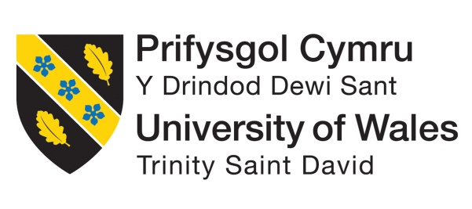

BMIH5004
Management and Organisational Behaviour
LEVEL 5

Assessment 2: Management & Organisational Behaviour

[Student ID]2122725
[Institute Name]Liviu Zaharia

[Date]

Table of Contents
Introduction 3
Context and Importance 3
Significance of Audit 3
Main Body 3
Organisational Structure 3
Organisational Culture - Handy's model of organisational culture 5
Power 5
Task Culture 5
Person Culture 6
Role Culture 6
Recent change initiatives, their impact and how well these were managed 6
Structural Change 7
Cultural Change 7
Process Change 7
Strategic Change 7
People/Organizational Development Change 8
IT Systems Change 8
The organisation’s strategic direction and current business performance 9
Strategic Decisions 9
Conclusion 9
References 11

Introduction
It is quite evident that the global hospitality and tourism industry has a competitive and dynamic place, which is marked through constant changes with consumer preferences along with the market trends (Voegeli, 2021). In this aspect, the “International Hotel Group (IHG)” has appeared as the most important player, piloting the challenges within the industry associated with a diversified portfolio of hotels particularly commitment to incomparable customer experiences. However, the assignment provides a thorough audit and analysis of IHG, emphasising on critical factors, i.e., “organisational structure, culture, current change initiatives and strategic direction”.

Context and Importance
It can be identified by Awasthi, Dhawan and Soyav (2020) that IHG examines the importance of expansively understanding the firm’s operational systems in order to sustain and improvise its position within the hospitality industry through constant growth and development. However, this audit intends to offer a comprehensive analysis of the “International Hotel Group’s” cultural composition, corporate structure, the proficiency of existing transformation endeavours, and the arrangement between its strategic direction and existing business results. Nonetheless, the assignment intends to offer individual in leadership roles, industry viewers and stakeholders with valued insights through a detailed valuation of these topics.

Significance of Audit
According to Kilson (2022), external and internal market forces for the firm have a considerable impact on the hotel industry. It can be identified that conducting an audit of IHG’s culture and organisational structure are significance because of various reasons. This eventually enables to analyse IHG’s capability to regulate and maintain resilience considering constant evolving market demands. It has been examined that a comprehensive hold of continuous change projects and their consequences offers an important understandings within the firm’s capacity to manage and sustain such changes. Nonetheless, evaluating the placement between IGH’s strategic approach and its existing business outcomes that offers an inclusive view of the hotel’s position within the tourism industry, intending to give an overall viewpoint.

Main Body

Organisational Structure
The organisation is involved in hotel administration through three different yet important business models, i.e., “franchising, management and ownership and leasing as well as management”. However, the organisation within this specific industry has a considerable concentration on the conventional, premium and prestige domains of the property market (Thanh, 2019). The company has collected a selection of different brands, particularly intended for catering the exceptional requirements and needs of every client.

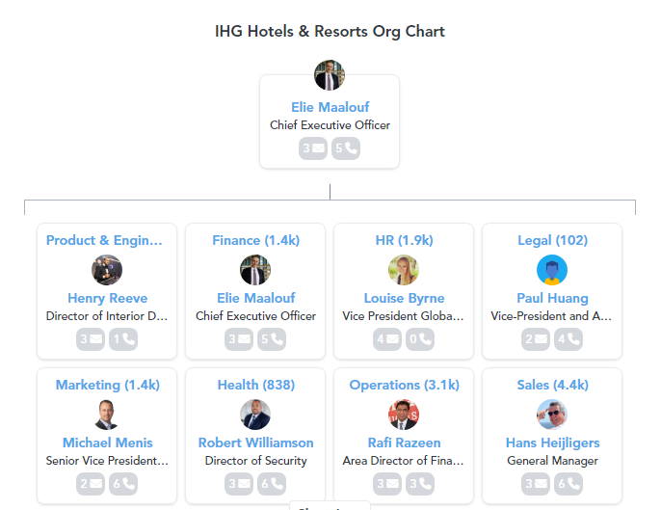

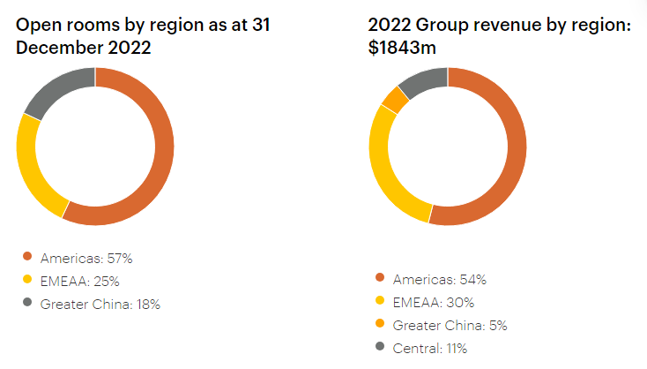
Franchise opportunities or hotel management services for third-party hotel owners rely on many factors. The factors consist of the market's maturity, the owner's preference, and sometimes the brand in question. The franchise concept is often used in developed regions like Europe and the Americas. Conversely, emerging markets like Greater China usually follow the controlled model (Kumar and Sharma, 2014). Due to our asset-light strategy, the quantity of hotels owned, leased, and managed has significantly decreased from over 180 hotels eighteen years ago to a few at now.
Franchise owners want to operate their companies independently without engaging in competition with each other. By affiliating their hotel with our popular brand, franchisees may use our extensive reservation system and reward programme. Furthermore, we provide a diverse range of tools, including marketing campaigns and revenue management systems, to attract new customers and generate demand. Our franchise fees' growth is determined by three factors: the rise in our room count, the revenue per available room (RevPAR), and the royalty fees (Yu, 2008). The franchise agreement is typically a conventional contract, although there may be modifications that are tailored to the local region. A sample contract usually includes a royalty fee ranging from 5% to 6% of the revenue earned by the room. However, this might differ according on the country and the brand.

Organisational Culture - Handy's model of organisational culture

Power
It is quite evident that a Power Culture is classified through a centralization of decision-making authority with a small group of key individuals at the firm. Martin (2017) identified that the “International Hotel Group (IHG)” shows characteristics that are aligned with a Power Culture. It can be examined that top executives at the organisation are accountable to make significant decisions, which considerably influence the firm’s direction, outlining its hierarchical structure. However, the focus of authority restricts employees’ independence and involvement in decision-making, which might results in dissatisfaction and favoritism amongst the employees. Nonetheless, the model also shows that IHG’s organisational structure is hierarchical associated with some significant decision-makers exercising considerable control and valuing strict devotion to directives over reinforcing a cooperative decision-making atmosphere.

Task Culture
Hiršová, Komárková and Pirožek (2018) analysed that organisational culture of IHG shows aspects of the Task Culture, contrasting with Power Culture. However, it is quite distinctive aspect between two civilizations. In this aspect, the major emphasis is on cooperative collaboration when people having identical interests and skills work together to get towards a mutual and address the challenges. It can be identified that these cross-functional teams often involve more than three members, who value attaining a collective goal and fostering practical problem-solving approaches.

Person Culture
According to Shier and Handy (2016), IHG endorses shared or cooperative culture where the firm’s aims and objectives are valued despite of individual interests. However, it is an opposition to the Individualistic culture. This approach dejects employees from valuing their personal issues above the firm’s by reinforcing a sense of accountability and connection amongst employees. It can be examined that commitment towards a mutual objectives that promotes a strong relationship with the firm, resulting to loyalty and dynamic engagement within decision-making procedure. Meanwhile, this approach integrates with the notion that the achievement of the company depends on the cooperative efforts of its employees, focusing on the benefits that are offered to individuals within the company.

Role Culture
It can be analysed that IHG deliberately allocates positions on the basis of individual’s skills and capabilities through role culture. Undoubtedly this culture offers accountability and possession by focusing worker independence in choosing their capabilities and assistances. However, the professionals at the hotel are identified for their practical strategy and keenness to manage issues, assuring a balance between responsibility and authority (Saunders, Altinay and Riordan, 2009). Nonetheless, the firm could focus on maximising employee performance by adopting a culture or environment that evidently demonstrates, roles, resulting towards a collective sense of responsibility and success amongst personnel.

Recent change initiatives, their impact and how well these were managed
According to Ogbonna and Harris (2002), IHG’s existing transformation tries to demonstrate the dynamic nature of tourism and hospitality industry. Likewise with various prevalent firms, the “International Hotel Group (IHG)” might opt to initiate numerous organisational changes for aligning with its changing corporate needs and strategic objectives; while these involve:

Structural Change
Sufi (2008) examined that the “International Hotel Group (IHG)” might possibly experience considerable changes with its organisational agenda, comprising “reorganisation, restructuring or mergers and acquisitions”. In this aspect, IHG applies structural alignments for adapting towards changing market circumstances and simultaneously improvising operational efficiency. It can be examined that by using this strategy, the firm ensures its capability to immediately adapt to new transformations within the hospitality business and rapidly react to such developments. Nonetheless, the firm sets itself for long-term growth and competitiveness.

Cultural Change
It is quite evident that cultural change associated with “International Hotel Group (IHG)” integrates intentionally evolving the values, beliefs, behaviours and attitudes, which are generally comprised by the entire business. In this aspect, IHG implies a systematic approach for cultural change to reinforce innovation, increasing employee motivation, and synchronising organisational culture with the firm’s changing objectives. According to Bavik (2016), the firm intends to generate a professional environment, which values innovation and flexibility for meeting existing business requirements and ensuring long-term achievement within the contemporary landscape of hospitality and tourism industry.

Process Change
Process change at IHG involves amending workflow and business procedures for implementing the change. It can be identified that IHG deliberately approaches process change for optimising operations, improvising customer service principles, and integrating advanced technologies. According to Olsen and Connolly (2000) IHG is intending to rationalize its internal operations for improvising operational proficiency, enhancing customer’s experience, and staying updated with technological advancements. It can be examined that IHG optimally implements industry changes and sustains its obligation to offer exceptional hospitality services by implementing a proactive approach to process development.

Strategic Change
It can be identified that considerable revisions to the IHG’s business approach are important to achieve strategic change within the company. This is done through deliberate implication of these improvisations to proactively face and minimise existing challenges, leveraging upcoming opportunities and adapting to market trends. Moreover, IHG sustains its agility in the dynamic hospitality industry through implying a flexible approach (Harrison, 2003). However, the company is well-placed to take maximum advantage of growth projections and effectively overcoming issues within the domain. The company intends reserve a competitive edge, building and maintaining flexibility and attaining accomplishment within the dynamic worldwide tourism industry. Nonetheless, it is attained through strategically coordinating its activities with the dynamic transformations in the industry.

People/Organizational Development Change
It is evident that the growth and expansion of the firms and their employees in undertaking a change process emphasised on enhancing employee’s skills and capabilities along with firm’s overall growth and development. According to Smither, Houston and McIntire (2016), IHG vigorously implies “leadership development, talent development, and training and development programmes” for adapting to the changing landscape of hospitality industry. It can be identified that such courses are provided to the personal since the company values the growth and expansion of its employees to ensure that employees possess the skills and capabilities to adjust to industry development. Undoubtedly this helps the company to ensure that its workers can get adjusted within changing situations; while, this reinforces the environment of the company that is emphasised on continuous innovation and enhancement; while, IHG improvises its organisational resilience and efficiently fulfilling the changing needs of the international hotel industry by implementing this method.

IT Systems Change
The IT Systems change procedure of the IHG includes systematically improvising the architecture and information technology systems. In this aspect, IHG capitalises in new and advance technology and system upgrades to manage competitiveness and meeting changing consumer preferences. It can be examined that this is executed to meet the needs of its customers; however, IHG sustains its repute as a leader in technological inventions in hotel industry through implementing a proactive approach. Subsequently, the firm might improvise its operating proficiency and offer client’s a smooth and outstanding experience. According to Kansakar, Munir and Shabani (2019), IHG has intentionally integrated itself to efficiently fulfil the digital needs of the visitors by the implication of changing information technology solutions. This has resulted to increase in the firm’s overall adaptability and competitiveness in the rapid changing international hospitality and tourism industry.

The organisation’s strategic direction and current business performance
Tucci (2022) demonstrated that strategic management is a continuous procedure comprising wide-ranging planning, thorough monitoring, general analysis, and comprehensive assessment of all aspects of the firm. However, the major aim is based on attaining integration of the company’s objectives; meanwhile, fostering flexibility and resilience considering internal and external scenarios. By implementing this strategy, the company could now make proactive decisions for improvising and updating its operational goals and ensuring sustained accomplishment in the longer run. Nonetheless, Tucci’s notion signifies the iterative nature of strategic management, which focuses on the need of staying flexible and proactive for navigating the details of current corporate environments.

Strategic Decisions
It can be identified by Köseoglu et al. (2023) that strategic management at IHG is quite essential as it considerably impacts decisions regarding key organisational concerns. However, IHG assures its long-term route integrates with evolving market landscapes and consumer needs through continuous analysis, research and appropriate planning. Moreover, the extensive variety of actions, for example, overall growth and diversified choices elaborates a strategic position emphasised on attaining competitive advantage as compare to the rivals. It has been analysed that IHG implies strategic resource and allocation of the skills to improvise its operational capacities, resulting to the growth of innovation and operational quality. The company improvises its plans through analysing the existing performance of every product or service that is offered by IHG, which enables the firm to improvise its offerings and staying upgraded within the market (Tajeddini, Martin and Ali, 2020). Undoubtedly, IHG places a considerable focus on fulfilling the consumer needs and prioritising stakeholders to create stable associations and maintaining effective and strong brand repute.

Conclusion
Conclusively, it can be identified that the “International Hotel Group (IHG)” implies strategic management to efficiently navigating the continuous changing hospitality and tourism industry. It is evident that this specific management strategy influences the decisions, which outlines the company’s long-term direction, defining various activities, and ensuring that it stays competitive and upgraded. However, IHG tries to maintain its competitive edge through proficiently adjusting environmental changes, improvising resource allocation, and evaluating product performance. Moreover, the strategic decision of the company are outlined by focusing on the importance of stakeholders, influencing market position of the firm and offering instruction for operational efficiency. Nonetheless, IHG strategically emphasis on stakeholder needs invention and implementation for assuring the firm’s resilience and long-term achievement within the evolving and dynamic business environment.

References
Awasthi, A., Dhawan, D. and Soyav, M., 2020. Role of employee behaviour in hospitality industry. International Journal of Scientific and Technology Research, 9(1), pp.2208-2210.
Bavik, A., 2016. Developing a new hospitality industry organizational culture scale. International Journal of Hospitality Management, 58, pp.44-55.
Harrison, J.S., 2003. Strategic analysis for the hospitality industry. Cornell Hotel and Restaurant Administration Quarterly, 44(2), pp.139-152.
Hiršová, M., Komárková, L. and Pirožek, P., 2018. The prediction of financial performance in dependence on the type of organisational culture. Trends Economics and Management, 12(32), pp.63-74.
Kansakar, P., Munir, A. and Shabani, N., 2019. Technology in the hospitality industry: Prospects and challenges. IEEE Consumer Electronics Magazine, 8(3), pp.60-65.
Kilson, G.A., 2022. The Use of Digital Media for the Employer Brand Management in Hotels (Doctoral dissertation).
Köseoglu, M.A., Topaloglu, C., Parnell, J.A. and Lester, D.L., 2013. Linkages among business strategy, uncertainty and performance in the hospitality industry: Evidence from an emerging economy. International Journal of Hospitality Management, 34, pp.81-91.
Kumar, R. and Sharma, S., 2014. Corporate social responsibility-A study on hotel industry. Asian Journal of Multidisciplinary Studies, 2(4), pp.25-32.
Martin, A., 2017. An investigation into contemporary hotel general managers behaviour and activity in the context of private, franchise and chain ownership/business models (Doctoral dissertation).
Ogbonna, E. and Harris, L.C., 2002. Managing organisational culture: Insights from the hospitality industry. Human Resource Management Journal, 12(1), pp.33-53.
Olsen, M.D. and Connolly, D.J., 2000. Experience-based travel: How technology is changing the hospitality industry. Cornell Hotel and Restaurant Administration Quarterly, 41(1), pp.30-40.
Saunders, M.N., Altinay, L. and Riordan, K., 2009. The management of post-merger cultural integration: implications from the hotel industry. The Service Industries Journal, 29(10), pp.1359-1375.
Shier, M.L. and Handy, F., 2016. Executive leadership and social innovation in direct-service nonprofits: Shaping the organizational culture to create social change. Journal of Progressive Human Services, 27(2), pp.111-130.
Smither, R., Houston, J. and McIntire, S., 2016. Organization development: Strategies for changing environments. Routledge.
Sufi, T., 2008. Hospitality industry: An overview of strategy, structure and globalization. Journal of Hospitality Application & Research, BIT Mesra, Ranchi, 3(1), pp.50-57.
Tajeddini, K., Martin, E. and Ali, A., 2020. Enhancing hospitality business performance: The role of entrepreneurial orientation and networking ties in a dynamic environment. International Journal of Hospitality Management, 90, p.102605.
Thanh, L.M., 2019. Organizational Structure at the Contemporary Interface. In Contemporary Human Resources Management in the Tourism Industry (pp. 1-24). IGI Global.
Voegeli, C., 2021. A Case Study of Knowledge Management Practices at the Intercontinental Hotels’ Group. Available at SSRN 3819409.
Yu, L., 2008. The structure and nature of the international hospitality industry. The Sage handbook of hospitality management, pp.62-89.

