

Coursework:
Programming Assignment with Associated Documentation

3/27/2026

Student Name: David Nyadu Larbi
Student Number: 2407275
Course Title: Scripting And Programming Concepts
Module Number: ACCA5036_BIRM
GitHub Link: https://github.com/dav-2407275/Bright-Minds-Academy-s-manual-booking-system-.git
Sample logo for Bright Minds Academy

Table of Contents
1.0 INTRODUCTION 1
2.0 REQUIREMENT ANALYSIS 2
3.0 SOFTWARE DESIGN AND DEVELOPMENT 4
3.1.1 Flowchart 4
Purpose of the Flowchart: 5
Flowchart Explanation: 5
3.1.2 Pseudocode 7
3.2 Implementation Decisions 10
3.2.1 Data Structures 12
3.2.2 Programming Constructs 14
Functions: 14
Control Structures: 14
Error Handling: 17
Conditional Checks: 17
3.2.3 Python Modules and Libraries 18
4.0 TESTING AND DEBUGGING 21
4.1 Role of Testing in Software Environment 21
4.2 Type of Errors in Programming 22
Syntax Errors: 22
Logical Errors: 22
Runtime Errors: 22
4.3 Example of Test Cases 22
5.0 EVALUATION 27
Future Improvements 28
Data Persistence: 28
User Authentication: 28
Graphical User Interface (GUI): 28
Booking Management: 28
Notification System: 28
Calendar View: 29
Advanced Search: 29
Error Logging: 29
Self-Reflections 29
Bibliography 30

1.0 INTRODUCTION
Bright Minds Academy's manual booking system is inefficient and error-prone; adopting a digital solution is essential to improve accuracy, efficiency, decision-making, and competitiveness in today’s fast paced environment. [1].
Manual paper-based records are tangible, easy to use, and don’t require power, but they have limited storage, are slow to search, and prone to damage or loss, whereas digital records provide larger storage, instant searchability, easy updates, and better accessibility, making resource management more efficient, organized, flexible, scalable, and sustainable in the long run.
This proposed Python based software system aims to provide an easy to use, reliable equipment booking platform that enables staff to add equipment, assign bookings, view reservations, and search records via a menu-driven interface, with data stored in simple structures like lists and dictionaries, serving as a foundation for future enhancements such as permanent data storage and user login features to adapt to the institution’s evolving needs.

2.0 REQUIREMENT ANALYSIS
The MoSCoW prioritization method, renowned for its simplicity and widespread adoption in software requirements prioritization, systematically classifies requirements into four categories, Must Have, Should Have, Could Have, and Won't Have thus be streamlining the decision making process. [2].

Must Have
An Essential requirements
The system must provide staff with real-time inventory access, accurate data entry, conflict detection for bookings, detailed records, efficient search, input validation, a user-friendly command line interface (CLI), and uses Python lists and dictionaries for flexible data management.
Should Have
Automating inventory updates ensures real-time accuracy, reduces errors, streamlines operations, displays instant availability, prevents conflicts, and supports scalability through secure storage, authentication, and increased capacity for efficient resource management.
Could Have
The programme could have adding advanced search filters and automated notifications would improve data accuracy, enhance planning, prevent missed appointments, and boost resource management and overall organizational efficiency.
Won't Have
Integration with external platforms requires extra resources and planning, so it is postponed. Current release focuses on a strong Command Line Interface (CLI), with future plans to explore mobile access for greater user convenience and system versatility.
Below are table showing about the requirement analysis
Must Have
Critical Features for system operation
Requirement | Description
View School Equipment | The system must have real-time, complete information on all equipment instantly.
Add Equipment | Staff must have the ability to input new equipment into the inventory.
Record Bookings | Means to assign equipment to students and other staffs for specific dates, with conflict detection.
View Booking Records | Overview of current and past bookings for planning must be possible for transparency.
Search Functionality | The system must have searching of records by equipment name, student name, or booking date functionality.
Input Validation | Validate data entries for accuracy and completeness
User Interface | Simple, menu-driven CLI (Command Line Interface) for easy navigation and operation
Data Storage | Python lists and dictionaries for managing data during development

Should Have
Important features that improve efficiency but are not critical immediately
Requirement | Description
Automation of Inventory Updates | The system must have automating updates when equipment is added, borrowed, or returned.
Real time Resource Status | Display current availability instantly
Future Enhancements | Support for data persistence and user authentication
Could Have
Nice to have features for future enhancements
Requirement | Description
Advanced search filters | Additional filtering options for refined searches
Notification System | Alerts for upcoming bookings, overdue returns, or low stock

Won’t Have
Features not planned for current development phase
Requirement | Description
External Platform Integration | Connecting to external platforms is outside current scope.
Mobile App Version | No mobile interface planned in this phase

Structure Diagram
A structure diagram visually represents system components, their relationships, hierarchy, and data flow, simplifying complex concepts and enhancing understanding, communication, and organization of system architecture. [3].
The structure diagram for the Student Equipment Booking System highlights modules like authentication, management, booking, and records, illustrating their connections to support modular design, ease of development, maintenance, and future scalability.
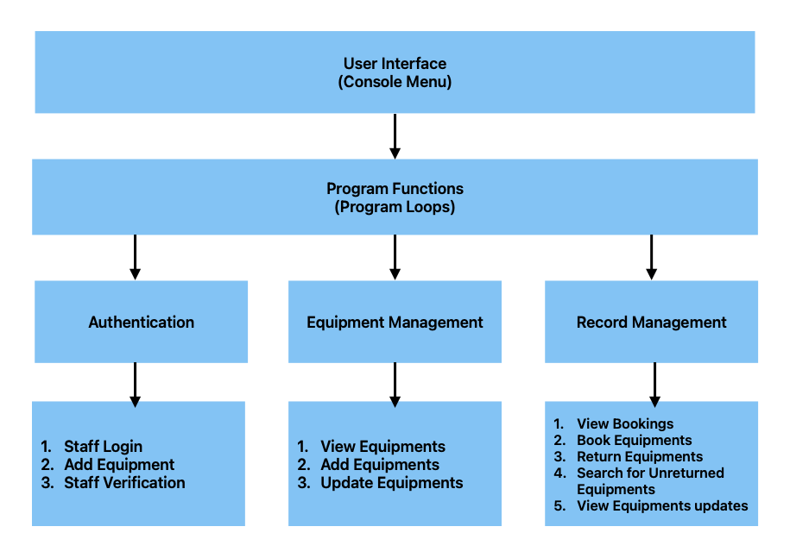

Figure 1 Structure Diagram

3.0 SOFTWARE DESIGN AND DEVELOPMENT
Introduction
Software development transforms ideas into functional applications through design and implementation, with a vital connection ensuring accurate requirements, coherence, and efficient operation across both phases for successful, user-focused software solutions.
Software Design
Software design is essential for planning architecture, components, data flows, user interfaces, algorithms, and module interactions, ensuring the system is intuitive, efficient, maintainable, scalable, and reliable, thereby supporting long-term success and adaptability.
Software Development
The development phase involves coding, testing, debugging, and integrating components to transform the design into a functional application, ensuring it meets requirements, functions correctly, and is ready for deployment.

3.1.1 Flowchart
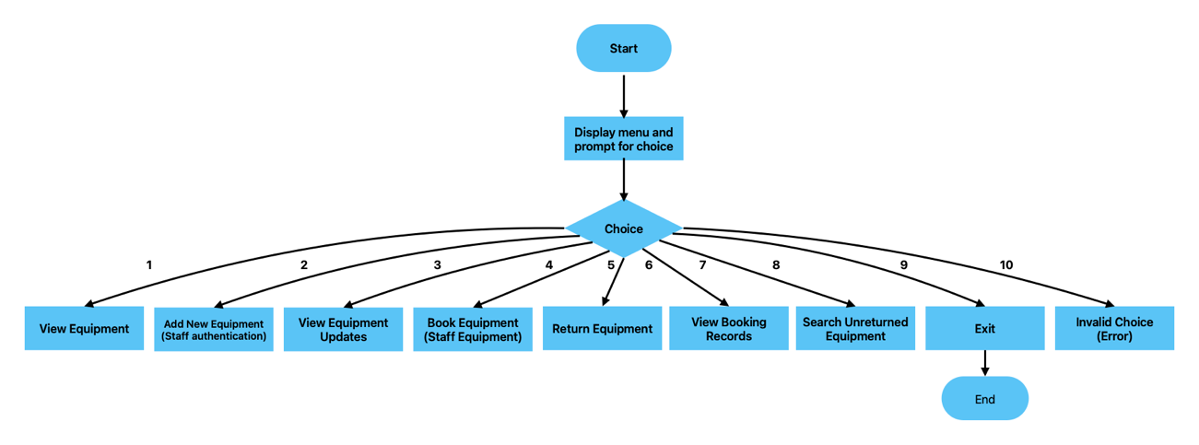

Figure 2 Flowchart of the main Manu
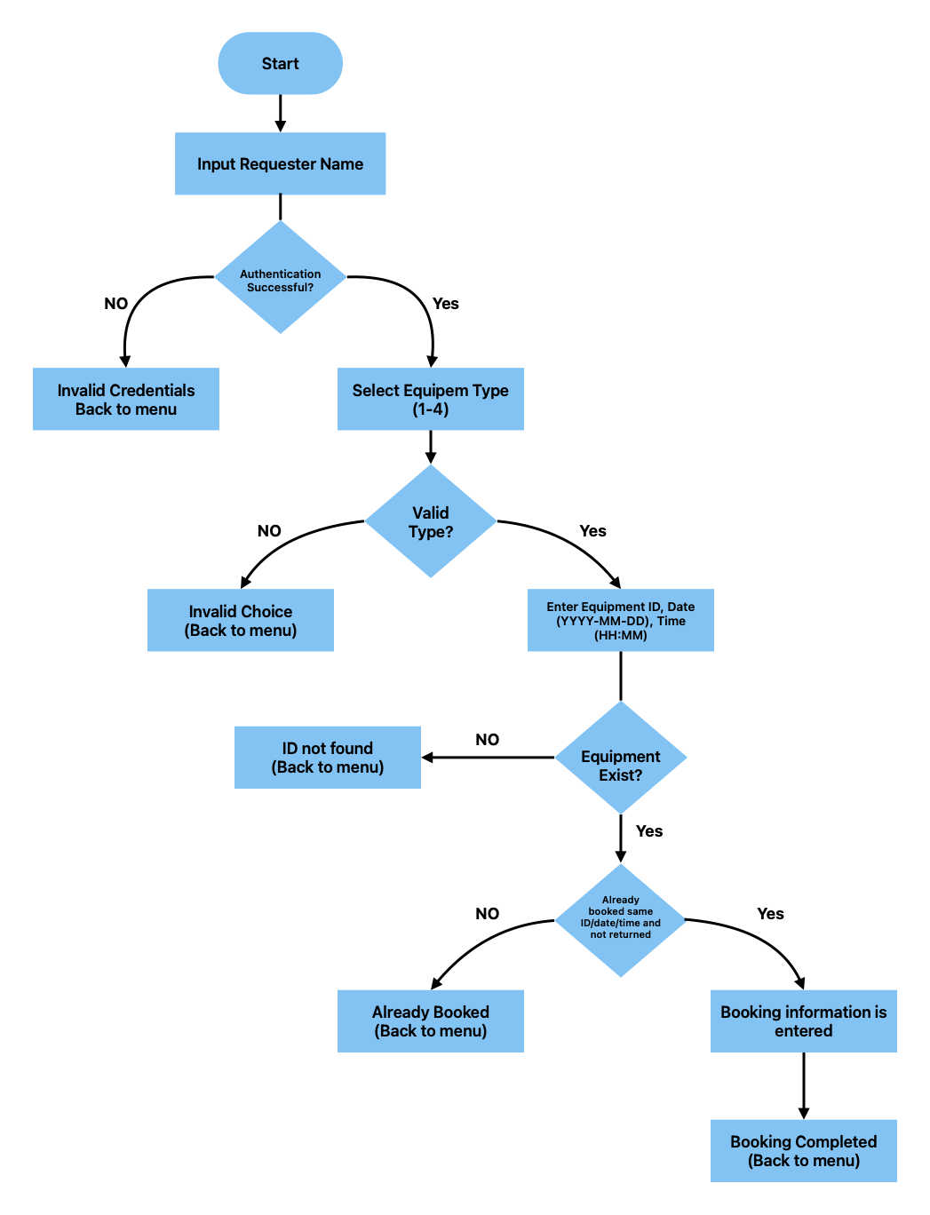

Figure 3 Flowchart of the module

Purpose of the Flowchart:
The flowchart visually illustrates the equipment booking system's logic, guiding development by showing user input processing, output generation, decision points like validation and conditions, ensuring proper handling of various scenarios throughout the system.

Flowchart Explanation:
Menu Flowchart
As shown in Fig.1, when the program starts, it displays a list of options that users or administrators can choose from. For example, if a user wants to view the school equipment, they will select option number 1. This selection then directs the program to the authentication function in Fig.2. The same process applies to all other choices.
Functions
The process in Fig.2 begins immediately after a user selects an option from the main menu in Fig.1. It captures the user's choice and prompts for details such as the requester's name and staff credentials (username and password) for authentication. If the selection is invalid, the system redirects back to the main menu for a retry. If valid, it asks for the equipment type; invalid types redirect again to the main menu. The system then requests the equipment ID to verify its existence. If the ID is valid, it checks if the equipment is already booked; if booked, it displays details and returns to the main menu. If available, it proceeds with the booking process.

Authenticate
The system prompts the user to enter a staff username and password, then verifies these credentials against the stored data. It returns ‘True’ if the authentication is successful and ‘False’ if the credentials are invalid.
View equipment
Selecting option 1, as shown in Fig.1, prompts the system to display all available equipment, systematically organized by category, along with the detailed information of each item.
Add equipment function
The add equipment function allows staff to add new equipment after authentication, prompting for details, updating lists, and recording the activity in system logs.
View equipment updates
The view equipment updates function displays a comprehensive log of all recorded actions, including equipment additions, bookings, and returns, providing administrators with a detailed review of system activity.
Booking equipment
The booking equipment function enables staff to reserve equipment after authentication, prompting for requester and equipment details, verifying availability to prevent double-booking, and recording the transaction in system logs.
Return equipment
The return equipment function enables staff to process the return of equipment using its ID, subsequently updating the system records to reflect the return.
View booking records
The view booking records function displays all current reservations, including requester name, equipment ID, date, and time, enabling administrators and staff to monitor bookings, assess utilization, and manage resources efficiently.
Search unreturned
The search unreturned function identifies and compiles a list of booked equipment that remains unreturned, helping staff track overdue items, minimize loss, ensure timely returns, and maintain accurate inventory records for improved equipment management and accountability.

3.1.2 Pseudocode
Pseudocode outlines and details the structure and logic of the code, derived from analysing and comprehending the meaning and functionality of the original source code [4]. This pseudocode shows how a system manages equipment bookings. It starts by setting up staff login details and lists of equipment. The system includes functions to log in staff, check if dates and times are correct, and see if equipment exists or is already booked. Users can view all equipment, add new items (if authorized), and see activity records. They can also book, return, or remove equipment, with the system verifying each action to prevent errors. Finally, it repeatedly shows a menu, waits for user input, performs the chosen action, and stops when the user chooses to exit.

BEGIN
Initialize staff_credentials as a dictionary of username-password pairs
Initialize equipment as a dictionary with categories:
Classrooms (list of IDs)
Projectors (list of name-ID pairs)
Laptops (list of name-ID pairs)
Tablets (list of name-ID pairs)
Initialize records as an empty list to store activity logs

FUNCTION authenticate():
Prompt user for username and password
IF credentials match staff_credentials:
Return username (authenticated staff name)
ELSE:
Return null (authentication failed)

FUNCTION is_valid_date(date_str):
TRY to parse date_str with format "YYYY-MM-DD"
IF success:
Return true
CATCH parse error:
Return false

FUNCTION is_valid_time(time_str):
TRY to parse time_str with format "HH:MM"
IF success:
Return true
CATCH parse error:
Return false

FUNCTION equipment_exists(equipment_type, equipment_id):
RETURN true if equipment_id exists in equipment[equipment_type], else false

FUNCTION equipment_id_already_used(equipment_id):
RETURN true if equipment_id exists anywhere in equipment data, else false

FUNCTION booking_exists(equipment_id, date, time):
RETURN true if there's an unreturned booking for equipment_id at date and time, else false

FUNCTION view_equipment():
DISPLAY all equipment organized by category

FUNCTION add_equipment():
staff_auth = authenticate()
IF staff_auth not valid:
EXIT
PROMPT for equipment_type, name (optional), equipment_id, date, time
VALIDATE equipment_type, date, time formats
IF equipment_id already used:
DISPLAY error and CANCEL
ELSE:
ADD new equipment to equipment[equipment_type]
LOG addition in records
DISPLAY success message

FUNCTION view_records():
DISPLAY all activity records

FUNCTION book_equipment():
requester_name = prompt for requester name
staff_auth = authenticate()
IF not valid:
EXIT
SELECT equipment_type from options
PROMPT for equipment_id, date, time
VALIDATE formats
CHECK if equipment exists
CHECK if equipment already booked at that date/time
IF available:
CREATE booking record with details
ADD record to records
DISPLAY confirmation

FUNCTION return_equipment():
PROMPT for equipment_id
SEARCH records for matching booking not yet returned
IF found:
Mark as returned
DISPLAY success
ELSE:
DISPLAY not found or already returned

FUNCTION view_booking_records():
DISPLAY all booking records

FUNCTION search_unreturned():
FILTER bookings not yet returned
DISPLAY them
FUNCTION remove_equipment():
staff_auth = authenticate()
IF not valid:
EXIT
PROMPT for equipment_type, equipment_id
IF equipment found:
REMOVE equipment
LOG removal
DISPLAY success
ELSE:
DISPLAY not found message
MAIN LOOP:
DISPLAY menu options:
1. View Equipment
2. Add Equipment
3. View Activity Records
4. Book Equipment
5. Return Equipment
6. View Bookings
7. Search Unreturned
8. Remove Equipment
9. Exit
READ user choice
CALL corresponding function based on choice
IF choice is Exit:
BREAK loop
END

3.2 Implementation Decisions
The implementation decisions for this Student Equipment Booking System are cantered around creating a simple, organized, and functional program that facilitates equipment management through user interaction. Key decisions include:

1. Data Storage Structures
Dictionaries and Lists: The system uses dictionaries to store staff credentials and equipment data, enabling quick lookups and organized grouping of related items. Lists are employed to maintain records and collections of equipment and booking actions, supporting dynamic addition and retrieval.

2. User Authentication
Credential Verification: Staff authentication is implemented via a straightforward username-password check against predefined credentials. This ensures that only authorized personnel can perform sensitive operations like adding equipment or booking.

3. Modular Function Design
Separation of Concerns: Each core operation (viewing equipment, adding equipment, booking, returning, viewing records) is encapsulated within dedicated functions. This modular approach improves code readability, maintainability, and potential scalability.

4. Interaction Flow and Control
Menu-Driven Interface: A main loop presents users with options, enabling an intuitive interaction flow. Users select actions by inputting numbers, and the program directs to corresponding functions, facilitating ease of use.

5. Input Validation and Error Handling
Basic Validation: The system checks for valid equipment types, existing equipment IDs, and booking conflicts, preventing inconsistent states and ensuring data integrity.

6. Booking and Return Logic
Conflict Prevention: Before confirming a booking, the system verifies that the equipment isn't already booked for the same date and time, avoiding double-bookings.
Return Processing: Equipment can be marked as returned by updating the corresponding record, with simple iteration to locate the booking entry.

7. Record Keeping
Action Logs: All significant actions (adding equipment, bookings, returns) are logged in a records list, which can be reviewed to track history and manage equipment lifecycle.

8. Control Flow and Program Termination
Loop with Exit Condition: The main loop continues until the user chooses to exit, providing continuous interaction without restarting the program, ensuring a user-friendly experience.

3.2.1 Data Structures
A data structure is a systematic way to store and organize data efficiently, with types like arrays, linked lists, trees, and graphs, each suited for specific operations, impacting performance and clarity. [5].The two data structures used in this project are list and dictionary.
List
A Python list is a flexible collection of values within square brackets, allowing items of different types, supporting operations like looping, concatenation, length calculation with `len()`, and slicing with specified start, end, and step, such as ‘[4:8:2]’, enabling efficient data manipulation. [6].
Dictionary
A Python dictionary is a collection enclosed in curly brackets ({}), storing data as key-value pairs, allowing efficient access via unique keys rather than positions, making it ideal for associating specific values with identifiable labels or keys. [7].
The ‘staff_credentials’ dictionary enhances data management, clarity, and scalability by enabling quick, secure authentication through efficient key-value access, ensuring only authorized staff perform sensitive operations and maintaining system security effectively.
The ‘equipment’ dictionary categorizes resources with lists of dictionaries, facilitating efficient management, display, verification, and addition of items, ensuring clarity, flexibility, security, and ease of system maintenance
Below are the variables and the corresponding data structures employed for each within this project.
Staff Credentials
Variable Name | Data Type | Purpose | Sample Value | Description
Staff credentials | Dictionary (dict) | Stores staff Usernames as keys and passwords as values | {“Luks” : “Lukes@2026”, ..} | Used for authenticating staff members to restrict access

Equipment
Variable Name | Data Type | Purpose | Sample Value | Description
Equipment | Dictionary (dict) | Stores categories of equipment, each with a list of items | {“Classrooms” : [{“ID” : “CR001”}, ..], ..} | Organizes all equipment by category for easy management

Records
Variable Name | Data Type | Purpose | Sample Value | Description
Records | List (list) | Stores all booking and equipment management actions | [] or list of dictionaries with action details | Keeps track of add, book, return actions, and booking history.

Functions
Variable / Parameter Name | Data Type | Purpose | Sample Value | Description
Name | String (str) | Used for user input during authentication | “Luks” | Stores username entered by user
Password | String (str) | Stores password entered for authentication | “Luks@2026” | Stores password entered by user
equipment_type | String (str) | Stores selected equipment category | “Laptops” | Represents the category chosen for actions like booking
Equipment_id | String (str) | Stores equipment ID for specific operation | “HP001” | Unique identifier for equipment
Requester | String (str) | Name of person requesting equipment | “John” | Used during booking requests
date | String (str) | Stores date input in YYYY-MM-DD | “2024-05-01” | Represents the date of booking or action
Time | String (str) | Stores time input in HH:MM format | “14:30” | Represents the time of booking or action

3.2.2 Programming Constructs
Modular functions are self-contained code blocks that perform specific tasks, enhancing code organization, readability, and maintenance, enabling reuse, reducing redundancy, and improving software efficiency by dividing complex problems into manageable parts.
In this program, functions like ‘add_equipment()’, ‘record_booking()’, ‘view_bookings()’, and ‘search_records()’ streamline code, improve readability, facilitate maintenance, and promote reusability for efficient operation management.

Functions:
add_equipment()
The function invoked under "2. Add New Equipment" handles authentication, input validation, data updates, and recording, isolating the process to improve code clarity, ease of updates, and debugging related to equipment addition.

record_booking()
Although the code implements booking directly within ‘book_equipment()’, the step where booking details are appended to `records` could be refactored into a dedicated function, centralizing record creation and ensuring process consistency.

view_bookings()
Called under "6. View Booking Records," this function filters and displays records, allowing easy modifications to display format or filtering criteria without impacting other code parts.

search_records()
Corresponds to the ‘search_unreturned()’ function, which filters the `records` list to find bookings that are not marked as returned. Encapsulating this logic allows for easy adjustments to search criteria or output formatting, and improves overall code clarity.

Control Structures:
Control structures are programming constructs that define the execution order and interpretation rules, such as evaluating arguments before operations or executing statements sequentially, ensuring proper program flow and logical processing. [8]. In this Python project, control structures such as ‘if-else’, ‘while’, and ‘for’ are integral to managing program flow and ensuring proper functionality:
if-else statements
If-else statements are widely used for input validation and decision-making, verifying credentials and inputs to ensure valid operations, prevent errors, and safeguard restricted functions like adding equipment or booking.

While loop
In the ‘main()’ function maintains the program’s continuous operation by repeatedly displaying the menu options until the user chooses to exit. This structure allows users to perform multiple actions without restarting the program, providing an interactive and user-friendly experience.

for loops
The for or loops iterate over collections like ‘equipment’ and ‘records’, enabling efficient data display, filtering, and searching in functions like ‘view_equipment()’, ‘view_booking_records()’, and ‘search_unreturned()’.

These control structures collectively facilitate logical flow, input validation, continuous operation, and efficient data handling, making the program robust, interactive, and easy to maintain.
IPO (Input-Process-Output)
The Input-Process-Output (IPO) model is a straightforward framework that divides system functions into three parts: receiving data (input), performing operations (process), and providing results (output), aiding in system analysis, design, and improvement. [9]. The table below illustrates how the code in this project takes input from users, processes the information, and then produces results based on those inputs.

IPO Table for this project
Component | Input | Process | Output
Authenticate Staff | Staff name and password | Verify credentials against ‘staff_credentials’ | True (authenticated) or False (invalid)
View Equipment | None | Retrieve and display data from equipment dictionary | Display list of all equipment with details
Add Equipment | Staff login credentials Equipment type, Name (optional), Equipment ID,Date,Time | Authenticate staff; validate equipment type; append new equipment to equipment; record action on records | Confirmation message; update in records
View Equipment Update | None | Retrieve and display all records from records | List of all add/update action
Book Equipment | Requester name Equipment type, Equipment ID, Date, Time | Authenticate staff; verity equipment exists; check for double bookings; record booking in records | Booking confirmation or error message
Return Equipment | Equipment ID | Find booking record; mark as returned | Confirmation message or error if not found
View Booking Records | None | Retrieve and display all booking records from records | List of bookings with details
Search Unreturned Equipment | None | Filter records for bookings not marked as returned | List of unreturned equipment bookings
Exit | None | End program | Program terminates

Error Handling:
Exceptions are unexpected situations like invalid inputs or network failures; error handling code manages these errors to ensure the program responds appropriately and continues functioning smoothly.
Errors are mainly classified into input-related errors, caused by invalid user data or commands, and occasional errors, resulting from unpredictable system events like memory exhaustion or network loss, which are environment-dependent and less predictable. [10].
Effective error handling, including input validation and try-except blocks, manages errors gracefully, ensuring correct data, preventing crashes, and providing users with a reliable, smooth, and user-friendly system experience.
Input Validation
In the current implementation, input validation is relatively basic. It checks whether the selected equipment type exists and if the equipment ID is valid before proceeding.
Credential Verification
During login, the system verifies user credentials to control access. However, it does not currently check whether inputs like dates and times are in the correct format or valid; it simply accepts whatever the user enters.
Enhancing Date and Time Validation
To improve reliability, additional checks could be added to verify that dates follow the proper format (e.g., YYYY-MM-DD) and that times are within valid ranges (e.g., HH:MM). These validations would help ensure data correctness before processing, making the system more dependable and user-friendly.
Input Validation Practices
Input validation throughout the code ensures data accuracy by verifying equipment types, IDs, and names, preventing duplicates and errors when adding equipment, thereby maintaining data consistency and integrity.
Handling Date Inputs
Functions like ‘validate_date()’ use error-catching techniques to prevent crashes from invalid formats, ensuring only valid dates are accepted, improving robustness, guiding users, maintaining data integrity, and creating a reliable, user-friendly system.

Conditional Checks:
In this Python project, conditional checks play a vital role in controlling the program’s flow and ensuring valid, logical operations throughout the system:
Authentication Checks
Functions like ‘authenticate()’ use ‘if’ statements to verify credentials; if correct, access is granted, otherwise an error message appears, ensuring only authorized staff can perform sensitive actions like adding equipment or booking.

Input Validation:
‘If’ conditions validate user inputs for equipment types or IDs, checking choices like ‘if not equipment_type:’, informing users of invalid selections, and preventing further errors or invalid operations.
Existence and Duplicate Checks:
Before booking or returning equipment, ‘any()’ with ‘if’ statements verify existence and status, such as checking if equipment ID exists; if not, an error message appears, stopping invalid bookings or returns.
Booking Conflict Prevention:
When booking equipment, the system employs a complex ‘if’ statement to prevent double-booking at the same date and time; if an existing booking is detected (‘if already_booked:’), it notifies the user and blocks the overlap.
Menu Selection Handling:
The main loop uses ‘if-elif-else’ statements to execute functions based on user choices; invalid inputs trigger prompts to retry, ensuring reliable operation, input validation, error prevention, and smooth, logical control flow throughout the system.

3.2.3 Python Modules and Libraries
Python modules organize and reuse code by containing functions, classes, and variables in separate files, which can be imported into other files, enabling efficient program structure, modular design, and improved code manageability. [11].
datetime Module
The program uses Python’s built-in ‘datetime’ module in ‘validate_date()’ to parse and verify user-entered dates, ensuring correct ‘YYYY-MM-DD’ format, catching invalid inputs with exception handling, and maintaining data integrity through reliable validation.
Built-in Functions
The code extensively utilizes Python functions like ‘input()’, ‘print()’, and ‘len()’, along with control flow statements such as ‘if’, ‘elif’, ‘else’, ‘for’, and ‘while’, to create an interactive, logical, and decision-driven program for various tasks. Below show the area where the inbuilt function are used.
- input()
In lines (8 and 9) of the code
name = input("Enter Authenticator name: ").strip()
password = input("Enter Authenticator password: ").strip()
Purpose: This function prompts the user to input data via console, returning their input as a string, and is used to collect information like login details, IDs, dates, times, and other user-provided data.
- print()
In lines (10 and 11) of the code.
print("Authentication successful.\n")
print("Invalid credentials.\n")
Purpose: This function shows text or other information on the screen. It's used to display messages, instructions, and details to the user.
- str()
In line 27 of the code.
str(i).zfill(3)
Purpose: This function changes an object into a string. For example, it converts numbers into text so they can be formatted, such as adding zeros at the beginning of IDs.
- strip()
In lines (8 and 9) of the code.
name = input("Enter Authenticator name: ").strip()
Purpose: This function trims spaces and unwanted characters from the start and end of a string, helping clean user input for accurate processing by removing extra spaces.
- datetime.strptime()
In lines (16 and 20) of the code.
datetime.strptime(date_text, "%Y-%m-%d")
Purpose: This function converts strings into date or time objects based on a format, used in ‘is_valid_date()’ and ‘is_valid_time()’ to validate correct date and time formats.
- ‘any()’
In lines (13 and 14)
return any(item.get("ID") == equipment_id for item in equipment.get(equipment_type, []))
Purpose: This function checks if any item in a list or collection is true, returning ‘True’ if so, and ‘False’ otherwise, used to verify conditions like existing equipment IDs.
- List comprehensions
In lines (13 and 14) of the code.
[{"ID": f"CR{str(i).zfill(3)}"} for i in range(1, 11)]
Purpose: This creates a list by iterating through numbers, generating dictionaries with IDs in a specific format, used to organize equipment lists with properly formatted, structured IDs.

- ‘if’ and ‘try-except’ blocks
In lines 17 – 21 of the code.
try:
datetime.strptime(date_text, "%Y-%m-%d")
return True
except ValueError:
return False
Purpose: This attempts to run code in ‘try’, catching errors like ‘ValueError’ in ‘except’, helping validate date/time formats without crashing the program on invalid input.
- ‘dict.get()’
In lines (34 and 37) of the code.
item.get("ID")
Purpose: This function retrieves a value by key from a dictionary, returning ‘None’ or a default if the key isn't found, ensuring safe access when key existence is uncertain.
- ‘list.append()’
In lines (26 and 50) of the code
equipment[equipment_type].append(new_item)
records.append({...})
Purpose: This function adds a new item to the end of a list. It's useful for adding new equipment entries or booking records as needed.
- ‘list.remove()’
In line 94 of the code.
equipment_list.remove(item)
Purpose: This function removes the first time a specific item appears in a list. It's used to delete equipment items from the inventory.

- ‘__name__ == "__main__"’
In line 229 of the code.
if __name__ == "__main__":
main()
Purpose: This checks if the script runs directly, executing ‘main()’ only when run standalone, not when imported, to control program startup.

Benefits of Using Python’s Standard Libraries Portability
Since modules like ‘datetime’ are part of Python’s standard library, the program can run on any system with Python installed without requiring additional external packages. This enhances portability and ease of deployment.
Reliability and Accuracy
The ‘datetime’ module offers reliable, tested methods for parsing and validating date inputs, reducing potential bugs related to date handling.
Simplicity
Utilizing built-in modules and functions helps maintain a clean and simple codebase, which simplifies maintenance and future updates without relying on external dependencies.

Application of Modules and Functions in this project Code
The program uses ‘validate_date()’ with ‘datetime’ to verify date formats during inputs like booking, while ‘input()’ and ‘print()’ facilitate user interaction; control flow ensures data validation and proper decision-making.
Utilizing Python’s built-in modules such as ‘datetime’ and core functions ensures that the application remains robust, portable, and easier to maintain, while also offering dependable input validation and smooth user interactions.

4.0 TESTING AND DEBUGGING

4.1 Role of Testing in Software Environment
Software testing is the primary process of examining and running software to identify any errors or issues. Its goal is to determine whether the system meets the specified requirements and to compare the expected results with the actual outcomes, highlighting any differences. [12].
Testing is essential in software development to ensure functionality, identify bugs early, handle errors gracefully, and verify features under various conditions, ultimately improving software quality, reliability, and user experience.
Both manual and automated testing are essential; manual testing explores user interactions to find issues, while automated tests ensure quick, consistent checks, improving software quality and early problem detection.

4.2 Type of Errors in Programming
Programming errors fall into several categories:

Syntax Errors:
Syntax errors are mistakes in code structure or format that break programming language rules, such as missing colons, parentheses, or typos. When encountered, execution stops, and error messages indicate the issues, which can be fixed by carefully reviewing and correcting the code to follow proper grammar.

Logical Errors:
Logical errors cause incorrect results without crashing, often from flawed algorithms or assumptions; debugging involves reviewing code, adding print statements, or using tools to identify and fix logic divergence.

Runtime Errors:
Runtime errors occur during execution from invalid operations like division by zero or data type conversions, potentially crashing the program. Managing them involves exception handling, input validation, and data checks to ensure graceful responses and prevent unexpected crashes.

4.3 Example of Test Cases
The following sections demonstrate various tests performed on the program to ensure its proper functionality.
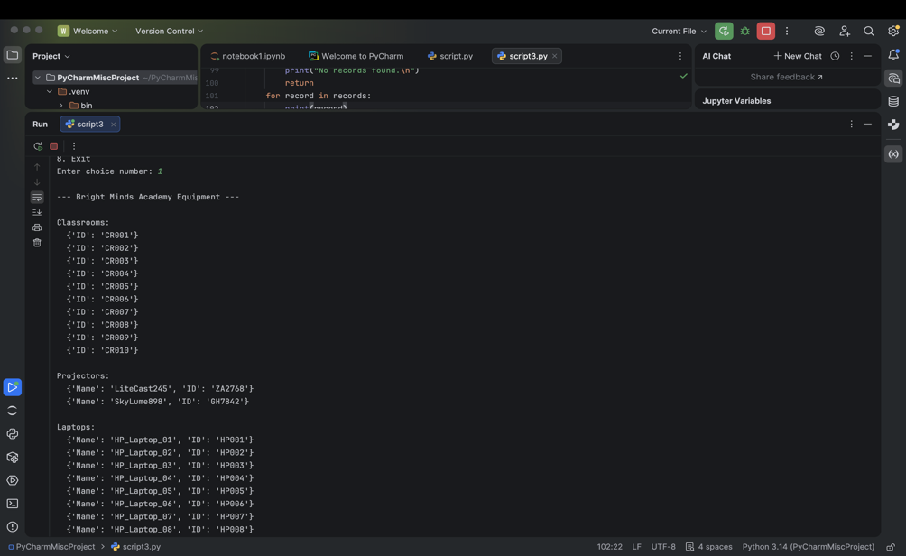

Figure 4 Choice 1 to view equipment inventory

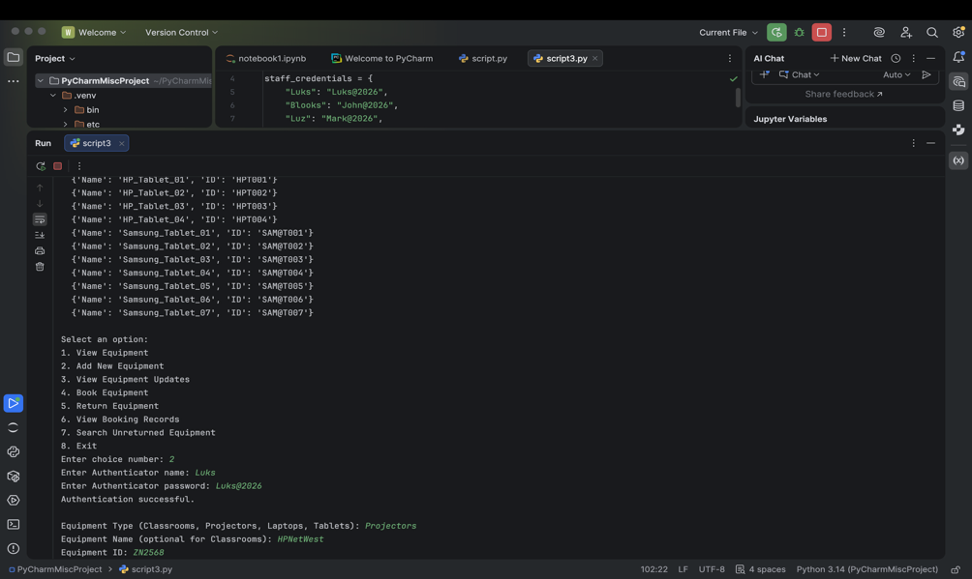

Figure 5 Authentication to add new equipment
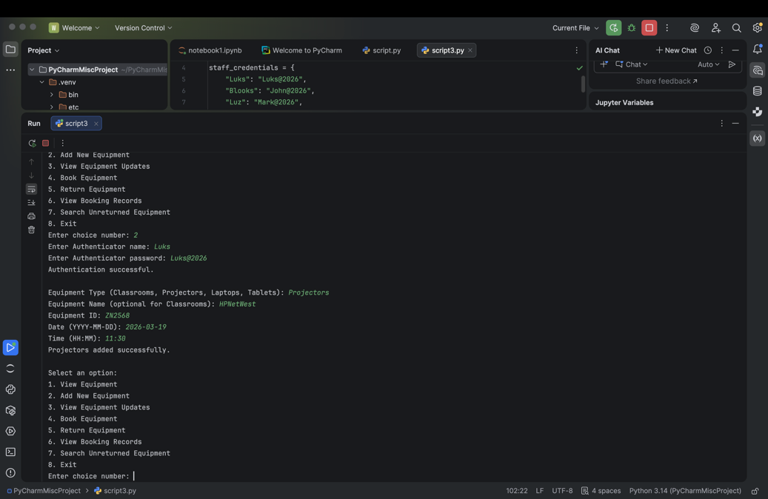

Figure 6 Result showing the new equipment is successful added to the inventory

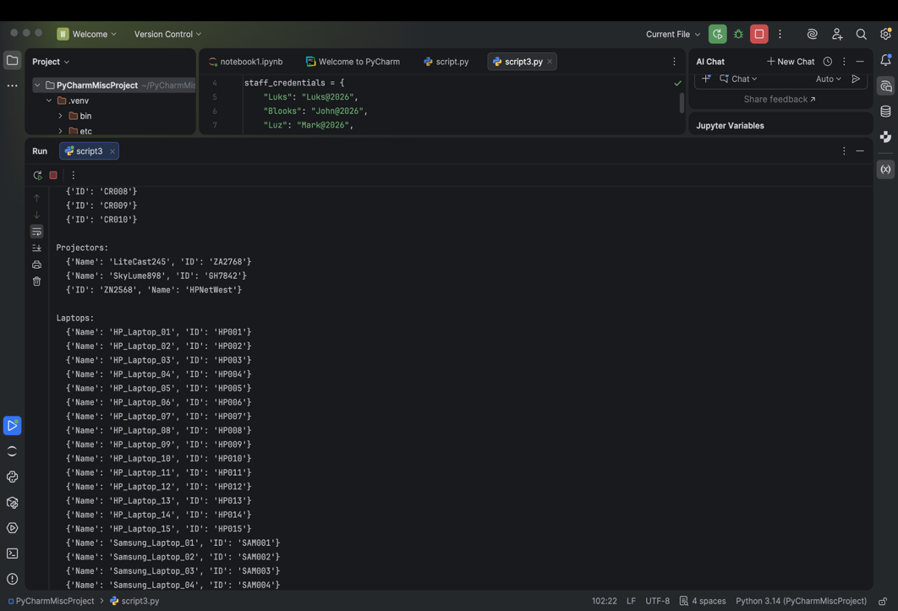

Figure 7 Choice 1 showing inventory with the new equipment added
As illustrated in Figures 4 to 6, the images demonstrate the process of viewing the inventory and adding new equipment to it. The system includes a security check that requires staff authentication before allowing the addition of new items. In this instance, the equipment added is a projector named "HPNetWest" with the ID "ZN2568."
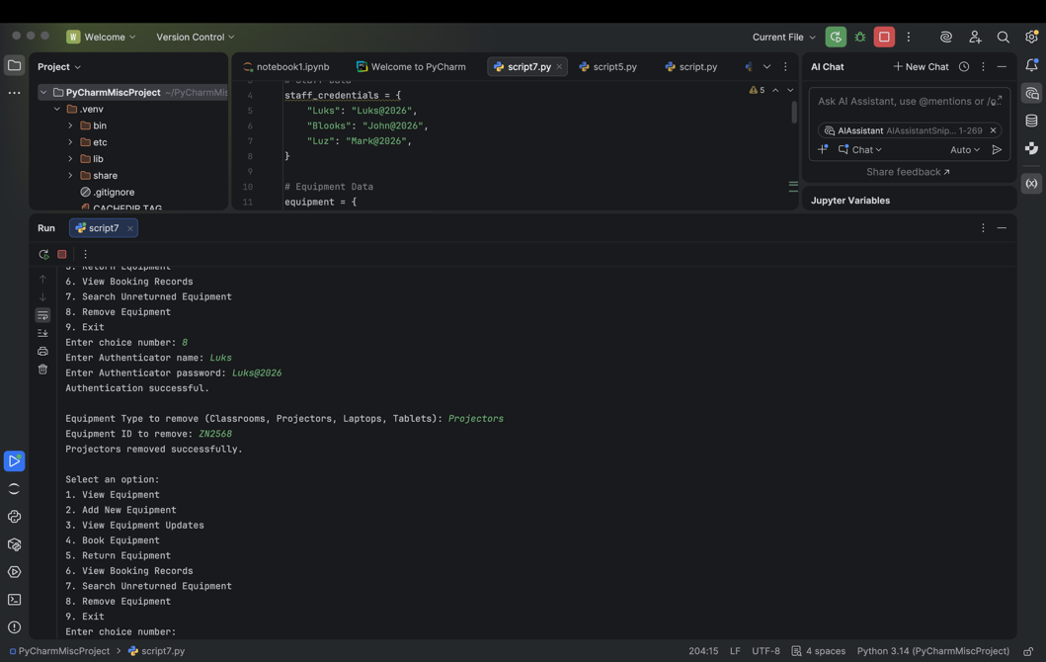

Figure 8 Showing the new equipment remove from the inventory
The images in Figure 7 illustrate the successful removal of the equipment named "HPNetWest" with ID "ZN2568" from the inventory, demonstrating that the deletion process was completed successfully.

Attempting to add duplicate equipment names to test duplicate handling.
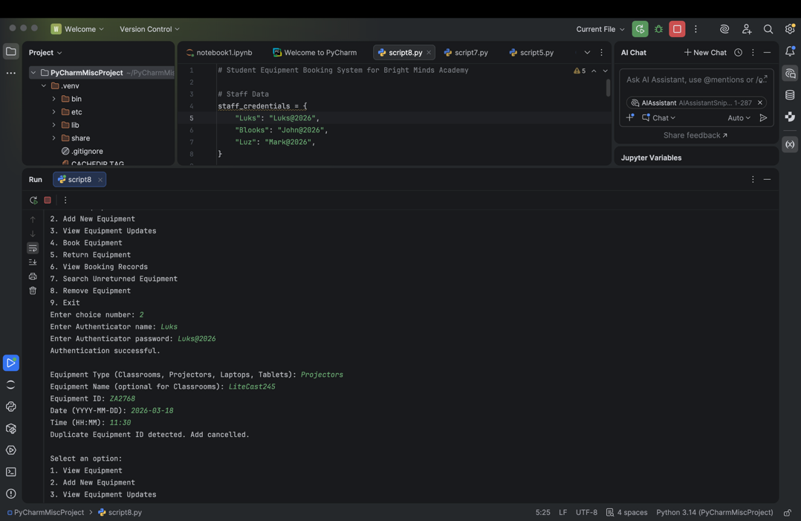

Figure 9 Duplicated equipment ID detected and adding cancelled
The image in Figure 8 shows the system's response when attempting to add equipment with an ID that already exists. This feature helps prevent duplicate entries and ensures data integrity.
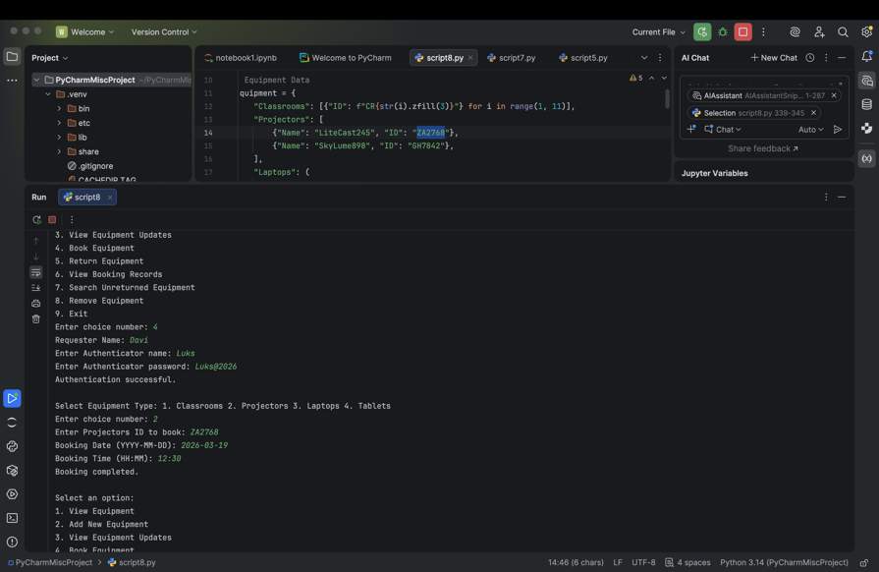
Booking equipment on a valid date and confirming the booking appears in the records.

Figure 10 Booking Equipment
Figure 9 demonstrates the successful booking of a projector with ID "ZA2768" by staff member Luks, who authenticated using his password "Luks@2026."
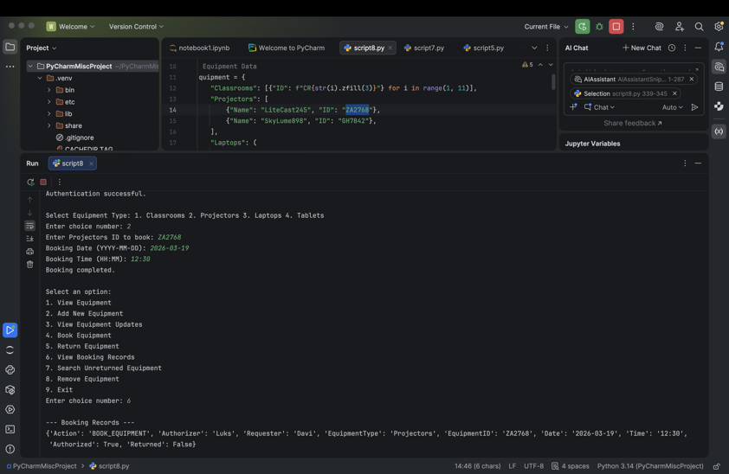

Figure 11 Viewing Booking records to confirm bookings
Figure 10 shows that option 6 was selected to view the booking record, confirming a successful booking.
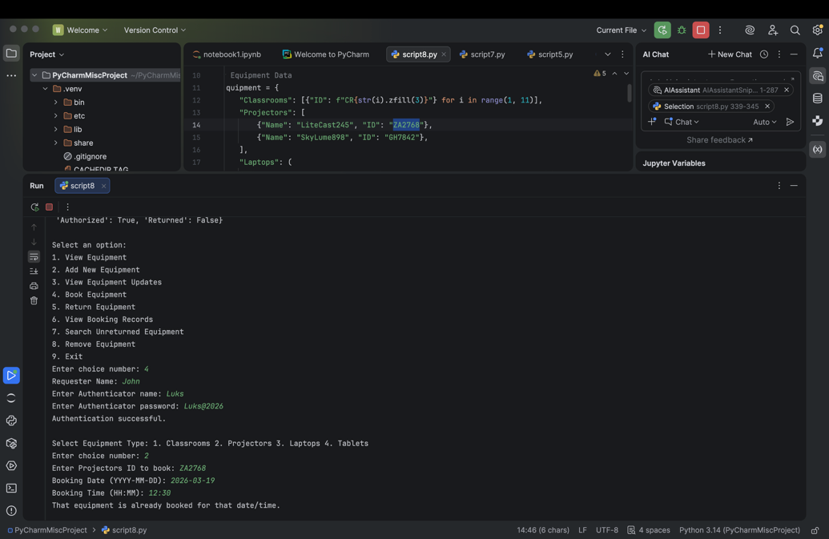
Trying to book the same equipment on the same date to test double booking prevention.

Figure 12 Trying to book the same equipment on the same date and time
Figure 11 demonstrates the system's response when attempting to book the same equipment for the same date and time. The program alerts staff that the equipment is already reserved.

Entering an invalid date format (2024-02-30) and verifying validation prompts.
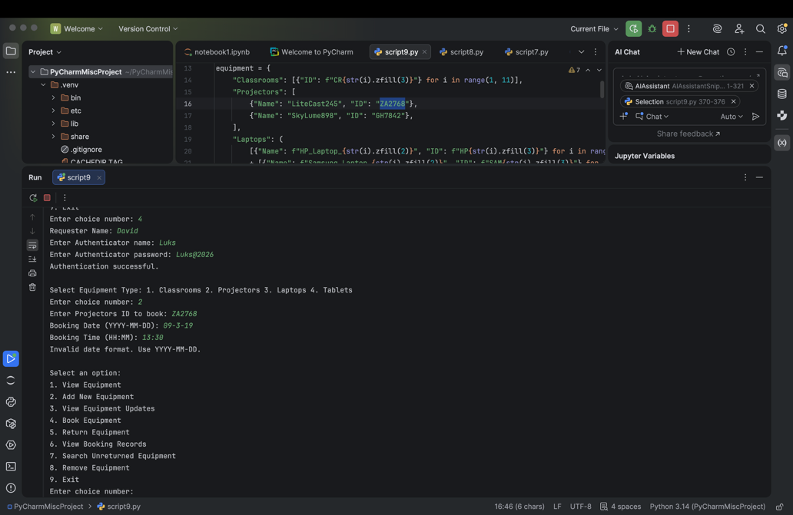

Figure 13 Booking an equipment with a wrong date format
Figure 12 shows the program alerting staff to input the correct date and time format during the booking process.

5.0 EVALUATION
Challenges Faced
Throughout the development of this booking system, I faced numerous challenges that tested my problem-solving skills and deepened my understanding of programming concepts, including designing efficient data storage with nested dictionaries for quick access, implementing meticulous validation logic to prevent double bookings, utilizing Python’s `datetime` module and exception handling for accurate date validation, and refining user interface prompts for clarity and usability. Managing complex control flow with nested functions to ensure stability and debugging edge cases like bookings on invalid dates or unavailable equipment also presented significant hurdles.

These experiences significantly enhanced my knowledge of data management, input validation, control structures, and debugging techniques. They reinforced the importance of adhering to best coding practices and meticulous planning, ultimately contributing greatly to my growth as a programmer and deepening my understanding of building robust, user-friendly applications.

Future Improvements
The current system provides a solid foundation but can be enhanced significantly. Future improvements include:
Data Persistence:
Implement file handling using CSV or JSON formats to store equipment information and booking records externally, ensuring data is preserved permanently, automatically loaded on program restart, and making the system more reliable and practical for real-world, long-term data management.
CSV (Comma-Separated Values)
CSV is a simple text format organizing data into rows and columns, with each value separated by commas, making it easy to read, edit, and widely used for spreadsheets and tabular data.
JSON (JavaScript Object Notation)
JSON is a human-readable, hierarchical data format that efficiently represents nested structures with objects and arrays, ensuring flexibility, organization, and seamless data exchange across diverse programming environments. [13].
Both formats help in saving data outside of the program so that it can be retrieved and used later, ensuring data persistence across program sessions.

User Authentication:
Implement a login system with user authentication and role assignment, like admin or staff, to restrict feature access, enhance security, and support future multi-user expansion with appropriate permissions.

Graphical User Interface (GUI):
Replace the current command-line interface (CLI) with a graphical user interface (GUI) using libraries like Tkinter. Tkinter is a programming tool in python use to Graphical User Interface (GUI) [14]. This improves system accessibility and efficiency for staff unfamiliar with command-line tools.

Booking Management:
Incorporate functionalities that allow users to cancel, modify, or reschedule existing bookings. These features will offer greater flexibility, enabling users to adjust their reservations easily and efficiently as their plans change.

Notification System:
Add notification features, such as email alerts or popup messages, to remind staff and students about upcoming bookings or alert them to any scheduling conflicts. These notifications help ensure everyone stays informed and can make necessary adjustments in a timely manner.

Calendar View:
Introduce a visual calendar display that shows all equipment bookings in a clear and organized way, allowing users to quickly see bookings across different days or weeks. This helps users easily understand the schedule at a glance and plan accordingly.

Advanced Search:
Add filtering options that allow users to sort and view bookings based on specific criteria such as date range, equipment type, or student. This feature makes it easier to find and manage relevant information quickly, improving the overall user experience and system usability.

Error Logging:
Implement logging features that record system activities and errors, enabling easier tracking and troubleshooting of issues. These improvements will help turn the prototype into a robust, scalable management tool with better security and user-friendliness, ensuring reliable operation and easier maintenance.

Self-Reflections
This assignment project has been a transformative experience that significantly advanced my competencies in software engineering, system design, and problem-solving within a real-world context. Initially motivated by the operational inefficiencies faced by Bright Minds Academy’s manual equipment management, I aimed to architect a scalable, reliable, and maintainable solution grounded in core programming principles. This endeavour necessitated a comprehensive understanding of data structures, modular programming paradigms, and input validation techniques, which I refined through iterative development and rigorous testing.

Throughout the development process, I confronted complex challenges in ensuring data consistency, preventing race conditions such as double bookings, and implementing robust validation protocols—particularly for date and time inputs. To address these, I leveraged Python’s ‘datetime’ module for precise temporal validation and incorporated exception handling to mitigate input errors, thereby enhancing system robustness. This reinforced my appreciation for the necessity of defensive programming practices and the importance of designing fail-safe mechanisms in user-facing applications.

Designing a command-line interface with an emphasis on user experience compelled me to implement intuitive navigation, comprehensive feedback, and error handling to facilitate seamless user interactions. This experience underscored the critical role of usability in system adoption and laid a solid foundation for future enhancements, including transitioning to a graphical user interface with Tkinter to improve accessibility for non-technical users.

Moreover, I applied principles of modularity and separation of concerns by encapsulating functionalities within discrete functions, which significantly improved code maintainability and scalability. The strategic use of dictionaries and lists for dynamic data management optimized performance and enabled straightforward extensions, such as the integration of persistent storage solutions like JSON or CSV files to ensure data durability across sessions.

Envisioning future developments, I am particularly interested in integrating role-based access control, real-time notification systems, advanced search and filtering capabilities, and a visual calendar interface—features that would elevate the system from a basic prototype to a comprehensive management platform. Incorporating logging and error-tracking mechanisms will further enhance system reliability, facilitate troubleshooting, and support continuous improvement.

This project has profoundly enriched my technical skill set, particularly in designing modular, scalable systems with a focus on data integrity, security, and user-centric design. It has also deepened my understanding of software lifecycle processes, including requirements analysis, iterative development, and strategic planning for feature expansion. Moving forward, I am motivated to explore advanced topics such as database integration, authentication protocols, and GUI development, with the aim of building sophisticated, enterprise-grade applications that effectively serve organizational needs.

Bibliography

[1] | H. Canli, “Improving Data Entry Quality in Enterprise Applications With NLP Methods: A Model Proposal Based on BERT and Deep Learning,” 2025. [Online]. Available: https://ieeexplore.ieee.org/document/11086599. [Accessed Wednesdy 11th March 2026 March 2026].
[2] | S. Vijayakumar, P. K. Krishna and H. M. Raviraja,, “Assessing the Effectiveness of MoSCoW Prioritization in Software Development: A Holistic Analysis across Methodologies,” 2023. [Online]. Available: https://www.proquest.com/docview/3275666461?accountid=130472&parentSessionId=%2ByDefaebb4W0%2F%2BUaklhMymqxGjriZ5JTDxFyXxVhLDA%3D&pq-origsite=primo&sourcetype=Scholarly%20Journals. [Accessed Wednesday 11th March 2026].
[3] | Shaowei Wang, Lingling Zhang, Xuan Luo, Yi Yang, Xin Hu, Tao Qin, Jun Liu, “Computer Science Diagram Understanding with Topology Parsing,” 30th July 2022. [Online]. Available: https://dl-acm-org.uwtsd.idm.oclc.org/doi/full/10.1145/3522689. [Accessed Saturday 14th March March 2026].
[4] | Alokia, Anas, Gad, Walaa, Nazih, Waleed, Aref, Mustafa, Abdel-Badeeh Salem, “Retrieval-Based Transformer Pseudocode Generation,” Vols. Vol.10,Iasa.4, 2022.
[5] | Hassan, Ietezaz ul and Panduru, Krishna and Walsh, Joseph, 2024. [Online]. Available: https://ieeexplore.ieee.org/document/10796474. [Accessed Tuesday 17th March 2026].
[6] | K. D. Lee, Python Programming Fundamentals, vol. 2nd ed. 2014, Decorah IA: Springer London, 2014, pp. 55 - 56.
[7] | Lutz, Mark, “Learning Python,” in Learning Python, vol. Fifth edition, O'REILLY, 2013, pp. 116 - 118.
[8] | Fisher, David Allen, “Control structures for programming languages,” Carnegie Mellon University ProQuest Dissertations & Theses, 1970. [Online]. Available: https://www.proquest.com/openview/c5f48c5f4adf1c2963102a59d7a5d7f8/1.pdf?pq-origsite=gscholar&cbl=18750&diss=y. [Accessed 17th March March 2026].
[9] | Braunschweig, Dave, “Programming Fundamentals,” 2018. [Online]. Available: https://press.rebus.community/programmingfundamentals/chapter/input-process-output-model/. [Accessed Wednesday 18th March March 2026].
[10] | Bai, Jia-Ju and Fu, Zi-Xuan and Xie, Kai-Tao and Jiang, Zu-Ming, “Testing Error Handling Code With Software Fault Injection and Error-Coverage-Guided Fuzzing,” IEEE Transactions on Dependable and Secure Computing, vol. 21, pp. 1724-1739, 2024.
[11] | Ferron, Nicolo, Manduchu, Gabriele, “ProQuest University of Wales Trinity St. Daivd,” [Online]. Available: https://www.proquest.com/docview/3172288056/D22B4322F9694BD5PQ/1?accountid=130472&sourcetype=Scholarly%20Journals. [Accessed Tuesday 18th March March 2026].
[12] | Hooda, Itti and Chhillar, Rajender Singh, February 2015. [Online]. Available: https://d1wqtxts1xzle7.cloudfront.net/75460098/pxc3901433-libre.pdf?1638346315=&response-content-disposition=inline%3B+filename%3DSoftware_Test_Process_Testing_Types_and.pdf&Expires=1773873909&Signature=Moq7htmiczmQ8dsyE~yuRbVE13b8elrTTbqvAk64bmz9-osTzfbL. [Accessed March 2026].
[13] | Ashraf Elnashar, Jules White, Douglas C Schmidt, “Enhancing structured data generation with GPT-4o evaluating prompt efficiency across prompt styles,” Frontiers in Artificial Intelligence, Vols. ISSN: 2624-8212 EISSN: 2624-8212 DOI: 10.3389/frai.2025.1558938 PMID: 40206704, 26 March 2025.
[14] | Chaudhary, Bhaskar, Tkinter GUI Application Development Blueprints: Build nine projects by working with widgets, geometry management, event handling, and more, Birmingham, 35 Livery Street: Packt Publishing Ltd, 2018, p. 1.
[15] | Lijuan, Chen and Bhaumik, Amiya and Xinfeng, Wang and Jingwen, Wu, “The effects of inventory management on business efficiency,” International Journal For Multidisciplinary Research, vol. 5, pp. 1 - 17, 2023.

