Syed Tajud Ali
2107638
BMIH5006
Destination Management of Manchester, UK

Lecturer: Ruth Taylor-Davies

Table of Contents
Introduction 3
1. Evaluate principles of sustainable tourism, using the three pillars of sustainability (economic, socio-cultural, and environmental) of your chosen destination 4
Economic sustainability 5
Socio-cultural sustainability 6
Environmental Sustainability 7
2. The development management plan of your chosen destination associated with the general principles of development should be evaluated and analysed throughout. 8
3. Practices should be identified, outlining regulations and organisations responsible for the implementation. 10
4. The travelling aspect of the industry should also be analysed, exploring how they are closely related. 11
5. Use Butler’s life cycle model and Doxey’s irridex model to determine which stages your chosen destination has been through / is currently at. Use data and statistics to back up your evidence. 12
Butler’s life cycle model 12
Doxey’s Irridex model 14
6. Provide recommendations for the future development of the destination, keeping sustainability at the core of your recommendations. 15
Conclusion 16
References 17

Introduction

Sustainable tourism refers to the exploration of new destinations in a sustainable way that benefits the economy, socio-cultural aspects of the destinations as well as the environment (Carr et al., 2016). This is a business report on hospitality industry that will focus on sustainable hospitality and tourism management. In the field of tourism, sustainability is now becoming a norm, and more tourists are opting for sustainable tourism. More precise and professionally recommended sustainable growth policies should be made by the authorities of Manchester. It will cover up past flaws and improve the current ones. The growth policies must ensure the safety of the environment also (Dimitrov et al., 2019).
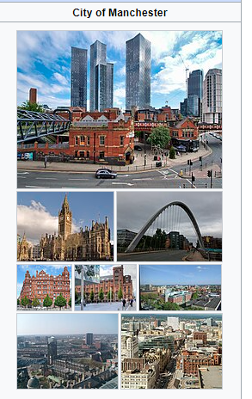
Figure: Manchester, UK (Carr et al., 2016).

Evaluate principles of sustainable tourism, using the three pillars of sustainability (economic, socio-cultural, and environmental) of your chosen destination.

The term “sustainability” is becoming a hot topic around the world, and the world population is becoming more conscious of it. The chosen destination “Manchester”, a popular tourist destination in the UK, is doing its best to follow the principles of sustainability and make this place sustainable both for the local people and the tourists (Streimikiene et al., 2021). The following is the evaluation of the sustainable tourism of Manchester, UK using the three pillars of sustainability.
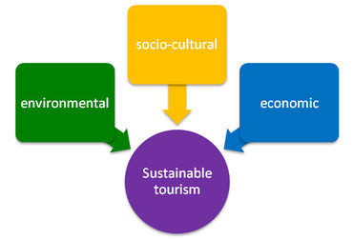
Figure: the three pillars of sustainable tourism (Carr et al., 2016).

Economic sustainability.

Economic diversification: A demand for economic sustainability is diversifying the local economy. Manchester is making strategic planning and implementation to make the economy of this city diversified with varieties of industries and businesses. The plan of Manchester is not to become entirely dependent upon its tourism sector (Carr et al., 2016).
Local and international employment: For maintaining economic sustainability as a tourist destination, Manchester is providing jobs for local and international employees in the various sectors of the economy. Thus, the local people are not counting only on the tourism industry. Along with employment, the rights and wages of these employees are maintained as well (Streimikiene et al., 2021).
Support the local businesses: An important part of economic sustainability is the growth of local businesses. Manchester is promoting local businesses to the tourists and tourists are more interacting with the local businesses. The growth of local businesses will make the economy of Manchester more stable (Budeanu et al., 2016).
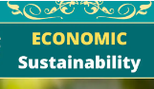
Figure: Economic sustainability (Streimikiene et al., 2021).

Socio-cultural sustainability.

Respect the local culture: Respecting the local culture of the tourist destination is a primary approach to promoting sustainability. Tourists coming to Manchester are encouraged to respect the local culture and customs. Promoting the local cultures and norms also strengthens the local community, and mutual interactions between the local people and the tourists gain more strength (Budeanu et al., 2016).
Promote the growth of living standards: Sustainable tourism in Manchester, UK promotes the growth of living standards of the local people. As a tourist destination, it is a mixture of local and international cultures. This encourages both the local people and the tourists to crave for developing their living standards. This can be achieved through educational and economic development (Carr et al., 2016).
Strength the community: Sustainable tourism upholds the local cultures of the rest of the world. In the case of Manchester too, the local cultures and traditions are getting recognition around the world, therefore strengthening the local community (Ooi et al., 2015).

Environmental Sustainability.

Preserving wildlife and natural resources: The sustainability of a tourist destination is incomplete if the environment is harmed. The authorities of “Manchester” are doing everything to preserve wildlife and natural resources. The tourists are encouraged not to harm any animals or natural resources such as forests, lakes, or rivers (Budeanu et al., 2016).
Promote the use of green energy: The increase in the use of green energy will promote the sustainability of the environment of Manchester, UK. It will decrease the pollution of this city. Tourists coming to Manchester are promoting the stance of increasing the use of green energy. It helps to save the environment and helps the bio-diversities to grow (Streimikiene et al., 2021).
Environmentally friendly transportation: The city of Manchester is trying to reduce the harm done by the transportation system. Therefore, discouraging the private vehicle and promoting the public transportation system for tourists is a great approach to saving the environment. Also, using trams and trains as transportation reduces carbon emissions in the air (Carr et al., 2016).
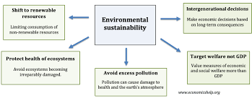
Figure: Environmental sustainability (Streimikiene et al., 2021).

The development management plan of your chosen destination associated with the general principles of development should be evaluated and analysed throughout.

Executive Summary

To gain long-term benefits, a development management plan for this city associated with the general principles of development is a need. The development plan for this destination is given below.
Sustainability Goals & Objectives
To ensure Sustainable transportation, Renewable energy, Zero waste and Responsible consumption.
Stakeholder Analysis
To make a proper development management plan for the tourist destination Manchester, the destination and the visitors should be analysed first. The planning will identify the tourist attractions in the city. To make the development management plan, this information is needed because the planning and implementation should support the normal flow of tourism (Hristov et al., 2018).
Environmental Impact Assessment
Improving the transportation system is a major part of the development planning. Providing adequate transportation systems for the tourists and the local population of Manchester is a must. The authorities of Manchester should increase public transport (Dedusenko et al., 2020).

Work Break-Down Structure
Sl. No. | Tasks | Starting date | Ending date | Duration (days)
1 |  | 5/15/2024 | 5/20/2024 | 6
2 |  | 5/21/2024 | 5/27/2024 | 7
3 | 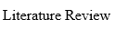 | 5/28/2024 | 6/18/2024 | 22
4 |  | 6/19/2024 | 6/25/2024 | 7
5 |  | 6/26/2024 | 7/7/2024 | 12
6 |  | 7/8/2024 | 7/14/2024 | 7
7 | 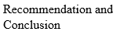 | 7/15/2024 | 7/23/2024 | 9
8 |  | 7/24/2024 | 3/26/2024 | 3

Schedule and Timeline

The development management plan will ensure the social growth of the local people. Building more educational institutions and encouraging local people to get more educational qualifications will grow the local community of Manchester. Resolving conflicts in the community is also necessary (Hristov et al., 2018).
Resource Allocation
After understanding the need of the visitors and also the local people, it is now time to develop the necessary infrastructure. Infrastructural development should support the present and future causes (Hristov et al., 2018).

Risk Management
The development management plan will not only develop the tourism sector but also other industries to grow the local economy. It will also analyse what type of tourist visits this place and examine their activities. It is also important to know the needs of local people. Creating more industries will increase jobs and provide economic security to the population of Manchester (Pearce, 2015).
Communication Plan
It is necessary to monitor and evaluate every aspect of the development plan continuously. The authority of this destination will properly examine the current development, and examine its effectiveness and impact on the social and environmental sides. To ensure long-term benefits from this destination, it is necessary to maintain everything properly (Dedusenko et al., 2020).
Monitoring and Evaluation
No environmental hazards should be done to develop the infrastructure. The infrastructural development should include making proper accommodations for tourists, necessary roads, parks, amusement parks, museums etc. (Pearce, 2015).
Continuous Improvement
To implement the development management plan for the tourist destination of Manchester, it is necessary to identify the practices outlining the regulations and organizational responsibilities. Below is a brief discussion about that.

Practices should be identified, outlining regulations and organisations responsible for the implementation.

Setting appropriate policies: To implement the development management plan, proper policies should be set both for the locals and tourists. Organizations operating in this place also must abide by the policies. The policies will outline sustainable tourism practices so that the best outcome can be achieved from this destination (Zhang et al., 2020).
Imposing regulations to safeguard the environment: The authorities of Manchester will impose strict regulations to safeguard the environment such as not polluting the environment, or dumping waste materials in the proper place. The regulations will ensure that the bio-diversities are not harmed due to tourism (Zhang et al., 2020).
Preserve the heritage: To implement the plan properly, the authority of Manchester will ensure that the local heritage is protected and preserved. It includes building museums, securing heritage places, renovating cultural infrastructures etc. (Stoffelen et al., 2018).
Involving communities: To ensure that the plan is properly implemented, the local communities must be involved in the process. The local communities should abide by the policies set by the authorities and try to secure the cultural values from being corrupted (Vargas-Sánchez et al., 2015).

The travelling aspect of the industry should also be analysed, exploring how they are closely related.

The travelling aspect of the industry is very crucial, and a smooth travelling experience is necessary to ensure the flow of tourists. Thus, a smooth travelling experience is closely related to ensuring the sustainable development of tourism in Manchester (Pencarelli, 2020). Below is an evaluation of how this can be achieved.
Streamline the travelling experience: The travelling experience of the tourists coming to Manchester should be streamlined and smooth. The authorities should create infrastructures such as airports, train stations, and bus stops so that tourists can visit the city easily (Kanwal et al., 2020).
Increase the number of transportation: The number of the public transportation system should be increased to control the flow of tourists visiting different attractions of this destination (Khan et al., 2017).
Reduce carbon emissions from transportation: To ensure environmental security, carbon and other greenhouse gas emissions must be reduced. To achieve that, electric vehicles such as trams, trains, and solar-powered vehicles should be increased (Kanwal et al., 2020).
Diversify the transportation medium: The transportation mediums should be diversified. The authorities of Manchester should not rely only upon the bus or trams but rather provide train services, airlines, small vehicles, boats etc. for the tourists and locals (Pencarelli, 2020).

Use Butler’s life cycle model and Doxey’s irridex model to determine which stages your chosen destination has been through / is currently at. Use data and statistics to back up your evidence.

Butler’s life cycle model

According to Butler’s life cycle model, the tourist destination Manchester has gone through six different stages. These are –
The Exploration Stage: In this stage, Manchester experienced small numbers of tourists, and the tourism industry was not the primary source of economy. But current data shows that 1.15 million people visit Manchester every year, therefore, Manchester is not in the exploration stage (Singh, 2021).
The Involvement Stage: This stage focuses on the involvement of the local people of Manchester in the tourism industry. This implies seasonal tourism, but as Manchester is already tourist crowded, this city has experienced this stage earlier (Butler, 2015).
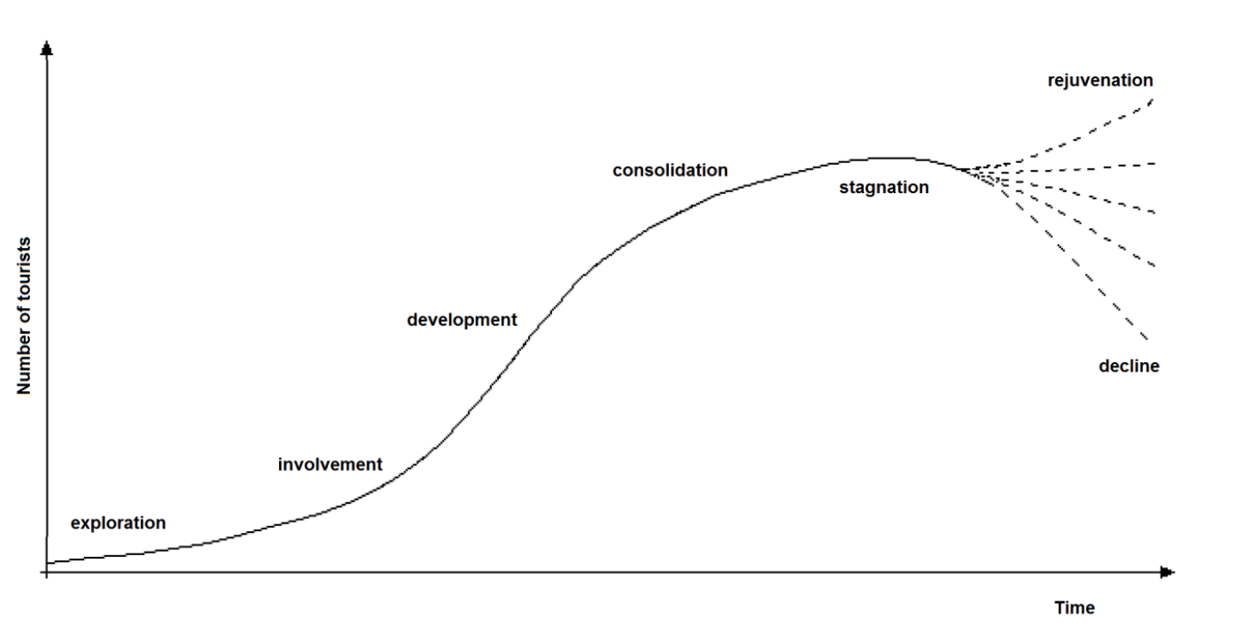
Figure: Butler’s life cycle model (Butler, 2015).

The development stage: High number of tourists, possibly exceeding the local population, indicates this stage. According to data, more than 1 million people Manchester every year, but this does not outnumber the local population, which is 2.8 million in 2023, during any season. Therefore, Manchester has not yet fully experienced this stage (Singh, 2021).
The Consolidation Stage: This stage indicates the slowing pace of tourist growth, and the economy is fully dependent on tourism. But in the case of Manchester, the growth of tourism is not declining, nor does the economy depend on tourism (Butler, 2015).
The stagnation stage: According to this stage, the number of tourists is at its peak, and the capacity of accommodating tourists is exceeded. But in the case of Manchester, this scenario has not come yet (Singh, 2021).
The rejuvenation Stage: According to Butler’s life cycle model, Manchester is in the Rejuvenation stage, which is more development of tourism is being seen. The number of tourists are getting increased every year. New planning and improvements are being implemented (Butler, 2015).

Doxey’s Irridex model

Using Doxey’s irridex model, the current stage of the tourist destination Manchester can be identified. The four stages of this model are given below-
Euphoria: During this stage, the people of Manchester feel a positive emotion toward the tourism sector of this city and the development of tourism. The anticipation of local people for the tourists coming to the city becomes very high. But as the city is already a tourist destination for decades, certainly the city is not in the Euphoria stage (Vargas-Sánchez et al., 2015).
Apathy: In this stage, the local people of Manchester feel neutral emotions for the tourists coming into the city. It happened after the development of tourism in the city which was decades ago (Okulicz-Kozaryn et al., 2017).
Annoyance: This stage indicates the annoyance of people or irritation towards the increasing number of tourists coming into the city. According to data, more than 1 million tourists are coming to the city, which makes the situation annoying for the local people (Zaidan et al., 2017).
Antagonistic: In this stage, the local people express their irritation in verbal or physical ways. But in Manchester, this scenario is not seen. Also, local people remain friendly towards tourists. Therefore, Manchester has not experienced this stage (Zaidan et al., 2017).
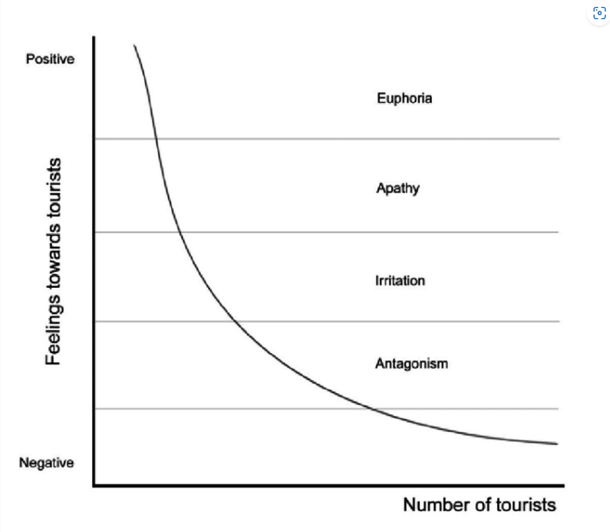
Figure: Doxey’s Irridex model (Okulicz-Kozaryn et al., 2017).

Provide recommendations for the future development of the destination, keeping sustainability at the core of your recommendations.

To promote the future development of tourism in Manchester, while keeping sustainability in the focus, the recommendations are -
Increase inclusion and connectivity: Tourism is incomplete without the connectivity of local people and their inclusion. So, for future development, the increase of local connectivity in tourism should be ensured (Dimitrov et al., 2019).
Promote cultural diversity: To make tourism more acceptable to people, the promotion of cultural diversity should be encouraged. The socio-cultural aspects of the destination will support this cause (Dimitrov et al., 2019).
Increase technology to smooth tourism experience: To make the tourism experience easier, the use of technology should be increased so that tourists can get information about the destination and get things done easily (Kozhokulov et al., 2021).
Establish sustainable growth policies: More precise and professionally recommended sustainable growth policies should be made by the authorities of Manchester. It will cover up past flaws and improve the current ones. The growth policies must ensure the safety of the environment also (Dimitrov et al., 2019).
Increase funding: The government should increase funding to develop the infrastructure in this destination (Kozhokulov et al., 2021).
Increase private sector involvement: The increase of the private sector in the destination will increase the economic prosperity of this place. New jobs will be created, and the living standards of the local people will improve (Dimitrov et al., 2019).

Conclusion.

The tourism industry of the UK is getting more popular day by day with millions of tourists coming in every year. Manchester is a popular destination among tourists coming to the country. Tourism is incomplete without the connectivity of local people and their inclusion. So, for future development, the increase of local connectivity in tourism should be ensured. To make the tourism experience easier, the use of technology should be increased so that tourists can get information about the destination and get things done easily. With the increase in the number of tourists in the city, the economic, socio-cultural, and environmental situations have changed (Dedusenko et al, 2020).

References.

Budeanu, A., Miller, G., Moscardo, G., & Ooi, C. S. (2016). Sustainable tourism, progress, challenges and opportunities: an introduction. Journal of Cleaner Production, 111, 285-294.
Butler, R. (2015). The evolution of tourism and tourism research. Tourism Recreation Research, 40(1), 16-27.
Carr, A., Ruhanen, L., & Whitford, M. (2016). Indigenous peoples and tourism: The challenges and opportunities for sustainable tourism. Journal of Sustainable Tourism, 24(8-9), 1067-1079.
Dedusenko, E. A., & Wagenseil, U. (2020). Sustainability focus in destination management. The case of Russia. Journal of Environmental Management & Tourism, 11(3 (43)), 529-537.
Dimitrov, N., Petrevska, B., & Terzić, A. (2019). Recommendations for tourism development of rural areas in North Macedonia.
Hristov, D., & Petrova, P. (2018). Destination management plans–a new approach to managing destinations in England: Evidence from Milton Keynes. Current Issues in Tourism, 21(2), 133-153.
Kanwal, S., Rasheed, M. I., Pitafi, A. H., Pitafi, A., & Ren, M. (2020). Road and transport infrastructure development and community support for tourism: The role of perceived benefits, and community satisfaction. Tourism Management, 77, 104014.Ariful
Khan, S. A. R., Qianli, D., SongBo, W., Zaman, K., & Zhang, Y. (2017). Travel and tourism competitiveness index: The impact of air transportation, railways transportation, travel and transport services on international inbound and outbound tourism. Journal of Air Transport Management, 58, 125-134.
Kozhokulov, S., Issanova, G., Chen, X., Kozhokulov, S., Issanova, G., & Chen, X. (2021). Conclusions and Recommendations for Tourism Development. Tourism in the Kyrgyz Republic: Social and Economic Development of the Issyk-Kul Region, 133-136.
Okulicz-Kozaryn, A., & Strzelecka, M. (2017). Happy tourists, unhappy locals. Social Indicators Research, 134, 789-804.
Ooi, N., Laing, J., & Mair, J. (2015). Social capital as a heuristic device to explore sociocultural sustainability: A case study of mountain resort tourism in the community of Steamboat Springs, Colorado, USA. Journal of Sustainable Tourism, 23(3), 417-436.
Pearce, D. G. (2015). Destination management in New Zealand: Structures and functions. Journal of Destination Marketing & Management, 4(1), 1-12.
Pearce, D. G. (2015). Urban management, destination management and urban destination management: A comparative review with issues and examples from New Zealand. International Journal of Tourism Cities.
Pencarelli, T. (2020). The digital revolution in the travel and tourism industry. Information Technology & Tourism, 22(3), 455-476.
Singh, S. (2021). Time, tourism area ‘life-cycle,’evolution and heritage. Journal of Heritage Tourism, 16(2), 218-229.
Stoffelen, A., & Vanneste, D. (2018). The role of history and identity discourses in cross-border tourism destination development: A Vogtland case study. Journal of destination marketing & management, 8, 204-213.
Streimikiene, D., Svagzdiene, B., Jasinskas, E., & Simanavicius, A. (2021). Sustainable tourism development and competitiveness: The systematic literature review. Sustainable development, 29(1), 259-271.
Vargas-Sánchez, A., do Valle, P. O., da Costa Mendes, J., & Silva, J. A. (2015). Residents' attitude and level of destination development: An international comparison. Tourism Management, 48, 199-210.
Zaidan, E., & Kovacs, J. F. (2017). Resident attitudes towards tourists and tourism growth: A case study from the Middle East, Dubai in United Arab Emirates. European Journal of Sustainable Development, 6(1), 291-291.
Zhang, L., & Zhang, J. (2020). A systematic review on tourism energy consumption, sustainable tourism, and destination development: A behavioral perspective. Transport and Energy Research, 295-313.

