A Discussion on The Dietary Reference Values and the Eatwell Guide Caroline Ellis 2204046 HNL.

This essay will firstly outline the development of the Dietary Reference Values (DRV) in the United Kingdom and the role of the Scientific Advisory Committee on Nutrition (SACN). Then it will discuss some of the Dietary Reference Values (DRV) for adults aged 19-64. Finally, it will consider the development and the role of the Eat Well Guide, and how these guidelines can be turned into practical advice for this age group.
At the beginning of the 20th Century, research on food focussed on nutrient discovery and
deficiency. More recent research has been focussed on reducing disease and eating a more
balanced diet to improve health. The aim of the Dietary Reference Values is to promote a
balance of nutrients (Lean and Combet, 2018).
In 1987 the Committee on the Medical Aspects of Food Policy (COMA) set up The Dietary
Reference Values (DRV) to replace the original 1979 Recommended Daily Amounts (RDA)
of food energy and nutrients for groups of people in the U.K. (Department of health, 2013).
COMA recognised that due to terminology such as Recommended Daily Intakes (RDIs) and
Recommended Daily Amounts (RDAs) that this may have made individuals believe that this
is the minimum intake to be healthy when the amounts could be more than an individual
needs (Department of Health, 2013).
Today most DRVs are still based on the 1991 COMA Report 41: Dietary Reference Values
for Food Energy and Nutrients for the United Kingdom. Since the COMA publication, the
Scientific Advisory Committee on Nutrition (SACN) in 2011 set up a framework for
evidence based nutrition in the U.K. and now advise UK government organisations on
nutrition and health related matters (Lean and Combet, 2018.) SACN has also completed a
number of reports to update advice these include The Carbohydrate and Health report (2015)
and the Vitamin D and Health Report (2016). Another important update from SACN is the
new energy level recommendations for the UK population, since it has become evident that
the measurement for Total Energy Expenditure (TEE) has advanced and also a consideration
when dealing with the impact of the growing obesity epidemic (SACN, 2011).

It is also important to mention before discussing DRV in the next section that
the 1991 report and DRV provide estimates for healthy individuals in the population, not
recommendations or goals. Figures given are the Estimated Average Requirements (EAR) for
individuals, meaning 50% will need more and 50% will need less. The Reference Nutrient
Intake (RNI) are the amounts individuals need in 97.5% of the population with 2.5% who
have lower requirements as in the lower reference nutrient intakes (LRNI). This could have
a number of causes like metabolic differences or illness. For this reason, there is also a safe
intake limit where there has been inadequate scientific data to be able to set a requirement
(Barasi, 2013). Our current advice on DRV and the Eatwell Guide which we will discuss
later is from Public Health England (2016a).

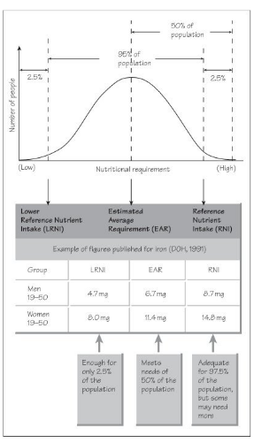
Figure 1. Basis of Dietary Reference values (Barasi, 2013).

The Dietary Reference Values for the age group 19-64 will be explored next. According to the SACN Dietary Reference Values for Energy Report (2011), energy requirements in calories has been capped at 2500 kcal/day for males and 2000 kcal/day for females aged 19-64, this is to address the issues around obesity. Care should be taken in applying this reference as a measurement, as there is a difference between Energy Expenditure (EE) and Physical Activity (PA) in individuals (Lean and Combet, 2018).
When these energy requirements are broken down into macronutrient content, protein consumption i.e. beans, pulses, fish and meat should be around 55.5 g/day for males and 45.0 g/day for females. Carbohydrates i.e. potatoes, bread, rice and pasta around 333 g/day for males and 267 g/day for females. This amount has been reduced recently from 60% to 50% of total daily energy consumption due to SACN’s Carbohydrates and Health report (2015). Further recommendations from this report for this age group is regarding free sugars. This includes sugars added to food and drinks, honeys, syrups, and fruit juices. The advice is to consume no more than 33 g/day for males and 27g/day for females. This only amounts to 5% of total daily energy consumption.
In terms of fats, i.e. cheese, butter and oils, adult males aged 19-64 are recommended to consume less than 97 g/day of fat and females 78 g/day. Furthermore advice is to consume less than a third of those, from saturated fats. In regard to salt intake for this age group the SACN report on Salt and Health (2003) advise no more than 6g/day for both males and females although state this amount in respects to being an achievable target for populations and not an optimum amount. The SACN Carbohydrate and Health report (2015) also details links with encouraging health benefits when including foods high in fibre such as wholegrains, pulses, fruits and vegetables in diets. They therefore recommend 30g/day for both males and females in the 19-64 age group.

Table 1. Government recommendations for energy, macronutrients, salt and dietary fibre for males and females aged 19-64. These are based on recommendations from the Committee on Medical Aspects of Food Policy (COMA) and the Scientific Advisory Committee on Nutrition (SACN).

Gender & Age | Males 19-64 | Females 19-64
Energy (MJ/day) | 10.5 | 8.4
Energy (kcal/day) | 2500 | 2000
Macronutrients
Protein (g/day) | 55,5 | 45.0
Fat (g/day) Less Than | 97 | 78
Saturated Fat (g/day) Less Than | 31 | 24
Polyunsaturated Fat (g/day) | 18 | 14
Monounsaturated fat (g/day) | 36 | 29
Carbohydrate (g/day) At Least | 333 | 267
Free Sugars (g/day) Less than | 33 | 27
Salt (g/day) Less Than | 6.0 | 6.0
Dietary Fibre (g/day) | 30 | 30

Regarding Micronutrients we must bear in mind that the figures given are the Estimated
Average Requirements (EAR) for healthy individuals in the U.K. population. Eating a
healthy balanced diet full of fruits and vegetables however should provide the population
with enough vitamins and minerals (British Nutrition Foundation, 2021). With reference to
Table 2 and 3, data shows that for the age group 19-64, the intake for most micronutrients
between genders are similar with few exceptions. There are considerations to take into
account, whereby supplementation may be beneficial in certain circumstances.
The first being Folate intake. Public Health England (2016) recommend in childbearing age
to take a Folate supplement of 400 µg/day until the 12th week of pregnancy to prevent the risk
of Spin Bifida in the baby. Another consideration is iron supplementation in females aged 19-
50 whereby RNI’s may be insufficient in heavy menstrual loss. The last consideration
regarding supplementation for all genders is the SACN Vitamin D and Health Report (2016)
where advice is to take 10µg/day for everyone in the winter months when there is not enough
sun, as it may be hard to get enough just through foods alone.

Table 2. Government recommendations for vitamins for males and females aged 19-64 (Public Health England, 2016).

Gender & Age | Males 19-64 | Females 19-64
Vitamin A (µg/day) | 700 | 600
Thiamin (mg/day | 1.0 | 0.8
Riboflavin (mg/day | 1.3 | 1.1
Niacin equivalent (mg/day) | 16.5 | 13.2
Vitamin B6 (mg/day) | 1.4 | 1.2
Vitamin B12 (µg/day | 1.5 | 1.5
Folate (µg/day) | 200 | 200
Vitamin C (mg/day | 40 | 40
Vitamin D (µg/day) | 10 | 10

Table 3. Government recommendations for minerals for males and females aged 19-64 (Public Health England, 2016).

Gender & Age | Males 19-64 | Females 19-64
Iron (mg/d) | 8.7 | 14.8 (19-50y) 8.7 (50-64y)
Calcium (mg/day) | 700 | 700
Magnesium (mg/day | 300 | 300
Potassium (mg/day) | 3500 | 3500
Zinc (mg/day | 9.5 | 7.0
Copper (mg/day | 1.2 | 1.2
Iodine (µg/day) | 140 | 140
Selenium (µg/day) | 75 | 60
Phosphorus (mg/day | 550 | 550
Chloride (mg/day | 2500 | 2500
Sodium (g/day) | 2.4 | 2.4

To make sense of the DRV the Eatwell Guide is advice for an individual whatever their ethnic origin, weight, or dietary choice. It shows the amounts and varieties of food an individual should eat to have a well-balanced diet (Public Health England, 2016 b). It is a visual representation to make it easier to understand what should be consumed to have a healthy balanced diet (Food Standards Agency, 2020). The Eatwell guide has been developed and updated from the original Eatwell Plate advice, due to further research from the SACN Carbohydrate and Health report 2015. Firstly Public Health England (2016 b) thought the original plate concept with the knife and fork may confuse individuals into thinking that was what should be eaten for every meal time, instead of a period of time. They also found that those consumers with poorer diets preferred drawn pictures rather than photos, so the images on the Eatwell guide were changed to make it more accessible. Another modification has been to the food group names to reflect current environmentally sound options for protein foods other than just animal sources. Food group sizes were also updated to reflect current advice on health. Advice though from SACN regarding energy consumption has not been applied to the Eatwell guide as individuals tend to under report energy consumption in the National Diet and Nutrition Survey (NSNS) (Cobiac et al 2016). Public health England (2016) take into account information from the NDNS about the food consumed by the population when formulating the Eatwell Guide so as not to make it unattainable.
Another development in the guide is that the segment containing foods that are high in fat and sugar, has been removed completely therefore not to be encouraged as part of a healthy diet. Now a small segment area to show that there should be just a low consumption of oils and spreads and that these should be unsaturated. Lastly Public health England (2016 b) have included in the updated Eatwell guide, advice about hydration, reinforcing there should be a limit on drinking fruit juice, additionally removing fruit juice from the fruit and vegetable section.
In terms of giving practical advice and guidelines to adults aged 19-64. The diet should be encouraged to be varied to achieve the recommended balance of macro and micro nutrients. It should have a large proportion of carbohydrates and fruit and vegetables choosing mostly from wholegrain breads, pasta and rice options and aiming for at least 5 portions of fruit and vegetables a day. The rest of the diet should be made up of good sources of protein, including plant based options, like beans, pulses and tofu, and to include 1-2 portions of fish a week, 1 of those being oily, and limiting processed and red meat choices. Dairy and plant alternatives should be part of the diet as should a small amount of fats as in oils and spreads, but should be unsaturated and low fat and sugar options. High fat and sugary snacks and drinks should be limited from the diet (Public Health England, 2018).
In conclusion, these guidelines for the DRV and the Eatwell Guide may be helpful for professionals, but at an individual level hard to clarify and translate into a practical guide. The Eatwell Guide may be recognisable to the public but there are flaws trying to interpret into meals. It also doesn’t take into consideration diets of the young, elderly or sick, where energy consumption may be low therefore nutrient dense food requirements higher (Lean and Combet 2018). Cobiac et al (2016) point out in regards to the Eatwell Guide that it is important to encourage individuals to change their diet quality, by eating more fruit and vegetables, eating less meat and foods that are high in sugar and fat, without adding to energy consumption. They found in their study that the updates to the Eatwell Guide could potentially have huge health improvements if everyone could follow the advice and therefore have further benefits on the burden of poor health impacts on society.

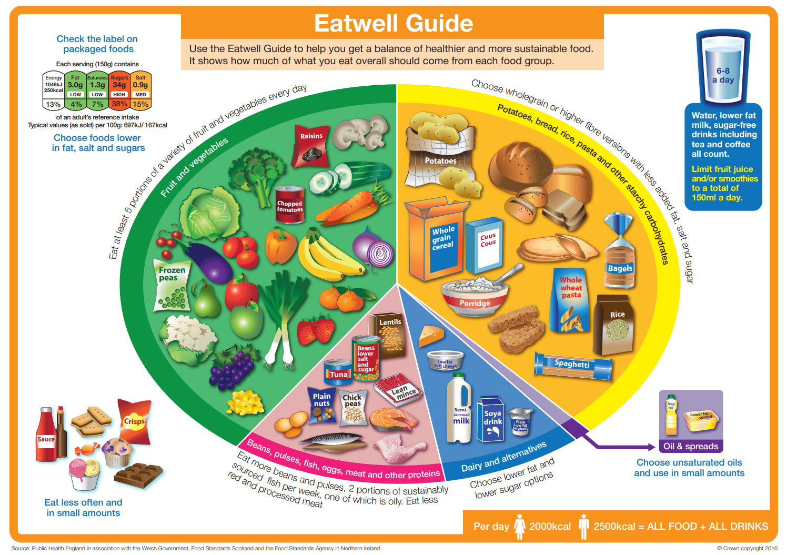

Figure 2: The Eatwell Guide (Public Health England, 2016b).

Word Count: 1678

References

Barasi, M. (2013) Nutrition at a glance. Wiley-Blackwell. Available at: https://www-vlebooks-com.ezproxy.uwtsd.ac.uk/Product/Index/429901?page=0 (Accessed: 27 November 2022)

British Nutrition Foundation (2021) Vitamins and Minerals. Available at: https://www.nutrition.org.uk/healthy-sustainable-diets/vitamins-and-minerals/?level=Health%20professional (Accessed 25 November 2022).

Cobiac, L. J., Scarborough, P., Kaur, A. and Rayner, M. (2016). The Eatwell Guide: Modelling the Health Implications of Incorporating New Sugar and Fibre Guidelines. PLoS One; PLos One, 11(12), pp.e0167859. Available at: https:// www.proquest.com/docview/1850750956?accountid=130472&parentSessionId=9TjNfAocgQAGn0lLaW5knl3yTVJRE9uk1TcjoLOs%2Bu0%3D&pq-origsite=primo

Department of Health (1991) Dietary Reference Values for food energy and nutrients for the United Kingdom: Report of the panel on dietary reference values of the committee on medical aspects of food policy: 5TH edn. LONDON: Stationary Office Books.

Food Standards Agency (2020) The Eatwell Guide and Resources. Available at: https://www.food.gov.uk/business-guidance/the-eatwell-guide-and-resources (Accessed: 21 November 2022).

Lean, M and Combet, E. (2017) Barasi’s Human Nutrition: A Health Perspective. 3rd edn. Boca Raton: Taylor and Francis.

Public Health England (2016) Government Dietary Guidelines: Available at: https://www.gov.uk/government/uploads/system/uploads/attachment_data/file/618167/government_dietary_recommendations.pdf (Accessed 18 November 2022).

Public Health England (2016)a Protecting and improving the nation’s health: The Eatwell Guide. Available at: https://assets.publishing.service.gov.uk/government/uploads/system/uploads/attachment_data/file/742750/Eatwell_Guide_booklet_2018v4.pdf (Accessed: 21 November 2022)

Public Health England (2016)b The Eatwell Guide. Available at: https://assets.publishing.service.gov.uk/government/uploads/system/uploads/attachment_data/file/528193/Eatwell_guide_colour.pdf (Accessed: 21 November 2022).

Public health England (2018) A Quick Guide to the Government’s Healthy Eating Recommendations. Available at: https://assets.publishing.service.gov.uk/government/uploads/system/uploads/attachment_data/file/742746/A_quick_guide_to_govt_healthy_eating_update.pdf#:~:text=The%20average%20energy%20requirement%20for%20a%20man%20is,should%20provide%20about%201.7%20MJ%2F400kcal%20of%20your%20energy (Accessed 27 November 2022).

Scientific Advisory Committee on Nutrition (2003) Salt and Health. Available at: https://assets.publishing.service.gov.uk/government/uploads/system/uploads/attachment_data/file/338782/SACN_Salt_and_Health_report.pdf (Accessed on 24 November 2022).

Scientific Advisory Committee on Nutrition (2011) Dietary Reference Values for Energy. Available at: https://assets.publishing.service.gov.uk/government/uploads/system/uploads/attachment_data/file/339317/SACN_Dietary_Reference_Values_for_Energy.pdf (Accessed: 23 November 2022).

Scientific Advisory Committee on Nutrition (2015) Carbohydrates and Health. Available at: https://assets.publishing.service.gov.uk/government/uploads/system/uploads/attachment_data/file/445503/SACN_Carbohydrates_and_Health.pdf (Accessed: 24 November 2022).

Scientific Advisory Committee on Nutrition (2016) Vitamin D and Health. Available at: https://assets.publishing.service.gov.uk/government/uploads/system/uploads/attachment_data/file/537616/SACN_Vitamin_D_and_Health_report.pdf (Accessed: 24 November 2022).

