Menu Engineering

Student Name: Robert-Daniel Mihalcea
Student ID: 2240761
Module Code: BMIH4002
Word Count: 390
Table of Contents
PART 1: Restaurant Concept 3
PART 2: Menu Design 4
Reference list 7

PART 1: Restaurant Concept
Engineering the layout of food and drink menus to maximise revenue is known as menu engineering, menu optimisation, or menu structuring (Walker, 2021). Elysium Eats, an authentic Mediterranean four-star restaurant, is not satisfied with just feeding its customers; instead, it strives to give them an experience they'll never forget and is introduced to the Hotel Trinity Hotel Chain. The restaurant has a warm and welcoming vibe thanks to the clever combination of vintage and contemporary decor. With its gentle lighting and warm, earthy tones, this space is perfect for unwinding and mingling.
The extensive menu was designed with picky diners in mind. It would be a friendly place for those who like the finer points of cuisine and are looking to set off on a trip of taste that has no geographical bounds. It will provide delicious options for vegetarians and vegans, highlighting the healthy plant-based foods common in Mediterranean cooking. There is a wide selection of tasty, healthful options for the health-conscious diner. It will consider the significance of respecting various dietary choices without compromising the genuineness of Mediterranean cuisine. A wide range of options may allow every member of the family to discover something they enjoy. Visitors in need of a genuine Mediterranean meal, city dwellers in need of a break from their hectic schedules, and lovers in search of a romantic atmosphere may all find what they're looking for at Elysium Eats.
The menu remains static and is a tribute to the timeless classics and unrivalled favourites of Mediterranean cooking. Each dish's preparation can be precisely adjusted thanks to the static menu, which guarantees consistent quality. This is a carefully compiled collection of the finest examples of this long and storied culinary custom. The options were determined after carefully examining sales data and client feedback. Each meal is a work of art unto itself, with a perfectly balanced array of ingredients that suggest fond memories and exciting new experiences.
Elysium Eats will be devoted to providing an out-of-the-ordinary eating experience that will leave an indelible impact on every customer. All decisions, from ideas to clientele to menu items, are inspired by a desire to capture the special chemistry that occurs when high-quality food is served in a warm and inviting setting. It's excited to show off its little piece of heaven in the Mediterranean to the visitor.

PART 2: Menu Design

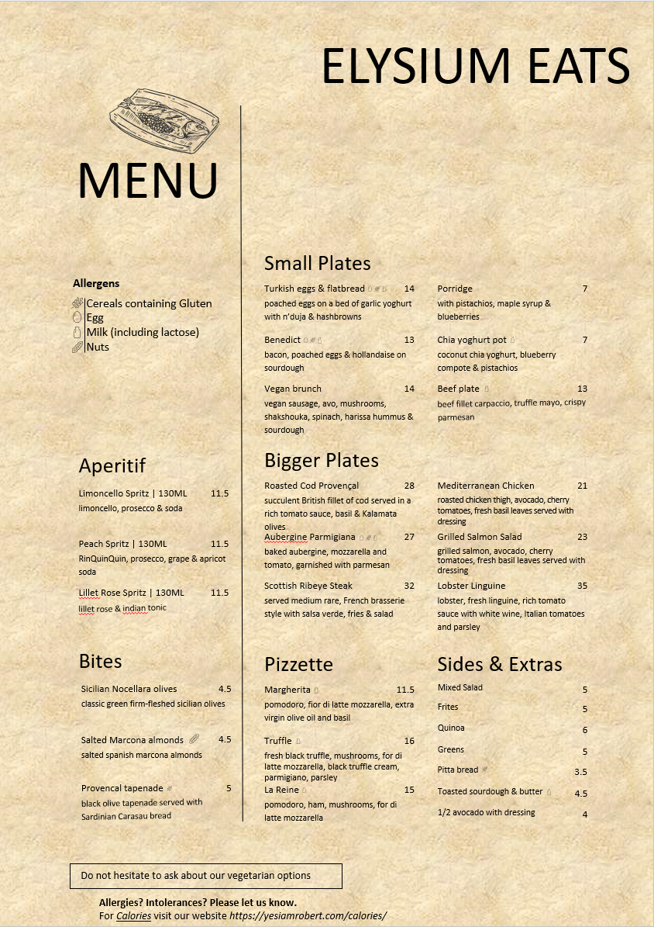
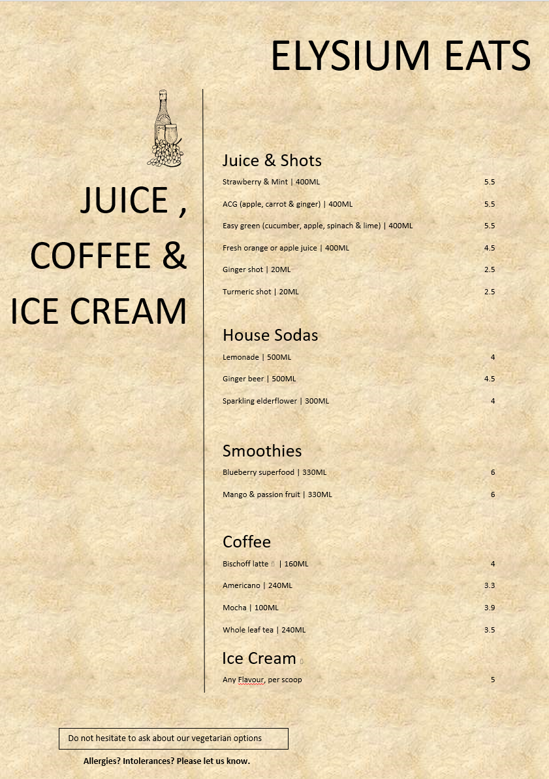

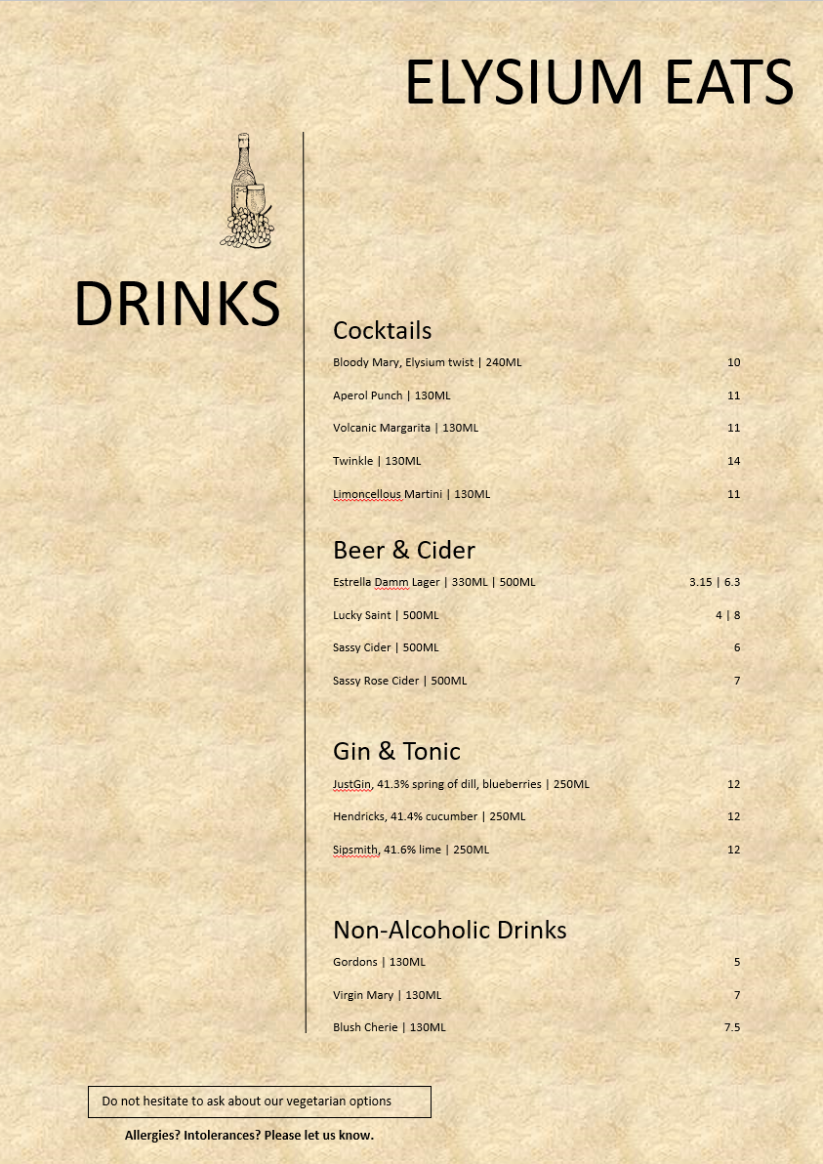

Reference list
Chalak, A., Hassan, H.F., Aoun, P. and Abiad, M.G. (2021). Drivers and Determinants of Food Waste Generation in Restaurants Serving Mediterranean Mezze-Type Cuisine. Sustainability, 13(11), p.6358. doi:https://doi.org/10.3390/su13116358.
Emel Memiş Kocaman and Büşra Meltem Türkmen (2022). The Effects of Use of Restaurant Management Systems Perceived by the Personnel According to Their Demographic Characteristics. IGI Global eBooks, 8(8), pp.256–274. doi:https://doi.org/10.4018/978-1-7998-9008-9.ch012.
Hill, E. and O’Sullivan, T. (2019). Marketing. London: Longman.
Ingrassia, M., Altamore, L., Pietro Columba, Raffermati, S., Giuseppe Lo Grasso, Bacarella, S. and Chironi, S. (2023). Mediterranean Diet, Sustainability, and Tourism—A Study of the Market's Demand and Knowledge. Foods, 12(13), pp.2463–2463. doi:https://doi.org/10.3390/foods12132463.
Juliana, J., Pramezwary, A., Nukak, N.A. and Situmorang, J.M.H. (2021). Using Contribution of Menu Engineering in Upscale Restaurants to Enhance Sales Volume. International Journal of Social and Management Studies, 2(4), pp.1–12. doi:https://doi.org/10.5555/ijosmas.v2i4.45.
Kotler, P. (2019). Principles of marketing. 17th ed. Hoboken: Pearson Higher Education.
Polese, F., Botti, A. and Monda, A. (2022). Value co-creation and data-driven orientation: reflections on restaurant management practices during COVID-19 in Italy. Transforming Government: People, Process and Policy, 16(2), pp.172–184. doi:https://doi.org/10.1108/tg-07-2021-0119.
Roy, D., Spiliotopoulou, E. and de Vries, J. (2022). Restaurant analytics: Emerging practice and research opportunities. Production and Operations Management, 31(10). doi:https://doi.org/10.1111/poms.13809.
Saiki, M., Shimpo, M., Akamatsu, R. and Komatsu, M. (2020). Restaurant menu-planning in Japan: A qualitative analysis. Journal of Foodservice Business Research, 7(6), pp.1–12. doi:https://doi.org/10.1080/15378020.2020.1842113.
Walker, J.R. (2021). The restaurant : from concept to operation. 9th ed. Hoboken, New Jersey: John Wiley & Sons, Inc.

