Reflective log
Disgrifiad byr o’r gweithgaredd (dim mwy na 50 o eiriau
Brief description of the activity (no more than 50 words)
A cooking activity in which the children in the group will assist the lead practitioner in making and decorating cakes. This will include weighing out ingredients, taking turns and using fine motor skills. As all children fall into the age group of 4-5 years, there will be six children in the group to comply with NSPCC (2018) adult to child ratio recommendations.

Nod/Amcan y gweithgaredd Aim/Objective of the activity
The main aim of this activity is to teach the children the different measurements that are involved in making cakes. They will be able to recognise numbers on the weighing scales and gain an understanding of how a weighing scale works. They will also gain an understanding of density and how the size of something does not necessarily result in a larger or smaller weight on the scale. Furthermore, since there are six children in the group, they will have to take turns during this activity and wait for certain parts of the process to be completed before moving on to the next step.
The foundation phase profile focuses on several things, and this activity directly addresses a range of skills included in the foundation phase profile such as oracy skills, measures and units, estimating and checking, fine manipulation, reading and writing numbers and temperature. (beta.gov.wales, 2017)

Eich rôl chi Your role
As the practitioner, my role in this activity is to assist the children in measuring out the ingredients and allowing them to recognise what they need to do to get the measurements right. I will need to allow time for the children to ask questions, but also question them on why they think certain ingredients weigh more even if there is less of it on the scales. I can use Bruner’s theory of scaffolding to recognise what skills the children have already and then use the previous skill set to improve their knowledge.

Agweddau cadarnhaol – pam? Positive aspects – why?
The positive aspects of this activity are that it included many skills the children would need to meet the criteria of the foundation phase profile. The activity provided the children to be independent with the option of asking questions and learning through experience. It built on any skills that the children had previously and exercise their minds by allowing them to think about things that they may have not previously given much consideration to such as, the density of certain ingredients and how mixing different ingredients together changes the structure and consistency of what was in the bowl.
It allowed the children’s oracy skills to be tested as they were asked to explain the processed step by step, they were also asked to explain and read the numbers on the weighing scale and express their opinion on whether they thought the number on the scale matched the numbers on the recipe that we were using. This links to number recognition.

Agweddau heriol – pam? Challenging aspects – why?
The group of children I used were of similar abilities. This meant that there was no opportunity for the children to learn from each other. There was a lack of independent learning from peers though plenty of independent learning available from the activity itself. Also, since there were six children in the group, I found at times it was hard to keep them all engaged while they waited for everyone to have a turn, also the process of weighing and measuring ingredients using the kitchen scales did not provide enough opportunity for all six children to get an enriched experience from it due to time constraints.

Pa wybodaeth arddangoswyd? What knowledge was demonstrated?
The knowledge that was demonstrated was number recognition, weighing and measuring, oracy skills, estimating outcomes. The children also learnt about temperature and how that effects the cooking process.

Pa sgiliau arddangoswyd? What skills were demonstrated?
On reflection, the skills I showed were listening and understanding. I showed patience and provided the children with skills that they will be able to use for many other activities.
Fine motor skills were the most obvious skills that were demonstrated by the children. Handling a knife and spoon, and mixing the ingredients in a bowl.
Pa werthoedd arddangoswyd? Which values were demonstrated?
The values that were shown and demonstrated by the children were equality, fairness, not judging others and their skills, power-sharing and kindness.
In particular power-sharing was the most demonstrated skill, as the children all gained the same experience as one another, they all took turns learning, weighing and measuring.
Beth allai cael ei wneud yn wahanol? Pam?
What could have been done differently? Why?
On reflection, there are many things that could have been done differently during this activity. I will use Gibbs’ reflective model to consider what could have been differently. Gibbs’ model is a six-step process. The first consideration is a description of what happened:
The children were very eager to start the activity, but as we got further in, they found the lots of waiting around to be boring. I also found that it was becoming increasingly difficult for the children to all be involved in the measuring of the ingredients. The next step is how I was feeling – the activity started with me feeling confident but there were times during the activity that I felt that I was losing the children’s interest and I had to work to get it back but not all of the children wanted to be brought back into the activity as they had lost interest.
The next step is what was good and bad:
The good things were that this activity ticked off a lot of boxes in the foundation phase profile, it was an enriching activity that provided the children with a range of opportunities and skills that followed closely alongside what is expected of them at their age. However, it was a long activity with six children which fed into boredom at times which affected the engagement.
The next step is the analysis:
There were maybe too many children in my group. Although the NSPCC suggested six children to one adult, due to the nature of the activity and there not being enough things to do to keep six children engaged I would suggest that a smaller more actively involved group would have been more desirable. Furthermore, the fact the group were all of a similar ability meant that there was no allowance for Vygotsky’s (1934) theory of MKO, however it was easy to apply Bruner’s scaffolding since they were all of the same ability and all had a similar skillset to work with.
The next step is conclusion:
The group is was given was too big, and there was not enough going on to keep every child engaged for the whole process. However, lessons were learned, every child had a clear understanding of the weighing scales and got the concept of density and how big does not always mean heavy.
The next step is action plan:
Given the opportunity to complete this activity again, I will consider using a smaller group so that the tasks that need to be completed are done with full engagement of the children, I will also consider using a mixed ability group to see if Vygotsky’s (1934) theory of more knowledgeable other allows the children more independence during the activity, rather than me taking the lead the children can all help each other with the things they find themselves more confident in.

Personal Development Plan
Area for further development (provide further details) | Why? | How? | Who/Where? | When?
- Knowledge | Become a teacher | Apply for a PGCE | Swansea University | By September 2019
- Knowledge | Look into child protection in the police force | Talk to Sioned, research online, look at qualifications needed. | UWTSD | Ongoing
- Skills | Safeguarding course | Ask Alison when the next course is taking place | UWTSD | Ongoing
- Skills | Paediatric first aid course | Ask Alison when the next course is taking place | UWTSD | Ongoing
- Values | Work on becoming more focused with the task at hand | Improve on my organisational skills to ensure that I am ready to complete tasks with little distractions | Independent | Ongoing
- Values | Be more patient | Challenge my patience more and recognise when I am becoming impatient in certain situations and improve myself | Independent | Ongoing
- Other?

Using reflective practice as a practitioner
Zeichner and Liston (2014) suggest that on the surface, practitioners who are favourable of the reflective practice movement must recognise that practitioners should be involved in the purpose and end of their work, that they should be able to examine their own work and values and they should be able to keep up with reform in education. Reflection also helps to understand the new knowledge of teaching should be available to all people, not just in an educational environment and it is a recognition that practitioners have ideas, beliefs and theories that can be considered to be a contribution to the betterment of teaching for all teachers and practitioners.

Briefing Paper
What is reflection?
Boud, et al. (1989) state that the activity of reflection is familiar to most people, so teachers and practitioners often overlook the process in their formal learning settings. Furthermore, practitioners do not often realise that reflection is even taking place and even more so that when it is being taken place it is working for everyone equally.
Duley (1981) suggests that reflection is a form of experiential learning. He goes on to suggest that the skill of experiential learning where people often struggle is the art of reflection. To fully appreciate the benefits of reflection, practitioners need to acknowledge what reflection is learning involves and how its influence can improve how they learn about themselves.
Similarly, Clarà (2015) argues that reflection is a descriptive notion and it links with the thinking process and gives clarity to an unclear situation. However, in contrast, Postholm (2008) considers reflection as a way to think in a new way or being able to see things from other perspectives and use it to further development.

Critical Thinking
Ennis (2011) suggests that critical thinking is a recognition of all of the critical thinking dispositions. A practitioner will use critical thinking to use imprecision to deduction, to help other areas of judgement. Furthermore, being able to provide a detailed analysis of assumptions and being able to apply an argument-to-best-explanation that is useful in everyday life. Critical thinking also places an emphasis on equivocation and the inclusion of value judgements.
Being able to think critically will allow a reflective practitioner to be clear and precise and take valuable lessons from the process.

Values
Anti-discriminatory, equality and fairness, non-judgemental, power-sharing and kindness are all important values to have as a practitioner. Ghaye (2010) states that describing has been done is a good starting point; after it is good practice to explain why the things that have been done have been done, both to ourselves and anyone else that was involved in the process. Our values play a key role in this process. Being a practitioner means that it is key to think and behave in certain ways and believe in certain things, `what exactly is being offered by means of education to the children in the setting and what the practitioner is capable of. What we do, think, and feel about teaching constitute our sense of professional identity.

Objectivity
To be an effective reflective practitioner it is important to remain objective. Lien, B.YH., Pauleen, D.J., Kuo, YM. et al. (2014) suggests that as well as remaining objective, a practitioner will need to be rational. Furthermore, they suggest that to be rational a practitioner will have an understanding of the experience and context of the task, whereas to be objective a practitioner will have an understanding of the experience on a more personal level.
Lien, B.YH., Pauleen, D.J., Kuo, YM. et al. (2014) go on to say that objectivity means that a practitioner can gain an insight of other people’s viewpoint, and the practitioner can use the practice of bracketing and suspension. Bracketing is a term coined by Edmund Husserl to describe the act of suspending judgement on a holistic scale and focus on the topic at hand.

Models of reflection to consider using
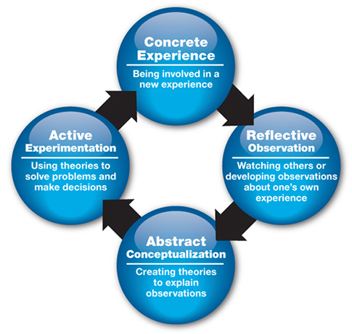
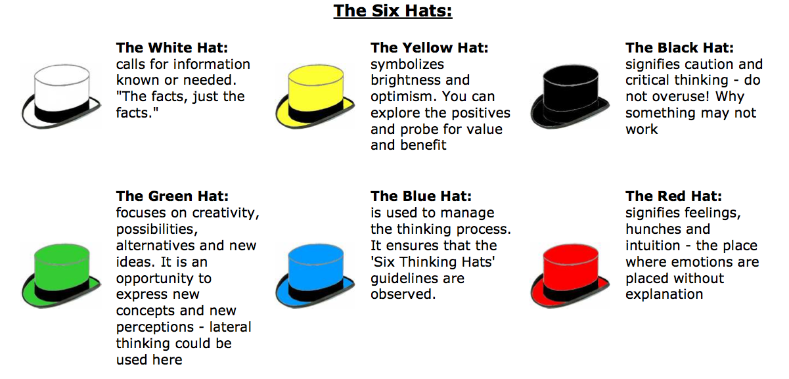

Graduate690.web.fc2.com, (2018) highlandliteracy.com, (no date)
Pektus (2000) describes Kolb (1984) cycle in the four steps. Concrete experience involves the senses and emotions in the activity. Concrete experience will make a practitioner think about their feelings. Reflective observation involves watching, listening, recording, discussing, and elaborating on the experience. This phase is where a person will make connections through experiences. Abstract conceptualisation will allow a practitioner to link theories and concepts into the learning process, and this is where a practitioner will do a lot of thinking. Active experimentation is the doing phase, where a practitioner will try out the activity for themselves and where the basis of reflection is gathered.
DeBono’s (1985) six thinking hat theory states that the main difficulty with thinking is confusion. As practitioners there is often too much to do all at once. Many emotions can often cloud our judgments, including information, logic and creativity crowding in. As a practitioner using this method, the practitioner can be able to separate emotion from logic, creativity from information and so on. This is the concept of the six thinking hats, allowing different emotions and logic to be tackled and understood separately. Putting on any of these hats will change the overall thinking process.
The six thinking hats allow us to call forth what we will and the convenience of the six thinking hats is the main selling point of this theory.

What is good practice?
According to the CIW (2018) the Foundation Phase curriculum has made a significant change from a more formal, competency-based way of learning, and now is designed to meet the needs of all children. The curriculum is designed to meet all children’s needs using a developmental, experiential and play-based approach. Giving children first-hand experiences allows them to develop an understanding of themselves and the world in which they live. By allowing children to learn through play they can experiment, take risks, problem solve and become independent in decision-making as well as making decisions as a group. The seven Areas of Learning identified complement each other and work together to provide a practical, relevant curriculum which develops children’s skills. They are: Personal and social development, well-being and cultural diversity, language, literacy and communication skills, mathematical development, knowledge and understanding of the world, physical development, creative development and welsh language development. CIW.gov.uk, (2018).
PPA (2018) states that good practise in the foundation phase means that the children in a setting learn to explore the world around them and should be given practical activities to learn from. These practical activities should be relevant to their developmental age. Good practice is allowing the children to consider what they have learnt using open-ended questions that make them think about different possibilities.
Wales.ppa.org (2018)

Conclusion
To conclude, reflective practice is essential in keeping up with reforms in education and is key to providing the best care for children in a setting. Mann, Gordon and McLeod (2007) state that the benefit of reflective practice can rely on how much support is given to a practitioner and the timing in which the reflection is being done.

References:
CIW.gov.uk, (2018)
Wales.ppa.org, (2018)

Reference List
Amulya, J. What is reflective practice? MIT paper, available from http://learningforinnovation.com/what%20is%20reflective%20practice.pdf
Boud, D., Keogh, R. and Walker, D. (1985) Promoting reflection in learning: a model. In D. Boud, R. Keogh and D. Walker (eds.) Reflection: turning experience into learning. London: Kogan Page.
Boud, D. and Walker, D. (1998) Promoting reflection in professional courses: the challenge of context. Studies in Higher Education, 23(2), 191-206.
Boud, D. and Fales, A. (1983) Reflective learning: key to learning from experience. Journal of Humanistic Psychology, 23(2), 99-117.
CIW (2018). National Minimum Standards for Regulated Childcare for children up to the age of 12 years. https://careinspectorate.wales/sites/default/files/2018-01/160411regchildcareen.pdf [Accessed: 25th January 2019]
Clarà, M. (2015). What Is Reflection? Looking for Clarity in an Ambiguous Notion. Journal of Teacher Education, 66(3), 261-271.
Dewey, J. (1993) How we think: A restatement of the relation of reflective thinking to the educative process. Heath: Boston.
Duley, J.S. (1981) Field experience education, The Modern American College, San Francisco.

Ennis, R. (2011). Critical Thinking Across the Disciplines, Inquiry, 26(2), 5-19.
Finlay, L. and Gough, B. (2003) Reflexivity: a practical guide for researchers in health and social sciences. Oxford: Blackwell Publishing.
Finlay, L. (2002) Negotiating the swamp: the opportunity and challenge of reflexivity in research practice. Qualitative Research, 2(2), 209-230.
Forrest, M. (2008) On becoming a critically reflective practitioner. Health Information and Libraries Journal, 25(3), 229-232.
Ghaye, T. (2011). Teaching and Learning through Reflective Practice. London: Routledge.

GOV.Wales (2017). Foundation Phase Profile. https://beta.gov.wales/sites/default/files/publications/2018-03/foundation-phase-profile-handbook-revised-september-2017.pdf [Accessed: 24th January 2019]

Husebo, S. and O’Regan, S. (2015) Reflective Practice and Its Role in Simulation. Clinical Simulation in Nursing, 11(8), 368-375.
Husserl, E. (1970). The crisis of European sciences and transcendental phenomenology (D. Carr, Trans). Evanston IL: Northwestern University Press.
Illeris, K and Nordgård, Y. (2012) Læring [Learning]. Gyldendal Akademisk: Oslo.

Johns, C. (2017) Becoming a Reflective Practitioner. (5th ed.) Wiley: Oxford.

Lien, B.YH., Pauleen, D.J., Kuo, YM. et al. (2014). The rationality and objectivity of reflection in phenomenological research, Quality & Quantity, 48(1), 189-196.

Mann, K., Gordon, J. and MacLeod, A. (2007) Reflection and reflective practice in health professions education: a systematic review. Advances in Health Science Education.

Moon, J. (2013) Reflection in learning and professional development: Theory and practice.
Routledge: New York.

Moss, P. and Petrie, P. (2002) From Children’s Services to Children’s Spaces: Public Policy, Children and Childhood. Routledge: London.

NSPCC (2018). Recommended Adult to Child Ratios. https://learning.nspcc.org.uk/research-resources/briefings/recommended-adult-child-ratios-working-with-children/ [Accessed: 24th January 2019]
Pektus, E. (2000). A Theoretical and Practical Framework for Service-Learning in Marketing: Kolb’s Experiential Learning Cycle, Journal of Marketing Education, 22(1), 64-70.
Postholm, M. B. (2008). Teachers developing practice: Reflection as a key activity. Teaching and Teacher Education, 24, 1717-1728.
Schutz, A. (1967) The Phenomenology of the Social World. Northwestern University Press: Evanston.
Tarrant, P. (2012) Reflective Practice and Professional Development. London: Sage.

Wales Pre-school Providers Association. (2017) What is the Foundation Phase?

https://walesppa.org/our-work/foundation-phase/ [Accessed: 25th January 2018]

Zeichner, K. and Liston, D. (1996) Reflective Teaching: An Introduction. Lawrence Erlbaum Associates Publishers.
Zeichner, K. and Liston, D. (2014). Reflective Teaching. New York: Routledge.
Paige-Smith, A. and Craft, A. (2011) Developing Reflective Practice in the Early Years.(2nd ed.) McGraw-Hill: Maidenhead.

