

Student Name:Galla Prasith

Student ID:2543438

Module Name: Marketing Management

Module Code: LCMB7024

Lecturer’s Name:Tushara balendran

Work Count:2869

Term 1

TABLE OF CONTENT

Introduction 3
Background 3
Proposed Brand Extension 4
1.1 Segmentation 4
1.2 Targeting 6
1.3 Differentiation 7
1.4 Positioning 7
2. Marketing Mix (4ps) 8
2.1. Product 9
2.2. Price 9
2.3. Place 10
2.4. Promotion 10
3. Conclusion 11
4. GIBBS Reflection 12
4.1. Description 12
4.2. Feelings 12
4.3. Evaluation 13
4.4. Analysis 13
4.5. Conclusion 13
4.6. Action plan 14
Reference list 15
Appendix 17

STDP and MARKETING MIX

Introduction

Spotify is a multinational online audio streaming service that was established in 2006 by Daniel Ek and Martin Lorentzon in Stockholm, Sweden, and officially launched in 2008. Spotify has changed how digital audio content is consumed through its on-demand provision of music, podcasts, and audiobooks via free and paid subscriptions. Currently, Spotify is the biggest audio streaming subscription service in the world, operating in 184 countries with around 761 million monthly active users and 293 million premium subscribers. Its catalog contains over 100 million songs, 7 million podcast episodes, and 700,000 audiobooks. Spotify's vision is "to bring creativity to the world–one note, one voice, one idea at a time" by connecting its users to the musicians, creators, and authors, as well as offering them a fun and personalized audio experience. Innovation, sustainability, and creator support are increasingly important values for the company(Spotify (2025). About spotify).In this report, a brand extension strategy is designed for Spotify in relation to a product that would be introduced under the current brand of Spotify. The strategy encompasses justification of the need for brand extension, analysis of the STDP strategy, 4Ps marketing mix analysis, and lastly, knowledge and skill acquisition through the design of the sustainable marketing strategy.(Spotify (2025). About spotify).

Background
Spotify was co-founded by Daniel Ek and Martin Lorentzon in Stockholm, Sweden in 2006, with the goal of offering a legitimate solution to music piracy. The music streaming site was officially launched in 2008, with a unique method of music streaming whereby listeners can listen to numerous music tracks instantaneously via the Internet. Its Freemium model, consisting of both a free version supported by advertisements and Premium paid subscriptions, played a critical role in revolutionizing the music industry on a global scale(Spotify (2025). About spotify).

Proposed Brand Extension
Spotify will launch Spotify SoundBar, which is a premium soundbar, for this report. This soundbar is aimed at improving the experience of Spotify consumers in enjoying their music, podcasts, and audiobooks. The soundbar will include the Spotify Connect feature in addition to other advanced technologies like audio personalization by artificial intelligence in order to fit the needs of consumers. In addition to all of the above features, it will be built based on sustainable practices like recyclable materials, technology, packing, and easy repairability.
- STDP Analysis
  - Segmentation

Market Segmentation is a technique in which the market is divided into segments, each segment consisting of consumers having identical needs and similarities. Market segmentation is an important marketing tool because it enables companies to develop appropriate marketing strategies based on knowledge of their consumers. When companies know about the segments with identical needs, they can develop their products to meet those needs.(Alexander Street, n.d.)

Market segmentation using geographic segmentation involves the creation of geographic segments through the use of the geographical location of the customer, which includes their place of residence, distance travelled, and cultural region. Geographic segmentation helps firms to target specific segments in the market by coming up with marketing strategies that address their unique needs and preferences.(Wu et al., 2021). Spotify SoundBar is concerned, geodemographic segmentation should include targeting customers who live in cities and metropolitan areas where technologies for smart homes and high-quality audio devices are popular among residents. Thus, Spotify should target countries that have reached the level of development like the UK, USA, Germany, Canada, Australia, and Japan.

This is the division of a market into sub-markets according to demographic factors such as age, gender, and life cycle. The factors above are used to determine how different needs and buying behavior of customers vary from one group to another.(Gajanova, Nadanyiova and Moravcikova, 2019). The consumers considered would be those that range between ages 25 to 45 years, male and female, with medium to high income status. The potential customers are individuals who are working and studying in universities, as well as people who create content and music lovers who are more willing to buy expensive smart audio products. They fit the stage in life they are at and can afford the product.
Market segmentation using psychographics involves segmenting markets based on consumer’s personality traits, lifestyle, values, interest and psychological attributes. In contrast to demographic segmentation, psychographic segmentation helps to gain a deeper insight into the way consumers’ minds work, their motivations and behaviour patterns.(Pitt, Bal and Plangger, 2020).The Spotify SoundBar is aimed at those people that love music, entertainment, and smart home gadgets. The customers like high-quality sound, convenience, environmental issues, and innovation. Music streaming, movie watching, games, and smart gadgets use are part of their lifestyle. The target customers will be ready to purchase the premium audio solution because it fits well into the Spotify system.

Behavioral Segmentation is the division of market into segments using the basis of behaviors, motivations, attitudes and needs of the consumers. Through behavioral segmentation, companies get to identify consumers with similar behavioral attributes, which enables them to develop product and service offerings to meet their needs.The intended Spotify Soundbar product requires the company to segment its market based on customer behaviors in relation to the usage of audio streaming services and smart technologies. These customer segments include Spotify Premium subscribers, people who listen to a lot of music and podcasts, those looking for an immersive audio experience, and people who have a high sense of loyalty towards the Spotify brand.

Segmentation Variable | Spotify Soundbar Target Market
Geographic | Urban areas in the uk , USA, Germany , Canada, Australia and Japan
Demographic | Adults aged 25-45 , middle to high income , proffessionals, student, content creators
Psychographic | Music lovers, tech enthusiasts, environmentally conscious consumer, smart home users
Behavioural | Spotify premium subsctibers, frequent stremers, loyal coustomers, user seeking premium audio quality
Table 1 : Segmentation
Source : created by the learner

  - Targeting

Targeting strategies involve the assessment of various market segments, followed by the selection of the best ones. These choices are made on grounds such as profitability, availability, growth prospects, and suitability with the organization’s strengths and resources.(Mora Cortez, Clarke and Freytag, 2024).Spotify will employ a differentiated targeting approach for the brand extension of the SoundBar, where they will be targeting more than one customer segment based on the specific needs of each of them. The key target segments for the brand extension will be Spotify Premium subscribers, music lovers, podcasters and audiobooks listeners, people living in smart homes, and eco-friendly customers. While these customer segments all have one thing in common – love for good audio quality, each of them is looking for something different from the product – whether it’s immersive audio, connectivity, or eco-friendliness.

Target segment | Needs
Spotify premium users | High quality audio and seamless spotify integration
Music enthusiastis | Immersive sound and dolby atmos
Podcast & audiobook lisiteners | Clear voice optimization
Smart home users | Integration with alexa, google home, apple home
Environmentally conscious consumers | Sustainable material and energy efficient design

Table 2 : Differentiated targeting
Source : created by learner

  - Differentiation

Product Differentiation is the process of designing a product that is perceived by the consumer as being different from the competitive products in terms of physical or non-physical attributes, including price. Such differences can be real or perceived, and they can be developed via product experience, promotion, and communication.(Dickson and Ginter, 1987) . In case of Spotify SoundBar, the process of differentiation occurs via unique features, which would allow for the differentiation of this device from competing models. The features of Spotify SoundBar include Spotify Connect capability, AI-based sound optimisation according to personal preferences, Dolby Atmos support, special modes for listening to podcasts and audiobooks, as well as sustainable aspects of the product, including use of recycled aluminum, energy-efficient technology, plastic-free packing, and repairability.

  - Positioning

Positioning is the process through which the positioning of an organization's products and images is created so as to be able to create a special place in the mind of the target audience. This is the process of creating unique perceptions of customers through differentiation from competitors.(Kalafatis et al., 2024). In terms of the Spotify SoundBar product being designed, its position in the market would include a high-end and sustainable smart audio speaker with Dolby Atmos audio experience, AI-enabled personalized listening, and Spotify ecosystem integration. As opposed to the existing competitors in this market, including brands like Bose, Sonos, and Sony, Spotify SoundBar sets itself apart by integrating deeply with Spotify streaming service and using sustainable materials in manufacturing the product.

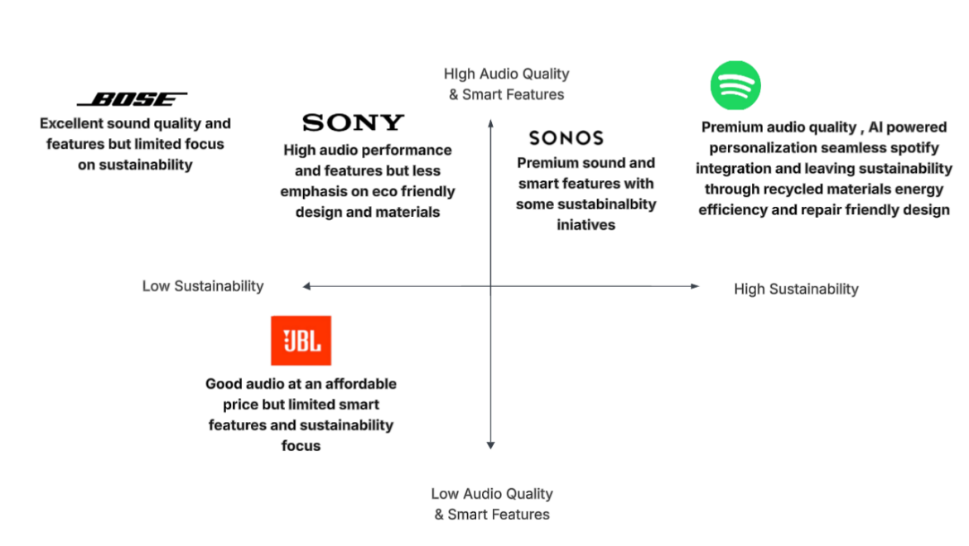
Figure 1 : Positioning map
Source : Created by the learner

Marketing Mix (4ps)
The marketing mix is described by (Wu & Li ,2018) as a business technique that enables companies to implement their marketing strategies through the selection of the product, the price to be charged for the product, the location from which the product is distributed, and finally, the promotion method used to convince customers to buy the products. In social commerce, the traditional marketing mix needs to be expanded to incorporate customer interactions and social media, giving rise to a new marketing mix that includes needs, communication, convenience, and social influence.
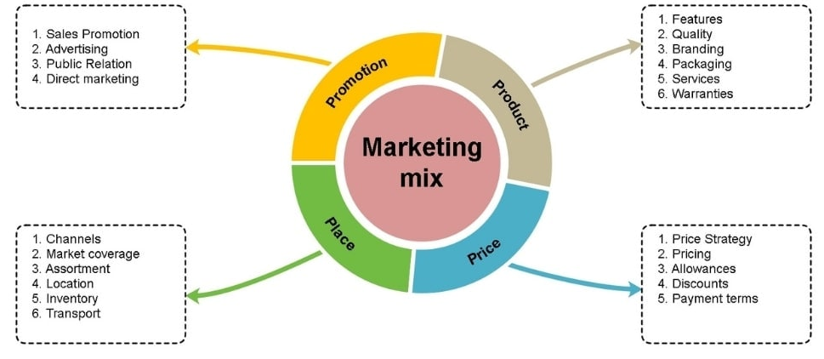
Figure 2 : 4ps
Source : https://share.google/UKAtuuQ6AIHXi3vki

Product

The product has been created by considering customer requirements in its development process. According to Resnick et al. (2016), there is an assertion that a successful product should be developed from the customer's point of view, and in the event of customer collaboration, the development of products should take place. In the same way, the Spotify SoundBar product has been created for the satisfaction of music fans, Spotify Premium users, smart home users, and environmentally friendly individuals through sound excellence and product sustainability.This product is sustainable. The proposed product, called SoundBar, will be made from recycled aluminum and recycled plastics and packed in non-plastic and recyclable packaging. Moreover, the product will have an energy-efficient design that consumes less electricity. What is more, the proposed product will have a modular design which means that the consumers can change components without changing the whole unit.

Price
The term "price" means what customers are willing to pay for a good or service. A good pricing strategy will ensure that the willingness to pay of customers is balanced with the cost of production of the good.(Ramos, 2025).Price skimming strategy will be employed in pricing Spotify’s SoundBar brand extension. Being an innovative smart audio device with advanced capabilities such as Dolby Atmos, artificial intelligence-driven personalized sound, integration with Spotify streaming service, and sustainable material construction, the Spotify SoundBar commands a higher price. The unique value propositions of the SoundBar make it appropriate to charge a higher price. Early adopters, music lovers, and users of Spotify Premium will be attracted to the product due to its superior quality. Spotify can consider lowering prices on the product as it gains more acceptance and competition in the marketplace.

Place
The term place refers to the distribution channels and the places that facilitate the availability of the product to consumers. Efficient distribution ensures convenience and increased market coverage through both physical and virtual channels.(Ramos, 2025). The omnichannel distribution approach will be used by Spotify for the brand extension of its SoundBar. Omnichannel distribution involves both direct distribution from the company's official website and application, and indirect distribution using electronics retail stores like Amazon, Currys, John Lewis, and Best Buy. An omnichannel distribution strategy will provide consumers with an opportunity to access the product using the most convenient channel for them while still maintaining brand consistency. It is in line with the findings of Ramos (2025) who indicates that the use of physical stores together with online retail makes the product more accessible, visible and convenient to the consumer.

Promotion
Integrated Marketing Communications (IMC) is defined as the integration of different marketing communication activities to make a well-organized strategy. In contrast to the fact that IMC is one communication activity, it is considered as a set of integrated activities that work together to build synergy.(Ots and Nyilasy, 2017). The IMC approach that will be used by Spotify includes digital marketing, advertising, sales promotion, direct marketing, public relations, and sponsorship. The digital marketing and advertising would act as the main promotional tools for the company and will include the Spotify app, website, social media channels, YouTube, and advertising to spread awareness about the Spotify SoundBar. Sales promotions that include discount and Spotify Premium subscription will drive trial and adoption. The public relations activities would include the communication of the innovative and sustainable nature of the product through press releases and technology reviews. The sponsorship activities would involve music festivals, artist partnerships, and Spotify Wrapped events. The direct marketing activities will use personalized emails and in-app notifications to drive engagement from existing Spotify users.

Promotional Tool | Use | Why
Digital Marketing | Primary | Spotify is a digital first brand,and its customers are active on digital platforms
Advertising | Primary | Creates awareness for the new spotify soundbar.
Sales Promotion | Supporting | Encourages trail and early adaptation
Public Relations | Supporting | Build credibility and promotes spotifys sustainability initatives
Sponsership | Supporting | Strengthens the connection with music and entertainment.
Direct Marketing | Supporting | Target existing spotify users with personalised offers

Table 3 : Promotion
Source : developed by the learner

Conclusion
Conclusion In summary, a sustainable brand extension plan has been devised for Spotify by way of introducing a product called Spotify SoundBar, which is a premium smart audio device that integrates modern technologies, seamless integration with Spotify, and environmentally friendly product design. This study showed that the proposed product line extension would be consistent with the company's vision and brand identity and cater to the growing consumer demand for innovative and environmentally friendly products. By using the STDP framework, the study found the right target markets, developed the right targeting strategy, and positioned the product as a premium and sustainable smart audio device with competitive advantage. Moreover, the marketing mix that consists of the customer-oriented product, price skimming strategy, omnichannel distribution, and integrated marketing communications (IMC) will make it possible to successfully launch and promote the new product.

GIBBS Reflection

Description
This task entailed the development of a sustainable brand extension strategy for Spotify through the development of the Spotify Soundbar. This task was divided into two major components which were; creating a Canva poster and making a presentation, then preparing a marketing report. This report entailed the use of various marketing concepts such as STDP analysis and Marketing mix (4Ps) to support the proposed brand extension. I carried out research from journals and other industry sources, applied various marketing concepts, and gave recommendations on how to launch the product.

Feelings
In the early stages of the assignment, I was motivated to develop a sustainable brand extension for Spotify since it enabled me to use marketing principles in relation to an actual company. At the same time, I was challenged when choosing appropriate academic resources and determining the marketing methods to be used in relation to the product. Throughout the process, I became more confident in using the marketing principles and designing a professional poster. The completion of the report brought about feelings of accomplishment since I was able to incorporate both theory and practice.

Evaluation
All in all, this task was quite a beneficial learning process. One of the strong sides of my work was the successful use of the marketing concepts such as STDP and Marketing Mix in order to create a realistic and sustainable brand extension plan. The design of Canva poster also helped me to be able to represent marketing data visually and professionally. But one of the difficulties in this case was the evaluation of various academic sources in order to find out what sources should be used to support each part of the report. Another difficulty was that of managing time during working on both tasks.

Analysis
This assignment has contributed greatly towards increasing my knowledge about strategic marketing and branding. The process of conducting the STDP analysis helped me develop my skill of segmenting the market, analyzing opportunities in the market, and positioning the product. The use of the Marketing Mix concept helped me learn about how product, price, place, and promotion are interrelated in creating value for customers. Moreover, the process of analyzing academic journals provided me with an insight into the importance of conducting research on various perspectives of marketing in order to choose the best possible marketing strategies.

Conclusion
All in all, this project has improved not only my academic knowledge but also my professional competencies. I have learned how to conduct more effective research, analyze data, communicate with people, write academic papers, use creativity, create designs using technology, and make presentations. All these competencies are very valuable in the marketing, brand management, and business consulting professions as professionals need to analyze markets, create marketing strategies, communicate their ideas, and make decisions based on facts.

Action plan
Future projects will enable me to refine my public speaking abilities through more regular presentations and building my confidence when responding to any audience queries. In addition, I will enhance my analytical abilities by acquiring the skillsets of marketing analytics software such as Google Analytics and Power BI that can be used to make marketing decisions based on numerical analysis. Additionally, I will work towards becoming better versed in the area of digital marketing by getting more exposure to social media marketing, SEO, and content marketing techniques.
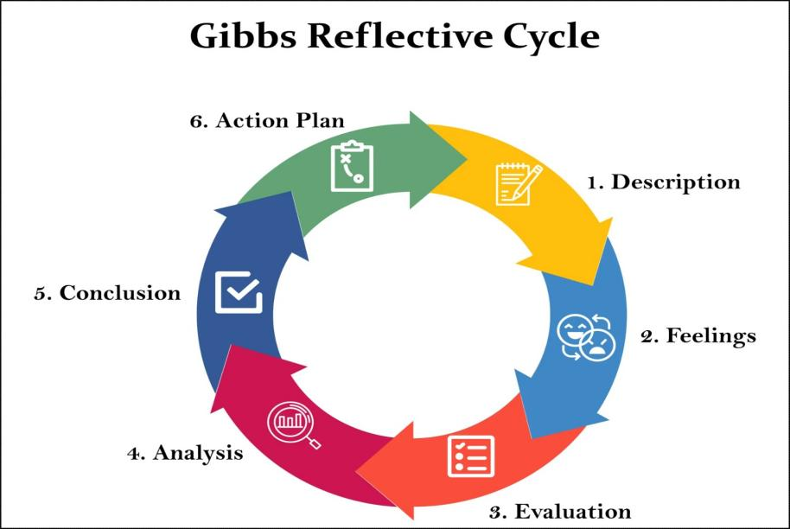
Figure 3 : GIBBS Refelction
Source : (McLeod, 2025)

Reference list
- Alexanderstreet.com. (2021). What is Market Segmentation. (2021). [online] Available at: https://video.alexanderstreet.com/watch/what-is-market-segmentation [Accessed 23 July 2026].
- Dickson, P.R. and Ginter, J.L. (1987). Market segmentation, product differentiation, and marketing strategy. Journal of Marketing, [online] 51(2), pp.1–10. doi:10.2307/1251125.
- Festa, G., Cuomo, M.T., Metallo, G. and Festa, A. (2016). The (r)evolution of wine marketing mix: From the 4ps to the 4es. Journal of Business research, 69(5), pp.1550–1555. doi:10.1016/j.jbusres.2015.10.015.
- Gajanova, L., Nadanyiova, M. and Moravcikova, D. (2019). The use of Demographic and psychographic segmentation to creating marketing strategy of Brand loyalty. Scientific annals of economics and business, 66(1), pp.65–84. doi:10.2478/saeb-2019-0005.
- Kalafatis, S.P., Blankson, C., Boatswain, M.L. and Tsogas, M.H. (2024). Positioning strategies in B2B marketing: The regulatory focus orientation. Journal of Business-to-Business marketing, 2025, VOL. 32, NO. 4, 425–461 (1051–712X), pp.1–37. doi:10.1080/1051712x.2024.2411455.
- Keller, K.L. (2016). Unlocking the power of integrated marketing communications: How integrated is your IMC program? Journal of Advertising, 45(3), pp.286–301. doi:10.1080/00913367.2016.1204967.
- Mora Cortez, R., Clarke, A.H. and Freytag, P.V. (2024). B2B market segmentation – an analysis of current practices and their implications. Journal of Business research, [online] 189(115114). doi:10.1016/j.jbusres.2024.115144.
- Ots, M. and Nyilasy, G. (2017). Just doing it: Theorising integrated marketing communications (IMC) practices. European journal of Marketing, [online] 51(3), pp.490–510. doi:10.1108/ejm-08-2015-0595.
- Pitt, C.S., Bal, A.S. and Plangger, K. (2020). New approaches to Psychographic consumer segmentation. European journal of Marketing, 54(2). doi:10.1108/ejm-01-2019-0083.
- Ramos, J.K. De G. (2025). The effectiveness of the marketing mix used by Penshoppe in terms of product, price, place, and promotion: A literature review. Jpair multidisciplinary research, 62(1), pp.77–92. doi:10.7719/jpair.v62i1.958.
- Resnick, S.M., Cheng, R., Simpson, M. and Lourenço, F. (2016). Marketing in SMEs: A “4ps” self-branding model. International journal of Entrepreneurial behavior & research, 22(1), pp.155–174. doi:10.1108/ijebr-07-2014-0139.
- Spotify (2025). About spotify. [online] Spotify. Spotify. Available at: https://newsroom.spotify.com/company-info/ [Accessed 19 July 2026].
- Wu, M., Jiang, C., Zhang, Y., Cao, J., Cheng, Y. and Liu, Y. (2021). Culture vs. distance: Comparing the effects of geographic segmentation variables on tourists’ destination images based on social media data. Computational urban science, 1(1). doi:10.1007/s43762-021-00012-z.
- Wu, Y.-L. and Li, E.Y. (2018). Marketing mix, customer value, and customer loyalty in social commerce. Internet research, 28(1), pp.74–104. doi:10.1108/intr-08-2016-0250.
- McLeod, S. (2025). Gibbs reflective cycle. [online] Simply Psychology. Available at: https://www.simplypsychology.org/gibbs-reflective-cycle.html [Accessed 7 Aug. 2026].

Appendix


