

BA International Hotel Management

Cultural Awareness
assignment

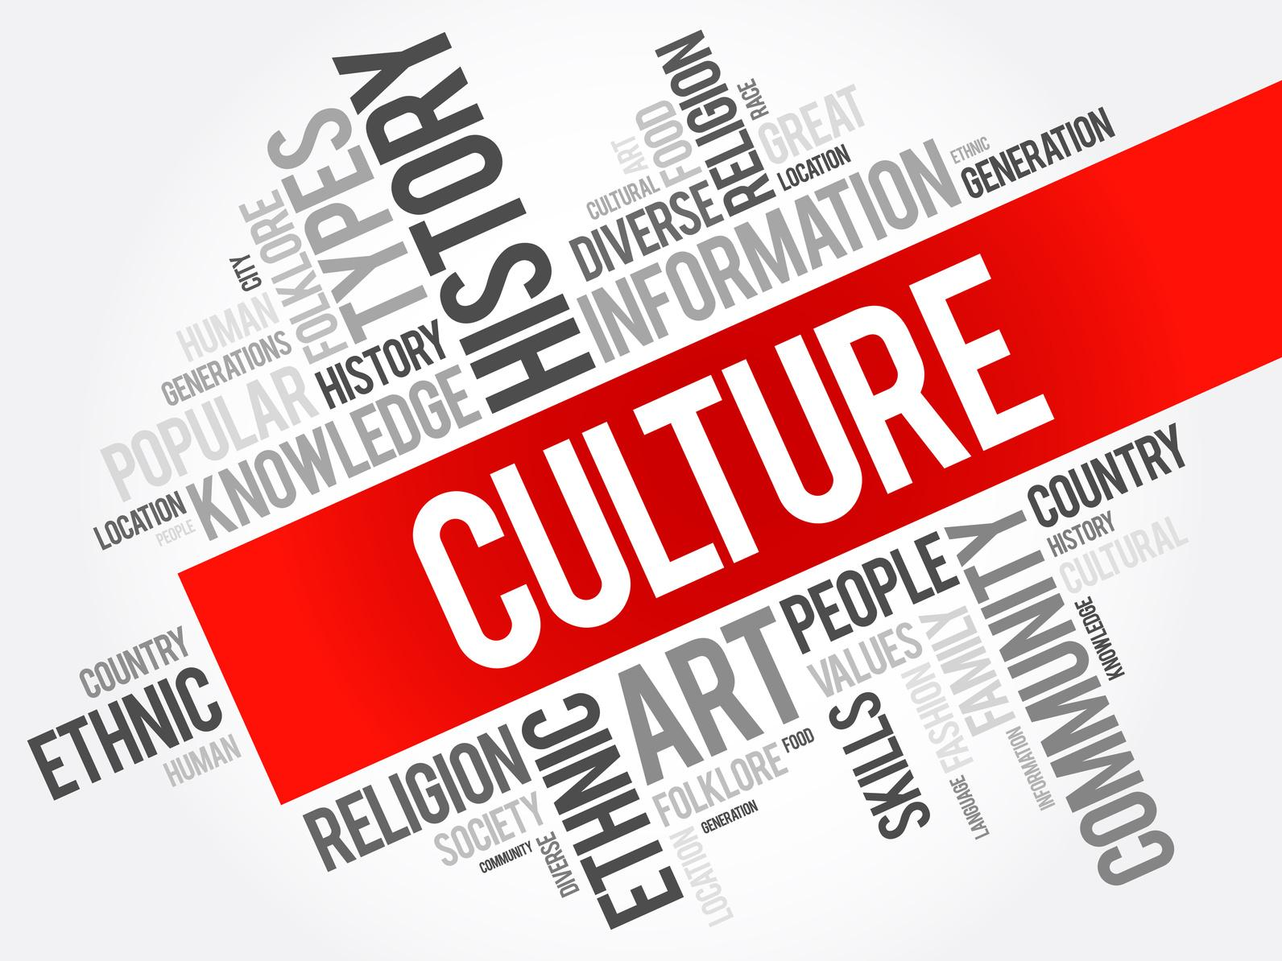

Module: M5X01923 Student: Vasvie Redzheb
Lecturer: Olubukola Adegbite Student number: 1909618

1
Content page

Executive summery……………………………………………………………3
Introduction………………………………………………………………………3
Hospitality industry and culture…………………………………………3
The purpose of the service…………………………………………………4
Cultural dimensions- guests and associates……………………….4
Turkey- Turks…………………………………………………………………….5
Bulgaria-Bulgarians……………………………………………………………6
Germany-Germans……………………………………………………………7
United Kingdom-Brits……………………………………………………….7
Russia-Russians…………………………………………………………………8
China-Chinese…………………………………………………………………..9
Conclusion……………………………………………………………………….10
References………………………………………………………………….11,12

2

Executive summery

Tourism industry, unlikely to others, is a combined industry and is represented by four main sectors- hospitality, transportation, retail and destination which is mainly entertainment and leisure driven. Travel and tourism contribute approximately 9.25 trillion USD to Global GDP (Gross Domestic Product) in 2019. (statista.com)
Considering the capacity of this service orientated sector where switching to automatic workforce is not an option, turn this industry to one of the biggest employment opportunities provider.
The main purpose of travelling and using the hospitality is the thirst of people to see new places and explore new cultures. By taking into account this fact, all management operators need to consider the importance of the cultural awareness between its associates not only towards the guest but also to each other in order to work in harmony avoiding discrimination in diverse environment.

Introduction

Hospitality industry is highly competitive market. Providing and selling service is very difficult nowadays due to overcrowded marketplace. As part of the Tourism industry, hospitality is provider of accommodation and food and beverage services and form the main segment of this sector. The industry itself has unique and diverse character with not only one purpose. This is the only sector with such a multifarious nature and pattern.
The aim of this assignment is to create an Aide Memoire, which will be used as a guide from all hotel associates in Eastern Europe. It also will assist them in their relation, behaviour and conduct toward international guest and colleagues. It will also dissect and examine the different cultures from those countries which are most likely to choose this part of Europe for their holiday destination.

Hospitality industry and culture

Briefly, culture is the characteristics and information of specific gather of individuals, including dialect, religion, social behaviour, art and music.

Working in a globally spread industry means not only servicing people from different places and cultures but also sharing the working environment with people from different ethnicity, background, nationality and a culture.
Those organizations are multi-cultural, multi-national centres, where being culturally educated is a must in order to tolerate, understand and treat in the right way each other.
Here comes the importance of the communication and being able to make a good connection with the opposite side- whether a guest or member of staff. Nowadays, improved inter-cultural communication is a key factor of establishing and upgrading the quality of the service. According to Gudykunst, (1987), intercultural communication is explained as a” involving interpersonal communication between people from different socio-cultural system and/or communication between different subsystem (e.g. ethic or
3
racial group) within the same socio-cultural system”. The main component of communication is language and language also influenced and formed via the culture. Therefore, culture is the backbone of the language and both are inextricably linked-

language is both an integral part of the construction of the culture and the way culture is expressed (Agar.1994 & Kramsch,1993). Hospitality sector is service orientated where productivity depends on the associates tolerated and rich communication skills. Considering that, managing and operating effectively hotels’ multicultural human resources is a vital.
For example, language teachers are the link between the individual with its own cultural values and etiquettes, and the new language and its new cultural approaches. The teachers are so called “cultural workers” (Giroux, 2005, p.71) who try to socialize and adapt the students to the new linguistics via helping them to evolve the intercultural and social connections with it.
Summarized, working in a globally spread industry as a hospitality, bring the need of speaking different languages, which lead to the conclusion that if someone is bilingual means that he is intercultural person-knows more that his own “habitat”.

The purpose of the service

The Oxford Learners Dictionary consist 16 (sixteen) definition for service. The term which is used in hospitality sector for service identification is a business or a person whose work involves doing something for customers but not producing goods; the work such a business does. (Oxford Learners Dictionary).
There is a ‘genetic’ link between hospitality and service. This industry is fully represented by the provided service. Selling service via already manufactured goods is the main aim of this sector.

Cultural dimensions- guests and associates

Proving a quality product- the service- is not something that depends only from the provider itself. As in all kind of business, success lean on well and effective operation, corporation and communication within the team.
Each guest, or a visitor is different and unique and has its own understanding and accepting behaviour shaped by its cultural dimensions. That is the reason why each one of them should be treated individually and should take under consideration that all of them has their personalized criteria and expectations.
For sure, not all the visitors can be fully satisfied. But even in this scenario, everyone should receive the same attention and care. It is not possible to know the person in front from the first sight- but if the service giver is well cultural educated, he can have the idea of how to act and serve different types of people. For example, Japanese people don’t like close contact or shaking hands, Germans don’t like personal questions; opposite of that Turkish people are very warm and social and like close contact- knowing all these, in first sight details, can help the employees to give the right type of greeting or service to the right person and avoid disappointed guest feedbacks.

4

Turkish culture- Turks- Merhaba

Turkey pass through many major changes in last century. Today, Turkey is the only land where extreme Eastern and modern Western live in balance and tolerance together. The Ottoman Empire and strategic geographical location, this region has very rich historical background. Mustafa Kemal Ataturk is a national hero, who convert and designed the Republic of Turkey into modern, Westernize, nation-state via rebuilding a new political, religious, social, economic reforms in 1923.
Turkey is packed with cultural heritage and own 13 spots inscribed on UNESCO’s World Heritage sites, and it is the world’s most visited 6th country.
Some of the interesting facts about this culture is that they are very warm people and open their home’s door to everyone in need, share their food and gives presents. They are very emotional nation and can cry easily for everything and overreacting. If someone sneeze outside people around tells “cok yasa”- or live long even if they don’t know the person.
Oil wrestling is a national sport.
When greeting and meeting they always kiss or touch both cheeks.
Very traditional lifestyle and respectful toward elder people.
Nazar or blue eye is believed that protects from evil and jealous glance and it’s in every house door or entance.
Turks drink a lot of tea- traditional Turkish tea and coffee- even when you go for shopping, barber shops they always serve a tea in order to welcome you.

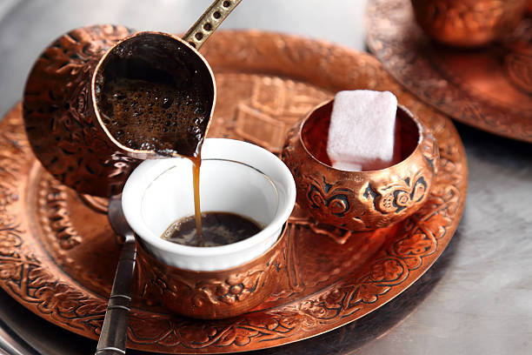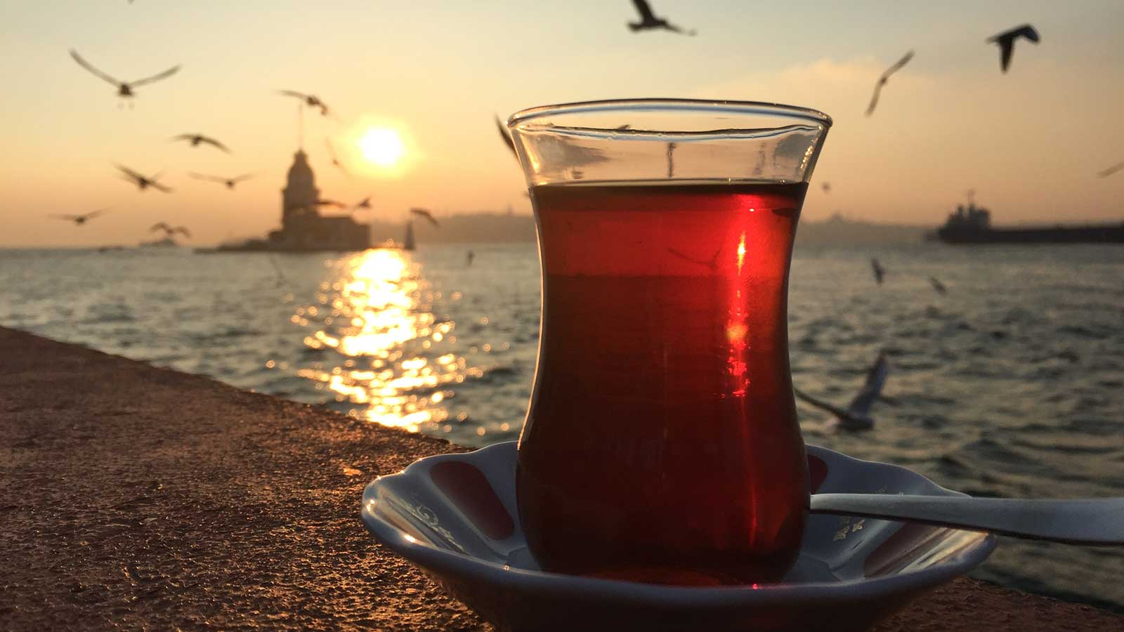

Turkish cuisine is very rich and also famous all around the world.
Most of the dishes have very intense and rich of spices tastes- Kebabs, Baklava, Dolma, Manti, Lahmacun
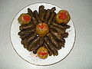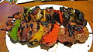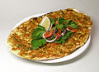

Dolma Kebab Baklava Lahmacun
5

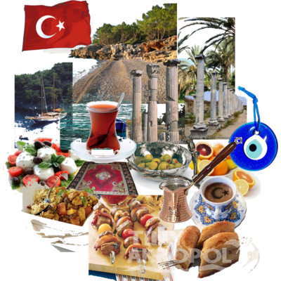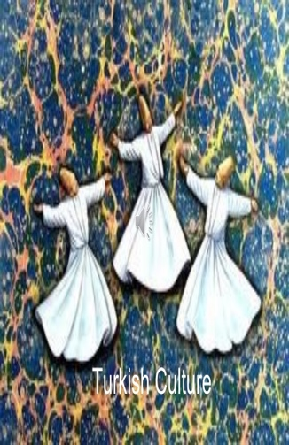
Famous Salt Bae is TURK

Bulgaria and Bulgarians- Здравейте

Bulgaria is the oldest country in the world founded in 681 and still exist. Bulgarian culture is blend and mixed from Thracians, Slavic and Bulgar traditions. Bulgaria witnessed Roman. Ottoman and Persian regimes. Bulgaria is the second richest of natural springs country in Europe and also here are found world’s oldest golden treasure- Thracian treasure.
Bulgaria is famous with its Rose valleys,
Bulgarians are warm but reserved people, not so open about their private and finances.
Unexplained fact is that when all the world shake heads to say No- Bulgarians shake head to say Yes and nod for No. They celebrate their name days and pay all the bill in the restaurant on their birthdays.
The most famous part of the Bulgarian cuisine is the yogurt where in 1905 a live bacillus founded by Stamen Grigorov and thanks to that lactobacillus Bulgaricus natural yogurt exist nowadays.
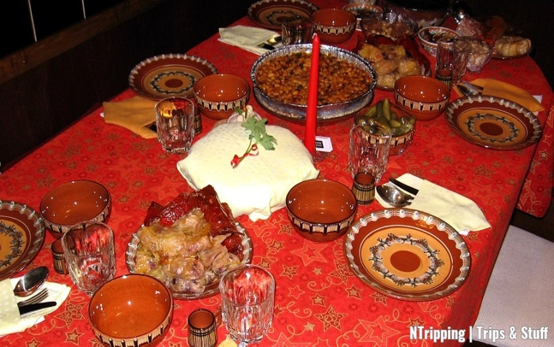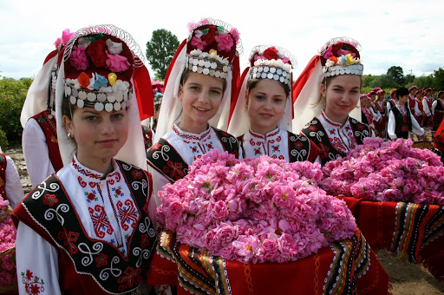

6


Hristo Stoickov- Bulgarian most famous footballer win Golden ball in 1994

Germany and Germans- Hallo
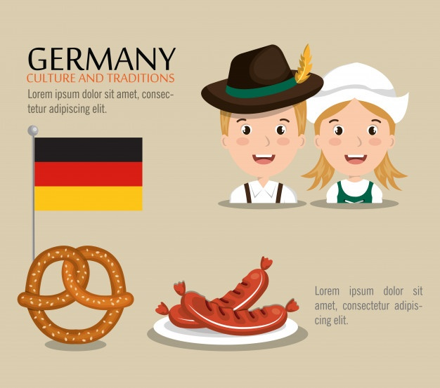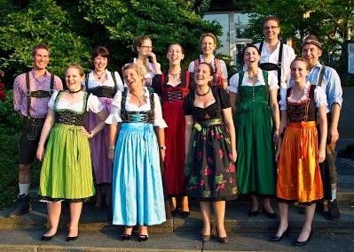

Germany is a unique country with key role in Europe’s history. They are true followers of the Roman Empire and are one of the strongest economies in the world.
Germans are cold and respect their own and others privacy. They are not very open nation and don’t make a lot of friends. Germans have highly planned and organized lifestyle and don’t like to talk about their financial position. They like to drink beer, especially in October when they celebrate the Octoberfest. Shaking hand and greet them in respectful way is what they preferred-short and polite.

United Kingdom and Brits- Hello

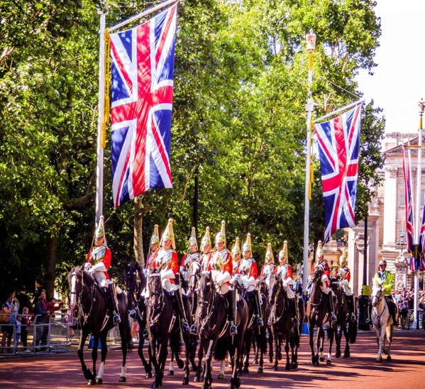

Generally, Brits are very social culture. The reason for that can be the language itself as English is an international language, so they can communicate with mostly everyone everywhere easily. Being able to connect and speak gives an extra confidence to the people, in general. British history is very rich and intense, full of ups and downs but still is a
7
Monarchy with the longest reigned Queen in the world- Queen Elizabeth II (1952-present).
Tea is the most popular drink among Brits, and they have certain times to drink it. Brits like the word-Sorry and even when they pass you and touch you slightly, they say sorry or apologize. Beside of that they are true nationalists and mostly follow the rules and laws, but the youth is very noisy and laud. The family connections are not so bound and when the kids grew up they need to look after their selves-most of their parents sell their houses once they retired and go on vacations in order to teach a lesson to their kids that they need to work hard and get what they want-nothing is gifted. Brits like to shake hands, kiss chicks and hug. Body language is very important for them because this show respect and appreciation. They are not afraid from getting close with others. They are reserved but not closed, especially those who live in big cities like London. Traditional breakfast for them is The Traditional British breakfast which includes- medium fried eggs, sausage, beans, bacon, mushrooms and tomatoes. Another traditional British food is fish and chips, roast beef, tode in the hole and Shepherd’s pie.
Another interesting fact about them is that they can ask how are you, are you ok, is that fine just with one word- Alright?

Russia and Russians- Привет

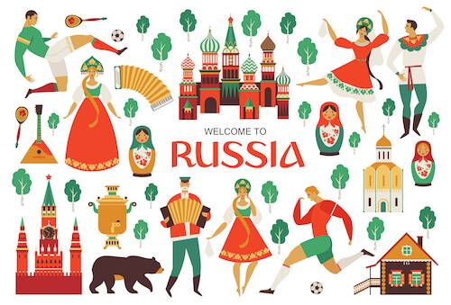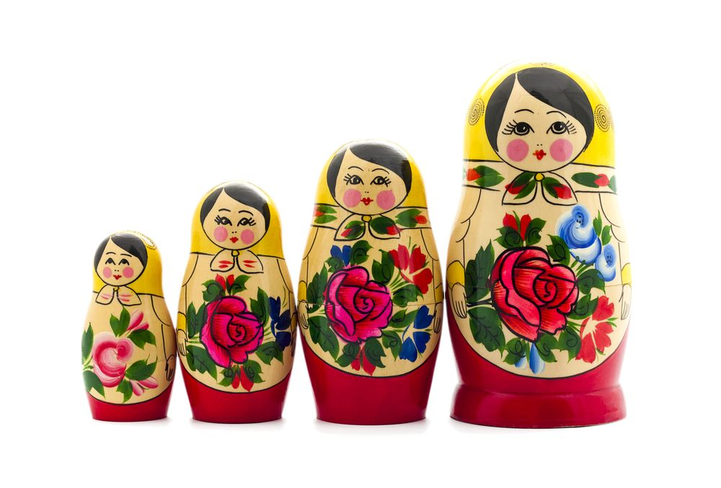
Russia is the biggest country in the world. Beside that fact travelling there is not very easy. The mindset is not very widely open there and most of them are cold as the weather there.
They like to drink vodka and also to have fun while parting. The lack of nice and warm beaches pushes them to travel a lot and buy holiday properties in countries like Bulgaria and Turkey-both places are preferable holiday destinations for them. Russians are friendly people and pay a lot of attention to their families and country. This nation is quite direct and if a Russian want to acquainted with someone he goes straight and ask directly- Davajtye poznacomimsya!- Let’s get acquainted- there is no random way of doing that. Also do not smile while travelling on public transport or greed a stranger with a smile- this can bring you quite unpleasant reactions as Russians are also very tempered and aggressive sometimes. Lunch is the most important meal of the day and the traditional lunch course consist a salad, soup and meat dish then drink and dessert- so much food for one time. So hotels and restaurants which Russians visit for a lunch need to be packed well.

8

China and Chinese- Ni hao
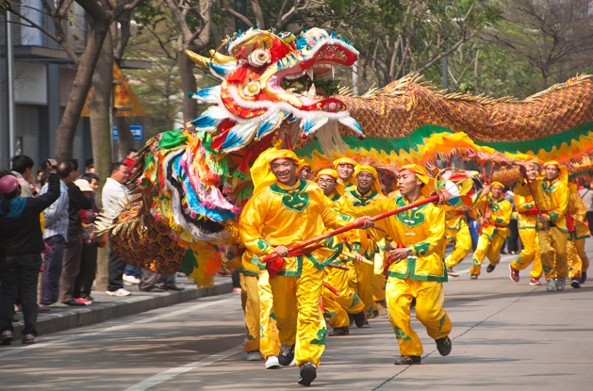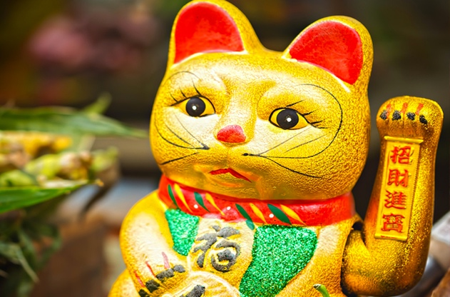

Chinese people are very polite and warm people. They are family orientated but do not put so much attention on the sizes of the places where they live, personal space is not an issue for them. As a culture they are very open to the world- open to take but close to give information out. Chinese people don’t use What supp or PayPal- they have their own social media. They believe to the luck of the numbers and number four and eight are unlucky and even avoid them in their telephone numbers. The lucky number is 6. They are true to their deep traditions and the food and cooking is very important for them. Despite the fact that Chinese people can invent and duplicate everything original, they also prioritize the health and still believe in traditional and old methods to recover and heal. They don’t like conversation for their outlook, body weight or skin tone with people not so close to them.
Chinese people like to travel in small groups or with few family members.

Do’s and Don’t | Greetings | Talking for private life | Use body language while talking | Compliment and smile | Handshake | Call by the name
Turkish | DO | DO | DO | DO | DO | DO
Bulgarians | DO | DON’T | DO | DO | DO | DO
Germans | DO | DON’T | DON’T | DON’T | DO | DON’T
Russians | DO | DON’T | DO | DON’T | DO | DO
Brits | DO | DO | DO | DO | DO | DO
Chinese | DO | DON’T | DON’T | DO | DON’T | DON’T

9

Conclusion

The components of the cultural dimensions need to be measured and practiced with empathy, sensitivity and adaptivity in order to avoid misunderstanding. Due to the growing hotel and hospitality industry as general, the demand for intercultural awareness as a subject also grow. That is the reason why, the directors need to make sure that they provide with proper training and information their associates toward different types of guests in the way to maintain a good relation and connection. Understanding distinctive societies will help and improve the service.

10

References:
Books:
Agar, M. (1994). Language shock: The culture in everyday conversation. New York, NY: Morrow

Giroux, H. A. (2005). Border crossing: Cultural workers and the politics of education (2nded.). New York, NY: Routledge

Gudykunst, W. B. (1987). Cross-cultural comparisons. In C. Berger & S. Chaffee (Eds.), Handbook of Communication Science. Beverly Hills, CA: Sage

Kramsch, C. (1993). Context and culture in Language teaching. Oxford, UK: Oxford University Press

Journals:
Kidwell, T., 2017. Understanding Culture: A Literature Review Comparing Three Cultural Pedagogies. Register Journal, 10(2), p.221.

Oktadiana, H. and Djauhar, R., 2011. The Importance of Understanding Cultural Awareness for Managers in the Hospitality Industry (in Indonesia). Binus Business Review, 2(1), p.230.

Toegepaste Taalwetenschap in Artikelen, 1995. From 'Language Awareness' To 'Cultural Awareness'?. 51, pp.49-64.

Websites:
Advance-he.ac.uk. 2020. Resource Guide: Cultural Awareness For Hospitality And Tourism | Advance HE. [online] Available at: <https://www.advance-he.ac.uk/knowledge-hub/resource-guide-cultural-awareness-hospitality-and-tourism> [Accessed 29 August 2020].

Collinsdictionary.com. 2020. Cultural Awareness Definition And Meaning | Collins English Dictionary. [online] Available at: <https://www.collinsdictionary.com/dictionary/english/cultural-awareness> [Accessed 29 August 2020].

Insights. 2020. The Benefits Of Cultural Diversity In Hospitality - Insights. [online] Available at: <https://insights.ehotelier.com/insights/2016/04/19/benefits-cultural-diversity-hospitality/> [Accessed 29 August 2020].

Matador Network. 2020. 17 Facts About Turkey That Will Surprise You. [online] Available at: <https://matadornetwork.com/notebook/17-facts-turkey-will-surprise/> [Accessed 29 August 2020].
11
Oxfordlearnersdictionaries.com. 2020. Oxford Learner's Dictionaries | Find Definitions, Translations, And Grammar Explanations At Oxford Learner's Dictionaries. [online] Available at: <https://www.oxfordlearnersdictionaries.com/> [Accessed 4 September 2020].

Statista. 2020. Travel & Tourism: Global Economic Impact 2006-2019 | Statista. [online] Available at: <https://www.statista.com/statistics/233223/travel-and-tourism--total-economic-contribution-worldwide/> [Accessed 1 September 2020].

12

