
\

Module name: Changemakers: Building your Personal Brand for Sustainable Employment
Module code: BMHP5015
Student name: Ana-Maria Melinda Avram
Student ID: 2415593
Component 1
Lecturer name: Caroline Salami
Table of Contents
Introduction 2
Reflection on Unit 1: Brand You 2
Screenshot 1: 3
Screenshot 2: 3
Screenshot 3: 3
Reflection on Week 2: It's a Small World 3
Screenshot 1: 4
Screenshot 2: 4
Screenshot 3: 4
Reflection on Unit 3: Opportunity Knocks 4
Screenshot 1: 5
Screenshot 2: 5
Screenshot 3: 5
Reflection on Unit 4: 5
Screenshots 6
Conclusion 6
Reference List 7

Introduction
In the Changemakers: Building Your Brand for Sustainable Employment module, I have gained a lot of knowledge and skills which have further helped me in my personal and professional development in the field of health and social care. This is a reflection activity that will reflect on the learning for each of the four units of this module: Brand You, It's a Small World, Opportunity Knocks and Happiness. All of the units have helped to build my knowledge around personal branding, cultural awareness, career opportunities, networking, resilience and wellbeing, which are all vital to my future and development as an effective health and social care professional. In the process of this reflection, I critically analyse the impact of the lectures, activities in class and independent learning on my attitudes, skills and future career aspirations. In addition, I draw on relevant models and theories in the academic field to show how reflective learning has supported my own learning and development as a professional. Overall, this assignment has enabled me to develop a better personal brand, an awareness of the importance of world connections, an awareness of career opportunities and the need to maintain my wellbeing to ensure sustainable employment in the health and social care sector.

Reflection on Unit 1: Brand You
In Unit 1, we explored the idea of Brand You and the value of ambition, self-awareness, goal setting, motivation and having a professional identity. I found the lectures to be stimulating and prompted me to think about my own values, my career goals and the skills needed to be an effective health and social care worker. Found out how to create a personal brand, what makes me tick, and how to put my best foot forward when it comes to the next job. A key take-away from this unit is the realisation that developing a professional identity is important and can only be done with self-awareness. Here I was able to think about my aims for my career and what strengths I have that could be applied to the health and social care sector during the lectures and Moodle activities. I felt that my ability to communicate, have empathy for others and support them is an attribute that I can build on my personal brand. The activities got me to consider the future of my career and not just a degree. Also, the discussions of ambition turned my mind. I learned that ambition is more than just a desire for success; it is a drive that gives one the impetus to overcome challenges and move forward despite obstacles. The lectures proved that ambition enhances resilience and makes people strive for goals in their careers.
The unit has enabled me to gain insight into goal setting. In class, we had a discussion and activities online to create a career plan by identifying what I want to do and what steps I would need to take to get there. The 3-step goal setting process made me think about a future career and what I must be thinking about in order to further develop my career with knowledge, experience and qualifications. The learning was also well tied in to Pink's Theory of Autonomy, Mastery and Purpose (Lane and Roberts, 2022). I knew that employees are more inclined to get enthusiastic about their career decisions (autonomy), always have the chance to improve their skill sets (mastery), and have a sense of purpose in their work. This system made me realise that career success is more about working for oneself and not for the reward. I also related my learning to Johari's Window (Luft and Ingham, 1955), which states that increasing awareness of self with feedback will enable people to be aware of their strengths and areas of development. The reflection on the abilities in the classroom allowed me to pinpoint the abilities which I need to develop and gain confidence in my existing skills.

Screenshot1: 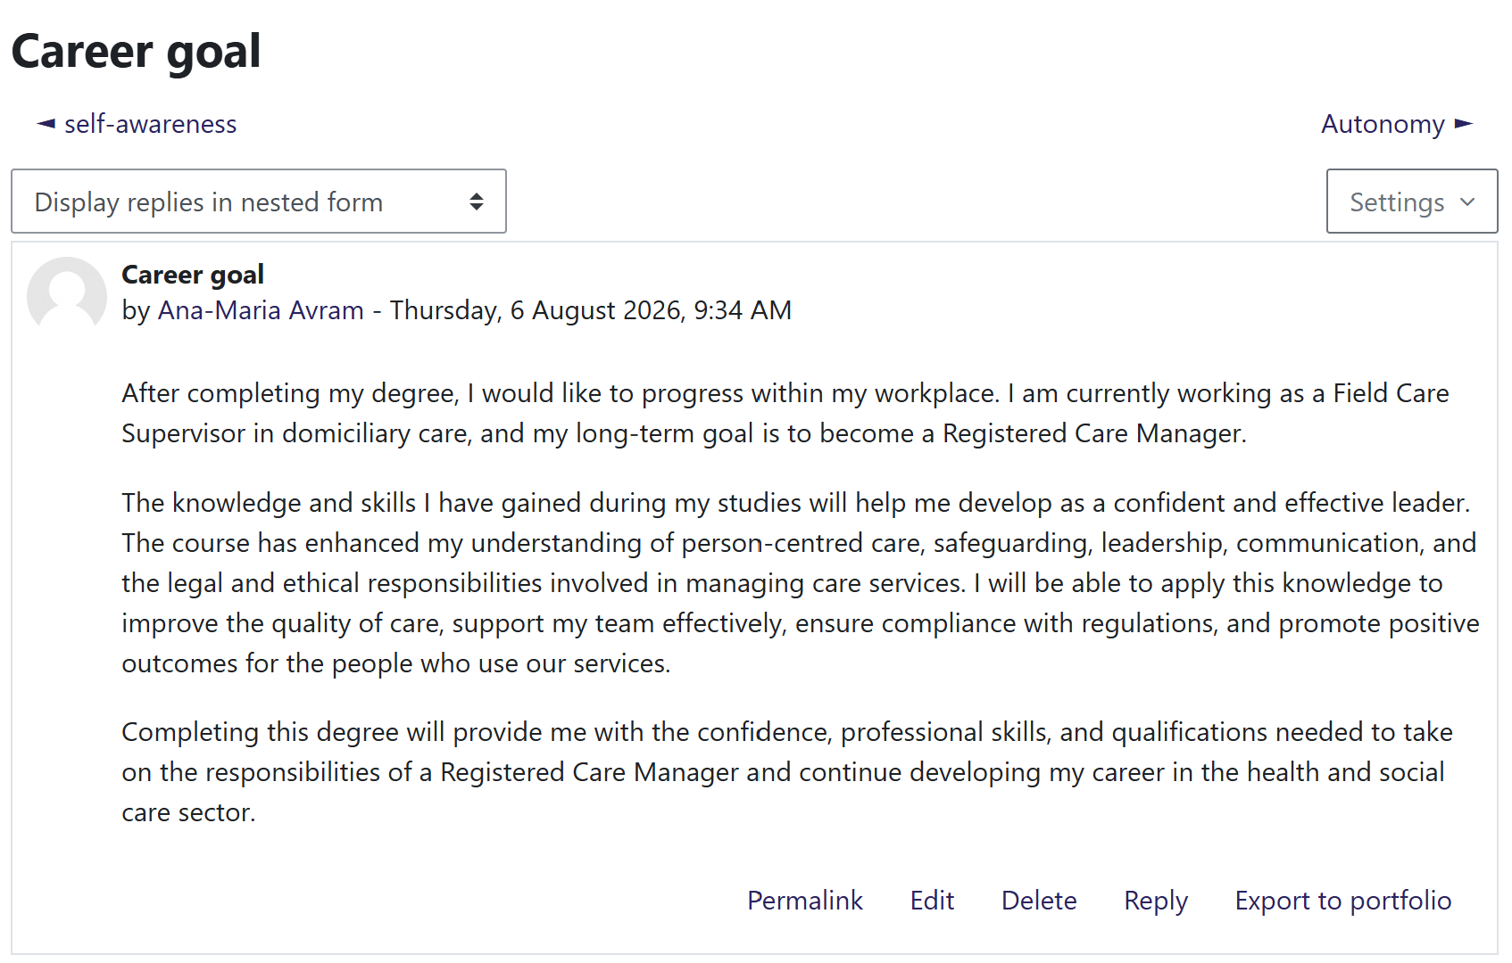

Screenshot2: 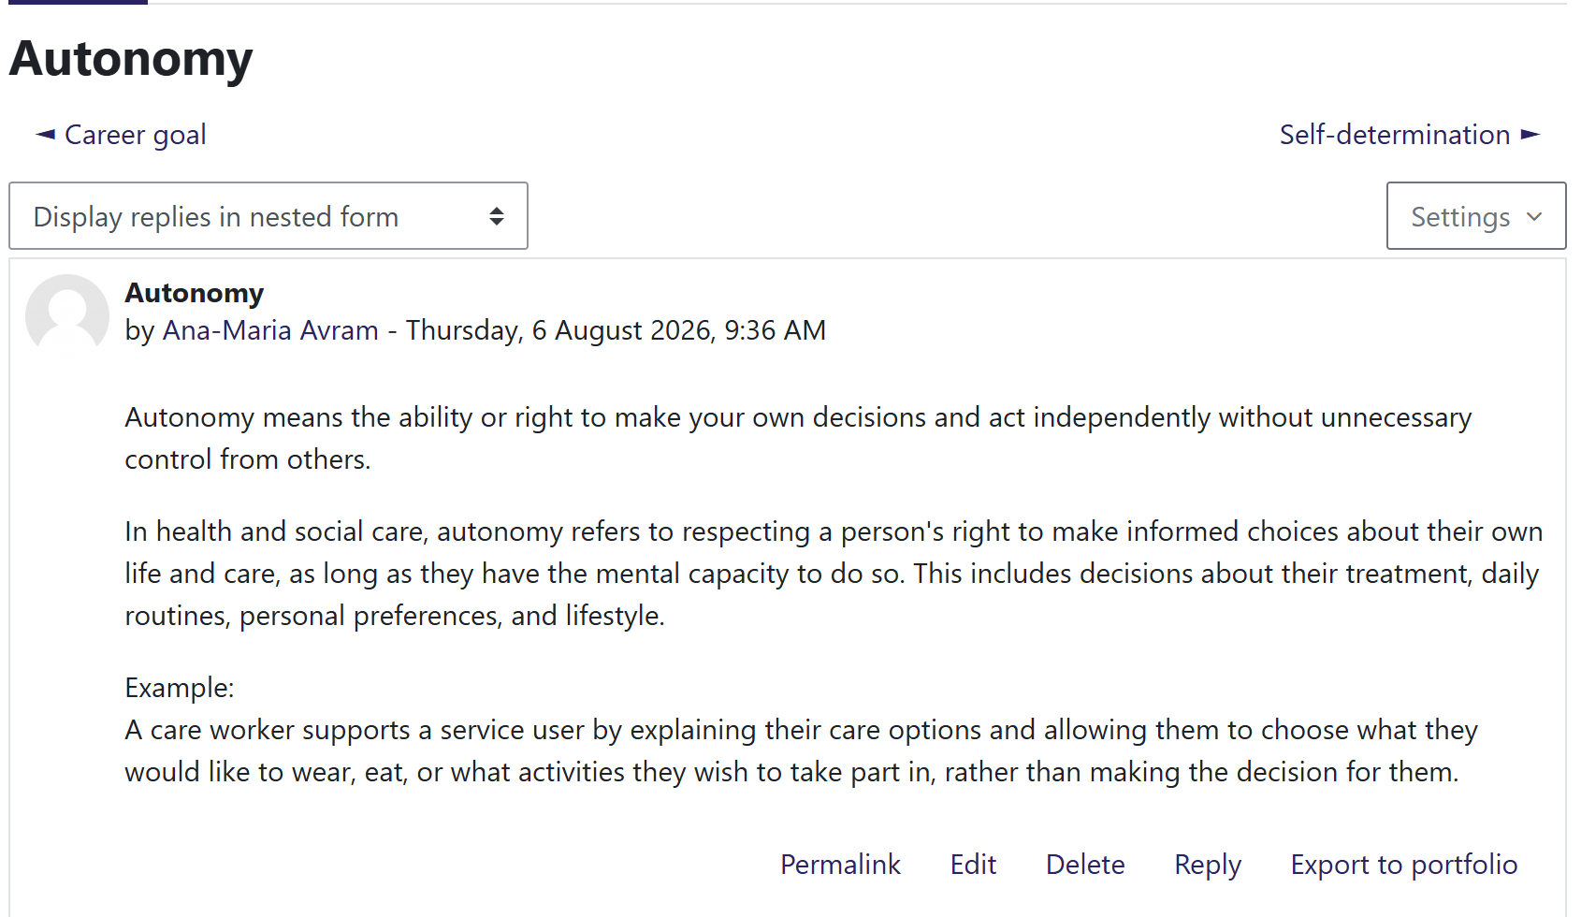

Screenshot3: 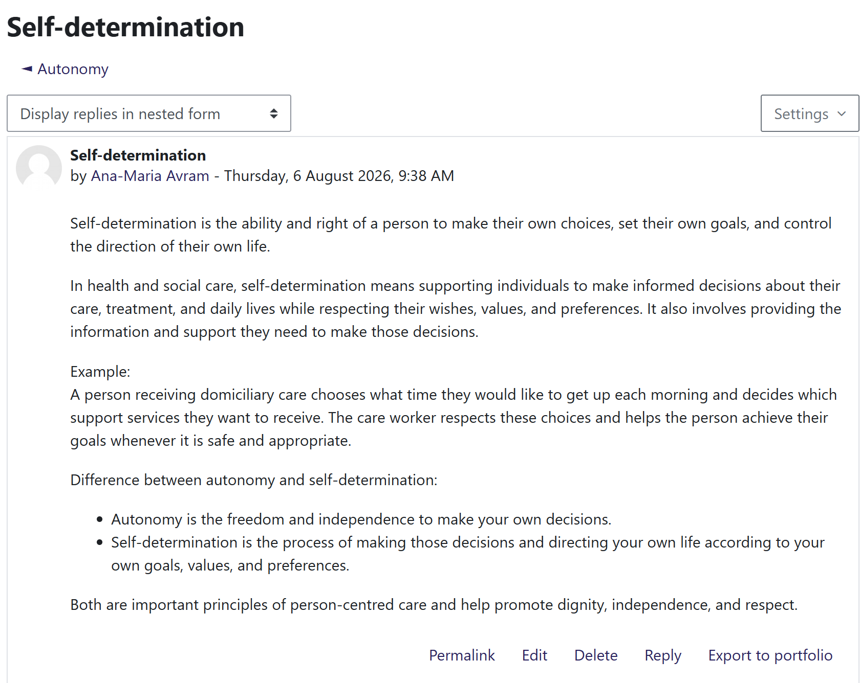

Reflection on Week 2: It's a Small World
During week 2 (It's a Small World), my knowledge of the effects of globalisation on health and social care practice was extended. The unit was based on global connections, cultural competence, diversity and the need to develop an understanding of the differences in beliefs, values and practices when providing care. I gained an understanding that health care and social care workers need to be culturally competent to deliver more equitable, respectful and person-centred care to people of all cultures. A key takeaway from this unit was the understanding of the way culture has an impact on people's health beliefs, communication styles and expectations of care. Before this unit, I had an understanding of diversity, but it was limited to respecting other cultures. It was, however, a learning experience which has made me realise that cultural competence is an ongoing process of learning, self-awareness and flexibility in professional practice. This has helped raise my awareness of inclusive practice and helped to remind me of the need to avoid stereotypes and discrimination. The unit also emphasised the extent to which globalisation has facilitated the flow of people, health care providers and health problems between countries. This means that health and social care organisations are becoming more multicultural. I found that people working in this field need to be able to communicate with others with a different cultural background, language and healthcare expectations. Cultural sensitivity development helps create trust, better communication and better health outcomes.
This learning experience was useful for me to recall Hofstede's Cultural Dimensions Theory as a tool to use for determining how cultural values affect behaviour and interactions. Cultures vary in their individualism versus collectivism and power distance, which affect communication, decision-making and expectations in healthcare (Liu and Li, 2023). Recognising these cultural differences helps practitioners to provide culturally sensitive and individual care. Additionally, the principles of person-centred care are about valuing and respecting their own beliefs, values and preferences and engaging them in decisions regarding their care (Li, et al. 2023). These models have helped me to develop a greater sensitivity towards the importance of cultural awareness and compassion in delivering quality care. In general, I feel like I am making myself more aware of my own assumptions and biases in Week 2. As I will become a health & social care professional, I know the need to build up cultural competence in my career. Through this learning, I have built my confidence in working with a diverse population, and it has brought to my attention the importance of fostering equality, inclusion and respectful communication in all aspects of my work.

Screenshot1: 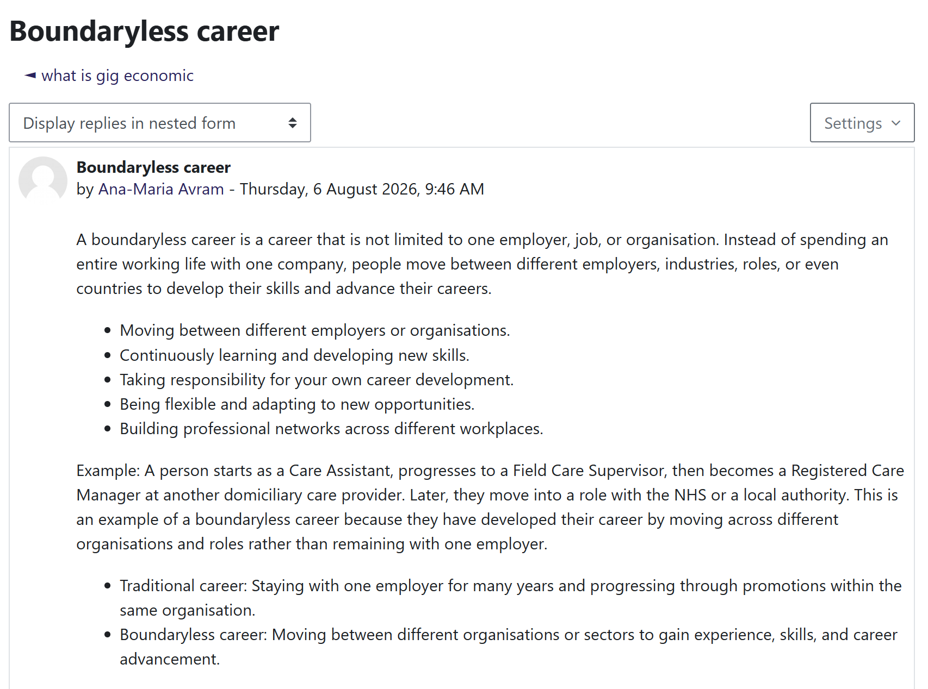

Screenshot2: 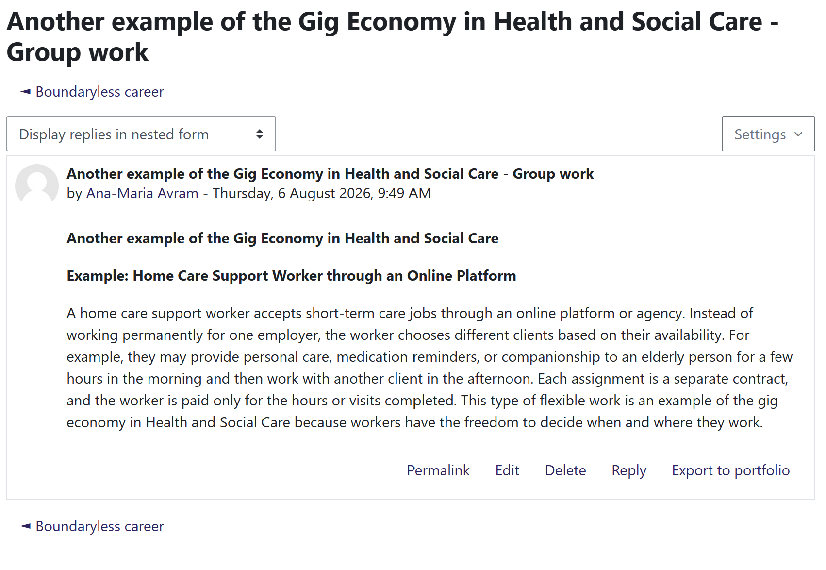

Screenshot3: 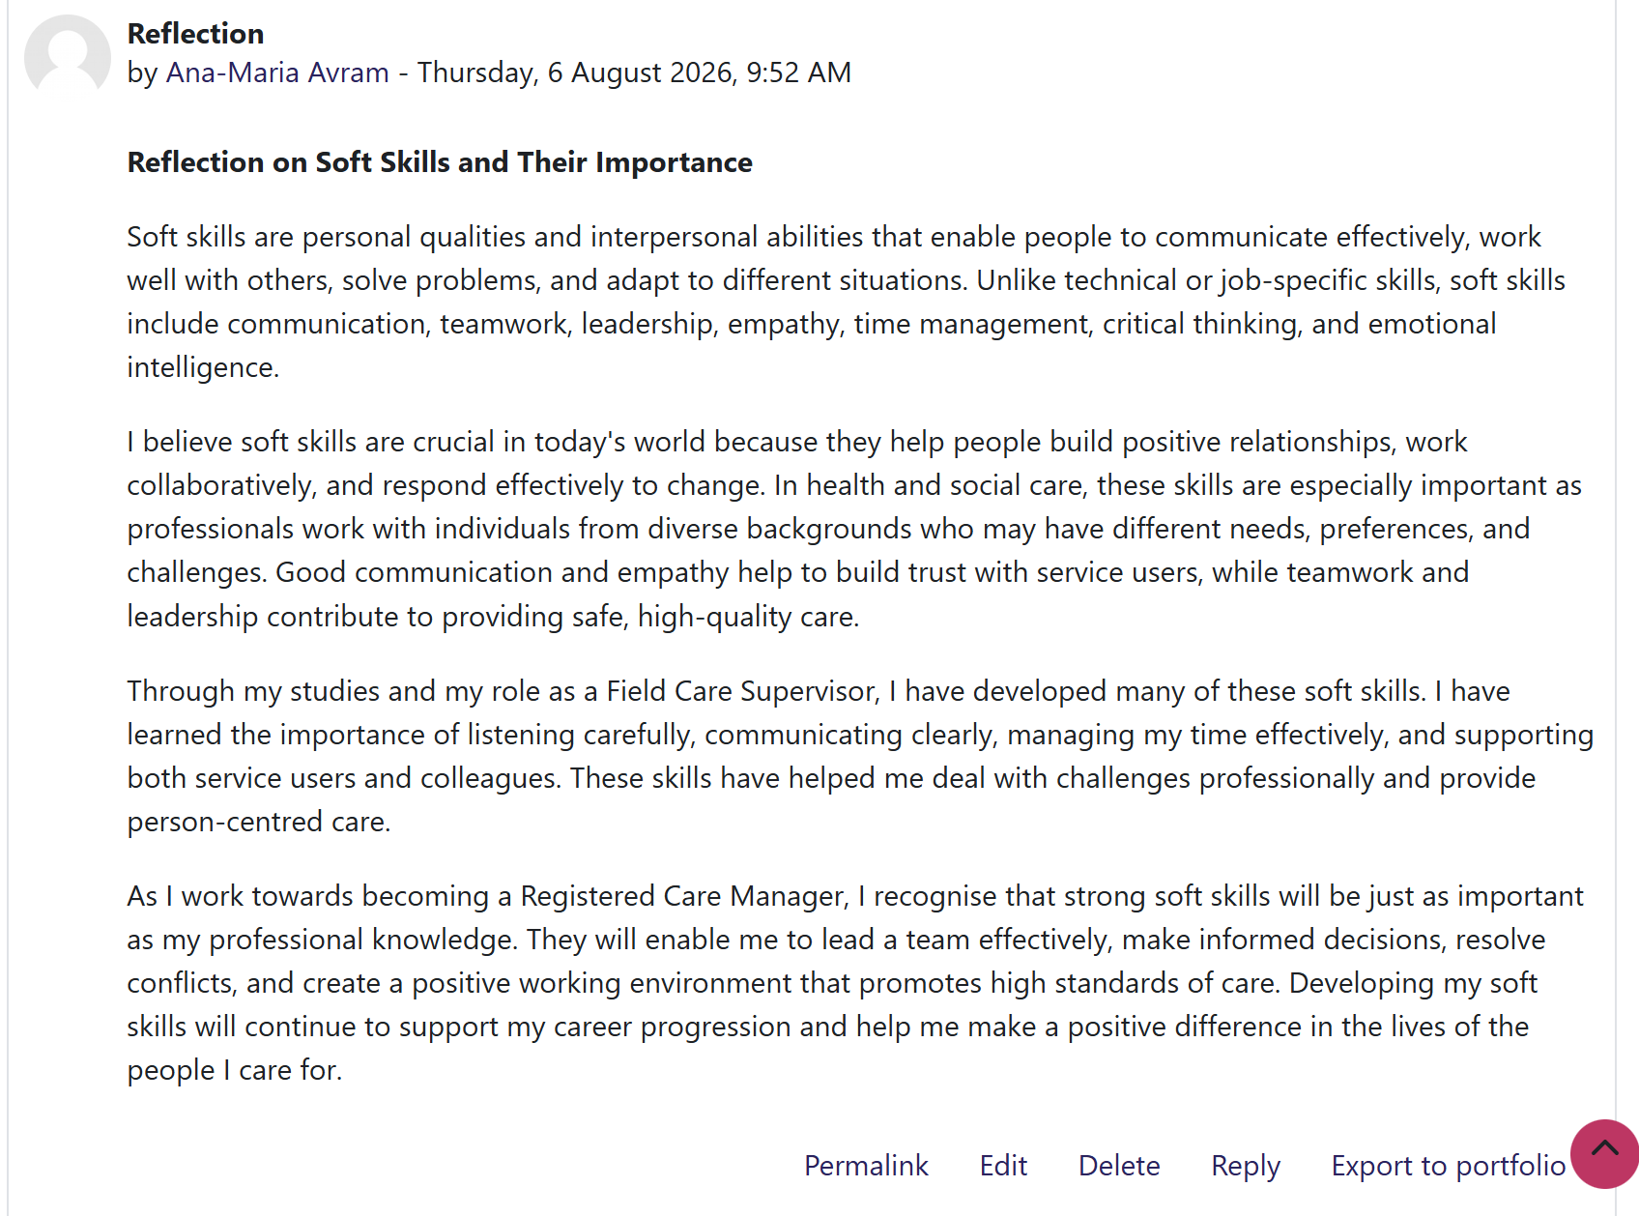

Reflection on Unit 3: Opportunity Knocks
Overall, Unit 3 helped me to further develop my awareness of ways to grow personally and professionally. The unit was primarily about identifying and seizing opportunities within the field of networking, valuing diversity, assessing personal strengths and establishing a professional identity. These included ideas that made me appreciate the fact that there are not necessarily job postings, but opportunities can arise from good relationships, involvement and learning. As I progressed in this unit, I came to understand that networking isn't just about giving out names and contact information. Making real working relationships can boost access to employment, to knowledge of industry and to personal support. I also gained insight that engaging with diverse individuals leads to innovation and increased perspectives during the discussions on diversity. This made me more confident to interact with others and understand the importance of being professional online and offline.
The activities helped me to think about what I am good at and what I could do better. I learned how I can assess my strengths and how they may help me in the future. This reflection is congruent with the SMART Goal Framework (Arafat, Woodin, and Tavares, 2024) that focuses on setting goals that are Specific, Measurable, Achievable, Relevant and Time-bound. Having developed clear career aspirations,,I have now set myself clear goals in this unit, including a desire to continue to build my professional network, to be able to contribute more to discussions and to continually develop employability skills. I had my development plan be more structured and realistic thanks to the application of SMART goals. The learning process is also in accordance with Gibbs' Reflective Cycle (1988). I discussed the learning experiences I had during the networking events, assessed what I had learnt from networking with classmates, reflected on how this might enhance my employability and created an action plan to develop professional networks beyond school. It enabled a reflective change in theoretical knowledge to practical strategies for career development.

Screenshot1: 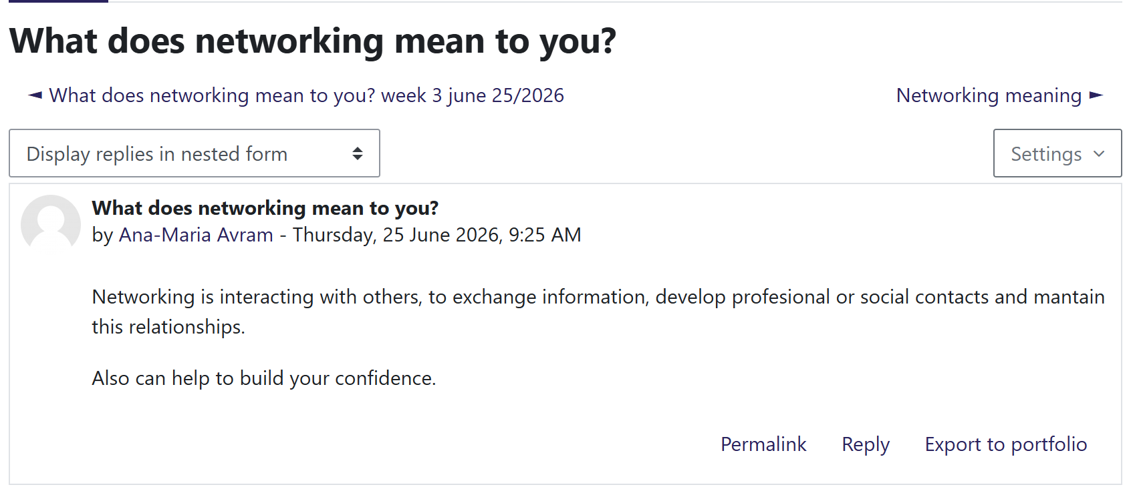

Screenshot2: 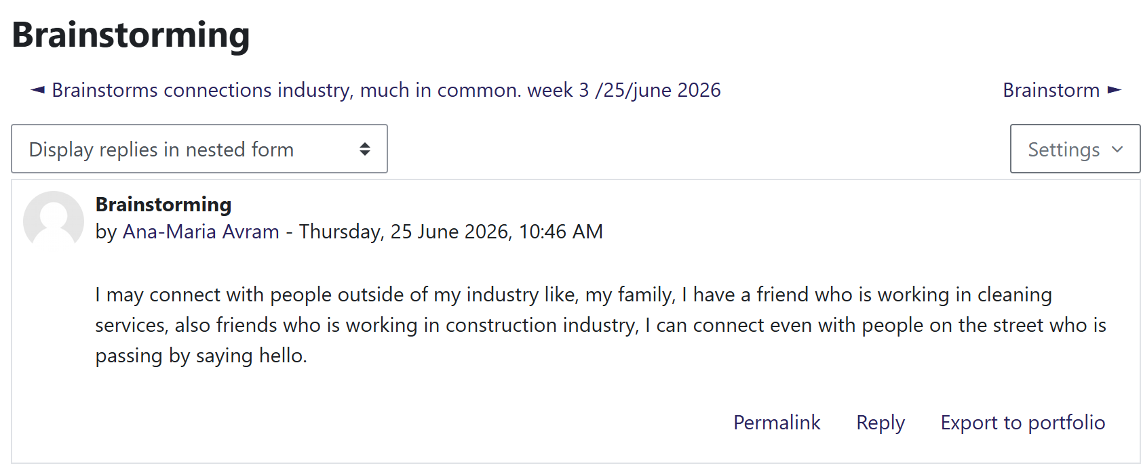

Screenshot3: 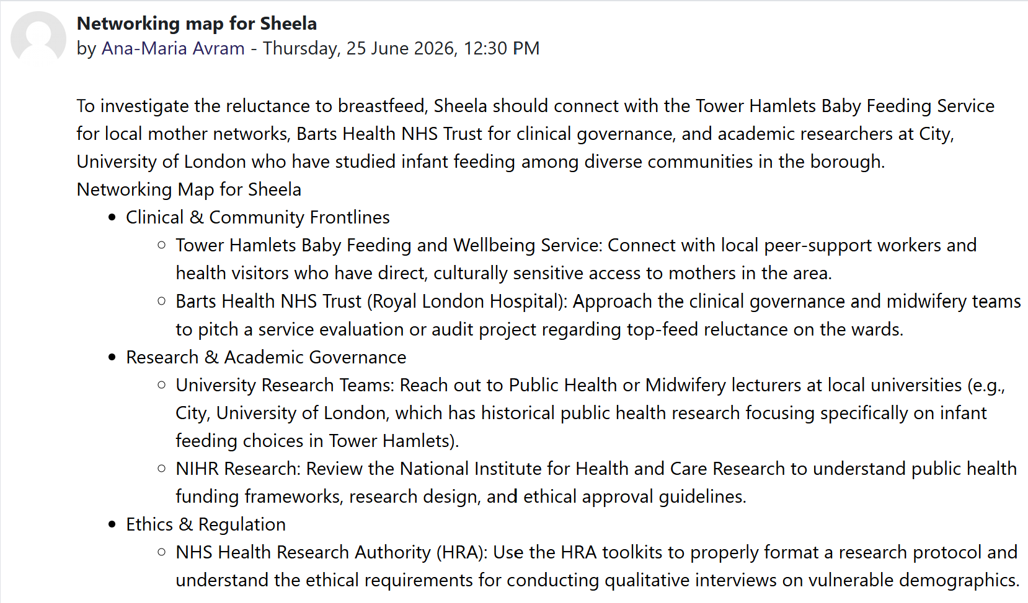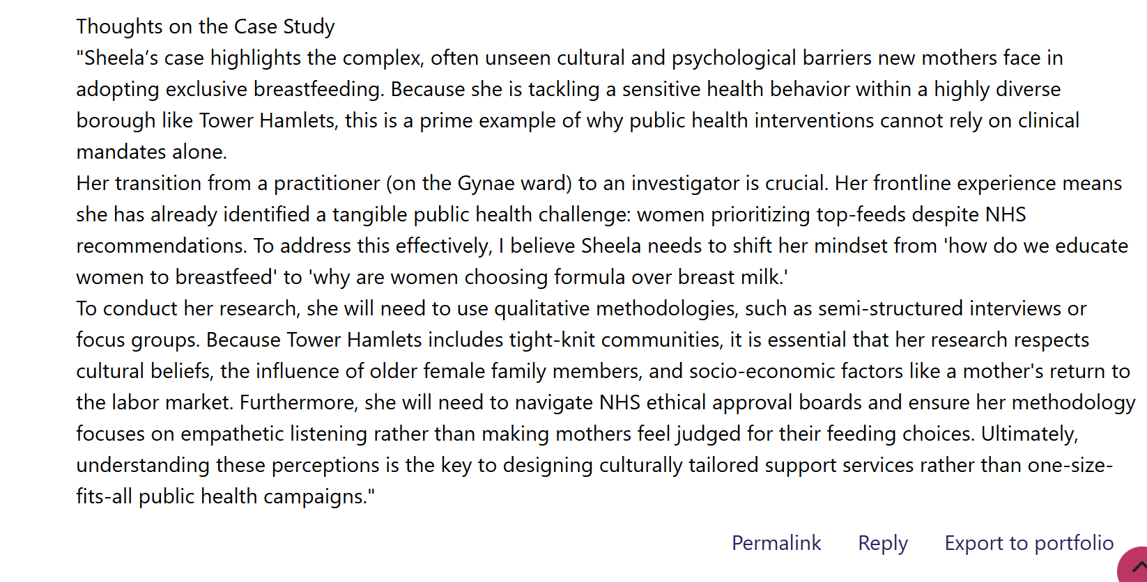

Reflection on Unit 4:
In Unit 4, I learned how happiness is related to wellbeing, resilience, work-life balance, and relationships in my personal and professional life. The themes of this week's learning were networking, the idea of a ‘network society', communication via digital platforms and building impactful professional connections. These subjects proved that happiness is not only individual success, but also developing supporting relationships to increase personal well-being and career growth.
This unit made me think about how vital it was to have positive relationships in order to maintain well-being and resilience. Networking was also discussed, and it was revealed that sharing information, helping others and developing professional relationships are elements of having a sense of self-confidence and supporting career growth (Redfern and Bennett, 2022). Before doing this unit, I was primarily connected with finding a job. I now realise, however, that networking is a continuous effort of developing trust, sharing experiences and learning from others. I was able to draw on the PERMA Model of Wellbeing to tie the learning activities with positive psychology (Osborn and Karandikar, 2023). Positive Emotion, Engagement, Relationships, Meaning and Accomplishment are the five key aspects of wellbeing identified by the model. The networking activities helped develop my understanding of the 'Relationships' component, as supportive professional relationships create a boost of confidence, decrease stress and boost motivation. I think these relationships will enable me to be resilient in any situation I have with problems in my future career in health and social care.
The sessionson bureaucracy, hierarchy, and the network society expanded my knowledge of the workings of modern organisations. I learned that while there is a structure and accountability within an organisation, there is better communication, collaboration and decision-making in an effective network. Persuasion and the power of the web were also discussed as important factors in the communication of a professional and ethical nature with colleagues, service users and multidisciplinary teams. According to the resilience theory, resilience is the ability to adapt to challenges, using both one's internal strengths and external resources. This thought sparked my understanding of how important professional networking is when facing challenges in my work life and to keep a balance between work and life. I also felt that digital communication systems enable professionals to share information more effectively and work inter-organisatorially to better provide services to the users of services.

Screenshots
Figure1: 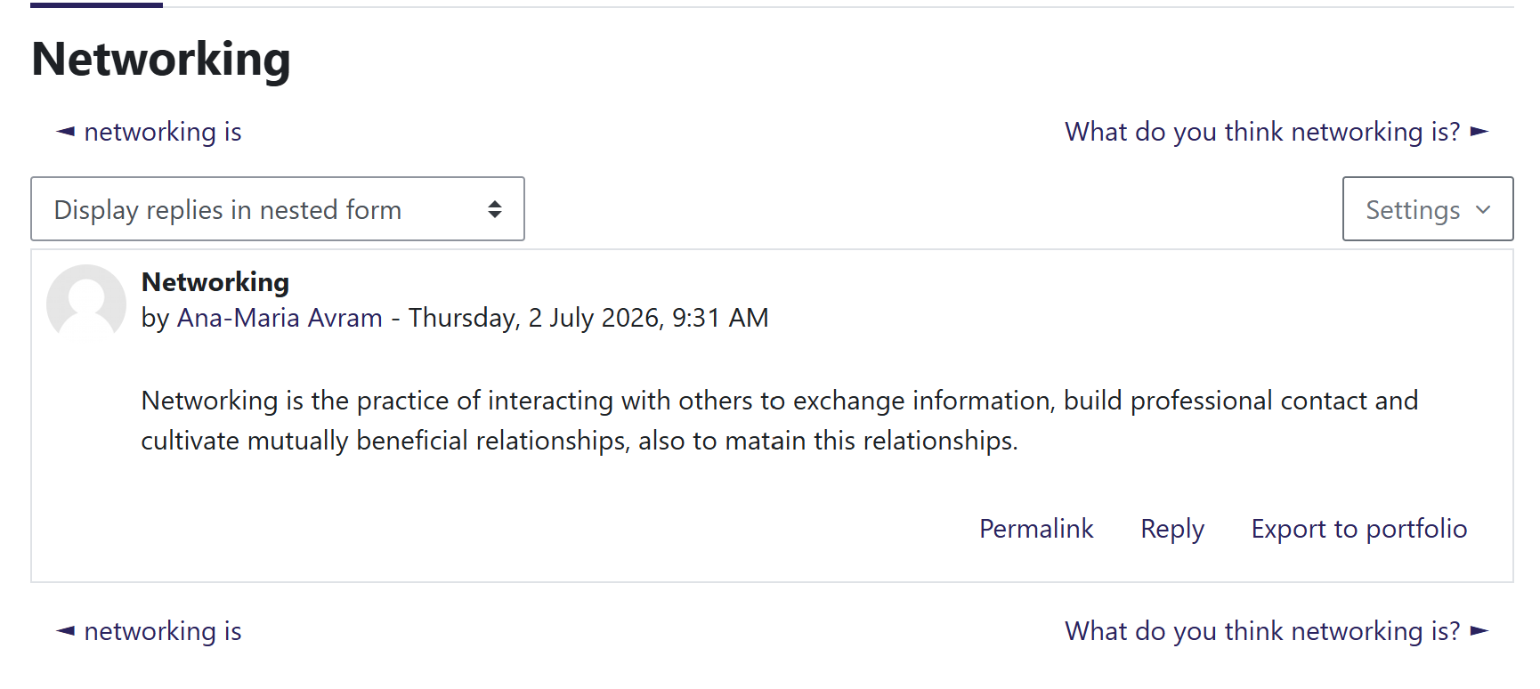
Figure2: 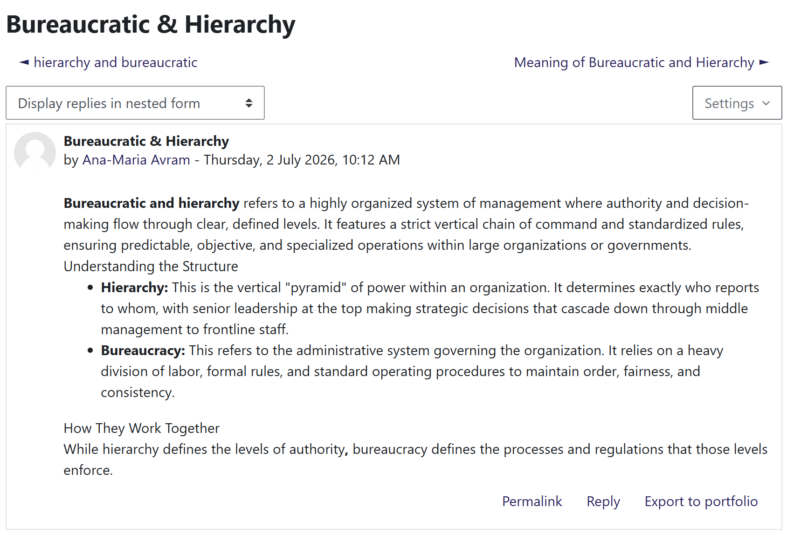
Figure3: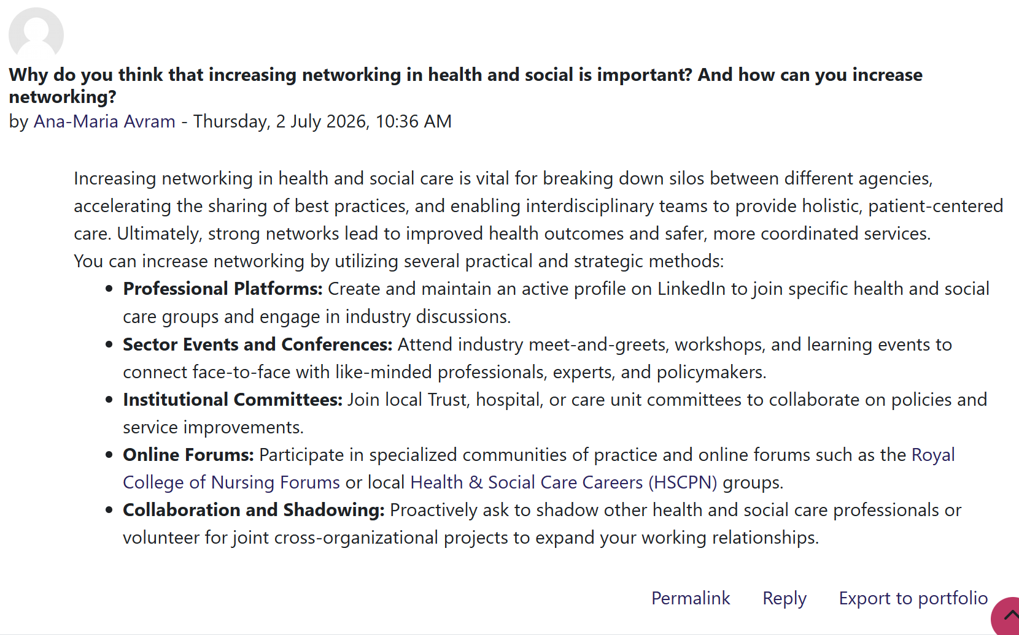

Conclusion
Overall, this module has helped me to build my knowledge, skills and behaviours to be successful in health and social care. Through reflection on the four units, I can acknowledge the importance of building my personal brand, being an open-minded person to cultural differences, and networking with others to gain employment opportunities, as well as working at a sustainable pace to achieve wellbeing and employment. This has led me to be more self-aware and resilient, as well as proactively planning my professional learning journey through the lectures and learning activities. The use of theories and reflective models has also helped me to assess and reflect on my experience and how I can self-reflect to improve my practice continually. This therefore makes me feel more confident in my communication skills, working with people of different backgrounds, working professionally with others and providing person-centred care. I feel that what I have learned in this module will help my future career as a health and social care worker to be caring, reflective and flexible, and have a commitment to lifelong learning and provide quality care in a constantly changing health and social care sector.

Reference List
Arafat, N.M., Woodin, J. and Tavares, A.S.M. (2024) 'Embedding reflection sessions in (inter)cultural awareness trainings: value and learning outcomes based on workshops for health and social care professionals', Mental Health Review Journal, 29(4), pp. 374–387. Available at: https://eprints.whiterose.ac.uk/id/eprint/233021/ (Accessed: 17 July 2026).
Lane, A.S. and Roberts, C. (2022) 'Contextualised reflective competence: a new learning model promoting reflective practice for clinical training', BMC Medical Education, 22, 71. Available at: https://doi.org/10.1186/s12909-022-03112-4 (Accessed: 17 July 2026).
Li, S., Miles, K., George, R.E., Ertubey, C., Pype, P. and Liu, J. (2023) 'A critical review of cultural competence frameworks and models in medical and health professional education: A meta-ethnographic synthesis', Medical Teacher, 45(10), pp. 1085–1107. Available at: https://doi.org/10.1080/0142159X.2023.2174419 (Accessed: 19 July 2026).
Liu, J. and Li, S. (2023) 'An ethnographic investigation of medical students’ cultural competence development in clinical placements', Advances in Health Sciences Education, 28, pp. 705–739. Available at: https://doi.org/10.1007/s10459-022-10179-7 (Accessed: 19 July 2026).
Osborn, P.R. and Karandikar, S. (2023) 'Practice-based knowledge perspectives of cultural competence in social work', Journal of Ethnic & Cultural Diversity in Social Work, 32(6), pp. 285–297. Available at: https://doi.org/10.1080/15313204.2022.2046228 (Accessed: 20 July2026).
Redfern, H. and Bennett, B. (2022) 'An intercultural critical reflection model', Journal of Social Work Practice, 36(2), pp. 135–147. Available at: https://doi.org/10.1080/02650533.2022.2067139 (Accessed: 20 July 2026).
Seeleman, C., Suurmond, J., Stronks, K., Cushman, L.F. and Scherpbier, A.J.J.A. (2009) 'Cultural competence: a conceptual framework for teaching and learning', Medical Education, 43(3), pp. 229–237. Available at: https://doi.org/10.1111/j.1365-2923.2008.03269.x (Accessed: 21 July 2026).
Sharifi, N., Adib-Hajbaghery, M. and Najafi, M. (2019) 'Cultural competence in nursing: A concept analysis', International Journal of Nursing Studies, 99, 103386. Available at: https://doi.org/10.1016/j.ijnurstu.2019.103386 (Accessed: 21 July 2026).
Campinha-Bacote, J. (2002) 'The process of cultural competence in the delivery of healthcare services: A model of care', Journal of Transcultural Nursing, 13(3), pp. 181–184. Available at: https://doi.org/10.1177/10459602013003003 (Accessed: 20 July 2026).

