

Name: Netsanet Yadergal
Student ID: 24131569
Module Code: BMHP5016
Module: Principles of Health and Social Care Practice
Lecturer name: Dr Itse Olaoye

Table of contents
1, Reflection on the Importance of Principles of Health and Social Care......................3
Introduction ....................................................................................................................3
1.1 Person-Centred Care: Theoretical Integration and in UK context.............................3
1.2 Partnership Working: Theoretical Integration and in UK context...............................4
1.3 Ethical Practice: Theoretical Integration and in UK context.......................................5
2. Practical Examples of Concepts in Practice Purpose...................................................6
2.1, person centre care.......................................................................................................6

2.2, partnership working .................................................................................................... 6

2.3, Ethical Considerations.................................................................................................7

2.4, Conclusion......................................................................................................................7
3, Self-Reflection as a Health and Social Care Professional ...............................................7
Introduction: My Role and Context......................................................................................7
3.1, Description ................................................................................................................8
3.2, Feeling ..........................................................................................................................8
3.3, Evaluation........................................................ ............................................................9
3.4, Analysis .........................................................................................................................9
3.5, Conclusion.....................................................................................................................9
3.5, Action plan ....................................................................................................................10
4, Conclusion.........................................................................................................................10
Reference .........................................................................................................................11-13
🩺1. Reflection on the Importance of Principles of Health and Social Care
Introduction
Three fundamental professional principles—person-centerer care, partnership working, and ethical practice—are critically examined in this reflective study as essential pillars for providing of high-quality health and social care. Each principle is defined and integrated with relevant theoretical frameworks, followed by an evaluation of its implications for professional practice and service-user outcomes. The report then applies these principles to a case scenario, demonstrating their interdependence in complex care management. Finally, Gibbs’ Reflective Cycle is used to synthesise learning across all three principles, highlighting their collective impact on professional development and outlining an action plan for future improvement.
1.1 Person-Centred Care: Theoretical Integration and the UK Context
Person-centred care, also known as patient- or people-centred care, focuses on each person’s individual needs, values, preferences, and circumstances, looking beyond symptoms to understand the whole person (Quality Compliance Systems, 2024; Local Government Association, 2025).
Maslow’s Hierarchy of Needs helps explain this approach by showing that people thrive when their physical, emotional, and psychological needs are met (Verywell Health, 2025). Using this framework encourages professionals to prioritise emotional security, autonomy, and involvement in care decisions, which supports better outcomes and reflects UK standards for dignity, safety, and independence (Gov.UK, 2014 & NICE, 2014).
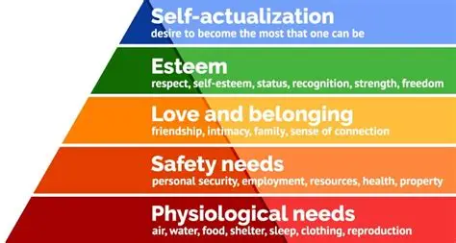
In the UK, person-centred care is seen as essential to high-quality support. When care is shaped around what people want and need, they feel listened to, are more engaged, and manage their health more effectively. This leads to better experiences, improved wellbeing, and reduced pressure on health services (NHS, 2022).
1.2 Partnership Working: Theoretical Integration and the UK Context
Partnership working means professionals, organisations, individuals, and families working together to plan and deliver care (Care Learning, 2024). It relies on effective communication, shared responsibility, and joint decision-making to meet complex needs and achieve better outcomes. This approach is common in settings such as childcare, schools, hospitals, and supported living.
Collaboration models highlight key ingredients for effective teamwork, including communication, coordination, accountability, and shared goals (Körner et al., 2016). Tuckman’s Team Development Model – forming, storming, norming, performing, and adjourning – shows how teams grow and work more effectively as they move through each stage (Tuckman & Jensen, 1977; Institute of Project Management, 2022).

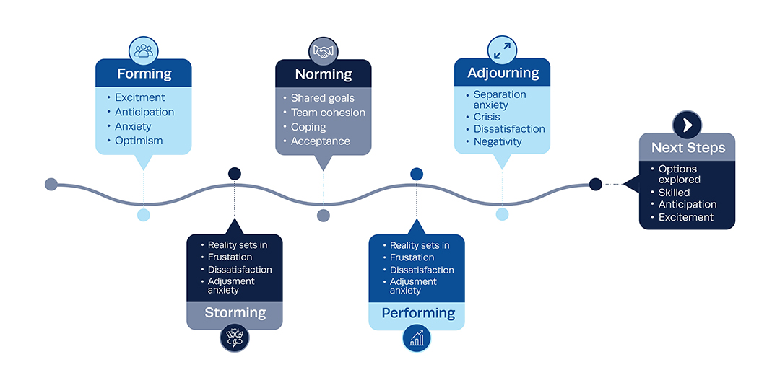
(Institute of Project Management., 2022)
In health and social care, strong teamwork helps meet people’s physical, emotional, and social needs, improving service quality, staff relationships, and safety (Care Learning, 2024). To design services and satisfy legal obligations for public engagement, NHS England and integrated care systems must collaborate strongly with communities. This is another fundamental component of UK policy. (NHS England, 2022).

1.3 Ethical Practice: Theoretical Integration and the UK Context
Ethical practice refers to the moral standards that guide professionals in deciding what is right and wrong (Care Learning, 2024). In health and social care, these standards are shaped by codes of conduct, laws, and organizational values (World Health Organization, 2022). They help practitioners navigate complex decisions, such as balancing a person’s autonomy with their safety.
To support staff with complex dilemmas, structured decision-making frameworks have been developed (Georgieva, Andreevska & Petkova, 2024) Ethical practice is based on four fundamental ethical principles: autonomy, beneficence, non-maleficence, and fairness (Varkey, 2021). These principles support informed consent, confidentiality, choice, acting in a person’s best interests, avoiding harm, and ensuring fairness.
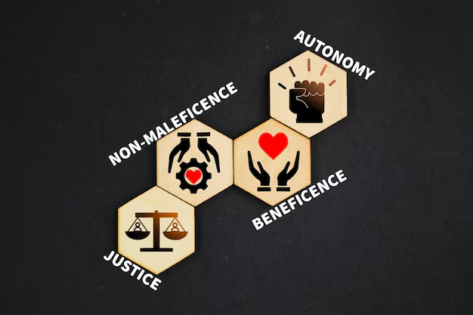

In the UK, ethical practice is essential to coordinated care. When professionals, organizations, and families work together ethically, individuals receive the right support at the right time. Ethical principles guide this collaboration by protecting autonomy, promoting wellbeing, preventing harm, and ensuring equal treatment for all (Care Learning, 2024).

🩺 2- Practical Examples of Concepts in Practice Purpose
Mrs A, an elderly woman with several physical health issues and early-stage dementia, was the subject of the observation during the placement. She was determined to support her independence despite her memory changes. Her need to take her own medication, which she considered an important part of keeping control over her everyday life, was especially clear in this.
She was concerned about losing her freedom and being seen as unable to manage, even though she occasionally acknowledged that her memory may result in errors. She was friendly and cheerful in daily activities, taking safety in routines and memories. Her circumstances showed how crucial freedom was to her identity, even as her need for treatment increased.
2.1, Person-Centered Care
Person-centred care was central to the team’s approach. Mrs A expressed a strong preference to manage her own medication, as she had done independently before entering the care home. The care team respected this by developing a tailored care plan that allowed her to self-administer under supervision. Her room was equipped with a secure medication dispenser, and staff provided gentle reminders rather than direct administration. This upheld her dignity and independence, which emphasizes promoting individual well-being, choice, and control over care decisions (Gov.UK, 2014 & Department of Health & Social Care, 2025).
2.2, Partnership Working
Effective partnership working was evident in the collaboration between professionals and Mrs A’s family. The district nurse coordinated with the GP to review her prescriptions, while care staff watched her daily routines. Mrs A’s daughter was actively involved in care planning meetings, offering insights into her mother’s habits and preferences. This collaborative approach ensured continuity of care and reduced the risk of medication errors (Department of Health & Social Care, 2025). Which promotes integrated care systems and joint decision-making across services to improve outcomes for service users (legislation.gov.uk, 2022).

2.3, Ethical Considerations
Ethical principles guide every decision. Respect for autonomy was paramount to Mrs A’s right to make decisions about her care, which was upheld, even when her cognitive decline posed challenges. The team conducted a Mental Capacity Act 2005 assessment to ensure she understood the risks and benefits of self-administering medication (GOV.UK, 2005). Informed consent was obtained, and confidentiality was supported throughout. Staff were careful not to show sensitive health information during family visits unless Mrs A agreed. Which stresses the importance of respecting and keeping dignity, privacy, and informed choice in care delivery (Gov.UK, 2014).
2.4, Conclusion
It demonstrates how person-centred care, collaborative efforts, and ethical actions may greatly improve health and social care outcomes. By respecting Mrs A’s preferences, involving her family, and adhering to legal and ethical standards, the team fostered a safe, empowering environment. Such practices not only improve individual experiences but also ensure compliance with UK legislation and professional guidelines, leading to better quality of care and service delivery.
🩺: Self-Reflection as a Health and Social Care Professional
Introduction: My Role and Context
As an aspiring health and social care professional undergoing both academic and practical training, I am committed to developing the skills, values, and knowledge needed to provide safe, compassionate, and effective care. My experience as a domiciliary carer supporting individuals with diverse physical, emotional, and cognitive needs has shaped my understanding of the profession. This reflection examines how person-centred care, partnership working, and ethical principles influence my current practice and contribute to my ongoing professional development. To structure this reflection, I will use Gibbs’ Reflective Cycle (1988), which provides a systematic framework for learning from experience through six stages

: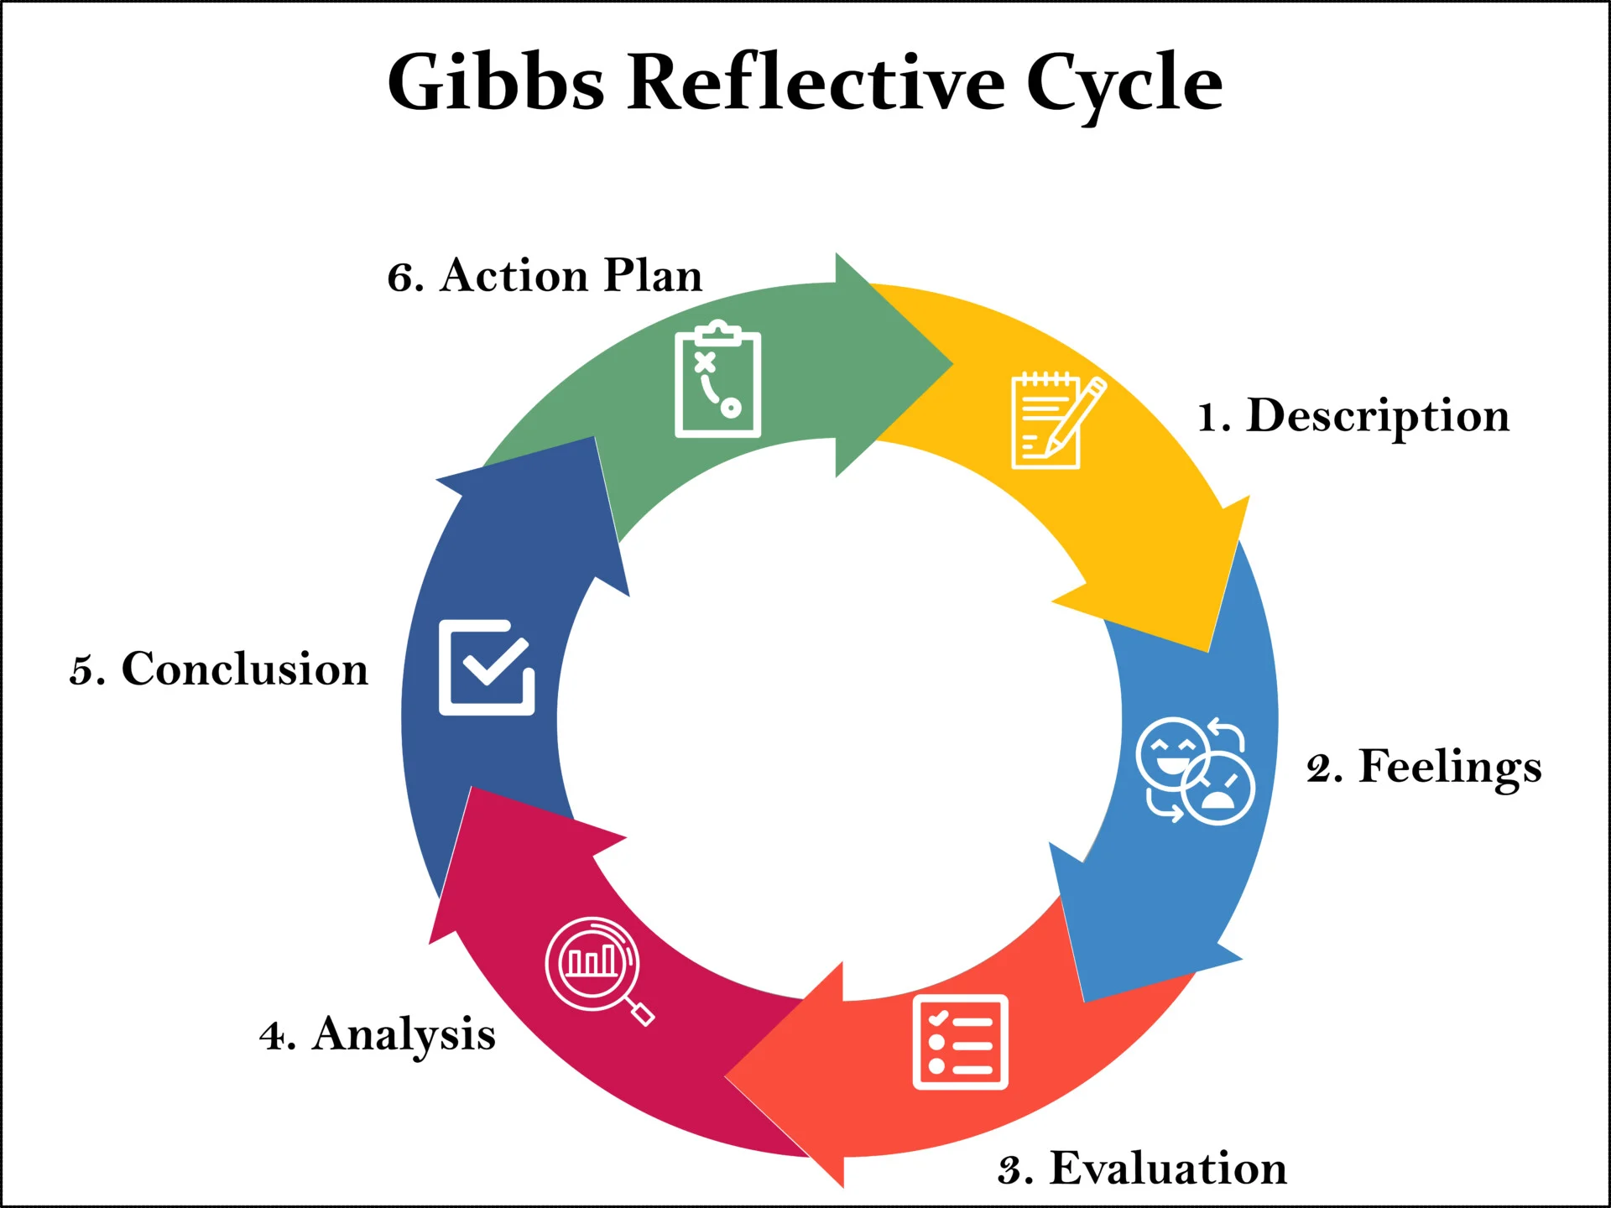 (McLeod, 2025).

3.1, Description
During my placement I encountered two linked situations that challenged my confidence and required me to integrate person-centred care, partnership working, and ethical practice in a holistic manner. The first involved a patient with dementia who repeatedly refused to shower, despite the evident need for hygiene support. The second involved another patient who refused essential medication, raising concerns about mental capacity, safeguarding, and duty of care. These incidents were not isolated tasks but complex situations that demanded a combined approach rather than single-principle problem-solving. Both scenarios made it clear that effective care requires understanding the individual, collaborating with others, and making ethically informed decisions that protect dignity and safety simultaneously.
3.2, Feeling
The pressures of applying academic concepts in real practice became evident through my emotional responses. When the patient refused to shower, I felt torn between respecting her autonomy and worrying about potential infection, discomfort, and skin breakdown. This tension made me question whether I was adequately upholding her dignity or unintentionally compromising her rights.
The medication refusal created a different form of anxiety. I understood the importance of respecting autonomy, yet I also felt responsible for ensuring safety, especially if the refusal indicated cognitive decline. I was additionally concerned about raising the issue with colleagues, as I did not want to appear inexperienced. These emotions highlighted the need for self-control, confidence, and open communication within the team.

3.3, Evaluation
After considering these situations, I concluded that person-centred care, partnership functioning, and ethical behaviors were all essential to delivering effective care. When the patient refused to take a shower, I initially focused on dignity and choice, but major improvement didn't happen until I sought counsel from others. I was able to ensure consistency and adjust my communication strategies thanks to their assistance. The medication rejection case requires team discussion to strike a balance between beneficence, safety, and autonomy rather than depending only on personal judgement of MDT role. A clear Mental Capacity Act assessment and safe decision-making were made possible by collaboration with senior staff (Mental Capacity Act 2005 and National Health Service, 2024). All things considered, these experiences strengthened my understanding that delivering high-quality care requires integrating all three concepts.
3.4, Analyze
I was able to assess my strengths and places for improvement because of these experiences. I demonstrated patience, empathy, and polite communication skills, all of which are indicative of strong person-centred beliefs. Additionally, I demonstrated a willingness to ask for help, which is essential for collaborative work. But I also understood that I need to be more confident when handling care refusals and have a deeper understanding of the Mental Capacity Act, ethical frameworks, and safeguarding. Additionally, I saw the necessity to use simpler language and comfort while communicating with people who have dementia. By developing these abilities, I will be able to provide CQC-compliant care that is safer, more reliable, and compliant with the law.
3.5, Conclusion
Reflecting on these experiences highlighted the importance of courage and humility in professional development. Courage enabled me to seek support, while humility helped me recognize my limitations. This strengthened my understanding of the emotional intelligence and confidence needed to deliver safe, compassionate care. The reflection also reinforced that person-centred care, partnership working, and ethical practice are interconnected foundations of high-quality care: person-centred care deepens understanding of individual needs, partnership working supports consistent decisions, and ethics protects rights and professional integrity. Using Gibbs’ Cycle helped me examine my actions and emotions, reinforcing my commitment to practicing responsibly, collaboratively, and with compassion.
3.6, Action plan
Area of Development | Action | Alignment to principle
Assertiveness & Communication | Undertake training on communication strategies for cognitive impairments and deepen MDT role understanding | Partnership working
Ethical & Legal Comprehension | Research and apply ethical frameworks and legislation (Mental Capacity Act 2005) in complex decisions. | Ethical Practice
Cultural Competence | Engage in education on cultural diversity to tailor care to individual needs and values | Person-Centred Care
Evaluation & Professionalism | Participate in team discussions, monitor outcomes, and contribute to continuous improvement of culture. | Well-Led/Effective (CQC Area)

3.6. Conclusion
My understanding of how ethics, partnership functioning, and person-centred care influence my job in health and social care has improved because of this reflection. By applying reflective models and aligning with professional standards, I am better equipped to navigate challenges and grow as a compassionate, competent practitioner. My journey is ongoing, and I am committed to learning, adapting, and advocating for the dignity and wellbeing of those I serve.

Reference
Bonebright, D.A. (2010) ‘40 years of storming: a historical review of Tuckman’s model of small group development’, Human resource development international, 13(1), pp. 111–120. Available at: https://doi.org/10.1080/13678861003589099.

Care Learning (2024). 2.1. Outline what partnership working means in health, social care and children’s and young people’s settings – Care Learning. [online] Care Learning. Available at: https://carelearning.org.uk/qualifications/level-1-award-hsc/pwcs-06-working/2-1-outline-what-partnership-working-means-in-health-social-care-and-childrens-and-young-peoples-settings [Accessed 22 Oct. 2025].
CQC (2022). The five key questions we ask - Care Quality Commission. [online] www.cqc.org.uk. Available at: https://www.cqc.org.uk/about-us/how-we-do-our-job/five-key-questions-we-ask.
Department of Health & Social Care (2025). Care and Support Statutory Guidance. [online] GOV.UK. Available at: https://www.gov.uk/government/publications/care-act-statutory-guidance/care-and-support-statutory-guidance.

Körner, M. et al. (2016) ‘Interprofessional teamwork and team interventions in chronic care: A systematic review’, Journal of interprofessional care, 30(1), pp. 15–28. Available at: https://doi.org/10.3109/13561820.2015.1051616.

Institute of Project Management. (2022). The 5 Stages of Team Development: Tuckman’s Model | IPM. [online] Institute of Project Management. Available at: https://instituteprojectmanagement.com/blog/the-5-stages-of-team-development/#undefined.
Georgieva, V., Andreevska, K. and Petkova, V. (2024) ‘Models of Ethical Decision Making in the Field of Healthcare Services – A Literature Review’, Acta Medica Bulgarica, 51(s2), pp. 182–187. Available at: https://doi.org/10.2478/amb-2024-0068.

GOV.UK (2005). Mental Capacity Act 2005. [online] Legislation.gov.uk. Available at: https://www.legislation.gov.uk/ukpga/2005/9/contents.
HCPC (2025). Standards of proficiency |. [online] www.hcpc-uk.org. Available at: https://www.hcpc-uk.org/employers/using-our-standards/standards-of-proficiency/.
Care Learning (2024). 1.1. Define Ethics, Morals And Values - Care Learning. [online] Care Learning. Available at: https://carelearning.org.uk/qualifications/level-3-extended-hsc/hsc-dmo3-ethics/1-1-define-ethics-morals-and-values/.
Local Government Association company (2025). Person-centred care | Local Government Association. [online] www.local.gov.uk. Available at: https://www.local.gov.uk/person-centred-care.
Legislation.gov.uk (2005). Mental Capacity Act 2005. [online] Legislation.gov.uk. Available at: https://www.legislation.gov.uk/ukpga/2005/9/section/1.
legislation.gov.uk (2022). Health and Care Act 2022. [online] Legislation.gov.uk. Available at: https://www.legislation.gov.uk/ukpga/2022/31/part/1/crossheading/integrated-care-partnerships.
Person-centred care (2017). Person-centred care | NHS England | Workforce, training and education. [online] NHS England | Workforce, training and education. Available at: https://www.hee.nhs.uk/our-work/person-centred-care?utm_source.
National Health Service (2024). Mental Capacity Act - Social Care and Support Guide. [online] nhs.uk. Available at: https://www.nhs.uk/social-care-and-support/making-decisions-for-someone-else/mental-capacity-act/.
NICE (2014). Person-centred care | Managing medicines in care homes | Guidance | NICE. [online] Nice.org.uk. Available at: https://www.nice.org.uk/guidance/sc1/chapter/person-centred-care?utm_source.
NHS England (2022). NHS England» Working in partnership with people and communities: statutory guidance. [online] www.england.nhs.uk. Available at: https://www.england.nhs.uk/publication/working-in-partnership-with-people-and-communities-statutory-guidance/.
NHS (2022). Person Centred Practice | NHS England | Workforce, training and education. [online] NHS England | Workforce, training and education. Available at: https://www.hee.nhs.uk/our-work/enhancing-generalist-skills/enhance-learning-resources/handbook/person-centred-practice?utm_source [Accessed 25 OQuality Compliance systems (2024). What is Person-Centred
are? | QCS. [online] QCS. Available at: https://www.qcs.co.uk/what-is-person-centred-care/ [Accessed 22 Oct. 2025].
Verywell Health's (2025). What Is the Hierarchy of Needs? [online] Verywell Health. Available at: https://www.verywellhealth.com/hierarchy-of-needs-maslow-s-five-categories-of-needs-5220468#citation-8.
Wahab, M. T., Lim, H. F. R., & Ng, Y. F. (2025). Unified Needs Assessments to Enable Systemic Healthcare Services Integration and Health System Transformation. International Journal of Integrated Care, 25, 277. https://doi.org/10.5334/ijic.ICIC24126
World Health Organization (2022). Ethics and Health. [online] www.who.int. Available at: https://www.who.int/westernpacific/health-topics/ethics-and-health.

