

Module: Psychology in Health and Social Care
Module Code: LCHS4010

Student Name : Gloria Armoo
Student ID : 2511523
Lecturer : Alice Clayton
Submission Deadline :21/7/2026

Contents

Introduction……………………………………………………………………………….2
Bowlby's Attachment Theory……………………………………………………………. 3
Overview of Bowlby's Attachment Theory…………………………………………….3/4
Application of Bowlby's Theory to Social Media and Mental Health………………... 4
Critical Evaluation of Bowlby's Theory…………………………………………………. 5
Erikson's Psychosocial Theory…………………………………………………………. 5
Overview of Erikson's Psychosocial Theory…………………………………………... 6
Application of Erikson's Theory to Social Media and Mental Health………………6/7
Critical Evaluation of Erikson's Theory………………………………………………… 7
Conclusion………………………………………………………………………………… 8
References………………………………………………………………………………... 9

The impact of social media on mental health in adolescence

Introduction

Social media is a lifestyle for adolescents and has affected the way adolescents communicate, learn, form relationships and showcase their identities. Instagram, TikTok, Snapchat and Facebook are websites that allow social interaction, entertainment and offer access to information. Recent data show that nearly 95 per cent of adolescents possess a smartphone and nearly 96 percent check the internet daily, with at least some spending several hours daily on a social media platform. Even though such platforms can foster friendships, help people express themselves and offer emotional support, overuse or unhealthy use of these platforms has been linked to anxiety, depression, low self-esteem, cyberbullying and poor body image. As a result, the role of social media in the mental health of adolescents has emerged as a central topic in the focus of health and social care practitioners, educators and families.

This essay explains how social media affects teenage mental illnesses by looking at some of the effects of social media, both positive and negative. This discussion uses the Attachment Theory by Bowlby and the Psychosocial Theory, as advanced by Erikson, to understand how the process of early attachment and identity formation as adolescents relates to their interactions on social media and affects their emotional wellbeing.

Bowlby's Attachment Theory
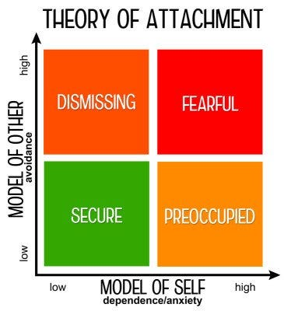
Figure 1: Bowlby's Attachment Theory
Source: (Bowlby, 1988)

Overview of Bowlby's Attachment Theory

John Bowlby came up with Attachment Theory to elucidate how initial emotional bonds shared by children and their primary caregivers affect psychological development in life. He held that infants have an inherent biological need to establish safe attachments, as such relationships guarantee security, safety and emotional safety (Bowlby, 1988). Children create representations of others, other relationships and people through repeated interactions with their caregivers, and these are known as internal working models. These mental models affect emotional regulation, behaviour and anticipation of future relationships during adolescence and adulthood.

According to Bowlby, secure attachment develops when caregivers are consistently responsive, supportive and emotionally available. Conversely, an inconsistent, neglecting, or rejecting style of caring can result in an insecure attachment style like anxious or avoidant
attachment (van der Horst et al., 2025). The adolescent stage is a period in which youths desire more independence as they still depend on the emotional provisions of parents and other adults whom they trust. Whereas the significance of peer relationships increases, attachment security remains to impact self-esteem, emotional resilience and mental wellbeing (Bowlby, 1988).

Application of Bowlby's Theory to Social Media and Mental Health

The Attachment Theory by Bowlby assists in explaining the differences between adolescents in relation to social media. Adolescents who are securely attached tend to be more emotionally stable, have healthier self-esteem and possess better coping skills (Robledo et al., 2022). This makes them more likely to act positively and build friendships on social media, enjoy social support, and join online communities without falling into excessive reliance on the opinions of others.

Conversely, teens who have experienced insecure attachment are usually in need of reassurance, acceptance, as well as validation in online interactions. Sections like likes, comments and numbers of followers can possibly turn into significant sources of self-esteem. This can lead them to be emotionally addicted to social media and disappointed upon being given minimal attention or a negative response. These teenagers are as well more prone to anxiety, loneliness, lowered self-esteem and depressive emotions due to cyberbullying or rejection online (Bowlby, 1988).

Simultaneously, social media is not a completely bad thing. In the situation of the secure attachment of adolescents, online support platforms may strengthen friendships, promote communication and provide support in uncomfortable circumstances (Safaria and Amanah, 2026). Thus, the theory developed by Bowlby suggests that the influence of social media is rather dependent on the quality of attachment relationships of adolescents and on their emotional control skills.

Critical Evaluation of Bowlby's Theory

The Attachment Theory developed by Bowlby possesses numerous strengths to explain the connection between social media and the mental health of adolescents. A key asset is that it shows why adolescents react in different ways to similar online experiences by acknowledging the long-term impact of their initial emotional relationships (Nguyen et al., 2024). Another significant point of the theory is the need for constructively supportive relations in the family in terms of enhancing resilience and preventing the negative impact of social media abuse on youth.

The theory, however, has limitations as well. It places much stress on the experiences of early childhood and pays less attention to subsequent factors like peer relations, school life, personality, transformation, and fast-moving computer technologies (Khadka, 2022). Attachment Theory does not adequately account for social media behaviour, which is influenced by numerous biological, psychological and environmental factors.

Erikson's Psychosocial Theory
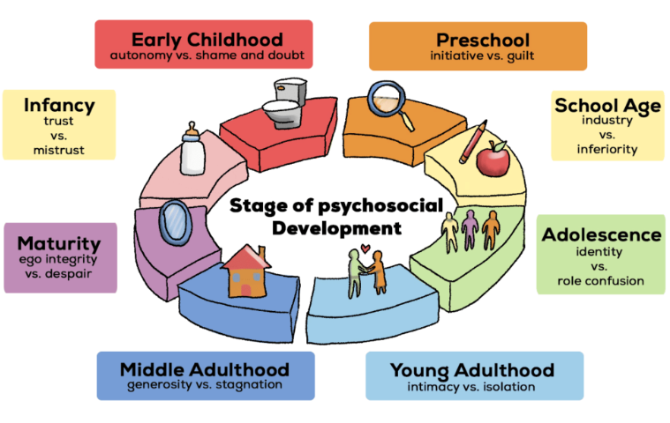
Figure 2: Erikson's Psychosocial Theory
Source: (Erikson, 1968)
Overview of Erikson's Psychosocial Theory

The Psychosocial Theory of Development was developed by Erik Erikson as the explanation of the way people develop through thematic stages of development, which are eight in the lifelong continuum. Every stage consists of a psychosocial conflict that has to be overcome to ensure healthy emotional, psychological and social growth (Erikson, 1968). In adolescence, the fifth stage, Identity versus Role Confusion, is critical since at this age, the youths start to discover who they are, what they think and how they can fit in society. At this age, young people want to be free of their parents; they become more affected by their peers, school and community. Effective conflict resolution will lead to a high level of identity, confidence in self and personal orientation (Qamar et al., 2026). Nevertheless, this lack of creating a distinct identity could culminate in confusion, indecision and low self-worth.

Erikson was of the opinion that identity is shaped by personal experiences as well as by the social environment. The teens take an active role in experimenting with various interests, values and relationships before a stable sense of self is established. Through this, they are made ready to join adulthood because they get ready to be confident and emotionally mature (Erikson, 1968). The theory by Erikson is thus a very useful theory to explain the issues surrounding adolescent mental health as it helps to explain how the social environment shapes self-esteem, confidence and wellbeing as well as emotional state at such a critical period of growth.

Application of Erikson's Theory to Social Media and Mental Health

Social media can be effectively explained in the context of Erikson's theory since online settings are critical environments in which adolescents are able to experiment and define what is needed. Social media has become a tool used by many adolescents to express their likes, views, success and experiences in life, in search of acceptance by friends and online communities (Rorije et al., 2023). Confidence can be enhanced through positive interactions, encouraging comments and healthy friendships, which should enhance self-expression and a positive sense of identity. Adolescents can also find people with whom they can relate through social media, which makes them feel accepted and less lonely.

But at the same time, social media can pose considerable difficulties with identity development. Teenagers are often subjected to selectively filtered images, unreal lifestyles and perfect standards of beauty and success (Yuen and Santo, 2025). The continuous comparison to influential individuals, celebrities and peers can lower self-esteem and develop a feeling of dissatisfaction with either appearance or accomplishments. The youths can also feel pressure to display a perfect image online so as to pass the test of likes, comments and followers. The negative online experiences such as cyberbullying, criticism and social exclusion may even increase stress and depression as well as anxiety (Abubakar, 2023).

Critical Evaluation of Erikson's Theory

The Psychosocial Theory proposed by Erikson has a number of strengths in explaining the connection between social media and mental health among adolescents. The first strength is that it is specific to adolescence as the identity-building stage and would become quite relevant to studying the effects of online experiences on self-esteem and emotional well-being (Erikson, 1959).

Although these are the strengths, the theory has shortcomings as well. Erikson fails to give a concrete reason why certain adolescents are more resilient to negative online experiences than others. Personality, family relationships, mental health history and individual coping strategies are other factors that can affect the impact of social media on psychological well-being (Rorije et al., 2023). Moreover, the theory was formulated before the advent of digital technology and as such fails to specifically take into account the special pressures posed by new social media technology.

Conclusion

The impact of social media on adolescent mental health is also a complex one with both positive and negative consequences instead of completely negative or positive ones. On the other hand, in addition to strengthening the bond between friends, allowing them to express themselves or share their feelings, and giving them emotional support, overuse, cyberbullying and social comparison can also lead to feelings of anxiety, depression and low self-esteem. The essay has discussed these effects through the use of the Attachment Theory of Bowlby and the Psycho-social Theory of Erikson. The theory by Bowlby shows that early attachment relationships affect the emotional reactions of adolescents to online activities in the same way as the theory by Erikson describes the influence of social media on identity development and the self-esteem of adolescents. A combination of these theories gives a more comprehensive insight into the reasons why teenagers are impacted by social media in a different manner, and why certain ones are more susceptible to its adverse influence.

References

Abubakar, B.U. (2023) “Erik Erikson’s Psychosocial Theory: As a Tool for Promoting Early Childhood Education in Nigeria,” African Journal of Humanities and Contemporary Education Research, 10(1).
Bowlby, J. (1988) “A Secure Base: Parent-Child Attachment and Healthy Human Development. London: Routledge.” DOI:10.1080/14616730210154216
Erikson, E.H. (1959) “Identity and the Life Cycle,” New York: International Universities Press. https://doi.org/10.1080/21674086.1960.11926165
Khadka, C. (2022) “The evolution of attachment theory: From Bowlby to modern perspectives,” TUTA Journal, pp.125-140. DOI:10.3126/tutaj.v10i1.74328
Nguyen, H.T., Vu, T.V., Nguyen, V.H.A., Hua, T.D. and Tran-Chi, V.L. (2024) “Exploring the impact of social networking usage on attachment styles and mental health: a study among college students in Vietnam,” Multidisciplinary Reviews, 7(8), p.2024172. DOI:10.31893/multirev.2024172
Qamar, R., Farooq, A. and Zarar, M. (2026) “Erik Erikson's Psychosocial Development Theory on Frankie McGrath's Character in Kristin Hannah's The Women,” Liberal Journal of Language & Literature Review, 4(2), pp.1904-1917.
Robledo, J.P., Cross, I., Boada-Bayona, L. and Demogeot, N. (2022) “Back to basics: A re-evaluation of the relevance of imprinting in the genesis of Bowlby’s attachment theory,” Frontiers in Psychology, 13, p.1033746. https://doi.org/10.3389/fpsyg.2022.1033746
Rorije, M., Damen, S., Janssen, M.J. and Minnaert, A. (2023) October “Applying Erikson’s theory of psychosocial development to understand autonomy development in children and youths with deafblindness: a systematic literature review,” In Frontiers in Education (Vol. 8, p. 1228905). Frontiers Media SA. DOI:10.3389/feduc.2023.1228905
Safaria, T. and Amanah, P.A. (2026) “Attachment patterns and socio-emotional predictors of problematic social media use: a machine learning approach,” Mental Health and Digital Technologies, 3(1), pp.85-106. https://doi.org/10.1108/MHDT-08-2025-0053
van der Horst, F.C., van Rosmalen, L. and van der Veer, R. (2025) “The American contribution to attachment theory: John Bowlby’s WHO trip to the USA in 1950 and the development of his ideas on separation and attachment,” Attachment & Human Development, 27(5), pp.662-683. DOI:10.1080/14616734.2024.2342665
Yuen, C.N. and Santo, J.B. (2025) “Erikson's Psychosocial Theory,” https://nsuworks.nova.edu/cgi/viewcontent.cgi?article=1064&context=edp/

