Understand the structure and function of the circulatory system

Task 1: Describe the function of the heart. (1.1)

The function of the heart is to pump oxygenated blood around the body to ensure all the organs and working tissues, the heart also pumps nutrients around the body.

Task 2: Using the image and space below, describe how blood moves through the four chambers of the heart and the stages of systemic and pulmonary circulation. (1.2, 1.3)
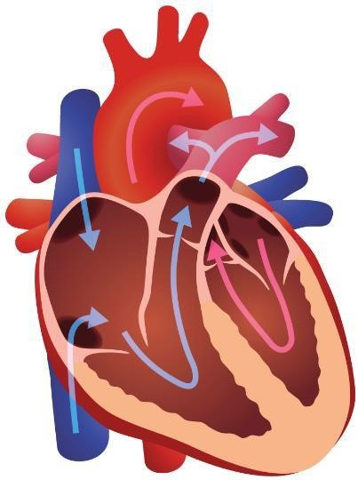
Description of blood flow:
There are 4 chambers where bloody flow occurs in the heart
1 – bloody flows from the right atrium to the right ventricle – deoxygenated blood returns to the right atrium from the body the right atrium then contracts causing blood to flow through the tricuspid valve into the right ventricle.
2 – the right ventricle then contracts and causes the deoxygenated blood to pump through the pulmonary valve into the pulmonary arteries this carries the blood into the lungs. This is then where pulmonary circulation occurs.
3 – the blood enters the left atrium, when the left atrium contracts it forces blood through the bicuspid valve into the left ventricle.
4 – the left ventricle as the strongest wall, this then means the left ventricle pumps the oxygenated bloody through the aortic valve into the aorta this process is then complete, and oxygenated blood is pumped around the body this process is constantly repeating itself. (systemic circulation)
Systemic and pulmonary circulation:
The pulmonary circulations the flow of deoxygenated blood from the right ventricle to the pulmonary artery to the lungs to be oxygenated and then transported back to the left atrium via the pulmonary vein.in the lungs the blood releases co2 and picks up o2 which then causes the bloody to be oxygenated.

The systemic circulation is the flow of oxygenated blood from the left ventricle to the body’s working tissues via the Aorta and the return of deoxygenated blood to the right atrium via the superior/inferior Vena Cava.

Task 3: Describe the structure and functions of blood vessels. (1.4)

Structure | Functions
Artery - One of the blood vessels is artery the structure of this is they have thick smooth (involuntary) muscular walls, smooth muscle contracts to push blood along the vessels, there are no valves as blood flows through them in one direction under very high pressure.  There is three layers tunica intima – inner layer  The tunica media – middle layer  Tunica externa - outer layer.  Vein - Use skeletal muscle contraction to help push blood back to the heart, as well as smooth muscular contraction called peristalsis. They work under low pressure. Thinner walls and larger lumen than arteries. Have non-return valves, which ensure blood flows in one direction back to the heart.  Capillary - Capillaries are found in capillary beds that carry blood through an organ or a tissue from arterioles to the venule. Have walls which are one cell thick to allow gaseous exchange, in and out of the body’s tissues. Smallest blood vessels out of the three. | Artery – it carries blood away from the heart and carries oxygenated blood an example of an artery could be an aorta this is the biggest artery in the body.  Vein – veins carry blood towards the heart, they carry deoxygenated blood with exception of pulmonary vein, the biggest vein in the body is the vena cava.  Capillary - Microscopic vessels where exchange of gases, nutrients, and waste occurs.

Task 4: Explain what blood pressure is and identify the different types of blood pressure classifications. (1.5, 1.6)

Blood pressure
Blood pressure is the force that the circulating blood exerts on the walls of the arteries, it is created by the pumping action of the heart and the resistance of the blood vessels. The reading is measured with two numbers, for example 120/80mmHg, these represent systolic and diastolic pressure.
Systolic – This should be the higher of the two numbers and is recorded first. It is the measurement of pressure once the left ventricle has contracted and blood is pumped into the aorta, exerting force on the walls of the vessel. The optimum figure is around 120mmHg.
Diastolic – This is when the measurement is taken whilst the heart is during the resting phase and is refilling with blood. The pressure against the artery wall is much lower, and the optimum figure is usually 80mmHg, it is the smaller number and is recorded second.

Blood pressure classifications
There are many different blood pressure classifications such as:
- Normal blood pressure – systolic – less than 120mmhg, diastolic less than 80mmhg this is a healthy blood pressure.
- Elevated blood pressure – systolic 120-129mmhg, diastolic less than 8-mmhg this blood pressure classification is not classified as a high blood pressure yet but a higher risk of developing hypertension.
- Hypertension stage 1 – systolic – 130-139mmhg, diastolic 80-89 this is now classed as high blood pressure it may require lifestyle changes and medication.
- Hypertension stage 2 – systolic - 140 mmHg or higher, Diastolic: 90 mmHg or higher this is very high blood pressure and requires medical treatment.
- Severe hypertension – systolic 180 or higher, diastolic – 120 or higher, requires serious medical treatment.

Learning outcome 2
Understand the structure and functions of the respiratory system
Task 1: Look at the image below. Using the image and spaces provided, label and describe the structure and function of the respiratory system. (2.1)

Top to bottom labelled:
1 – Pharynx
2 – Larynx
3 – Trachea
4 – Alveoli
5 – Bronchus
6 – Bronchioles
7 – Left lung
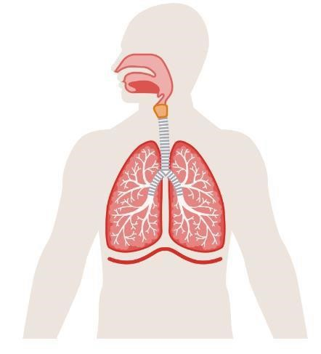
Structure
The respiratory system moves air from the nose → pharynx → larynx → trachea → bronchi → bronchioles → alveoli (the bronchi sub-divides into smaller passages called bronchioles. At the end of the bronchioles there are large numbers of alveoli (air sacs). These alveoli are surrounded by a dense network of capillaries and are the site where the diffusion of gases between the alveoli and capillaries takes place)., where oxygen and carbon dioxide are exchanged. Muscles like the diaphragm assist by creating pressure changes that allow breathing.

Function
The main functions of the respiratory system are to provide a route by which the supply of oxygen present in the atmosphere enters the body and provide a route for carbon dioxide to be expelled as a waste product. The lungs which are in the chest cavity are the site of diffusion of gases into and out of the bloodstream

Task 2: Identify the main muscles involved in breathing
The main muscles that are involved in breathing are the diaphragm, a large dome-shaped muscle under the lungs and the intercostal muscles that are between the ribs. The action of breathing is controlled by the autonomic nervous system, which means that we do not have to consciously think about it every time we want to take a breath in or breathe out. During times of laboured breathing. For example, during exercise the diaphragm is assisted by smaller muscles such as the internal and external intercostal muscles. When breathing during exercise the diaphragm is assisted by the intercostal muscles, obliques, rectus abdominis, and transverse abdominis to push out (exhale) carbon dioxide more forcefully and quickly than when at rest.

Task 3: Describe the route of air through the respiratory system.
The route of air through the respiratory system begins within the nasal cavity, air enters through the nose, next the air travels through the pharynx (throat), the air then travels from here to the larynx (voice box) the epiglottis ensures air goes into the larynx and not into the oesophagus, next the air then travels from the larynx to the trachea (wind pipe) then into the bronchi then towards the Bronchioles within the lungs, bronchi branch into smaller tubes called bronchiole and then finally into the alveoli this is the end of the rote of air through the respiratory system.

Task 4: Describe the process of gaseous exchange. (2.4)
Gaseous exchange is the process where oxygen and carbon dioxide are exchanged within the lungs and muscle tissue. Gaseous exchange within the lungs occurs between the alveoli and surrounding capillaries. Oxygen passes through the alveoli to the surrounding capillaries through the capillary wall (which is one cell thick, the same as the walls of the alveoli which allows gases to pass through them). This oxygen is then transported through the circulatory system via blood which carries millions of red blood cells. These are made up of haemoglobin and are our oxygen carriers.

Learning outcome 3
Understand the structure and functions of the skeleton
Task 1: The skeleton provides vital structure to the human body. Below, describe the basic functions of the skeleton. (3.1)
Protection - Protection of the vital internal organ such as the rib cage protecting the lungs or the cranium protecting the brain.
Movement – Our bones provide levers for movement; the skeleton allows us to move.
Shape/support - Bones provide a supported framework for the body and our shape. An example of this could be the mandible – it shapes our jawline.
Production - Within some long bones, red marrow produces white blood cells, red blood cells and platelets some examples of the long bones could be the femur or the tibia.
Muscle attachment – Without the bones the muscles and ligaments will not be able to attach to anything, so the skeleton provides them with attachment and provides surfaces for soft tissue attachments.
Storage – Bones act as storage reservoirs for minerals such as calcium.

Task 2: Using the images below, identify the bones of the axial and appendicular skeleton. (3.2)
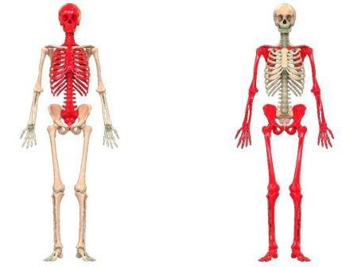

Image on left – labelled from top to bottom
- Cranium
- Neck Bones
- Sternum
- Spine
- Vertebra
- Coccyx

Image on right – labelled from top to bottom
- Clavicle
- Scapula
- Humorous
- Ulna
- Radius
- Carpals
- Ischium
- Phalanges
- Femur
- Patella
- Fibula
- Tipula
- Meta-Tarsals
- Phalanges

Task 3: Identify the different classification of bones. (3.3)
1. Irregular bones – have no set shape
2. Short bones - Cuboid in shape, being as wide as they are long.
3. Long bones - Are longer than they are wide and these bones act as levers to create movement, produce blood cells and store minerals
4. Sesamoid bones – small bones that develop along with tendons.
5. Flat bones – flat and have large surface area.

Task 4: Describe the main features of a long bone. (3.4)
The main feature of long bone is that they have bone marrow inside of them which produces white and red blood cells and platelets, they also store minerals and act as levers for the body to be able to move. An example of a long bone could be the femur or the humorous.

Task 5: Describe the stages of bone growth. (3.5)
Stage1 of bone growth is within the first 2 months, the foetus is formed out of cartilage, the second stage of bone growth is at 2 – 3 months, in this stage the foetus Around the cartilage periosteum develops. Blood, nutrients and minerals are transported to the middle of the bone. The primary ossification centre develops, where osteoblast cells start to build the diaphysis structure. Then there's the third stage which takes place during childhood in this stage of bone growth continues to develop and the primary ossification centre divides and Spongy bone develops at secondary ossification sites. Last stage of bone growth is during adolescence the growth plates ossify and then become epiphyseal lines this is usually around the age of 18 – 21.

Task 6: Describe the varying types of posture in terms of: (3.6)
Postural term | Description
Curves of the spine | Curves of the spine – kyphosis, When the kyphotic curve is excessive, we refer to this as someone having kyphosis. This occurs from people having bad posture when sitting down or driving.
Neutral spine alignment | Neutral spine alignment means holding your spine in its natural, healthy curve and they are not overly arched, rounded, or twisted. It’s the position where your body is most balanced, stable, and efficient, with the least stress on muscles and joints.
Movement  potential of the spine | This means how freely you can move your spine and the range of motion and flexibility you have in your spine.
Postural deviations | The different postural deviations of the spine are, Lordosis, Flat Back, Kyphosis and Scoliosis.

Learning outcome 4
Understand joints in the skeleton
Task 1: Identify the classifications of joints. (4.1)
1. Synovial – free moving joints
2. Cartilaginous – slightly movable
3. Fibrous - fixed/fused

Task 2: Describe the structure of synovial joints. (4.2)
Synovial joints are the most common and freely movable joints in the body they are also the most unstable joint in the body for example the knee.
Their structure is specialized to allow smooth movement while maintaining stability.

Task 3a: Using the table below, identify the types of synovial joint and their range of motion.(4.3)
Synovial joint | Joint type | Range of motion available
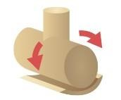 | Hinge joint | Movement in one plane, flexion and extension.
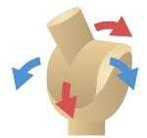 | Saddle joint. | Movement in two planes, flexion and extension and abduction and adduction.
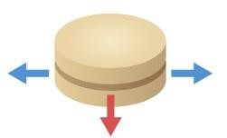 | Plane joint | Gliding movements only. E.g. wrist
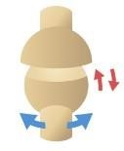 | Ball and socket joint | The range of movement for ball and socket is a lot, flexion and extension, abduction and adduction and rotation and circumduction.
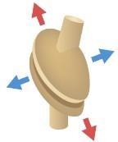 | Ellipsoid joint | Movement in two planes, flexion and extension and abduction and adduction.
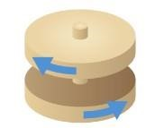 | Pivot Joint. | Rotation around one axis. E.g neck.

Task 3b: Describe joint movement potential and joint actions. (4.4, 5.6)
Joint action | Description | Joint example, eg wrist | Muscle example, eg quads
Flexion and extension | Flexion – is a bending movement that decreases the angle between two bones at a joint. Bending  Extension – is the opposite flexion and it increases the angle between two bones at a joint. Straightening | Elbow  Knee | Bicep brachii /Triceps brachii  Quadricep /hamstring
Adduction and abduction | Abduction – is any movement away from the body  Adduction – is any movement towards the body | Shoulder | Deltoid
Circumduction | A circular movement e.g. cricket bowl.  It involves abduction/adduction and flexion/extension. | Shoulder  Hip | Deltoid
Supination and pronation | Supination – is turning the palm up.  Pronation – is turning the pal down | Ulna (forearm) | Bicep brachii  Triceps brachii
Plantar flexion and dorsiflexion | Planar flexion – pointing toes down.  Dorsiflexion – is the movement of the toes pointing up. | Ankle | Gastrocnemius (calf)
Lateral flexion and reduction | Lateral flexion – is the movement of the spine bending sideways.  Reduction – is the movement of the spine returning back upright. | Spine (thoracis and lumbar) | Obliques
Horizontal flexion and extension | Horizontal flexion – is the movement when the arm moves across the body.  Horizontal extension – is the movement of the arm moving away from the body | Shoulder | Pectorals  Deltoid
Elevation and depression | Elevation – lifting a body part upwards  Depression – moving a body part downwards. | Scapular | trapezius

Task 4: Identify the body’s anatomical planes of movement. (4.5)
1. Sagittal plane – body gets split into two halves, left and right
2. Transverse plane – divides the body into upper and lower.
3. Frotal plane – divide the body into front and back.

Task 5: Define the anatomical terms of location. (4.6)
Table heading | Table heading
Distal | This means away from the point of the centre of the body or the point of origin.
Proximal | Closer to the centre of the body or the point of origin of a limb or structure
Anterior | This refers to the front or the direction towards the front of the body.
Posterior | This refers to the back of the body or the direction towards the back of the body.
Inferior | A position that is low or closer to the feet compared to anything else.
Superior | It means towards the head or the top of the body
Deep | It means further away from the body's surface, more internal.
Superficial | A body part located closer to the surface of the body.
Medial | This means closer to the midline of the body
Lateral | This means further away from the midline of the body.

Task 6: In the table below, describe the exercise variables and their effects on biomechanics and kinesiology. (4.7)
Exercise variable | Description | Effect on exercise
Levers | Lever is a structure that in most cases is a bone, muscle applies force on the lever to allow the lever to move, there are three different types of levers, fulcrum, load and effort. The effort is the muscle that is being used to allow the lever to be able to move, the load is the thing limb/object being moved and the fulcrum is the joint. | Levers provide the body with mechanical advantage to either increase force or increase speed/range of motion.
Centre of gravity | The point where the body's mass is evenly distributed. Changes with body position, movement, and external load. | It has a significant effect on balance, stability and efficiency which could lead to positive or negative outcomes in exercise.
Momentum | Momentum is how much motion an object has.  Mass x velocity | The more mass or velocity the more momentum, this would be good for sprinting o rugby, the lower the momentum the more stability you have.
Force | Force = mass x acceleration.  A push or pull created by muscles or exerted loads. | It can help improve your power during exercise; it can also allow you to lift heavier weights.

Learning outcome 3
Understand the muscular system
Task 1: Describe the characteristics and functions of the body’s 3 types of muscle. (5.1)
Muscle cell | Muscle type | Function | Characteristic
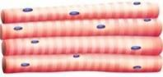 | Skeletal muscle | It is responsible for voluntary movement in body, moves bones at joints to allow actions like walking. | Voluntary muscle that is attached to the bones, striped long fibres.
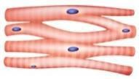 | Cardiac muscle | Found in the heart, pump blood through the body involuntary. | Involuntary muscle found in the heart wall, striped branched fibres.
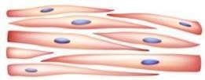 | Smooth muscle | Controls internal processes like digestion and found in internal organs | Involuntary muscle located in the walls of internal organs.

Task 2: Describe the basic structure of skeletal muscle. (5.2)
The skeletal muscle structure is made up of 70 percent water, 23 percent protein and 7 percent minerals, skeletal muscle is made up of several structures or layers. Each layer is made up of smaller and smaller pieces forming the smallest structures in the centre to the larger structures on the outside.

Task 3: Using the images below, identify and locate the anterior and posterior skeletal muscles.
(5.3)
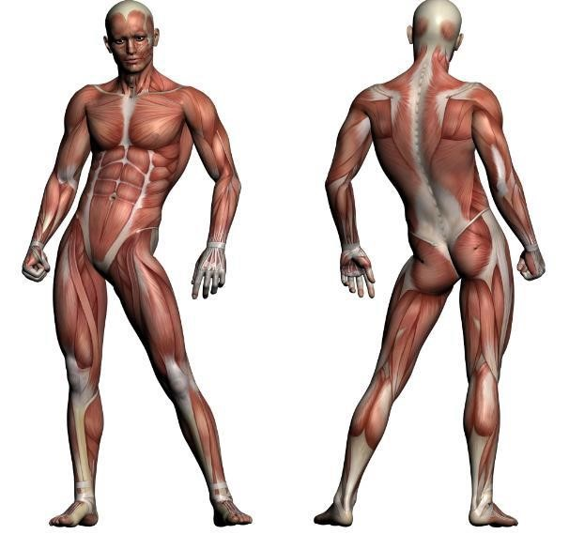
(
Muscles located within this
area under overlying
muscles)

Anterior – labelled from top to bottom:
1 – Deltoid
2 – Pectoral
3 – Bicep brachia
4 – Internal & External Obliques
5 – Rectus Abdominis
6 – Iliopsoas
7 – Adductors
8 – Quadriceps
9 - Tibialis Anterior

Posterior – labelled from top to bottom:
1 – Trapezius
2 – Rhomboids
3 – Triceps brachia
4 – Latissimus dorsi
5 - Erector Spinae
6 – Gluteus maximus
7 – Abductors
8 – Hamstrings
9 – Gastrocnemius
10 - Soleus

Task 4: Describe the structure and function of the pelvic floor muscles. (5.4)
The pelvic floor muscles form a supportive hammock like structure at the bottom of the pelvis, known as the pelvic diaphragm. They place a crucial role in supporting pelvic organs such as bladders, intestines. They aid with essential body functions like urination and childbirth they also assist with defecation.

Muscle action Muscle action type and description | Muscle action Muscle action type and description
Movement  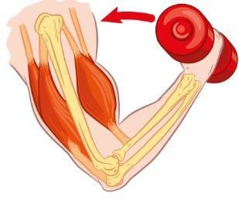 | This muscle action is flexion as the muscle is shortening and the angle of the bones at the elbow is decreasing, the muscle action for this exercise is concentric this also because the muscle is shortening.
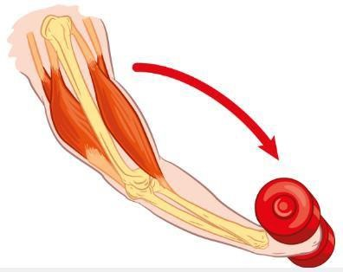  Movement | The muscle action for this image is extension as the joint is straightening and the angle is increasing, the muscle action type is eccentric as the muscle is extending.
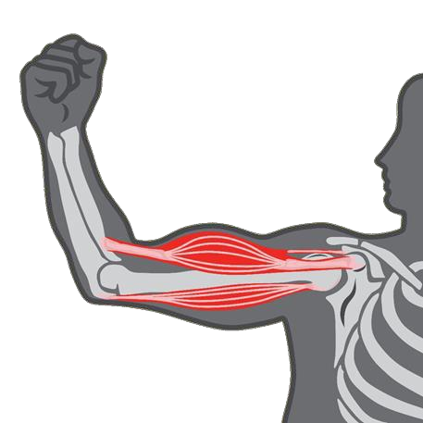  No m  ovement | The muscle action for this image is isometric, this is because there is no movement but there is force.

Muscle fibre | Description of characteristics
Type 1 | Type 1 is the slow twitch muscle fibre, this type has a small muscle diameter and is red, it allows athlete to take part in cardiovascular sports for longer periods as it increased the oxygen delivery, it relies on aerobic energy to fuel movement. It is very fatigue resistant and high endurance.
Type 2 | Type 2 A is a fast twitch muscle fibre that is a combination of speed and endurance, this is because they use both aerobic and anaerobic energy, they have moderate fatigue resistance, and it is good for team sports such as rugby or football.
Type 2 | Type 2 b is also a fast twitch muscle fibre but is just useful for speed and power, they are the fastest and most powerful fibre, but they fatigue very quickly, it uses anaerobic energy and is very helpful for weightlifting and jumping.

Learning outcome 6
Understand the life course of the musculoskeletal system and its implications for special populations’ exercise
Task 1: Describe the life course of the musculoskeletal system and its implications for exercise for the below special populations: (6.1)
Special population | Life course changes | Implications for exercise
Young people (13-18 years) | Some life course changed for this age is that there is often a rapid growth of bones, muscles and connective tissues, increase in muscle mass due to hormonal changes, The chambers of this age groups heart are smaller and therefore less powerful than an adult’s which results in a higher heart rate. As their stroke volume is reduced the heart needs to work harder to pump oxygenated body to the working muscles and tissues. This age group are less efficient at processing oxygen and need a higher intake of oxygen for aerobic activity. | For people this age, there are implications of exercise like avoiding heavy weights as this can cause stress on the growth of bones and muscles and cause further problems in the future instead of heavy weights do lighter weights with the correct technique this will not cause stress on the body.  Participation in sport to keep in shape is also another one.
Antenatal and postnatal women | During pregnancy the pelvic floor muscles weaken. Also, during pregnancy blood volume increases by 30%, but becomes diluted, so there are less red blood cells (cells that transport oxygen). During pregnancy, stroke volume, heart rate and consequently cardiac output increases. Heart rate and increased blood volume are the main factors in determining the increasing cardiac output. | During antenatal and postnatal it is advised to focus on posture and core stability also focus on pelvic floor strengthening and avoid high impact and contact sports as his can affect women negatively also another implication could be taking part in low aerobic exercises like walking.
Older adults (50+ years) | When aging something called Osteoarthritis occurs this is when the degeneration and wearing away of the articular cartilage thus exposing bone, which creates joint pain and can lead to a reduction in range of movement. | Low intensity exercises help with osteoarthritis as it reduces pain within the joints and helps the older adults stay moderately active.

Learning outcome 7
Understand energy systems and their relation to exercise
Task 1: Describe how carbohydrates, fats and proteins are used in the production of energy. (7.1)
Macronutrient | Description
Carbohydrate | Carbohydrates get broken down into glucose, which is then used to produce ATP which is the bodies energy currency.  Carbohydrates are used for high intensity exercise and provide the body with the energy to be able to take part in fast, short bursts of exercises like sprints and weightlifting.  (Starchy based foods i.e. pasta. rice, bread) – give us sugars, called glucose which is broken down and stored in our muscles and liver as glycogen.
Protein | Protein is broken down into amino acids, if needed this can be broken down into ATP to provide the body with energy however it is usually the last resort for energy. It is usually used to repair any micro tears in the muscles of the body and building muscle.  (meat, animal by-products, eggs)
Fat | Fat is broken down into fatty acids and glycerol, which then enters the Krebs cycle and produces ATP, fats are slow releasing sources of energy and provide long lasting source of energy.  (dairy products, meats, nuts) – give us triglycerides, which are broken down into fatty acids to release energy. They are an energy dense fuel source; containing twice as many kcals as proteins and carbohydrates.

Task 2: Explain the use of the 3 energy systems during aerobic and anaerobic exercise. (7.2)
Table Energy system | Explanation
ATP-PC | Exercising for a short period of time (0 to 10 seconds) requires an immediate source of energy to remake adenosine tri phosphate or ATP. The creatine phosphate system is the first energy system in which ATP is resynthesized and is anaerobic. When our body senses that we are beginning to exert maximal effort, it breaks down creatine phosphate for energy to resynthesize ATP, which is used up during maximal intensity. This energy system is the fastest way to produce energy, so it is used in exercises like sprinting and heavy lifting.
Aerobic | The aerobic energy system requires oxygen (aerobic) When oxygen is present, glucose can be completely broken down into carbon dioxide and water, in a process called aerobic respiration. Fatty acids and glucose are the main macro-nutrients used in aerobic respiration. Aerobic respiration takes more chemical reactions to produce ATP than either of the other systems. This energy source takes the longest but can also maintain for the longest so kt is used during exercise lie marathons.
Anaerobic glycolysis | The anaerobic energy system is also anaerobic. It releases the glucose in muscle glycogen; this glucose is broken down into lactic acid to release ATP. This process is constant and only becomes an issue when there is a large build-up of lactic acid. This lactic acid is the by-product from this system and creates the onset of blood lactate accumulation. This is the point at which lactate build up is greater than the muscles ability to remove it causing muscle pain or a ‘burn’ which in turn forces the participant to stop. The lactate system only lasts up to 60 to 180 seconds of maximum effort and is the primary fuel source for short distance runs like 200 – 400M races.

3: Identify the by-products of the 3 energy systems and describe their role in muscle fatigue. (7.3)
By-product | Role in muscle fatigue
ATP – PC system  Creatine | Fatigue occurs very quickly because phosphocreatine stores are very limited. It usually lasts 0–10 seconds).
Anaerobic glycolysis  Lactic acid | Lactate acidified the muscle, which causes a burning feeling in the muscle and can lead to cramps. it reduces enzyme activity and the ability of the muscles to be able to contract efficiently.
Aerobic  Carbon dioxide and water | This has a very small contribution to muscle fatigue usually the reasons for fatigue in this scenario is dehydration or glycogen depletion.

4. Define anabolism, catabolism and excess post-exercise oxygen consumption (EPOC).

Anabolism | Anabolism is the process of when small molecules and built up into bigger molecules, some examples of this could be building muscle tissue after exercise or tissue repair and growth.
Catabolism | This is essentially the opposite of anabolism, it is the process of bigger molecules breaking down into smaller molecules to release energy, an example of this could be breaking down fats into fatty acids.
EPOC | EPOC stands for Excess Post-Exercise Oxygen Consumption.  It is the amount of extra oxygen your body uses after exercise, it replenishes your body, removes lactic acid, repairs micro tears in muscles and restore ATP and phosphocreatine levels.

Learning outcome 8
Understand the nervous system and its relation to exercise
Task 1: Describe the role and functions of the nervous system. (8.1)
Role | Functions
The nervous system acts as a communication network within the body; its role is to detect and respond to changes inside and outside of the body. Changes are detected by a series of sensory receptors from both the internal and external environment. This information is then sent to the brain for analysis through a series of communication networks, from here an appropriate action (response) will be sent.  The main role of the nervous system is to control and co-ordinate the bodies activities and allow the body to be able to response to external and internal stimuli. | The main functions of the nervous system include the sensory input, the integration and the motor output.  The sensory input detects stimuli inside and outside the body, the sensory receptors monitor detect sound, touch, temperature, pressure.  The integration processes the information given by the sensory input and then stores information and makes decisions and prepares a response.  The motor output allows us to move our limbs, a signal is sent from the brain to the nervous system to allow us to move freely, it activates glands and muscles to create a response.

Task 2: Describe the principles of muscle contraction. (8.2)
Muscle contraction is caused by the sliding filament theory, muscles are made from sarcomeres which contain actin – thin and myosin – thick filament, when the muscle is contracting myosin heads attaches to actin then myosin pulls actin inwards and causes the sarcomere to shorten which causes the muscle contraction, also the nervous system has a huge role in muscle contraction because the motor output send an electrical signal to the muscle which causes the contraction, calcium also plays an important role to muscle contraction, it allows myosin you bind to actin by moving tropomyosin away from the binding sites, muscle contraction would not be possible without calcium. ATP also allows muscles to not remain locked and allows them to contract.

Task 3: Explain the ‘all or none law’/motor unit recruitment. (8.3)
This law means that the muscle fibre will either contract fully or not at all, this is because single muscle fibre do not just partially contract, if the stimuli does not reach a certain threshold then the muscle wont contract at all, the stimulus needs to reach a specific threshold and when it does reach it the muscle fibres will contract fully, so the stimulus threshold must be strong enough to contract muscles and partial contractions are not possible.

Task 4: Identify how exercise can enhance neuromuscular connections and improve motor fitness. (8.4)
Motor skill training is a recognised method of developing and training the nervous system for example plyometric training such as bounding, hurdles and speed ladders. As motor skills are learnt, sequences of movements are developed ensuring the actions required to perform specific tasks are smooth and efficient. As they are learnt skills this means they can be trained, developed and ultimately improved.
An increase in the number of aerobic enzymes, stored glycogen and triglycerides in the muscle fibres and it is also known for increasing the diameter of the recruited fibres (hypertrophy) due to an increase in the myofilaments within the fibres. Exercise is known for increasing the glycolytic activity of the muscle allowing more work to be performed under anaerobic conditions or high stress condition.

Learning outcome 9
Understand the structure and function of the digestive system
Task 1: Describe the function of each section of the digestive system. (9.1)
Table heading | Table heading
Mouth | The mouth is the start of the digestive system, food enters through the mouth, then in the mouth the teeth chew the food, which breaks it down into small pieces then allows it to be swallowed.
Oesophagus | The oesophagus is the transport tube of food and liquid into the stomach.
Stomach | The stomach can store food temporarily after it is travelled through the oesophagus, it them mixes and chemically digest the food and turns into a thick liquid called chyme, enzymes break down proteins in the stomach into smaller molecules.
Small intestine | The small intestine completes the chemical breakdown of food using enzymes from the pancreas and bile from the liver before passing through to the large intestine.
Large intestine | The large intestine main functions are water absorption, converting waste into solid stool for elimination and waste storage which is when it holds faeces until they are eliminated via the rectum and anus.

Task 2: Describe how fats, proteins and carbohydrates are digested and absorbed. (9.2)
Macronutrient | Enzymes used | Time scale | Location
Fat | Lipase from the pancreas.  Bile from the liver | Usually around 2 hours. | The location for fats is the small intestine, breaks up into fatty acids.
Protein | Pepsin in the stomach.  Trypsin from the pancreas. | 2-6 hours usually. | In the stomach and the small intestine.
Carbohydrate | Salivary amylase. | 1- 4 hours. | Mouth, saliva starts to break it down.

Task 3: Describe the role of dietary fibre in the maintenance of gut function. (9.3)
Dietary fibre is an indigestible part of pant food, it passes through the digestive system largely intact, it adds bulk to stool, so this means that it helps prevent constipation. It also makes the digestive flow a lot healthier, slows digestion, helping regulate nutrient absorption and maintain steady blood sugar levels and reduces risk of digestive disorders.

Task 4: Describe the role of the liver and pancreas in digestion.
The pancreas plays a role in digestion by producing digestive enzymes to break down carbohydrates, fats and proteins. The liver produces bile which contains salts that help break down large fat globules into smaller ones, it emulsifies fats to help the digestion process.

Task 5: Explain the importance of maintaining fluid levels for health and exercise performance.
(9.5)
Level of performance | Explanation | Role of water
Health | The reason why maintains fluid levels is so important for your health is because your body will not be able to function without proper fluid levels, it ensures organs like the heart and kidney work correctly and efficiently, without maintaining fluid levels it can lead to serious health issues. | Water is essential for every bodily function; it transports nutrients and waste. It also regulates temperature of your body and helps digestion and aids your brains functions and performance.
Exercise performance | The reason why maintaining fluid levels during performance is essential is because dehydration reduces blood volume which then means your heart has to work harder, which will fatigue you quicker because it decreases oxygen delivery which can lead to cramps are less strength and power during the performance which has a negative impact on exercise performance. | Water regulates the body temperature allowing exercise performance to continue, it prevents dehydration which leads to cramps, loss of strength and fatigue, it helps aid exercise performance and allows you to exercise for longer periods.

