Blogging to communicate

Elitsa Ivanova
Student ID:2123375
Assignment 1
LCBB4004 Marketing Fundamentals

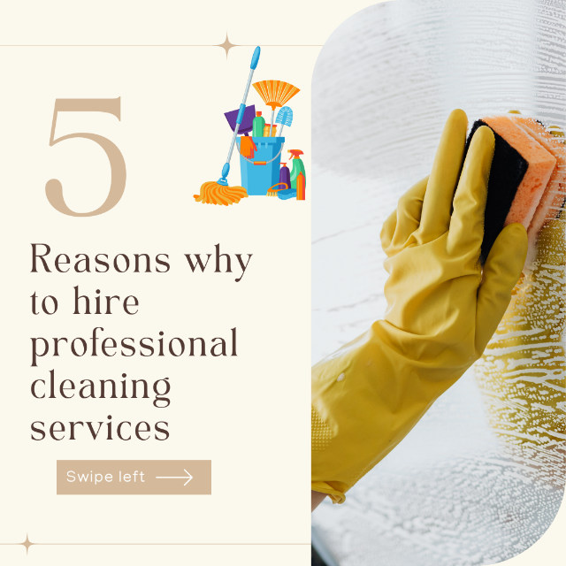
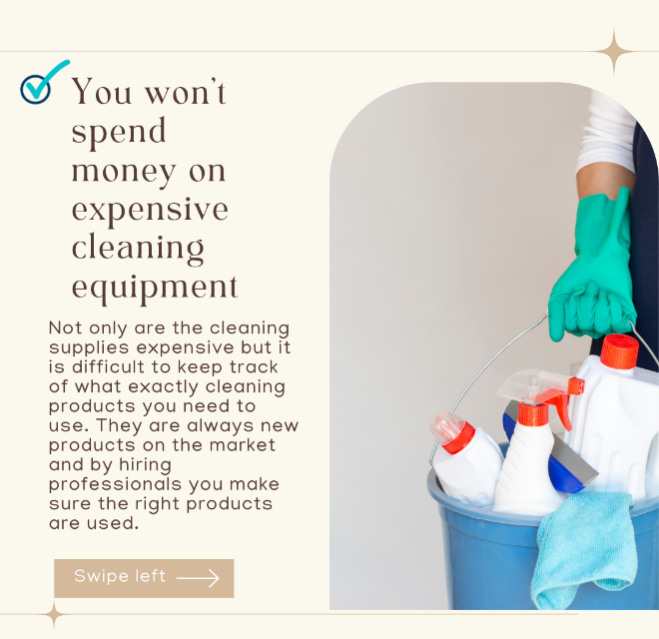

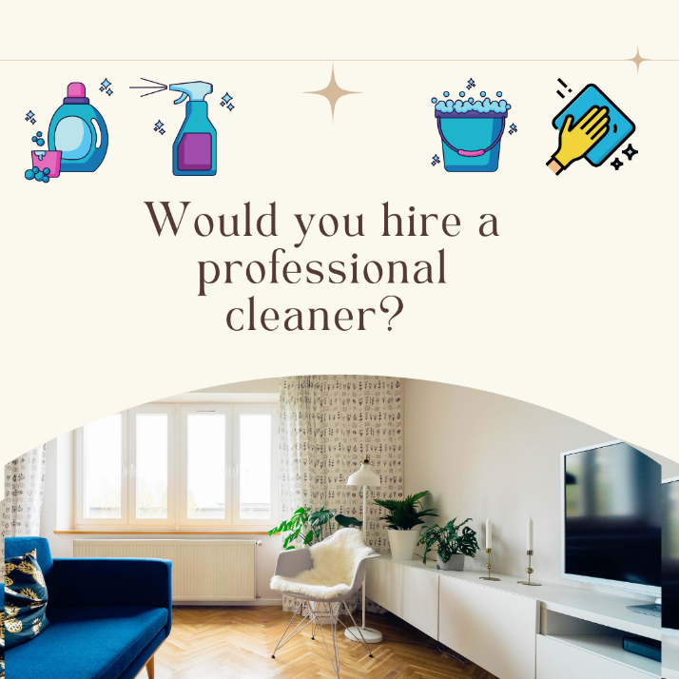
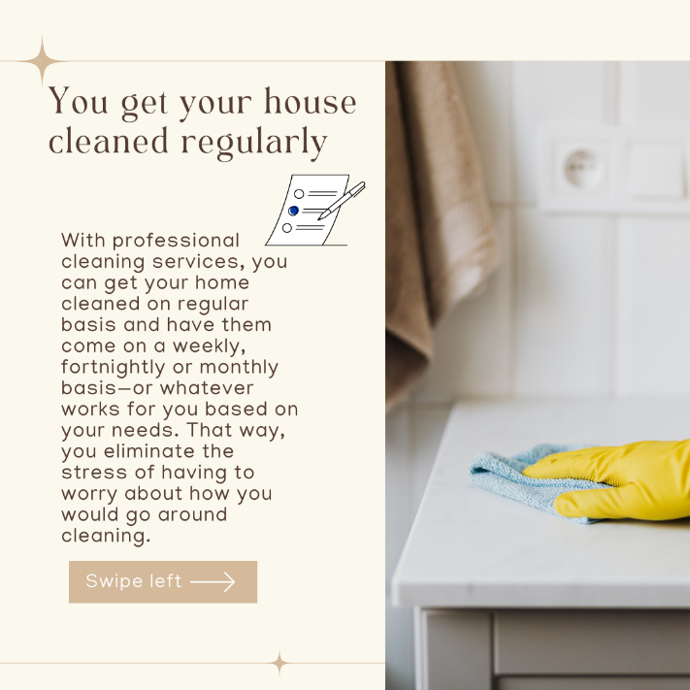
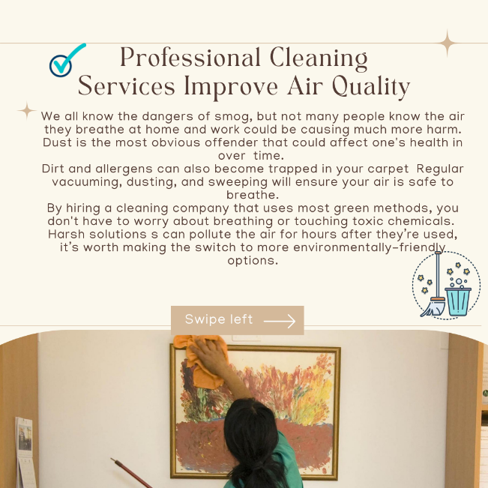
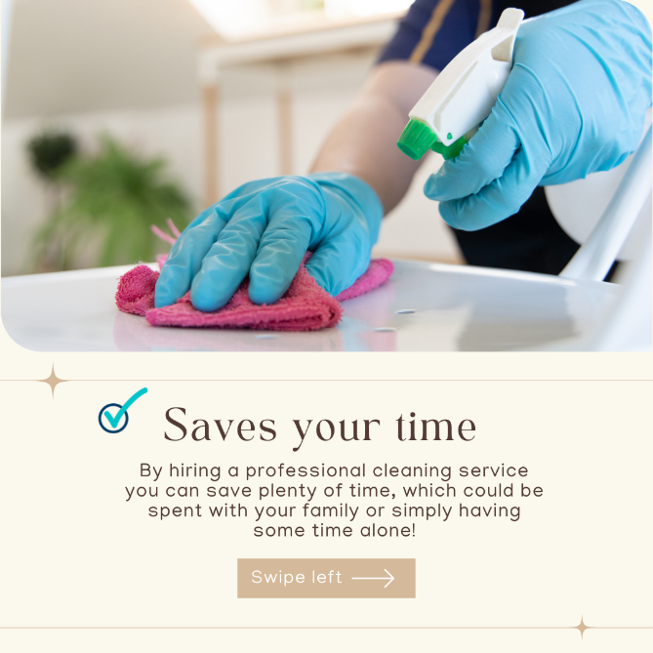

How to make Green cleaning products at home?

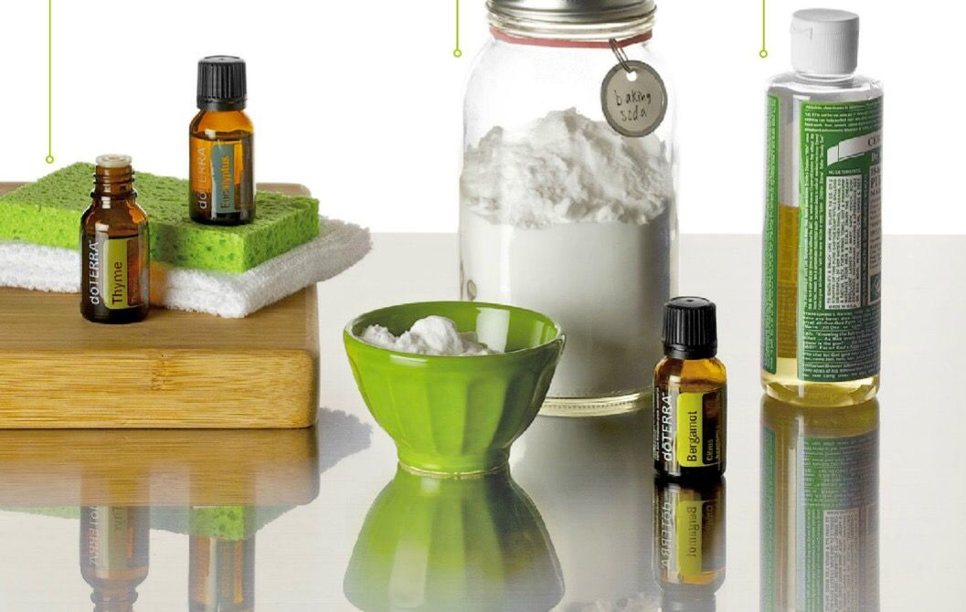

Keeping your house clean is essential but nowadays people are becoming more aware of the impact cleaning products have on one’s health as well as on the environment. People have been using cleaning products with toxic and harsh that can be very harmful.
When buying a cleaning product not all the ingredients are listed. According to research, most people are keen to switch to eco-friendly products but for many the cost might be an issue. Eco-friendly products could cost twice more than a normal product but people do not know there could be alternatives – you can make your own cleaning products in the comfort of your home!
There are many benefits of using green products, however I will just list a few:

- Eliminates toxins at home:
When you use green cleaning products in your home you eliminate the risks of exposure to toxic chemicals. As we know the cleaning products which are sold in the shops consists of harsh toxic chemicals These chemicals can actually cause damage to the furniture in your home and also affect the health and skin of those who are working with them.
According to research conducted by the American Medical Association has found that Triclosan, a common antibacterial ingredient has the ability to mess with one’s hormonal system and thyroid.
- Increased air quality in your home
Harmful chemical could be very dangerous if you have any allergies or overall health problem. Usually, the strong smell of these products could stay in the home Using green cleaning products allow you to increase the quality of air that flows throughout your house by eliminating toxins and allowing proper air flow.
- Be more environmentally friendly
In the recent year, people have started to think about the foot print we leave on the planet, people are turning to green products in order to help preserve the environment. Using green products will help reduce pollution to our water and minimize the impact on the ozone layer and climate change. Many green products come in recyclable packaging which reduces waste when you throw the into the recycling.
- Save money
It is well known that environmentally friendly products could cost a little bit more but many people are not aware that can use ingredients from their kitchen. Scientists have warned us that some household cleaners could be as bad for our lungs as smoking 20 cigarettes a day. Not only are green cleaning products cheaper when you use them in your home but investing in these products is also cheaper for companies as they have become much more competitive.

Why not trying essential oils for cleaning?
Essential oil are great ingredients to use as cleaning products due to their antibacterial properties. Many of the oils protect against bacteria, viruses as well as mold which makes them a great addition to the household.

Here are some oils which could be used:
- Tea Tree Oil
- Lavender Oil
- Sweet Orange Oil
- Eucalyptus Oil

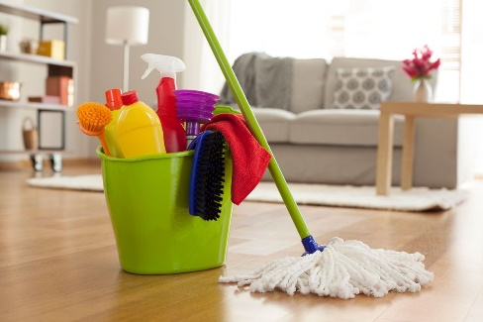
How to clean like a professional

Cleaning could be an activity which you either love or hate. It is very tiding and also takes a lot of time. That’s why I have done some digging and gathered some useful tips which would help you clean in no time as well as get results as it was done by professionals.
Get motivated – The first and the most important step to is be motivated to clean. At the end the goal is to have a clean and healthy environment to live in. It is very important to be in a clean and tidy space to be as it makes you more productive and it’s easier to get things done.
Schedule a time – When trying to schedule a time to clean for yourself you need to work around your personal schedule. You need to plan time for cleaning in a day when you have as little distractions as possible. Make sure you set a day in which you can spare around 4 to 6 hours to clean depending on the size of the house. Set a day and put a reminder in your phone which notifies you a day before. Once you have started cleaning, turn off your phone and play some music in the background. Make sure you have all of the cleaning supplies, having to go to the shop would be annoying and will take away time for your cleaning day.
Start with clearing out – It could be difficult to work around clattered places and surfaces. Before starting with the cleaning, clear out from the floor and the surfaces, it takes couple of second to move things aside to clean, but all those seconds add up. It would be of help, if you try to clear after yourself daily – when drinking a cup of tea, don’t just leave it on the table, you can simply take it to the kitchen and give it a quick wash.
Work from top to bottom – Reading through blogs, professional cleaners suggests that you should start your cleaning with work from top to bottom. They usually start with dusting and wiping high places, then work their way down, letting crumbs fall to the floor. A single vacuum and a mop will finish the job!
At the end of the day, the quicker you get the job done the faster you could have a rest in your clean and tidy home.
A day in a life of a professional cleaner – Blog
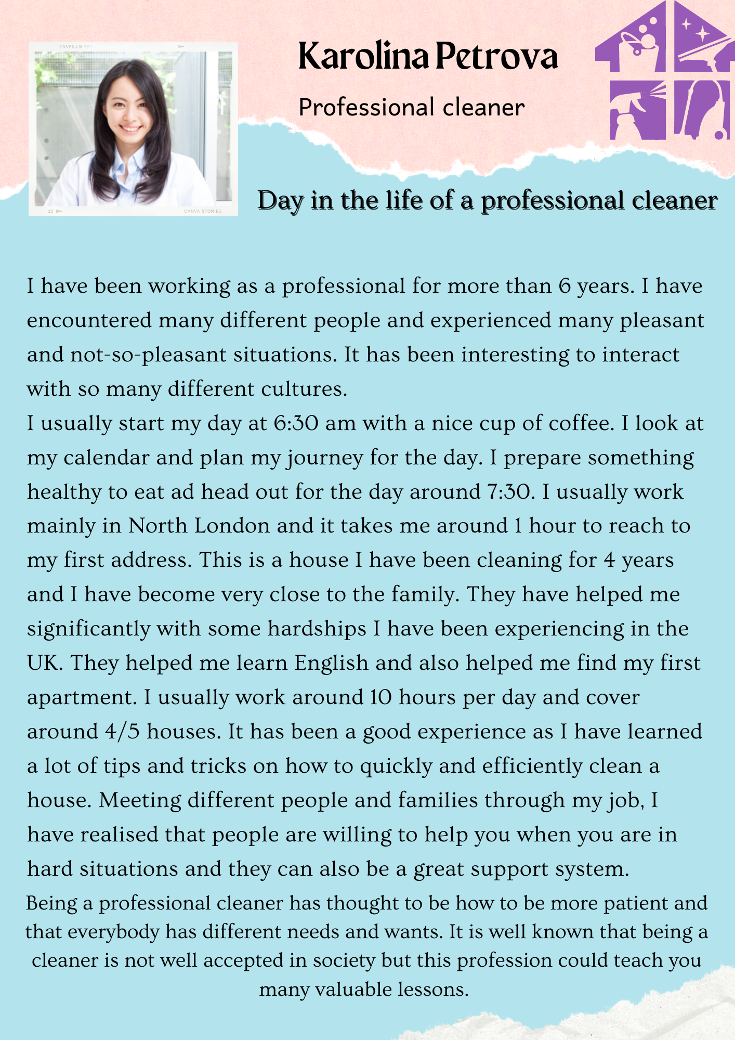

How to clean your house effectively in 30 minutes?
Nowadays, everybody is busy with their work or personal life, often one doesn’t have time for itself but what about cleaning? Hiring professional cleaners weekly could be a costly. That’s why I have done some research and I have found cleaning tips which could help you clean your house in 30 minutes or less.
It is important to deep clean your house on regular basis, the fast and light cleaning it’s the way of maintaining a hygienic home. This type of cleaning is great way to tackle the small jobs, so they don’t pile up.
Here are some tips on how you can quickly clean your home:
- Create a check list for your house
It would be useful if you can create a short checklist for each room of the house and what it needs it be done. It could be pinned on the door and it there as gentle reminder. Make a habit of clearing clutter, if you notice there is anything on the floor, put it back where it belongs. If you feel like your house is cluttered, you could buy some storage organisers and put it next to the door where you can store jackets and shoes.
- Set a timer
Setting a timer could encourage you to stay on track on don’t get distracted. Setting timer for 5-10minutes will make you clean the house faster.

Bathroom clean
One of the rooms which takes the longest to clean is the bathroom. Here are some tips:
Bathroom clean
- Start with the toilet
- Wipe all the surfaces
- Spray everything
- Mop the floor

Kitchen clean
- Remove everything from the counters
- Wipe well the worktops
- Clean the handles
- Give a quick wipe to the fridge

Living room clean
- Start with organising the table and putting away the necessary objects
- Dust the surfaces
- Reorganise any pillows or magazines
- Vacuum

The bedroom
- Open the blinds and the curtains
- Make the bed
- Tidy
- Vacuum

The hallway
- Put the shoes in the drawer
- Make sure all of your jackets hanging
- Vacuum

Why is social media marketing important for a small business?

Marketing could be found around you - how often do you scroll on social media and see advertisements for companies or small business promoting their services. Using social media marketing is a great way to put your business in the mind of the customers. Big companies do invest a lot of media in their social media marketing companies as it is much easier and quicker way to reach many different customers from all over the world. In this blog we will discuss the benefits of social media marketing and the it way it helped me bring more awareness to my cleaning company and attract potential customers.

What is social media marketing?
Social media marketing, also known as SMM. Social media is the use of social media website in order to connect with your audience or customers and helping them understand the brand or the services you offer better. By using social media marketing, you can tailor your content to on every social media platform in order to target different type of groups. It is a great way to connect with the people who follow you or are interested in what you are doing as well it’s great way to understand the needs and wants of the customers and make. According to research, there are more than 2.7 billion active users on Facebook alone. In this day and age, no business should be missing out on using social media.

What are the different types of social media marketing?
- Paid Advertising
- Content Marketing
- Ad Campaigns
- Email Marketing
- Influencer Marketing

What are the benefits of social media marketing for a small business?
Undoubtfully, social media marketing has become the most essential tool, which is way more profitable than the traditional marketing for a small business. Here are some of the benefits of social media marketing for small business:

Increases Brand Awareness - For a small business, it’s a great way to increase you brand visibility by being active on the chosen social media platforms.
Increased traffic – Having social media presents, could help you generate more traffic to your website. Business owners need to make sure the information shared on their website should be easy to find and valuable.
Increases Audience reach – You can reach different groups of people. You can adjust your social media settings in order for your posts to reach a specific group. It costs way less than the traditional way of marketing.
Customer Service – Social Media Marketing gives our customers the opportunity to reach easier. Customers are able to write reviews and provide you with feedback. This helps to promote your brand to the public.
Improves Customer Loyalty – The benefits of social media marketing for a small business are too many to mention. You can improve your customer loyalty by connecting personally and directly via setting automated messages. They can also find out about your opening times and also your availability for any appointments.

My own experience with social media marketing
When I set up my company few years ago, it has difficult to get many customers. Not only because the company was new but I didn’t know how to use social media marketing. It was after a set up a Facebook Page and Instagram profile, I realized how powerful SMM is. I started to follow other cleaning companies and follow closely what they were doing and they way they were using social media.

I started to share posts, many pictures, interesting articles and also tips and trick on my profiles. Slowly, my profile started to attract attention and got few bookings. I started to spend more time using posting and sharing with my follow and my business slowly grew. It was difficult at first but I did spend a lot of time learning how to create social media companies and ways to advertise my business. It was a great well to connect and establish connection with my clients.
After a year and a half, I could say I have a Facebook group with more than 7K followers, which engage with my posts and I get regular bookings. I managed to develop my website, which is easy to navigate and I get many feedbacks on how clear everything is.

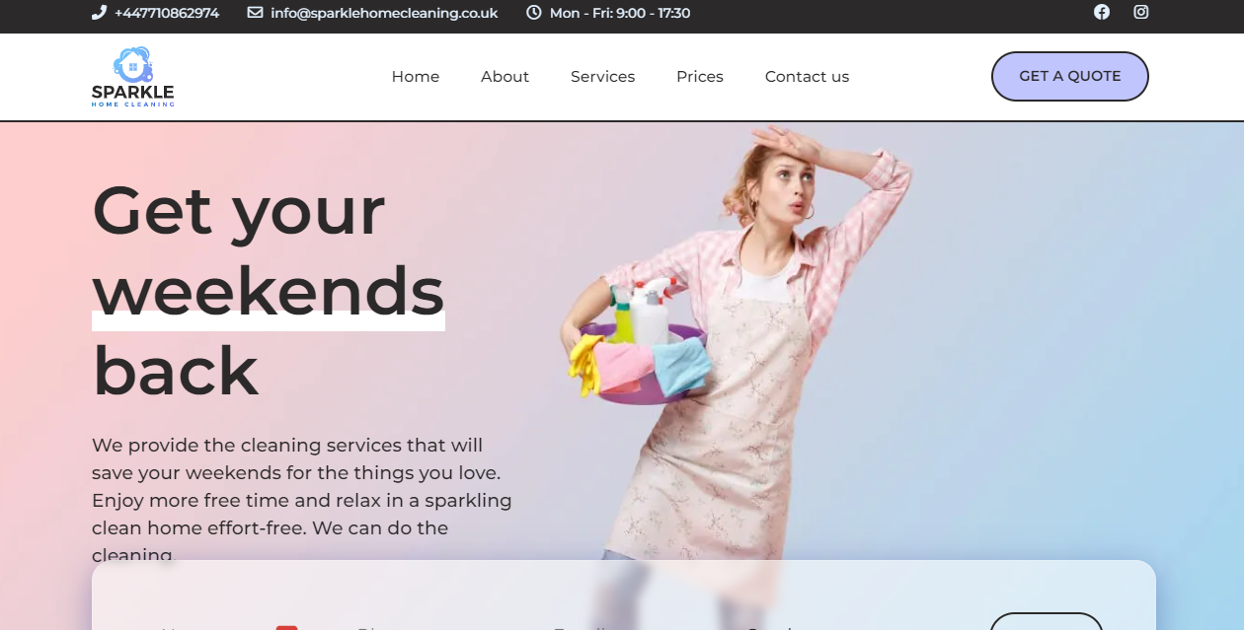

If you are thinking about starting your own business, do invest time do learn how social media marketing could be useful. It’s a great way to bring your business and customers together.

