The results of the primary data
The results of the questionnaire revealed a lot of problems, and the questionnaire did not set many questions because of the busy workload of the distribution staff. However, it was possible to obtain the important information needed and to analyse it. The questionnaire was distributed 40 times and 36 people were very willing to cooperate with the survey, but unfortunately 4 people refused to fill in the questionnaire.

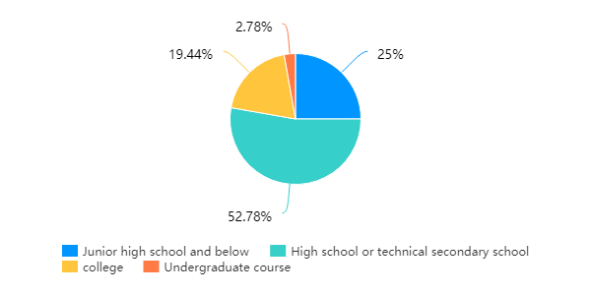
Figure 1 Educational background

The graph shows that of the 36 people who took part in the survey, 52.78% had a high school education, with 25% having a primary school education and barely more than 20% having a university education and above combined. This shows that the general level of education of Hungry Delivery staff is not high. In China, delivery workers have a very hard job and most university students do not choose to work in this industry after graduation, which is directly related to general perceptions and parental attitudes. They would consider delivery workers to be a very bad job and one that is only chosen by people who cannot find a job. So this has led to a generally low level of literacy among delivery workers. However, there are also cases where university students are employed and some choose to work part-time as delivery workers in their free time. This is because in the short term, the wages for delivery workers are not low enough to satisfy the needs of university students.
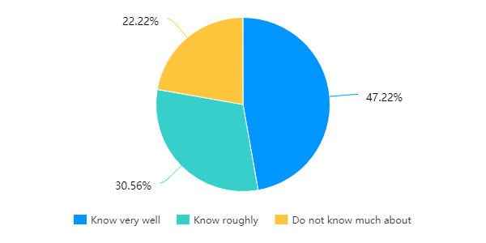
Figure 2 understanding of the performance appraisal program
From the analysis of the survey results, it is clear that 47.22% of the delivery staff are very aware of the performance appraisal, and only about 30.56% of those who understand it, only a small proportion of people do not understand the performance appraisal taken by the hungry company for delivery staff. This also shows that the performance appraisal is not fully implemented, which leads to the existence of performance appraisal is easy to be ignored problems occur.

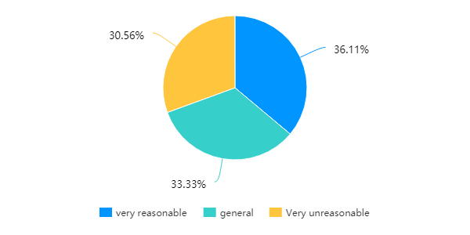
Figure 3 Do you think the performance indicators are scientific and reasonable?

The graph shows that 36.11% of employees consider performance appraisals to be reasonable, 33.33% consider them to be reasonable, but 30.56% consider them to be unreasonable. This shows that there is a problem with performance appraisal, which leads to employees not understanding or even not paying attention to performance appraisal.
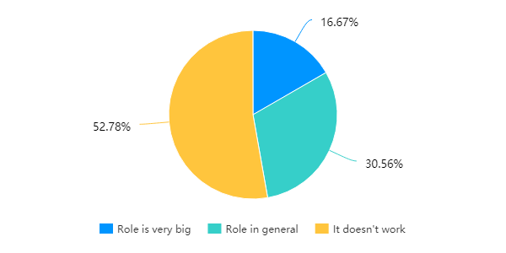
Figure 4 How much incentive does the current assessment method have for you to exert your work enthusiasm

The graph shows that 52.78% of people think that performance appraisals have no impact at all, and 30.56% of people think that performance appraisals have an average impact. Only 16.67% of people think that performance appraisals have a great impact. This indicates that the performance appraisals developed by Hungry Mash for its delivery staff are largely not in place.

The above is the data collected through the questionnaire and the important information has been selected for analysis. The following is the information obtained through communication with the regional managers of the distribution staff.
All the primary data were collected by contacting and consulting Ele. me distribution personnel, regional managers, and other working staff, and the collected data were also sorted out. For large takeout companies, there is a clear hierarchy of staff (takeout captain, takeout trainer, takeout knight, takeout rider). Among them, the cardinal number is the biggest, the change is most belong to the delivery rider. Delivery deliverers are divided into full-time deliverers and part-time deliverers. The difference between them is very simple. Full-time deliverers are mainly in the delivery industry and only responsible for delivery activities. Part-time deliverymen have other jobs and take time off work or at night to deliver food. At present, under the market salary management mode, the measurement standard of the part-time rider is single, "delivery quantity * unit price"; The salary model of full-time riders is calculated according to 'basic salary + subsidy + performance + commission + bonus+ promotion reward + seasonal subsidy'. The basic salary varies from region to region (100-300 yuan). Basic salary + benefits: 2,500-2,800 yuan (with regional differences). Commission: the part less than or equal to 200 orders shall be calculated at 2 yuan per order, while the part greater than or equal to 200 orders shall be calculated at 4 yuan per order. Commission: the part greater than or equal to 400 orders shall be calculated at 6 yuan per order. The commission should not exceed 10 yuan per order (greater than or equal to 5 kilometers). Deduction fee: 50 yuan each (bad rating); 200-300 yuan each (complaints). Based on salary, performance appraisal is carried out from three aspects. The first aspect is the performance appraisal index, which evaluates the delivery singular number delivered by the delivery personnel through their efforts. The second aspect is the ability to assess indicators, which refers to the distribution personnel to complete their work should have the ability. The third aspect is the attitude assessment index, which refers to whether the delivery personnel receives bad comments after the completion of the order. Ele. me's performance in terms of distribution personnel generally extends from these three aspects. At the same time, for the performance appraisal of the delivery personnel, Ele. me adopts the point deduction system, the full mark is 100 points, and if the work is not carried out in accordance with the rules and regulations, points will be deducted, and fines will be imposed. The selection is conducted once every two months, and the delivery personnel without points deduction for two months can be judged on the gold medal rider, the bonus is 200 yuan. Points will be deducted, but the highest will be awarded a silver medal rider; the prize is 100 yuan. The rider with the points deducted, and the second place is awarded the bronze medal, and the prize is 50 yuan. At the same time, riders of different levels of gold and silver have a commission of 1-3 yuan (according to the level of riders) in each order. If the score is lower than 60 points in two months, clearance treatment will be conducted.

Part of ele. me performance appraisal regulations
Ele. me adopts KPI Key Performance indicators for riders, which simplifies the tedious evaluation criteria into several Key indicators. To some extent, the evaluation method to compare the performance of riders with key indicators is an effective combination of object management and pareto. The main assessment criteria are as follows:
1.The company allows employees to apply for sick leave, personal leave, marriage leave and funeral leave according to actual needs. The basic salary within 2 days of each leave shall be paid for the whole month.
2.The horseman will be rewarded with a bonus of 50 yuan for not being late for work and not leaving early every month. Those who do not ask for leave or leave without reasons will be treated as absenteeism, 50 yuan for one day.
3.It is strictly prohibited for the rider to ask for tips from customers during his/her work. Once found, the rider will be fined 50 yuan, and his/her performance points will be deducted.
4.No one is allowed to quarrel with customers for any reason, and comments and insults are strictly prohibited. Once found, the first fine of 200 yuan, warning, deduction of 50 performance points, the second monthly salary of zero, and dismissal.
5.The company sets up a reward system and sets up 3 awards, such as 200 yuan for the first prize for the gold medal rider, 100 yuan for the second prize for the silver medal, 50 yuan for the third prize for the bronze medal rider, and the first prize for the one with the highest score in the comprehensive evaluation, and so on.
6.During the working period, the mobile phone must be guaranteed to have electricity frequently and must be equipped with charging treasure. During the peak period, the mobile phone cannot be shut down.
7.Each person's performance is divided into 100 points, and the two months 'performance is less than 60 points, and the company will be cleared.
In addition to complying with Ele. me's customized regulations and performance review requirements; riders are also required to collect a self-evaluation summary form at a designated place at the end of each day. Evaluate their daily work status during breaks. In addition, the station master will rate the daily work of the riders. It can be seen that Ele. me has rigorous requirements on riders, and has formulated very detailed assessment contents. Meanwhile, it adopts mandatory assessment methods to let riders work in strict accordance with the requirements, so as to ensure that the performance assessment is carried out for every rider.

Problems with Ele. me's the performance appraisal review
In human resource management, performance appraisal is an essential part, which directly reflects the performance of employees, and the appraisal results are closely related to a variety of factors. It can not only reflect the performance of employees and indirectly reflect the performance of the enterprise, but also be linked to performance and reflect the income of employees. A scientific performance appraisal system can fundamentally reflect the current state of the company, and the improvement of the appraisal system is directly related to the success or failure of the core work.
In the modern competitive society, the problems of low internal efficiency and unclear division of labour in Ele. me are more prominent. Compared with other enterprises in the sales industry at home and abroad, Ele. me mainly has the following three problems in the performance appraisal of riders:
First lies in the assessment index aspect, the performance appraisal index is will the moral character, the work performance, the ability, and the attitude USES the scientific way union organization characteristic of dividing the item and the standard. Ele. me has a clear bias in this regard. The setting is not scientific, lack of logic between each other, indicators at all levels and the final indicators are not consistent. This leads to quantification difficulties in the actual work of the rider and the inability to evaluate. In the process of assessment, more emphasis is placed on the results, and no attention is paid to the intermediate process, which cannot be further deepened, and the most effective results cannot be obtained.
The second is to take a hard assessment, leading to misunderstanding of performance assessment. According to the 2018 takeout group insight report, 52 per cent of riders have a high school or vocational college degree, while 28 per cent have a junior high school degree or less. According to this report, it can be learned that the general educational level of Ele. me riders are not very high, so the issues they consider are contrary to the content of the company's performance appraisal. From the rider's point of view, performance appraisal is a way for them to get the bonus, and their first thought is how to make their delivery time shorter, more efficient and complete more orders. They will see the performance criteria as a roadblock on their way to getting a bonus, not so much because of the work they are doing.
Finally, performance appraisal methods cannot be implemented. Although Ele. me conducts appraisals; they tend to be superficial, which makes it impossible to evaluate performance truly. It is more related to the income, which is difficult to be implemented in the actual work of the riders. In case of problems, the points deduction system is adopted, which leads to a great discount in its function. What's more, the assessment method adopted by Ele. me for the riders is to deduct points from the usual work of the station master, and to score by the distribution staff themselves after the completion of the work. This will create a loophole, so that no one knows what happened during the process of delivering the food to the rider, and whether the rider violated the assessment rules in the blind area of supervision, such as whether the rider violated traffic rules, opened the food without permission and stole food. This makes it difficult for Ele. me's performance appraisal to be implemented in the rider's work.

The appendix
The questionnaire used in the questionnaire and the results of the survey
1.Your educational background[single]
Options | Subtotal | Proportion
Junior high school and below | 9 | 25%
High school or technical secondary school | 19 | 52.78%
college | 7 | 19.44%
Undergraduate course | 1 | 2.78%
This question is valid for the number of people who have completed it | 36
2.Your educational background[single]
Options | Subtotal | Proportion
Junior high school and below | 9 | 25%
High school or technical secondary school | 19 | 52.78%
college | 7 | 19.44%
Undergraduate course | 1 | 2.78%
This question is valid for the number of people who have completed it | 36

3.Your working years[single]
Options | Subtotal | Proportion
1 year and below | 8 | 22.22%
1-3 years | 13 | 36.11%
3-5years | 13 | 36.11%
5-10years | 2 | 5.56%
This question is valid for the number of people who have completed it | 36

4.Your understanding of the performance appraisal program (including indicators, processes, methods)[single]
Options | Subtotal | Proportion
Know very well | 17 | 47.22%
Know roughly | 11 | 30.56%
Do not know much about | 8 | 22.22%
This question is valid for the number of people who have completed it | 36

5.Do you think the performance indicators (such as order number, attendance, order satisfaction) are scientific and reasonable?[single]
Options | Subtotal | Proportion
very reasonable | 13 | 36.11%
general | 12 | 33.33%
Very unreasonable | 11 | 30.56%
This question is valid for the number of people who have completed it | 36

6.Do you work according to the targets you set?[single]
Options | Subtotal | Proportion
Strictly carry out | 6 | 16.67%
Generally perform | 21 | 58.33%
Don't perform | 7 | 19.44%
Completely ignored | 2 | 5.56%
This question is valid for the number of people who have completed it | 36

7.How often are examinations conducted?[single]
Options | Subtotal | Proportion
A month | 36 | 100%
A quarter of | 0 | 0%
Half a year | 0 | 0%
A year | 0 | 0%
This question is valid for the number of people who have completed it | 36

8.How did you get to know the results of the assessment?[multiple]
Options | Subtotal | Proportion
Direct system feedback | 4 | 11.11%
Superior manager or stationmaster notice | 34 | 94.44%
Notice of written documents | 2 | 5.56%
This question is valid for the number of people who have completed it | 36

9.Do you think the results are fair and objective?[single]
Options | Subtotal | Proportion
Very fair | 22 | 61.11%
Basic fairness | 11 | 30.56%
Very unfair | 3 | 8.33%
This question is valid for the number of people who have completed it | 36

10.If you have any objection to the assessment result, can you appeal?[single]
Options | Subtotal | Proportion
Yes | 36 | 100%
No | 0 | 0%
This question is valid for the number of people who have completed it | 36

11.After the appeal is lodged, who will handle the feedback?[single]
Options | Subtotal | Proportion
Artificial customer service | 0 | 0%
Superior manager or stationmaster | 36 | 100%
This question is valid for the number of people who have completed it | 36
12.How well and effectively do you think the assessment results are used for salary and level promotion?[single]
Options | Subtotal | Proportion
Excellent results | 7 | 19.44%
Very general | 18 | 50%
Effect is very poor | 11 | 30.56%
This question is valid for the number of people who have completed it | 36

13.How much incentive does the current assessment method have for you to exert your work enthusiasm?[single]
Options | Subtotal | Proportion
Role is very big | 6 | 16.67%
Role in general | 11 | 30.56%
It doesn't work | 19 | 52.78%
This question is valid for the number of people who have completed it | 36

