Question 1:
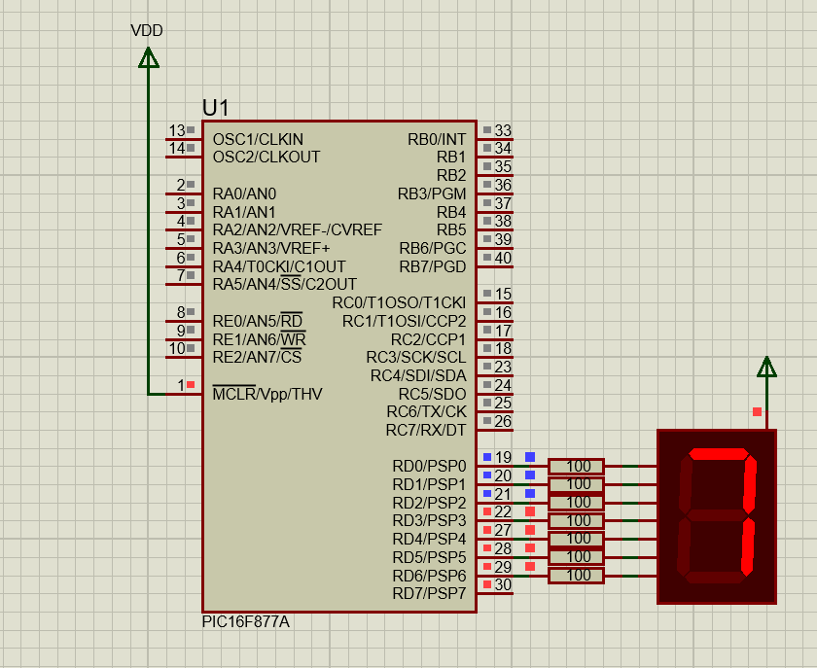
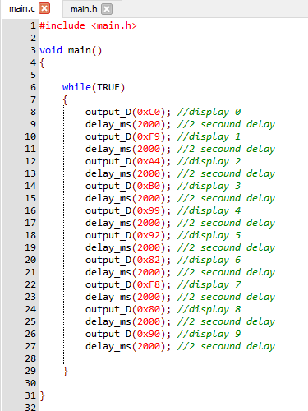
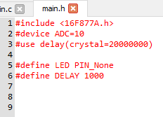

Question 2:
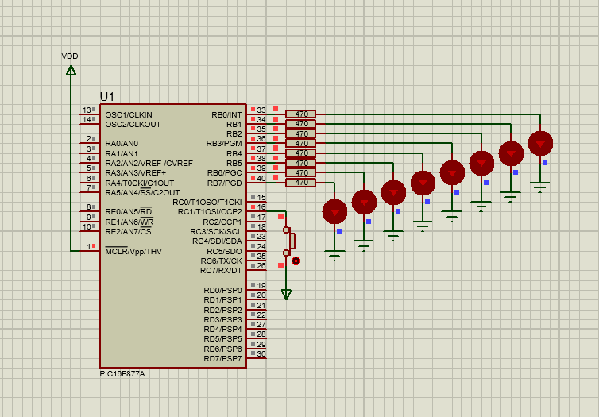
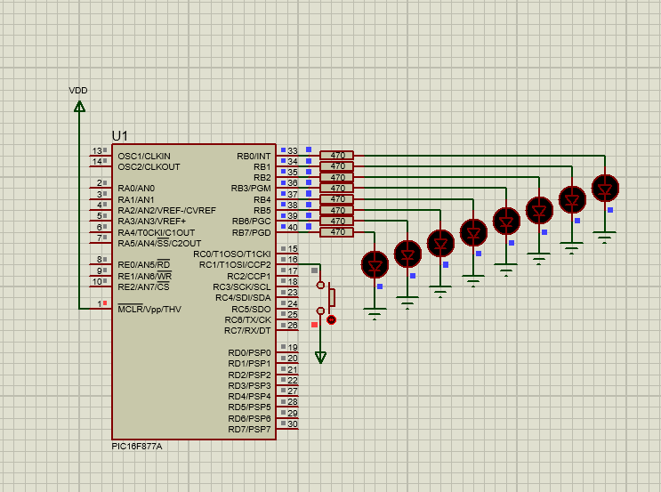
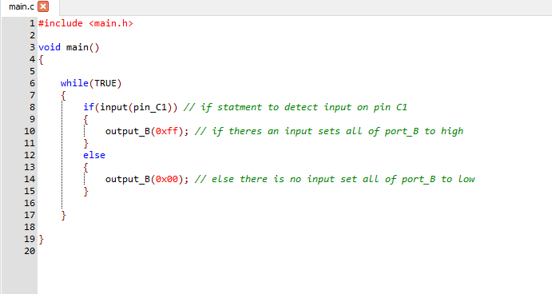

Question 3:
i:a: Circuit is a humidity circuit. Used for detecting humidity in an environment and when a certain level is reached the LED will turn on this level can be set using the potentiometers. The secondary LED is used as a power indicator.

i:b: This circuit uses an LM393 Dual comparator. The potentiometer one is used to simulate the humidity in the room as that is increased at the set level determined by the second potentiometer will then send power to the LM393. This then switches to allow LED 2 to turn on indicating humidity level has been reached. The two smaller valued resistors are used as current limiting for the LED’s. The LED 1 is used as a power indicator.
i:c:
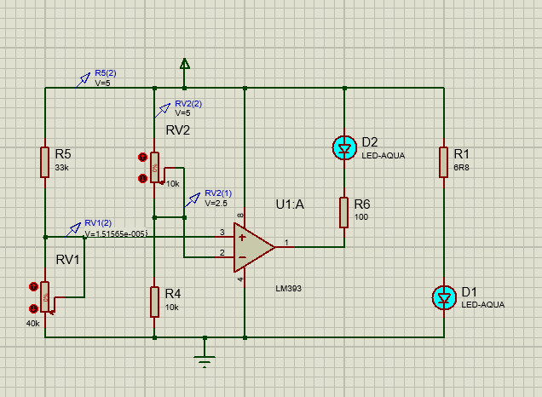
Question 4:
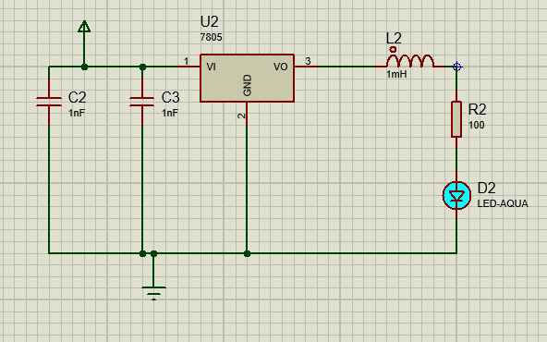
4.i.b. A buck convertor is SMPS circuit used to regulate power to a load. The 7805 chip is used as a step-down source to provide 5V to the LED. The capacitors are used to smooth out the voltage. Inductor is used to control the inductance in the circuit.

